Blue_Group_Week2_Milestone2_Flowchart and_Pseudocode

Hello Instructor Mark,

This week assignment is a continuation of the first milestone assignment (Software Requirement document) for our client **Blue Group Solutions.** The software created is for the shipping and receiving system on the stock department. Our group with the members listed below designed a system work flow shown by figure 1.0 below.

The group members are,

* Adam Bartels
* Fredrick Ondieki
* Joe Donnelly
* Jestin Toomer

**Top Design Model**

The general system workflow of the system describes what key players in the system need to do or what the system does. The system flow starts when users powers on the hardware component which in our case, the client computers running windows operating systems. After the system is on, the user is prompted to log in into the system by entering valid user name and password. If the username and passwords entered are not correct or valid, the user is prompted to enter the second and the third time. After unsuccessful logging attempt, the system terminates after the third and last attempt.

On the other hand, successful logging in to the system leads the user to the window which has tabs labeled, **Stock Department**, **Receiving Department**, **Shipping Department**, and the **Quality Control(QA).** With limited access only by the system administrators, who have clearance from the manager as discussed on the requirement document, the user can access the **Stock inventory**, **Products** and the **Stock Reports** on the system. For example, when a stock department supervisor or the team leader logs in to the system, the person can be able to view data on the stock inventory, products, and stock reports tabs. On the other hand, an employee working on the shipping or receiving department have access only to the product tab on the system.

**Flowchart modules**

**Stock Department**

In addition, **figure 2.0** describes all the events that happens in a stock department. As discussed above, the same case scenarios happen. After the user successfully logs into the system and selects the stock department tab, the following windows tabs are displayed; the **Stock Inventory, Products,** and **Stock Reports.** The system administrator has access to all the window tabs in the contrary to the stock department employees.

Therefore, clicking on the **inventory tab**, the user can access the stock inventory database. The stock inventory database takes the table format as shown in **Table 1.0** On this tab, the administrator can also add a product into the database or correct any error that may occur during data entry into the system.

|  |  |  |  |  |
| --- | --- | --- | --- | --- |
| Date | Product Name | Product Number | Status | Quantity |
| July 22, 2017 | Master Cylinder | 40-67893 | Active | 780 |
|  |  |  |  |  |
|  |  |  |  |  |
|  |  |  |  |  |

Table 1.0

On the other hand, when the user clicks on the **products tab**, the system displays the products table as shown in **Table 2.0 a** having the following properties. Shipping employees have access to this tab as they can add product lines into the inventory database by clicking the add/delete button. In the same case, when a person clicks on the status tab, the product can be active or inactive. The product line column will list all the products in the database in a list.

|  |  |  |  |  |  |
| --- | --- | --- | --- | --- | --- |
| Date | Product Lines | Product Name | Product Number | Status | Add/Delete |
| July 22, 2017 | List of product lines | Various names | Various No. |  |  |
|  |  |  |  |  |  |
|  |  |  |  |  |  |
|  |  |  |  |  |  |

Table 2.0 a

Also, when a user clicks on the **stock reports tab**, the administrator can view the product details as shown in **Table 3.0**. Also, the user can print out any information that is available or per the need. However, while on this window, the administrator cannot add or remove data on products on the data base unlike while on the inventory tab.

|  |  |  |  |  |
| --- | --- | --- | --- | --- |
| Date | Product Name | Product Number | Status | Quantity |
| July 22, 2017 | Master Cylinder | 40-67893 | Active | 780 |
|  |  |  |  |  |
|  |  |  |  |  |

Table 3.0

**Receiving Department**

In receiving department, all the activities involved in logging in to the system and selecting the receiving tab uses the same procedure as the stock department. However, the slight difference between the stock and the receiving department is that the employees can only use the **products tab**. **Figure 3.0** summaries the activities around the stock department. For example, when goods are delivered to the company, the stock employees counter checks the carrier number with the one on the system or scheduled delivery for the day. After the paperwork is signed and everything is ready, the employees unloads the trucks separating the damaged products.

The “good” products are scanned into the system by adding/deleting button as shown in **table 2.0.a** The delete button is made inactive so that the employees cannot delete anything from the inventory database. If wrong information is entered to the database, the supervisor can correct the error by accessing the stock department portal.

The damaged goods are staged awaiting quality check and as well sent for repairs before being received and entered to the inventory database.

**Shipping Department**

In the shipping department, the user follows the same procedure as discussed and shown in **figure 4.0.** In this department, the system administrator (Supervisor) can access all the tabs on the system and view all the tables by clicking on the respective departments. For instance, the user can view the stock inventory database by accessing the stock department portal. However, the employees working in this department can only access the **product tab** and as well view the **product table** as shown in **table 2.0.a** However, since the activity involved here is to ship which means good are being removed from the system (stock inventory database) the employees use **table 2.0 b.**

Therefore, by scanning out the number of product lines ordered by the customer and as well as checking the remove button, the inventory data reduces by number of product lines scanned out. Moreover, before shipping or loading the truck carriers, the quality control associate confirms the shipment and inspects the goods for damages. Otherwise the shipment is ready and the loading employees confirms the carrier and as well as the shipment number.

|  |  |  |  |  |  |  |
| --- | --- | --- | --- | --- | --- | --- |
| Date | Product Line | Product Name | Product Number | Status | Remove | Quantity |
| July 23, 2017 | List | Turbo | 23-1109 | Active |  | 123 |
|  |  |  |  |  |  |  |

Table 2.0 b

**Quality Control(QA)**

The quality control personnel also follow the same procedure as all the other when logging to the system as shown in **figure 5.0**. The person can view essentially all the tables in the system. The main objective of the quality control is to inspect the goods in the company and check the customer return complains.

For instance, when goods are returned by the customer, the goods are staged out awaiting quality control. The quality associate inspects the items and sends the goods to be repaired if they are damaged or change the labels on the product lines being shipped. The goods are then staged awaiting to be received section ready to be fed again to the inventory database.

In addition, the quality associate can use **table 2.0 a.** However, this happens occasionally, but the main entry of goods to the system is through the receiving department.

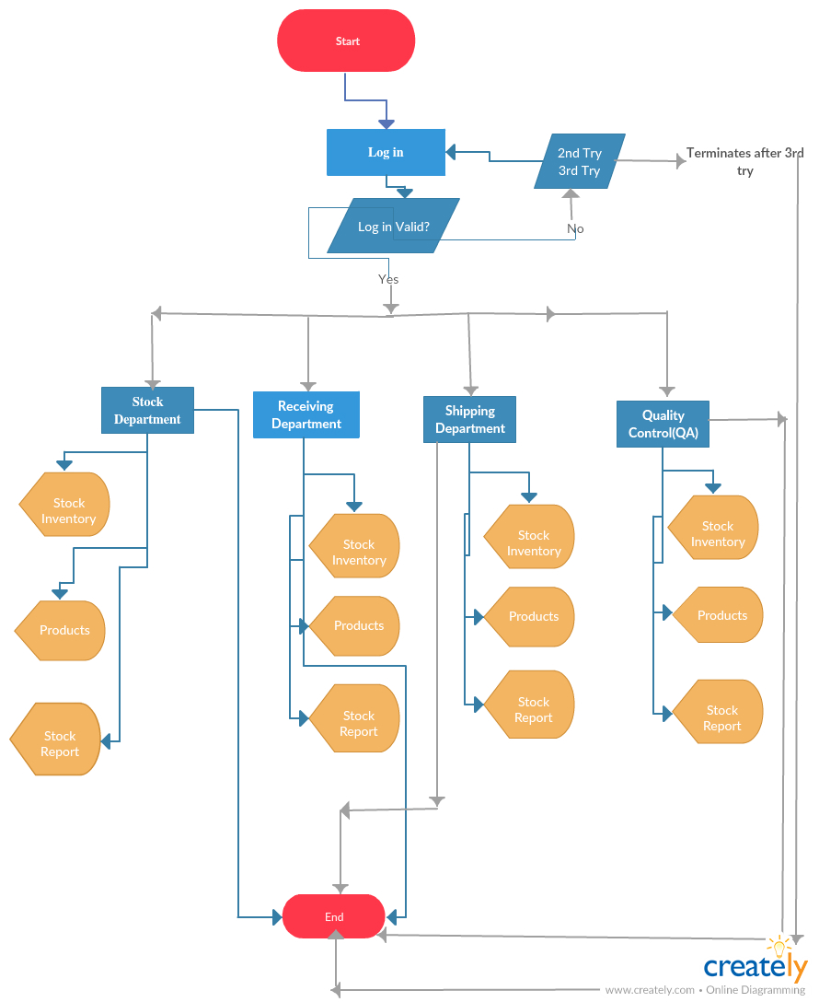

Figure 1.0

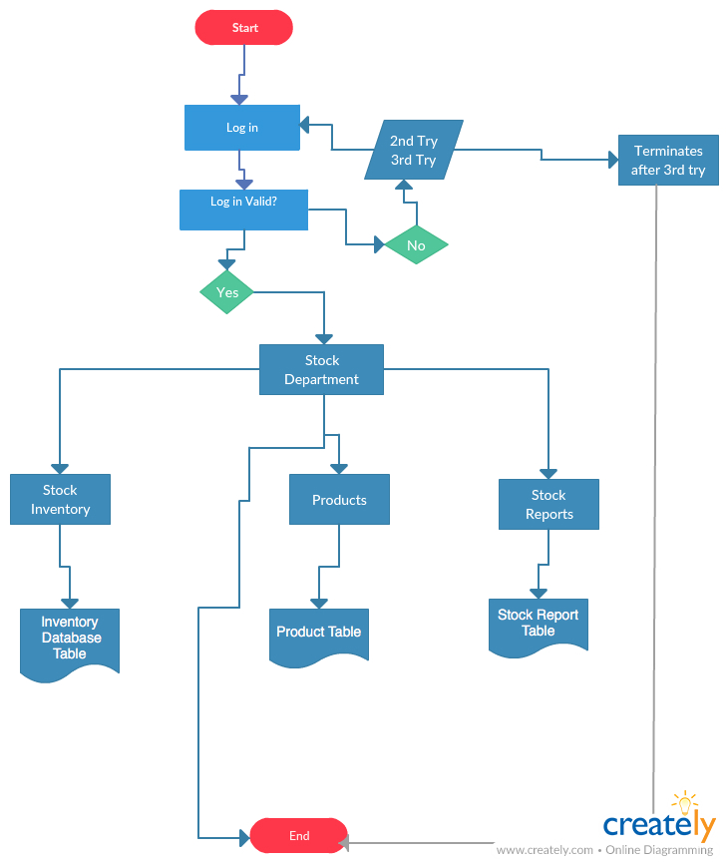Figure 2.0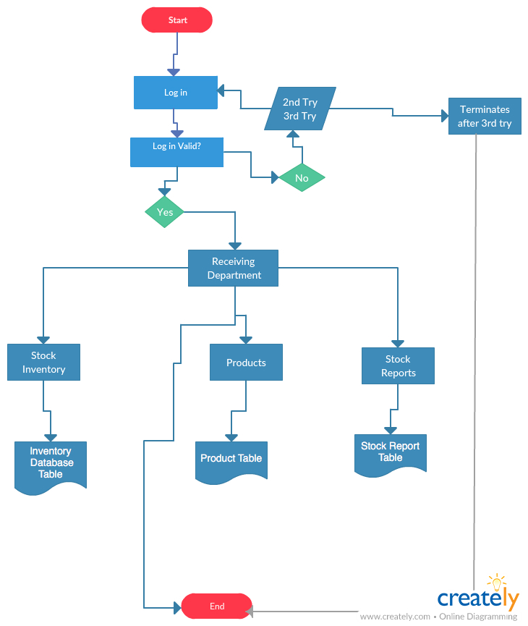

Figure 3.0

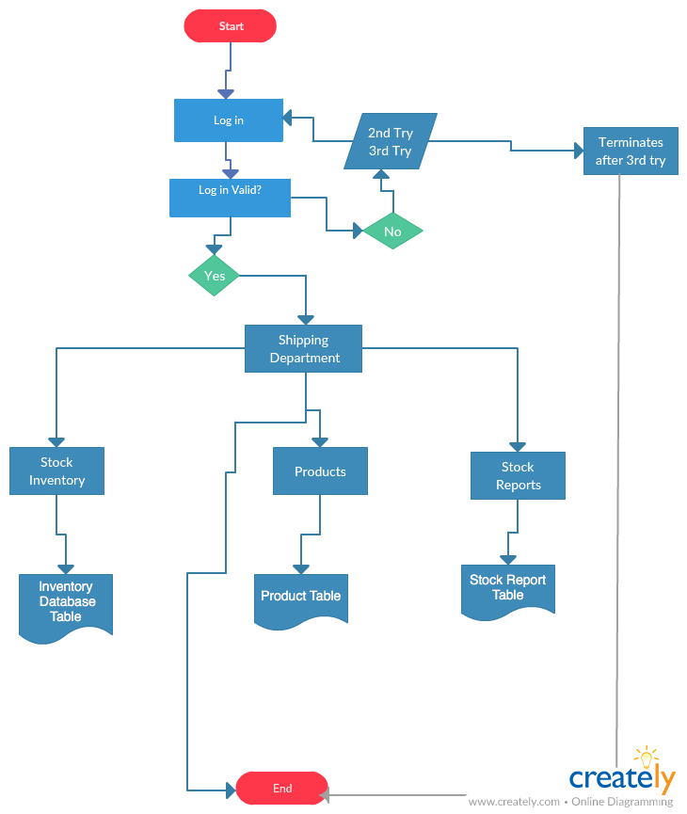

Figure 4.0

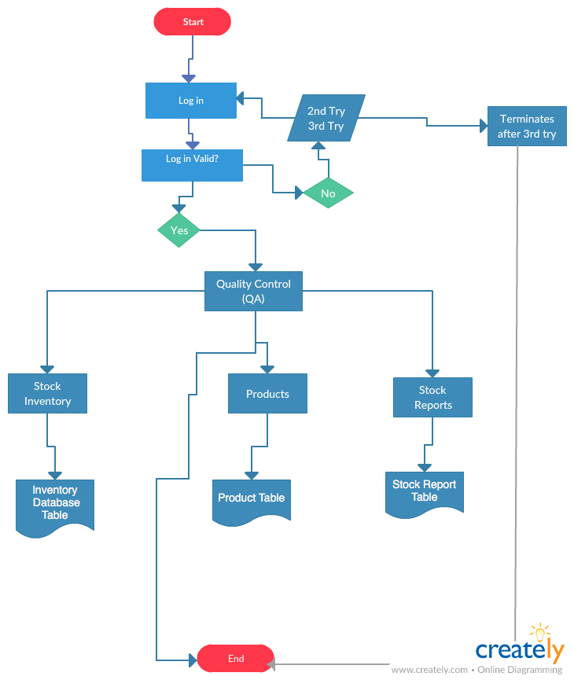

Figure 5.0

**Pseudocode**

**Design Workflow pseudocode**

**Start**

CLICK log on portal

ENTER user name

ENTER password

*IF (username and password is valid)*

*Log in*

*ELSE IF (username and password not valid)*

*Log in 2nd time*

*Log in;*

*ELSE IF (username and password not valid)*

*Log in 3rd time*

*Log in;*

*ELSE*

*Terminate after 3rd try*

*END IF*

CLICK Button tab1

View Stock Department Data

*END*

CLICK Button tab2

View Receiving Department Data

*END*

CLICK Button tab3

View Shipping Department Data

*END*

CLICK Button tab4

View Quality Department Data

*END*

**END**

**Stock Department flowchart pseudocode**

**Start**

CLICK log on portal

ENTER user name

ENTER password

*IF (username and password is valid)*

*Log in*

*ELSE IF (username and password not valid)*

*Log in 2nd time*

*Log in;*

*ELSE IF (username and password not valid)*

*Log in 3rd time*

*Log in;*

*ELSE*

*Terminate after 3rd try*

*END IF*

CLICK Button tab1

View Stock Department Data

Display Stock Inventory

Display Products

Display Stock reports

Click Stock Inventory

*Display the Inventory Database Table*

*Add items to the database*

*End*

Click Products

*Display the Products table*

*End*

Click Stock reports

*Display the Stock Reports Table*

*Print the Report;*

*End*

**END**

**Receiving Department flowchart pseudocode**

**Start**

CLICK log on portal

ENTER user name

ENTER password

*IF (username and password is valid)*

*Log in*

*ELSE IF (username and password not valid)*

*Log in 2nd time*

*Log in;*

*ELSE IF (username and password not valid)*

*Log in 3rd time*

*Log in;*

*ELSE*

*Terminate after 3rd try*

*END IF*

CLICK Button tab2

View Receiving Department Data

*IF (system administrator)*

*ENTER user name*

*Enter password*

*log in;*

*Display Stock Inventory*

*Display Products*

*Display Stock reports*

*ELSE*

*Display Products*

*END IF*

Click Stock Inventory

*Display the Inventory Database Table*

*End*

Click Products

*Display the Products table*

*End*

Click Stock reports

*Display the Stock Reports Table*

*End*

**END**

**Shipping Department flowchart pseudocode**

**Start**

CLICK log on portal

ENTER user name

ENTER password

*IF (username and password is valid)*

*Log in*

*ELSE IF (username and password not valid)*

*Log in 2nd time*

*Log in;*

*ELSE IF (username and password not valid)*

*Log in 3rd time*

*Log in;*

*ELSE*

*Terminate after 3rd try*

*END IF*

CLICK Button tab3

View Shipping Department Data

*IF (system administrator)*

*ENTER user name*

*Enter password*

*log in;*

*Display Stock Inventory*

*Display Products*

*Display Stock reports*

*ELSE*

*Display Products*

*END IF*

Click Stock Inventory

*Display the Inventory Database Table*

*End*

Click Products

*Display the Products table*

*End*

*Bool Remove (is the quantity of items ordered right)*

*Check the remove button if true;*

*Else false;*

*Bool Status (is the item ordered in stock)*

*Check the Status button if true;*

*Else false;*

Click Stock reports

*Display the Stock Reports Table*

*End*

**END**

**Quality Control(QA) flowchart pseudocode**

**Start**

CLICK log on portal

ENTER user name

ENTER password

*IF (username and password is valid)*

*Log in*

*ELSE IF (username and password not valid)*

*Log in 2nd time*

*Log in;*

*ELSE IF (username and password not valid)*

*Log in 3rd time*

*Log in;*

*ELSE*

*Terminate after 3rd try*

*END IF*

CLICK Button tab4

View Quality Control Department Data

*IF (system administrator)*

*ENTER user name*

*Enter password*

*log in;*

*Display Stock Inventory*

*Display Products*

*Display Stock reports*

*ELSE*

*Display Products*

*Display Stock reports*

*END IF*

*Display the Inventory Database Table*

*Add items to the database*

*End*

Click Products

*Display the Products table*

*End*

Click Stock reports

*Display the Stock Reports Table*

*Print the Report;*

*End*

**END**

Reference:

Inventory Management system (n.d.). Retrieved on July 23, 2017 from

<https://www.slideshare.net/copo7475/inventory-management-system-16598132>

Introduction to Pseudocode (n.d.). Retrieved on July 23, 2017 from

<https://www.slideshare.net/DamianGordon1/pseudocode-10373156>

Pseudocode: An introduction(n.d.). Retrieved on July 23, 2017 from

<http://faculty.ccri.edu/mkelly/COMI1150/PseudocodeBasics.pdf>