User Name

Harry Jones

Fred Barnes

CO600: Application readme

14 March 2016

Fred Barnes

CO600: Document Type

Create Your Own Quiz Readme

Overview

In this application, users are able to create their own quizzes and upload them to a database for playing on ANXED.

Quizzes require a title, description, and at least one question. Optionally, users may upload an image to use as the tile for their quiz on the website.

A question may have between 2 and 4 possible answers, with one of them being correct.

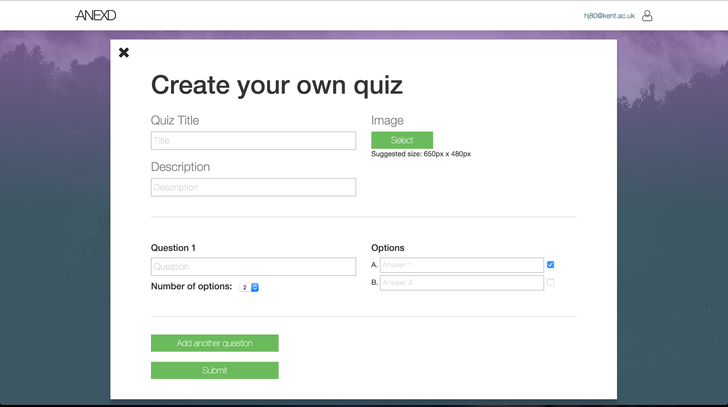

*Screenshot of the Create Your own Quiz interface*