Wa40

Waqas Aslam

Fred Barnes

CO600: Application readme

14 March 2016

Fred Barnes

CO600: Document Type

Video Annotate Readme

Overview

The YouTube Commenting App is an app to allow collaborative comments on a YouTube video. This could be your own YouTube video or any other video on YouTube.

Users will join the lobby and will be given the ability to comment at a specific time of a YouTube video through their mobile/handheld device, which is used as the typing apparatus.

Use cases:

* Educational purposes
  + A lecturer could play an educational video during the lecture and students have the opportunity to annotate the video at any given time stamp.
* Business Use
  + Users can be in a meeting using a company video. Others can use this to annotate the video, suggestions etc.

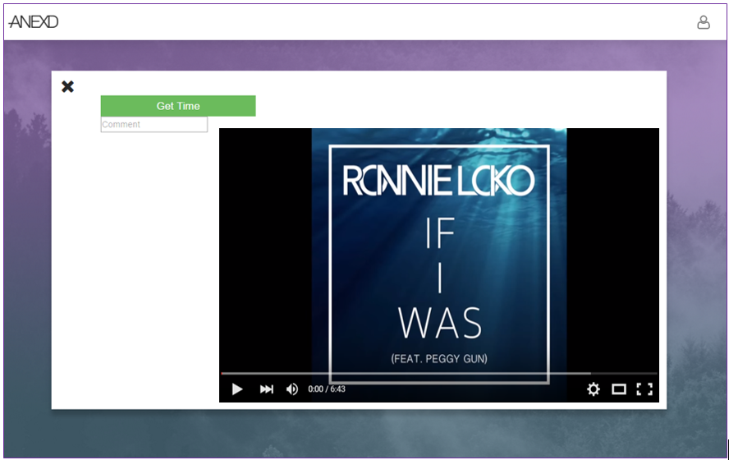

*Screenshot of the YouTube Annotate App*

Currently, there is a “get time” button on the main desktop view, which is there for testing purposes, however, the layout remains the same.

Comments will be displayed on the side with a time stamp. The timestamp is connected to the video.

The video is currently hard coded for this concept, but a URL field can be implemented in the next build iteration.

A simple, clean interface with the necessary functionality.

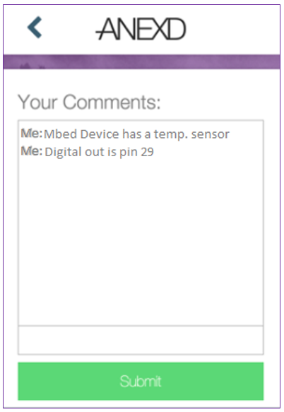Mobile Screen

The mobile screen is where the user will type their message. You can view messages typed, and at what point in time of the video.

The messages will be passed to the desktop view which everyone can see.