

HOMETASK : 08
NAME : Simran Chouhan
SEMESTER : 5th
SECTION : 24_AIT_KRG-G1-A
UID : 24BAI70124
SUBJECT CODE : 24CSP-310
SUBJECT NAME : Advanced Database Management System
FACULTY'S NAME : Mr. Alok Kumar

(A)
A company maintains customer information, product information, and sales order information in three separate tables: customer_master, product_catalog, and sales_orders.
The company wants to provide an order report to an external client. The report must contain the Order ID, Order Date, Customer Name, Product Name, and Final Amount.
For every order, first calculate the Gross Amount using:
Gross Amount = Unit Price × Quantity
Then calculate the Discount Amount using:
Discount Amount = Gross Amount × Discount Percentage / 100
Finally, calculate the Final Amount using:
Final Amount = Gross Amount − Discount Amount
Create a complex view using the three tables to generate this report. The view should expose only the required five columns and should not expose the customer's phone/email, product brand/unit price, or the order's quantity/discount percentage.
The company also wants to provide access to an external client. Create a PostgreSQL user named client_user and give this user only SELECT permission on the view. The client must not have direct access to the three original tables and must not be allowed to modify the view data.
Output:
order_id | order_date | full_name | product_name | final_amount
1 | 2025-09-01 | Amit Sharma | Smartphone X100 | 47500.00
2 | 2025-09-02 | Priya Verma | Laptop Pro 15 | 58500.00
3 | 2025-09-03 | Ravi Kumar | Wireless Earbuds | 15000.00
4 | 2025-09-04 | Neha Singh | Smartwatch Fit | 27600.00
5 | 2025-09-05 | Arjun Mehta | Gaming Console | 39600.00
6 | 2025-09-06 | Priya Verma | Smartphone X100 | 23750.00
7 | 2025-09-07 | Amit Sharma | Wireless Earbuds | 10000.00

Solution:
CREATE OR REPLACE VIEW vw_final_amount_calculation
AS
SELECT o.order_id, o.order_date, c.full_name, p.product_name,
ROUND((p.unit_price*o.quantity -
p.unit_price*o.quantity*o.discount_percent/100.0), 2) AS final_amount
FROM sales_orders AS o
JOIN product_catalog AS p
ON o.product_id = p.product_id
JOIN customer_master AS c
ON o.customer_id = c.customer_id;

SELECT * FROM vw_final_amount_calculation;

CREATE USER client_user
PASSWORD '12345';

GRANT SELECT ON vw_final_amount_calculation TO client_user;

(B)
An e-commerce company wants to regularly analyze the performance of its product categories.
The company stores product, category, customer, and order information in separate tables. To generate the category performance report, the database needs to perform multiple JOINs, GROUP BY, aggregate functions, DISTINCT counting, calculated values, and CASE statements.
Since the same report is generated frequently, executing the complete analytical query every time can increase database workload.
Create a PostgreSQL Materialized View named: mv_category_sales
Also demonstrate that when new order data is inserted, the Materialized View does not automatically reflect the change and must be refreshed.
Finally, use EXPLAIN ANALYZE to compare the performance of the original analytical query with the Materialized View query.
Output:
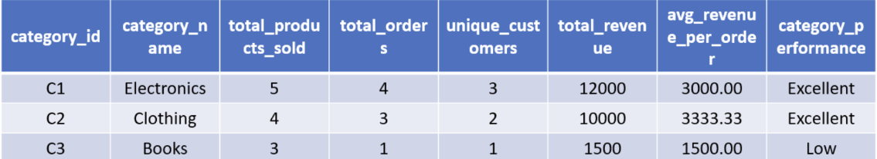
Solution:
CREATE MATERIALIZED VIEW mv_category_sales AS
SELECT cat.category_id, cat.category_name,
SUM(o.quantity) AS total_products_sold,
COUNT(DISTINCT o.order_id) AS total_orders,
COUNT(DISTINCT o.customer_id) AS unique_customers,
SUM(o.quantity * o.unit_price) AS total_revenue,
ROUND(SUM(o.quantity * o.unit_price) /
COUNT(DISTINCT o.order_id), 2) AS average_revenue_per_order,
CASE
WHEN SUM(o.quantity * o.unit_price) >= 10000 THEN 'EXCELLENT'
WHEN SUM(o.quantity * o.unit_price) >= 6000 THEN 'GOOD'
WHEN SUM(o.quantity * o.unit_price) >= 3000 THEN 'AVERAGE'
ELSE 'LOW'
END AS category_performance
FROM order_details o
JOIN product_master p ON o.product_id = p.product_id
JOIN category_master cat ON p.category_id = cat.category_id
GROUP BY cat.category_id, cat.category_name;

EXPLAIN ANALYZE
SELECT * FROM mv_category_sales;

REFRESH MATERIALIZED VIEW mv_category_sales;

