

NAME :Simran Chouhan SEMESTER:4th
SECTION:24_AIT_KRG-G1 UID:24BAI70124
SUBJECT CODE:24CSH-298
FACULTY’S NAME: Mr .SHALABH BHATIA

Topic : Experiment 4

AIM:
To design and implement PL/SQL programs utilizing conditional control statements such as IF–ELSE, ELSIF, ELSIF ladder, and CASE constructs in order to control the flow of execution based on logical conditions and to analyze decision-making capabilities in PL/SQL blocks.

Software Requirements:
- Database Management System:
  - PostgreSQL
- Database Administration Tool:
  - pgAdmin

Objective:
Implement control structures in PL/SQL (IF-ELSE, ELSE-IF, ELSE-IF LADDER, CASE STATEMENTS in PL-SQL BLOCK)

Problem Statement
Develop and execute PL/SQL programs that demonstrate the use of conditional control statements. The programs should employ IF–ELSE, ELSIF, ELSIF ladder, and CASE statements to evaluate given conditions and control the flow of execution accordingly, thereby illustrating decision-making capabilities in PL/SQL blocks.
TABLE CREATION:
CREATE TABLE student_lab (
student_id SERIAL PRIMARY KEY,
student_name VARCHAR(50),
marks INTEGER,
day_no INTEGER
);

INSERT INTO student_lab (student_name, marks, day_no) VALUES
('Manan', 95, 1),
('Aarav', 78, 3),
('Simran', 62, 5),
('Kunal', 45, 7),
('Neha', -5, 9);

1. Problem Statement – IF–ELSE Statement
Write a PL/SQL program to check whether a given number is positive or non-positive using the IF–ELSE conditional control statement and display an appropriate message.
CODE:
DO $$
DECLARE
r RECORD;
BEGIN
FOR r IN SELECT * FROM student_lab LOOP
IF r.marks > 0 THEN
RAISE NOTICE '% has POSITIVE marks (%).', r.student_name, r.marks;
ELSE
RAISE NOTICE '% has NON-POSITIVE marks (%).', r.student_name, r.marks;
END IF;
END LOOP;
END $$;

2. Problem Statement – IF–ELSIF–ELSE Statement
Write a PL/SQL program to evaluate the grade of a student based on the obtained marks using the IF–ELSIF–ELSE statement and display the corresponding grade.
CODE:
DO $$
DECLARE
r RECORD;
BEGIN
FOR r IN SELECT * FROM student_lab LOOP
IF r.marks >= 90 THEN
RAISE NOTICE '% : Grade A', r.student_name;
ELSIF r.marks >= 75 THEN
RAISE NOTICE '% : Grade B', r.student_name;
ELSIF r.marks >= 60 THEN
RAISE NOTICE '% : Grade C', r.student_name;
ELSE
RAISE NOTICE '% : Grade F', r.student_name;
END IF;
END LOOP;
END $$;

3. Problem Statement – ELSIF Ladder
Write a PL/SQL program to determine the performance status of a student based on marks using an ELSIF ladder and display the appropriate result.
DO $$
DECLARE
r RECORD;
BEGIN
FOR r IN SELECT * FROM student_lab LOOP
IF r.marks >= 90 THEN
RAISE NOTICE '% : EXCELLENT', r.student_name;
ELSIF r.marks >= 75 THEN
RAISE NOTICE '% : VERY GOOD', r.student_name;
ELSIF r.marks >= 60 THEN
RAISE NOTICE '% : GOOD', r.student_name;
ELSIF r.marks >= 50 THEN
RAISE NOTICE '% : AVERAGE', r.student_name;
ELSE
RAISE NOTICE '% : POOR', r.student_name;
END IF;
END LOOP;
END $$;

4. Problem Statement – CASE Statement
Write a PL/SQL program to display the name of the day based on a given day number using the CASE conditional statement.
CODE:
DO $$
DECLARE
r RECORD;
day_name TEXT;
BEGIN
FOR r IN SELECT * FROM student_lab LOOP
day_name := CASE r.day_no
WHEN 1 THEN 'Monday'
WHEN 2 THEN 'Tuesday'
WHEN 3 THEN 'Wednesday'
WHEN 4 THEN 'Thursday'
WHEN 5 THEN 'Friday'
WHEN 6 THEN 'Saturday'
WHEN 7 THEN 'Sunday'
ELSE 'INVALID DAY'
END;

RAISE NOTICE '% : Day % is %', r.student_name, r.day_no, day_name;
END LOOP;
END $$;

OUTPUT:
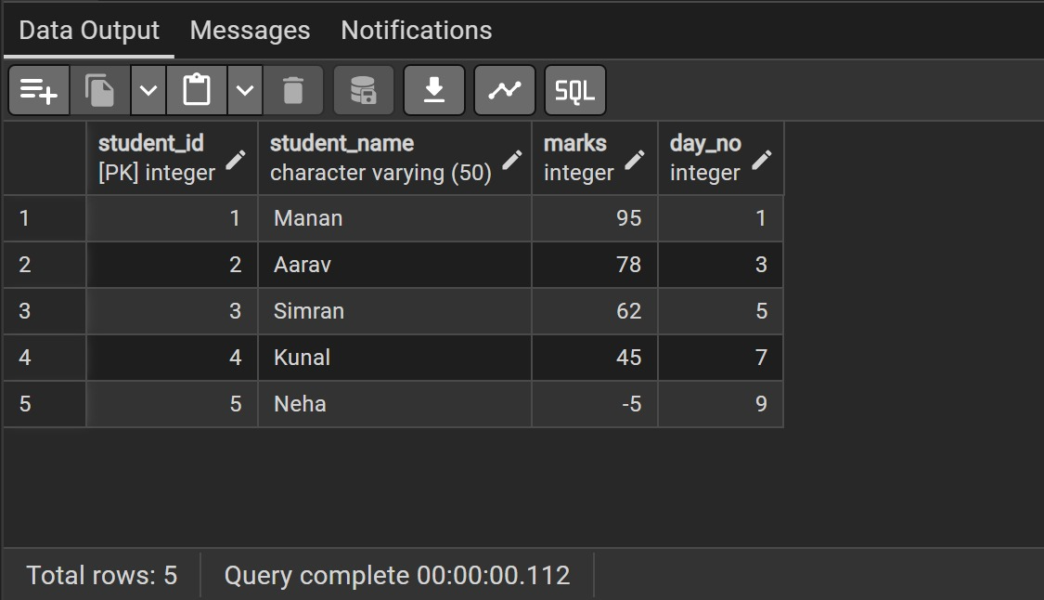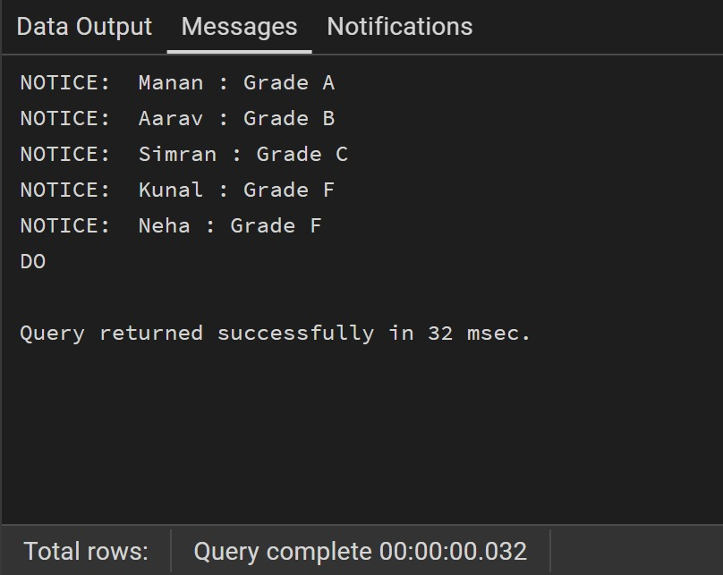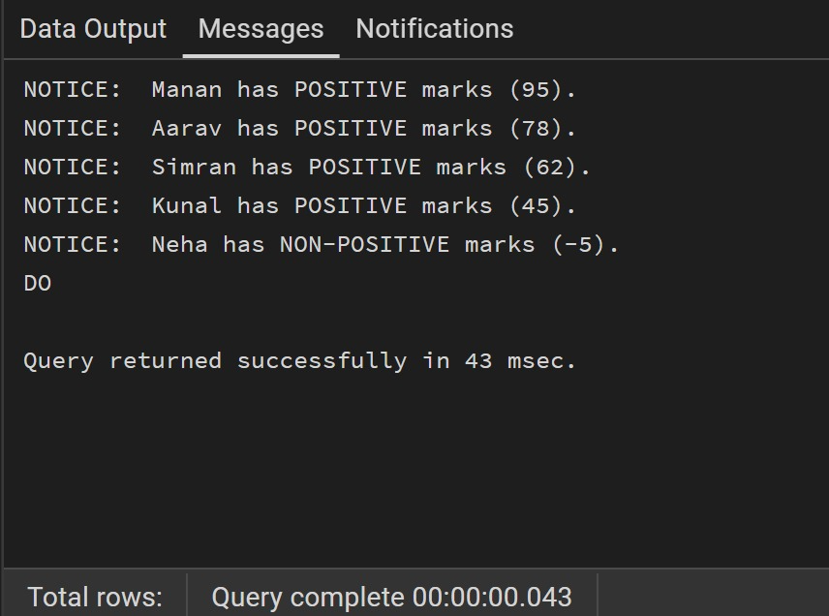

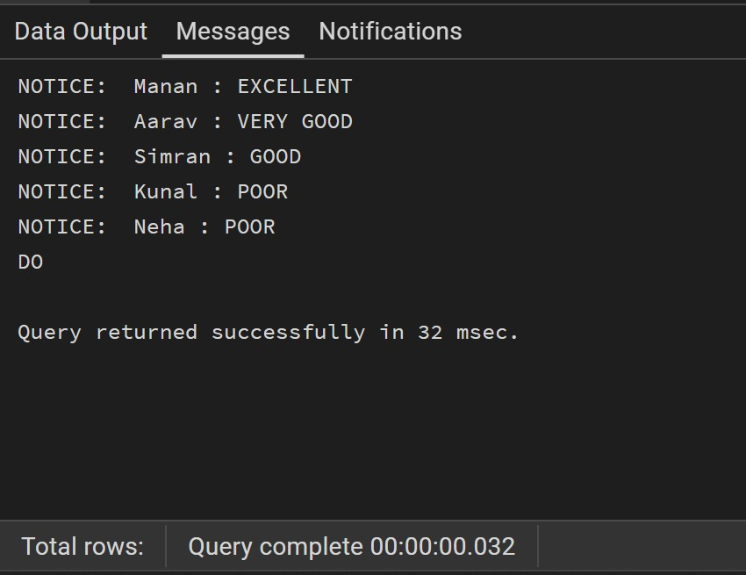
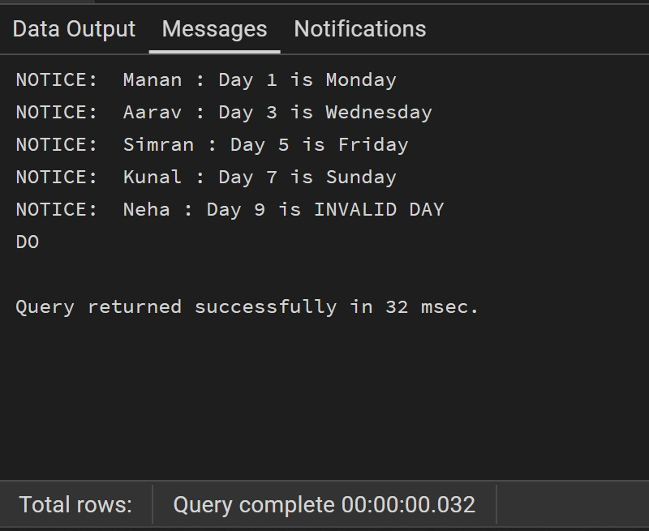
LEARNING OUTCOMES:
- Ability to design and use a single relational table effectively to support multiple logical conditions and decision-making scenarios.
- Ability to implement conditional control structures (IF–ELSE, IF–ELSIF–ELSE, and CASE) using PL/pgSQL for data-driven decision making.
- Ability to retrieve and process table records using loops and apply logical branching based on attribute values.
- Improved understanding of how database control structures enhance data validation, classification, and interpretation within stored program blocks.

