

NAME :Simran Chouhan SEMESTER:4th
SECTION:24_AIT_KRG-G1 UID:24BAI70124
SUBJECT CODE:24CSH-298
FACULTY’S NAME: Mr Shalabh Bhatia

Lab Experiment 7

AIM

To design and implement simple views, complex views, and materialized views, and analyze their performance differences to understand their impact on query optimization.

Objective of the Session

• To create simple and complex views
• To implement materialized views
• To compare execution performance of different views
• To understand how materialized views improve query efficiency.

Software Requirements
Database Management System:
Oracle Database Express Edition (Oracle XE)
PostgreSQL Database
Database Administration Tool / Client Tool:
Oracle SQL Developer (for Oracle XE)
pgAdmin (for PostgreSQL)

Experiment Question :
Create:
- A simple view based on a single table
- A complex view using joins and aggregation
- A materialized view storing precomputed results
Then compare their performance using execution time.

Practical/Experiment steps:
- Create employee and department tables
- Insert sample data
- Create a simple view
- Create a complex view using joins and aggregation
- Create a materialized view
- Run SELECT queries on all views
- Compare execution time using EXPLAIN ANALYZE
- Observe and analyze performance differences

CODE:
-- Create Tables
CREATE TABLE department (
dept_id INT,
dept_name VARCHAR(50)
);

CREATE TABLE employee (
emp_id INT,
emp_name VARCHAR(50),
salary INT,
dept_id INT
);

-- Insert Data
INSERT INTO department VALUES (1, 'HR'), (2, 'IT');

INSERT INTO employee VALUES
(1, 'Simon', 30000, 1),
(2, 'Alex', 50000, 2),
(3, 'John', 25000, 1);

-- Simple View
CREATE VIEW simple_view AS
SELECT emp_id, emp_name, salary FROM employee;

-- Complex View (Join + Aggregation)
CREATE VIEW complex_view AS
SELECT d.dept_name, AVG(e.salary) AS avg_salary
FROM employee e
JOIN department d ON e.dept_id = d.dept_id
GROUP BY d.dept_name;

-- Materialized View (PostgreSQL)
CREATE MATERIALIZED VIEW mat_view AS
SELECT d.dept_name, AVG(e.salary) AS avg_salary
FROM employee e
JOIN department d ON e.dept_id = d.dept_id
GROUP BY d.dept_name;

-- Performance Check
EXPLAIN ANALYZE SELECT * FROM simple_view;
EXPLAIN ANALYZE SELECT * FROM complex_view;
EXPLAIN ANALYZE SELECT * FROM mat_view;

OUTPUT:
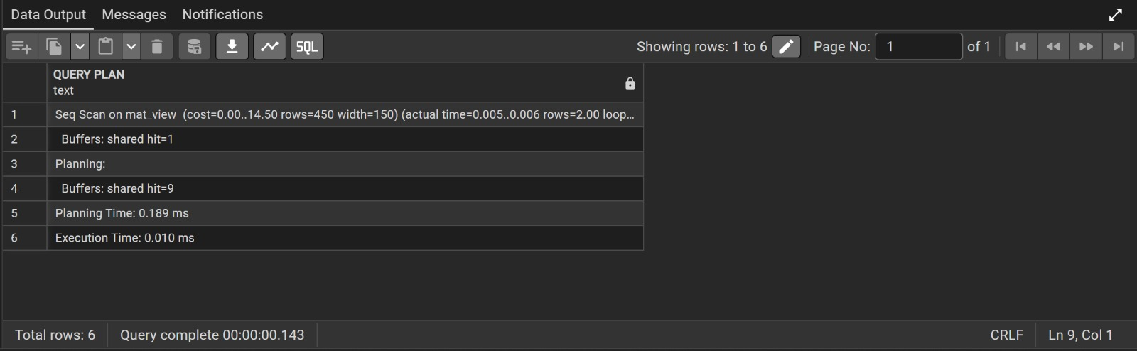

Learning Outcome
After completing this experiment, the student will be able to:
- Understand the concept of simple, complex, and materialized views
- Differentiate between dynamic views and stored results
- Analyze query performance using execution time
- Understand how materialized views improve efficiency
- Apply optimization techniques in real-world database systems

