

NAME :Simran Chouhan SEMESTER:4th
SECTION:24_AIT_KRG-G1 UID:24BAI70124
SUBJECT CODE:24CSH-298
FACULTY’S NAME: Mr Shalabh Bhatia

Lab Experiment 2

AIM
To understand and implement SQL SELECT queries using various clauses such as WHERE, ORDER BY, GROUP BY, and HAVING to retrieve and manipulate data efficiently from relational database tables.

Objective of the Session
- To practice writing SQL SELECT statements.
- To apply filtering conditions using the WHERE clause.
- To sort query results using the ORDER BY clause.
- To group records using the GROUP BY clause.
- To filter grouped data using the HAVING clause.
- To analyze data using aggregate functions like COUNT(), SUM(), AVG(), MIN(), and MAX().

Software Requirements
- Database:
  - Oracle Database Express Edition (Oracle XE)
  - PostgreSQL Database (PgAdmin)

Experiment Question :
An organization maintains an EMPLOYEE table to store details of its employees.
The structure of the table is as follows:
Column Name | Data Type
emp_id | NUMBER
emp_name | VARCHAR
Department | VARCHAR
Salary | NUMBER
joining_date | DATE
Practical/Experiment steps:
- Display the department name and the average salary of employees for each department.
- Consider only those employees whose salary is greater than 20,000.
- Display only those departments where the average salary is greater than 30,000.
- Arrange the final output in descending order of average salary.

Note: Use the following SQL clauses in your query:
- WHERE
- GROUP BY
- HAVING
- ORDER BY

CODE:

OUTPUT:
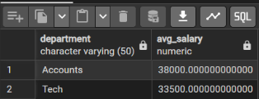

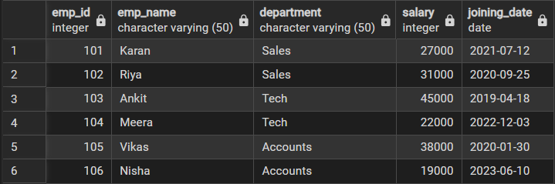

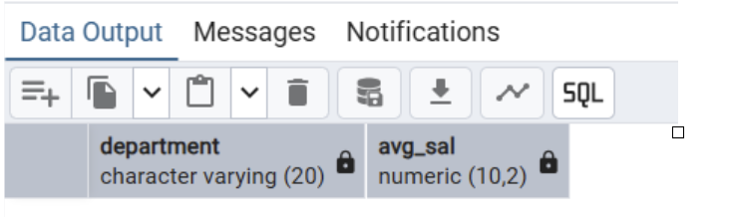

Learning Outcome
After completing this experiment, students will be able to:
- Filter records using the WHERE clause.
- Group records using GROUP BY.
- Apply conditions on grouped data using HAVING.
- Sort query results using ORDER BY.

