**HOTEL REGISTRATION**

**Objective:**

Design an efficient database model and a website that allow clients, hotels, and brokers to seamlessly interact with each other.

**Languages used:**

* **Back end**: PHP.
* **Front end**: HTML and CSS.

**Program Hierarchy**

1. **Database design:**
   1. ER-diagram (in the following page).

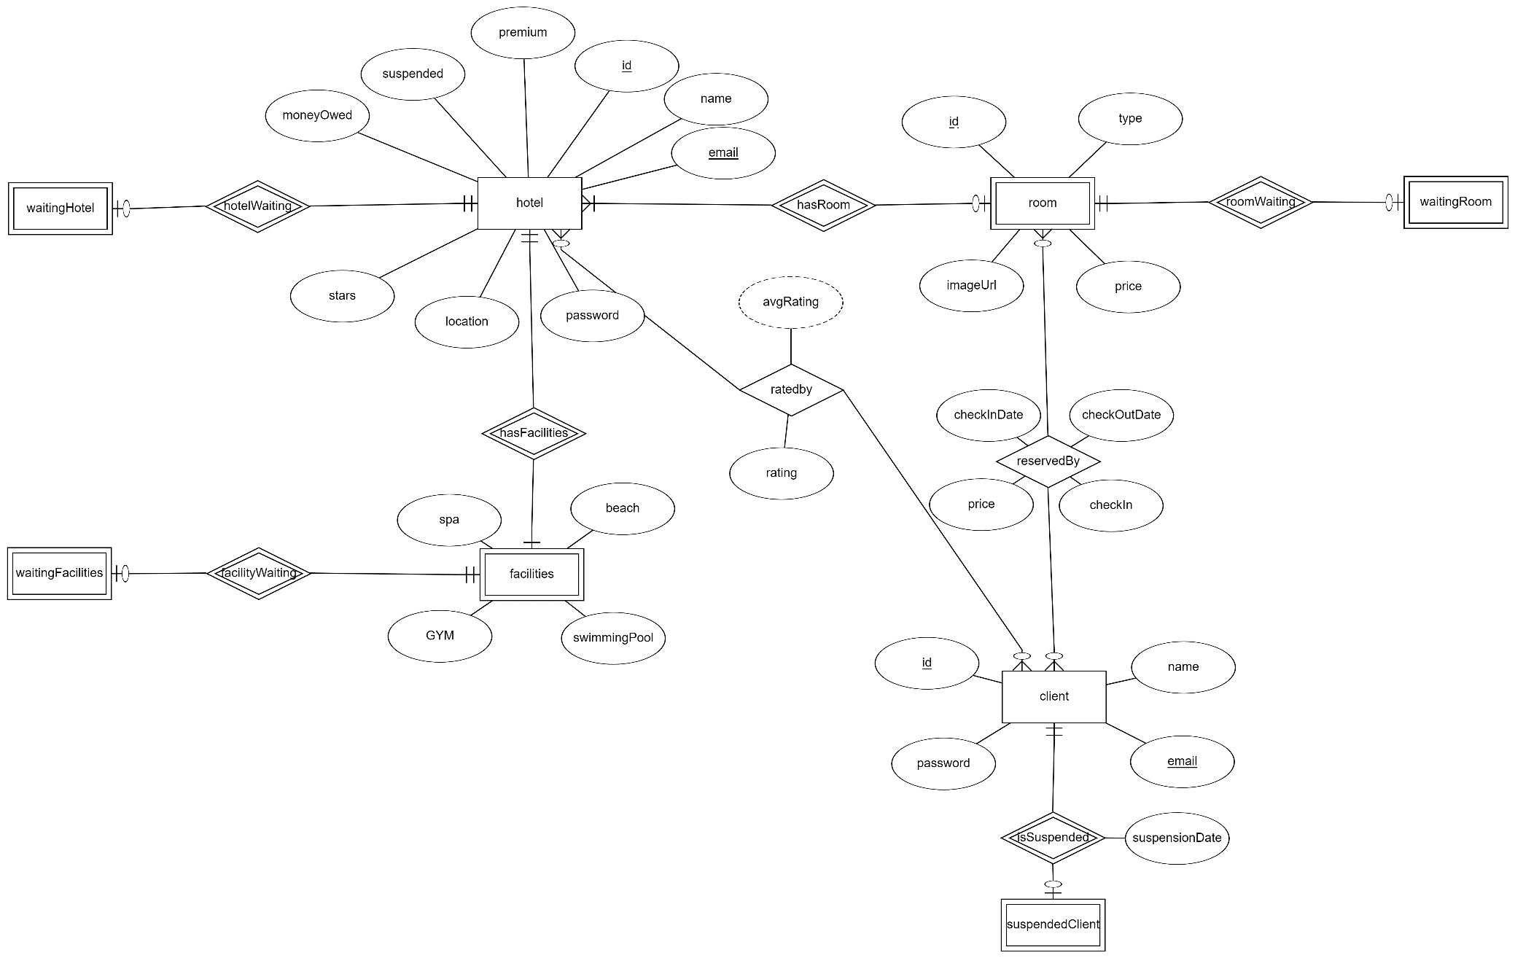

**2) Relational schema:**

Derived from the previous ER-diagram using the 7 steps stated in the lectures and is in 3rd normal form.

**PART 1**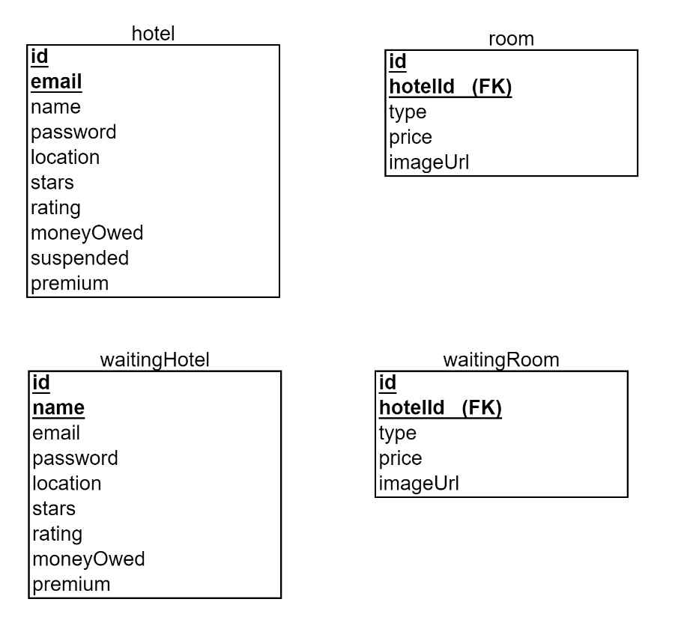

**PART 2**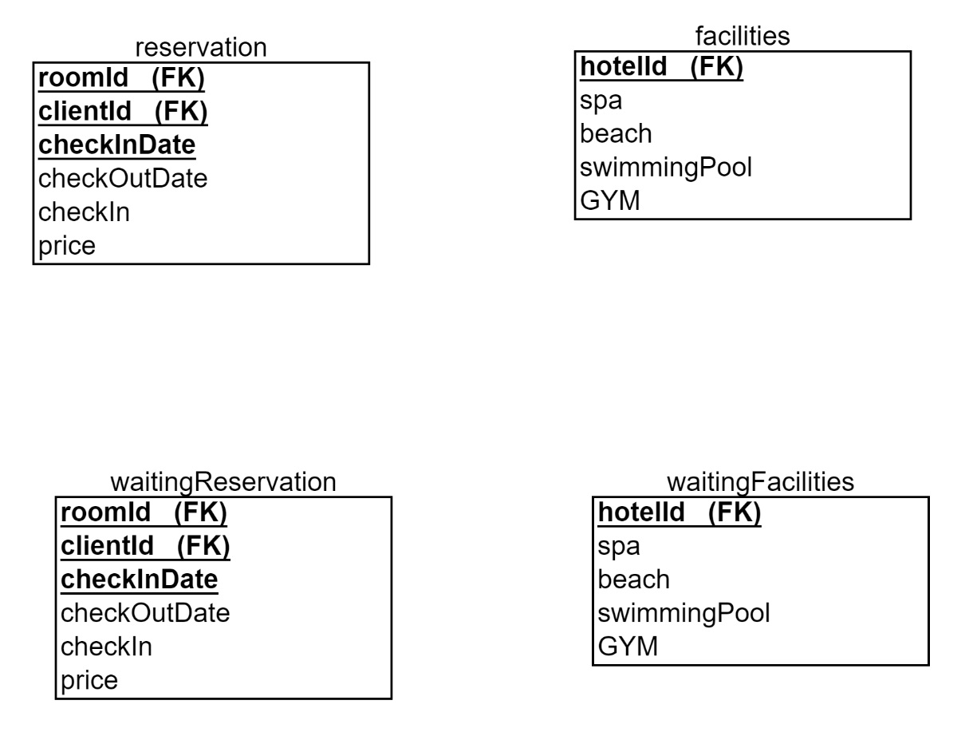

**PART 3**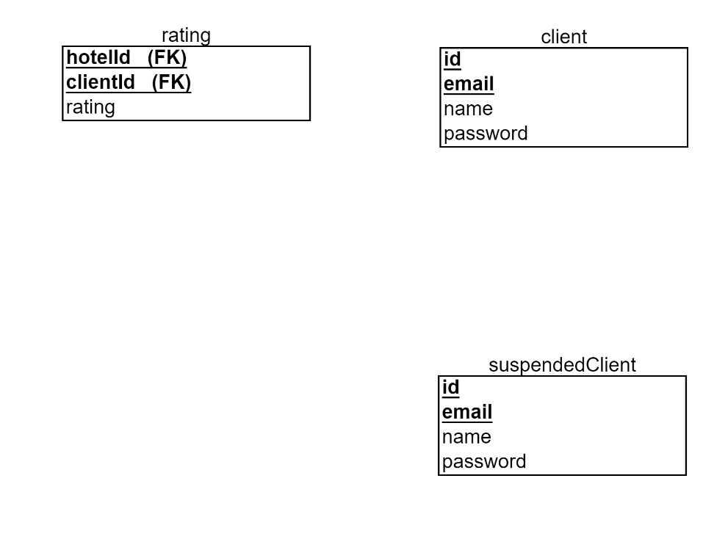

**b) Website design:**

**a) login.php**

**b) clientRegistration.php**

**c) hotelRegistration.php**

**d) adminLanding.php**

**e) clientLanding.php**

**f) hotelLanding.php**

**g) rate.php**

**1. login.php:**

* Takes email and password.
* Checks which radio butto is clicked and thus queries it’s respective table to search for the logins entered.
* **If the logins are found:** redirects the user to their respective landing page: client,hospital, or admin.
* **Has separate buttons for:**
  + Client registration: redirects to clientLanding.php
  + Hotel registration: redirects to hotelLanding.php
  1. **clientRegistration:**

Takes input and inserts a new tuple into ‘client’ table with the data entered.

* 1. **hotelRegistration:**
     1. Takes input from hotel user.
     2. New hotel and room tuples are inserted into waitingHotel and waitingRoom temporarily untill an admin approves this new hotel account, when approved: the hotel tuple is moved from waitingHotel to hotel and the rooms are moved from -waitingRoom to room.