Lab 1 description report

Simple Shell

***In this Lab we’re making a simple shell like the terminal using c language.***

My Code consists of some functions like “tokenizer2” which splits the string to some small strings depending on the spaces using strtok() c function and many of std C functions while using strings and sys time.

There’s another function called handler used to handle the SIGCHILD

which is produced to declare the death of a child of the main process.

So, it writes to a logfile that a child is terminated at a certain time taken from system.

Code overall idea is to execute simple commands through console of my program through execvp() function , Chdir for cd and exit() for exit. Flow is as follows:

1. Sting are tokenized from user.
2. Ampersand is checked if available or not, depending on that a flag is raised with e-num value.
3. A child is created using fork() function and the child ID is checked for validity.
4. Then process is handled to the child and executed.
5. Depending on the Ampersand & Operation the parent waits or continues executing.
6. Action is taken upon child death by writing to a log file.

All pictures below are available at better quality in the project folder sent to you.

Here are some simple runs of the program: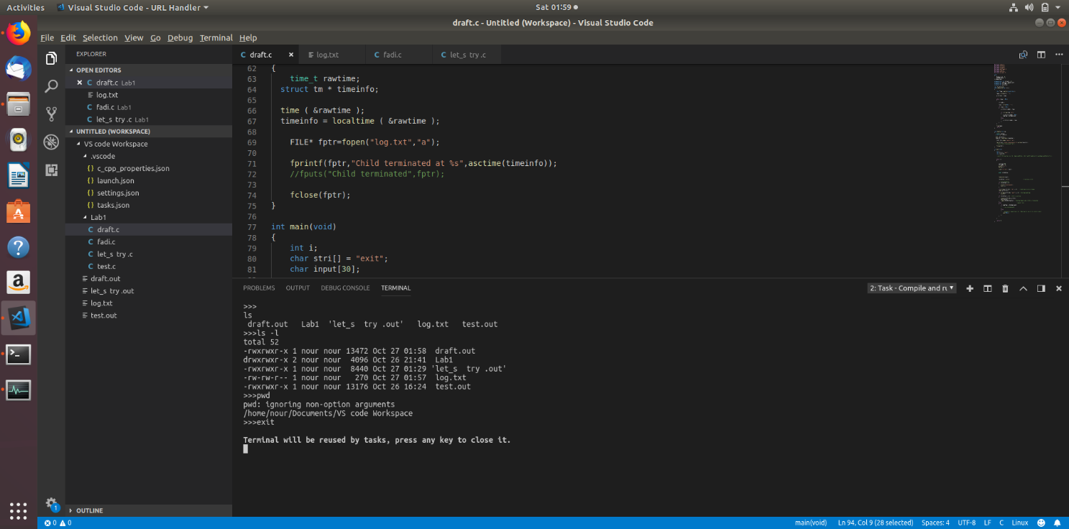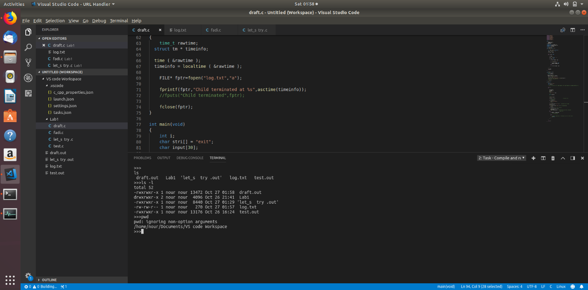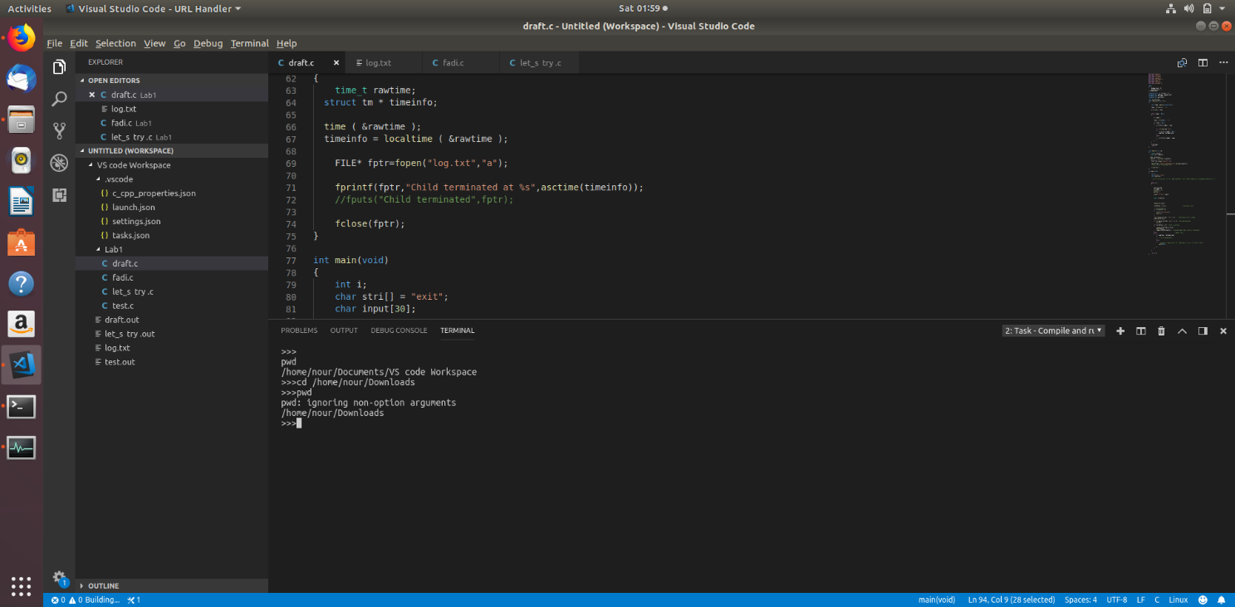

Also, I’ve installed the KSysGuard package to monitor the processes but I couldn’t find it , I only found this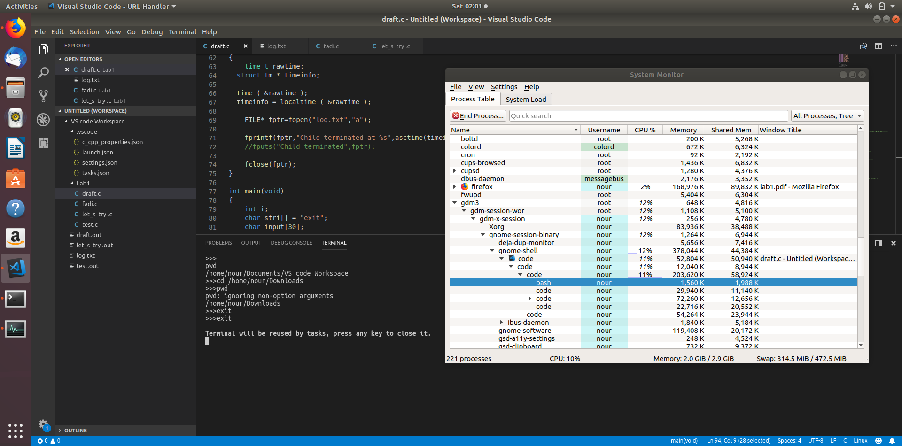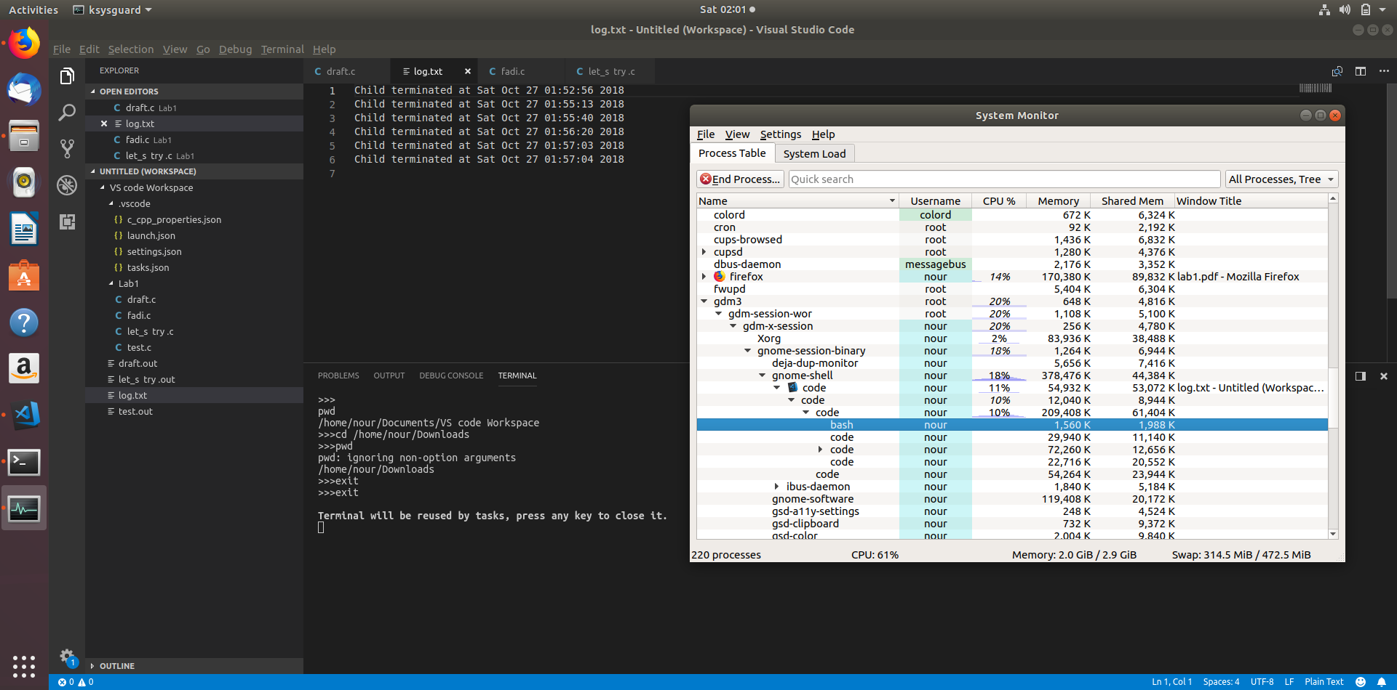By: Nour El-Din Mustafa --------------------------------------------------- ID:3784