Dallin Marshall

Passive Tracking Device

**User Manual**

**Introduction**2

**Description of Equipment**3

**Materials**4

**Directions**5

**Set up destination for GPS text messages**6

**Connect the GPS antenna**10

**Install the PTD to vehicle battery**11

**Interpret GPS Output**12

**Troubleshooting**14

**Conclusion**15

**Table of Contents**

The PTD is a passive tracking device that allows users to track vehicles such as ATVs and send the location to a pre-defined cellular device (smartphone, iPad, anything with a SIM card or a cell number). This device was designed to offer users an alternative to the active tracking solutions. Passive tracking solutions offer three major advantages over conventional active devices on the market.

**Introduction**

1. Passive tracking devices require less power to operate
2. Passive tracking devices offer distinctly cheaper monthly service contracts
3. The active tracked features are not necessary for all applications

The PTD has been designed and manufactured to offer these benefits to our clients. With these objectives in mind we tailored our stress tests to ensure that your PTD functions and gives you the peace of mind that your vehicles are able to be tracked. Whether you are using the PTD for personal use or as an enterprise solution we encourage you to take advantage of our award winning customer service.

To connect the PTD, you will need two screwdrivers:

**Description of Equipment**

1. A standard Phillips screwdriver for connecting the power leads to the vehicle battery.
2. A small flathead screwdriver to connect the power leads to the device itself.

NOTE: You will need to provide your own SIM card. This can be purchased from any GSM cell phone provider, such as AT&T or T-Mobile.

Our recommendation is T-Mobile because of their inexpensive pay-as-you-go plans. These plans allow users to pay rates as low as 10₵ per SMS.

In the box, you will find the following parts:

**Materials**

1. GPS antenna
2. Passive Tracking Device (PTD)
3. Power leads
4. Micro USB cable

NOTE: The cell antenna comes pre-installed.

There are four steps to prepare your Passive Tracking Device for use:

*Quick Start*

**Directions**

1. Setting up destination for GPS text messages (pg. 6-9)
2. Connecting the GPS antenna (pg. 10)
3. Installing the PTD in vehicle and connect to battery (pg. 11)
4. Interpreting the GPS readout (pg. 12-13)

**Quick Start**

**1. Connect the PTD to your computer with the micro USB cable.**

**2. Initialize serial communication at 4800 baud.**

**3. Press Reset button to reset device.**

**4. At prompt, enter $ and the ten-digit phone number, then a second $.**

**Directions: Set up destination for GPS text messages**

For Windows 7, 8, or 10:

1. Use the USB cable provided to connect the Passive Tracking Device (PTD) to a USB port on your Windows computer.
2. Press the windows key and the ‘X’ key simultaneously. The system configuration window appears. If you have Windows 7, use these steps instead:
   1. Open the Start menu.
   2. Right-click on the Computer menu item.
   3. In the menu that opens, choose Properties. The System Properties window opens.
3. Click Device Manager. The Device Manager window opens.

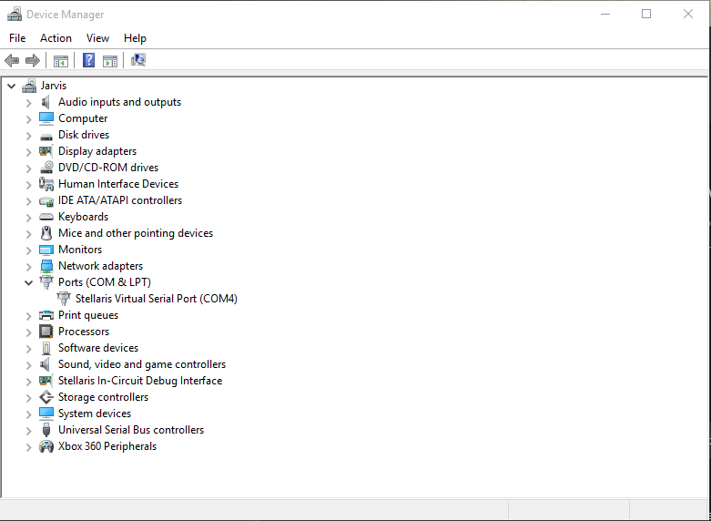

1. Click the expansion arrow to expand the Ports menu.
2. Make a note of which communication port your PTD is connected to. Note: This can change each time you connect the PTD, because Windows assigns the ports upon connection and many USB devices share the ports. In my case this is COM4.

Next, open PuTTY:

**Set up destination for GPS text messages -- Continued**

1. To communicate with the PTD a small application called PuTTY is needed. PuTTY can be obtained free of charge from many sites on the internet but we recommend going to <http://www.ninite.com> to obtain PuTTY.
2. Locate PuTTY under the Developer Tools section of the page and check the box on the Left.

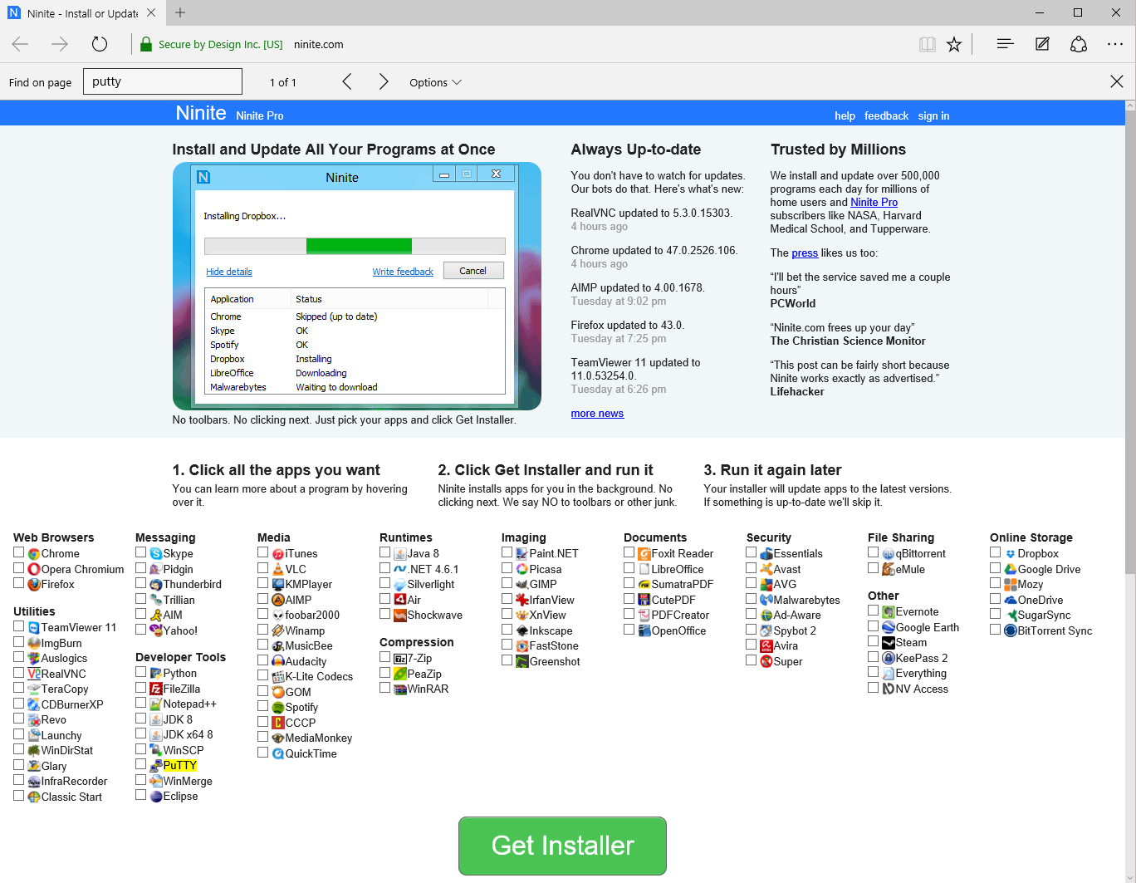

1. Click the Get Installer button at the bottom of the web page to download the installer.
2. Click the executable file and follow prompts to install PuTTY.
3. Open the Start Menu and search for PuTTY and click it to open PuTTY.

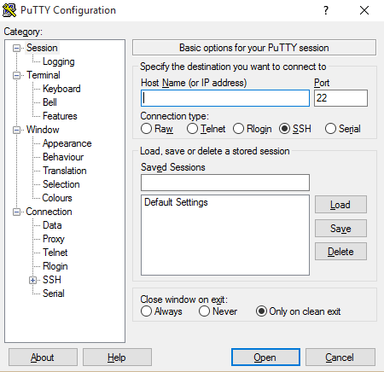

Second, configure PUTTY:

**Set up destination for GPS text messages -- Continued**

1. Click the Serial radio button.
2. At the prompt, enter the communication port number previously noted from Step 5 above.

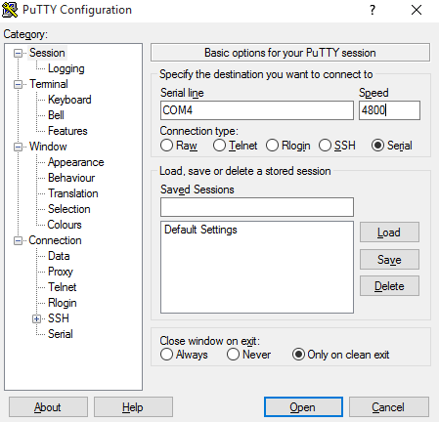

1. Click the Serial link on the left side of the window. A new Serial menu opens.
2. Enter 4800 in the Speed box.
3. Set the Flow Control box to None.

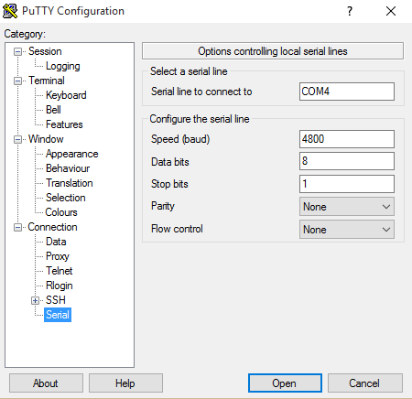

1. Click the Open button. A command window will open.

Third, configure the connection:

**Set up destination for GPS text messages -- Continued**

1. Press the Reset button to reset the PTD. This will force the PTD to resend a prompt for the destination phone number.

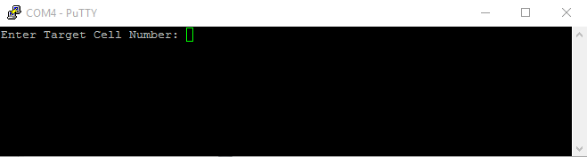

1. In the command window, enter a dollar sign and a 1, followed by the ten-digit cell phone number, followed by a second dollar sign. It will look like this:

$15552131239$

1. As soon as the PTD receives the cell number, it will send a confirmation prompt indicating a successful cell number change as shown below.

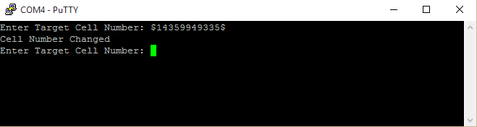

Attach the antenna to the PTD:

**Quick Start**

**There is only one step in this procedure: Attach the GPS antenna to the PTD using the connection cord provided.**

**Directions: Connect the GPS antenna**

1. Locate the SMA port on the PTD.
2. Screw the antenna cable into the SMA port. Ensure that the connection is finger-tight.

**Caution:** Do not over-tighten.

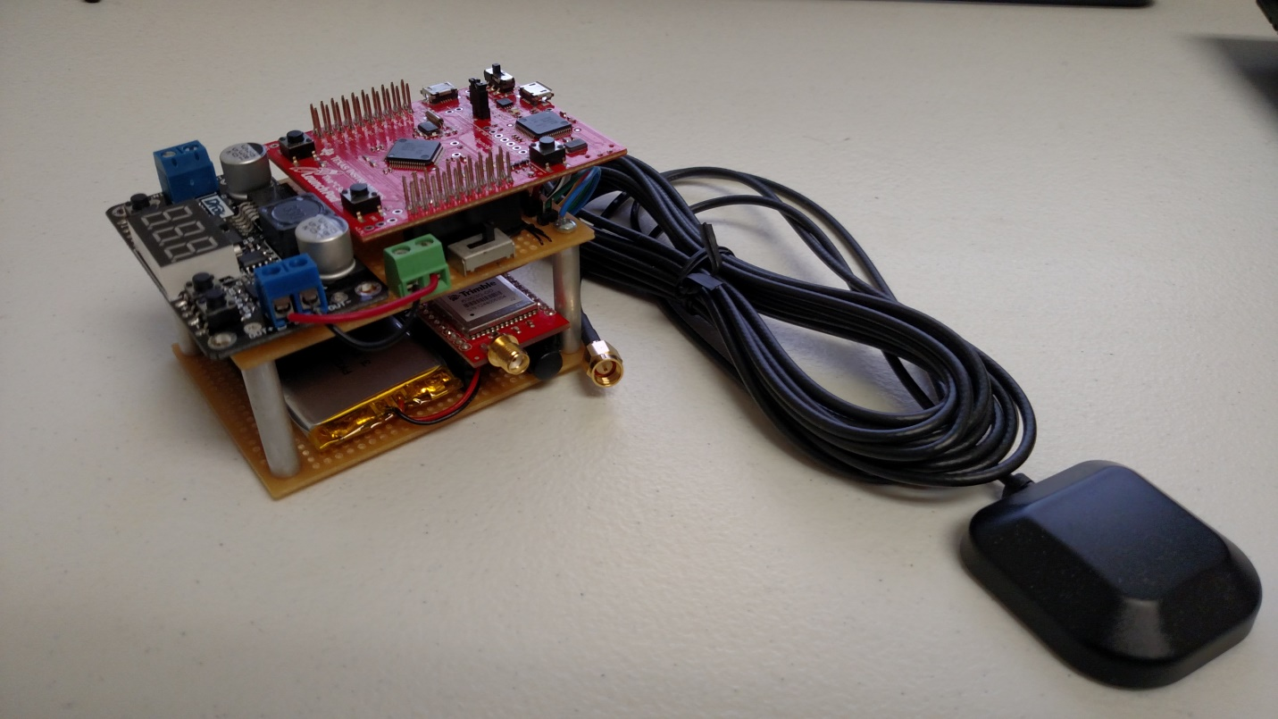

**Quick Start**

1. **Ensure that the device is off.**
2. **Connect the negative power lead to the negative battery terminal.**
3. **Connect the positive power lead to the positive battery terminal.**
4. **On the other end of the power cord, connect the negative lead to the negative terminal on the PTD.**
5. **Connect the positive lead to the positive terminal on the PTD.**
6. **Press the power switch to activate the PTD.**

Now you are ready to connect the PTD to your vehicle’s battery.

**Directions: Install the PTD to vehicle battery**

1. Set the Power switch to the **Off** position to ensure that the device is off.
2. Connect the negative power lead to the negative battery terminal.
3. Connect the positive power lead to the positive battery terminal.
4. On the other end of the power cord, connect the negative lead to the negative terminal on the PTD.
5. Connect the positive lead to the positive terminal on the PTD.
6. Switch the power switch to activate the PTD.

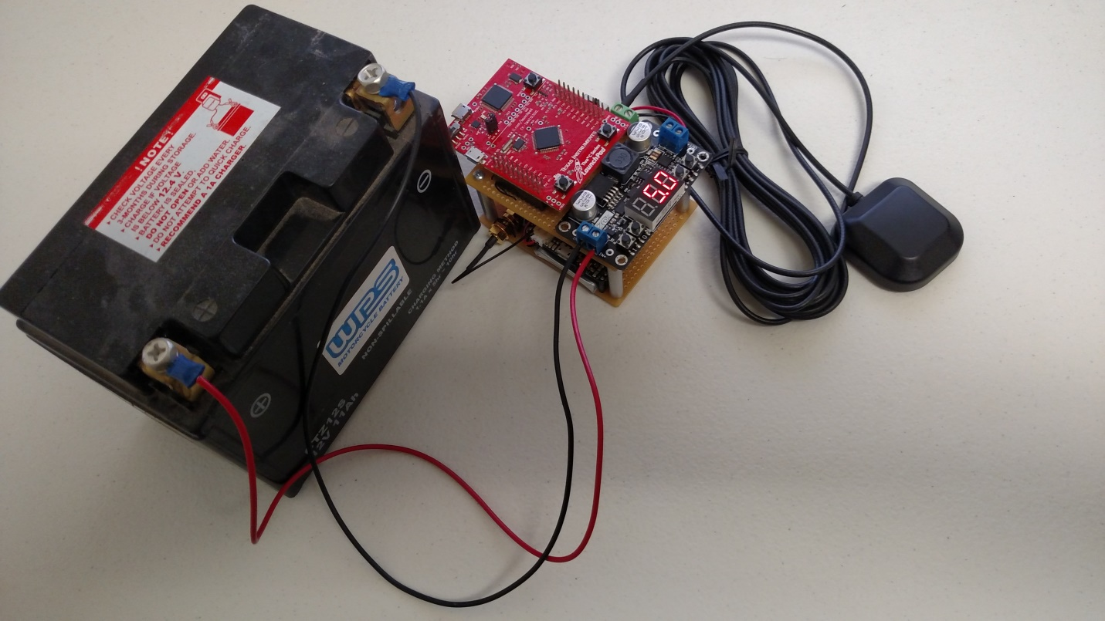

**Quick Start**

1. **Locate Latitude and Longitude values from SMS text**
2. **Go to** [**http://www.gpsvisualizer.com/map_input?form=data**](http://www.gpsvisualizer.com/map_input?form=data)
3. **Insert Latitude and Longitude in ‘Or paste your data here:’ box**

**Note: values that are either ‘S’ for South or ‘W’ for West need to be preceded by a minus sign.**

1. **Click Draw the Map**

Plot the GPS point on a Map:

**Directions: Interpret GPS Output**

1. Locate the Latitude and Longitude values in the SMS Text received from the PTD.

Time: 044717.00 UTC

Latitude: 4145.48572 N

Longitude: 11150.01067 W

Altitude: 01383 M

1. Use an internet browser and navigate to <http://www.gpsvisualizer.com/map_input?form=data>.
2. Enter the Latitude and Longitude in the box provided. Note: the negative sign on the longitude value. This is because South and West are considered negative values.

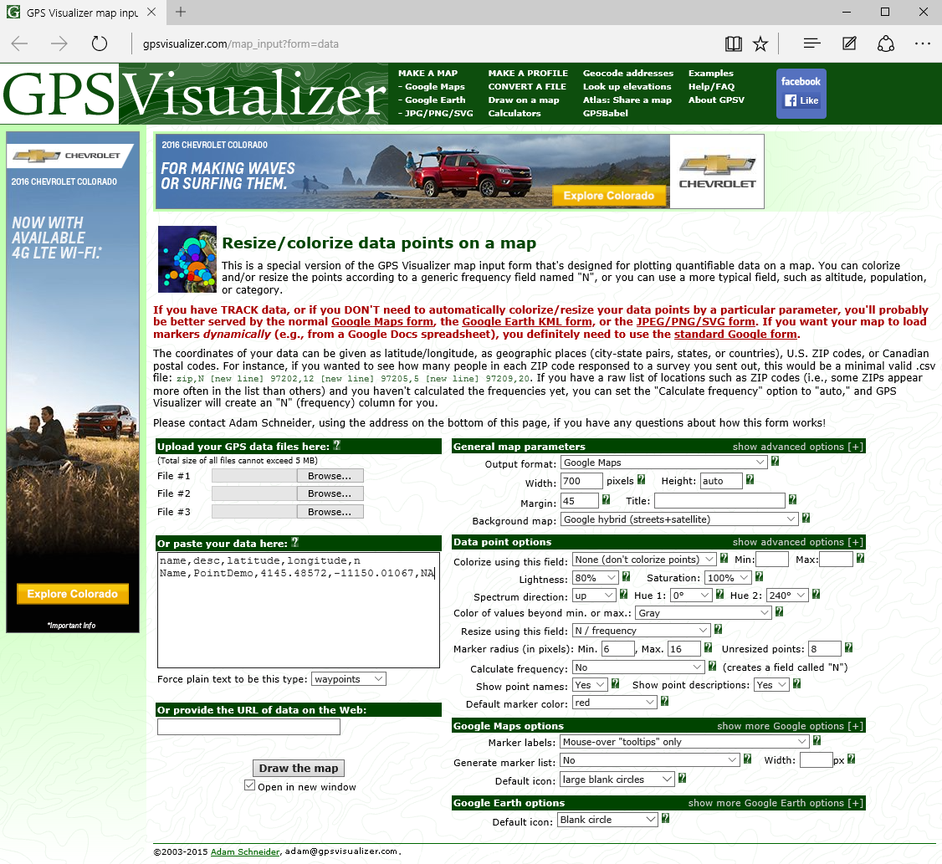

1. Click the Draw the Map button and a window will open with your GPS point plotted.

**Interpret GPS Output -- Continued**

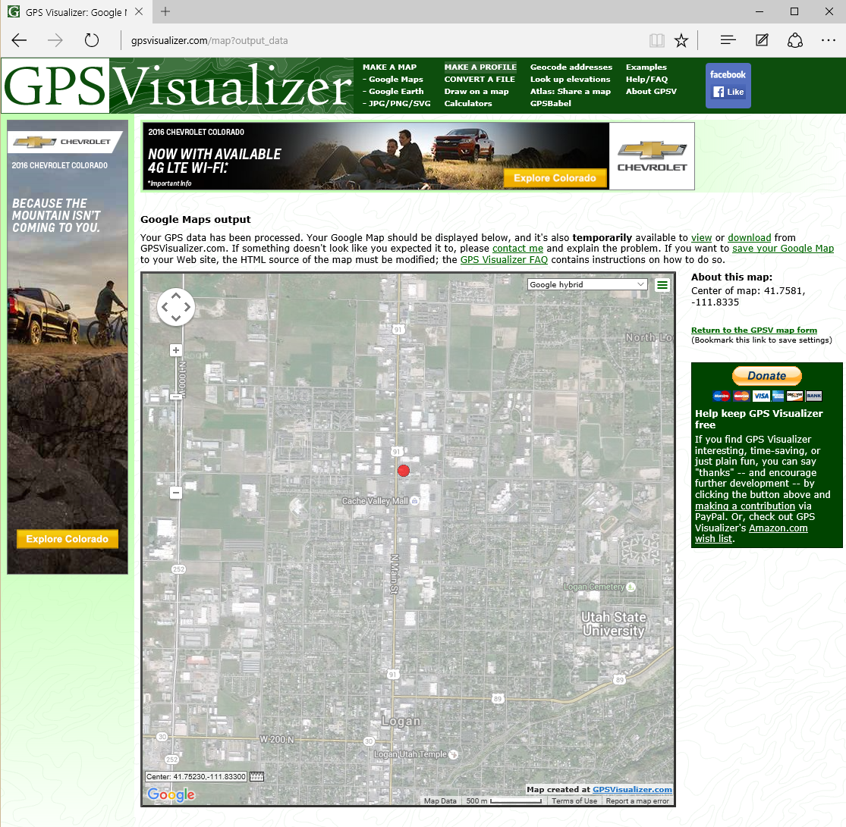

|  |  |
| --- | --- |
| **Problem** | **Solution** |
| There is no message on your phone or didn’t receive message. | 1. Press the Reset button to reset the PTD. This will force the PTD to resend a prompt for the destination phone number. 2. In the command window, enter a dollar sign and a 1, followed by the ten-digit cell phone number, followed by a second dollar sign. It will look like this:   $15552131239$   1. As soon as the PTD receives the cell number, it will send a confirmation message indicating a successful connection.   For more help on this subject see the Directions section of this manual (pg. 6-9) |
| Still not getting message on phone. | Disconnect and reconnect the antenna. |
| Antenna disconnects. | Reconnect using the instructions to Connect the GPS antenna found in this manual(pg. 10). |

**Troubleshooting**

Thank you for purchasing the Passive Tracking Device! We hope you are pleased with your experience using it. Feel free to contact us if you have any questions.

**Conclusion**

Here is our contact information: (435) 549-0055

Go to the website for more information about our services: <http://bluejarvis23.github.io/ptd/>