# Cover Page

# Background Information

Today, the need of increasing quality of life through automation is a huge market

## Concept

## Verification + Identification of needs, wants, and opportunities

# Project proposal

## Identification and exploration of the need

* For the elderly, hearing impaired doorbell.
* Timer for medicine
* Visual smoke alarm
* General better quality of life through automation, ie email alerts

## Design Proposal

Many new innovations come out today and revolutionise the way lives work in the world for most of the population. But what about that other bit of the population, the elderly? My design proposes to give the elder demographic a higher quality of life, by meeting a few crucial needs of the target market. These needs are:

* Missing alerts due to being hearing impaired

## Struggling to turn off lights due to aching pains

* Forgetting to turn off lights when going out
* Concerned about high costing electricity bills each month
* Light is too bright for comfort
* Light is not the right colour to concentrate

All of the needs will be fulfilled with my design, of the Light++.

## Preliminary Research

I have already completed preliminary research on all of the needs, to ensure they are real needs and not just charlatan needs.

* Missing alerts due to being hearing impaired: In 1993, the Asutralian Bereua of Statistics compiled the number of those with a disability, which was 18.1% of the population. Of this number, 31.5% had a hearing impairment. This equates to 5.7% of Australias population having a disability. This justifies the need for a visual stimulus rather than an auditory stimulus to be produced when an alert is activated.
* Struggling to turn off lights due to aching pains

## Analysis of Research

## Justification of Need

After establishing that there is indeed a market for this product, I have to evaluate my findings and ask myself why am I doing this product. A good criteria to evaluate the justification of a need is to have a rational scenario, mimicking scenario, regulations scenario, and a standards scenario.

* Rational Scenario: This is the action of looking at hard facts and numbers to see if they need can be justified through logic. Rational scenarios do not take into account ethics or legalities, but nor does it exclude them. It is simply the logic behind the need. In my case, the logic is sound and is justified by my statistic in my preliminary research. The data shows that there is definitely a target market for my product and on
* Mimicking Scenario: This is more colloquially known as the “if they did it, we can do it” scenario. The mimicking scenario is the research of other products on the market and looking at how they became a success, and drawing inspiration from that. In my research I have thouroughly gone through the design process and marketing process of the Domus - RGB LED Downlight Flare. From this product I have drawn inspiration from such features as the aesthetic ‘satin white alimium frame’ and the functional wireless communication method. Although the mimicking scenario is a good method to success, if you mimic a product too much, your own product might look like knockoff or not become successful as the exact same product is already out there on the market.
* Regulation Scenario: In this scenario you look closely at the rules and regulations in place that you must work with to create your product. An initial need I had in mind was for an easy instllation of my product by the user. This would allow the average human to buy my product off the shelf and install it themselves with ease when they get home. Unfortunetately, due to reugalations and laws this need could not be fulfilled by my product, and thus will shape the design process of my product as it will no longer target that particular aspect.
* Standards Scenario: While regulations provide an explicit measure to justify change, standards expectations provide implicit reasons for change. When you use the standards scenario to justify your agenda, you are not proposing that the product needs something as much as you are suggesting that if the product doesn’t need that something, it will be of a disadvantage. Through this scenario, I can justify the use of the mobile phone as a controller for my product as not having it used in this product, in today’s era of technology, will be of a great disadvantage.

## MDP Parameters

When creating my MDP there will be many parameters I must abide to. Many of these parameters would not be as strict if this project was created professionally, but since I am a Year 12 student the parameters are very closed in. Some parameters to consider are time, skills, finance, resources, and personal limitations.

* Time: Time is a major consideration when designing the product as you cannot go over the deadline, nor do you want to finish with too much time spare. Finishing over the deadline will result in a penalty to the success of the product. In this case the penalty is major and result in a complete failure of the product. If I finish with too much time to spare, than my product may not be the best it can possibly be.  
  In total, I have about 200 days to complete this product.
* Skills: This parameter can be split into 2 different categoires pre-learned skills, and intra-learned skills.
  + Pre-learned skills are skills that I already have acquired. Here is a table of them:

|  |  |
| --- | --- |
| 1 | ***Fundamental Awareness*** (basic knowledge) |
| 2 | ***Novice*** (limited experience) |
| 3 | ***Intermediate*** (practical application) |
| 4 | ***Advanced*** (applied theory) |
| 5 | ***Expert*** (recognized authority) |

|  |  |  |  |  |
| --- | --- | --- | --- | --- |
| Skill | Proficentcy Level | Where I learnt it | Where I am possibly going to use it | Needed proficentcy Level |
| * + Soldering | * + Advanced | * + Self taught at home though a hobby for repairing old circuits. | * + I will be using this skill throughout my project to solder compnents together | * + Intermediate |
| * + Programming C | * + Fundamental Awareness | * + Reading other peoples code | * + To program the behaviour of integrated circuits such as the common ‘arduino’ chip the Atmega328PU | * + Intermediate |
| * + Programming Python | * + Intermediate | * + Self taught through the Board of Studies Software Design and development course | * + To program the main control system that will dispense commands to the light systems | * + Advanced |
| * + Circuit Building | * + Novice | * + Through YouTube tutorials | * + To build the senders and recievers of the lights | * + Intermediate |
| * + Network Infrastructures | * + Advanced | * + Year 10 work experience, and ongoing applied theory for my own homes infrastructure | * + To allow the user to interface with the lights | * + Novice |

* + intra-learned skills are skills that need to be learnt in order to complete a stage of development in either the planning process or design process. For this project I will need to learn many skills to a high proficiency level. Here is a list:
    - Digital 3D modelling
    - 3D printing and preparing the print
    - Basic woodwork
    - Basic painting
* Finance: This parameter can also be split up into 2 different categories: research and production cost, and the cost of the final product.
  + Research and Production Cost: This is the total budget for the purchasing of different materials and resources to create my product. Usually when creating a product this is a ver expensive process and can not usually be done without a money incentive kickstart. As I am only in Year 12 with no income, I do not have much money to spend on various resources and materials for the design, so I am planning on setting up a spreadsheet that documents all of my purchases. My mum and dad have both granted me $200 to spend freely on this product, so this will be my maximum budget. Thankfully many resources I would notmally have to pay for are free to me through my schools own workshop rooms which offer lots of equipment, I also have the resource of being able to talk to knowledgeable individuals in the field through that Technology Staff at my school. With these 2 free resources, I think $200 should be enough to complete the research and production of a few of my products.
  + Cost of the Final Product: Through my preliminary research there are many competing products that do similar things to mine. I have not done indepth research on these products but a main flag stood out to me on each, their price. Most of these products are averaging roughly $100 per bulb! And that’s even without the main computer system, which either does not exist or goes upwards of $1000. This is redicolous and is one of the main aspect keeping these types of products from reaching mainstream. I propose my final product to cost around $25 per light, and $100 for the computer system.
* Resources: I have already briefly covered the resources that are in my parametres, but there aare man <>
* Personal Limitations: this

## Design Brief

# Project management

## Areas of investigation

|  |  |  |  |
| --- | --- | --- | --- |
|  | Type of Research | Conduction of research | Level of information output |
| 1 | Descriptive | * Focus Groups * Interviews | High |
| 2 | Historical | * Investigation of historical events | Medium |
| 3 | Experimental | * Developing Prototypes * Sample Testing | Very High |
| 4 | Operational | * Assessing pre-existing products * Testing of pre-existing products * Visiting Sites * Product Testing | Medium |

|  |  |  |  |  |
| --- | --- | --- | --- | --- |
|  | Areas of Investigation | Type of Investigation (see key) | How I will conduct this investigation | Justifications or reason for this investigation and direction for further action |
| Electricty use of an LED | * Electricity usage of an LED * Electricity useage of a standard globe | Experimental (sample testing) | I will set up two circuits that consist just of a power supply and the light source in question. I will measure the volatage and ampere that the light uses, and convert it to watts <> to test what uses the most electricty | I am investigating this to make sure that LEDs can be used as a synonymous substitute to traditional ceiling globes. If LEDs use around the same electricty or less electircty than traditional standard globes, I will continue my project using LEDs. |
| Brightness of an LED | * Luminosity of LED * Luminosity preffered by public |  |  |  |
| Cheapness of variable wireless communication methods |  |  |  |  |
|  |  |  |  |  |
|  |  |  |  |  |
|  |  |  |  |  |
|  |  |  |  |  |

## Criteria to evaluate success

|  |  |  |  |  |
| --- | --- | --- | --- | --- |
| Criteria | Priority | Explanation | Method of Evaluation | Page No. |
| Function | | | | |
| Easy implementation / install | High | In order to be successful, the  product needs to be easy to implement. This includes how easy it is to install, and connect it to the various sensors. | Timed tests of the time it takes to install a normal light, and the light++. It should not take more than twice as long to install the light++ then the normal light. |  |
| Consumer Use | High | To be considered a success this product must get a positive response from the target market. | I will conduct a demonstration in front of the target market (the elderly) and record their opinions through a survey. |  |
| All in one solution | High | To be a success the product must be able to work without any use of additional competing products. | Through an evaluation of an electrician when the product is replacing the existing system. |  |
| Intuitive | High | The product must be able to function correctly when used by a beginner with no previous knowledge. | The target market (elderly) will be given a test of the product and a survey will record whether or not they could use it. |  |
| Improves on existing competing product | Medium | Must contain all features out there that similar products use, plus more additional features. | <to fill> |  |
| Aesthetics | | | | |
| Shape and Form | Low |  |  |  |
| Luminosity | High |  |  |  |
| Interface for Communication | High |  |  |  |

## Action, time and finance plans

### Action Plan

|  |  |  |  |
| --- | --- | --- | --- |
| Step | Process | Tools/Techniques | Safety Issues |
| 1 | Write up detailed design brief | Computer, word processor | * Posture while using computer as this is a long process * Adequate break times to ensure health is good |
| 2 | Start Preliminary Research | Internet, brochures, site visits, surveys, emails | * Danger posed from meeting stranger at site visits. * Danger of computer virus’ from the internet |
|  |  |  |  |
|  |  |  |  |
|  |  |  |  |
|  |  |  |  |
|  |  |  |  |

### Finance Plan

My budget for this project is $200 as previously mentioned, as my parents have kindly contributed this to me. This budget is not set in stone though, as I can always take money from my own bank account. It is still very important I strictyly stick to the structure of this finance plan.

|  |  |  |  |  |
| --- | --- | --- | --- | --- |
| Item | Item Description | Proposed Cost | Actual Cost | Justification of Difference |
| Raspberry Pi | The raspberry pi is the brains of the entire project. It is the centre of all communication that occurs in Light ++’s infrastrcutre. | 50 | 45 | 50 |
| 3 x Arduino Uno | The Arduino Uno’s were initially to prototype each node (light). Since then <> they have changed purpose and now can be considered as part of the final product. Arduino Uno’s contain a microprocessor that I have hooked up to the LEDs. The microprocessor sends out a singal to these LEDs based upon certain events that are happening around them. | 60 | 25   * I purchased the first one for $15, then purchased the second one for $10 as second hand. The third I borrowed off a friend for free. |  |
| 6 x NRF240I+ | The NRF240I+ radio frequency modules are very reliable for sending small amounts of data over radio frequency waves. They are at every point of Light ++’s infrastructure, including hooked up to the Raspberry Pi (through median of an Arduino), and also connected to each Light ++ node. | 20 | 24   * Initially I purchased 2 of these from eBay for $2 each, they worked fine but took 4 weeks to arrive. The next 4 I wanted fast, so I decided to order from an Australian warehouse called dx.com. They were $5 each and were exactly the same as the eBay ones. |  |
| 25 x RGB LEDs | These are just simple RGB LEDs with a diameter of 5mm. Their brightness is not good enough to be in the final product, but I am purchasing them for prototyping. | 5 | 4 |  |
| 25 x White LEDs | These again are just simple LEDs that emit a white colour. They are not bright enough for the final product, so instead will only be used for prototypes. | 2 | 2 |  |
| Various Resistors | Throughout my project I will need various resistors, varying from 1 Ohm though to 15k Ohm. Although not all variations of ohm rsistance will be used in the final product/prototypes, I will need them on the go for building test circuits or debugging various compnentns. | 3 | 3 |  |
| 3 x Bread Boards | Bread boards, or also known as prototype boards, are just simply a large board with femal pin headers. This allows me to easily just plug a component into the board without having to solder anything. | 15 | 7   * I purchased my first one for $7, borrowed the second one from the same friend whome I borrowed the third Arduino from, and I got the 3rd breadboard free through a deal on a website while buying unrelated electronic components. |  |
| Other Competitors Products | I will need to purchase other competitors products to see how they have achieved a task. This will allow me to get more of an indepth analysis on how others have attempted to comply with a need. | 30 | 0   * My Design and Technology teacher had 2 spare that I could keep. |  |
| 1 x HanRun W5100 Wiznet Ethernet Shield | This is an addition to the Arduino Uno that allows it to receive HTTP requests through a local IP address. I was initially planning on using this instead of the Raspberry Pi, but the Arduino itself did not have enough processing power, so I had to opt for the Raspberry Pi which already had a built in Ethernet controller, making the Wiznet Shield redundant. | 15 | 10 |  |
| 1 x SPI Ethernet Hookup | Again, the same as above. This was initially purchased as a add-on to the Arduino, but this idea was later discarded. I purchased two different Ethernet controllers to test which one was best. | 10 | 4 |  |
| 2 x High Power LED Star |  | 10 | 10 |  |
| 5 x Perf Boards |  | 15 | 10 |  |
| 1 x Sheet of PCB copper |  | 20 | 20 |  |
| 1 x Acid Powder |  | 20 | 0   * My Design and Technology teacher has some spare that I could use. |  |
| Other Various Components |  | 30 | <> |  |
|  |  | <> | <> | 5 |

## Selection and use of resources

# Project development and realisation

## Idea Generation

### Inner Workings

Software of Raspberry Pi

The software on the Raspberry Pi serves three different purposed, to get user input, to process the input, and output that in the communication protocol that the infrastructure can understand. Here is the list of the order of events that occur:

1. The Raspberry Pi (RPi) initialises a local server on the network
2. The RPi then waits for a HTTP request to be made
3. The RPi reads the users input and cuts out the bits it does not need
4. The RPi then reads the first 4 characters of the data it has. These 4 characters will spell out the type of function that the user is planning on using. An example of this can be ‘fire’ or ‘door’.
5. The RPi then runs the corresponding function to what the user has asked for
6. The next 3 characters are read. These three characters are the address destination. The first character defines the room of the destination address, the second is for data accuracy, and the third is for the light address in that specific room. I will get into the specifics of the protocol <> after this.
7. The next 16 character are read, these are the data characters. The RPi will process these characters differently depending on the function that it is set to perform.
8. The next 2 characters are read. These characters are part of an error checking process to make sure the data is accurate.
9. After all characters have been read and processed, it is now time for the RPi to repack the data into respective format to be sent to the Arduino via Serial communication.

The protocol used for the sending of data through the network is of my own creation. Through my completion of the Information, Processes and Technology Board of Studies course I completed in 2013 I had adequate knowledge to do so. The protocol I made consists of 4 parts, the function type, the destination address, the data to process, and an error checking method similar to a checksum. An example data package sent with my protocol may look something like “send3.620000010000012”, to break down this data into information, here is what it does: Send the following information to the 6th light in the 3rd room, Red: 200, Green: 000, Blue: 100, White: 000 and check that it is correct with the error checking code of 12. This would result in the addressed light in lighting up into a purple colour. The error checking method is done by summing up all the characters in the data packet (excluding the last two characters, which are the error checkers) in their ASCII numerical values. After these values are added together, the number can for example 1539. When the number is over a 99 (a two digit number) the digits are then added together, like so: 1 + 5 + 3 + 9, which equals 18. 18 is now our error checking number that will be added to the end of the data packet.

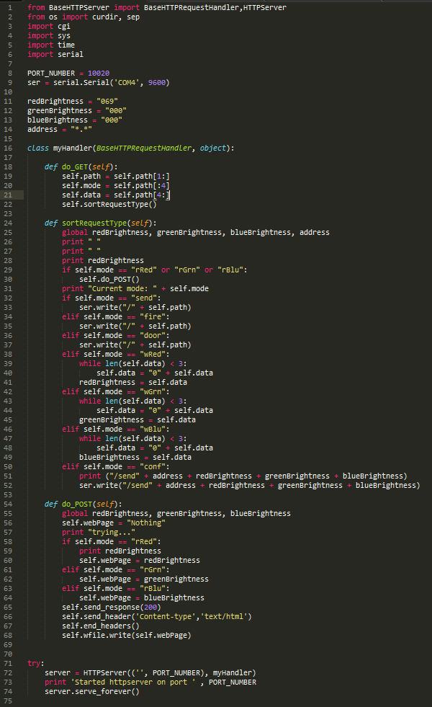

Software of Arduino Sender

The software on the Arduino Sender serves four different purposes, to read the RPi Serial input, to read button input, to process the input, and output that in the communication protocol that the infrastructure can understand using radio frequency. Here is the list of the order of events that occur:

1. Forever wait until the RPi attempts to send something
2. Once the RPi sends data through Serial, read what it says byte by byte.
3. Optional error checking could be done here, but the chance of an error produced by the communication of Serial is almost 1 in a million, so it would not be worth checking as the error will be picked up later in the data’s journey <>.
4. Barely any processing is done to the data packets on the Arduino Sender. The only thing that is added is an End Char at the end of the transmission to signal the end of transmission. This is a special invisible char that has an ASCII value of 2.
5. The Arduino Sender goes through byte by byte and displays that onto radio frequency waves.

The sent data packet is almost identical to the one the RPi passes to the Arduino sender, albeit the end character that consists of the special End Char character.

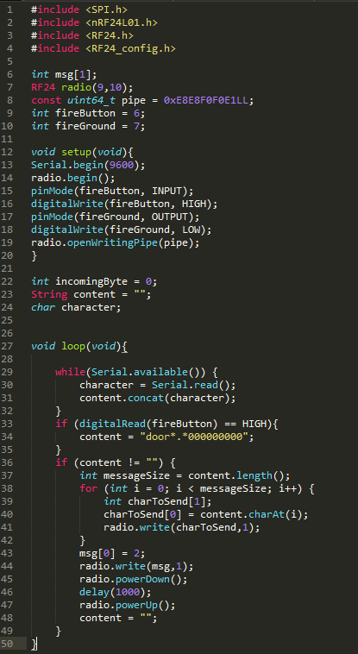

Software of Arduino Receiver



Software of Controller (Mobile Phone)

### Functions

Standard RGB Function

The standard

Fire Alarm Function

Door Bell Function

Timer Function

### Aesthetics

Aesthetics of Light Shell

Aesthetics of Physical Light Output

Aesthetics of Display

### Circuit Creation

Creation of Raspberry Pi Circuit

Creation of Arduino Sender Circuit

Creation of Arduino Receiver Circuit

Creation of LED Driver Circuit

Creation of Final Microprocessor Circuit

## Degree of Difference

Do a spider web chart!

## Exploration of Existing Ideas

## Consideration of Design Factors Relevant to the Major Design

## Project Appropriate

# Project evaluation

## Criteria for evaluation

## Analysis of evaluation

## Impact of the major design project on the individual, society and the environment.