

**The Gpg4win Compendium**

Secure e-mail and file encryption using GnuPG for Windows

Based on a version by

Ute Bahn, Karl Bihlmeier, Manfred J. Heinze, Isabel Kramer und Dr. Francis Wray.

Extensively revised by

Werner Koch, Florian v. Samson, Emanuel Schütze and Dr. Jan-Oliver Wagner.

Translated from the German original by

Brigitte Hamilton

A publication of the Gpg4win Initiative

Version 3.0.0 from 30th November 2016

**Publisher’s details**

Copyright c 2002 Bundesministerium für Wirtschaft und Technologie1 Copyright c 2005 g10 Code GmbH Copyright c 2009, 2010 Intevation GmbH

Permission is granted to copy, distribute and/or modify this document under the terms of the GNU Free Documentation License, Version 1.2 or any later version published by the Free Software Foundation; with no Invariant Sections, no Front-Cover Texts, and no Back-Cover Texts. A copy of the license is included in the section entitled “GNU Free Documentation License”.

1Any copying, distribution and/or modification to this document may not create any impression of an association with the Bundesministerium für Wirtschaft und Technologie (Federal Ministry for Economics and Technology)

**About this compendium**

The Gpg4win Compendium consists of three parts:

Part I “For Novices”: A quick course in Gpg4win.

Part II “For Advanced Users”: Background information for Gpg4win.

Annex: Additional technical information about Gpg4win.

Part I “For Novices” provides a brief guide for the installation and daily use of Gpg4win program components. The practice robot Adele will help you with this process and allow you to practice the de-and encryption process (using OpenPGP) until you have become familiar with Gpg4win.

The amount of time required to work through this brief guide will depend on your knowledge of your computer and Windows. It should take about one hour.

Part II “For Advanced Users” provides background information which illustrates the basic mechanisms on which Gpg4win is based, and also explains some of its less commonly used capabilities. Part I and II can be used independently of each other. However, to achieve an optimum understanding, you should read both parts in the indicated sequence, if possible.

The Annex contains details regarding the specific technical issues surrounding Gpg4win, including the GpgOL Outlook program extension.

Just like the cryptography program package Gpg4win, this compendium was not written for mathematicians, secret service agents or cryptographers, but rather was written to be read and understood by anyone.

The Gpg4win program package and compendium can be obtained at:

<http://www.gpg4win.org>

3

**Legend**

This compendium uses the following text markers:

Italics are used for text that appears on a screen (e.g. in menus or dialogs). In addition, square brackets are used to mark [ buttons ].

Sometimes italics will also be used for individual words in the text, if their meaning in a sentence is to be highlighted without disrupting the text flow, by using bold fond (e.g.only OpenPGP).

Bold is used for individual words or sentences which are deemed particularly important and hence must be highlighted. These characteristics make it easier for readers to quickly pick up highlighted key terms and important phrases.

Typewriter font is used for all file names, paths, URLs, source codes, as well as inputs and outputs (e.g. for command lines).

4

**Contents**

|  |  |  |  |
| --- | --- | --- | --- |
| **I.** | **For Novices** | | **8** |
| **1.** | **Gpg4win – Cryptography for Everyone** | | **9** |
| **2.** | **Encrypting e-mails: because the envelope is missing** | | **11** |
| **3.** | **How Gpg4win works** | | **14** |
| **4.** | **The passphrase** | | **25** |
| **5.** | **Two methods, one goal: OpenPGP & S/MIME** | | **28** |
| **6.** | **Installing Gpg4win** | | **30** |
| **7.** | **Creating a certificate** | | **41** |
|  | 7.1. | Creating an OpenPGP certificate . . . . . . . . . . . . . . . . . . . . . . . . . . . . | 44 |
|  | 7.2. | Creating an X.509 certificate . . . . . . . . . . . . . . . . . . . . . . . . . . . . . . | 50 |
|  | 7.3. | Certificate creation process complete . . . . . . . . . . . . . . . . . . . . . . . . . . | 56 |
| **8.** | **Distribution of public certificates** | | **58** |
|  | 8.1. | Publishing per e-mail, with practice for OpenPGP . . . . . . . . . . . . . . . . . . . | 59 |
|  | 8.2. | Publish via OpenPGP certificate server . . . . . . . . . . . . . . . . . . . . . . . . . | 65 |
|  | 8.3. | Publishing X.509 certificates . . . . . . . . . . . . . . . . . . . . . . . . . . . . . . | 67 |
| **9.** | **Decrypting e-mails, practicing for OpenPGP** | | **68** |
| **10. Importing a public certificate** | | | **72** |
| **11. Certificate inspection** | | | **75** |
| **12. Encrypting e-mails** | | | **82** |
| **13. Signing e-mails** | | | **86** |
|  | 13.1. | Signing with GpgOL . . . . . . . . . . . . . . . . . . . . . . . . . . . . . . . . . . | 87 |
|  | 13.2. | Checking signatures with GpgOL . . . . . . . . . . . . . . . . . . . . . . . . . . . | 92 |
|  | 13.3. | Reasons for a broken signature . . . . . . . . . . . . . . . . . . . . . . . . . . . . . | 93 |
|  | 13.4. | Encryption and signature . . . . . . . . . . . . . . . . . . . . . . . . . . . . . . . . | 94 |
| **14. Archiving e-mails in an encrypted form** | | | **95** |

5

The Gpg4win Compendium 3.0.0



Contents

|  |  |  |
| --- | --- | --- |
| **II. For Advanced Users** | | **97** |
| **15. Certificate details** | | **98** |
| **16. The certificate server** | | **100** |
| 16.1. | Key server configuration . . . . . . . . . . . . . . . . . . . . . . . . . . . . . . . . | 101 |
| 16.2. | Search and import certificates from certificate servers . . . . . . . . . . . . . . . . . | 103 |
| 16.3. | Export certificates to OpenPGP certificate servers . . . . . . . . . . . . . . . . . . . | 103 |
| **17. Encrypting file attachments** | | **104** |
| **18. Signing and encrypting files** | | **105** |
| 18.1. | Signing and checking files . . . . . . . . . . . . . . . . . . . . . . . . . . . . . . . | 106 |
| 18.2. | Encrypting and decrypting files . . . . . . . . . . . . . . . . . . . . . . . . . . . . . | 114 |
| **19. Importing and exporting a private certificate** | | **122** |
| 19.1. | Export . . . . . . . . . . . . . . . . . . . . . . . . . . . . . . . . . . . . . . . . . . | 123 |
| 19.2. | Import . . . . . . . . . . . . . . . . . . . . . . . . . . . . . . . . . . . . . . . . . . | 124 |
| **20. System-wide configuration and pre-population for S/MIME** | | **126** |
| **21. Known problems and help** | | **128** |
| 21.1. | GpgOL menus and dialogs no longer found in Outlook . . . . . . . . . . . . . . . . | 128 |
| 21.2. | GpgOL buttons are not on the Outlook 2003 toolbar . . . . . . . . . . . . . . . . . . | 128 |
| 21.3. | GpgOL button are listed unter “Add-Ins” (Outlook 2007) . . . . . . . . . . . . . . . | 128 |
| 21.4. | Errors when starting GpgOL . . . . . . . . . . . . . . . . . . . . . . . . . . . . . . | 128 |
| 21.5. | Installation of Gpg4win on a virtual drive . . . . . . . . . . . . . . . . . . . . . . . | 129 |
| 21.6. | GpgOL does not check “CryptoEx” InlinePGP e-mails . . . . . . . . . . . . . . . . | 129 |
| 21.7. | Does not allow S/MIME operations (system service “DirMngr” not running) . . . . . | 130 |
| 21.8. | S/MIME operations not allowed (CRLs not available) . . . . . . . . . . . . . . . . . | 130 |
| 21.9. | S/MIME operations not allowed (root certificate is not trustworthy) . . . . . . . . . . | 131 |
| **22. Files and settings in Gpg4win** | | **132** |
| 22.1. | Personal user settings . . . . . . . . . . . . . . . . . . . . . . . . . . . . . . . . . . | 132 |
| 22.2. | Cached certificate revocation lists . . . . . . . . . . . . . . . . . . . . . . . . . . . | 132 |
| 22.3. | Trustworthy root certificates from DirMngr . . . . . . . . . . . . . . . . . . . . . . | 133 |
| 22.4. | Other certificates from DirMngr . . . . . . . . . . . . . . . . . . . . . . . . . . . . | 133 |
| 22.5. | System-wide configuration for use of external X.509 certificate servers . . . . . . . | 134 |
| 22.6. | System-wide trustworthy root certificates . . . . . . . . . . . . . . . . . . . . . . . | 135 |
| 22.7. | User marking of trustworthiness of root certificates . . . . . . . . . . . . . . . . . . | 136 |
| **23. Detecting problems in Gpg4win programs (log files)** | | **137** |
| 23.1. | Activating Kleopatra log files . . . . . . . . . . . . . . . . . . . . . . . . . . . . . . | 138 |
| 23.2. | Activating GpgOL log files . . . . . . . . . . . . . . . . . . . . . . . . . . . . . . . | 139 |
| 23.3. | Activating DirMngr log file . . . . . . . . . . . . . . . . . . . . . . . . . . . . . . . | 140 |
| 23.4. | Activating GnuPG log files . . . . . . . . . . . . . . . . . . . . . . . . . . . . . . . | 141 |
| 23.5. | Activating GpgME log files . . . . . . . . . . . . . . . . . . . . . . . . . . . . . . . | 142 |

6

The Gpg4win Compendium 3.0.0



Contents

|  |  |  |
| --- | --- | --- |
| **24. Why Gpg4win cannot be broken ...** | | **143** |
| **25. GnuPG and the mystery of large numbers** | | **144** |
| 25.1. | Calcualting with residue classes . . . . . . . . . . . . . . . . . . . . . . . . . . . . | 146 |
| 25.2. | RSA algorithm and calculating with residue classes . . . . . . . . . . . . . . . . . . | 149 |
| 25.3. | RSA encryption with small numbers . . . . . . . . . . . . . . . . . . . . . . . . . . | 150 |
| 25.4. | Display using different base numbers . . . . . . . . . . . . . . . . . . . . . . . . . . | 155 |

|  |  |
| --- | --- |
| **III. Annex** | **162** |
| **A. Information on the GpgOL Outlook extension** | **163** |
| **B. Using GnuPG with other e-mail programs** | **166** |
| **C. Automatic installation of Gpg4win** | **167** |
| **D. Transfer from other programs** | **169** |
| **E. Uninstalling Gpg4win** | **171** |
| **F. History** | **173** |
| **G. GNU Free Documentation License** | **174** |
| **Index** | **181** |

7

**Part I.**

**For Novices**

8

**1. Gpg4win – Cryptography for Everyone**

What is Gpg4win? Wikipedia answers this question as follows:

Gpg4win is an installation package for Windows (2000/XP/2003/Vista) with computer programs and handbooks for e-mailand file encryption. It includes the GnuPG encryption software, as well as several applications and documentation. Gpg4win itself and the programs contained in Gpg4win are Free Software.

The “Novices” and “Advanced Users” handbooks have been combined for this second version under the name “Compendium”. In Version 2, Gpg4win includes the following programs:

GnuPG

GnuPG forms the heart of Gpg4win – the actual encryption software.

Kleopatra

The central certificate administration of Gpg4win, which ensures uniform user navigation for all cryptographic operations.

GNU Privacy Assistant (GPA)

is an alternative program for managing certificates, in addition to Kleopatra.

GnuPG for Outlook (GpgOL)

is an extension for Microsoft Outlook 2003 and 2007, which is used to sign and encrypt messages.

GPG Explorer eXtension (GpgEX)

is an extension for Windows Explorer which can be used to sign and encrypt files using the context menu.

Claws Mail

is a full e-mail program that offers very good support for GnuPG.

Using the GnuPG (GNU Privacy Guard) encryption program, anyone can encrypt e-mails securely, easily and at no cost. GnuPG can be used privately or commercially without any restrictions. The encryption technology used by GnuPG is secure, and cannot be broken based on today’s state of technology and research.

GnuPG is Free Software1. That means that each person has the right to use this software for private or commercial use. Each person may and can study the source code of the programs and – if they have the required technical knowledge – make modifications and forward these to others.

With regard to security software, this level of transparency – guaranteed access to the source code – forms an indispensable foundation. It is the only way of actually checking the trustworthiness of the programming and the program itself.

* Often also referred to as Open Source Software (OSS).

9

The Gpg4win Compendium 3.0.0



Chapter 1. Gpg4win – Cryptography for Everyone

GnuPG is based on the international standard OpenPGP (RFC 4880), which is fully compatible with PGP and also uses the same infrastructure (certificate server etc.) as the latter. Since Version 2 of GnuPG, the cryptographic standardS/MIME (IETF RFC 3851, ITU-T X.509 and ISIS-MTT/Common PKI) are also supported.

PGP (“Pretty Good Privacy”) is not Free Software; many years ago, it was briefly available at the same conditions as GnuPG. However, this version has not corresponded with the latest state of technology for some time.

Gpg4win’s predecessors were supported by the Bundesministerium für Wirtschaft und Technologie as part of the Security on the Internet initiative. Gpg4win and Gpg4win2 were supported by the Bundesamt für Sicherheit in der Informationstechnik (BSI).

Additional information on GnuPG and other projects undertaken by the Federal Government for security on the Internet can be found on the webpages [www.bsi.de](http://www.bsi.de) and [www.bsi-fuer-buerger.de](http://www.bsi-fuer-buerger.de) of the Bundesamt für Sicherheit in der Informationstechnik.

10

1. **Encrypting e-mails: because the envelope is missing**

The encryption of messages is sometimes described as the second-oldest profession in the world. Encryption techniques were used as far back as Egypt’s pharaoh Khnumhotep II, and during Herodot’s and Cesar’s time. Thanks to Gpg4win, encryption is no longer the reserve of kings, but is accessible to everyone, for free.

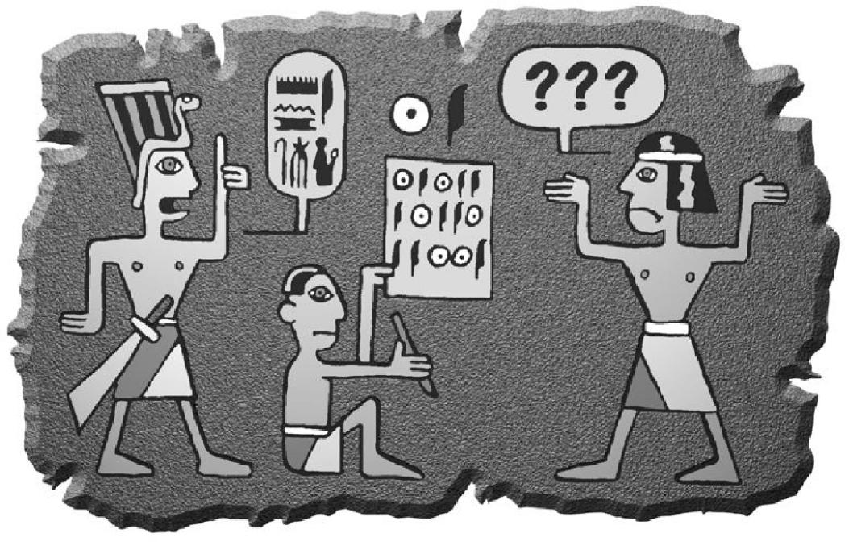

Computer technology has provided us with some excellent tools to communicate around the globe and obtain information. However, rights and freedoms which are taken for granted with other forms of communication must still be secured when it comes to new technologies. The Internet has developed with such speed and at such a scale that it has been difficult to keep up with maintaining our rights.

With the old-fashioned way of writing a letter, written contents are protected by an envelope. The envelope protects messages from prying eyes, and it is easy to see if an envelope has been manipulated. Only if the information is not important, do we write it on an unprotected post card, which can also be read by the mail carrier and others.

11

The Gpg4win Compendium 3.0.0



Chapter 2. Encrypting e-mails: because the envelope is missing

You and no one else decides whether the message is important, confidential or secret.

e-mails do not provide this kind of freedom. An e-mail is like a post card - always open, and always accessible to the electronic mailman and others. It gets even worse: while computer technology offers the option of transporting and distributing millions of e-mails, it also provides people with the option of checking them.

Previously, no one would have seriously thought about collecting all letters and postcards, analyse their contents or monitor senders and recipients. It would not only have been unfeasiable, it would have also taken too long. However, modern computer technology has made this a technical possibility. There are indications that this is already being done on a large scale. A Wikipedia article on the Echelon system1 provides interesting background information on this topic.

Why is this an issue – because the envelope is missing.



1<http://www.heise.de/tp/r4/artikel/6/6928/1.html>

12

The Gpg4win Compendium 3.0.0



Chapter 2. Encrypting e-mails: because the envelope is missing

What we are suggesting here is essentially an “envelope” for your electronic mail. Whether you use it, when or for whom and how often - that is entirely up to you. Software such as Gpg4win merely returns the right to choose to you. The right to choose whether you think a message is important and requires protection.

This is the key aspect of the right to privacy of correspondence, post and telecommunications in the Basic Law, and the Gpg4win program package allows you to exercise this right. You do not have to use this software, just as you are not required to use an envelope. But you have the right.

To secure this right, Gpg4win offers a so-called “strong encryption technology”. “Strong” in this sense means that it cannot be broken with known tools. Until recently, strong encryption methods used to be reserved for military and government circles in many countries. The right to make them accessible to all citizens was championed by Internet users, and sometimes also with the help of visionary people in government institutions, as was the case with support for Free Software for encryption purposes. Security experts around the world now view GnuPG as a practical and secure software.

It is up to you how you want to value this type of security.

You alone decide the relationship between the convenience of encryption and the highest possible level of security. These include the few but important precautions you must make to implement to ensure that Gpg4win can be used properly. This compendium will explain this process on a step-by-step basis.

13

**3. How Gpg4win works**

The special feature of Gpg4win and its underlying “Public Key” method is that anyone can and should understand it. There is nothing secretive about it – it is not even very difficult to understand.

The use of individual Gpg4win program components is very simple, even though the way it works is actually quite complicated. This section will explain how Gpg4win works – not in all details, but enough to explain the principles behind this software. Once you are familiar with the principles, you will have considerable trust in the security offered by Gpg4win.

At the end of this book, in Chapter 24, you can also open the remaining secrets surrounding “Public Key” cryptography and discover why it is not possible to break messages encrypted with Gpg4win using current state of technology.

14

The Gpg4win Compendium 3.0.0



Chapter 3. How Gpg4win works

**Lord of the keyrings**

Anyone wishing to secure something valuable locks it away – with a key. Even better is a key that is unique and is kept in a safe location.



If the key should ever fall into the wrong hands, the valuables are no longer secure. Their security stands and falls with the security and uniqueness of the key. Therefore the key must be at least as well protected as the valuables themselves. To ensure that it cannot be copied, the exact characteristics of the key must also be kept secret.

15

The Gpg4win Compendium 3.0.0



Chapter 3. How Gpg4win works

Secret keys are nothing new in cryptography: it has always been that keys were hidden to protect the secrecy of the messages. Making this process very secure is very cumbersome and also prone to errors.



The basic problem with the “ordinary” secret transmission of messages is that the same key is used for both encryption and decryption, and that both the sender as well as recipient must be familiar with this secret key. For this reason, these types of encryption systems are also called “symmetric encryption”.

This results in a fairly paradoxical situation: Before we can use this method to communicate a secret

(an encrypted message), we must have also communicated another secret in advance: the key. And that is exactly the problem, namely the constantly occuring issue of always having to exchange keys while ensuring that they are not intercepted by third parties.

16

The Gpg4win Compendium 3.0.0



Chapter 3. How Gpg4win works

In contrast – and not including the secret key – Gpg4win works with another key that is fully accessible and public. It is also described as a “public key” encryption system.

This may sound contradictory, but it is not. The clue: It is no longer necessary to exchange a secret key.

To the contrary: The secret key can never be exchanged! The only key that can be passed on is the public key (in the public certificate) – which anyone can know.

That means that when you use Gpg4win, you are actually using a pair of keys – a secret and a second public key. Both key components are inextricably connected with a complex mathematical formula. Based on current scientific and technical knowledge, it is not possible to calculate one key component using the other, and it is therefore impossible to break the method.

Section 24 explains why that is.

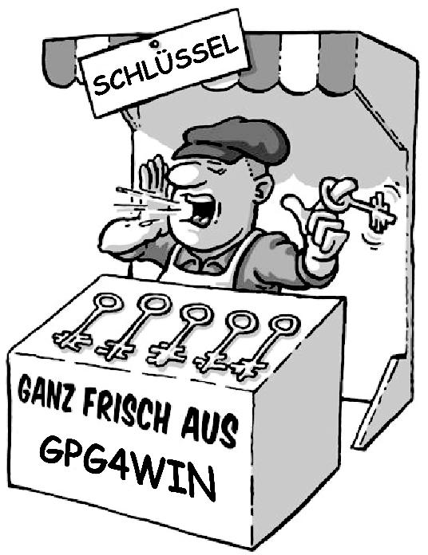

17

The Gpg4win Compendium 3.0.0



Chapter 3. How Gpg4win works

The principle behind public key encryption

The secret or private key must be kept secret.

The public key should be as accessible to the general public as much as possible.

Both key components have very different functions:

The secret key component decrypts messages.

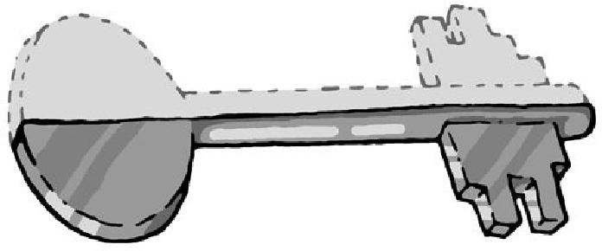

The public key component encrypts messages.

18

The Gpg4win Compendium 3.0.0



Chapter 3. How Gpg4win works

**The public mail strongbox**

This small exercise is used to explain the difference between the “public key” encryption system and symmetric encryption (“non-public key” method) ...

The “secret key method” works like this:

Imagine that you have installed a mail strongbox in front of your house, which you want to use to send secret messages.

The strongbox has a lock for which there is only one single key. No one can put anything into or take it out of the box without this key. This way, your secret messages are pretty secure.

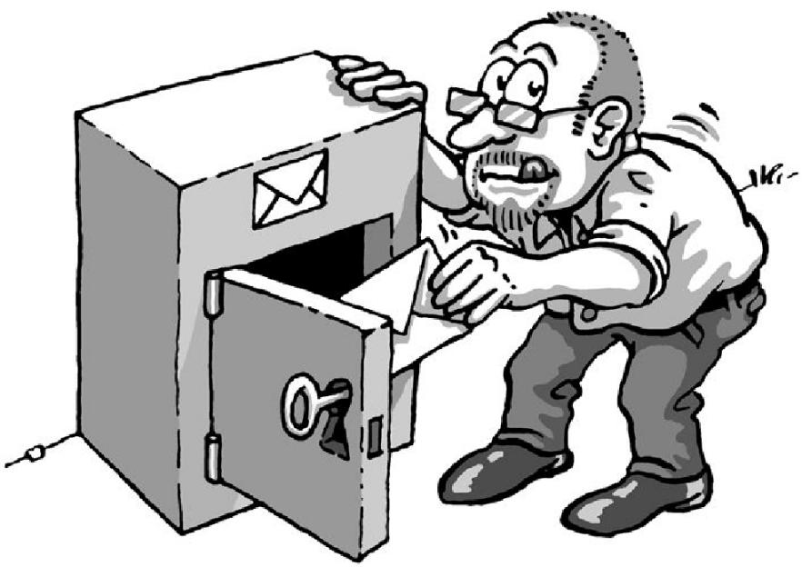

Since there is only one key, the person you are corresponding with must have the same key that you have in order to open and lock the mail strongbox, and to deposit a secret message.

19

The Gpg4win Compendium 3.0.0



Chapter 3. How Gpg4win works

You have to give this key to that person via a secret route.

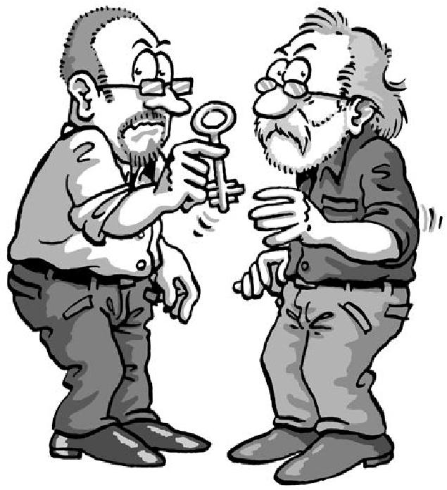

20

The Gpg4win Compendium 3.0.0



Chapter 3. How Gpg4win works

They can only open the strongbox and read the secret message once they have the secret key.

Therefore everything hinges on this one key: If a third party knows the key, it is the end of the secret messages. Therefore you and the person you are corresponding with must exchange the key in a manner that is as secret as the message itself.

But actually – you might just as well give them the secret message when you are giving them the key...

How this applies to e-mail encryption: Around the world, all participants would have to have secret keys and exchange these keys in secret before they can send secret messages per e-mail.

So we might as well forget about this option ...

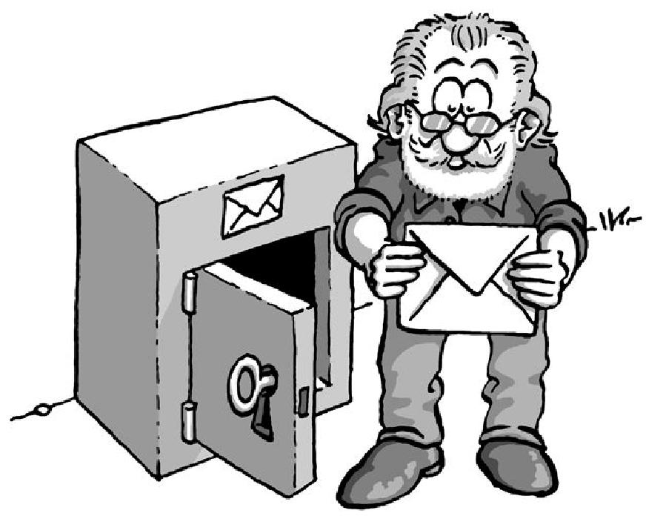

21

The Gpg4win Compendium 3.0.0



Chapter 3. How Gpg4win works

Now the “public key” method

You once again install a mail strongbox in front of your house. But unlike the strongbox in the first example, this one is always open. On the box hangs a key – which is visible to everyone – and which can be used by anyone to lock the strongbox (asymetric encryption method).

Locking, but not opening: that is the difference!

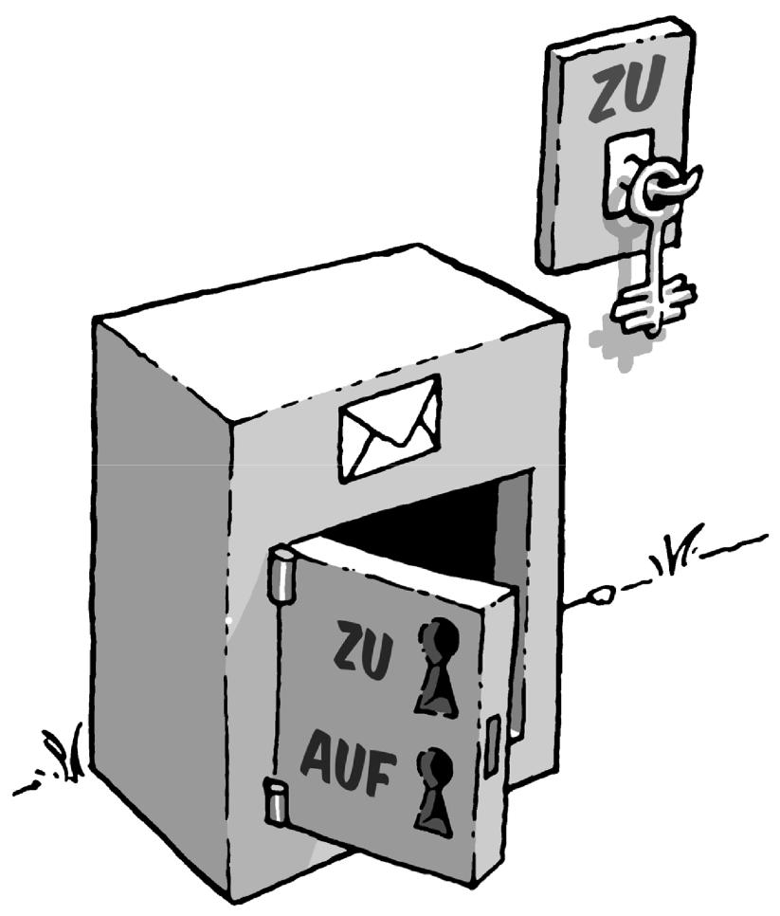

This key is yours and – as you might have guessed – it is your public key.

If someone wants to leave you a secret message, they put it in the strongbox and lock it with your public key. Anyone can do this, since the key is available to everyone.

No one else can open the strongbox and read the message. Even the person that has locked the message in the strongbox cannot unlock it again, e.g. in order to change the message.

This is because the public half of the key can only be used for locking purposes.

The strongbox can only be opened with one single key: your own secret and private part of the key.

22

The Gpg4win Compendium 3.0.0



Chapter 3. How Gpg4win works

Getting back to how this applies to e-mail encryption: Anyone can encrypt an e-mail for you.

To do this, they do not need a secret key; quite the opposite, they only need a totally non-secret , “public” key. Only one key can be used to decrypt the e-mail, namely your private and secret key.

You can also play this scenario another way:

If you want to send someone a secret message, you use their mail strongbox with their own public and freely available key.

To do this, you do not need to personally know the person you are writing to, or have to speak to them, because their public key is always accessible, everywhere. One you have placed your message in the strongbox and locked it with the recipient’s key, the message is not accessible to anyone, including you. Only the recipient can open the strongbox with his private key and read the message.

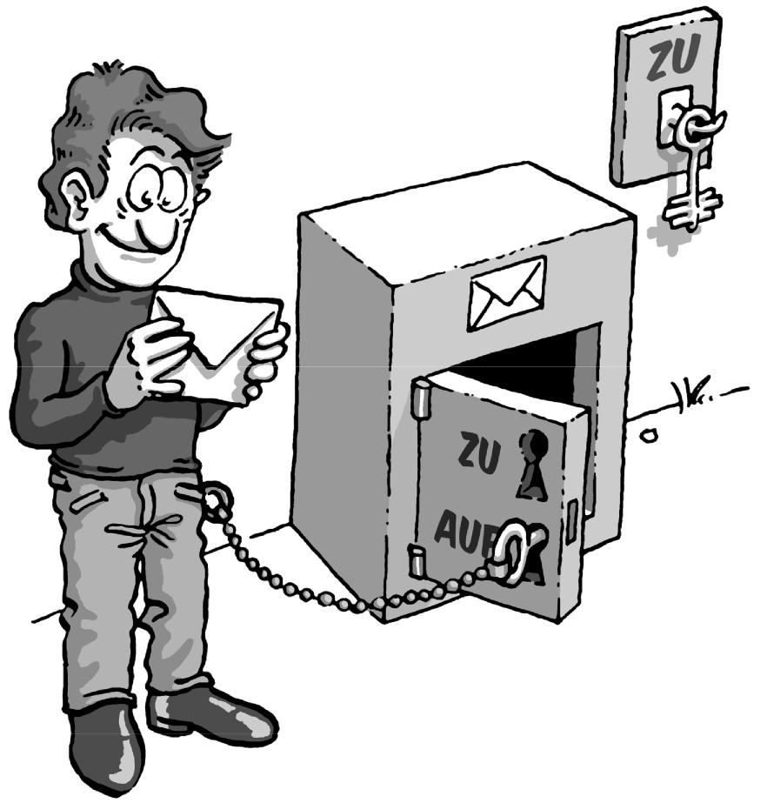

23

The Gpg4win Compendium 3.0.0



Chapter 3. How Gpg4win works

But what did we really gain: There is still a secret key!

However, this is quite different from the “non-public key” method: You are the only one who knows and uses your secret key. The key is never forwarded to a third party – it is not necessary to transfer keys in secret, nor is it advised.

Nothing must be passed between sender and recipient in secret – whether a secret agreement or a secret code.

And that is exactly the crux of the matter: All symmetric encryption methods can be broken because a third party has the opportunity to obtain the key while the key is being exchanged.

This risk does not apply here, because there is no exchange of secret keys; rather, it can only be found in one and very secure location: your own keyring – your own memory.

This modern encryption method which uses a non-secret and public key, as well as a secret and private key part is also described as “asymmetric encryption”.

24

**4. The passphrase**

As we have seen in the last chapter, the private key is one of the most important components of the “public key” or asymmetric encryption method. While one no longer needs to exchange the key with another party in secret, the security of this key is nevertheless the "key" to the security of the “entire” encryption process.

On a technical level, a private key is nothing more than a file which is stored on your computer. To prevent unauthorised access of this file, it is secured in two ways:



First, no other user may read or write in the file – which is difficult to warrant, since computer administrators always have access to all files, and the computer may be lost or attacked by viruses, worms or Trojans .

For this reason we need another layer of protection: the passphrase. This is not a password – a passphrase should not consist of only one word, but a sentence, for example. You really should keep this passphrase “in your head” and never have to write it down.

At the same time, it cannot be possible to guess it. This may sound contradictory, but it is not. There are several proven methods of finding very unique and easy to remember passphrases, which cannot be easily guessed.

25

The Gpg4win Compendium 3.0.0



Chapter 4. The passphrase

Think of a phrase that is very familiar to you, e.g.:

People in glass houses should not be throwing stones.

Now, take every third letter of this sentence:

oegsoehloerisn (Pe**o**pl**e** in **g**la**s**s h**o**us**e**s s**h**ou**l**d n**o**t b**e** th**r**ow**i**ng **s**to**n**es.)

While it may not be easy to remember this sequence of letters, it is also unlikely that you will forget how to arrive at the passphrase as long as you remember the original sentence. Over time, and the more often you use the phrase, you will commit it to memory. No one else can guess the passphrase.

Think of an event that you know you will never forget about. Maybe it’s a phrase that you will always associate with your child or partner, i.e. it has become “unforgettable”. Or a holiday memory or a line of text of a song that is personally important to you.

Use capital and small letters, numbers, special characters and spaces, in any order. In principle, anything goes, including umlaute, special characters, digits etc. But remember – if you want to use your secret key abroad at a different computer, please remember that not all keyboards may have such special characters. For example, you will likely only find umlaute (ä, ö, ü usw.) on German keyboards.

You can also make intentional grammar mistakes, e.g. “mustake” instead of “mistake”. Of course you also have to be able to remember these “mustakes”. Or, change languages in the middle of the phrase. You can change the sentence:

In München steht ein Hofbräuhaus.

into this passphrase:

inMinschen stet 1h0f breuhome

Think of a sentence that does not make sense, but you can still remember e.g.:

The expert lamenting nuclear homes

Knitting an accordeon, even during storms.

A passphrase of this length provides good protection for your secret key.

It can also be shorter if you use capital letters, for example:

THe ExPERt laMenTIng NuclEAr hoMES.

While the passphrase is now shorter, it is also more difficult to remember. If you make your passphrase even shorter by using special characters, you will save some time entering the passphrase, but it is also morr likely that you will forget your passphrase.

Here is an extreme example of a very short but also very secure passphrase:

R!Qw"s,UIb *7\$

However, in practice, such sequences of characters have not proven themselves to be very useful, since there are simply too few clues by which to remember them.

26

The Gpg4win Compendium 3.0.0



Chapter 4. The passphrase

A bad passphrase can be “broken” very quickly, if it ...

... is already used for another purpose (e.g. for an e-mail account or your mobile phone). The same passphrase would therefore already be known to another, possibly not secure, software. If the hacker is successful, your passphrase becomes virtually worthless.

... comes from a dictionary. Passphrase finder programs can run a password through complete digital dictionaries in a matter of minutes – until it matches one of the words.

... consists of a birth date, a name or other public information. Anyone planning to decrypt your e-mail will obtain this type of information.

... is a very common quote, such as “to be or not to be”. Passphrase finder programs also use quotes like these to break passphrases.

... consists of only one word or less than 8 characters. It is very important that you think of a longer passphrase.

When composing your passphrase, please do not use any of the aforementioned examples. Because anyone seriously interested in getting his hands on your passphrase will naturally see if you used one of these examples.

Be creative! Think of a passphrase now! Unforgettable and unbreakable.

In Chapter 7 you will need this passphrase to create your key pair.

But until then, you have to address another problem: Someone has to verify that the person that wants to send you a secret message is real.

27

1. **Two methods, one goal: OpenPGP &**

**S/MIME**

You have seen the importance of the “envelope” for your e-mail and how to provide one using tools of modern information technology: a mail strongbox, in which anyone can deposit encrypted mails which only you, the owner of the strongbox, can decrypt. It is not possible to break the encryption as long as the private key to your “strongbox” remains your secret.

Still: If you think about it, there is still another problem. A little further up you read about how – in contrast to the secret key method – you do not need to personally meet the person you are corresponding with in order to enable them to send a secret message. But how can you be sure that this person is actually who they say they are? In the case of e-mails, you only rarely know all of the people you are corresponding with on a personal level – and it is not usually easy to find out who is really behind an e-mail address. Hence, we not only need to warrant the secrecy of the message, but also the identity of the sender – specifically authenticity.

Hence someone must authenticate that the person who wants to send you a secret message is real. In everyday life, we use ID, signatures or certificates authenticated by authorities or notaries for “authentication” purposes. These institutions derive their right to issue notarisations from a higher-ranking authority and finally from legislators. Seen another way, it describes a chain of trust which runs from “the top” to “the bottom”, and is described as a “hierarchical trust concept”.

In the case of Gpg4win or other e-mail encryption programs, this concept is found in almost mirror-like fashion in S/MIME. Added to this isOpenPGP, another concept that only works this way on the Internet. S/MIME and OpenPGP have the same task: the encryption and signing of data. Both use the already familiar public key method. While there are some important differences, in the end, none of these standards offer any general advantage over another. For this reason you can use Gpg4win to use both methods.

28

The Gpg4win Compendium 3.0.0



Chapter 5. Two methods, one goal: OpenPGP & S/MIME

The equivalent of the hierarchical trust concept is called “Secure / Multipurpose Internet Mail Extension” or S/MIME. If you use S/MIME, your key must be authenticated by an accredited organisation before it can be used. The certificate of this organisation in turn was authenticated by a higher-ranking organisation etc. – until we arrive at a so-called root certificate. This hierarchical chain of trust usually has three links: the root certificate, the certificate of the issuer of the certificate (also CA for Certificate Authority), and finally your own user certificate.

A second alternative and non-compatible notarisation method is the OpenPGP standard, does not build a trust hierarchy but rather assembles a “Web of trust”. The Web of Trust represents the basic structure of the non-hierarchical Internet and its users. For example, if User B trusts User A, then User B could also trust the public key of User C, whom he does not know, if this key has been authenticated by User A.

Therefore OpenPGP offers the option of exchanging encrypted data and e-mails without authentication by a higher-ranking agency. It is sufficient if you trust the e-mail address and associated certificate of the person you are communicating with.

Whether with a trust hierarchy or Web of Trust – the authentication of the sender is at least as important as protecting the message. We will return to this important protection feature later in the compendium. For now, this information should be sufficient to install Gpg4win and understand the following chapters:

Both methods – OpenPGP andS/MIME – offer the required security.

The methods are not compatible with each other. They offer two alternate methods for authenti-cating your secret communication. Therefore they are not deemed to be interoperable.

Gpg4win allows for the convenient and parallel use of both methods – you do not have to choose one or the other for encryption/signing purposes.

Chapter 7 of this compendium, which discusses the creation of the key pair, therefore branches off to discuss both methods. At the end of Chapter 7 the information is combined again.

In this compendium, these two symbols will be used to refer to the two alternative methods:

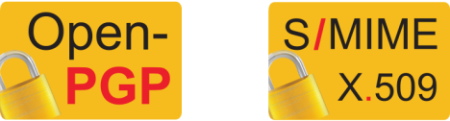

29

**6. Installing Gpg4win**

Chapters 1 to 5 provided you with information on the background related to encryption. While Gpg4win also works if you do not understand the logic behind it, it is also different from other programs in that you are entrusting your secret correspondence to this program. Therefore it is good to know how it works.

With this knowledge you are now ready to install Gpg4win and set up your key pair.

If you already have a GnuPG-based application installed on your computer (e.g. GnuPP, GnuPT, WinPT or GnuPG Basics), please refer to the Annex D for information on transferring your existing certificates.

You can load and install Gpg4win from the Internet or a CD. To do this, you will need administrator rights to your Windows operating system.

If you are downloading Gpg4win from the Internet, please ensure that you obtain the file from a trustworthy site, e.g.: [www.gpg4win.org](http://www.gpg4win.org). To start the installation, click on the following file after the download:

gpg4win-2.0.0.exe (or higher version number).

If you received Gpg4win on a CD ROM, please open it and click on the “Gpg4win” installation icon.

All other installation steps are the same.

The response to the question of whether you want to install the program is [ Yes ].

30

The Gpg4win Compendium 3.0.0



Chapter 6. Installing Gpg4win

The installation assistant will start and ask you for the language to be used with the installation process:

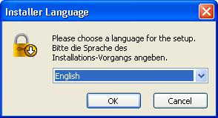

Confirm your language selection with [ OK ].

Afterwards you will see this welcome dialog:

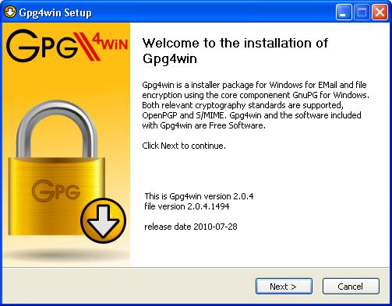

Close all programs that are running on your computer and click on [ Next ].

31

The Gpg4win Compendium 3.0.0



Chapter 6. Installing Gpg4win

The next page displays the licensing agreement – it is only important if you wish to modify or forward Gpg4win. If you only want to use the software, you can do this right away – without reading the license.

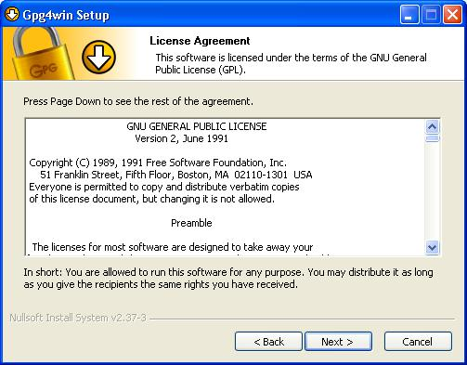

Click on [ Next ].

32

The Gpg4win Compendium 3.0.0



Chapter 6. Installing Gpg4win

On the page that contains the selection of components you can decide which programs you want to install.

A default selection has already been made for you. Yo can also install individual components at a later time.

Moving your mouse cursor over a component will display a brief description. Another useful feature is the display of required hard drive space for all selected components.

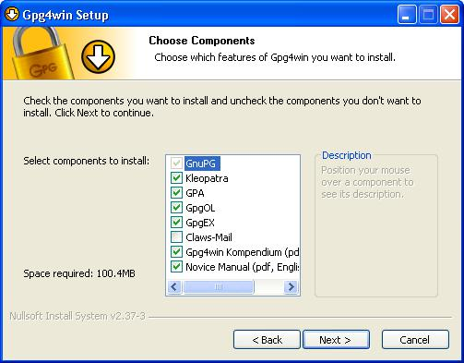

Click on [ Next ].

33

The Gpg4win Compendium 3.0.0



Chapter 6. Installing Gpg4win

The system will suggest a folder for the installation, e.g.: C:nProgrammenGNUnGnuPG

You can accept the suggestion or select a different folder for installing Gpg4win.

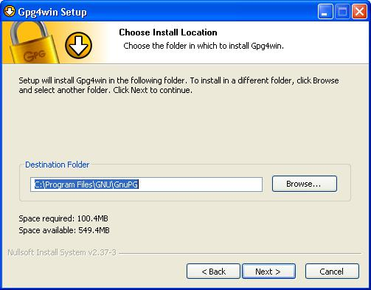

Then click on [ Next ].

34

The Gpg4win Compendium 3.0.0



Chapter 6. Installing Gpg4win

Now you can decide which links should be installed – the system will automatically create a link with the start menu. You can change this link later on using the Windows dashboard settings.

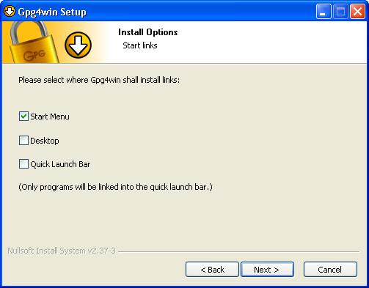

Then click on [ Next ].

35

The Gpg4win Compendium 3.0.0



Chapter 6. Installing Gpg4win

If you have selected the default setting – link with start menu – you can define the name of this start menu on the next page or simply accept the name.

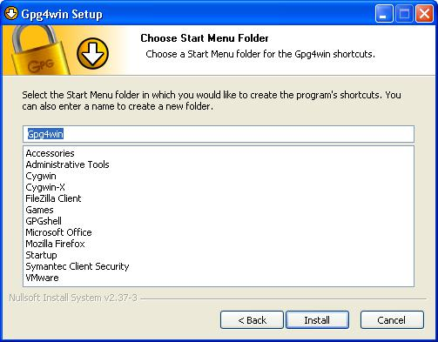

Then click on [ Install ].

36

The Gpg4win Compendium 3.0.0



Chapter 6. Installing Gpg4win

During the installation process that follows, you will see a progress bar and information on which file is currently being installed. You can press [ Show details ] at any time to show the installation log.

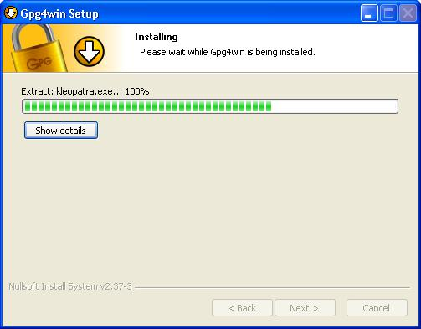

Once you have completed the installation, please click on [ Next ].

37

The Gpg4win Compendium 3.0.0



Chapter 6. Installing Gpg4win

The last page of the installation process is shown once the installation has been successfully completed:

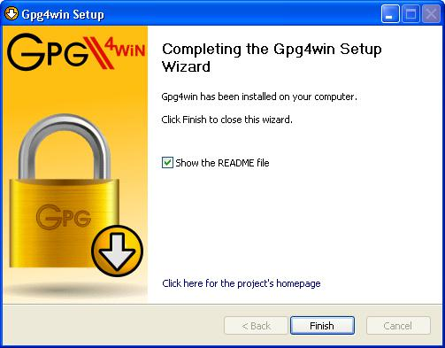

You have the option of displaying the README file, which contains important information on the Gpg4win version you have just installed. If you do not wish to view this file, deactivate this option.

Then click on [ Finish ].

38

The Gpg4win Compendium 3.0.0



Chapter 6. Installing Gpg4win

In some cases you may have to restart Windows. In this case, you will see the following page:

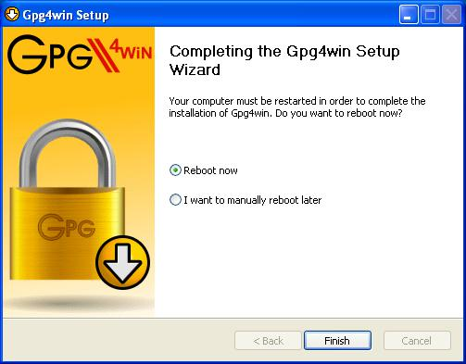

Now you can decide whether Windows should be restarted immediately or manually at a later time.

Click on [ Finish ].

Please read the README file which contains up-to-date information on the Gpg4win version that has just been installed. You can find this file e.g. via the start menu: Start!Programs!Gpg4win!Documentation!Gpg4win README

39

The Gpg4win Compendium 3.0.0



Chapter 6. Installing Gpg4win

And that’s it!

You have successfully installed Gpg4win and are ready to work with the program.

For information on automatically installing Gpg4win, as may be of interest for software distribution systems, please see the Annex C “Automatic installation of Gpg4win”.

40

**7. Creating a certificate**

Now that you have found out why GnuPG is so secure (Chapter 3), and how a good passphrase provides protection for your private key (Chapter 4), you are now ready to create your own key pair .

As we saw in Chapter 3, a key pair consists of a public and a private key. With the addition of an e-mail address, login name etc., which you enter when creating the pair (so-called meta data), you can obtain your private certificate with the public and private key.

This definition applies to both OpenPGP as well as S/MIME (S/MIME certificates correspond with a standard described as “X.509”).

It would be nice if I could practice this important step of creating a key pair ....

Not to worry, you can do just that – but only with OpenPGP:



If you decide for the OpenPGP method of authentication, the “Web of Trust”, then you can practice the entire process for creating a key pair, encryption and decryption as often as you like, until you feel very comfortable.

This “dry run” will strengtthen your trust in Gpg4win, and the “hot phase” of OpenPGP key pair creation will no longer be a problem for you.

Your partner in this exercise is Adele . Adele is a test service which is still derived from the GnuPP predecessor project and is still in operation. In this compendium we continue to recommend the use of this practice robot. We would also like to thank the owners of gnupp.de for operating this practice robot. Unfortunately, we cannot ensure, that Adele is working. We know that Adele has some problems. Please inform yourself under <https://wiki.gnupg.org/EmailExercisesRobot>about any issues you may encounter.

Using Adele, you can practice and test the OpenPGP key pair which you will be creating shortly, before you start using it in earnest. But more on that later.

41

The Gpg4win Compendium 3.0.0



Chapter 7. Creating a certificate

Let’s go! Open Kleopatra using the Windows start menu:

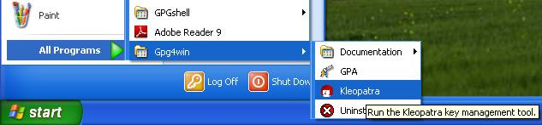

You will see the main Kleopatra screen – the certificate administration:

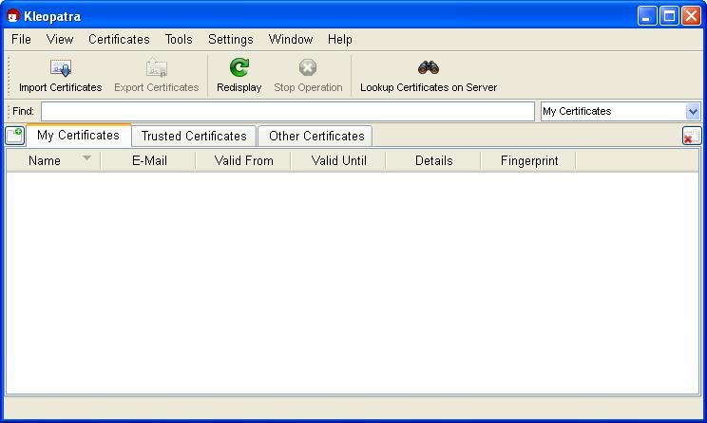

At the beginning, this overview will be empty, since you have not created or imported any certificates yet.

42

The Gpg4win Compendium 3.0.0



Chapter 7. Creating a certificate

Click on File!New Certificate.

In the following dialog you select the format for the certificate. You can choose from the following:

OpenPGP (PGP/MIME) or X.509 (S/MIME).

The differences and common features of the two formats have already been discussed in Chapter 5.

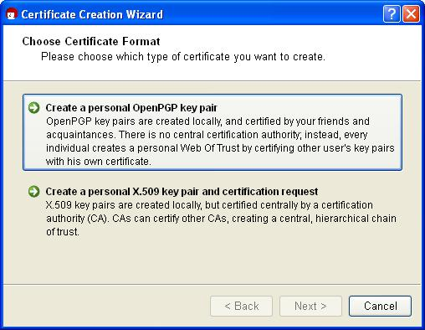

This chapter of the compendium breaks off into two sections for each method at this point. Information is then combined at the end of the Chapter.

Depending on whether you chose OpenPGP or X.509 (S/MIME), you can now read either:

Section 7.1: Creating an OpenPGP certificate (see next page) or

Section 7.2: Creating an X.509 certificate (see page 50).

43

The Gpg4win Compendium 3.0.0



Chapter 7. Creating a certificate

**7.1. Creating an OpenPGP certificate**

In the certificate option dialog, click on [ Create personal OpenPGP key pair ].



Now enter your e-mail address and your name in the following window. Name and e-mail address will be made publicly visible later.

You also have the option of adding a comment for the key pair. Usually this field stays empty, but if you are creating a key for test purposes, you should enter "test" so you do not forget it is a test key. This comment becomes part of your login name, and will become public just like your name and e-mail address.

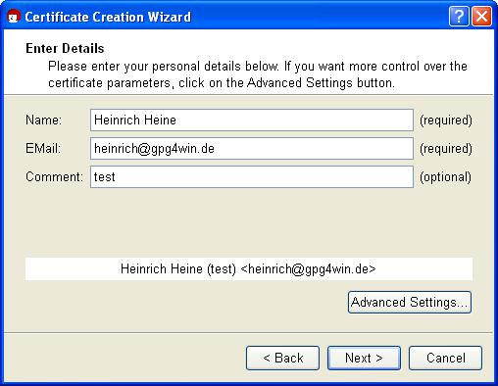

If you first wish to test your OpenPGP key pair, you can simply enter any name and fictional e-mail address, e.g.:

Heinrich Heine and heinrich@gpg4win.de

The Advanced settings are only be required in exceptional cases. For details, see the Kleopatra handbook (via Help!Kleopatra handbook).

Click on [ Next ].

44

The Gpg4win Compendium 3.0.0



Chapter 7. Creating a certificate

You will see a list of all of the main entries and settings for review purposes. If you are interested in the (default) expert settings, you can view these via the All details option.

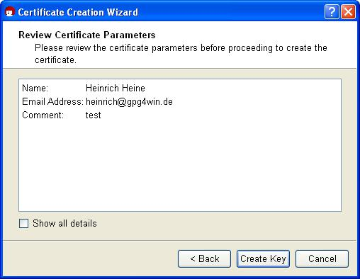

If everything is correct, click on [ Create key ].

45

The Gpg4win Compendium 3.0.0



Chapter 7. Creating a certificate

Now to the most important part: entering your passphrase!

To create a key pair, you must enter your personal passphrase:

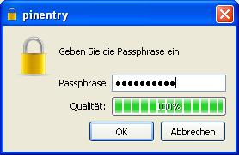

If you have read Chapter 4 you should now have an easy-to-remember but hard to break secret passphrase. Enter it in the dialog displayed at the top.

Please note that this window may have been opened in the background and is not visible at first.

If the passphrase is not secure enough because it is too short or does not contain any numbers or special characters, the system will tell you.

At this point you can also enter a test passphrase or start in earnest; it’s up to you.

To make sure that you did not make any typing errors, the system will prompt you to enter your passphrase twice. Always confirm your entry with [ OK ].

46

The Gpg4win Compendium 3.0.0



Chapter 7. Creating a certificate

Now your OpenPGP key pair is being created:

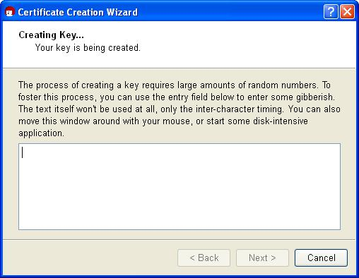

This may take a couple of minutes. You can assist the creation of the required random numbers by entering information in the lower input field. It does not matter what you type, as the characters will not be used, only the time period between each key stroke. You can also continue working with another application on your computer, which will also slightly increase the quality of the new key pair.

47

The Gpg4win Compendium 3.0.0



Chapter 7. Creating a certificate

As soon as the key pair creation has been successful, you will see the following dialog:

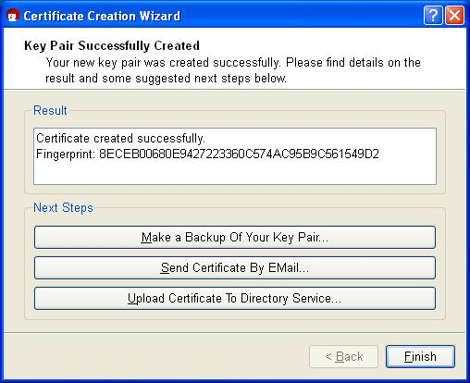

The 40-digit “fingerprint” of your newly generated OpenPGP certificate is displayed in the results text field. This fingerprint is unique anywhere in the world, i.e. no other person will have a certificate with the same fingerprint. Actually, even at 8 digits it would already be quite unlikely that the same sequence would occur twice anywhere in world. For this reason, it is often only the last 8 digits of a fingerprint which are used or shown, and which are described as the key ID. This fingerprint identifies the identity of the certificate as well as the fingerprint of a person.

However, you do not need to remember or write down the fingerprint. You can also display it later in Kleopatra’s certificate details.

48

The Gpg4win Compendium 3.0.0



Chapter 7. Creating a certificate

Next, you can activate one or more of the following three buttons:

**Creating a backup copy of your (private) certificate...**

Enter the path under which your full certificate (which contains your new key pair, hence the private and public key) should be exported:

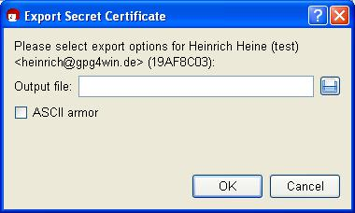

Kleopatra will automatically select the file type and store your certificate as an .asc or.gpg file

– depending on whether you activate or deactivate the ASCII armor option. For export, click on [ OK ].

Important: If you save the file on the hard drive, you should copy the file to another data carrier (USB stick, diskette or CD-ROM) as soon as possible, and delete the original file without a trace, i.e. do not leave it in the Recycle bin! Keep this data carrier and back-up copy in a safe place.

You can also create a back-up copy later; to do this, select the following from the Kleopatra main menu: File!Export private certificate... (see Chapter 19).

**Sending a certificate via e-mail ...**

Clicking on this button should create a new onee-mail – with your new public certificate in the attachment. Your secret Open PGP key will of course not be sent. Enter a recipient e-mail address; you can also add more text to the prepared text for this e-mail.

Please note: Not all e-mail programs support this function. Of course you can also do this

manually: If you do not see a newe-mail window, shut down the certificate creation assistant, save your public certificate via File!Export certificate and sent this file via e-mail to the people you are corresponding with. For more details see Section 8.1.

**Sending certificates to certificate servers...**

Chapter explains how to set up a globally available OpenPGP certificate server in Kleopatra, and how you can publish your public certificate on this server 16.

This completes the creation of your OpenPGP certificate. End the Kleopatra assistant with [ Finish ].

Now let’s go to Section 7.3 on page 56. Starting at that point, the explanations for OpenPGP and X.509 will again be identical.

49

The Gpg4win Compendium 3.0.0



Chapter 7. Creating a certificate

**7.2. Creating an X.509 certificate**

In the certificate format selection dialog on page , 43 click on the button

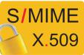

* Create personal X.509 key pair and authentication request ].

In the following window, enter your name (CN = common name), your e-mail address (EMAIL), organisation (O) and your country code (C). Optionally, you can also add your location (L = Locality) and department (OU = Organizational Unit).

If you first wish to test the X.509 key pair creation process, you can enter any information for name, organization and country code, and can also enter a fictional e-mail address, e.g.:CN=Heinrich

Heine,O=Test,C=DE,EMAIL=heinrich@gpg4win.de

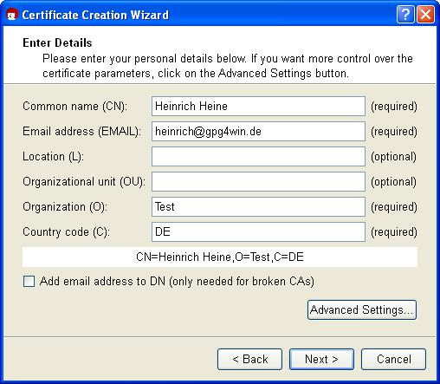

The Advanced settings will only be required in exceptional cases. For details, see the Kleopatra handbook (via Help!Kleopatra handbook).

Click on [ Next ].

50

The Gpg4win Compendium 3.0.0



Chapter 7. Creating a certificate

You will see a list of all main entries and settings for review purposes. If you are interested in the (default) expert settings, you can view these via the All details option.

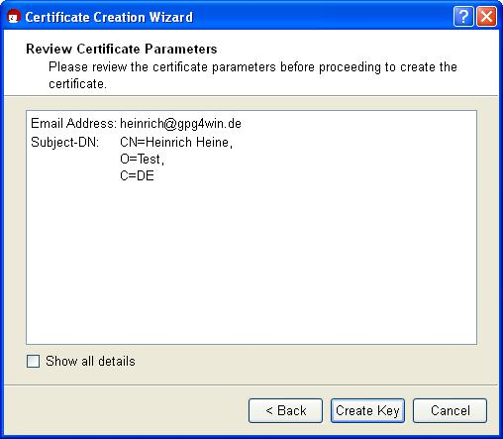

Once everything is correct, click on [ Creat key ].

51

The Gpg4win Compendium 3.0.0



Chapter 7. Creating a certificate

Now to the most important part: Entering your passphrase!

In order to create a key pair, you will be asked to enter your passphrase:

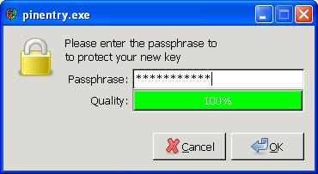

If you have read Chapter 4 you should now have an easy-to-remember but hard to break secret passphrase. Enter it in the dialog displayed at the top!

Please note that this window may have been opened in the background, so it may not be visible at first.

If the passphrase is not secure enough because it is too short or does not contain any numbers or special characters, the system will let you know.

At this point you can also enter a test passphrase or start in earnest; it’s up to you.

To make sure that you did not make any typing errors, the system will prompt you to enter your passphrase twice. Finally, you will be asked to enter your passphrase a third time: By doing that, you are sending your certificate request to the authenticating instance in charge. Always confirm your entries with [ OK ].

52

The Gpg4win Compendium 3.0.0



Chapter 7. Creating a certificate

Now your X.509 key pair is being created:

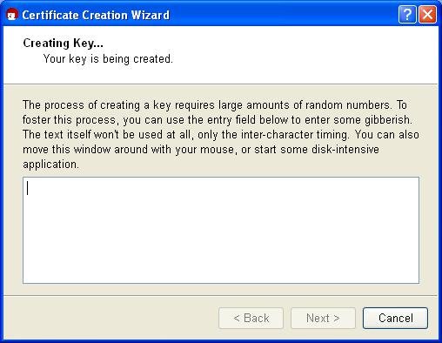

This may take a couple of minutes. You can assist the creation of the required random numbers by entering information in the lower input field. It does not matter what you type, as the characters will not be used, only the time period between each key stroke. You can also continue working with other applications on your computer, which will slightly increase the quality of the key pair that is being created.

53

The Gpg4win Compendium 3.0.0



Chapter 7. Creating a certificate

As soon as the key pair has been successfully created, you will see the following dialog:

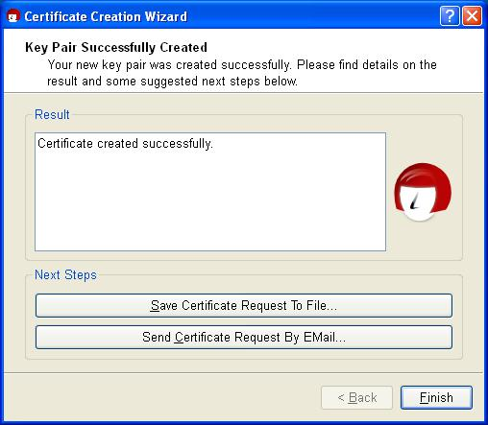

The next steps are triggered with the following buttons:

**Save request in file...**

Here, you enter the path under which your X.509 certificate request should be backed up, and confirm your entry. Kleopatra will automatically add the file ending .p10 during the saving process. This file can then be sent to an authentication instance (in short CA for Certificate Au-thority). Further below, we will refer you to cacert.org, which is a non-commercial authentication instance (CA) that issues X.509 certificates free of charge.

**Sending an request by e-mail ...**

This creates a new e-mail with the certificate request which has just been created in the attachment. Enter a recippient e-mail address – usually that of your certificate authority in charge; you can also add more text to the prepared text of this e-mail.

Please note: Not all e-mail programs support this function. Of course you can also do this manually: If you do not see a new e-mailwindow, save your request in a file (see above) and send it by e-mail to your certificate authority (CA).

As soon as the CA has processed your request, the CA system administrator will send you the completed X.509 certificate, which has been signed by the CA. You only need to import the file into Kleopatra (see Chapter 19).

End the Kleopatra assistant with [ Finish ].

54

The Gpg4win Compendium 3.0.0



Chapter 7. Creating a certificate

**Creating an X509 certificate using www.cacert.org**

CAcert is a non-commercial certificate authority which issues X.509 certificates free of charge. It offers an alternative to commercial root CAs, some of which charge very high fees for their certificates.



To create a (client) certificate at CAcert, you first have to register at [www.cacert.org](http://www.cacert.org).

Immediately following registration, you can create one or more client certificates on cacert.org: please make sure you have sufficient key length (e.g. 2048 bits). Use the web assistant to define a secure passphrase for your certificate.

Your client certificate is now created.

Afterwards you will receive an e-mail with two links to your new X.509 certificate and associated CAcert root certificate. Download both certificates.

Follow the instructions to install the certificate on your browser. In Firefox, you can use e.g. Edit!Settings!Advanced!Certificates to find your installed certificate under the first tab “Your certificates" with the name (CN) CAcert WoT User.

You can now issue a personal X.509 certificate which has your name in the CN field. To do this, you must have your CAcert account authenticated by other members of the CACert Web of Trust. Information on obtaining such a confirmation can be found on the Internet pages of CAcert.

Then save a backup copy of your personal X.509 certificate. The ending .p12 will automatically be applied to the backup copy.

Attention: This .p12 file contains your public and your private key. Please ensure that this file is protected againt unauthorised access.

To find out how to import your personal X.509 certificate in Kleopatra, see Chapter 19.

Let’s now look at Section 7.3 on the next page. This is where explanations for OpenPGP and X.509 are identical again.

55

The Gpg4win Compendium 3.0.0



Chapter 7. Creating a certificate

**7.3. Certificate creation process complete**

This completes the creation of your OpenPGP or X.509 key pair. You now have a unique elec-tronic key.

During the course of this compendium, we will always use an OpenPGP certificate for sample purposes – however, all information will also apply accordingly to X509 certificates.

You are now back in the Kleopatra main window. The OpenPGP certificate which was just created can be found in the certificate administration under the tab My certificates:

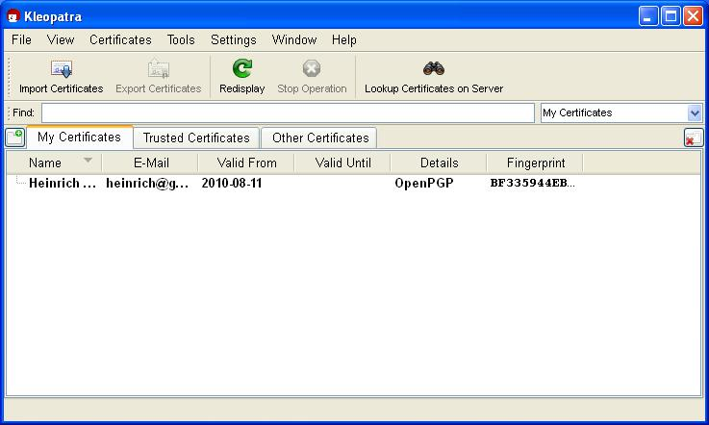

56

The Gpg4win Compendium 3.0.0



Chapter 7. Creating a certificate

Double-click on your new certificate to view all details related to the certificate:

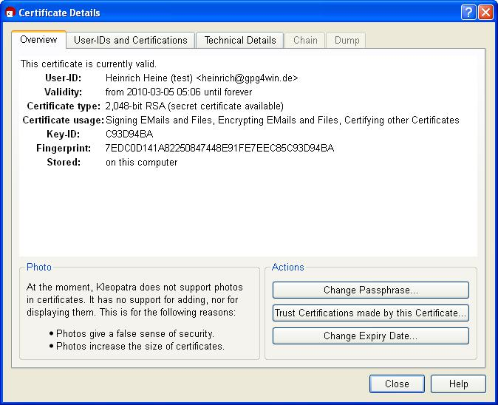

What do the certificate details mean?

Your certificate is valid indefinitely, i.e. it has no “built-in expiry date”. To change its validity at a later point, click on [ Change expiry date ].

For more details about the certificate, see Chapter 15.

57

**8. Distribution of public certificates**

When using Gpg4win on a daily basis, it is very practical that for the purpose of encrypting and checking signatures you are always dealing with “public” certificates which only contain public keys. As long as your own secret key and the passphrase which protects it are secure, you have already gone a long way towards ensuring secrecy.

Everyone can and should have your public certificate, and you can and should have the public certificates of your correspondence partners – the more, the better.

Because:

To exchange secure e-mails, both partners must have and use the public certificate of the other person. Of course the recipient will also require a program capable of handling certificates – such as the Gpg4win software package with Kleopatra certification administration.

Therefore, if you want to send encrypted e-mails to someone, you must have their public certificate to encrypt the e-mail.

In turn, if someone wants to send you encrypted e-mails, he must have your public certificate and use it for encryption purposes.

For this reason you should now allow access to your public certificate.

Depending on how many people you corespond with, and which certificate format you are using, you have several options. For example, you can distribute your public certificate ...

... directly via e-mail to specific correspondence partners – see Section 8.1.

... on an OpenPGP certificate server (applies only to OpenPGP) – See Section 8.2. ... via your own homepage.

... in person, e.g. with a USB stick.

Let’s look at the first two variants on the following pages.

58

The Gpg4win Compendium 3.0.0



Chapter 8. Distribution of public certificates

**8.1. Publishing per e-mail, with practice for OpenPGP**

Do you wish to make your public certificate accessible to the person you are corresponding with? Simply send them your exported public certificate per e-mail. This section will show you how this works.

Practice this process with your public OpenPGP certificate! Adele can assist you. The following exercises only apply to OpenPGP; for information on publishing public X.509 certificates, please see page 67.



Adele is a very nice e-mail robot which you can use to practice correspondence. Please note, that Adele may not be working. Don’t be concerned if Adele is not answering, you may better practice with a human being, because it is usually more pleasant to correspond with a smart human being rather than a piece of software (which is what Adele is, after all), you can imagine Adele this way:



First, send Adele your public OpenPGP certificate. Using the public key in this certificate, Adele will send an encrypted e-mail back to you.

You then use your own secret key to decrypt Adele’s response. To be able to respond to Adele with an encrypted e-mail, Adele has attached her own public certificate.

Adele acts just like a real person you are corresponding with. Of course, Adele’s e-mails are not nearly as interesting as those from the people you are actually corresponding with. On the other hand, you can use Adele to practice as much as you like – which a real person might find bothersome after a while.

So, now you export your public OpenPGP certificate and send it via e-mail to Adele. The following pages how how this works.

59

The Gpg4win Compendium 3.0.0



Chapter 8. Distribution of public certificates

**Exporting your public OpenPGP certificate**

Select the public certificate to be exported in Kleopatra (by clicking on the corresponding line in the list of certificates) and then click on File!Export certificates... in the menu. Select a suitable file folder on your PC and save the public certificate with the file type.asc e.g.: mein-OpenPGP-Zertifikat.asc. The other file types, which can be selected, .gpg or.pgp, will save your certificate in binary format. That means that in contrast to an .ascfile, they cannot be read in the text editor.

When you select the menu item, please make sure that you are only exporting your public certificate – and not the certificate of your entire key pair with the associated private key by mistake.

Review the file once more by selecting Windows Explorer and selecting the same folder that you indicated for the export.

Now open the exported certificate file with a text editor, e.g. WordPad. The text editor will display your public OpenPGP certificate as it really looks – a fairly confusing block of text and numbers:

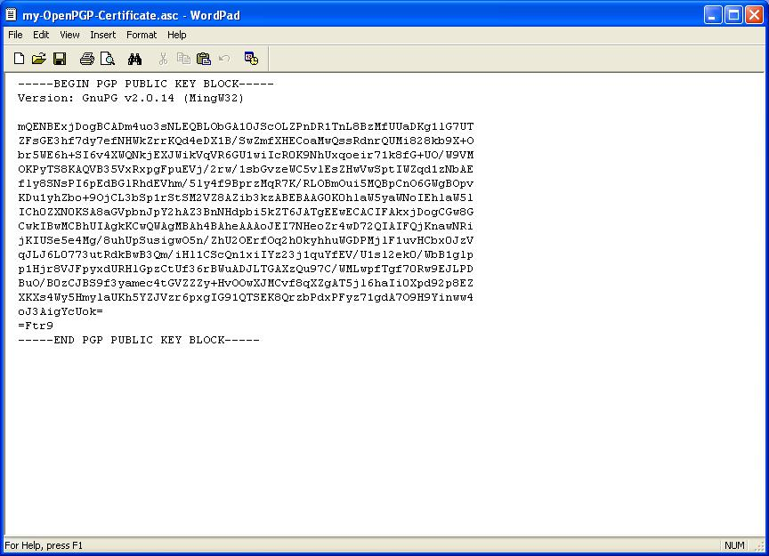

60

The Gpg4win Compendium 3.0.0



Chapter 8. Distribution of public certificates

When publishing your OpenPGP certificate by e-mail, there are two variants which can take into account whether an e-mail program can send attachments.

**Variant 1: Send public OpenPGP certificate as an e-mail text**

This option always works, even if you are not able to attach files – as may be the case with some e-mail services on the Web.

Also, it is a way of seeing your public certificate for the first time, knowing exactly what is behind it, and what the certificate actually consists of.

Highlight the entire public certificate in the text editor from

---BEGIN PGP PUBLIC KEY BLOCK---

up to

---END PGP PUBLIC KEY BLOCK---

and copy it with the menu command or the key shortcut Ctrl+C. Now you have copied the certificate in the memory of your computer (Clipboard in a Windows context).

Now you can start your e-mail program – it does not matter which one you use – and add your public certificate into an empty e-mail. In Windows, the key command for adding (“Paste”) is Ctrl+V. You may know this process – copying and pasting – as “Copy & Paste”.

The e-mail program should be set up in such a way that it is possible to send only text messages and not HTML formated messages (see Section 13.3 and Annex A).

Now address this e-mail to adele@gnupp.de and write something in the subject line e.g. My public OpenPGP certificate.

61

The Gpg4win Compendium 3.0.0



Chapter 8. Distribution of public certificates

This is approximately what your e-mail will look like:

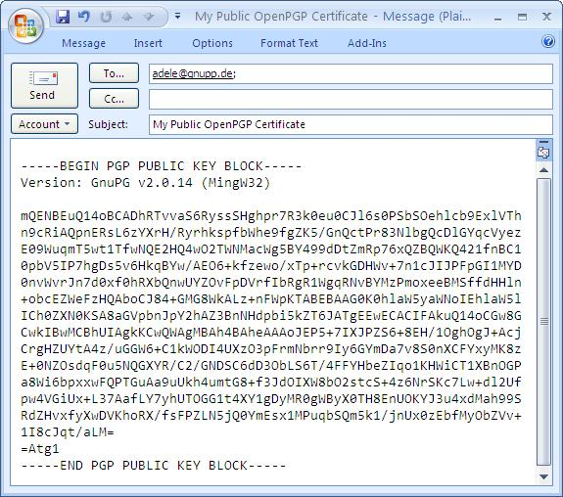

Now send the e-mail to Adele. Make sure to include your own e-mail address as the sender. Otherwise you will never receive Adele’s response ...

62

The Gpg4win Compendium 3.0.0



Chapter 8. Distribution of public certificates

**Variant 2: Send public OpenPGP certificate as an e-mail attachment**

As an alternate to Variant 1, you can also send your exported public OpenPGP certificate directly as an e-mail file attachment. This is often the simpler and more commonly used method. Above, you learnt about the “Copy & Paste” method, because it is more transparent and easier to understand.

Now write another e-mail to Adele – this time with the certificate file in the attachment:

Add the previously exported certificate file as an attachment to your new e-mail – just as you would for any other file (e.g. pulling the file into the emtpy e-mailwindow). Add the recipient (adele@gnupp.de) and a subject, e.g.: My public OpenPGP certificate - as a file attachment.

Of course you can also add a few explanatory sentences. However, Adele does not need this explana-tions, because her only purpose is to help you practice this process.

Your finished e-mail should look something like this:

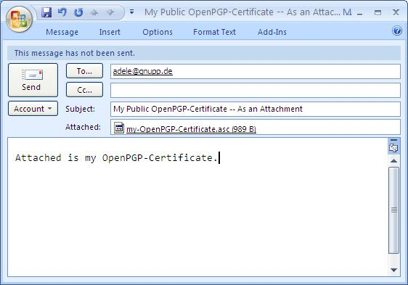

Now send the e-mail and attachment to Adele.

63

The Gpg4win Compendium 3.0.0



Chapter 8. Distribution of public certificates

**In short:**

You have exported your public OpenPGP certificate in Kleopatra into a file. Subsequently, you have also copied the content of the file directly into an e-mail and attached the complete file as an e-mailattachment. Both e-mails have been sent to someone else – in this case, to Adele.

The same process applies if you are sending your public certificate to a real e-mail address. Usually, you should send public certificates as a file attachment, as described in Variant 2. This is the easiest way to do it, both for you and the recipient. And it also has the advantage that your recipient can import your certificate file directly into his own certificate administration (e.g. Kleopatra).

64

The Gpg4win Compendium 3.0.0



Chapter 8. Distribution of public certificates

**8.2. Publish via OpenPGP certificate server**

Please note: You can only distribute your OpenPGP certificate via an OpenPGP certificate server.



Publishing your public OpenPGP certificate on a public certificate server is always a good idea, even if you are only exchanging encrypted e-mails with just a few people. This way, your public certificate is accessible to everyone on an Internet server. This saves you time in having to send your certificate e-mail to all of the people you are corresponding with.

At the same time, publishing your e-mail address on a certificate server can also make your e-mail address more susceptible to spam. This can only be addressed with good spam protection.

This is how it works: Select your public OpenPGP certificate in Kleopatra and click on File!Export certificate to server.... If you have not defined a certificate server, you will see a warning:

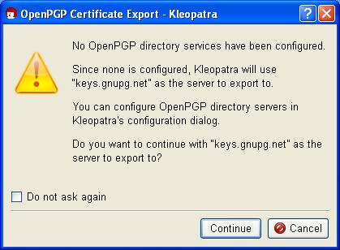

The public OpenPGP certificate server already contains keys.gnupg.net default settings. Click on

* Continue ] to send your selected public certificate to this server. There, your public certificate is distributed to all globally connected certificate servers. Anyone can download your public certificate from one of these OpenPGP certificate servers and use it send you a secure e-mail.

If you are only testing this process, please do not send the practice certificate: In the top dialog, click on [ Cancel ]. The test certificate is worthless and cannot be removed by the certificate server. You would not believe how many test certificates with names like “Julius Caesar”, “Helmut Kohl” or “Bill Clinton” are already floating around on these servers ...

65

The Gpg4win Compendium 3.0.0



Chapter 8. Distribution of public certificates

**In short:**

Now you know how to publish your public OpenPGP certificate on an OpenPGP certificate server on the Internet.

For information on how to search for the public OpenPGP certificate of people you are corre-sponding with on a certificate server, see Chapter 16. You can read this chapter now or later when you need this function.

66

The Gpg4win Compendium 3.0.0



Chapter 8. Distribution of public certificates

**8.3. Publishing X.509 certificates**

In the case of public X.509 certificates, this process is even easier: all you need to do is to send a signed S/MIME e-mail to the person you are corresponding with. Your public X.509 certificate is contained in this signature, and can be imported into the recipient’s certificate administration.



Unfortunately, you cannot use Adele to practice X.509 certificates since the robot only supports OpenPGP. Therefore you should pick another person to write you, or alternately write to yourself.

Some public X.509 certificates are distributed by the certificate authority. This is usually done using X.509 certificate servers, which however do not synchronize on a global basis, as is the case with OpenPGP key servers.

When you export your public X.509 certificate, you can highlight the entire public certificate chain and save it in a file – generally the root certificate, CA certificate and personal certificate – or only your public certificate.

The first is recommended since the person you are corresponding with may be missing some parts of the chain, which he otherwise would have to find. To do this, click on all elements of the certificate chain in Kleopatra while holding the Shift key, and export the highlighted certificate into a file.

If the person you are corresponding with does not have the root certificate, he must indicate that he trusts it, or have an administrator do so, in order to finally also trust you. If this has already been done (e.g. because they are both part of the same “root”), then this shiop is already in place.

67

1. **Decrypting e-mails, practicing for OpenPGP**

Gpg4win, the certificate of your key pair and of course your passphrase are all you need to decrypt e-mails.

This Chapter shows you step for step how to decrypt e-mails in Microsoft Outlook using the Gpg4win program component GpgOL.

Initially, you can practice this process with Adele and your public OpenPGP certificate. The following exercises again only apply to OpenPGP – explanations regarding the decryption of S/MIME e-mails can be found at the end of this chapter on page 71.



In Section 8.1 you sent your public OpenPGP certificate to Adele. Using this certificate, Adele will now encrypt an e-mail and send a message back to you. You should receive Adele’s response after a short time period.



68

The Gpg4win Compendium 3.0.0



Chapter 9. Decrypting e-mails, practicing for OpenPGP

**Decrypting a message with MS Outlook and GpgOL**

Most e-mail programs also have special program extensions (“plugins”), which can be used to perform the encryption and decryption process directly in the e-mail program. GpgOL is such a program extension for MS Outlook, which is used here to decrypt Adele’se-mails. For more information on other software solutions, please see Annex B. You can read this section now, or later when you need this function.

Start MS Outlook and open Adele’s response e-mail. Until now, you have only known Kleopatra as a certificate administration program. However, the program can do much more than that: It can control the actual GnuPG encryption software and hence not just manage your certificates but also take care of all cryptographic tasks (with GnuPG’s assistance). Kleopatra provides the visual user interface, hence the dialogs which you as the user see while you encrypt or decrypt e-mails.

Hence Kleopatra processes Adele’s encrypted e-mails. These e-mails have been encrypted by Adele using your public OpenPGP key.

To decrypt the message, Kleopatra will now ask for your passphrase that protects your private key.

Enter your passphrase.

The decryption is successful if you do not see an error dialog! You can now read the decrypted e-mail.

You can retrieve the exact results dialog of the decryption by clicking on Extras!GpgOL decryp-tion/check in the menu of the opened e-mail.

However, surely you also want to see the result, namely the decrypted message ...

69

The Gpg4win Compendium 3.0.0



Chapter 9. Decrypting e-mails, practicing for OpenPGP

**The decrypted message**

Adele’s decrypted response will look something like this1:

Hello Heinrich Heine,

here is an encrypted response to your e-mail.

I received your public key with the key ID FE7EEC85C93D94BA and the name ‘Heinrich Heine <heinrich@gpg4win.de>’.

Attached is the public key of adele@gnupp.de, the friendly e-mail robot.

Regards,

adele@gnupp.de

The text block that follows is Adele’s public certificate.

In the next chapter, you will import this certificate and add it to your certificate administration. You can use imported public certificates at any time to encrypt messages to the people you are corresponding with, or to check their signed e-mails.

* Depending on the software version of Adele, it may look differently. It’s translated from German.

70

The Gpg4win Compendium 3.0.0



Chapter 9. Decrypting e-mails, practicing for OpenPGP

**In short:**

1. You have decrypted and encrypted an e-mail using your private key.
2. Your correspondence partner has attached his own public certificate, so that you can answer him in encrypted form.

**e-mail decryption using S/MIME**

So this is how e-mails are decrypted using the private OpenPGP key – but how does it work with S/MIME?



The answer: The same!

To decrypt an encrypted S/MIME e-mail, simply open the message in Outlook and enter your passphrase in the pin entry dialog. You will see a status dialog that is similar to that shown for OpenPGP. After closing this dialog, you will see the decrypted S/MIME e-mail.

Differently from OpenPGP decryption, however, when using S/MIME you cannot use Adele to practice, since Adele only supports OpenPGP.

71

**10. Importing a public certificate**

The person you are corresponding with does not always have to send their public certificate when they send signed e-mails to you. You can simply store their public certificate in your certificate administrator – e.g. Kleopatra.

**Storing a public certificate**

Before you import a public certificate into Kleopatra, you must save it in a file. Depending on whether you received the certificate as an e-mailfile attachment or as a block of text contained in your e-mail, please proceed as follows:

If the public certificate was included as an e-mail file attachment, save it on your hard drive – just as you would normally do.

If the public certificate was mailed as a block of text that was included in the e-mail, you have to highlighte the entire certificate:

In the case of (public) OpenPGP certificates, please highlight the area from

---BEGIN PGP PUBLIC KEY BLOCK---

up to

---END PGP PUBLIC KEY BLOCK---

just as we have seen in Section 8.1.

Now use Copy & Paste to insert the highlighted section into a text editor and save the public certificate. For file endings, you should use .asc or .gpg for OpenPGP certificates and .pem or .der for X.509 certificates.

72

The Gpg4win Compendium 3.0.0



Chapter 10. Importing a public certificate

**Importing public certificates into Kleopatra**

Whether you have saved the public certificate as an e-mail attachment or text block – in both cases, you will be importing it into your Kleopatra certificate administration. To do this, start Kleopatra if the program is not running already. In the menu, click on File!Import certificate..., search for the public certificate you have just saved and import it. You will receive an information dialog showing the result of the import process:

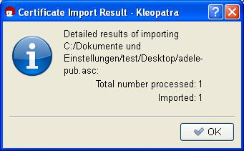

It displays the imported public certificate in Kleopatra, in a separate tab Imported certificates with the title <Path to certification file>”:

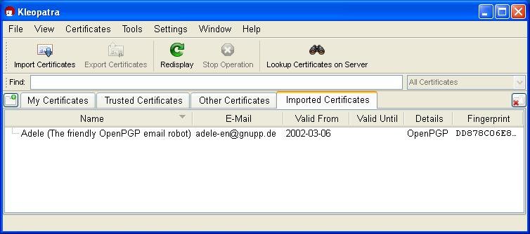

This tab is used for checking purposes, since a file can contain more than one certificate. You can close the tab using the Fenster!Close tab command or via the “Close tab” button on the right side of the window).

Now change over to the tab “Other certificates”. You should also be able to see the public certificate you have imported.

Now you have imported someone else’s certificate – in this case Adele’s public OpenPGP certificate – into your certificate administration. You can use this certificate at any time to send encrypted messages to the owner of the certificate, and to check his signatures.

73

The Gpg4win Compendium 3.0.0



Chapter 10. Importing a public certificate

As soon as you are exchanging encrypted e-mail more frequently and with a larger number of persons, you will likely want to search and import for certificates on globally available key servers. To see how this works, please see Chapter 16 .

**Before continuing, an important question:**

How do you know that the public OpenPGP certificate really came from Adele? It is possible to send e-mails under someone else’s name – in this respect, merely having the sender’s name does not mean anything.

So how can you ensure that a public certificate actually belongs to the sender?

This key question related to certificate inspections is explained in the next Chapter 11.

74

**11. Certificate inspection**

How do you know if a certificate actually belongs to the sender? And vice versa – why should the person you are writing to believe that the certificate you sent to him is really yours? The sender’s name on an e-mail means nothing, just like putting a sender’s name on an envelope.

If your bank, receives an e-mail with your name, with a request to transfer your entire bank balance to a numbered account in the Bahamas, we should hope that it will refuse to do so – no matter what the e-mail address is. On its own, an e-mail address itself does not really say anything about the sender’s identity.

75

The Gpg4win Compendium 3.0.0



Chapter 11. Certificate inspection

**Fingerprints**

If you are only corresponding with a very small circle of people, it is easy to check their identity: You check the fingerprint of the other certificate.

Each certificate features a unique identification, which is even better than someone’s fingerprint. For this reason this identification is also referred to as a “fingerprint”.

If you display the details of a certificate in Kleopatra, e.g. by double-clicking on the certificate, you will see its 40-character fingerprint, among other things:



The fingerprint of the above OpenPGP certificate is therefore as follows:

7EDC0D141A82250847448E91FE7EEC85C93D94BA

In short - the fingerprint clearly identifies the certificate and its owner.

Simply call the person you are corresponding with and let them read the fingerprint of their certificate to you. If the information matches the certificate you have on hand, you clearly have the right certificate.

Of course you can also meet the owner of the certificate in person, or use another method to ensure that certificate and owner can be matched. Frequently, the fingerprint is also printed on business cards; therefore, if you have a business card whose authenticity is guaranteed, you can save yourself a phone call.

76

The Gpg4win Compendium 3.0.0



Chapter 11. Certificate inspection

**Authenticating an OpenPGP certificate**

Once you have obtained confirmation of the authenticity of the certificate “via a fingerprint”, you can authenticate it – but only in OpenPGP. With X.509, users cannot authenticate certificates – this can only be done by the certificate authorities (CA).



By authenticating a certificate, you are letting other (Gpg4win) users know that you are of the opinion that this certificate is real – hence authentic: You are acting as a kind of “godfather” for this certificate, and help to increase the general level of trust in its authenticity.

So how does the authentication process work?

In Kleopatra, select an OpenPGP certificate that you think is real and would like to authenticate. In the

menu, select: Certificates!Authenticate certificates...

Reconfirm the OpenPGP certificate to be authenticated in the following dialog, using [ Next ]:

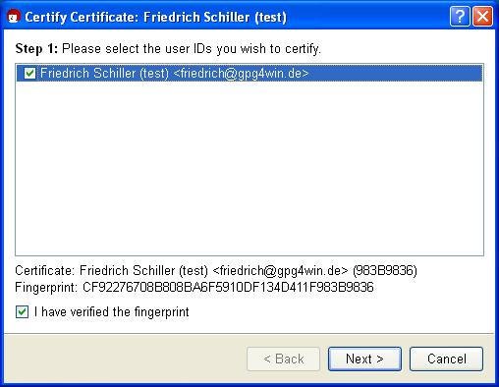

77

The Gpg4win Compendium 3.0.0



Chapter 11. Certificate inspection

In the next step, select your own OpenPGP certificate, which you will use to authenticate the certificate selected in the last step:

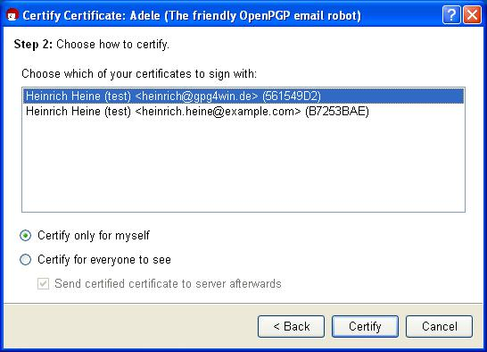

Here you decide whether to [ Authenticate for private use only ] or or [ Authenticate and make visible to all ]. With the last variant, you have the option of subsequently uploading the authenticated certificate to an OpenPGP certificate server, and hence make an updated and authenticated certificate available to the entire world.

Now confirm your selection with [ Authenticate ].

Similar to the process of signing an e-mail, you also have to enter your passphrase when authenticating a certificate (with your private key). The authentication proccess is only complete once this information is entered correctly.

78

The Gpg4win Compendium 3.0.0



Chapter 11. Certificate inspection

Following a successful authentication, the following window appears:

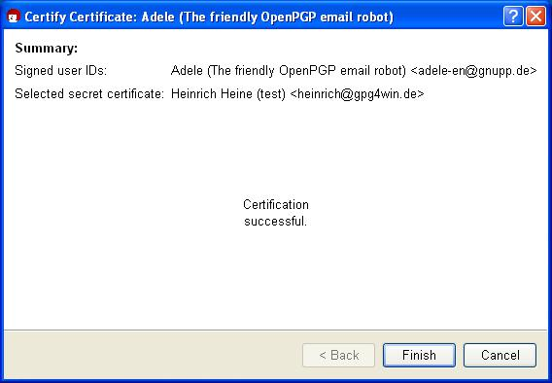

Do you want to check the authentication one more? To do this, open the certificate details of the certificate you have just authenticated.Select the tab User ID and authentications and click on the button [ Obtain authentications ].

You will now see all authentications contained in this certificate, sorted by user ID. You should also be able to see your certificate in this list, if you have just authenticated it.

79

The Gpg4win Compendium 3.0.0



Chapter 11. Certificate inspection

**Web of trust**

The process of authenticating certificates creates a “Web of Trust” (WoT), which extends beyond the group of Gpg4win users and their correspondence, and it means that you are not always required to verify an OpenPGP certificate for its authenticity.

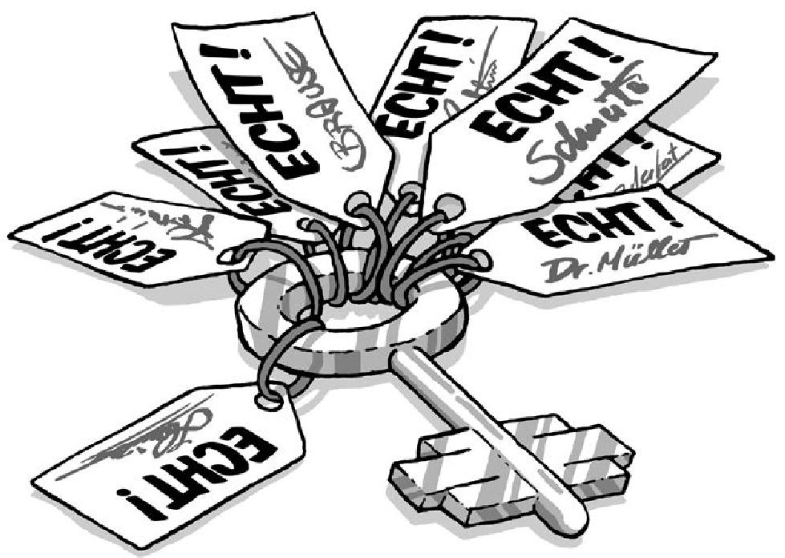

Naturally, trust in a certificate will increase if it has been authenticated by a lot of people. Your own OpenPGP certificate will receive authentications from other GnuPG users over time. This enables more and more people to trust that this certificate is really yours and not someone else’s.

The continued weaving of this “Web of Trust” creates a flexible authentication structure.

There is one theoretical possibility of making this certificate test null and void: Someone plants a wrong certificate on you. In other words, you have a public OpenPGP key that pretends to be from X but in reality was replaced?? by Y. If this falsified certificate is authenticated, it clearly creates a problem for the “Web of Trust”. For this reason it is very important to make sure that prior to authenticating a certifidate, you make absolutely sure the certificate really belongs to the person that purports to own it.

But what if a bank or government authority wants to check whether the certificates of their customers are real? Surely, they cannot call them all ...

80

The Gpg4win Compendium 3.0.0



Chapter 11. Certificate inspection

**Authentication instances**

In this case, we need a “superordinate” instance that all users can trust. After all, you do not personally check the ID of a person not known to you by phoning the municipal office, but rather trust that the office that issued the ID will have already checked and authenticated these details.

These types of authentication instances also exist in the case of OpenPGP certificates. In Germany, for example, the magazine c’t has long been offering such a service free of charge, as have many universities.



Therefore, if you have received an OpenPGP certificate whose authenticity has been confirmed by such an authentication instance, you should be able to rely on it.

Such authentication instances or “Trust Centers” are also provided for in other encryption methods – such as S/MIME. However, in contrast to the "Web of Trust", these feature a hierarchical structure, with a “top authentication instance” that authenticates additional “sub-instances” and entitles them to authenticate user certificates (see Chapter 5).



The best way to describe this infrastructure is to use the example of a seal: The sticker on your license plate can only be provided by an institution that is authorised to issue such stickers, and they have received that right from another superordinate body. On a technical level, an authentication is nothing more than an authenticating party signing a certificate.

Of course, hierarchical authentication infrastructures are much better suited to the requirements of government and official instances than the loose “Web ofTrust” of GnuPG, which is based on mutual trust. At the same time, the key aspect of the authentication is the same for both: Gpg4win also supports a hierarchical authentication (S/MIME) in addition to the “Web of Trust” (OpenPGP). Accordingly, Gpg4win offers a basis that corresponds with the Signature Act of the Federal Republic of Germany.

If you would like to learn more about this topic, the following websites provide more information on this and other IT security topics:

[www.bsi.de](http://www.bsi.de)

[www.bsi-fuer-buerger.de](http://www.bsi-fuer-buerger.de) [www.gpg4win.org](http://www.gpg4win.org)

Another, rather technical, information source on the issue of authentication infrastructure is the GnuPG handbook, which can also be found at:

[www.gnupg.org/gph/en/manual.html](http://www.gnupg.org/gph/en/manual.html)

81

**12. Encrypting e-mails**

Now it is getting exciting again: You are sending an encrypted e-mail.

In this case, you will need Outlook (or another e-mail program that supports cryptography), Kleopatra and of course the public certificate of the person you are correspondign with.

Note for OpenPGP:

You can use Adele to practice the encryption process with OpenPGP; on the other hand, Adele does not support S/MIME. You can send the e-mail to be encrypted to adele@gnupp.de. It does not matter what your write in your message, since Adele cannot read it.



Note for S/MIMIE:

Following the installation of Gpg4win, the S/MIME functionality is already activated in GpgOL. If you want to turn off S/MIME (with GnuPG), for example to use Outlook’s own S/MIME function, you have to deactivate the option Activate S/MIME support in the following GpgOL option dialog under Extras!Options!GpgOL:

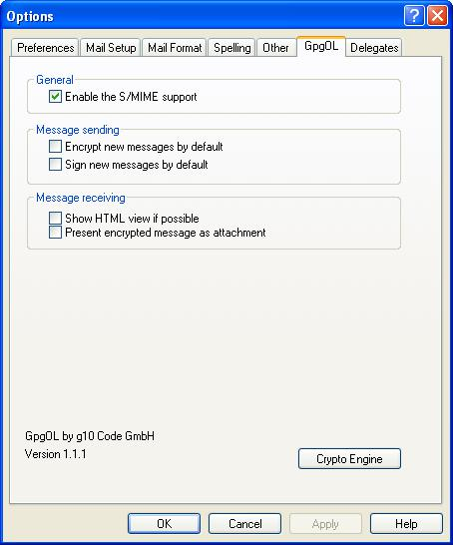

82

The Gpg4win Compendium 3.0.0



Chapter 12. Encrypting e-mails

**Send an encrypted message**

First, compose a new in Outlook and address it to the person you are writing to.

To send your message as in an encrypted form, select the item Extras!Encrypt message in the menu of the message window. The button with the lock icon in the tool bar is activated – you can also click right on the lock.

Your Outlook message windows should look something like this:

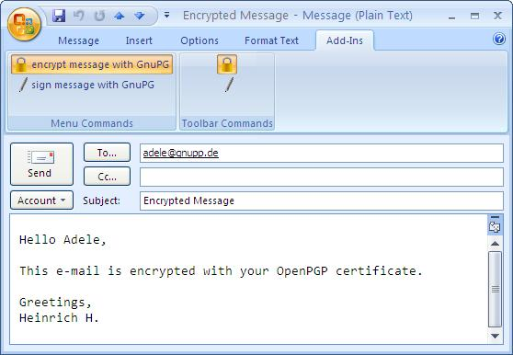

Now click [ Send ].

Gpg4win will automatically detect the protocol – OpenPGP or S/MIME – of the public certificate provided by the person you are corresponding with.

As long as there is only one certificate that matches the recipient’s e-mail address, your message will be encrypted and sent.

83

The Gpg4win Compendium 3.0.0



Chapter 12. Encrypting e-mails

**Selecting certificates**

If Kleopatra is not able to clearly determine a recipient certificate using the le-mail address, e.g. if you have an OpenPGP and S/MIME certificate from the person you are corresponding with, a selection dialog which allows you to select the right certificate will be displayed.

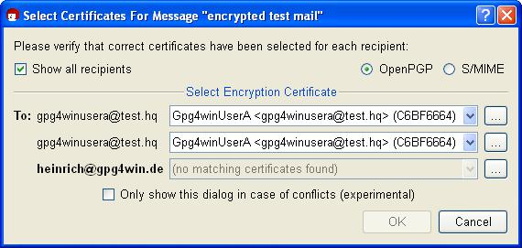

If Kleopatra is not able to find the public certificate of the person you are corresponding with, you probably have not imported it into your certificate administration yet (see Chapter 10) or perhaps have not authenticated it yet (for OpenPGP; see Chapter 11), or have not expressed your trust in the root certificate of the certification chain (for S/MIME, see Chapter 22.7).

You need the correct public certificate of your correspondence partner to encrypt your messages.

Remember the principle in Chapter 3:

You have to use someone’s public certificate to send them an an encrypted e-mail.

84

The Gpg4win Compendium 3.0.0



Chapter 12. Encrypting e-mails

**Completing the encryption process**

Once your message was successfully encrypted and sent, you will receive a confirmation message:

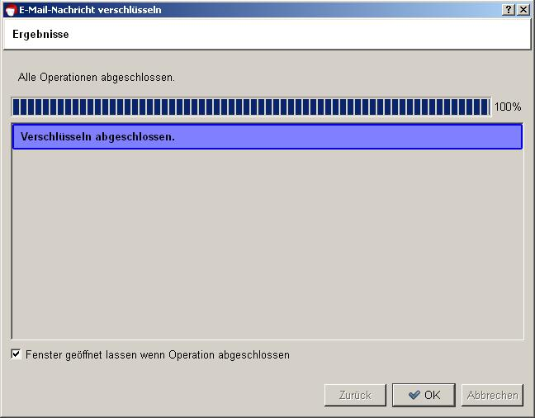

Congratulations! You have encrypted your first e-mail!

85

**13. Signing e-mails**

In Chapter 11 you learnt more about verifying the authenticity of a public OpenPGP certificate, and signing it with your own private OpenPGP key.

This chapter also explains how to sign a complete e-mail rather than only the certificate. That means applying a digital signature to the e-mail – which is a form of an electronic seal.

“Sealed” in this way, the text can still be read by everyone, but it allows the recipient to find out whether the e-mail was manipulated or modified during delivery. The signature tells the recipient that the message is really from you. And: If you are corresponding with someone whose public certificate you do not have (for whatever reason), you can at least “seal” the message with your own private key.

You have probably noticed that this digital signature is not identical to an e-mail “signature”, which is sometimes included at the end of an e-mail and includes such items as telephone number, address and website. While these e-mail signatures simply function as a type of business card, a digital signature will protect your e-mail from manipulation and clearly confirms the sender.

Besides, a digital signature cannot be compared with a qualified electronic signature, as it went into effect as part of the Signature Act (22 May 2001). However, it serves exactly the same purpose for private or professional e-mail communication.



86

The Gpg4win Compendium 3.0.0



Chapter 13. Signing e-mails

**13.1. Signing with GpgOL**

In fact, signing an e-mail is even easier than encrypting it (see Chapter 12). Once you have composed a new e-mail, go through the following steps – similar to the encryption process:

Send message with signature Select certificate

Completing the signing process

These steps are described in detail on the following pages.

**Sending a signed message**

First, compose a new e-mail in Outlook and address it to the person you are writing to.

Before you send your message, tell the system that your message should be sent with a signature: To do this, activate the button with the signature pen or the menu item Format!Sign message.

Your e-mail window would then look something like this:

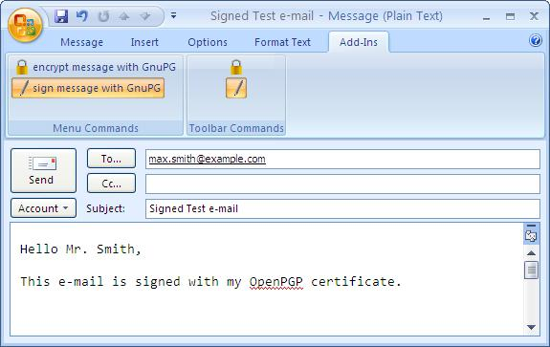

Now click on [ Send ].

87

The Gpg4win Compendium 3.0.0



Chapter 13. Signing e-mails

**Selecting certificates**

Just as is the case for encrypting e-mails, Gpg4win automatically detects the protocol – OpenPGP or S/MIME – for which your own certificate (with the private key for signing) is available.

If you have your own OpenPGP and S/MIME certificate with the same e-mail address, Kleopatra will ask you to select a protocol before the e-mail is signed:

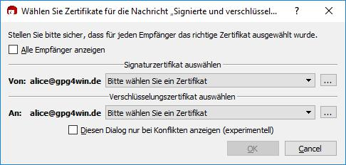

If you have several certificates (e.g. two OpenPGP certificates for the same e-mail address) for the selected method,Kleopatra will open a window which displays your certificates (here: OpenPGP), each with its own private key:

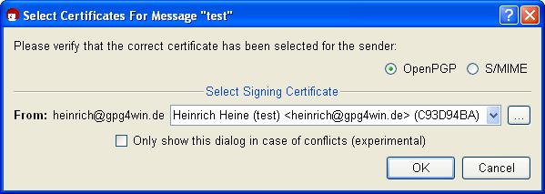

Confirm your selection with [ OK ].

88

The Gpg4win Compendium 3.0.0



Chapter 13. Signing e-mails

**Completing the signing process**

In order to complete the signing process for your e-mail, you will be asked to enter your secret passphrase in the following pin entry window:

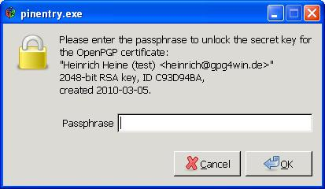

This is required because:

You can only sign with your own private key.

It makes sense, because only your own private key confirms your identity. The person you are corresponding with can then check your identity using your public certificate, which he already has or can obtain. Because only your private key matches your public certificate.

Confirm your passphrase entry with [ OK ]. Your message is now signed and sent.

Once your message has been signed successfully, the following dialog appears:

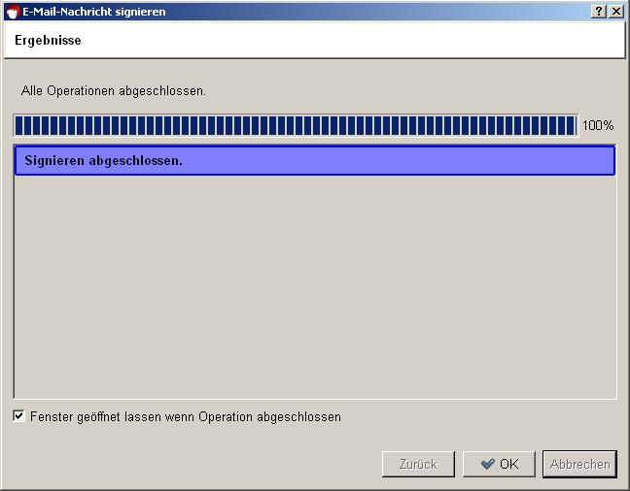

89

The Gpg4win Compendium 3.0.0



Chapter 13. Signing e-mails

Congratulations! You have encrypted your first e-mail!

90

The Gpg4win Compendium 3.0.0



Chapter 13. Signing e-mails

**In short:**

You have learnt how to sign an e-mail using your own certificate – which contains your private key.

You know how to encrypt an e-mail using the public certificate of the person you are writing to.

Now you are familiar with the two most important techniques for sending secure e-mails: encryption and signatures.

Of course you can also combine the two techniques. From now on, eacht time you send an e-mail, think about how you want to send it – depending on the importance and required level of protection for your e-mail:

non-encrypted encrypted

signed

signed and encrypted (more on this in Section 13.4)

You can use these four combinations with either OpenPGP or S/MIME.

91

The Gpg4win Compendium 3.0.0



Chapter 13. Signing e-mails

**13.2. Checking signatures with GpgOL**

Let’s assume you have received a signed e-mail from the person you are corresponding with.

It is very easy to check this digital signature. All you need is the public OpenPGP or X.509 certificate of your correspondence partner. You should have already imported his public certificate into your certificate administration prior to performing this check (see Chapter 10).

To check a signed OpenPGP or S/MIME e-mail, proceed as you would for decrypting an e-mail (see

Chapter 9):

Start Outlook and open a signed e-mail.

GpgOL will automatically transfer the e-mail to Kleopatra for a signature check. Kleopatra will report the result in a status dialog, e.g.:

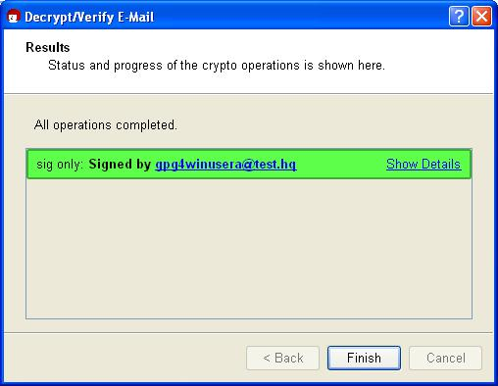

The signature check was successful! Now close to the dialog in order to read the signed e-mail.

If you want to perform the check again manually, select Extras!Decrypt/Check GpgOL in the menu of the open e-mail.

If the signature check is not successful, it means that the message was changed during the delivery process. Because of the technical nature of the Internet, it is possible that the e-mail was unintentionally modified because of a defective transmission. That is probably the most likely cause. However, it can also mean that the text was changed intentionally.

Section 13.3 has information on how to proceed in such a case.

92

The Gpg4win Compendium 3.0.0



Chapter 13. Signing e-mails

**13.3. Reasons for a broken signature**

There are several reasons for a broken signature:

If you receive the message “Bad signature” or “Check failed”, it is a warning that your e-mail may have been manipulated! That means that it is possible that someone changed the e-mail’s contents or the subject line.

At the same time, a broken signature does not necessarily mean that the e-mail was manipulated. It is also possible that the e-mail was modified due to a defective transmission.

In any case, you should always take a broken signature seriously and ask the sender to resend the e-mail!

It is recommended that you set your program to only send e-mails in “text” format and not in “HTML” format. However, if you decide to use HTML for signed or encrypted e-mails, it is possible that formatting information will be lost by the time it reaches the recipient, which can result in a broken signature.

In Outlook 2003 and 2007, you can set the message format to Text only in Extras!Options!E-Mail Format.

93

The Gpg4win Compendium 3.0.0



Chapter 13. Signing e-mails

**13.4. Encryption and signature**

You know: A message is usually encrypted using the public certificate of your correspondence partner, who then decrypts the e-mail using his private key.

The reverse possibility – encryption with a private key – does not make sense, since the whole world knows the associated public certificate and could then decrypt the message.

However, as you have already seen in this chapter, there is still another method to create a file using your private key – namely the signature.

A digital signature confirms the author – because if someone successfully applies your public certificate to this file (the signature), this file could only have been encoded by your private key. And only you can have access to this key.

You can combine both options, namely encrypting and signing the e-mail:

1. You sign the message with your own private key. This proves that you are the author.
2. You then encrypt the text using the public certificate of the person you are correpsonding with.

This means that the message has two security characteristics:

1. Your seal on the message: the signature with your private key.
2. A solid outer envelope: encryption using the public certificate of the person you are corresponding with.

Your correspondence partner opens the outer strong envelope with his own private key. This ensures secrecy, because only this key can be used to decode the text. He reads the seal with your public certificate, which proves that you were the author, because if your public certificate matches, the seal (digital signature) can only have been encoded with your private key.

It is pretty tricky when you think about it, but also very simple.

94

**14. Archiving e-mails in an encrypted form**

You should also archive your important – and hence possibly encrypted – e-mails in only one way:

encrypted.

Of course you can simply save a clear text version of your texts, but that is actually not required. If your message was supposed to be secret, it should not be stored on your computer in clear text. Therefore you should always store your encrypted sent e-mails in an encrypted form!

You can probably already guess the problem: To decrypt your archived (sent) e-mails, you will need the private key of the recipient – and you don’t or will ever have it ...

So what to do?

Very easy: You also encrypt to yourself!

The message is encrypted once for the actual person you are writing to – e.g. Adele – and once more for you, using your own public certificate. This way, you can later make the e-mail legible using your own private key.

Gpg4win will automatically encrypt each encrypted message to your own certificate. To do this, Gpg4win uses your sender e-mail address. If you have multiple certificates for an e-mail address, you have to select the certificate to encrypt to during the encryption process.

95

The Gpg4win Compendium 3.0.0



Chapter 14. Archiving e-mails in an encrypted form

**In short:**

1. You have encrypted an e-mail using the public certificate of the person you are corresponding with, and used it to answer him.
2. Kleopatra additionally encrypts your sent encrypted e-mails using your own public certificate, so that the messages remain legible for you.

And that’s it! At the end of the first part of this compendium, you have gained a lot of introduc-tory knowledge about Gpg4win.

Welcome to the world of free and secure e-mail encryption!

For an even better understanding of how Gpg4win really works in the background, we recommend that you read the second part of the Gpg4win compendium. It contains even more interesting stuff!

96

**Part II.**

**For Advanced Users**

97

**15. Certificate details**

In Chapter 7.3, you have already seen the detailed dialog for the certificate you generated. It contains a lot of information about your certificate. The following section provides a more detailed overview of the most important points, with brief information on the differences between OpenPGP and X.509 certificates, including:

user ID

fingerprints key ID

validity

trust in certificate holders (OpenPGP only) authentications (OpenPGP only)

**The user ID** consists of the name and e-mail address which you entered during the certificate creationprocess, e.g.

Heinrich Heine <heinrich@gpg4win.de>

For OpenPGP certificates, you can use Kleopatra to add additional user IDs to your certificate using the menu Certificates!Add user ID... menu item. This makes sense if, for example, you wish to use the same certificate for another e-mail address.

Please note: Kleopatra only allows you to add user IDs for OpenPGP certificates, but not X.509.

**Fingerprints** are used to differentiate multiple certificates from each other. You can use fingerprintsto look for (public) certificates, which are stored on a globally available OpenPGP certificate server (key server) or an X.509 certificate server. You can read more about certificate servers in the next chapter.

**The key ID** consists of the last eight characters of the fingerprint and fulfils the same function. Whileless characters make it easier to handle key IDs, they also increase the risk of multiple hits (different certificates with the same ID).

**The validity** of certificates describes the duration of their validity and their expiry date, if applicable.

In the case of OpenPGP certificates, the validity is usually set to Indefinite . You can change this in Kleopatra by clicking on [ Change expiry date ] in the certificate details – or select the Certificates!Change expiry date and enter a new date. This means that you can declare the certificate valid for a limited time period, e.g. in order to issue it to outside employees.

The validity of X.509 certificates is defined by the certificate authority when the certificate is issued, and cannot be changed by the user.

98

The Gpg4win Compendium 3.0.0



Chapter 15. Certificate details

**Trust in the certificate holder** quantifies your own subjective confidence that the owner of theOpenPGP certificate is real (authentic) and that he will also correctly authenticate other OpenPGP certifictes. You set the trust with [ Change trust in certificate holder ] in the certificate details, or via the menuCertificates!Change trust status menu item.



The trust status is only relevant for OpenPGP certificates. No such method exists for X.509 certificates.

**Authentications** of your OpenPGP certificate include the user IDs of those certificate holders whoare convinced of the authenticity of your certificate and have thus authenticated it. Trust in the authenticity of your certificate increases with the number of authentications you receive from other users.



Authentications are only relevant to OpenPGP certificates. This type of trust mechanism does not exist for X.509 certificates.

You do not necessarily have to know the certificate details to use Gpg4win on a daily basis, but they do become relevant when you want to receive or change new certificates.

You already learnt how to inspect and authenticate someone else’s certificate and about the “Web of Trust” in Chapter 11.

99

**16. The certificate server**

Section 8.2 already provided a lot of information on how to use a certificate server to publish your public (OpenPGP or X.509) certificate. This section will take a closer look at certificate servers, and will show you how to use them with Kleopatra.

Key servers can be used by all programs that support the standards OpenPGP or X.509. Kleopatra supports both types, hence both OpenPGP as well as X.509 certificate servers.

**OpenPGP certificate servers** (also called “key server”) are organized on a decentralised basisand synchronize each other on a global basis. There are no current statistics about their number of how many OpenPGP certificates they contain. This shared network of OpenPGP certificate servers provides better availability and prevents individual system administrators from deleting certificates which would make secure communication impossible (“Denial of Service” attack).

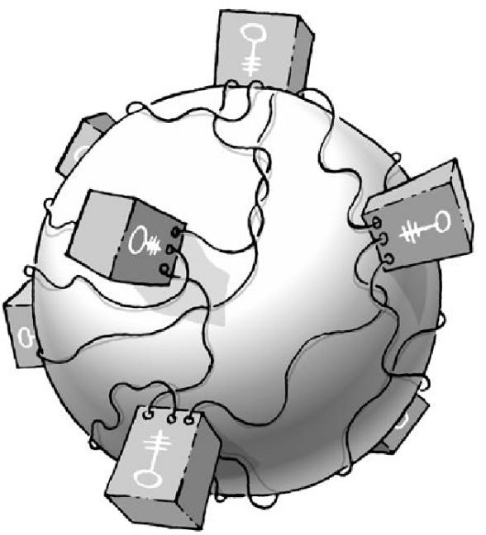

**X.509 certificate servers** are generally made available by the certificate authorities via LDAP andare sometimes also described as directory services for X.509 certificates.



100

The Gpg4win Compendium 3.0.0



Chapter 16. The certificate server

**16.1. Key server configuration**

Open the configuration dialog in Kleopatra:

Settings ! Configure Kleopatra...

Now set up a new certificate server under the group Directory Services by clicking on the New button.

Select between OpenPGP or X.509.

In OpenPGP, a default OpenPGP certificate server with the server address hkp://keys.gnupg.net (Port: 11371, Protokoll: hkp) will be added to the list. You can use this server without making any changes – or you can use one of the suggested OpenPGP server addresses on the next page.

For X.509 you will see the following default settings for an X.509 certificate server: (Protokoll: ldap,

Servername: server, Server-Port: 389). Complete the information on the server name and basic DN of your X.509 certificate server and check the server port.

If your certificate server requires a user name and password, activate the option Requires user authenti-cation and enter the required information.

The screenshot below shows a configured OpenPGP certificate server:

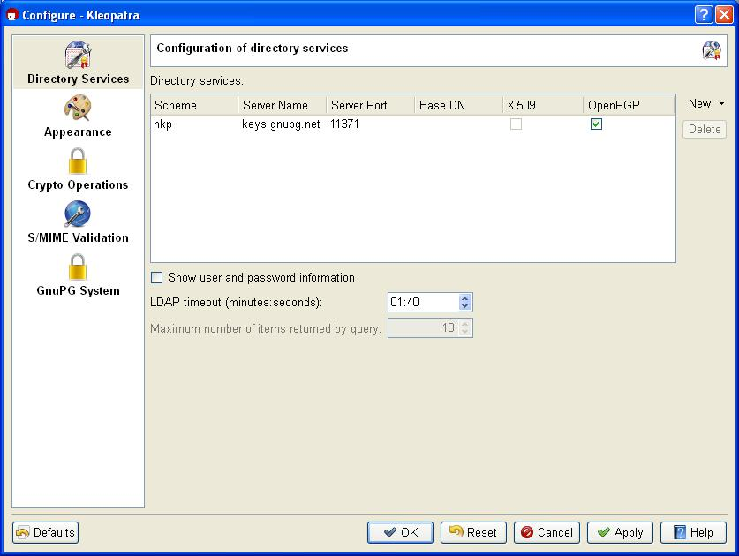

Confirm the configuration by pressing [ OK ]. You have successfully configured your certificate server.

To ensure that you have correctly configured the certificate server, it is helpful to start e.g. a certificate search on the server (for instructions, see Section 16.2).

101

The Gpg4win Compendium 3.0.0



Chapter 16. The certificate server

Proxy setting: If you use a proxy in your network, you need to configure it in the file:

%APPDATA%\gnupg\gpg.conf

To enable the proxy add a new line with the content:

keyserver-options http-proxy=<proxy-adresse>

Explanations regarding the system-wide configuration of X.509 key servers can be found in Sec-tion 22.5.

**OpenPGP certificate server addresses**

We recommend that you only use up-to-date OpenPGP certificate servers, since only they can handle the newer OpenPGP characteristics.



Here is a selection of well-functioning certificate servers:

hkp://blackhole.pca.dfn.de hkp://pks.gpg.cz

hkp://pgp.cns.ualberta.ca hkp://minsky.surfnet.nl

hkp://keyserver.ubuntu.com hkp://keyserver.pramberger.at http://keyserver.pramberger.at http://gpg-keyserver.de

If you have problems with your firewall, it is best to try certificate servers whose URL begins with:

http://

The certificate servers under the addresses

hkp://keys.gnupg.net (Kleopatra pre-selection, see screenshot on previous page) hkp://subkeys.pgp.net

are a collection point for an entire network of these servers; a concrete server will be selected randomly.

Attention: Do not use ldap://keyserver.pgp.com as a certificate server, since it does synchro-

nize with other servers (Status: May 2010).

102

The Gpg4win Compendium 3.0.0



Chapter 16. The certificate server

**16.2. Search and import certificates from certificate servers**

Once you have configured at least one certificate server, you can now look for and import certificates.

To do this, in Kleopatra click on File!Search for certificates on server....

You will see a search dialog with an input field into which you can enter the name of the certificate holder – or ideally – the e-mail address of his certificate.

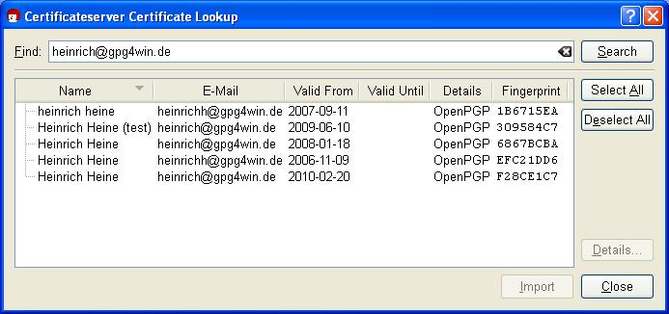

To view the details of a selected certificate, click on the button [ Details... ].

If you wish to add one of the certificates you have found into your local certificate collection, select the certificate from a list of search results and click on [ Import ].

Kleopatra will subsequently display a dialog with the import results. Confirm with [ OK ].

If the import was successful, you will see the selected certificate in Kleopatra’s certificate administra-tion.

**16.3. Export certificates to OpenPGP certificate servers**

If you have configured an OpenPGP certificate server as described in Section 16.1, a click of your mouse will send your public OpenPGP certificate around the world.



Select your OpenPGP certificate in Kleopatra and then click on the menu item File!Export certificate to server....

You only need to send your certificate to any of the available OpenPGP certificate servers, since almost all of these will synchronize on a global level. It may take one to two days until your OpenPGP certificate is actually available worldwide, but then you will have a “global" certificate.

If you export your certificate without first having configured an OpenPGP certificate server, Kleopatra will suggest the default server hkp://keys.gnupg.net.

103

**17. Encrypting file attachments**

If you want to send an encrypted e-mail and attach files, you generally also want your attachments to be encrypted.

Where GnuPG is well integrated into your e-mail program, attachments should be treated just like the actual text of your e-mail, hence they should be signed, encrypted or both.

GpgOL automatically assumes the encryption and signing of attachments.

In the case of encryption tools that are not as well integrated into an e-mail program, you have to be careful: Attachments are often sent along in uncrypted form.

What to do in such a case? Easy: you encrypt the attachment separately and then attach it to the e-mail.

Therefore this is no different from simply encrypting files, as described in Chapter 18.

104

**18. Signing and encrypting files**

You can use Gpg4win for signing and encrypting not just e-mails, but also individual files. The principle is the same:

You sign a file using your private certificate, to ensure that the file cannot be modified.

Then encrypt the file using a public certificate, to prevent unauthorized persons from seeing it.

Using the application GpgEX, you can sign or encrypt files out of Windows Explorer – with both OpenPGP or S/MIME. This chapter shows you exactly how this works.

If you are sending a file as an e-mail attachment, e.g. GpgOL will automatically look after signing and encrypting your file together with your e-mail. You do not have to do anything else.

105

The Gpg4win Compendium 3.0.0



Chapter 18. Signing and encrypting files

**18.1. Signing and checking files**

When signing a file, you are mainly concerned about making sure it is not changed, rather than keeping it secret (Integrity).

Signing is very easy using GpgEX from the Windows Explorer context menu. Select one or more files or folders and use the right mouse key to select the context menu:

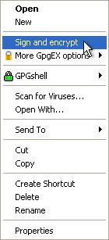

You will see the Sign and encrypt menu.

106

The Gpg4win Compendium 3.0.0



Chapter 18. Signing and encrypting files

In the following window, select the option Sign:

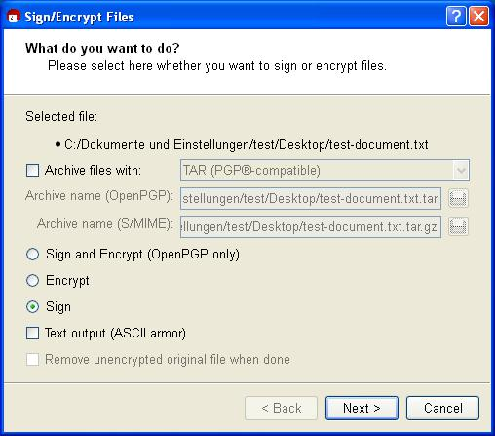

If required, you can also use the option Output as text (ASCII armor). The signature file will receive the file ending .asc (OpenPGP) or .pem (S/MIME). These file types can be opened with any text editor – you will however only see the numbers and letters you have already seen before.

If this option is not selected, the signature will be created with the ending .sig (OpenPGP) or .p7s (S/MIME). These files are binary files, and they cannot be viewed in a text editor.

Then click on [ Next ].

107

The Gpg4win Compendium 3.0.0



Chapter 18. Signing and encrypting files

In the following dialog – if not already selected by default – select your private (OpenPGP or S/MIME) certificate with which you want to sign the file.

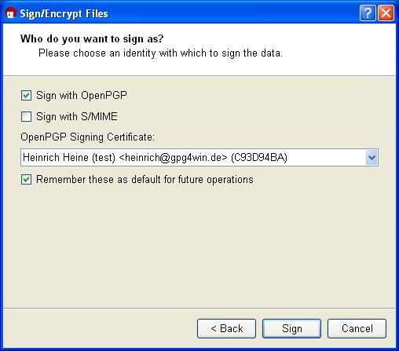

Now confirm your selection with [ Sign ].

Enter your passphrase in the pin entry dialog.

108

The Gpg4win Compendium 3.0.0



Chapter 18. Signing and encrypting files

Once the signing process has completed successfully, the following window appears:

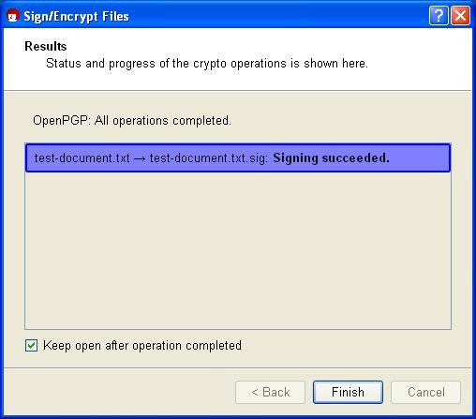

You have now successfully signed the file.

A “separate” signature is always used to sign a file. That means that your file that is to be signed will remain unchanged and a second file with the actual signature will be created. To verify the signature later on, you will need both files.

The example below shows which new file you will receive if you sign your selected file (here <dateiname>.txt) using OpenPGP or S/MIME. There are four possible resulting file types:

**OpenPGP:**

<filename>.txt ! <filename>.txt**.sig**

<filename>.txt ! <filename>.txt**.asc** (output as text/ASCII-armor)

**S/MIME:**

<filename>.txt ! <filename>.txt**.p7s**

<filename>.txt ! <filename>.txt**.pem** (output as text/ASCII-armor)

109

The Gpg4win Compendium 3.0.0



Chapter 18. Signing and encrypting files

**Checking a signature**

Now check the integrity of the file that has just been signed, i.e. check that it is correct!

To check for integrity and authenticity, the signature file – hence the file with the ending .sig, .asc, .p7s or .pem – and the signed original file (original file) must be in the same file folder. Select the signature file and select the entry Decrypt and check from the Windows Explorer context menu:

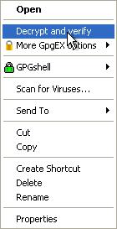

110

The Gpg4win Compendium 3.0.0



Chapter 18. Signing and encrypting files

You will see the following window:

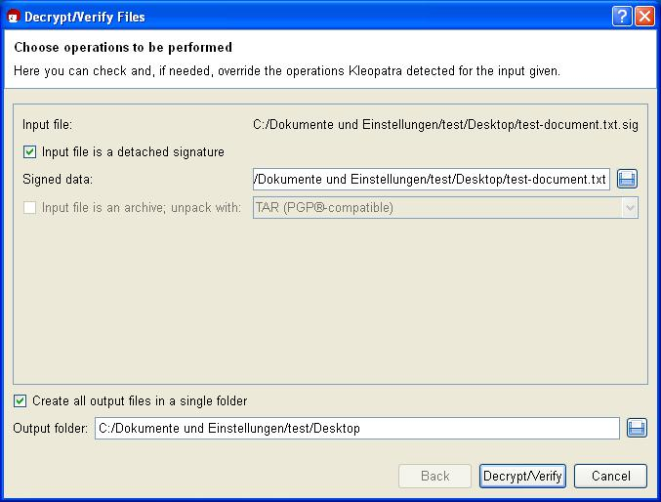

Under Enter file, Kleopatra shows the full path to your selected signature file.

The option Input file is a separate signature is activated since you have signed your original file (here: Signed file) with the input file. Kleopatra will automatically find the associated signed original file in the same file folder.

The same path is also automatically selected for the Ouput folder. It only becomes relevant however once you are processing more than one file simultaneously.

Confirm the operations with [ Decrypt/Check ].

111

The Gpg4win Compendium 3.0.0



Chapter 18. Signing and encrypting files

Following a successful check of the signature, the following window appears:

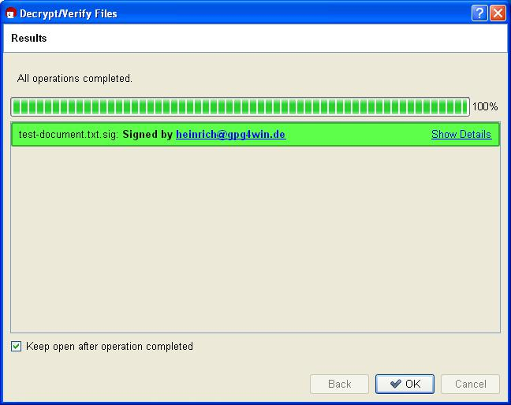

The result shows that the signature is correct – therefore you can be sure that the file’s integrity has been preserved and therefore the file has not been modified.

112

The Gpg4win Compendium 3.0.0



Chapter 18. Signing and encrypting files

Even if only one character is added to the original file, or is deleted or modified, the signature will be shown as having been broken (Kleopatra displays the result as a red warning):

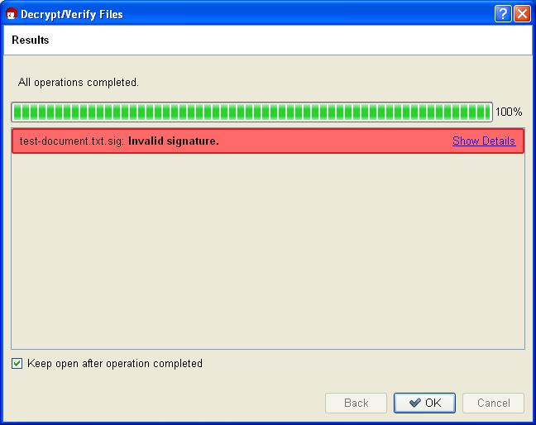

113

The Gpg4win Compendium 3.0.0



Chapter 18. Signing and encrypting files

**18.2. Encrypting and decrypting files**

Files can be signed and encrypted just like e-mails. You should practice it once more in the following section using GpgEX and Kleopatra.

Select one (or more) file(s) and open the context menu using your right mouse key:



Select Sign and encrypt again.

114

The Gpg4win Compendium 3.0.0



Chapter 18. Signing and encrypting files

You will see the already familiar dialog from signing a file (see also section 18.1).

In the top field, select the option Encrypt:

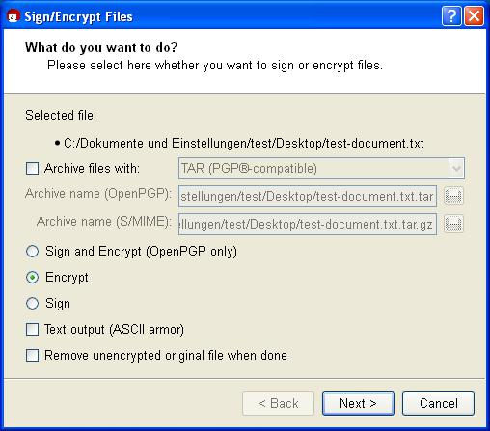

You should only change the encryption settings if this is required:

**Output as text (ASCII armor):** When you activate this option, you will obtain the encrypted filewith the file ending .asc (OpenPGP) or .pem (S/MIME). These file types can be opened with any text editor – but you will only see the mixture of letters and characters you have already seen before.

If this option is not selected, the system will create an encrypted file with the ending .gpg (OpenPGP) or .p7m (S/MIME). These files are binary files, so they cannot be viewed with a text editor.

**Delete unencrypted original:** If this option is activated, the selected original file will be deletedafter encryption.

Click on [ Next ].

115

The Gpg4win Compendium 3.0.0



Chapter 18. Signing and encrypting files

Who should the file be encrypted for? Select one or more recipient certificates in the next dialog:

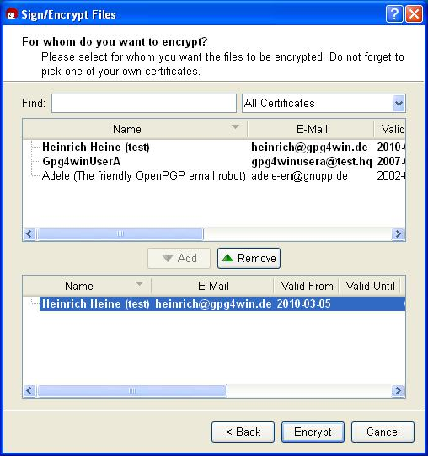

To make your selection, choose the required certificates in the top portion and press [ Add ]. You will see all selected certificates in the lower dialog portion for review purposes.

Depending on the selected recipient certificate and its type (OpenPGP or S/MIME), your file is then encrypted using OpenPGP and/or S/MIME. So if you selected an OpenPGP certificate and an S/MIME certificate, you will receive two encrypted files. The possible file types for the encrypted files are found on the next page.

Now click on [ Encrypt ]: The file is encrypted.

116

The Gpg4win Compendium 3.0.0



Chapter 18. Signing and encrypting files

After a successful encryption, the results window should look something like this:

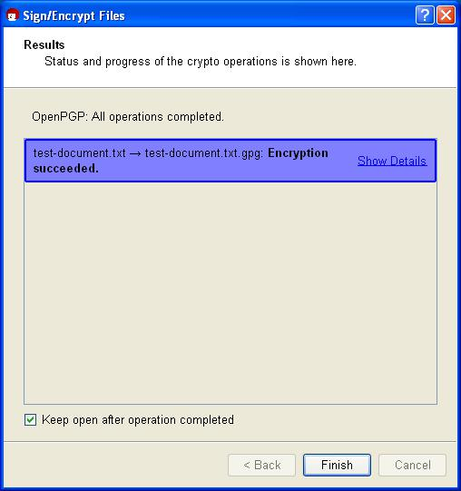

That’s it! You have successfully encrypted your file!

Similar to signing a file, the result will depend on the selected encryption method (OpenPGP or S/MIME). An encryption of your original file (here <filename>.txt) can result in four possible file types:

**OpenPGP:**

<filename>.txt ! <filename>.txt**.gpg**

<filename>.txt ! <filename>.txt**.asc** (for output as text/ASCII-armor)

**S/MIME:**

<filename>.txt ! <filename>.txt**.p7m**

<filename>.txt ! <filename>.txt**.pem** (for output as text/ASCII-armor)

You now forward one of these four possible encrypted files to your selected recipient. In contrast to signing a file, the unencrypted original file is of course not forwarded.

117

The Gpg4win Compendium 3.0.0



Chapter 18. Signing and encrypting files

**Decrypting a file**

Now you can decrypt the previously encrypted file for test purposes.

To this end, you should also have encrypted to your own certificate during the previous encryption process – otherwise you cannot decrypt the file with your private key (see Chapter 14).

Select the encrypted file – hence one that ends with .gpg, .asc, .p7m or .pem – and select the entry

Decrypt and check in the Windows Explorer context menu:



118

The Gpg4win Compendium 3.0.0



Chapter 18. Signing and encrypting files

If you like, you can still change the output folder in the following decryption dialog.

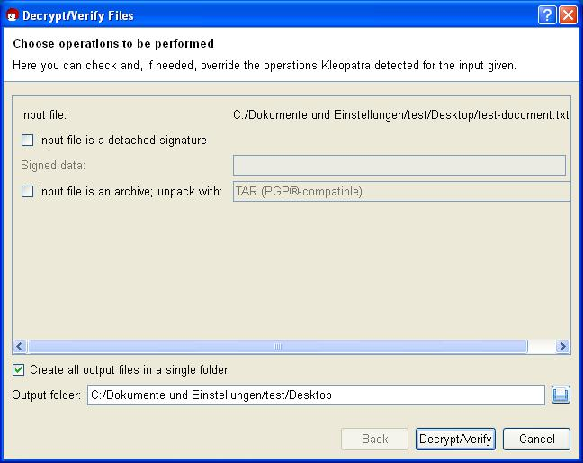

Click on [ Decrypt/Check ].

Then enter your passphrase.

119

The Gpg4win Compendium 3.0.0



Chapter 18. Signing and encrypting files

The result shows that the decryption was successful:

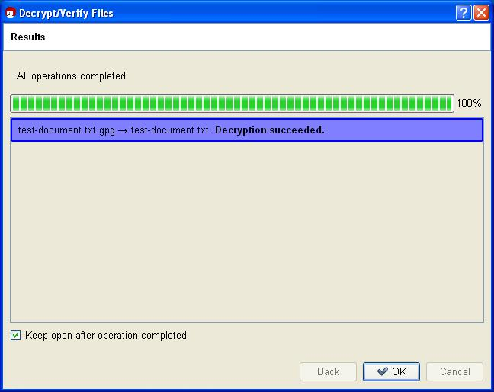

You should now be able to easily read the decrypted file or use it with a corresponding program.

120

The Gpg4win Compendium 3.0.0



Chapter 18. Signing and encrypting files

**In short**

You have learnt how to do the following using GpgEX:

sign files

check signed files encrypt files

decrypt files

**Simultaneous encryption and signature**

You have probably already noticed this option in the corresponding dialogs. If you select it, GpgEX will combine both tasks in one step.

Please ensure that signatures are applied first, before the encryption process.

The signature is therefore always encrypted at the same time. It can only be viewed and checked by those who have successfully decrypted the file.

If you want to sign and encrypt the file, you can only do it with OpenPGP at this time.

121

1. **Importing and exporting a private certificate**

Chapters 8 and 10 explained the import and export of certificates. You exported your own certificate in order to publish it, and you have imported the certificate of your correspondence partner and thus attached it to your “key ring” (i.e. accepted it into your certificate administration).

This process always referred to public keys. However, sometimes it is also necessary to import or export a private key. For example, if you wish to continue to use an already existing (OpenPGP or S/MIME) key pair with Gpg4win, you have to import it. Or, if you want to use Gpg4win from another computer, the entire key pair has to be transferred to that computer – the public and private key.

122

The Gpg4win Compendium 3.0.0



Chapter 19. Importing and exporting a private certificate

**19.1. Export**

You must make up a backup copy using Kleopatra anytime you transfer a private certificate to another computer or want to save it to another hard drive partition or backup medium.

You may have already set up such a backup copy at the end of your OpenPGP certificate creation process. Since your OpenPGP certificate may have received additional authentications in the meantinme, you should back it up again if applicable.

Open Kleopatra, select your own certificate click on File!Export private certificate.



Select the path and the file name of the output file. The file type is set automatically. Depending on whether you want to export a private OpenPGP or S/MIME key, the file ending .gpg (OpenPGP) or .p12 (S/MIME)will be selected by default. These are binary files which contain your encrypted certificate (including the private key).

When you activate the option ASCII-protected (ASCII armor), the file ending .asc (OpenPGP) or .pem (S/MIME) will be selected. These file types can be opened with any text editor – but you will only see the "mess" of numbers and characters that we have already seen before.

If this option is not selected, an encrypted file with the ending .gpg (OpenPGP) or .p12 (S/MIME) will be created. These files are binary files, so they cannot be viewed with a text editor.

Kleopatra stores both key parts – private and public – in one private certificate.

Attention: Please handle this file very carefully. It contains your private key and therefore information that is critical to security!

123

The Gpg4win Compendium 3.0.0



Chapter 19. Importing and exporting a private certificate

**19.2. Import**

To import your previously exported private certificate into Kleopatra, proceed as you would for importing other public certificates (see Chapter 10):

Click on File!Import certificate... and select the file to be imported. If it concerns a PKCS12 file (e.g.

type .p12), the system will first ask you for a passphrase to unlock the private key:

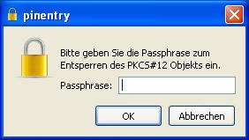

Now enter the prassphrase – which could also be a new one – that is used to protect your private key after the import is complete:

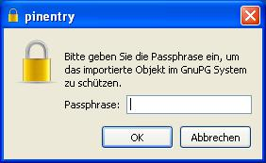

Repeat the passphrase entry. If your passphrase is too short or consist only of letters, the system will give you a corresponding warning.

124

The Gpg4win Compendium 3.0.0



Chapter 19. Importing and exporting a private certificate

Following a successful import, an information window displaying the results of the import process will appear; here is an example of a private OpenPGP certificate:

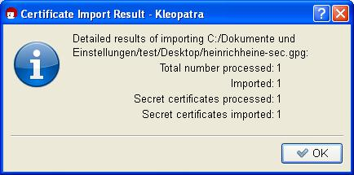

Kleopatra has imported both the private as well as the public key from the backup file. Your certificate can be found in “My certificates” in Kleoatra’s certificate administration.

Please also save the backup copy of your private certificate – if possible on a physically secured (e.g. in a vault) external medium. Then delete it from your hard drive and also remember to remove the deleted file from your “recycling bin”. Otherwise this file poses a great security risk for your secret e-mail encryption.

There may be cases when you are not able to import a certificate exported with PGP (“Pretty Good Privacy”). This is because some PGP versions use an algorithm (IDEA) which cannot be supported by GnuPG for legal reasons.



To take care of this problem, simply change the passphrase in PGP and export/import the OpenPGP certificate again. If this also does not work, set the passphrase in PGP to “empty”, that is, no protection, and export/import again – in this case you must ensure that you have securely deleted the file and then set up a new real passphrase in PGP and Gpg4win.

Congratulations! You have successfully exported and reimported your key pair.

125

1. **System-wide configuration and pre-population for S/MIME**

As part of a central software distribution or environments in which many users are working on one computer, it makes sense to set up some system-wide specifications and pre-populations for Gpg4win.



This relates particularly to S/MIME, because in the case of specified chains of trust it makes sense that users share the information.

Some typical system-wide settings include:

**Trustworthy root certificates:** To avoid a situation where each user must search and install therequired root certificates, and check and authenticate the trustworthiness of the same (see Section 22.7), it is useful to install a system-wide pre-population of the most important root certificates.

To this end, the root certificates should be saved – as described in Section 22.3 – and the trustworthy root certificates should be defined – as described in Section 22.6.

**Directly available CA certificates:** To save users from searching and importing the certificates ofcertificate authorities, it also makes sense to pre-populate the system with the most important CA certificates. For a description, see Section 22.4.

**Proxy for certificate server and certificate revocation list searches:** With respect to valid-ity information, X.509 protocols offer different options. Most certification agencies publish certificate revocation lists (also described as CRLs , supported as per RFC5280) and OSCP (as per RFC2560). OSCP has more recent information, but with the disadvantage that network traffic occurs all the way to the OSCP service, and it is therefore possible to see with whom messages are being exchanged. GnuPG can work with both options; component “DirMngr” that runs as the system-wide service.

Internal networks cannot permit individual computers to directly connect to the outside (central firewall), but can provide an acting service, a so-called “proxy”. DirMngr can also handle HTTP and LDAP proxies .

S/MIME certificates usually contain information on where your certificate revocation list can be picked up externally. Oftentimes it includes HTTP, but also directory services via LDAP. In contrast to OpenPGP, the client cannot pick where to pick up the certificate revocation list, but has to follow the available information. Since some certificates only provide certificate revocation lists via LDAP, it is necessary to allow both HTTP as well as LDAP queries to the outside. If possible, an acting service can ensure, at the content level, that only X.509 certificate revocation lists with correct information are transmitted.

If your network requires a proxy for the HTTP and HKP or LDAP queries required for OpenPGP or S/MIME, please follow these steps:

1. Set the X.509 certificate server search to a proxy, as described in Section 22.5.

126

The Gpg4win Compendium 3.0.0



Chapter 20. System-wide configuration and pre-population for S/MIME

1. Set the certificate revocation list search to a proxy, also described in Section 22.5.
2. Restart the DirMngr (see Section 21.7).

127

**21. Known problems and help**

**21.1. GpgOL menus and dialogs no longer found in Outlook**

It may happen that the menus and dialogs added to Outlook by GpgOL can no longer be found.

This may be due to a technical problem that caused Outlook to deactivate the GpgOL component.

Reactivate GpgOL via the Outlook menu:

Outlook2007: ?!Deactivated components

Outlook2003: ?!Info!Deactivated components

To (de)activate GpgOL manually, use Outlook’s add-in manager:

Outlook2003: Extras!Options!Other!Advanced options... ! Add-In manager...

Outlook2007: Extras!Trust relations Center!Add-Ins – then select Exchange - Client exten-sions under Manage and click on [ Go to... ].

**21.2. GpgOL buttons are not on the Outlook 2003 toolbar**

If there are already a lot of buttons on the toolbar of the message window, Outlook 2003 will not necessarily display GpgOL’s signature/encryption icons.

You can display these buttons by clicking on the small icon with the arrow pointing downwards on the tool bar (Options for toolbar): You will see an overview of all non-displayed buttons. Clicking on an entry will move it into the visible area of the toolbar.

**21.3. GpgOL button are listed unter “Add-Ins” (Outlook 2007)**

Outlook 2007 introduced the so-called “ribbon” interface. This multi-functional bar in the Outlook message window has different tabs. The GpgOL buttons (for encryption, signatures etc.) are organised under the “Add-Ins” tab; Outlook saves all buttons of extensions in that location. It is not possible to integrate the GpgOL buttons under “Messages”, for example.

You can adjust your tool bar for quick access and add the toolbar commands of the Add-Ins tab.

**21.4. Errors when starting GpgOL**

If you have first installed Gpg4win (and hence the GpgOL program component) on a drive, then uninstalled it and re-installed it on another drive? If yes, it is possible that Outlook will continue to search for the GpgOL path on the first (old) drive.

128

The Gpg4win Compendium 3.0.0



Chapter 21. Known problems and help

This means that the GpgOL program extension is no longer started when Outlook starts, and the following error message appears:

The extension ’<old path to gpgol.dll>’ could not be installed or loaded. The problem can be solved by using ’Detect and repair’ in Help, among other things.

You can solve this problem by resetting the internal Outlook (cached) program extension path. To do this, please delete the following file:

%APPDATA%\Lokale Einstellungen\Application data\Microsoft\ Outlook\extend.dat

Outlook should not be running during this process. Then restart Outlook, and it should work fine with GpgOL.

**21.5. Installation of Gpg4win on a virtual drive**

Please note that it is not possible to install Gpg4win on a virtual drive simulated with the command subst. These virtual drives can only be used locally by the current user. System services, such as DirMngr, do not see these drives. Therefore the installation path is not valid – the installation will stop with error type error:StartService: ec=3. Please install Gpg4win on a drive that is available across the system.

**21.6. GpgOL does not check “CryptoEx” InlinePGP e-mails**

To check or decrypt signed or encrypted InlinePGP e-mail(s) sent by the Outlook program extension “CryptoEx”, S/MIME support must be activated in the GpgOL options.

Make sure that the following option is active in Outlook under Extras!Options!GpgOL:

Activate S/MIME support.

129

The Gpg4win Compendium 3.0.0



Chapter 21. Known problems and help

**21.7. Does not allow S/MIME operations (system service “DirMngr” not running)**

The “Directory Manager” (DirMngr) is a service installed by Gpg4win, which manages access to certificate servers. One task of the DirMngr is to load certificate revocation lists (CRLs) for S/MIME certificates.



It is possible that S/MIME operations (signature creation and check, encryption and decryption) cannot be performed because DirMngr is not available. Therefore Gpg4win default settings must ensure that DirMngr checks the revocation lists – if this is not done, the operation cannot be performed, since it means the potential use of a compromised certificate.

To address this problem, the system administrator restarts DirMngr. This is done via System control!Administration!Services. You will see DirMngr in the list – and the service can be restarted via the context menu.

**21.8. S/MIME operations not allowed (CRLs not available)**

It is possible that S/MIME operations (signature creation and check, encryption and decryption) cannot be performed because the CRLs are not available. Therefore Gpg4win default settings must ensure that revocation lists are checked – if this is not done, the operation cannot be performed, since it means the potential use of a compromised certificate.



Help is provided by setting up an acting service (“proxies”)for picking up revocation lists (see Section 22.5).

In an emergency (or for testing purposes, CRL checks can also be turned off. To do this, open the Kleopatra menu Settings!Set up Kleopatra and then the group S/MIME check. Activate the option Never consult recovation lists.

Attention: Be aware that this also means that you run a higher risk of using a compromised certificate.

Turning off the revocation list check is never a substitute for setting up a proxy.

130

The Gpg4win Compendium 3.0.0



Chapter 21. Known problems and help

**21.9. S/MIME operations not allowed (root certificate is not trustworthy)**

The respective root certificate must be trusted for a full review of X.509 certificate chains. Otherwise it is not possible to perform S/MIME operations (signature creation and check, encryption and decryption).



To express your trust in a root certificate, you have two options.

Write the fingerprint of the corresponding root certificate in a system-wide configuration file. Now the root is trustworthy for all users. To do this, you must have Windows administrator rights. For a detailed description, see Section 22.6.

Root certificate set by user (no system-wide adjustment required). To do this, you must mark the option Allow marking of root certificates as trustworthy in Kleopatra’s settings. After that, every time you import a new root certificate, you will be asked whether you trust it. For more details, see Section 22.7.

131

**22. Files and settings in Gpg4win**

**22.1. Personal user settings**

The personal settings for each user are found in the file folder:

%APPDATA%\gnupg

Often, this is the following folder:

C:\Documents and settings\<name>\Application data\gnupg\

Please note that this is a hidden file folder. To make it visible, you have to activate the option Show all files and folders under the group Hidden files and folders in the tab View of the Explorer Extras!Folder options menu

This file folder contains all personal GnuPG data, hence private keys, certificates, trust settings and configurations. This folder is not deleted when Gpg4win is uninstalled. Please ensure that you make regular backup copies of this folder.

**22.2. Cached certificate revocation lists**

The system-wide service Mngr (Directory Manager) also checks whether an X.509 certificate is blocked and can therefore not be used. To this end, certificate revocation lists (CRLs) are picked up from the issuing offices for the certificates (CAs) and cached for the duration of the validity period.



The lists are saved under:

C:\Documents and Settings\LocalService\Lokale Settings\Application data\ GNU\cache\dirmngr\crls.d\

These are protected files, which Explorer does not display by default. However, if you wish to show these files, deactivate the option Hide protected system files in the Window Explorer View settings.

No changes should be made to this file folder.

132

The Gpg4win Compendium 3.0.0



Chapter 22. Files and settings in Gpg4win

**22.3. Trustworthy root certificates from DirMngr**

For a full review of X.509 certificates, you must trust the root certificates which were used to sign the revocation lists.



The root certificates which the DirMngr should trust across the entire system when performing its checks are stored in the following file folder:

C:\Documents and settings\All Users\Application data\ GNU\etc\dirmngr\trusted-certs\

Important: The corresponding root certificates must be available as files in DER format in the above file folder, with the file name .crt or .der.

The DirMngr runs as a system-wide service and must be restarted if changes have been made to the “trusted certs” file folder. Afterwards, the root certificates saved in this folder are set to trustworthy for all users.

Please also see Section 22.6 in order to completely trust root certificates (system-wide).

**22.4. Other certificates from DirMngr**

Since the X.509 certificate chain must be checked prior to a cryptography operation, the corresponding certificate of the authentication instance (“Certificate Authority”, CA) must also be checked.



For immediate availability, CA certificates can be saved in this (system-wide) file folder:

C:\Documents and settings\All Users\Application data\ GNU\lib\dirmngr\extra-certs\

Certificates that are not available here and/or not available from users must automatically be loaded by X.509 certificate servers.

These CA certificates can also be imported manually by a user however.

It makes sense to store the most important CA certificates in this folder as part of system-wide specifications.

133

The Gpg4win Compendium 3.0.0



Chapter 22. Files and settings in Gpg4win

**22.5. System-wide configuration for use of external X.509 certificate servers**

GnuPG can be configured in such a way that allows the system to search for missing X.509 certificates or certificate revocation lists on external X.509 certificate servers (see also Chapter 20).



To conduct a X.509 certificate search, the system service DirMngr uses a list of certificate servers which can be entered in the file

C:\Documents and settings\All Users\Application data\ GNU\etc\dirmngr\ldapservers.conf

These certificate servers are used for all users (system-wide). In addition, users can also set up additional user-specific certificate servers for certificate searches – e.g. directly via Kleopatra (see Chapter 16.1).

The exact syntax for certificate server entries in the aforementioned configuration file is as follows:

HOSTNAME:PORT:USERNAME:PASSWORD:BASE_DN

If access to external X.509 certificate servers is blocked by firewalls in the internal network, it is also possible to configure a proxy service in ldapservers.conf for transmitting the certificate search, as illustrated in the following sample line:

proxy.mydomain.example:389:::O=myorg,C=de

With respect to a search of Certificate Revocation Lists (CRLs), the same directory contains a configuration file from:

C:\Documents and settings\All Users\Application data\ GNU\etc\dirmngr\dirmngr.conf

Please note that only administrators can write in this file.

You can add the following proxy options to this configuration file (each option in a row):

http-proxy HOST[:PORT] This option uses HOST und PORT for accessing the certificate server. The environment variable http_proxy will be overwritten if this option is activated.

Example:

http-proxy http://proxy.mydomain.example:8080

ldap-proxy HOST[:PORT] This option uses HOST und PORT for accessing the certificate server. If no port number is listed, the standard LDAP port 389 will be used. This option will overwrite the LDAP URL contained in the certificate, or will use HOST andPORTif no LDAP URL has been entered.

only-ldap-proxy This option ensures that DirMngr only uses the proxy configured under ldap-proxy. Because otherwise DirMngr will try to use other configured certificate servers, if the connection via ldap-proxy is not successful.

134

The Gpg4win Compendium 3.0.0



Chapter 22. Files and settings in Gpg4win

**22.6. System-wide trustworthy root certificates**

The pre-populated root certificates which are deemed as trustworthy for the entire system are defined in the



C:\Documents and settings\All Users\Application data \GNU\etc\gnupg\trustlist.txt file.

To mark a root certificate as trustworthy, the corresponding fingerprint of the certificate, followed by an empty space and a large S must be entered into the above file. A certificate is explicitly marked as not trustworthy if the row beings with the prefix “!”. You can also enter multiple root certificates. In that case, please ensure that each fingerprint is located in a new row. A row that begins with # will be treated as a comment and ignored.

Important: The end of the file must be followed by an empty row.

An example:

* CN=Wurzel ZS 3,O=Intevation GmbH,C=DE A6935DD34EF3087973C706FC311AA2CCF733765B S
* CN=PCA-1-Verwaltung-02/O=PKI-1-Verwaltung/C=DE DC:BD:69:25:48:BD:BB:7E:31:6E:BB:80:D3:00:80:35:D4:F8:A6:CD S
* CN=Root-CA/O=Schlapphuete/L=Pullach/C=DE !14:56:98:D3:FE:9C:CA:5A:31:6E:BC:81:D3:11:4E:00:90:A3:44:C2 S

In some cases it is useful to reduce the criteria for checking the root certificate. To do this, you can set an additional flag relax after the S: <FINGERPRINT> S relax

Important: Using relax reduces the level of security, so it needs to be decided on a case-by-case basis and should only be used in the case of problems.

For more details, see current GnuPG documentation (item “trustlist.txt”):

<http://www.gnupg.org/documentation/manuals/gnupg/Agent-Configuration.html>

Therefore the exact syntax for entries in trustlist.txt is as follows:

[!]<FINGERABDRUCK> S [relax]

whereby ! and relax are optional.

Instead of the flag S, the values P and * are also provided, which are reserved for future use.

Important: To fully mark root certificates as trustworthy in Kleopatra (certificate is highlighted in blue), the root certificates must also be stored for the DirMngr, as described in Section 22.3.

135

The Gpg4win Compendium 3.0.0



Chapter 22. Files and settings in Gpg4win

**22.7. User marking of trustworthiness of root certificates**

Root certificates can also be marked as trustworthy by individual users – this means that a system-wide configuration (see Section 22.3 and 22.6) is then not required.



Open the Kleopatra menu Settings!Configure Kleopatra and then the groupo S/MIME check. Then activate the option Allow root certificates to be marked trustworthy. Now, if you are using a root certificate that has not been previously marked as trustworthy, the system will ask you whether you wish to classify it as trustworthy. Please ensure that the gpg-agent may have to be restarted before a change takes effect (e.g. by logging in and out).

The root certificates which you have marked as trustworthy (or explicitly marked as non-trustworthy)

are automatically stored in the following file:

C:\Dokumente und Einstellungen\<Nutzername>\ Application data\gnupg\trustlist.txt

The same syntax applies to trustlist.txt as described in Section 22.6.

136

1. **Detecting problems in Gpg4win programs (log files)**

It is possible that one of the Gpg4win program components does not work as expected.

Quite often this is due to a feature related to the work environment, which Gpg4win software developers are not able to detect.

To assist them with finding the problem, or to allow users to see the detailed technical processes, Gpg4win programs also offer help.

Usually though, this type of help must first be activated. One of the most important tools are log files: This is where detailed diagnostic information on internal technical processes is stored. By looking at a log file, a software developer can often quickly detect a problem and the possible solution, even if the program may seem very complex at the beginning.

If you wish to send an error report to the software developer, you may this information helpful:

<http://gpg4win.org/reporting-bugs.html>

Log files – described as „debug information” in the above-mentioned URL – frequently offer valuable information and should therefore be attached to an error report.

This chapter describes how to activate program process information (which is what log files essentially are) for individual Gpg4win programs.

137

The Gpg4win Compendium 3.0.0



Chapter 23. Detecting problems in Gpg4win programs (log files)

**23.1. Activating Kleopatra log files**

Kleopatra log data consists of many files, therefore the first step is to create a file folder for the log files, for example: C:\TEMP\kleologdir

Please note that these are user settings, not system administrator settings. Therefore the settings must be made for each user who wants to create Kleopatra log data, and you must ensure that different kleologdir file folders are used.

The path to this folder must be noted in the new environment variables KLEOPATRA_LOGIDR:

To do this, open the control panel, choose System, then the tab Advanced and finally the button

* Environment variables ].

Add the following new user variable:

Name of variable: KLEOPATRA_LOGDIR

Value of variable: C:\TEMP\kleologdir

Make sure that the entered file folder actually exists. You can also create it afterwards.

To ensure the log function goes into effect, Kleopatra must be shut down and restarted, the file folder of log data must exist and must be available for Kleopatra to write on.

While Kleopatra is used, it will record process information in the file kleo-log (main log file) as well as possibly many files with a name that following this pattern:

pipe-input-<TIME STAMP>-<RANDOM CHARACTER>

It may be that this information is not enough for a software developer to detect the error. He will then ask you to create another environment variable – just as you did earlier:

Name of variable: KLEOPATRA_LOGOPTIONS

Value of variable: all

It is possible that the log files become very big very quickly. You should activate the log function only for provoking a specific error function and hence record it.

You can then turn the log function off again by deleting the environment file or slightly varying its name (so it can be easily reactivated later on). Do not forget to delete or move the log files, especially if they have become very large or there are a lot of files. It also makes sense to remove the log files before you start a new recording.

138

The Gpg4win Compendium 3.0.0



Chapter 23. Detecting problems in Gpg4win programs (log files)

**23.2. Activating GpgOL log files**

To activate a GpgOL log file, you have to start a “Registry Editor". To do this, enter the command regedit under Start!Execute or into an input request field.

Now select the following GpgOL key from the tree structure on the left hand side:

HKEY_CURRENT_USER\Software\GNU\GpgOL

On the right hand side you will see a list of entries (so-called character sequences), some of which already have pre-defined values. These entries are created when Outlook is first started with GpgOL.

To activate the GpgOL log file, double-click on the entry enableDebug and set this value to 1.

To set a value for logFile, enter the name of the file into which the log file should be written, for example: C:\TEMP\gpgol.log

Restart Outlook to start the recording process.

Remember that this file can become very large. Set enableDebug to 0 as soon as you no longer require the GpgOL log data recordings.

Also do not forget to delete or move the log file, especially if it has become a very large file. Before starting a new recording, it also makes sense to remove the log file.

More advanced technical information on GpgOL – such as more possible values for enableDebug – can be found in the technical (English) GpgOL handbook. It can be found in your Gpg4win installation directory, usually:

C:\Programme\GNU\GnuPG\share\doc\gpgol\gpgol.pdf

139

The Gpg4win Compendium 3.0.0



Chapter 23. Detecting problems in Gpg4win programs (log files)

**23.3. Activating DirMngr log file**

The DirMngr is a system-wide service, therefore log files can only be activated with administrator rights.

To activate the log file, open the following configuration file:

C:\Documents and settings\All Users\Application data\ GNU\etc\dirmngr\dirmngr.conf

Add the following two rows in the configuration file (the path to the log file can of course be adjusted):

debug-all

log-file C:\TEMP\dirmngr.log

Then restart DirMngr under System controls!Administration!Services so that the modified configu-ration file is reimported and the new settings become active.

Comment out your adjustment in the aforementioned configuration file (hence # debug-all) as soon as you no longer need the DirMngr log file recording.

Also do not forget to delete or move the log file, especially if it has become a very large file. Before starting a new recording, it also makes sense to remove the log file.

140

The Gpg4win Compendium 3.0.0



Chapter 23. Detecting problems in Gpg4win programs (log files)

**23.4. Activating GnuPG log files**

You can activate the individual creation of a log file for each of the following GnuPG components:

GPG Agent

GPG for S/MIME GPG for OpenPGP Smartcard Daemon

Users can also make personal configurations for these programs. This also includes the setup of a log file for the program process.

The respective log file is activated in the GnuPG backend – which can be reached via the Kleopatra menu Settings!Configure Kleopatra...!GnuPG system. This configuration window features two debug options for eac hof the four programs:

Option Set debug level to

Here you define the details of the information to be recorded. Debug level 4 - Guru is the highest level and creates very big files. If you no longer need these files, set the debug level to 0 - None).

Option Write log to FILE in server mode

Here, you enter the log file into which all debug information should be stored, e.g.

C:\TEMP\gpg-agent.log

Restart Kleopatra (you may have to shut down the pgp-agent via Task Manager, if it is still running), or you log out and log back into your Windows system.

Also do not forget to delete or move the log file, especially if it has become a very large file. Before starting a new recording, it also makes sense to remove the log file.

141

The Gpg4win Compendium 3.0.0



Chapter 23. Detecting problems in Gpg4win programs (log files)

**23.5. Activating GpgME log files**

The log file settings for GpgME (“GnuPG Made Easy”) must be made for each user – just like in Kleopatra.

Open the Windows control panel, select System, then the tab Advanced and then the button

* Environment variables ]. Add the new user variable:

Name der Variable: GPGME_DEBUG

Wert der Variable: <DEBUGLEVEL;PFAD>, also z.B.: 5;c:\TEMP\gpgme.log

Please note that the file order you have entered must also exist. You can also set it up afterwards.

The recommended diagnostic level is the value 5. In most cases, this level supplies sufficient informa-tion. If not, then advanced users can gradually increase this level.

To turn log data recording off, set the diagnostic level to the value 0 or remove the user variable.

Also do not forget to delete or move the log file, especially if it has become a very large file. Before starting a new recording, it also makes sense to remove the log file.

142

**24. Why Gpg4win cannot be broken ...**

... at least not with currently known methods, and provided the software is free of errors.

In reality however, it is precisely those errors in the programs that provide opportunities for obtaining secret information when the software is used, or errors that are contained in the operating system. Free software on the other hand offers virtually the best prerequisites to avoid these types of errors.

Each example in this compendium has shown that there is a connection between the private and public key. Secret messages can only be decrypted if both match.

You do not really have to know the secret behind this mathematical connection – Gpg4win will also work without it. At the same time, even laymen can understand this complex mathematical method, since it only uses basic arithmetic methods (addition, subtraction, multiplication and division) in order to define a special kind of addition and multiplication. The fact that there are no secret methods and algorithms is what is behind the security philosophy of cryptography and the principle of Free Software. Finally, this is also the best way of really understanding why GnuPG (the actual machinery behind Gpg4win) is so secure.

In other words, this is where the free program that follows the compulsory portion begins.

143

1. **GnuPG and the mystery of large numbers**

Cryptography for non-mathematicians

There have been several attempts at ’cracking’ the RSA algorithm on which GnuPG is based1, i.e. to calculate a private key when only the public key is known. However, this type of calculation has never been successful for the key lengths (1024 Bit and above) that are used in GnuPG. While it might be possible on a theoretical level, it is practically impossible since even with plenty of time (many years) and thousands of networked computers, there would never by sufficient storage to complete the last steps of this calculation.

At the same time, it is entirely possible that one day an ingenious mathemtatical idea will provide a solution to the mathematical issues behind RSA. However, this is unlikely to happen anytime soon.

From time to time the German Federal Agency for Security in Information Technology (BSI) publishes forecasts and assessments with regards to how long certain key lengths can likely be used for absolute security guarantee. GnuPG’s standard settings far exceed these minimum requirements. As touched upon in the previous chapter, the mathemetical elements form by far the most secure portion of practically applied cryptography.

* Here we use RSA as an example, since it is easier to understand than the ElGamal algorithm, which is used as a pre-setting to GnuPG.

144

The Gpg4win Compendium 3.0.0



Chapter 25. GnuPG and the mystery of large numbers

The following discussion will show you how this mathematical method works. While not all details will be covered - as this would be far beyond the scope of this manual - with some effort on your part it will enable you to make correct en/decryption calculations and thus discover the “mystery of big numbers”.

Even non-mathematicians and mortals can understand this complex mathematical method. All that is required is a good grasp of simple additions and multiplication processes. It may be compared to the concept of a free skate, because the free skate is really much more about substance than the short program which is much heavier on the required elements. But most importantly, it will help you to understand why GnuPG is so secure.

But first let us get some terminology out of the way:

An algorithm is a mathemetical method for modifying or transforming data or informa-tion.

Arithmetics is the method by which numbers are added and multiplied.

Encryption using GnuPG is based on the so-called RSA algorithm2. RSA is derived from the last names of Ron Rivest, Ami Shamir und Ben Adleman, who discovered this algorithm in 1978. This algorithm uses a type of arithmetic which is called arithmetic with residue classes or “modular (or modulo) arithmetic” .

2RSA is actually optional since due to patent reasons the ElGamal algorithm, which is based on the more difficult to explain problem of discrete logarithm, is used as the standard.

145

The Gpg4win Compendium 3.0.0



Chapter 25. GnuPG and the mystery of large numbers

**25.1. Calcualting with residue classes**

Calculating with residue classes means only calculating the “residue” (or remainder) which remains after an integer division by a whole number. This number, by which the division is carried out, is called the “module” or “modular number”. If we calculate with the factor or the modular number 5, for example, this is called “arithmetic modulo 5”.

For in allustration of how arithmetic with residue classes - also called modular or congruence arithmetic - works, imagine the face of a clock:



This clock is an example of arithmetic modulo 12 (hence the factor is also 12) — a clock with an ordinary dial, except that it has a 0 where one would expect to see the 12. Using this example we can describe modulo arithmetic by simply moving the imaginary dial.

For example, to calculate 3 + 2, we begin at digit 2 and turn the dial by three digits (or start at 3 and turn by two digits, which works out to the same). The result is 5.

Using the same method to add 7 + 8, the result is 3. Why? 3 is the residual that results when dividing 15 (i.e. 7 + 8) by 12. To multiply 5 by 7, start at 0 and move forward by 5 digits each time for seven times (or begin by 0 and move forward by 7 digits 5 times). In both cases the dial stops at 11 because 11 is the residual obtained from dividing 35 (i.e.7 5) by 12.

146

The Gpg4win Compendium 3.0.0



Chapter 25. GnuPG and the mystery of large numbers

Therefore, by using arithmetic with residue classes we add and divide numbers according to the conventional rules of everyday arithmetics, while always only using the residual that remains after the division. The modulus (the factor) is added to indicate that the rules of modular arithmetic rather than conventional arithmetic are applied, hence we would say, for example, “4 modulo 5”, or in short “4 mod 5”.

A modulo 5 for example would be represented by a clock with only 5 numbers (0, 1, 2, 3, 4), hence:

4 mod 5 + 3 mod 5 = 7 mod 5 = 2 mod 5

Said another way, using arithmetic modulo 5 the result of adding 4 and 3 would be 2.

Another example of modulo 5 arithmetics:

8 mod 5 + 6 mod 5 = 14 mod 5 = 4 mod 5

You can see that it doesn’t matter in which sequence you proceed, because you could also write:

8 mod 5 + 6 mod 5 = 3 mod 5 + 1 mod 5 = 4 mod 5

3 is the same as 8, and 1 the same as 6, since you are only interested in the respective residual that remains after the division by the factor of 5.

The last examples highlight the fact that by using this type of arithmetic, you can add a whole-number multiple of the module number (here 5) at any time, but the result will always be the same.

147

The Gpg4win Compendium 3.0.0



Chapter 25. GnuPG and the mystery of large numbers

This pattern also works for multiplication.

An example:

4 mod 5 2 mod 5 = 8 mod 5 = 3 mod 5

You can also write:

9 mod 5 7 mod 5 = 63 mod 5 = 3 mod 5

since you can simply deduct 60, hence 5 12.

But you could also write:

9 mod 5 7 mod 5 = 4 mod 5 2 mod 5 = 8 mod 5 = 3 mod 5

because 4 corresponds with 9 and 2 corresponds with 7, if you examine only the residual after a division by 5.

Again, we see that it does not matter if we simply leave out the multiple of five.

Since this makes everything much simpler, we will do this before adding or multiplying numbers. This means that we only need to concern ourselves with numbers 0, 1, 2, 3, 4 when doing arithmetic modulo 5, as we can leave out all that is divisible by 5.

Three more examples:

1. 5 mod 11 3 mod 11 = 15 mod 11 = 4 mod 11
2. 2 mod 7 4 mod 7 = 1 mod 7
3. 13 mod 17 11 mod 17 = 7 mod 17

The last example becomes clear when one considers that using conventional arithmetic 13 11 = 143 and 143 = 8 17 + 7.

148

The Gpg4win Compendium 3.0.0



Chapter 25. GnuPG and the mystery of large numbers

**25.2. RSA algorithm and calculating with residue classes**

Computers store letters as numbers. All the letters and symbols found on a computer keyboard are actually stored as numbers between 0 and 255.

As a result, it is possible to convert a message into a series of numbers. The method (or algorithm) used for this process will be described in the next section, which will introduce the method used for the encryption with GnuPG: the RSA algorithm. This algorithm converts a series of numbers (which can represent a message) into a different series of numbers (transformation) in such a way that the message is thereby encrypted. Using the correct method, the message is securely encoded and may only be decoded by the right recipient.

These are the principles behind the RSA algorithm:

You created two large prime numbers when you entered your passphrase for creating a certificate (they are described as p and q). Only you, or actually your computer, knows these two prime numbers and you must ensure they stay secret.

They are now used to create three additional numbers:

**The first number** is the result of muliplying the two prime numbers, i.e. the product. This productis described as modulus and indicated by the letter n. It is the module number we will later use for our calculations.

**The second number** is the so-calledpublic exponente, and is a number with specific requirements(coprime to (p 1)(q 1)). Often the numbers 41 or 65537 are used.

**The third number** is calculated from the public exponent (the second number) and the two primenumbers. This number is the secret exponent and is described with d. The formula for the calculation is as follows:

d = e 1 mod (p 1)(q 1)

The first and second number are published — your public key. Both are used to encrypt messages. The third number — your private key — must be kept secret. Afterwards, the two prime numbers (p und q) are no longer required.

When an encrypted message is received, it can be decrypted using the first (n) and third number (d). Only the receipient knows both parts of the key — his public and private key. The rest of the world only knows the public key (n und e).

The trick of the RSA algorithm is that it makes it impossible to calculate the private key portion (d) from the public key portion (n and e) and hence decrypt the message because — only the person with d is able to decrypt the message.

149

The Gpg4win Compendium 3.0.0



Chapter 25. GnuPG and the mystery of large numbers

**25.3. RSA encryption with small numbers**

We will initially be using small numbers in order to show how the method works. However, in practice much larger multi-digit prime numbers are used.

Let’s take prime numbers 7 and 11 and use them to encrypt numbers — or letters, which is one and the same to the computer — according to the RSA algorithm.

We will first be creating the public key

**The first number** is 77, the product of the multiplication of the two prime numbers 7 and 11. 77will be used later as the modulus for the encryption and decryption process.

**The second number** is the public exponent. For the purpose of this examples, we have selected thenumber 13.

**The third number** is the private key. This number is calculated as below:

First, we deduct 1 from each of our prime numbers 7 und 11 (hence 7 1 and 11 1) and multiply the two resulting numbers to obtain 60: (7 1) (11 1) = 60. 60 is our module number for the further calculation of the private key (however, not to be confused with the actual modulus 77).

Now we look for a number which, when multiplied with the public key, results in the number 1, when using module 60:

13 mod 60 ? mod 60 = 1 mod 60

The only number that fits this requirement is 37 because

13 mod 60 37 mod 60 = 481 mod 60 = 1 mod 60

37 is the only number that results in 1 when multiplied with 13, using module 60.

150

The Gpg4win Compendium 3.0.0



Chapter 25. GnuPG and the mystery of large numbers

**Encrypting a message with the public key**

We now divide the message into a series of numbers between 0 and 76, i.e. 77 numbers, because both encryption and decryption use module 77 (the product obtained from the prime numbers 7 and 11).

Each one of these numbers is now multiplied with itself 13 times, as per modulo 77 arithmetics.

Remember: 13 is our public key.

Let’s take an example using the number 2 which is converted into 30, because 2 2 2 2 2 2 2 2 2 2 2 2 2 2 = 213 = 8192 = 30 mod 77.

Another example: 75 is converted into 47, because 75 is multiplied by itself 13 times and divided by 77, leaving the residual 47.

If you use this calculation for all numbers between 0 and 76 and insert the results into a table, it will look as follows:

|  |  |  |  |  |  |  |  |  |  |  |  |
| --- | --- | --- | --- | --- | --- | --- | --- | --- | --- | --- | --- |
|  |  | 0 | 1 | 2 | 3 | 4 | 5 | 6 | 7 | 8 | 9 |
|  |  | |  |  |  |  |  |  |  |  |  |
| 0 |  | 0 | 1 | 30 | 38 | 53 | 26 | 62 | 35 | 50 | 58 |
| 10 |  | 10 | 11 | 12 | 41 | 49 | 64 | 37 | 73 | 46 | 61 |
| 20 |  | 69 | 21 | 22 | 23 | 52 | 60 | 75 | 48 | 7 | 57 |
| 30 |  | 72 | 3 | 32 | 33 | 34 | 63 | 71 | 9 | 59 | 18 |
| 40 |  | 68 | 6 | 14 | 43 | 44 | 45 | 74 | 5 | 20 | 70 |
| 50 |  | 29 | 2 | 17 | 25 | 54 | 55 | 56 | 8 | 16 | 31 |
| 60 |  | 4 | 40 | 13 | 28 | 36 | 65 | 66 | 67 | 19 | 27 |
| 70 |  | 42 | 15 | 51 | 24 | 39 | 47 | 76 |  |  |  |

Table 25.1.:

The left column shows multiples of tens, the upper row shows the units.

151

The Gpg4win Compendium 3.0.0



Chapter 25. GnuPG and the mystery of large numbers

**Decrypting a message using the private key**

To reverse the example above using the number 2, i.e. to decode the message, we multiply 30 (the converted 2) by itself 37 times (3037). The result is calculated using module number 77. Remember: 37 is the private key.

This repeated multiplication results in 2 mod 77. The other example: the number 47 mod 77 is decoded into the number 75 mod 77.

Table 25.2 shows the exact allocation of the 77 numbers between 0 and 76.

|  |  |  |  |  |  |  |  |  |  |  |  |
| --- | --- | --- | --- | --- | --- | --- | --- | --- | --- | --- | --- |
|  |  | 0 | 1 | 2 | 3 | 4 | 5 | 6 | 7 | 8 | 9 |
|  |  | |  |  |  |  |  |  |  |  |  |
| 0 |  | 0 | 1 | 51 | 31 | 60 | 47 | 41 | 28 | 57 | 37 |
| 10 |  | 10 | 11 | 12 | 62 | 42 | 71 | 58 | 52 | 39 | 68 |
| 20 |  | 48 | 21 | 22 | 23 | 73 | 53 | 5 | 69 | 63 | 50 |
| 30 |  | 2 | 59 | 32 | 33 | 34 | 7 | 64 | 16 | 3 | 74 |
| 40 |  | 61 | 13 | 70 | 43 | 44 | 45 | 18 | 75 | 27 | 14 |
| 50 |  | 8 | 72 | 24 | 4 | 54 | 55 | 56 | 29 | 9 | 38 |
| 60 |  | 25 | 19 | 6 | 35 | 15 | 65 | 66 | 67 | 40 | 20 |
| 70 |  | 49 | 36 | 30 | 17 | 46 | 26 | 76 |  |  |  |

Table 25.2.: Number transformation modulo 77, using the private key 37

In order to transform a number using Table 25.2, we use the same method as for Table 25.1. An example: 60 is transformed into the number in row 60 and column 0. Hence 60 is transformed to 25.

This is not surprising, as if we assume that using Table 25.1 for the conversion of 25 results in 60, it only stands to reason that we should obtain 25 for the transformation of 60 when using Table 25.2. In doing so we used the public key, 13, for the conversion (codification) of a number, and the private key 37 in order to reverse the process, i.e. decoding. We have used modulo 77 arithmetics both for the encryption and decryption process.

152

The Gpg4win Compendium 3.0.0



Chapter 25. GnuPG and the mystery of large numbers

**Executive Summary**

You have ...

created two random prime numbers using the computer;

created the product and both the public and private subkey from these numbers; encrypted a message using the public key;

decrypted a message using a private key.

The two prime numbers selected can be so large that it is impossible to decipher them by any publicly known product. This is the basis for the security of the RSA algorithm.

We have seen that the calculations can become quite complex, even when a simple example is used. In this case, the person who made the key public has published the numbers 77 and 13 as a public key. With this information, anyone can send this person an encrypted number of series of numbers using the method described above — as in the example of Table 25.1. The intended recipient of the encrypted series of numbers can decode these using the number 77 and the private key 37.

Of course, a simple example such as this one does not guarantee a particularly secure encryption, as it is quite clear that 77 is the product of 7 and 11.

As a result, it would be fairly easy to crack the code of this simple example. The discerning reader will also have noticed that there are a whole series of numbers, such as the number 11 and its multiples (22, 33 etc) and neighbouring numbers convert into themselves.

|  |  |  |  |  |  |  |  |  |  |  |
| --- | --- | --- | --- | --- | --- | --- | --- | --- | --- | --- |
|  | 0 | 1 | 2 | 3 | 4 | 5 | 6 | 7 | 8 | 9 |
|  |  |  |  |  |  |  |  |  |  |  |
| 0 | 0 | 1 | 51 | 31 | 60 | 47 | 41 | 28 | 57 | 37 |
| 10 | 10 | 11 | 12 | 62 | 42 | 71 | 58 | 52 | 39 | 68 |
| 20 | 48 | 21 | 22 | 23 | 73 | 53 | 5 | 69 | 63 | 50 |
| 30 | 2 | 59 | 32 | 33 | 34 | 7 | 64 | 16 | 3 | 74 |
| 40 | 61 | 13 | 70 | 43 | 44 | 45 | 18 | 75 | 27 | 14 |
| 50 | 8 | 72 | 24 | 4 | 54 | 55 | 56 | 29 | 9 | 38 |
| 60 | 25 | 19 | 6 | 35 | 15 | 65 | 66 | 67 | 40 | 20 |
| 70 | 49 | 36 | 30 | 17 | 46 | 26 | 76 |  |  |  |

Table 25.3.:

153

The Gpg4win Compendium 3.0.0



Chapter 25. GnuPG and the mystery of large numbers

This appears to be a further weakness of this encryption method: one could assume that this would limit the security of the algorithm. However, imagine that the product of two large, randomly selected, prime numbers results in the following:

114,381,625,757,888,867,669,235,779,976,146,612,010,

218,296,721,242,362,562,561,842,935,706,935,245,733,

897,830,597,123,563,958,705,058,989,075,147,599,290,

026,879,543,541

In this example it is no longer possible to discern the starting prime numbers. As a result it is very difficult to determine the private key using the public key. Even the fastest computers in the world would have great difficulty in calculating the two prime numbers. Hence - all that is required is to select prime numbers that are big enough to deter all known methods for determination in practice. Furthermore, the proportion of number which are converted into themselves – as shown in above in 25.1 and25.2, continuously decreases as the prime numbers get bigger.

Of the prime numbers in the range which we use for encryption in practice, this portion is to small that the RSA algorithm is in no way restricted by it.

The larger the prime numbers, the more secure the encryption. A normal PC has no difficulty in obtaining the product from the two large prime numbers. However, no computer in the world can derive the original prime numbers from this product – at least not in the foreseeable future.

154

The Gpg4win Compendium 3.0.0



Chapter 25. GnuPG and the mystery of large numbers

**25.4. Display using different base numbers**

In order to understand how messages are encrypted, one should know how a computer stores numbers and above all, how they can be represented in many different number bases.

For this purpose, let us first look at the power of numbers.

Two to the power of one, displayed as 21 = 2;

Two to the power of three, displayed as 23 = 2 2 2 = 8;

Two to the power of 10, displayed as 210 = 2 2 2 2 2 2 2 2 2 2 = 1024.

Each number to the power of zero equals 1, e.g. 20 = 1 and 50 = 1. Put more generally, it means that a number is multiplied by itself as many times as indicated by the number of the power.

The concept of a number basis can also be seen in the example of an odometer in a vehicle: the right wheel counts to the next number after each kilometre, according to the known sequence: 0, 1, 2, 3, 4, 5, 6, 7, 8, 9, 0, 1, 2, ...

Each time the right wheel reaches 0, the wheel on the left counts up by a level. And each time when this second wheel reaches 0, the wheel to its left also goes up by one . . . and so on.

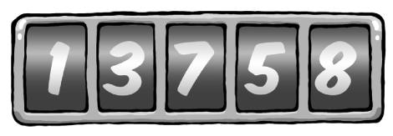

The right wheel counts single kilometres. When it marks an 8, it means 8 kilomtres. The wheel to the left shows every full ten kilometres: a 5 means 50 kilometres. This is followed by the hundred indicator: a 7 means 700 kilometres.

We use the same principles to illustrate regular numbers with the digits 0 to 9.

For example, “578” means 5 100 + 7 10 + 8, which corresponds to 578.

Here we have the “5” which stands for five hundred, “7” for seventy and “8” for eight. In this case the base is 10, one which is quite familiar to us.

Hence the right digit represents the ’units’ of a particular number (i.e. it is multiplied with 1), the digit to the left represents the ’tens’ (i.e. multiplied by 10), the next for ’hundreds’ (i.e. multiplied by

1. and so on. Since we usually represent numbers using a basis of 10, we do not need to separately indicate the base. On a more formal level, this would be indicated as 5510 for the number 55, whereby the base is represented by the subscript number.

If we are not using a base of 10, we have to use a corresponding subscript to indicate the relevant number.

Assume that, instead of using the digits 0 to 8, the odometer indicator only included digits 0 to 7. The right wheel would thus continue to count up one level after each kilometres, with the resulting number series looking as follows:

0; 1; 2; 3; 4; 5; 6; 7; 0; 1; 2; :::

155

The Gpg4win Compendium 3.0.0



Chapter 25. GnuPG and the mystery of large numbers

For example, your three-digit odometer using the base 8 would represent the following number:

356

The 6 on the right wheel counts single kilometres, hence 6 80 = 6 kilometres.

The 5 on the wheel beside it stands for 5 81, hence 40 kilometres.

The 3 left of that stands for each 64 kilometres per revolution, in this example 3 82 kilometres.

This is how calculating numbers with basis of 8 works. An example: 728 represents 7 81 +2 80 = 58.

In this illustration, the “2” from 72 stands for 2, but the “7” stands for 7 8.

Larger numbers are gradually assembled in the same way, so that 4538 actually reprsents 4 64+5 8+3, which results in 29910t.

For 4538, the “3” stands for 3, the “5” for 5 8 and the “4” for 4 64, whereby the “64” is in turn derived from 8 8.

In the example above digits are multiplied by ascending powers of 8, from left to right. The right digit is multiplied with 80 (i.e. 1), while the the digit to the left is multiplied wiht 81 (i.e. 8), and the one to the left with 82 (i.e. 64), and so on.

When representing numbers with a base of 10, there is no higher digit than 9 (i.e. 10 minus 1). Hence there is no digit which represents 10 or a higher number. In order to represent 10, we need two digits with which to write “10”.

So we only have digits 0 to 9.

Much the same applies when calculating with the base number 8: the only available digits are 0 to 7. If we wish to represent a number higher than seven using this base, we must again use two digits. For example, 910 is 118, 7310 is 1118.

156

The Gpg4win Compendium 3.0.0



Chapter 25. GnuPG and the mystery of large numbers

Computers stores numbers as a series of zeros and ones. This is called the binary system or arithmetics using the base number 2, because we are only using the digits 0 and 1. Imagine counting kilometres with an odometer whose wheel only has two digits: 0 and 1. Hence, using the binary system, the number 101012, for example, would look as follows

1 24+0 23+1 22+0 21+1 20 =1 16+0 8+1 4+0 2+1=21

Groups of eight binary digits are also used in computer technology - the well known “byte”. A byte can consist of values anywhere from 0 - represented as byte 000000002 — and 255 — represented as byte 111111112. A byte therefore represents the number to the base of 28 = 256.

Two more examples:

101010102 = 170

000001012 = 5

Since the computer stores letters, digits and symbols as bytes, let us see the role played by the representation to the base of 256.

157

The Gpg4win Compendium 3.0.0



Chapter 25. GnuPG and the mystery of large numbers

Let’s take the syllable “un”. The computer stores “u” as 117, and the “n” as 110.

These number values are standard for all computers and are called ASCII code.

You can also represent the syllable “un” with the following number:

117 28 1 + 110 28 0 = 117 256 + 110 = 30062

Accordingly, the letter sequence “und” would be represented with the number

117 28 2 + 110 28 1 + 100 28 0 = 117 65536 + 110 256 + 100 = 7695972

since “d” is represented by 100.

We have therefore internally represented numbers and symbols which are available on a computer keyboard as normal numbers using the base of 10 by numbers to the base of 28 = 256.

Accordingly we are able to turn every message into a big number. A long message leads to an enormously large number, which we wish to encrypt with the RSA algorithm.

However, we must ensure that the number into which the message is encrypted does not become larger than the product of the prime numbers (modulus), otherwise it creates problems, as we will see below.

Since the next process is comprised a number of steps, let’s first summarize and then examine the individual steps in turn:

1. The message aba, cad, aca is converted into numbers, as described above.
2. This representation, for example using a basis of 22 = 4 (instead of 28 = 256), is converted into a representation using a basis of 10, so that you can use the Table 25.1 for encryption purposes, as this table displays numbers using a basis of 10. This creates a coded message using a basis of 10.
3. To recognise the coding, as compared to “clear text”, convert the message that was coded using a basis of 10 back into a basis of 4, and convert it back into a letter sequence.
4. This turns the message aba, cad, aca into the encrypted message dbb, ddd, dac.

158

The Gpg4win Compendium 3.0.0



Chapter 25. GnuPG and the mystery of large numbers

And now in detail:

1. Convert the message aba, cad, ada into numbers.

Assuming we limit the messages to the four letters a, b, c und d, using this — very simple — example we could represent the four letters by the number values 0, 1, 2 and 3, and hence have

a = 0; b = 1; c = 2 und d = 3

Now encrypt the message aba, cad, aca. Encode the message using prime numbers 7 and 11, with the public key 77 und 13 and associated private key 37. You area already fa-miliar with this example from an earlier chapter: You used it to construct the tables 25.1 and 25.2.

1. This representation using a basis of 4 is converted into one using a basis of 10. To do this, you can use Table 25.1 for encryption purposes, which also uses numbers with a basis of 10.

Because you are using four letters for the message, calculate using a basis of 4. For a modulo 77 calculation, you have to break down the message into pieces of three digits each, because the largest three-digit number using a basis of 4 is 3334. Using a basis of 10, this number has a value of 63.

If instead you were to divide the message into pieces of four characters each, 33334 would exceed the value of 7610 and would result in unwanted ambiguity.

As a result, the message of three-digit pieces would result in

aba; cad; aca

Now assign your number values to the characters and do not forget that the pieces represent three-digit numbers using a basis of 4.

Since you are representing the letters with the numbers a = 0, b = 1, c = 2, d = 3, the resulting message will look as follows:

0104; 2034; 0204

Using a basis of 10, this message will be represented by the number sequence 4, 35, 8. Why?

For example, take the middle part 2034:

|  |  |  |
| --- | --- | --- |
| 3 40; also 3 1; | | also 3: |
| 0 41; | also 0 4; | also 0: |
| 2 42; | also 2 16; | also 32: |

159

The Gpg4win Compendium 3.0.0



Chapter 25. GnuPG and the mystery of large numbers

1. For encryption purposes, you can now use Table 25.1 from page 151, which was calculated using a basis fo 10. We use this table because you are working with the already familiar key pair. This created a coded message using a basis of 10.

To encrypt the message, you now use the aforementioned table 25.1. The message now turns into the number sequence 53, 63, 50 (basis of 10).

1. Converted back to a basis of 4, the message becomes 3114; 3334; 3024. Converting it to a letter sequence creates dbb, ddd, dac, which is very different from the original message.

Therefore we reverse the process and transform the number sequence 53, 63, 50 using Table 25.2 to obtain the sequence 4, 35, 8, which precisely corresponds with the original message.

Using Tables 25.1 and25.2 you can also encrypt messages using the private key (e.g. first use Table 25.2 and then decode with the public key (i.e. Table 25.1) and thus restore your original number). This allows the owner of the private key to encrypt messages using the RSA algorithm, and it proves that the messages can only come from him.

160

The Gpg4win Compendium 3.0.0



Chapter 25. GnuPG and the mystery of large numbers

**The bottom line is...**

.... while this process is complicated in its details, the principle on the other hand is fairly easy to

understand. After all, you should not just trust a method but also - at least on the basis of understanding the approach behind it - be able to see behind its mode of operation. Many of the other details can easily be found in other books (z.B.: R. Wobst, “Abenteuer Kryptologie”) or on the Internet.

In any case, now you know: if someone should ever attempt to crack your encrypted e-mails, the process will keep them busy for such a long time that they will lose all interest in actually reading your messages. . . ...

161

**Part III.**

**Annex**

162

1. **Information on the GpgOL Outlook extension**

GpgOL is a program extension for Microsoft Outlook; it integrates the operation of GnuPG into Outlook.

Since Outlook is a proprietary product, hence is not available as free software with a source code, this integration still has a number of issues. In other words: Operation is not as comfortable as offered by, for example, e-mail programs with integrated encryption and signature components (e.g. KMail/Kontact).

GpgOL is installed by the Gpg4win installation asisstant. On the next startup of Outlook, the menu

Extras!Options will contain the tab GpgOL:



163

The Gpg4win Compendium 3.0.0



Appendix A. Information on the GpgOL Outlook extension

The tab GpgOL is divided into three areas:

1. General information: Turn on S/MIME support

Once Gpg4win has been intalled, S/MIME functionality is activated in GpgOL. This refers to the S/MIME support of GnuPG. Outlook itself also supports X.509 and S/MIME, but of course does not work with the Gpg4win component GnuPG. This means that all settings, certificate management and user dialogs will be different. Please also note that Outlook itself does not offer any OpenPGP support.

If you wish to use S/MIME with Gpg4win in Outlook, leave the GpgOL-Option Activate S/MIME support activated. If you wish to use S/MIME supported by Outlook, deactivate this GpgOL S/MIME option.

1. Sending messages:

Encrypt new messages with default settings Sign new messages with default settings

These two options control whether new messages are encrypted and/or signed with the default settings. You can also change these settings when you create a message. Only the buttons are activated accordingly.

1. Reading messages:

Show HTML display where possible

This option can be used to display the HTML version of a message. Normally, or if HTML format is not available, the message will be shown in text format.

Display encrypted message as attachment



The encrypted portion of the message is also shown as an attachment. This means that users can save the encrypted part separately, or process it in another manner.

All options are already pre-populated following a new installation.

164

The Gpg4win Compendium 3.0.0



Appendix A. Information on the GpgOL Outlook extension

To send encrypted messages using Outlook, you have to ensure that you do not use Microsoft Word to compose messages.

It is also recommended that you do not use HTML messages.

These items can be controlled in the menu item Extras!Options on the E-Mail format tab. The message format should be set to Text only (see highlighted area). However, if you still want to use HTML for signed or encrypted e-mails, it is possible that the formatting information will be lost by the time the message reaches the recipient.

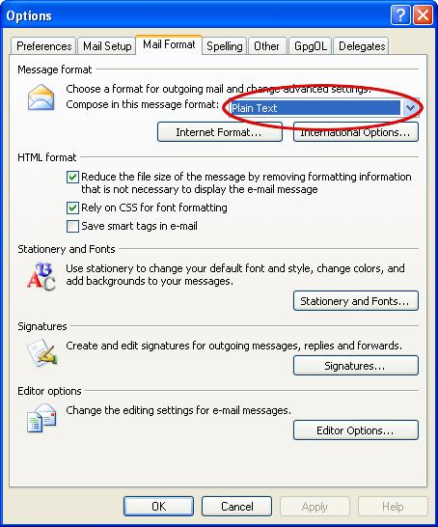

Please note: The program extension GpgOL from Gpg4win makes it possible to handle e-mails according to the OpenPGP standard in Outlook 2003/2007.

In WindowsXP and Outlook 2003, Gpg4win also enables Outlook 2007 to decrypt and create AES encrypted S/MIME e-mails, since along with GnuPG, Gpg4win brings along its own cryptocomponents that are independent of Outlook and Windows. Only Outlook 2007 under Windows Vista can handle AES encrypted S/MIME e-mails without Gpg4win.

165

**B. Using GnuPG with other e-mail programs**

The Gpg4win compendium mainly looks at the Outlook e-mail program. However, GnuPG can also be used with all other e-mail programs. However, there are great differences in user comfort – the better GnuPG is integrated into an e-mail program, the easier it is to use it.

The simplest method, e.g. if an e-mail program does not know anything about GnuPG, is to encrypt using the clipboard, with Kleopatra’s assistance. This only works for OpenPGP; for S/MIME and complex PGP/MIME e-mails you will have to use intermediate storage as a file. Both methods are described in the first part of this compendium.

Currently, an integration of GnuPG is offered for the following e-mail programs under Windows:

**Thunderbird** withEnigmail1.

**Outlook as of Version 2003** with GpgOL. GpgOL is a part of the Gpg4win package.

**Claws Mail:** This e-mail program is part of the Gpg4win package, and can be optionally installed.Such an installation already configures the program extension for the use of PGP/MIME and S/MIME. This extension however does not use Kleopatra, and therefore does not currently offer the same comfort as offered by the GpgOL Outlook extension.

**KMail/Kontact:** KMail and Kontact offer a comfortable and proven integration of GnuPG. They areavailable for almost all GNU/Linux systems and recently also for Windows and MacOS X.

1<http://www.thunderbird-mail.de/wiki/Enigmail_OpenPGP>

166

**C. Automatic installation of Gpg4win**

This chapter looks at automated installations (without user dialogs).

In some cases, such as for software shared systems, it is necessary that the installation of Gpg4win works without interaction using dialogs. However, in order to still define all installation settings in advance, Gpg4win supports the configuration of the installation path and other options on the command line as well as a control file.

The installation path can be indicated with the option /D=<PFAD>, which must be submitted as the last option on the command line. The file name (here: gpg4win.exe) may vary depending on the version. It does make a difference whether you use capital or small letters when entering information in the command line. If required, access rights (e.g. read and write) may also be configured in the installation folder. An example:

gpg4win.exe /D=D:\Programme\Gpg4win

Using the option /S, the installation runs “silently”, hence without any dialogs. If no other parameters are set, all default settings will be adopted.

Gpg4win also supports a so-called control file. You can use the option /C=<INIFILE> to enter a control file (name usually ends in .ini).

Another example:

gpg4win.exe /S /C=C:\TEMP\gpg4win.ini

This .ini file should contain exactly one section [gpg4win]. It is where various settings can be made, including absolute path information for the configuration files to be installed. Relative paths, hence those that are dependent on the current working directory, cannot be entered here. Absolute paths contain the complete path including the drive name. Usually settings must be entered if the default settings should not be used. Exceptions to this rule are documented in the example on the next page.

167

The Gpg4win Compendium 3.0.0



Appendix C. Automatic installation of Gpg4win

This is an example of the contents in a control file which displays all authorized key words:

[gpg4win]

* Installation settings. Leave out or leave empty for
* Default settings

inst_gpgol = true

inst_gpgex = true

inst_kleopatra = true

inst_gpa = true

inst_claws_mail = false

inst_compendium = true

* The locations at which linkages are to be prepared. inst_start_menu = true

inst_desktop = false

inst_quick_launch_bar = false

* In contrast to the other options, this option overwrites
* the user’s settings in the installation assistant.

inst_start_menu_folder = Gpg4win

* Standard configuration files. gpg.conf = D:\config\gpg-site.conf

gpg-agent.conf = D:\config\gpg-agent-site.conf trustlist.txt = D:\config\trustlist-site.txt dirmngr.conf = D:\config\dirmngr-site.conf dirmngr_ldapserver.conf = D:\config\dirmngr_ldapserver-site.conf scdaemon.conf = D:\config\scdaemon-site.txt

gpa.conf = D:\config\gpa-site.conf

A corresponding request for automatic installation with a control file gpg4win.ini and an installation path D:\Programme\Gpg4win could look as follows:

gpg4win.exe /S /C=C:\TEMP\gpg4win.ini /D=D:\Programme\Gpg4win

168

**D. Transfer from other programs**

This section explains how you can transfer from other Gnu-based programs to Gpg4win. The installation program recognizes some of these programs and will warn you in that case.

Generally it is recommended that you remove an existing installation of a another GnuPG-based program before installing Gpg4win. It is important that the existing certificates are backed up prior to the installation process.

The only really meaningful way to do this is to use the options available in the old program. Search for a menu item to back up your private certificates as well as a menu item for backing up all existing public certificates. Then back them up to one or more files.

As soon as you have installed Gpg4win, check whether your old certificates are already there. You can do this using the Kleopatra or GPA certificate managers. If your certificates are already there, the old encryption system already corresponded with the new conventions for certificate storage locations, and you need not do anything else.

If however your old certificates do not appear, simply import them from the backup copies. Please read Chapter 19.

If your old cryptography system uses the GPA certificate manager, you can use the backup option offered by this program. It should be very similar to the function of the GPA version from Gpg4win.

If you cannot find any way of locating your old certificates, please use the Windows dashboard tools to search for files with the name secring.gpg and pubring.gpg and import these two files using Kleopatra1.

* This is not an official method, but it still works with all current GnuPG versions.

169

The Gpg4win Compendium 3.0.0 Appendix D. Transfer from other programs



**Migration from Gpg4win-1.1.x to Gpg4win-2.x**

It is highly recommended that you first uninstall Gpg4win-1.1.x before installing Gpg4win-2.x.

**Technical background**

The problem with a migration that does not include a deinstallation of Gpg4win-1.1.x is highlighted by the following squence:

1. Installation of Gpg4win in version X, incl. component K.
   1. Installation of Gpg4win in version X+1, but component K is now de-selected. The result: The old K component remains installed in Version X.
   2. Deinstallation of Gpg4win in version X+1.

The result: The component K in version X remains "orphaned".

This is a restriction on Gpg4win since the first version.

Comment 1: When switching from 1.1.x to 2.x, this case will always occur, since certain components K are no longer in existence (e.g. GpgEE), and hence must be deemed as (automatically) de-selected.

Comment 2: In the case of MSI, Windows assumes the task of removing components that are no longer in use. This means that the MSI installation assistant acts correctly in the above scneario (old component K in version X is no longer on the operating system after step 2).

170

**E. Uninstalling Gpg4win**

If you wish to uninstall Gpg4win, you should first shut down all other applications that are not required, and backup all certificates. If you are working on a computer with restricted rights, you will need to be registered with administrator rights for deinstallation purposes. If the installation was already carried out through your user account, it has administrator rights.

Important:

Before you start the deinstallation process, it is highly recommended that you “clean” your e-mails in Outlook which have been processed with GpgOL of all GpgOL information. Because: Gpg4win/GpgOL sets a specific marker for each of your crypto-e-mails in Outlook. You have to reset this marker prior to uninstalling the program, so that other cryptography software can later read and encrypt your e-mails correctly.

For the purpose of this re-migration, GpgOL will make the following function available in Outlook: Select an Outlook e-mail folder, whose e-mails you wish to reset, then click on Extras ! Remove GpgOL features from this folder.

You will be advised that GpgOL will be shut down (for the subsequent deinstallation process). Confirm whether you wish to clean the e-mails of the respective folder of the GpgOL markings with Yes. Now execute this command for all Outlook folders.

Once you have reset all folders, you can begin to uninstall Gpg4win.

There are three ways of uninstalling the program:

Using Microsoft Windows’ dashboard tools:

Open Start!Settings!Control panel!Software and select GnuPG for Windows.

Activating [ Remove ] will uninstall all Gpg4win program components from your operating system.

Another way of uninstalling Gpg4win is to use the exe file gpg4win-uninstall.exe. This file is supplied with Gpg4win and can be found in your installation folder (usually C:nProgrammenGNUnGnuPGn). If you have selected a path that is different from the default path during the installation process, you will find the deinstallationprogram in the corresponding location.

This exe file is also found in the start menu under Gpg4win.

171

The Gpg4win Compendium 3.0.0



Appendix E. Uninstalling Gpg4win

In all three cases, all Gpg4win files will be removed from the installation folder, and from the link in the start menu, desktop and quick start bar.

User-specific and system-wide application file folders with the configuration settings below will not be deleted:

User-specific GnuPG application data

in %APPDATA%\gnupg, generally corresponds with file folder:

C:\Documents and settings\<Benutzername>\ Application data\gnupg\

This gnupg file folder contains all personal GnuPG information, hence private certificates, trust settings and program configurations.

System-wide GnuPG application data

in %COMMON_APPDATA%\GNU, usually corresponds with file folder:

C:\Documents and settings\All Users\ Application data\GNU\

**Uninstalling Gpg4win-1.1.3**

Once Gpg4win-1.1.3 has been uninstalled, the following file folders or registry keys will remain:

File name:

%APPDATA%ngnupg (Continues to be used by a Gpg4win2 installation.)

Important: This is where your personal private and public certificates and GnuPG settings are found.

Registry key:

HKLMnSoftwarenGNUnGnuPG (No longer used by a Gpg4win2"=installation.) HKCUnSoftwarenGNUnGPG4Win (No longer used by a Gpg4win2"=installation.) HKCUnSoftwarenGNUnGpgOL (No longer used by a Gpg4win2"=installation.) HKCUnSoftwarenGPGee (No longer used by a Gpg4win2"=installation.)

172

1. **History**

“GnuPP für Einsteiger”, 1st edition March 2002 and “GnuPP für Durchblicker”, 1st edition March 2002, Authors: Manfred J. Heinze, TextLab text+media Consultants: Lutz Zolondz, G-N-U GmbH Illustrations: Karl Bihlmeier, Bihlmeier & Kramer GbR Layout: Isabel Kramer, Bihlmeier & Kramer GbR Technical text: Dr. Francis Wray, e-mediate Ltd. Editors: Ute Bahn, TextLab text+media

Publisher: Bundesministerium für Wirtschaft und Technologie (BMWi) Available at <http://www.gnupp.de/pdf/einsteiger.pdf>und <http://www.gnupp.de/pdf/durchblicker.pdf>.

Revised non-published version of TextLab text+media.

“Gpg4win für Einsteiger” and “Gpg4win für Durchblicker”, December 2005 Revision: Werner Koch, g10 Code GmbH

Publisher: the Gpg4win Initiative

Thanks to the authorisation of the BMWi dated 14 November 2007, the non-modifiable “Impres-sum” section was removed and adapted to the current version.

The “Gpg4win Compendium” combines “Gpg4win für Einsteiger” and “Gpg4win für Durch-blicker” and has been comprehensively updated and supplemented for Gpg4win2 between 2009 and 2010.

Major revision:

Werner Koch, g10 Code GmbH

Florian v. Samson, Bundesamt für Sicherheit in der Informationstechnik (BSI) Emanuel Schütze, Intevation GmbH

Dr. Jan-Oliver Wagner, Intevation GmbH

Translated into English from the German original by: Brigitte Hamilton (<http://www.linguaetc.com>)

Gpg4win program package and Gpg4win Compendium are available at: <http://www.gpg4win.org>

173

**G. GNU Free Documentation License**

Version 1.2, November 2002

Copyright c 2000,2001,2002 Free Software Foundation, Inc.

51 Franklin St, Fifth Floor, Boston, MA 02110-1301 USA

Everyone is permitted to copy and distribute verbatim copies of this license document, but changing it is not allowed.

Preamble

The purpose of this License is to make a manual, textbook, or other functional and useful document “free” in the sense of freedom: to assure everyone the effective freedom to copy and redistribute it, with or without modifying it, either commercially or noncommercially. Secondarily, this License preserves for the author and publisher a way to get credit for their work, while not being considered responsible for modifications made by others.

This License is a kind of “copyleft”, which means that derivative works of the document must themselves be free in the same sense. It complements the GNU General Public License, which is a copyleft license designed for free software.

We have designed this License in order to use it for manuals for free software, because free software needs free documentation: a free program should come with manuals providing the same freedoms that the software does. But this License is not limited to software manuals; it can be used for any textual work, regardless of subject matter or whether it is published as a printed book. We recommend this License principally for works whose purpose is instruction or reference.

1. APPLICABILITY AND DEFINITIONS

This License applies to any manual or other work, in any medium, that contains a notice placed by the copyright holder saying it can be distributed under the terms of this License. Such a notice grants a world-wide, royalty-free license, unlimited in duration, to use that work under the conditions stated herein. The “Document”, below, refers to any such manual or work. Any member of the public is a licensee, and is addressed as “you”. You accept the license if you copy, modify or distribute the work in a way requiring permission under copyright law.

A “Modified Version” of the Document means any work containing the Document or a portion of it, either copied verbatim, or with modifications and/or translated into another language.

A “Secondary Section” is a named appendix or a front-matter section of the Document that deals exclusively with the relationship of the publishers or authors of the Document to the Document’s

174

The Gpg4win Compendium 3.0.0



Appendix G. GNU Free Documentation License

overall subject (or to related matters) and contains nothing that could fall directly within that overall subject. (Thus, if the Document is in part a textbook of mathematics, a Secondary Section may not explain any mathematics.) The relationship could be a matter of historical connection with the subject or with related matters, or of legal, commercial, philosophical, ethical or political position regarding them.

The “Invariant Sections” are certain Secondary Sections whose titles are designated, as being those of Invariant Sections, in the notice that says that the Document is released under this License. If a section does not fit the above definition of Secondary then it is not allowed to be designated as Invariant. The Document may contain zero Invariant Sections. If the Document does not identify any Invariant Sections then there are none.

The “Cover Texts” are certain short passages of text that are listed, as Front-Cover Texts or Back-Cover Texts, in the notice that says that the Document is released under this License. A Front-Cover Text may be at most 5 words, and a Back-Cover Text may be at most 25 words.

A “Transparent” copy of the Document means a machine-readable copy, represented in a format whose specification is available to the general public, that is suitable for revising the document straightforwardly with generic text editors or (for images composed of pixels) generic paint programs or (for drawings) some widely available drawing editor, and that is suitable for input to text formatters or for automatic translation to a variety of formats suitable for input to text formatters. A copy made in an otherwise Transparent file format whose markup, or absence of markup, has been arranged to thwart or discourage subsequent modification by readers is not Transparent. An image format is not Transparent if used for any substantial amount of text. A copy that is not “Transparent” is called “Opaque”.

Examples of suitable formats for Transparent copies include plain ASCII without markup, Texinfo input format, LaTeX input format, SGML or XML using a publicly available DTD, and standard-conforming simple HTML, PostScript or PDF designed for human modification. Examples of transparent image formats include PNG, XCF and JPG. Opaque formats include proprietary formats that can be read and edited only by proprietary word processors, SGML or XML for which the DTD and/or processing tools are not generally available, and the machine-generated HTML, PostScript or PDF produced by some word processors for output purposes only.

The “Title Page” means, for a printed book, the title page itself, plus such following pages as are needed to hold, legibly, the material this License requires to appear in the title page. For works in formats which do not have any title page as such, “Title Page” means the text near the most prominent appearance of the work’s title, preceding the beginning of the body of the text.

A section “Entitled XYZ” means a named subunit of the Document whose title either is precisely XYZ or contains XYZ in parentheses following text that translates XYZ in another language. (Here XYZ stands for a specific section name mentioned below, such as “Acknowledgements”, “Dedications”, “Endorsements”, or “History”.) To “Preserve the Title” of such a section when you modify the Document means that it remains a section “Entitled XYZ” according to this definition.

The Document may include Warranty Disclaimers next to the notice which states that this License applies to the Document. These Warranty Disclaimers are considered to be included by reference in this License, but only as regards disclaiming warranties: any other implication that these Warranty Disclaimers may have is void and has no effect on the meaning of this License.

175

The Gpg4win Compendium 3.0.0



Appendix G. GNU Free Documentation License

2. VERBATIM COPYING

You may copy and distribute the Document in any medium, either commercially or noncommercially, provided that this License, the copyright notices, and the license notice saying this License applies to the Document are reproduced in all copies, and that you add no other conditions whatsoever to those of this License. You may not use technical measures to obstruct or control the reading or further copying of the copies you make or distribute. However, you may accept compensation in exchange for copies. If you distribute a large enough number of copies you must also follow the conditions in section 3.

You may also lend copies, under the same conditions stated above, and you may publicly display copies.

3. COPYING IN QUANTITY

If you publish printed copies (or copies in media that commonly have printed covers) of the Document, numbering more than 100, and the Document’s license notice requires Cover Texts, you must enclose the copies in covers that carry, clearly and legibly, all these Cover Texts: Front-Cover Texts on the front cover, and Back-Cover Texts on the back cover. Both covers must also clearly and legibly identify you as the publisher of these copies. The front cover must present the full title with all words of the title equally prominent and visible. You may add other material on the covers in addition. Copying with changes limited to the covers, as long as they preserve the title of the Document and satisfy these conditions, can be treated as verbatim copying in other respects.

If the required texts for either cover are too voluminous to fit legibly, you should put the first ones listed (as many as fit reasonably) on the actual cover, and continue the rest onto adjacent pages.

If you publish or distribute Opaque copies of the Document numbering more than 100, you must either include a machine-readable Transparent copy along with each Opaque copy, or state in or with each Opaque copy a computer-network location from which the general network-using public has access to download using public-standard network protocols a complete Transparent copy of the Document, free of added material. If you use the latter option, you must take reasonably prudent steps, when you begin distribution of Opaque copies in quantity, to ensure that this Transparent copy will remain thus accessible at the stated location until at least one year after the last time you distribute an Opaque copy (directly or through your agents or retailers) of that edition to the public.

It is requested, but not required, that you contact the authors of the Document well before redistributing any large number of copies, to give them a chance to provide you with an updated version of the Document.

4. MODIFICATIONS

You may copy and distribute a Modified Version of the Document under the conditions of sections 2 and 3 above, provided that you release the Modified Version under precisely this License, with the Modified Version filling the role of the Document, thus licensing distribution and modification of the Modified Version to whoever possesses a copy of it. In addition, you must do these things in the Modified Version:

176

The Gpg4win Compendium 3.0.0



Appendix G. GNU Free Documentation License

1. Use in the Title Page (and on the covers, if any) a title distinct from that of the Document, and from those of previous versions (which should, if there were any, be listed in the History section of the Document). You may use the same title as a previous version if the original publisher of that version gives permission.
2. List on the Title Page, as authors, one or more persons or entities responsible for authorship of the modifications in the Modified Version, together with at least five of the principal authors of the Document (all of its principal authors, if it has fewer than five), unless they release you from this requirement.
3. State on the Title page the name of the publisher of the Modified Version, as the publisher.
4. Preserve all the copyright notices of the Document.
5. Add an appropriate copyright notice for your modifications adjacent to the other copyright notices.
6. Include, immediately after the copyright notices, a license notice giving the public permission to use the Modified Version under the terms of this License, in the form shown in the Addendum below.
7. Preserve in that license notice the full lists of Invariant Sections and required Cover Texts given in the Document’s license notice.
8. Include an unaltered copy of this License.
9. Preserve the section Entitled “History”, Preserve its Title, and add to it an item stating at least the title, year, new authors, and publisher of the Modified Version as given on the Title Page. If there is no section Entitled “History” in the Document, create one stating the title, year, authors, and publisher of the Document as given on its Title Page, then add an item describing the Modified Version as stated in the previous sentence.
10. Preserve the network location, if any, given in the Document for public access to a Transparent copy of the Document, and likewise the network locations given in the Document for previous versions it was based on. These may be placed in the “History” section. You may omit a network location for a work that was published at least four years before the Document itself, or if the original publisher of the version it refers to gives permission.
11. For any section Entitled “Acknowledgements” or “Dedications”, Preserve the Title of the section, and preserve in the section all the substance and tone of each of the contributor acknowledgements and/or dedications given therein.
12. Preserve all the Invariant Sections of the Document, unaltered in their text and in their titles. Section numbers or the equivalent are not considered part of the section titles.
13. Delete any section Entitled “Endorsements”. Such a section may not be included in the Modified Version.
14. Do not retitle any existing section to be Entitled “Endorsements” or to conflict in title with any Invariant Section.
15. Preserve any Warranty Disclaimers.

If the Modified Version includes new front-matter sections or appendices that qualify as Secondary Sections and contain no material copied from the Document, you may at your option designate some

177

The Gpg4win Compendium 3.0.0



Appendix G. GNU Free Documentation License

or all of these sections as invariant. To do this, add their titles to the list of Invariant Sections in the Modified Version’s license notice. These titles must be distinct from any other section titles.

You may add a section Entitled “Endorsements”, provided it contains nothing but endorsements of your Modified Version by various parties–for example, statements of peer review or that the text has been approved by an organization as the authoritative definition of a standard.

You may add a passage of up to five words as a Front-Cover Text, and a passage of up to 25 words as a Back-Cover Text, to the end of the list of Cover Texts in the Modified Version. Only one passage of Front-Cover Text and one of Back-Cover Text may be added by (or through arrangements made by) any one entity. If the Document already includes a cover text for the same cover, previously added by you or by arrangement made by the same entity you are acting on behalf of, you may not add another; but you may replace the old one, on explicit permission from the previous publisher that added the old one.

The author(s) and publisher(s) of the Document do not by this License give permission to use their names for publicity for or to assert or imply endorsement of any Modified Version.

5. COMBINING DOCUMENTS

You may combine the Document with other documents released under this License, under the terms defined in section 4 above for modified versions, provided that you include in the combination all of the Invariant Sections of all of the original documents, unmodified, and list them all as Invariant Sections of your combined work in its license notice, and that you preserve all their Warranty Disclaimers.

The combined work need only contain one copy of this License, and multiple identical Invariant Sections may be replaced with a single copy. If there are multiple Invariant Sections with the same name but different contents, make the title of each such section unique by adding at the end of it, in parentheses, the name of the original author or publisher of that section if known, or else a unique number. Make the same adjustment to the section titles in the list of Invariant Sections in the license notice of the combined work.

In the combination, you must combine any sections Entitled “History” in the various original documents, forming one section Entitled “History”; likewise combine any sections Entitled “Acknowledgements”, and any sections Entitled “Dedications”. You must delete all sections Entitled “Endorsements”.

6. COLLECTIONS OF DOCUMENTS

You may make a collection consisting of the Document and other documents released under this License, and replace the individual copies of this License in the various documents with a single copy that is included in the collection, provided that you follow the rules of this License for verbatim copying of each of the documents in all other respects.

You may extract a single document from such a collection, and distribute it individually under this License, provided you insert a copy of this License into the extracted document, and follow this License in all other respects regarding verbatim copying of that document.

7. AGGREGATION WITH INDEPENDENT WORKS

178

The Gpg4win Compendium 3.0.0



Appendix G. GNU Free Documentation License

A compilation of the Document or its derivatives with other separate and independent documents or works, in or on a volume of a storage or distribution medium, is called an “aggregate” if the copyright resulting from the compilation is not used to limit the legal rights of the compilation’s users beyond what the individual works permit. When the Document is included in an aggregate, this License does not apply to the other works in the aggregate which are not themselves derivative works of the Document.

If the Cover Text requirement of section 3 is applicable to these copies of the Document, then if the Document is less than one half of the entire aggregate, the Document’s Cover Texts may be placed on covers that bracket the Document within the aggregate, or the electronic equivalent of covers if the Document is in electronic form. Otherwise they must appear on printed covers that bracket the whole aggregate.

8. TRANSLATION

Translation is considered a kind of modification, so you may distribute translations of the Document under the terms of section 4. Replacing Invariant Sections with translations requires special permission from their copyright holders, but you may include translations of some or all Invariant Sections in addition to the original versions of these Invariant Sections. You may include a translation of this License, and all the license notices in the Document, and any Warranty Disclaimers, provided that you also include the original English version of this License and the original versions of those notices and disclaimers. In case of a disagreement between the translation and the original version of this License or a notice or disclaimer, the original version will prevail.

If a section in the Document is Entitled “Acknowledgements”, “Dedications”, or “History”, the requirement (section 4) to Preserve its Title (section 1) will typically require changing the actual title.

9. TERMINATION

You may not copy, modify, sublicense, or distribute the Document except as expressly provided for under this License. Any other attempt to copy, modify, sublicense or distribute the Document is void, and will automatically terminate your rights under this License. However, parties who have received copies, or rights, from you under this License will not have their licenses terminated so long as such parties remain in full compliance.

10. FUTURE REVISIONS OF THIS LICENSE

The Free Software Foundation may publish new, revised versions of the GNU Free Documentation License from time to time. Such new versions will be similar in spirit to the present version, but may differ in detail to address new problems or concerns. See http://www.gnu.org/copyleft/.

Each version of the License is given a distinguishing version number. If the Document specifies that a particular numbered version of this License “or any later version” applies to it, you have the option of following the terms and conditions either of that specified version or of any later version that has been published (not as a draft) by the Free Software Foundation. If the Document does not specify a version number of this License, you may choose any version ever published (not as a draft) by the Free Software Foundation.

179

The Gpg4win Compendium 3.0.0



Appendix G. GNU Free Documentation License

ADDENDUM: How to use this License for your documents

To use this License in a document you have written, include a copy of the License in the document and put the following copyright and license notices just after the title page:

Copyright c YEAR YOUR NAME. Permission is granted to copy, distribute and/or modify this document under the terms of the GNU Free Documentation License, Version 1.2 or any later version published by the Free Software Foundation; with no Invariant Sections, no Front-Cover Texts, and no Back-Cover Texts. A copy of the license is included in the section entitled “GNU Free Documentation License”.

If you have Invariant Sections, Front-Cover Texts and Back-Cover Texts, replace the “with...Texts.” line with this:

with the Invariant Sections being LIST THEIR TITLES, with the Front-Cover Texts being LIST, and with the Back-Cover Texts being LIST.

If you have Invariant Sections without Cover Texts, or some other combination of the three, merge those two alternatives to suit the situation.

If your document contains nontrivial examples of program code, we recommend releasing these examples in parallel under your choice of free software license, such as the GNU General Public License, to permit their use in free software.

180

**Index**

ASCII armor, 107, 115, 123 Asymmetric encryption, 22, 24 Authentication, 28, 41, 81 Authentication instances, 81 Authenticity, 28 Automatic installation, 167

Bundesamt für Sicherheit in der Informationstechnik, 10

Bundesministerium für Wirtschaft und Technologie, 10

CAcert, 55

Certificate

authenticate, 77

CA, 67, 126

chain, 67, 131

create, 41

details, 98

export, 60, 103, 123

import, 72, 103, 124

public, 58

request, 52

selection, 84

User ID, 98

validity, 98

Certificate Administration, 9 Certificate administration, 42 Certificate Authority (CA), 29, 54, 81 Certificate issuer, 29

Certificate Revocation Lists, 126, 132, 134 Certificate server, 100

OpenPGP, 100

search for certificates, 103

set up, 101

X.509, 100

Chain of trust, 28

Check

signature with GpgOL, 92

Claws Mail, 9, 166

Correspondence secrecy, 13

CRLs, see Certificate Revocation Lists

CryptoEx, 129

Cryptography, 9

Denial of Service, 100

Diagnostic level, 142

Directory Manager, see DirMngr

DirMngr, 126, 130, 132, 133, 140

E-mail

archive in encrypted form, 95

decrypt, 68

encrypt, 82

encrypt and sign, 94

sign, 86

Echelon system, 12

Encrypting file attachments, 104

Enigmail, 166

Envelope, 11

Expiry date, 98

File

check signature, 110

decrypt, 118

encrypt, 114

sign, 106

Fingerprint, 48, 76

Free Software, 9

GNU FDL, 174–180

GNU Free Documentation License, see GNU FDL

GNU Privacy Assistent, see GPA GnuPG, 9

GnuPG für Outlook, see GpgOL

GnuPP, 41, 173

GPA, 9

GPG Explorer eXtension, see GpgEX

181

The Gpg4win Compendium 3.0.0



Appendix G. GNU Free Documentation License

|  |  |  |
| --- | --- | --- |
| GpgEX, 9, 105 | plugin, 163 |  |
| GpgOL, 9 | Passphrase, 25 |  |
| GpgOL options, 164 |  |
| PGP, 10 |  |
|  |  |
| Hierarchical trust concept, 28 | Pinentry, 89 |  |
| HTTP, 126, 134 | Prime numbers, 149–159 |  |
| Installation, 30 | Proxy, 102, 126, 134 |  |
| “Public Key” Method, 14, 18 |  |
| Integrity, 106 |  |
|  |  |
| Key | Re-migration of GpgOL, 171 |  |
| Residue classes, 146 |  |
| create, 41 |  |
| Root certificates, 126, 131, 133, 135, 136 |  |
| ID, 48, 98 |  |
| RSA algorithm, 144–161 |  |
| pair, 17, 24, 41, 122 |  |
|  |  |
| private, 23 | S/MIME, 10, 28 |  |
| public, 23 | Security philosophy, 143 |  |
| Key server, see Certificate server | Signature |  |
| Kleopatra, 9, 42 | broken, 93 |  |
| KMail, 166 | digital, 86 |  |
| Kontact, 166 | qualified electronic, 86 |  |
| LDAP, 100, 126, 134 | Signature Act, 86 |  |
| Signature law, 81 |  |
| Log file, 137 |  |
| Symmetric encryption, 16, 19 |  |
| DirMngr, 140 |  |
|  |  |
| GnuPG, 141 | Telecommunication secrecy, 13 |  |
| GpgME, 142 | Thunderbird, 166 |  |
| GpgOL, 139 | Trojans, 25 |  |
| Kleopatra, 138 | Troubleshooting, 128 |  |
| Mail secrecy, 13 | trustlist.txt, 135, 136 |  |
| Trustworthy root certificates, 126, 133, 136 |  |
| Mail strongbox, 19, 22, 28 |  |
|  |  |
| Migration from Gpg4win, 170 | Uninstallation, 171 |  |
| Modulo arithmetics, 145 | Viruses, 25 |  |
| “Non-Public Key” Method, see Symmetric |  |
|  |  |
| encryption | Web of Trust, 29, 80 |  |
| OpenPGP, 10, 28 | Windows-Explorer, 9 |  |
| Worms, 25 |  |
| create certificate, 44 |  |
|  |  |
| OSCP, 126 | X.509, 10, 41 |  |
| Outlook, 68, 128, 166 | create certificate, 50 |  |

182