PDA : Software development

ERIC CARLES – CodeClan – E18
11/17 – 03/18
Version N°2, updated 12/04/2018

Contents
1 Week 2 4
1.1I.T 5 4
1.2I.T 6 5
2Week 3 6
2.1I.T 3 6
2.2I.T 4 7
3Week 5 9
3.1A.D 1 9
3.2A.D 2 10
3.3A.D 3 11
3.4A.D 4 12
3.5A.D 6 13
3.6P 5 14
3.7P 6 15
3.8P 10 16
3.9P 13 17
3.10P 14 18
3.11P 15 20
3.12I.T Task A 21
4Week 6 22
4.1I.T 7 22
5Week N°9 25
5.1A.D 5 25
5.2I.T1 26
5.3I.T2 26
5.4P 11 28
5.5P12 29
6Week N°11 32
6.1P.18 32
7Week 12 33
7.1P16 33
8Week 14 34
8.1P1 34
8.2P2 35
8.3P3 36
8.4P4 36
8.5P7 37
8.5.1Sequence diagram 37
8.5.2Collaboration diagram 37
8.6P8 38
8.6.1Object diagram N°1 38
8.6.2Object diagram N°2 38
8.7P9 40
8.7.1Algorithm N°1 40
8.7.2Algorithm N°2 40
8.8P17 41
8.9I&T 42

- Week 2
  - I.T 5
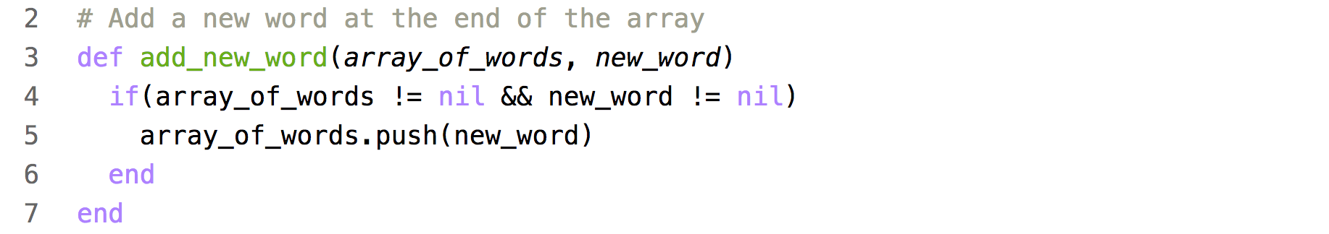
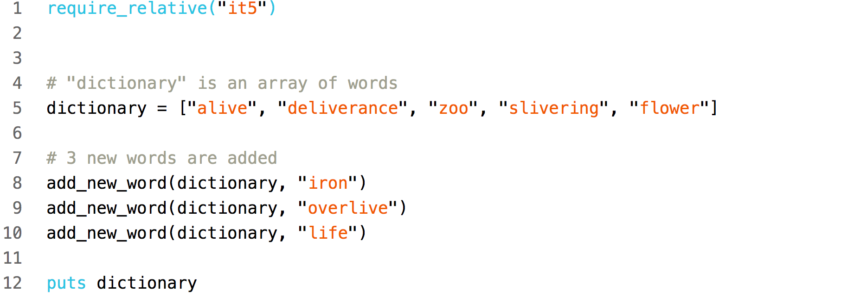

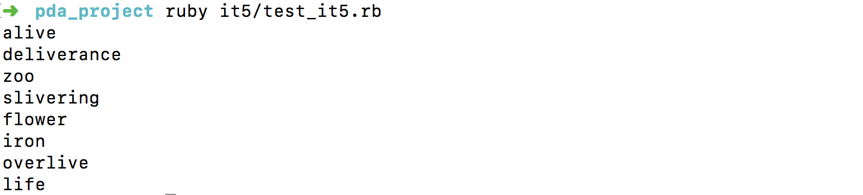

  - I.T 6

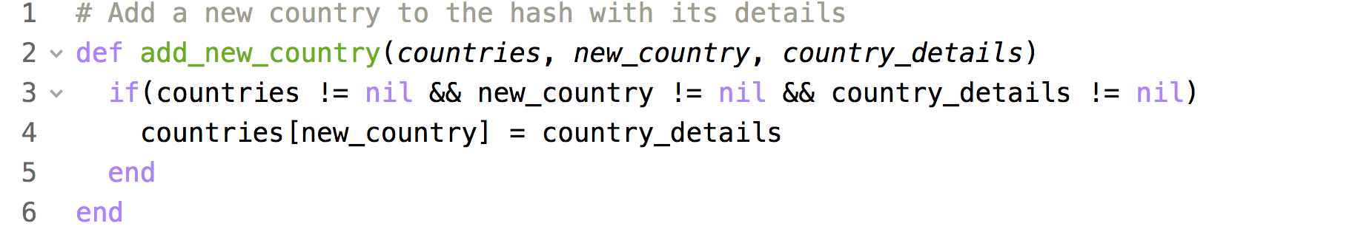

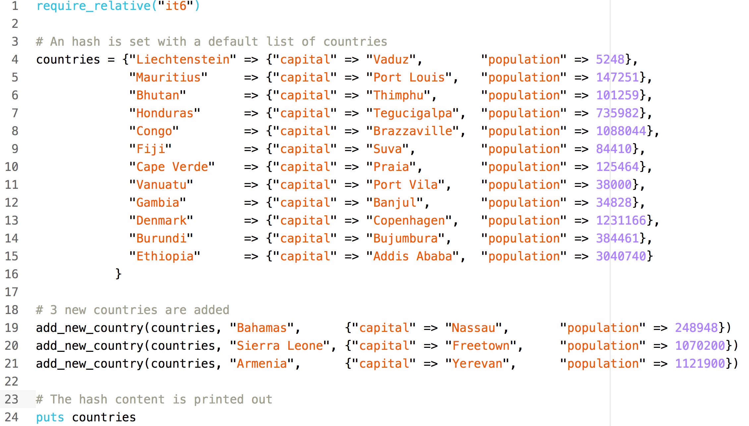
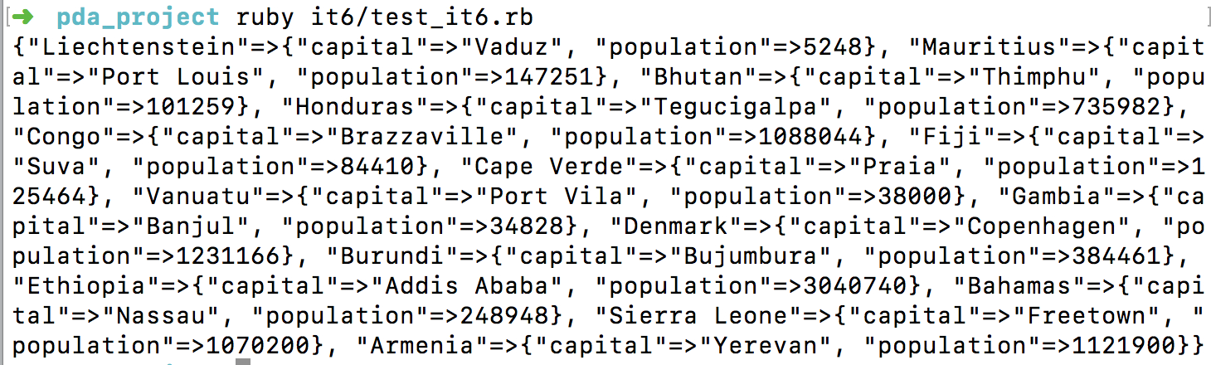

- Week 3
  - I.T 3
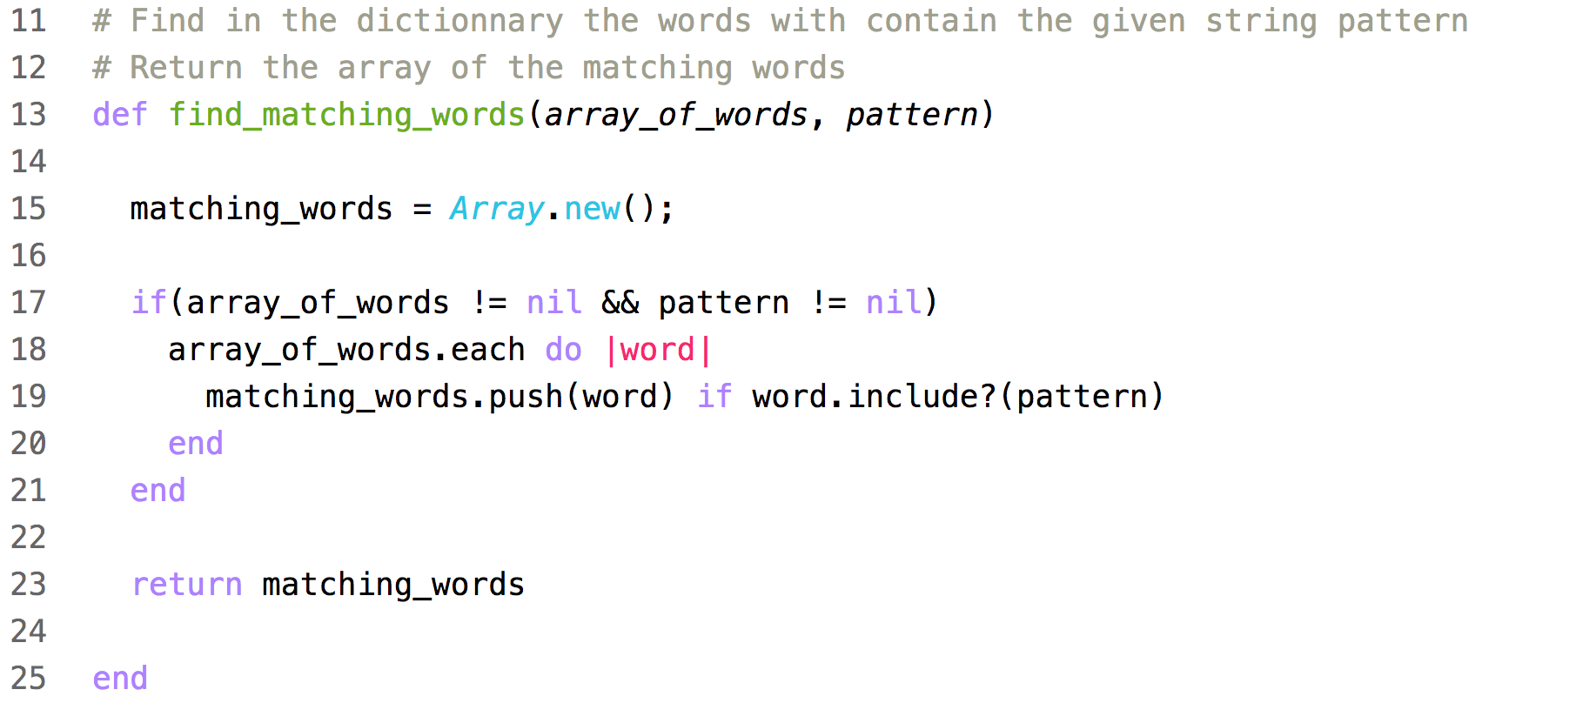
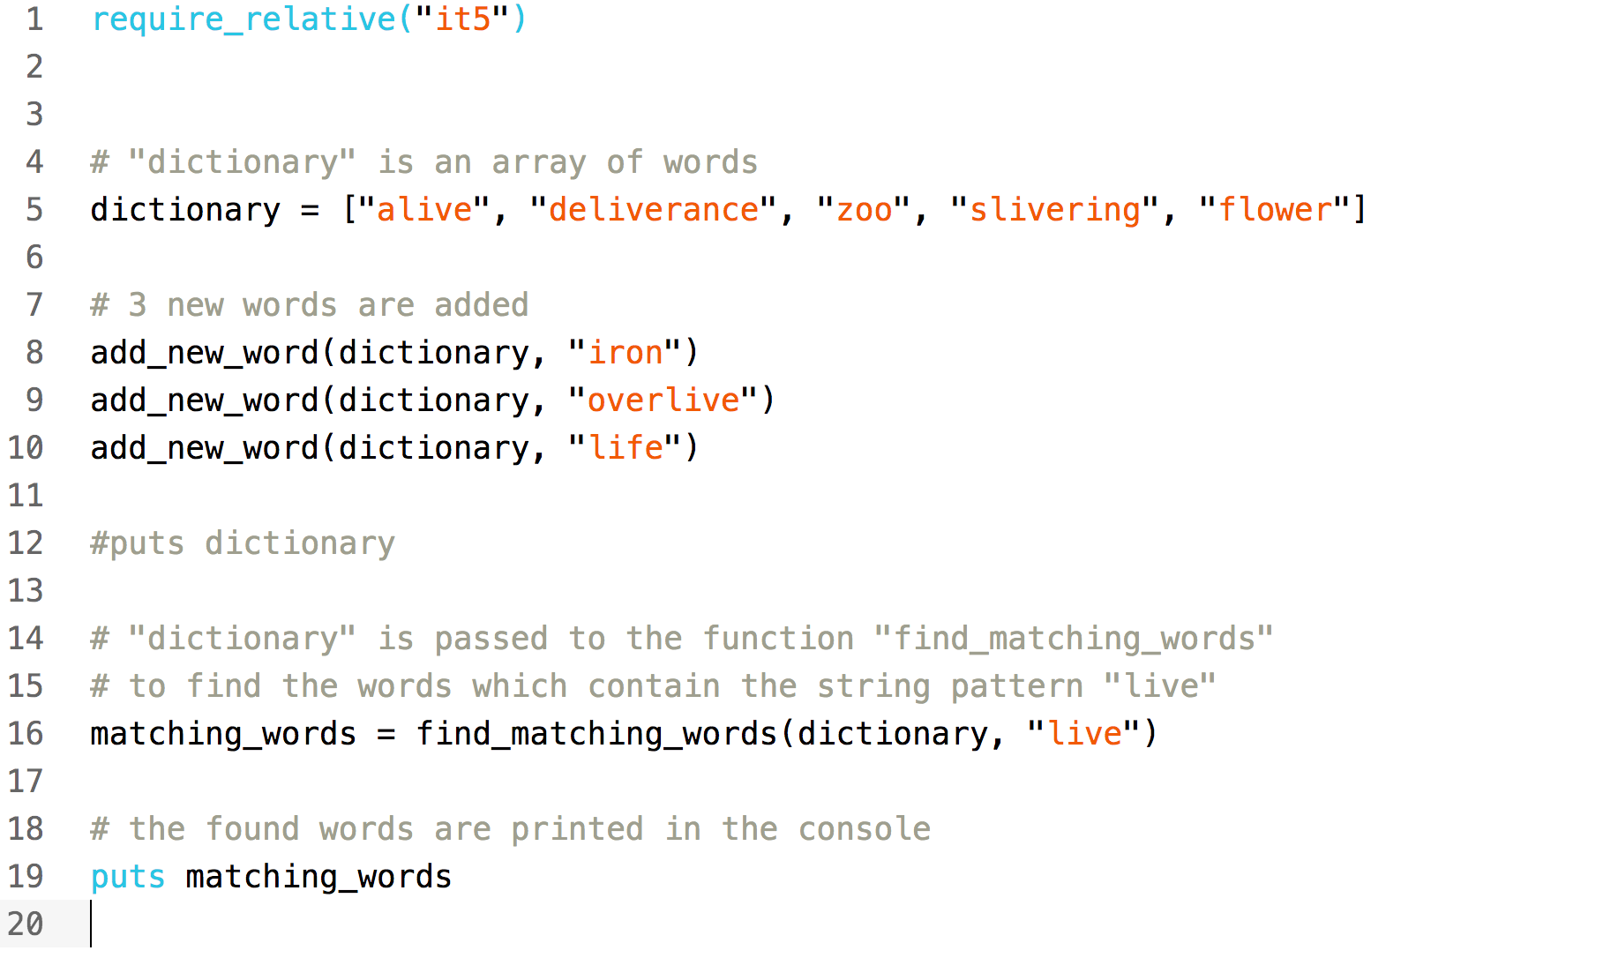
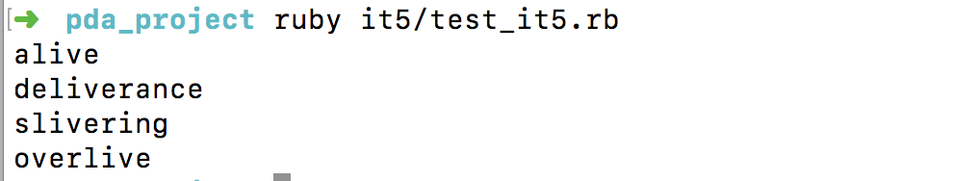
  - I.T 4
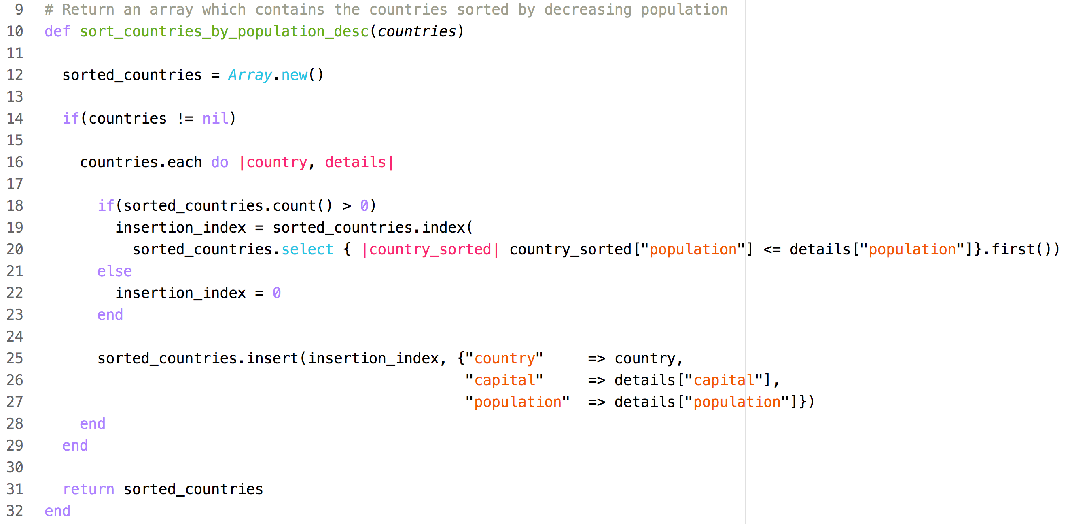
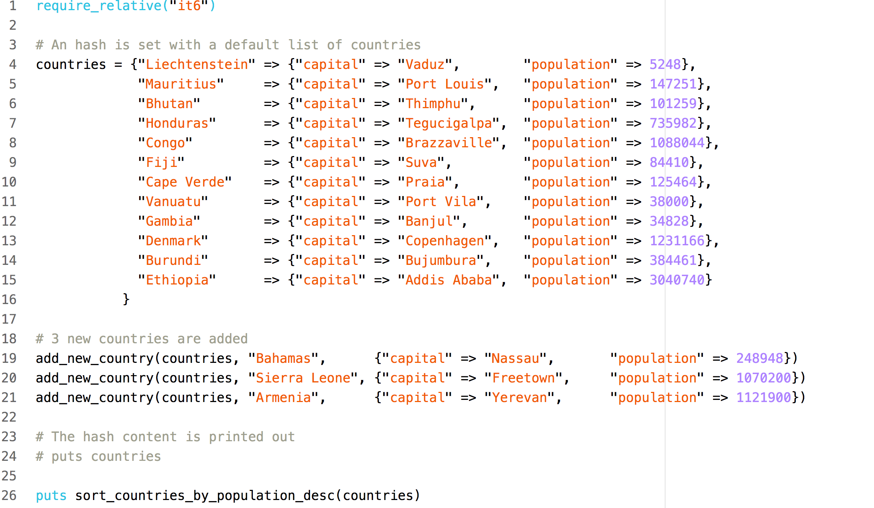
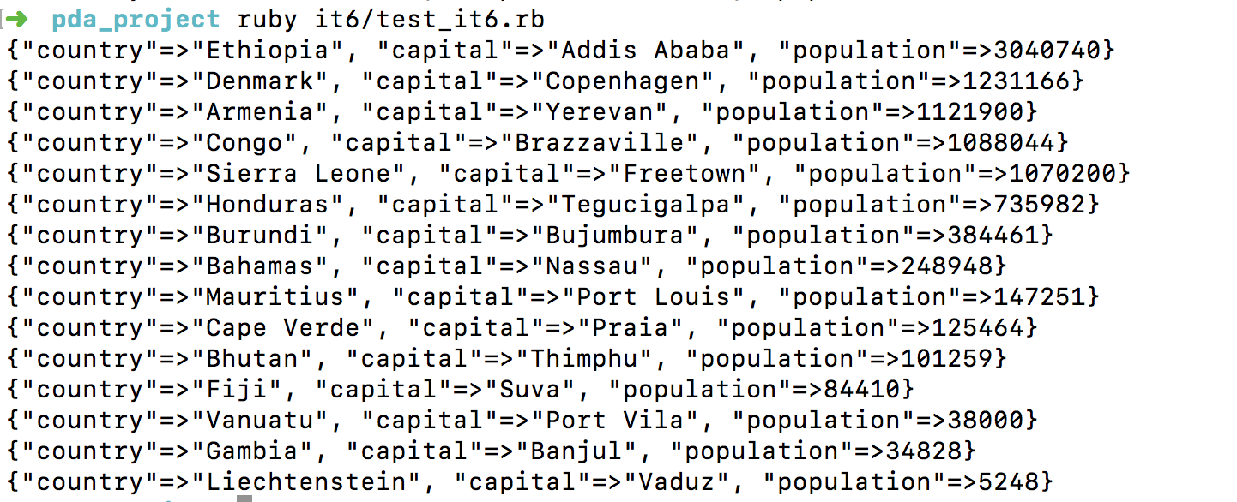
- Week 5
  - A.D 1
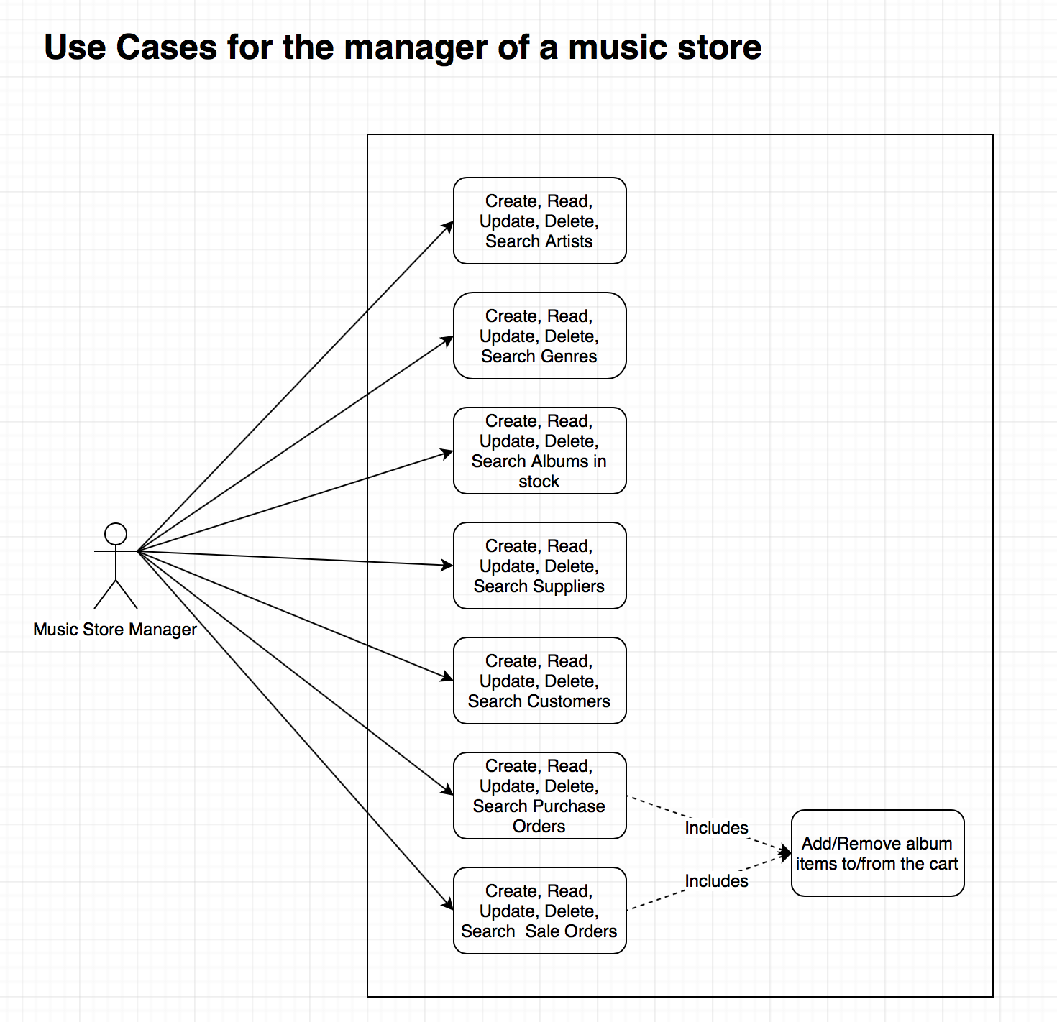

  - A.D 2

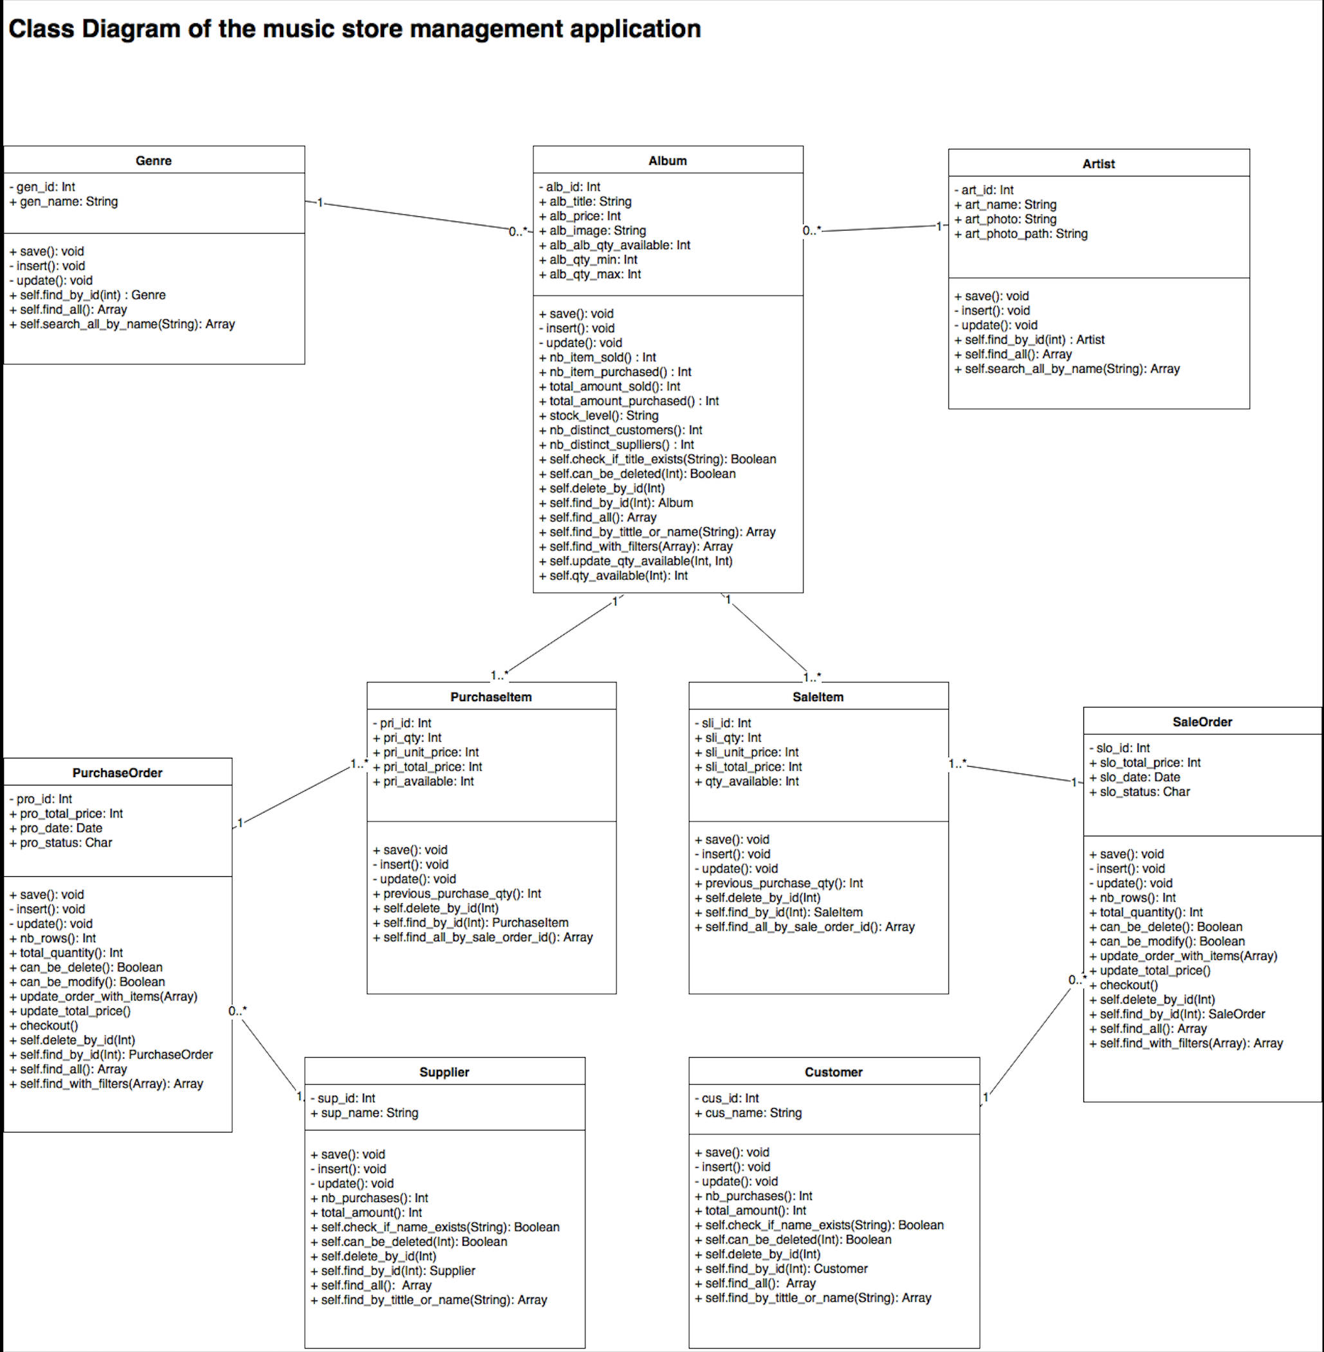

  - A.D 3

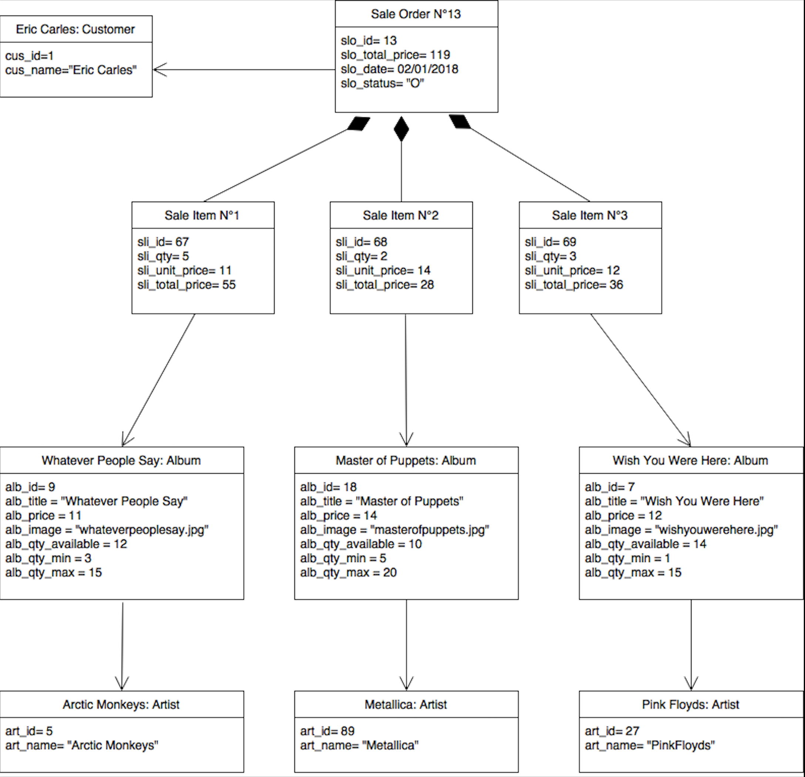

  - A.D 4
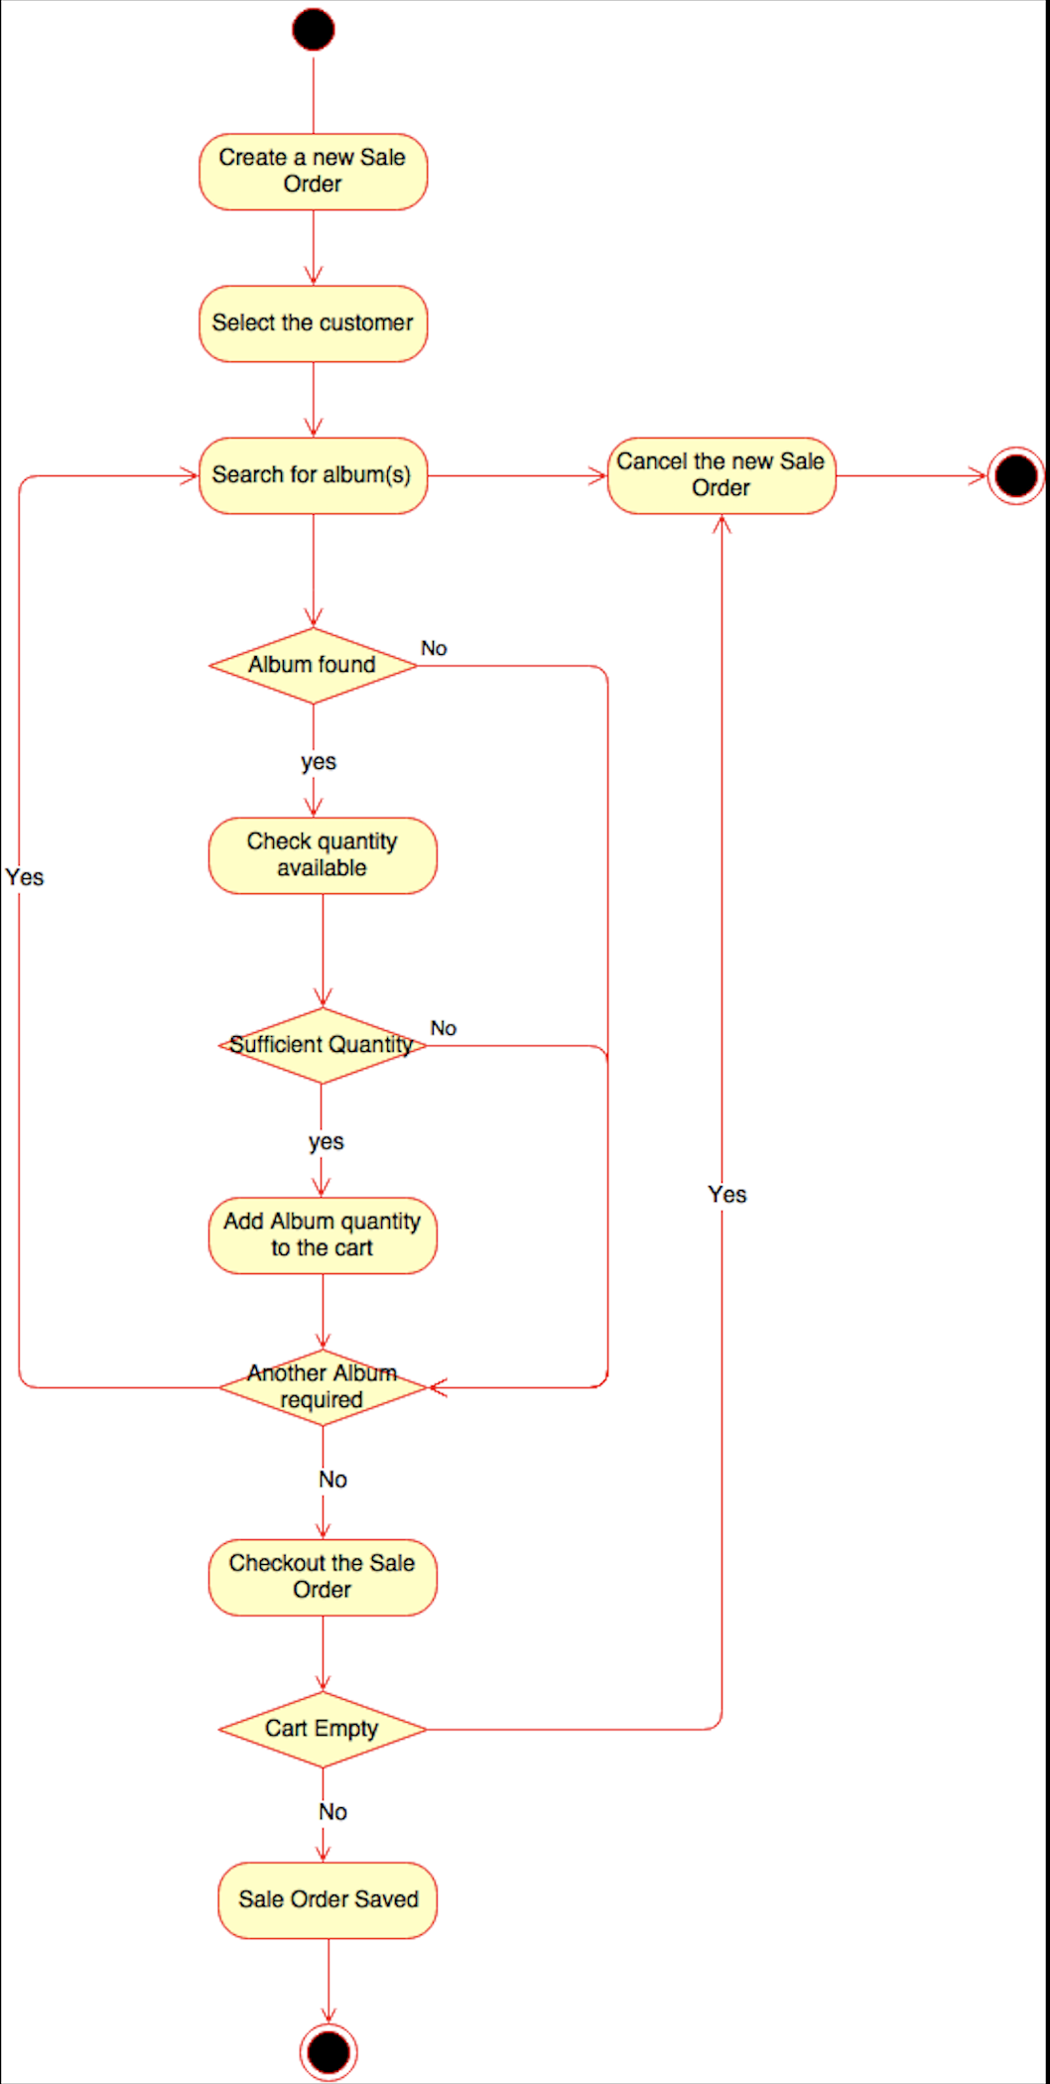
  - A.D 6

Topic | Possible effect of constraints on product | Solution
Hardware and software platforms | The software platform is made of Ruby without any Javascript. This induces that when the user performs an action then the whole page is reloaded. | Track the status of each page to be sure that after reloading the status page is still consistent.
Performance requirements | The Ruby language is not well-known for its performance and can induce a time lagging. | Limit the number of results on each page.
Persistent storage and transactions | The data like the artists, the albums, the album sales and purchases must be persisted. | Use the “postgresql” database as a support for persistence.
Usability | The application might be used with different screen resolutions. | Implement responsive user interfaces.
Budget | The cost of licenses must be £0. | Use only free frameworks and tools like the Ruby Sinatra framework and Atom as an IDE.
Time limitation | 1 week project. | Ordered the functional project priorities relying on the “MosCow” approach.

  - P 5

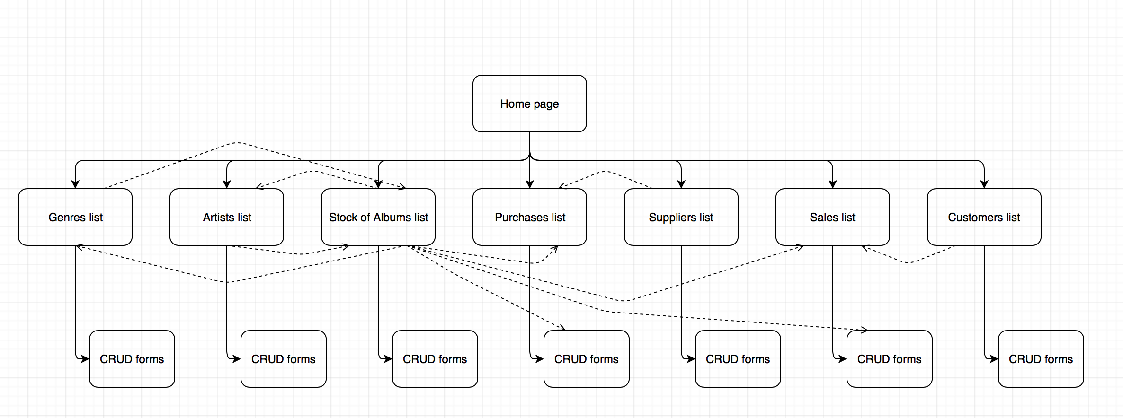
  - P 6

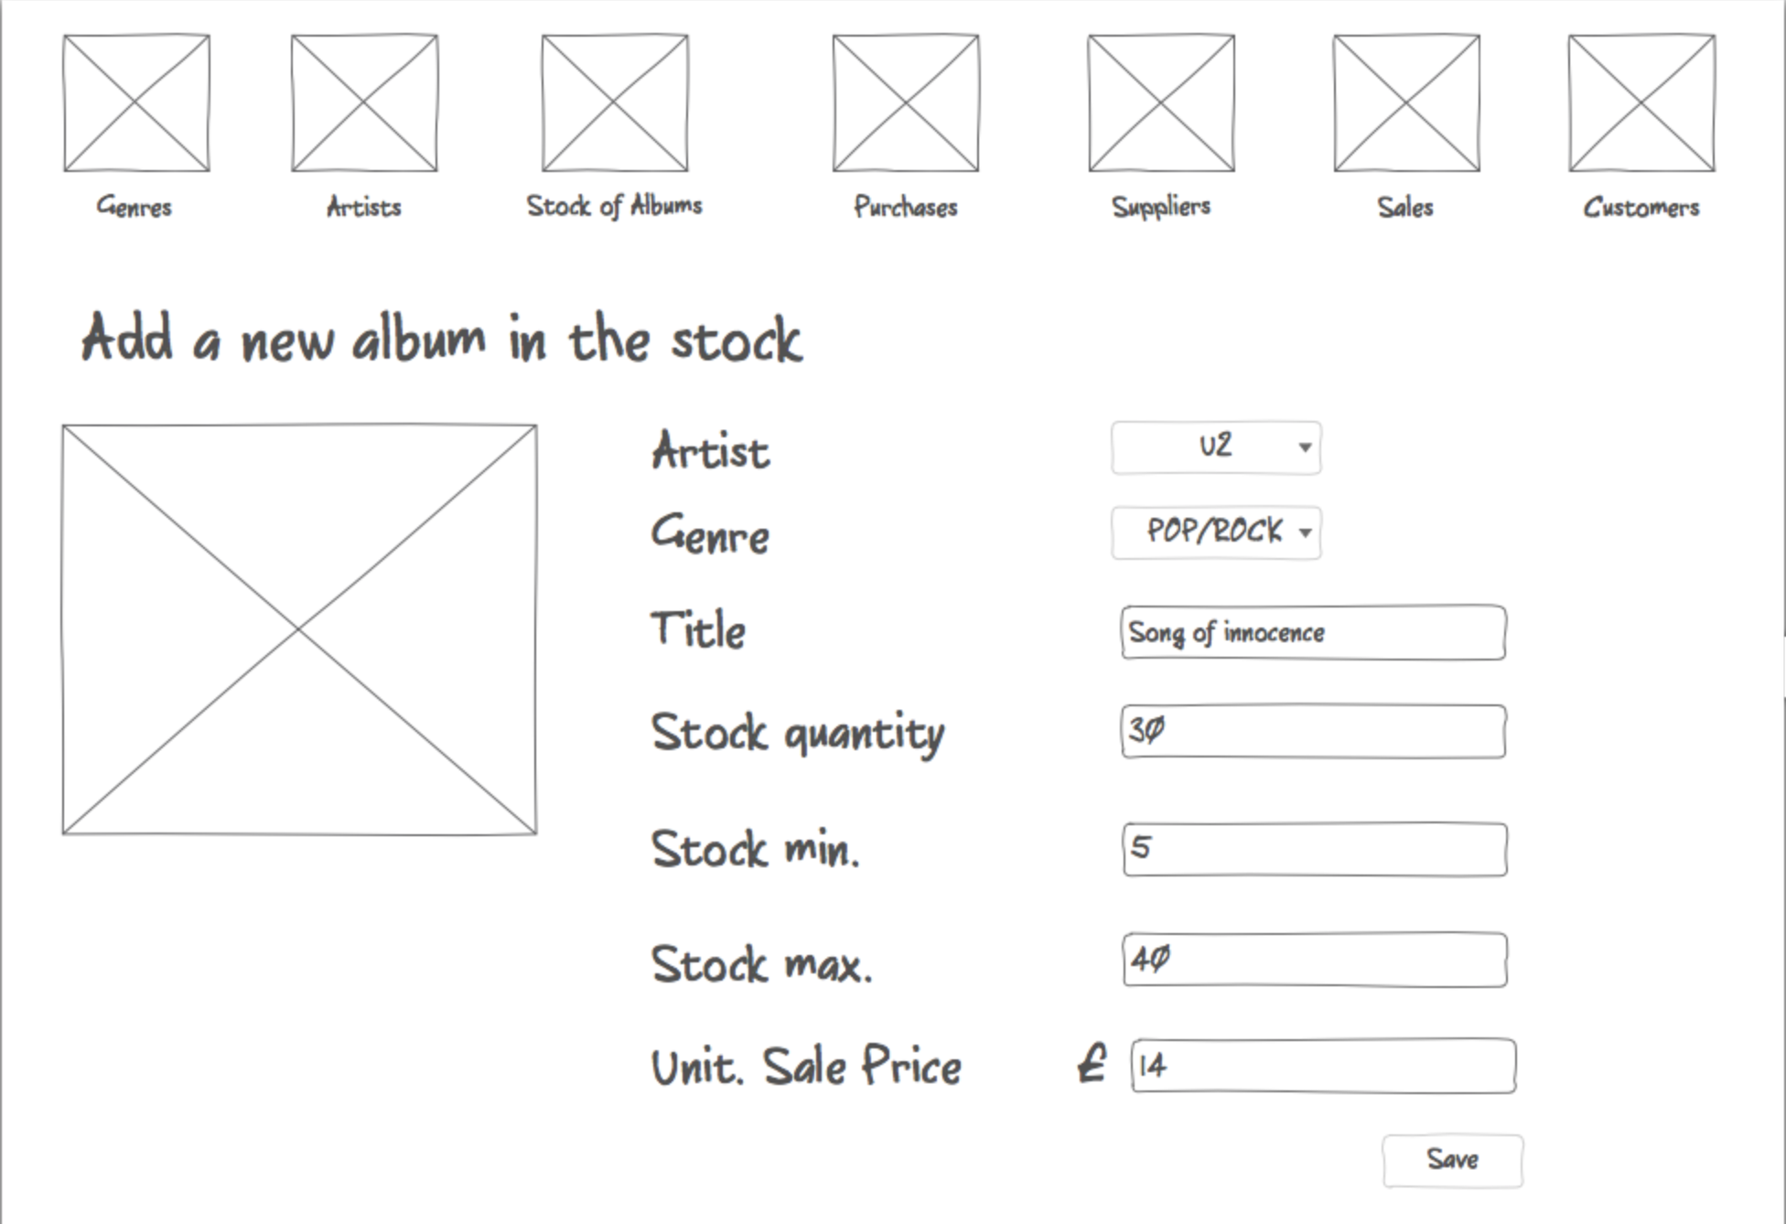Wireframe N°1/2 : Create/Modify an album

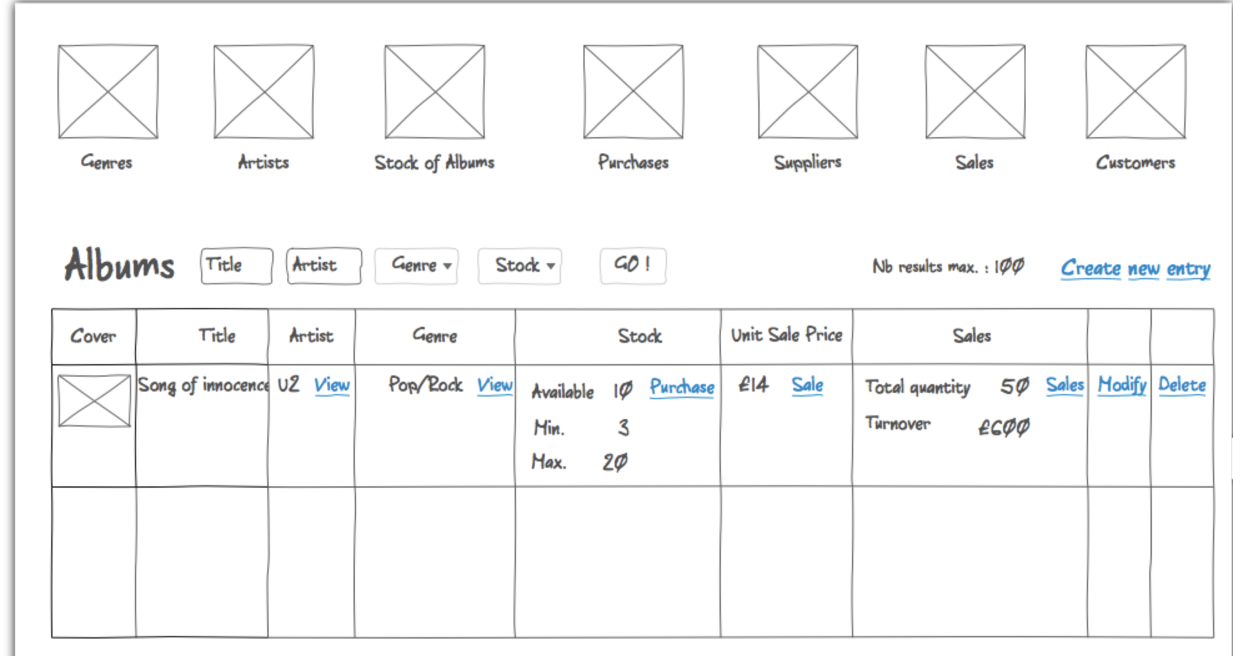Wireframe N°2/2 : List of albums in stock
  - P 10
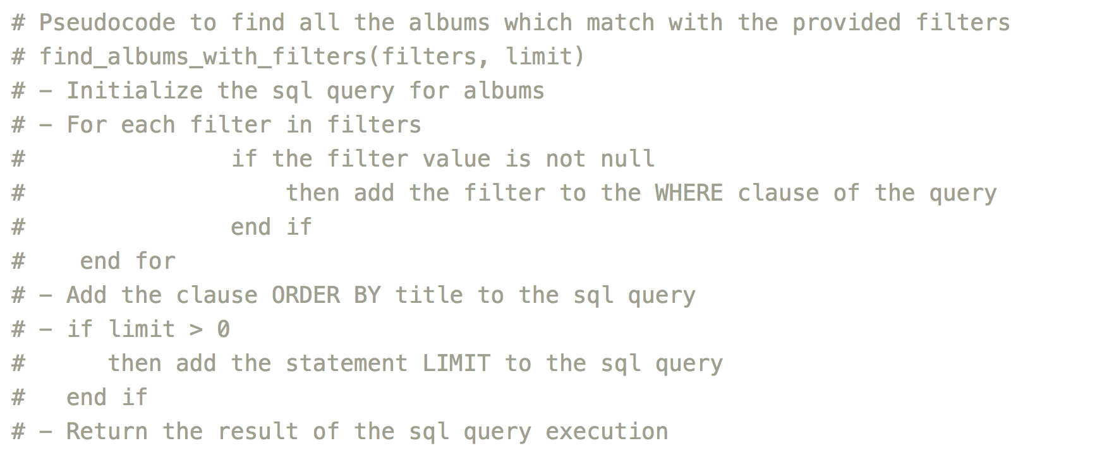
  - P 13

The manager creates a new stock entry for the album “Wish You Were Here” :
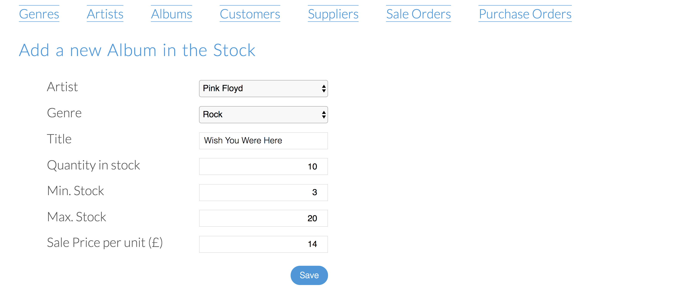
As a result, the new album is now present in the stock :
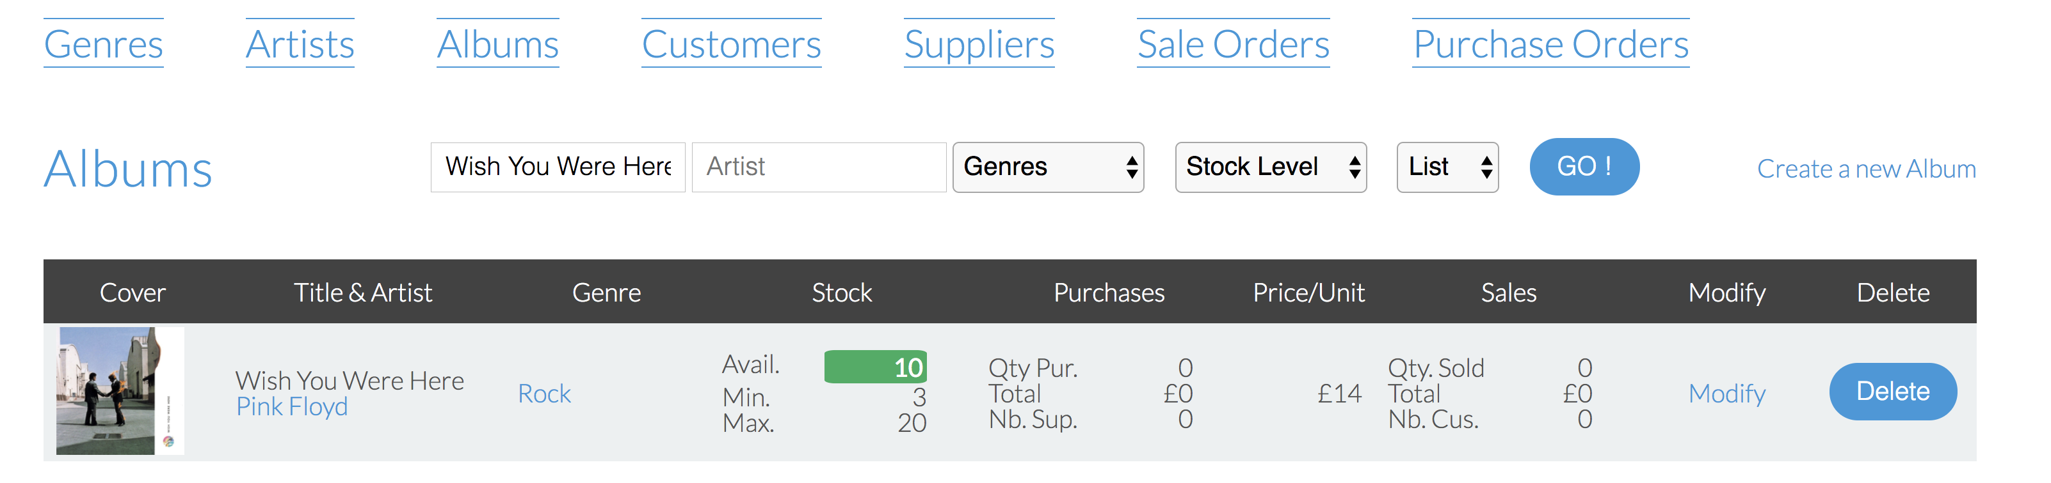

  - P 14

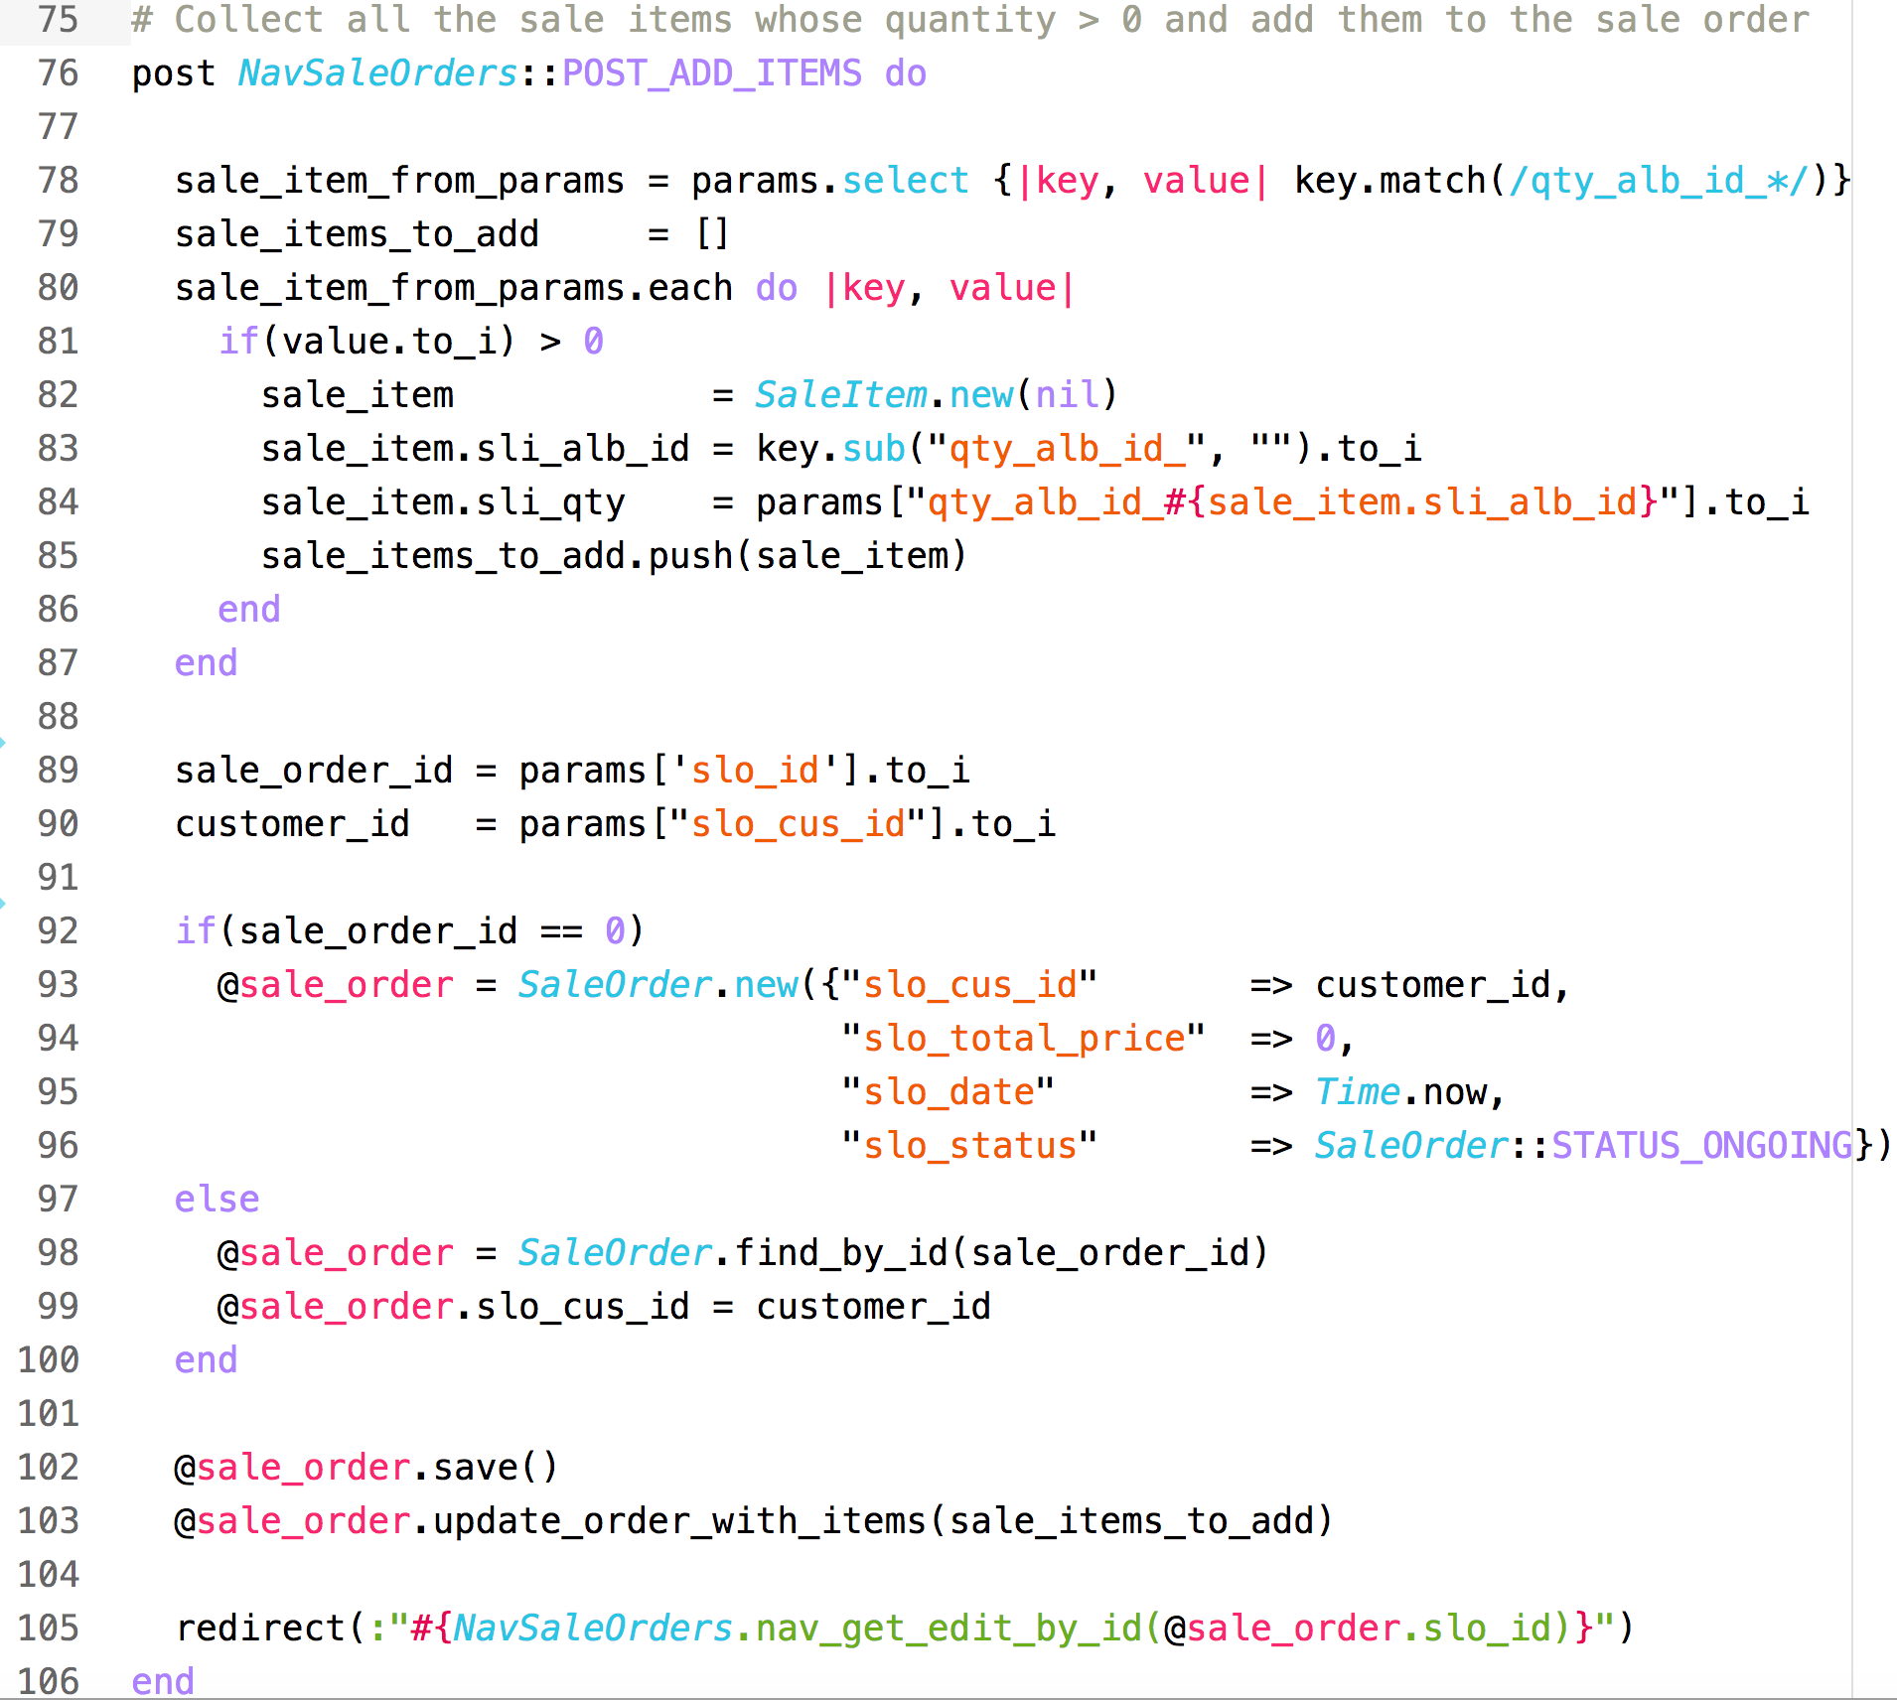
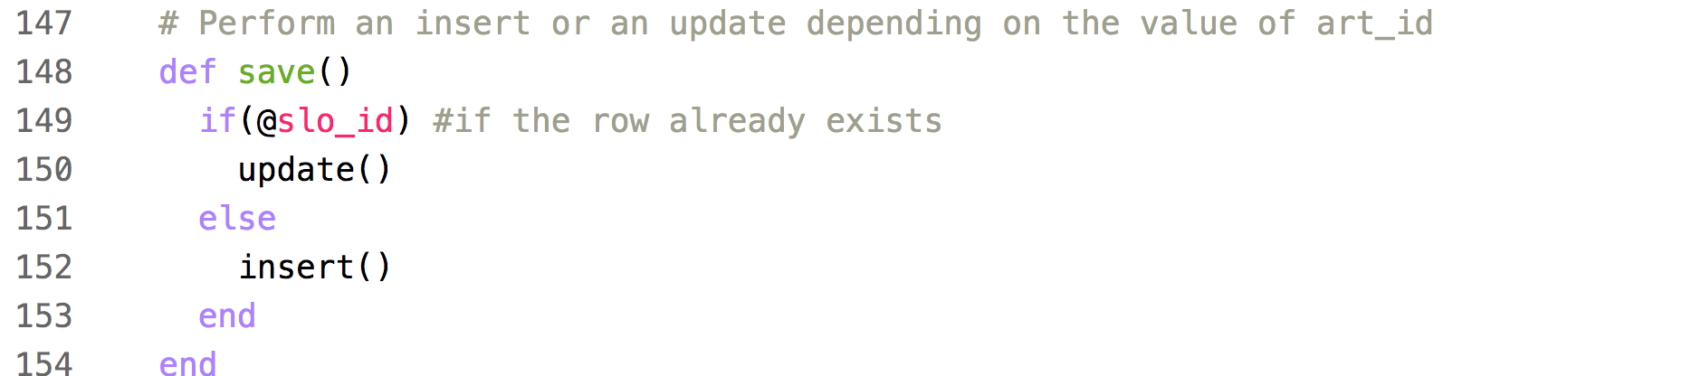

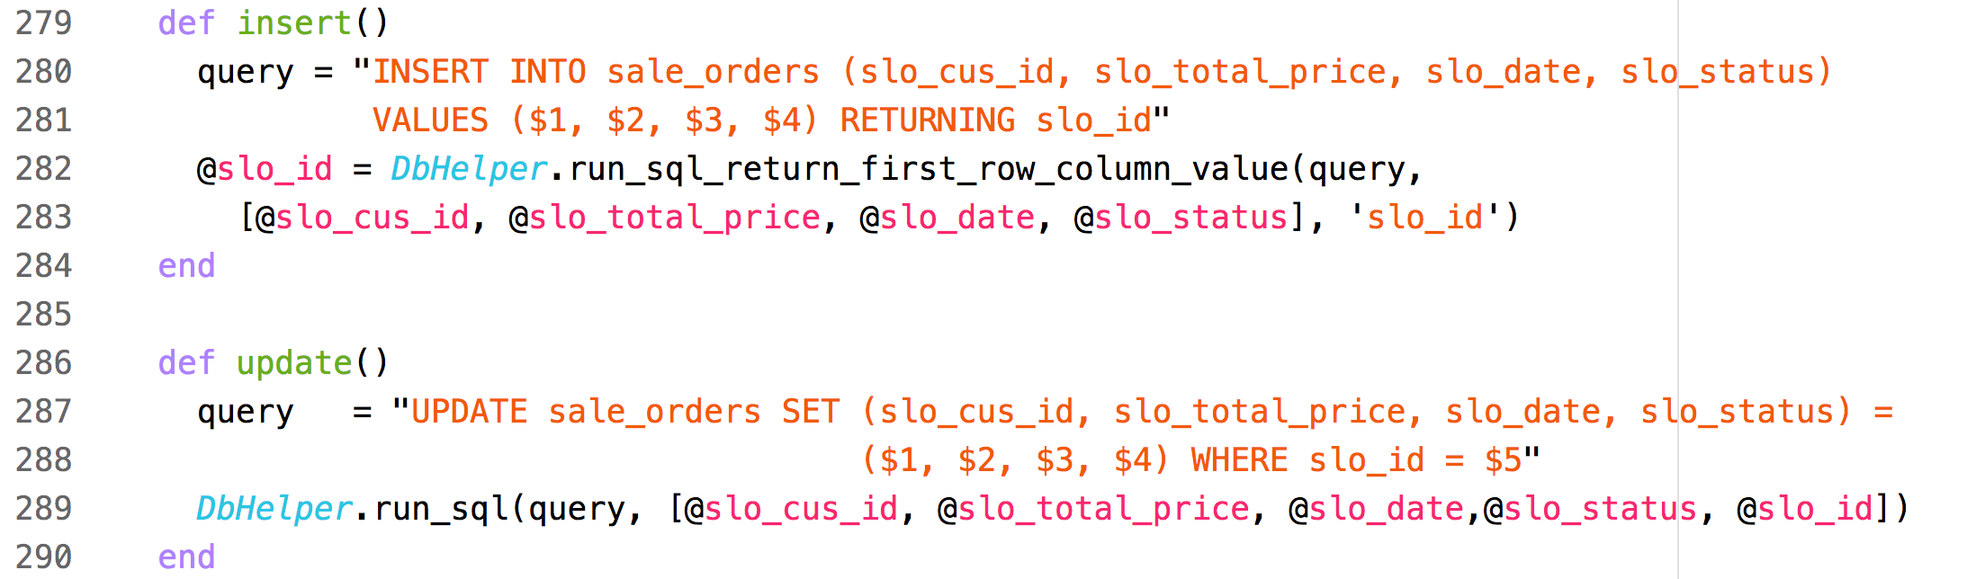
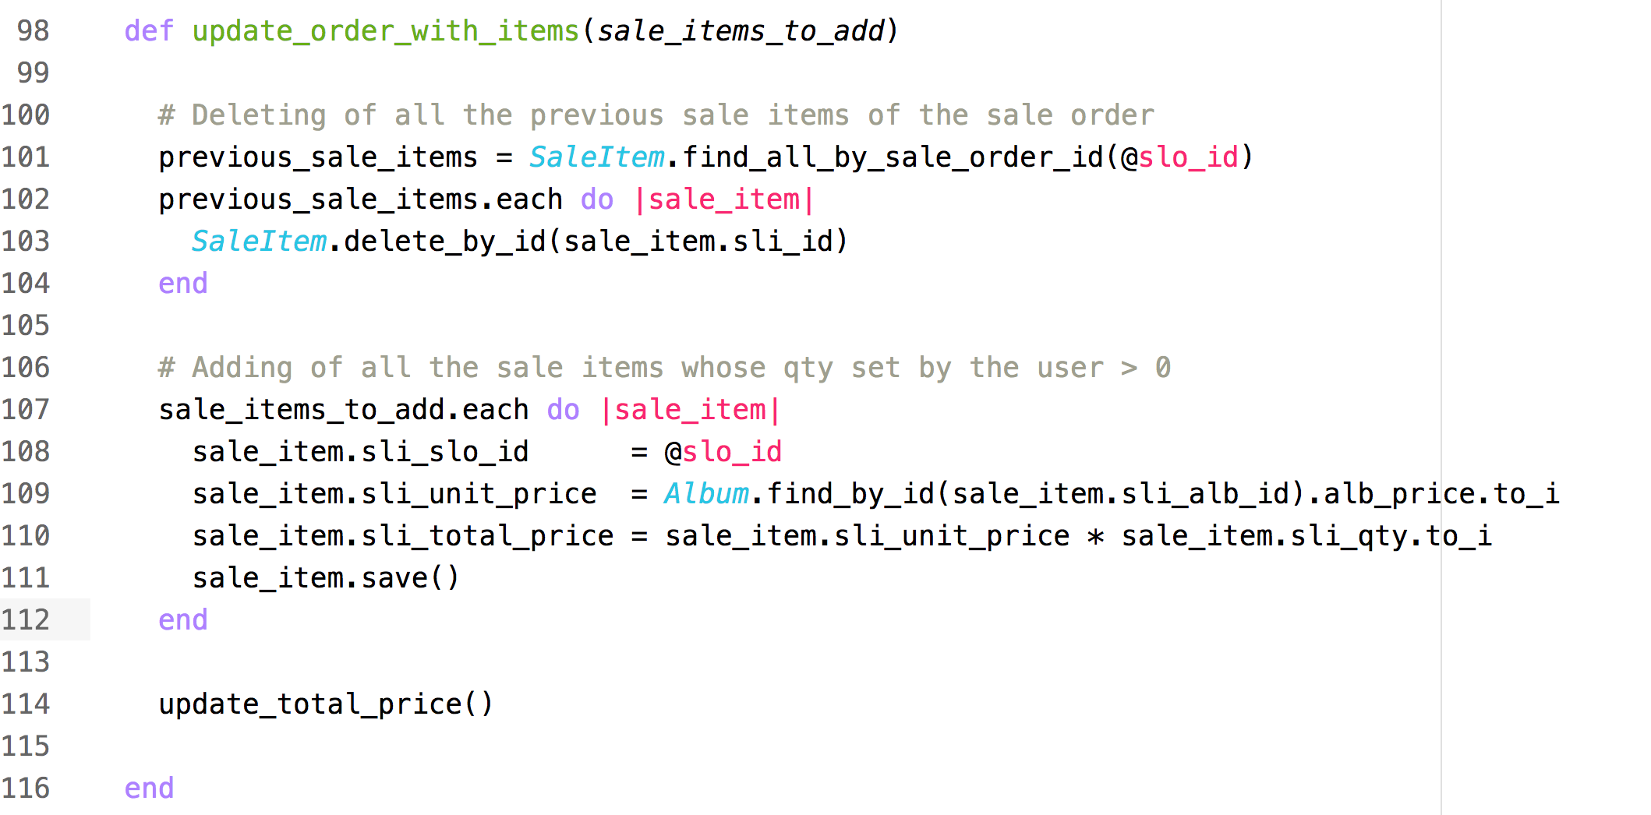

  - P 15

The manager of the music albums store wants to select the albums whose kind is “Pop” and which are running low :
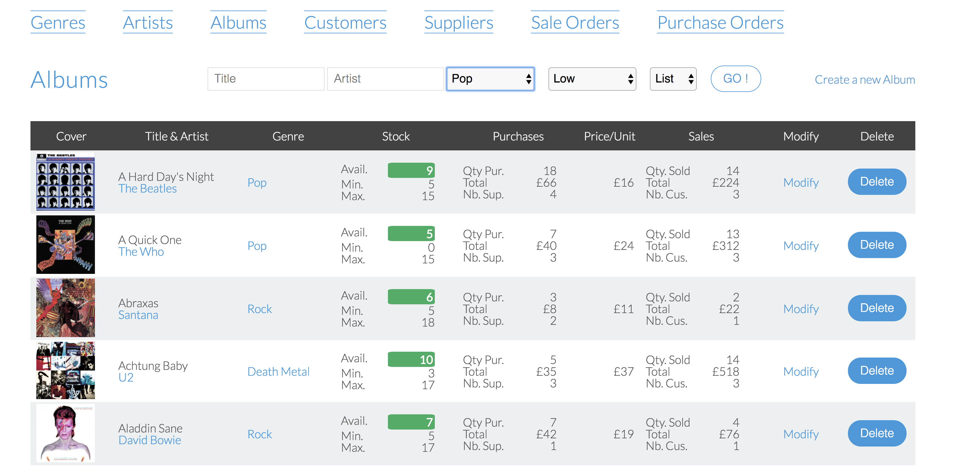
As a result, the list of the matching albums is displayed :

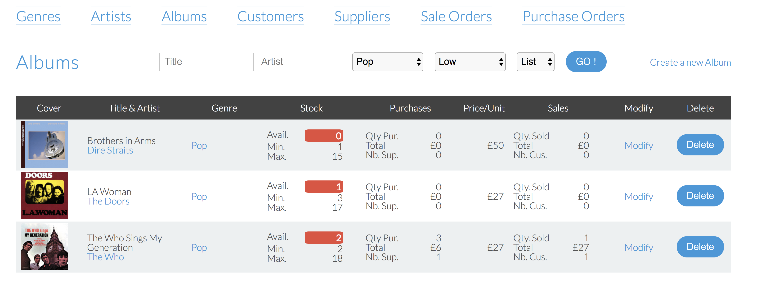

  - I.T Task A

Please check https://github.com/BlueMorning/Eric_Carles_E18_PDA for the Task A.

The 3 tests which fail :
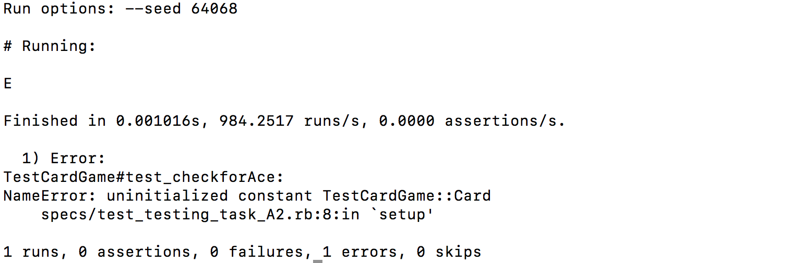

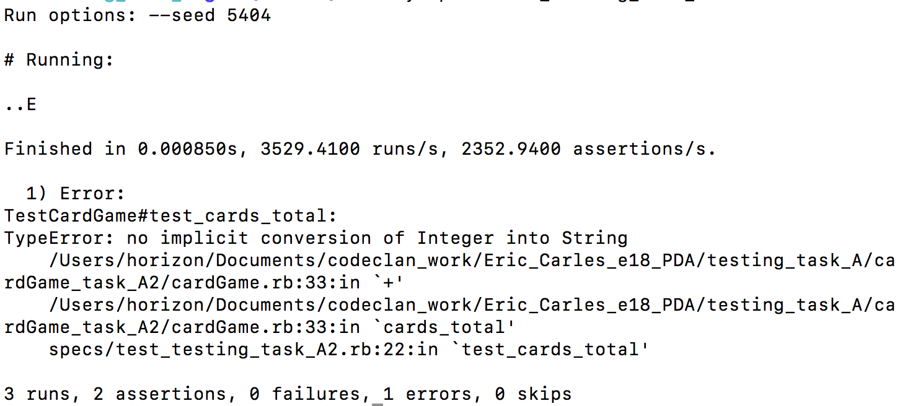
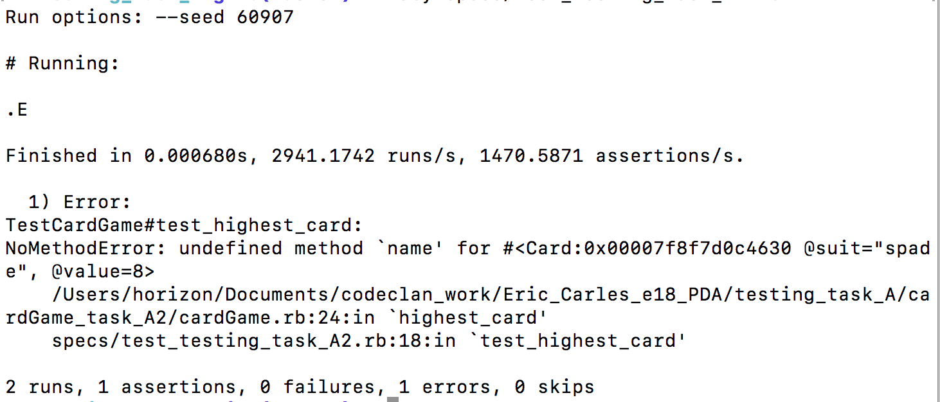

The 3 tests which pass :

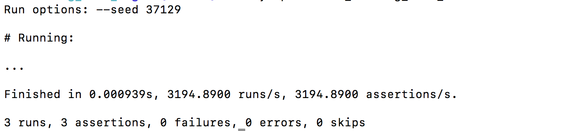
- Week 6
  - I.T 7
1) The class “Game” contains a list of Heroes which are “Damageable” (they can receive damages).

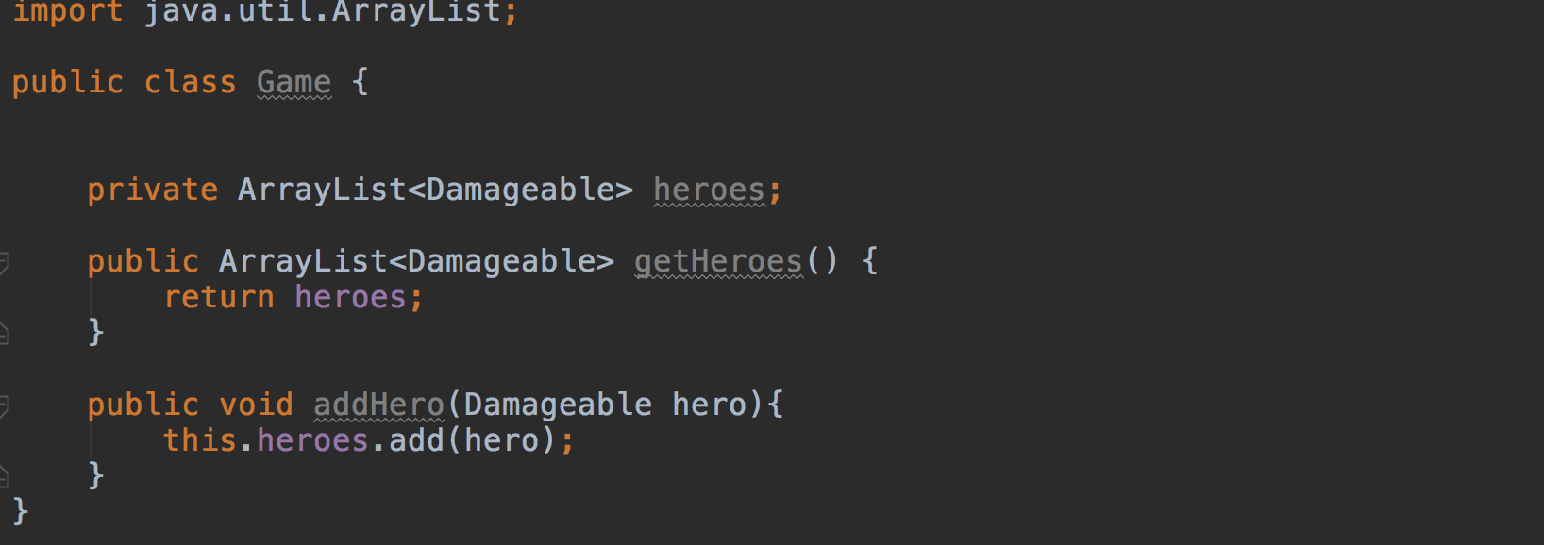
2) Both classes Warrior and Wizard implement the “Damageable” interface.

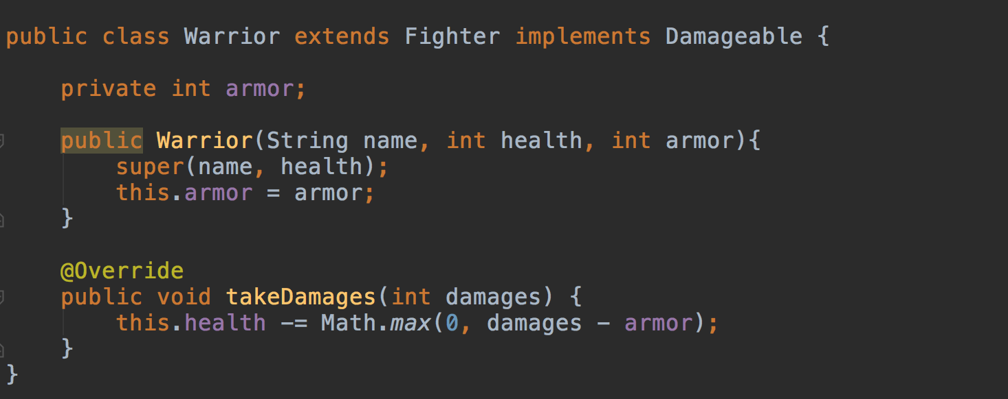
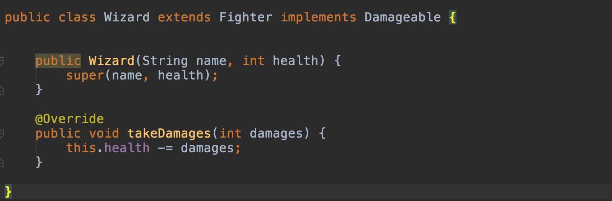

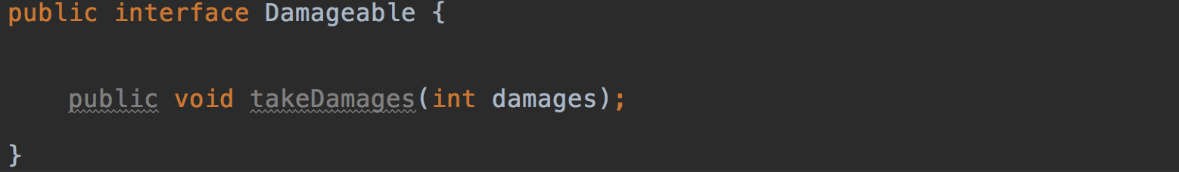
3) The “Damageable” interface contains an abstract the “takeDamages” method
- Week N°9
  - A.D 5
In this example, the class “Train” inherits from the abstract class “TransportVehicle”

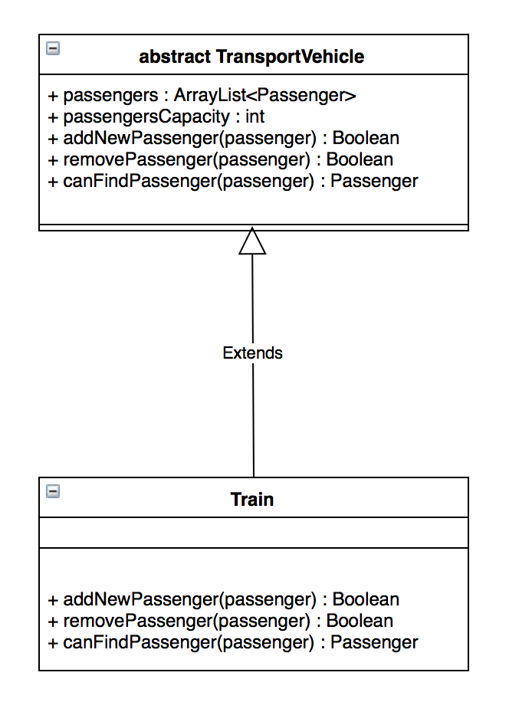
  - I.T1
The “TransportVehicle” class is an abstract class whose properties passengerCapacity and passengers are declared “protected” and which contains 3 public abstract methods “findPassenger”, “addPassenger” and “removePassenger”.

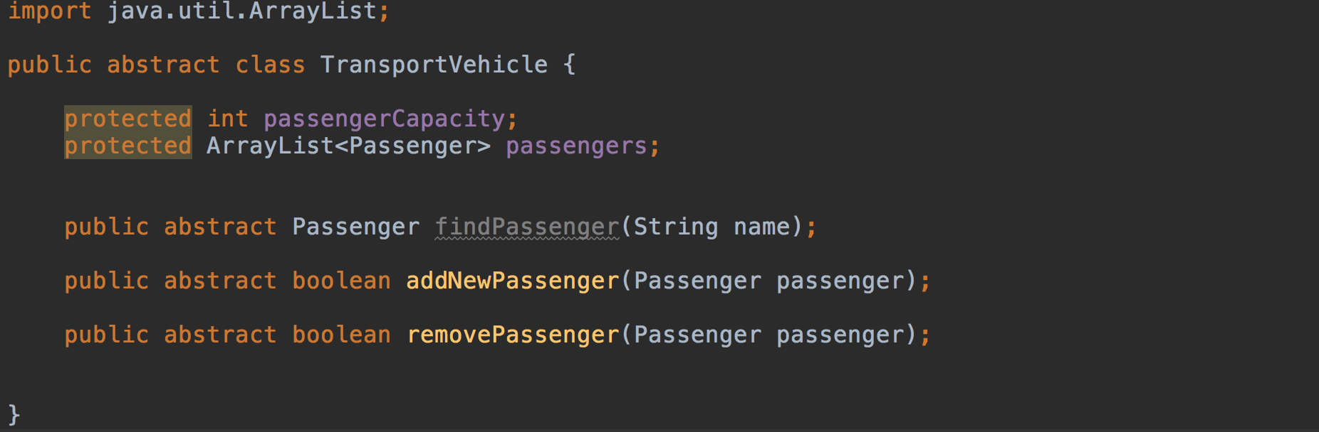

In this second example, the class Passenger has a property “name” which is declared as private thus it's visibility is limited to the class itself. The public method “getName” provides a way to other classes to get the name of the passenger.

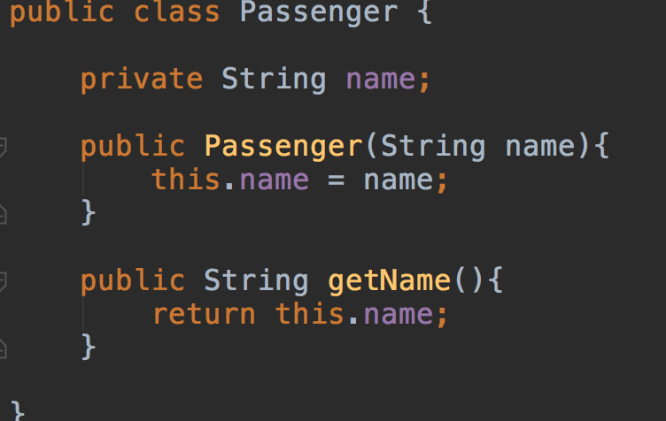

  - I.T2
The “TransportVehicle” class is an abstract class.
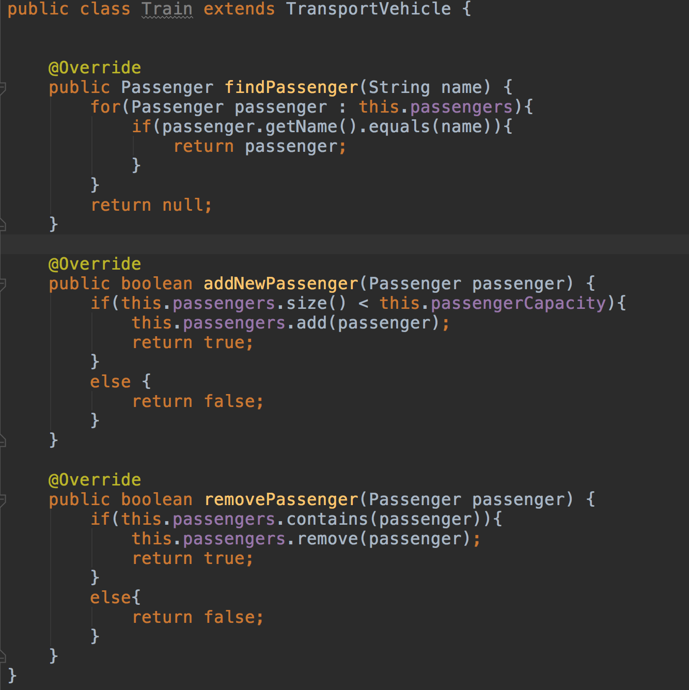
The “Train” class inherits from TransportVehicle with the keyword “extends” :

The “Train” class uses the property “passengerCapacity” and “passengers” inherited from the “TransportVehicle” class to manage the passengers who get on or off the train and overrides the methods : “findPassenger”, “addPassenger” and “removePassenger”.

The testing files for this inheritance demonstration are :

1) Testing file for the passenger

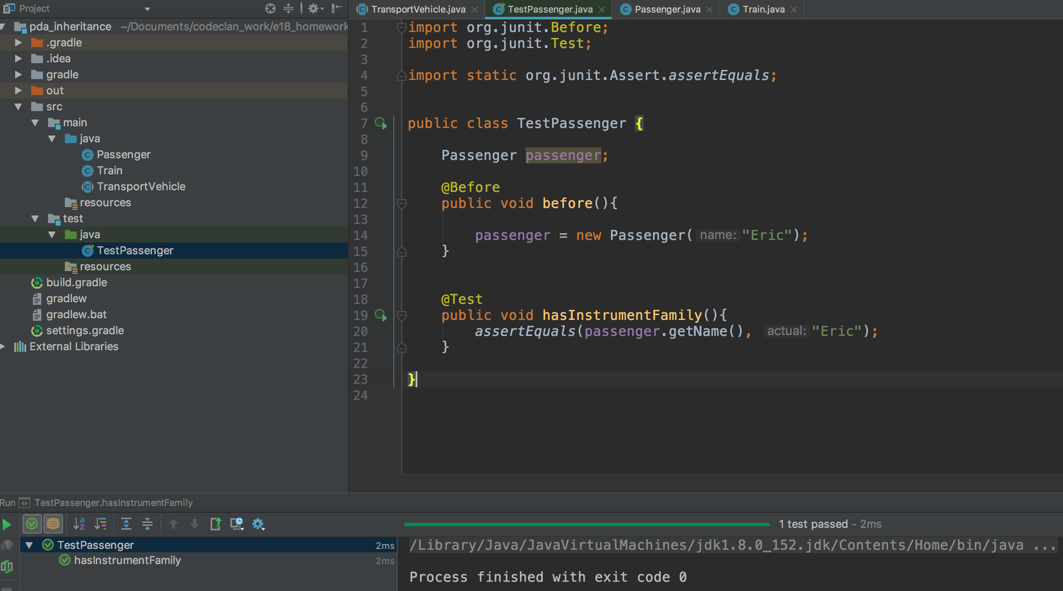

2)
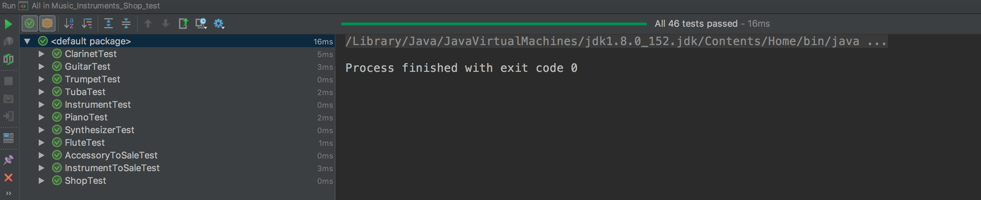
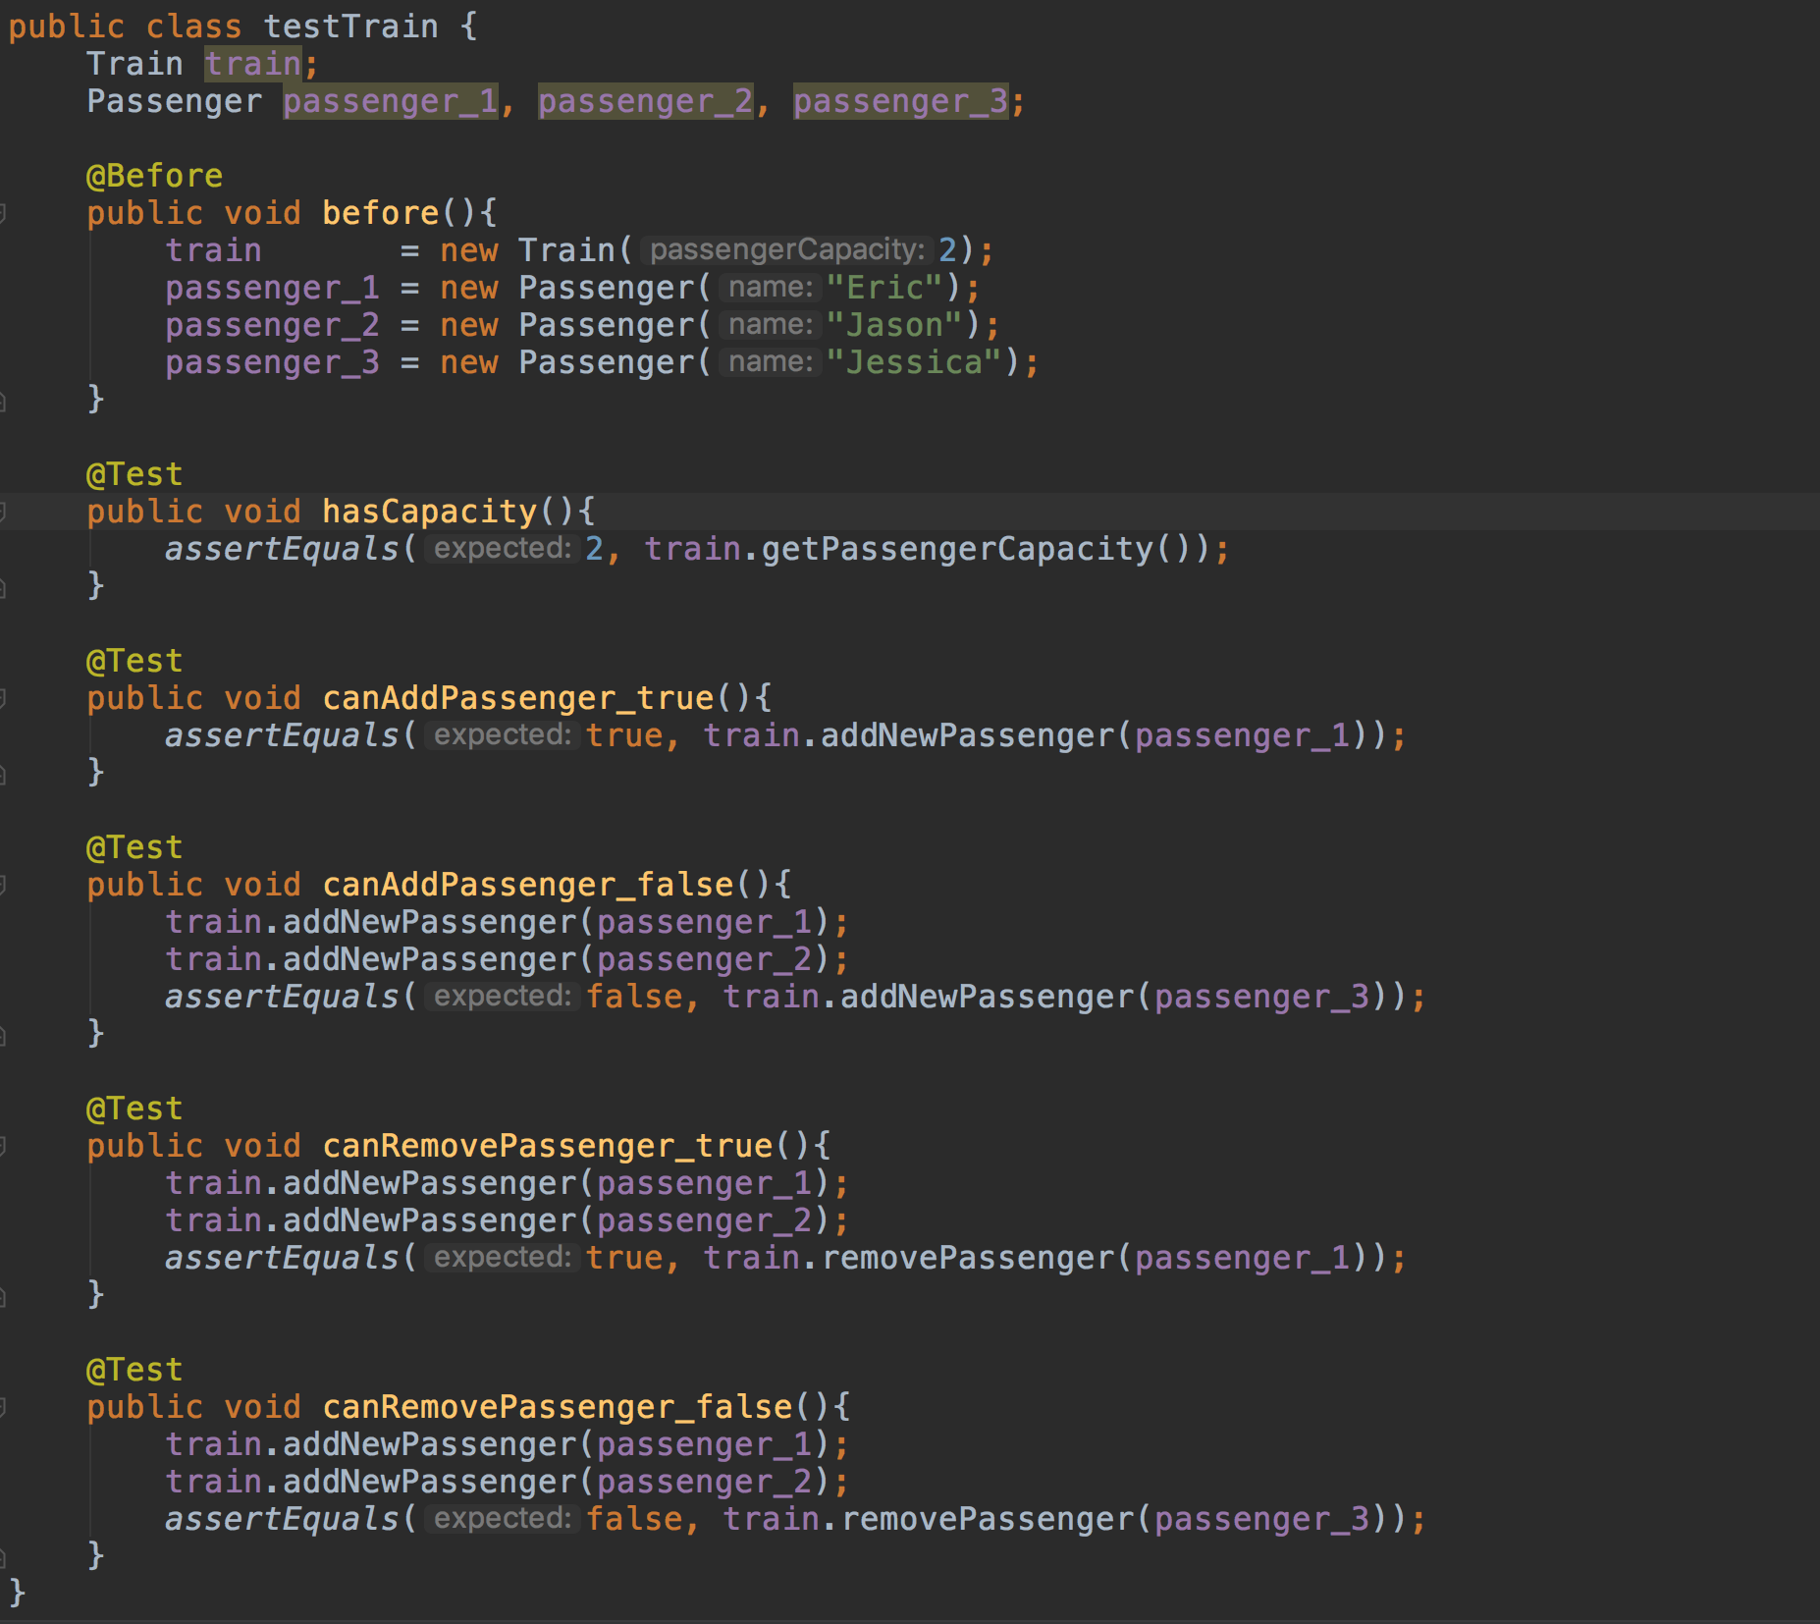
2) Testing file for the Train class which extends TransportVehicle
  - P 11

https://github.com/BlueMorning/music_store_project

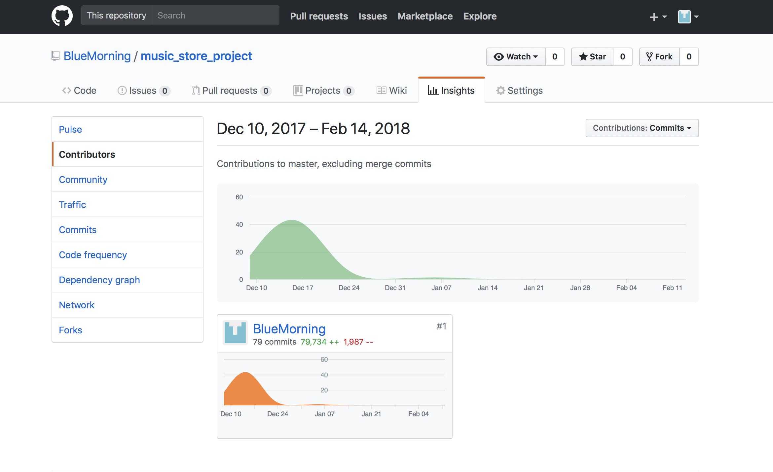

  - P12
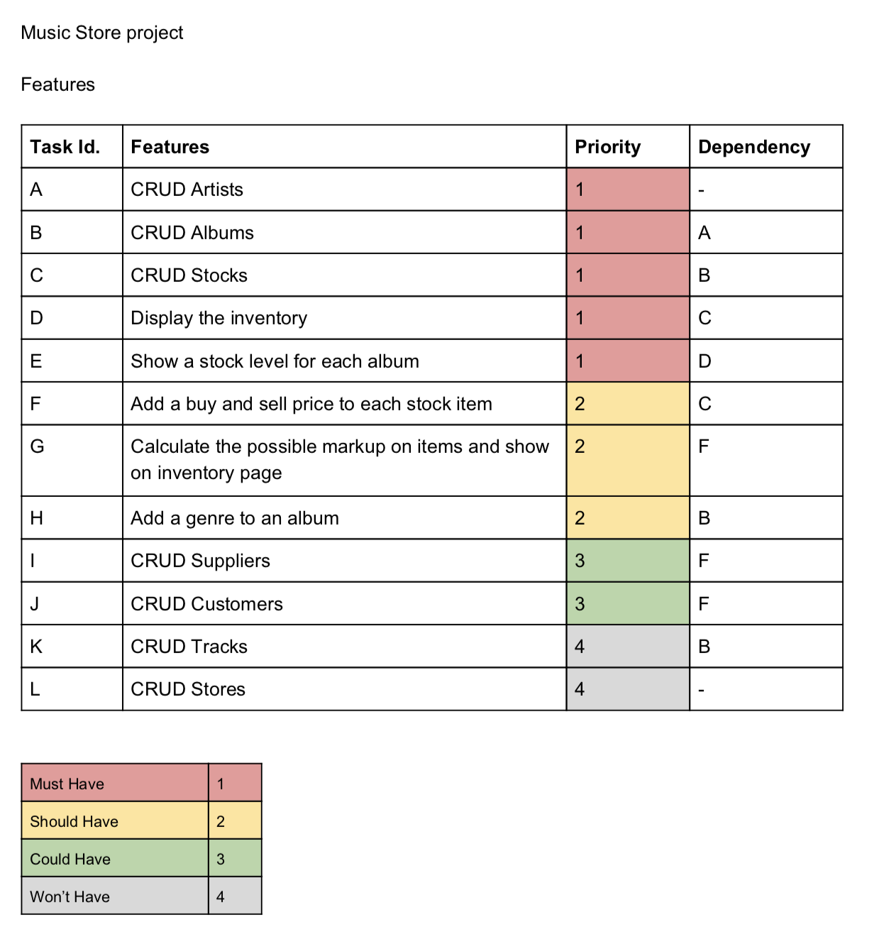
About the planning of the Music Store project, the features and their priorities are referenced in the table above :

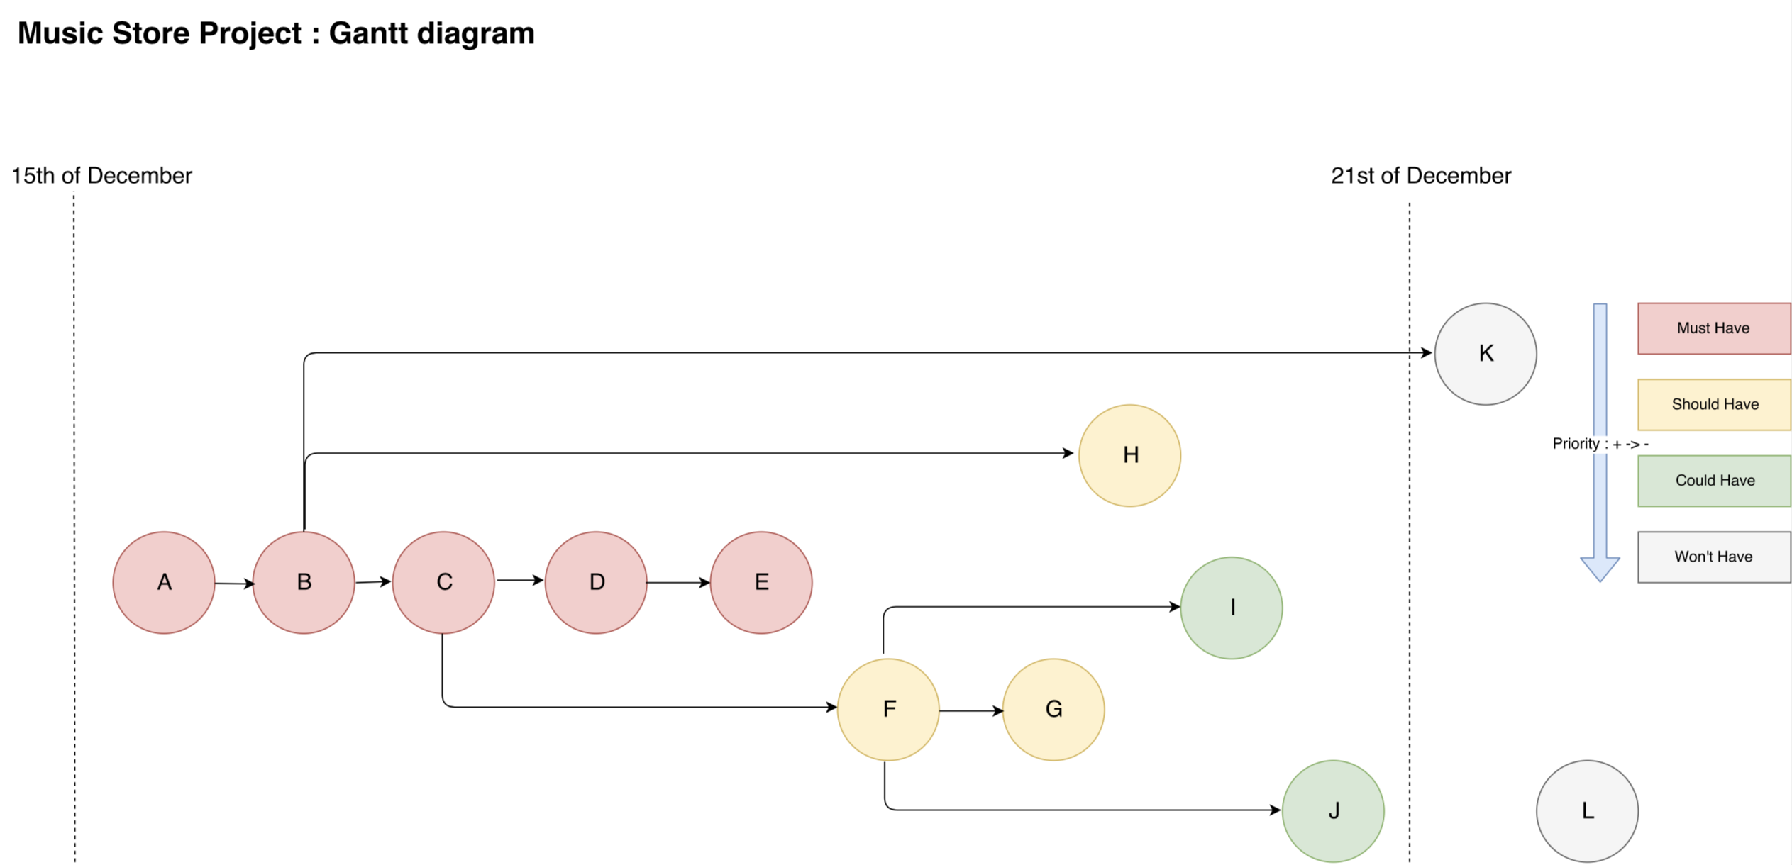
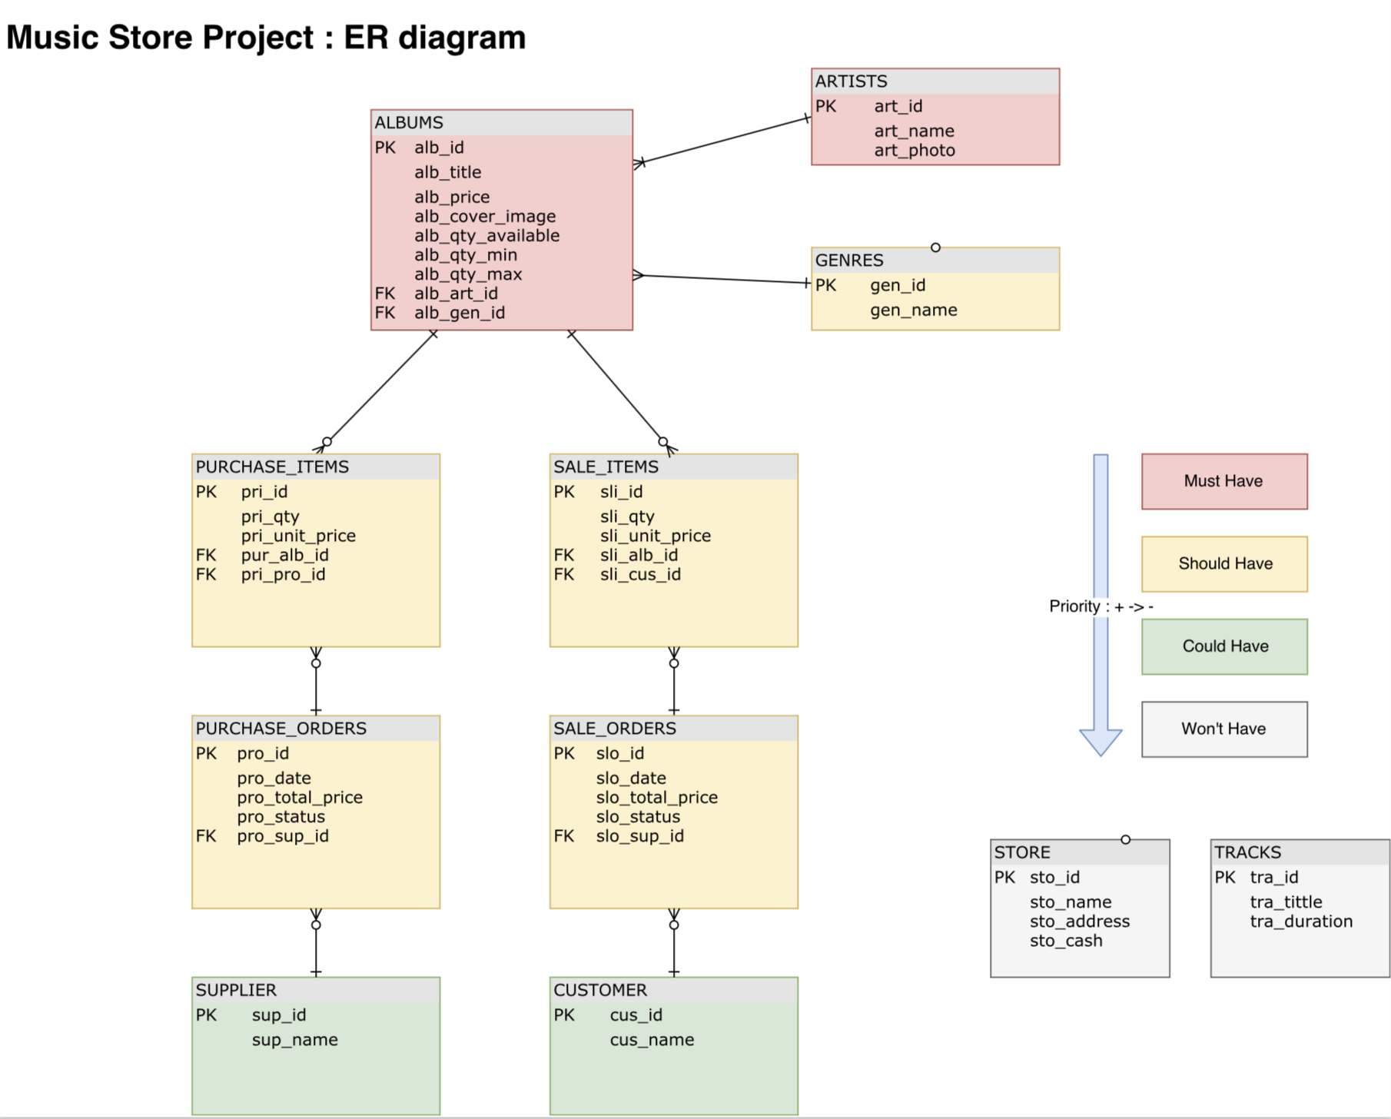
From the priorities and by following the dependencies between features, I drew this Gantt diagram to order the tasks :

The ER diagram describes the schema of the database in order to persist data fro the Music Store :

This stage of development was just after adding the list of albums :

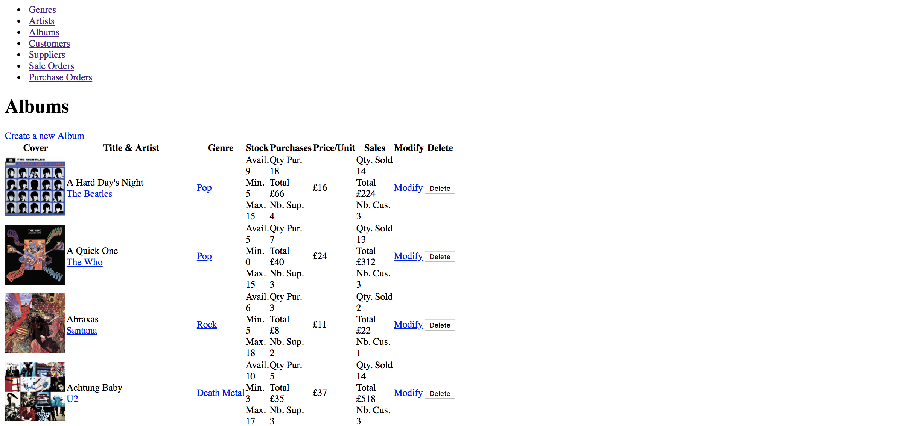
This stage of development was just after adding the form to filter the albums and the styling :

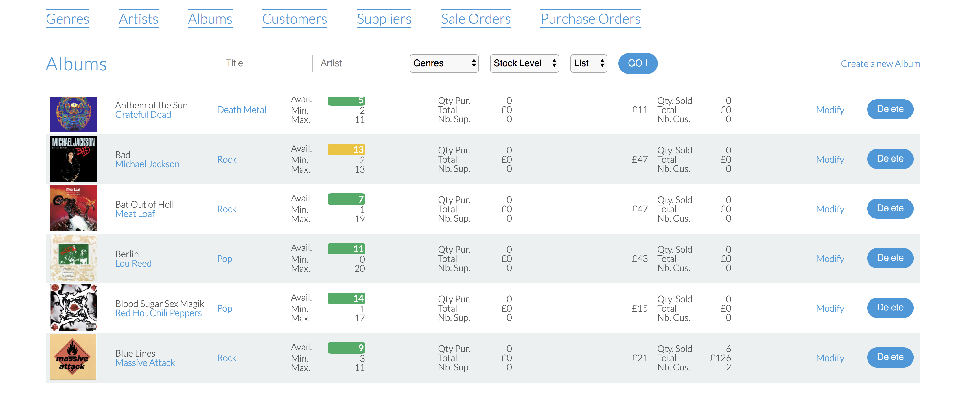
- Week N°11
  - P.18
The test code is the “getProposition” method which is expected to return a proposition as a String depending on the type of question answered :

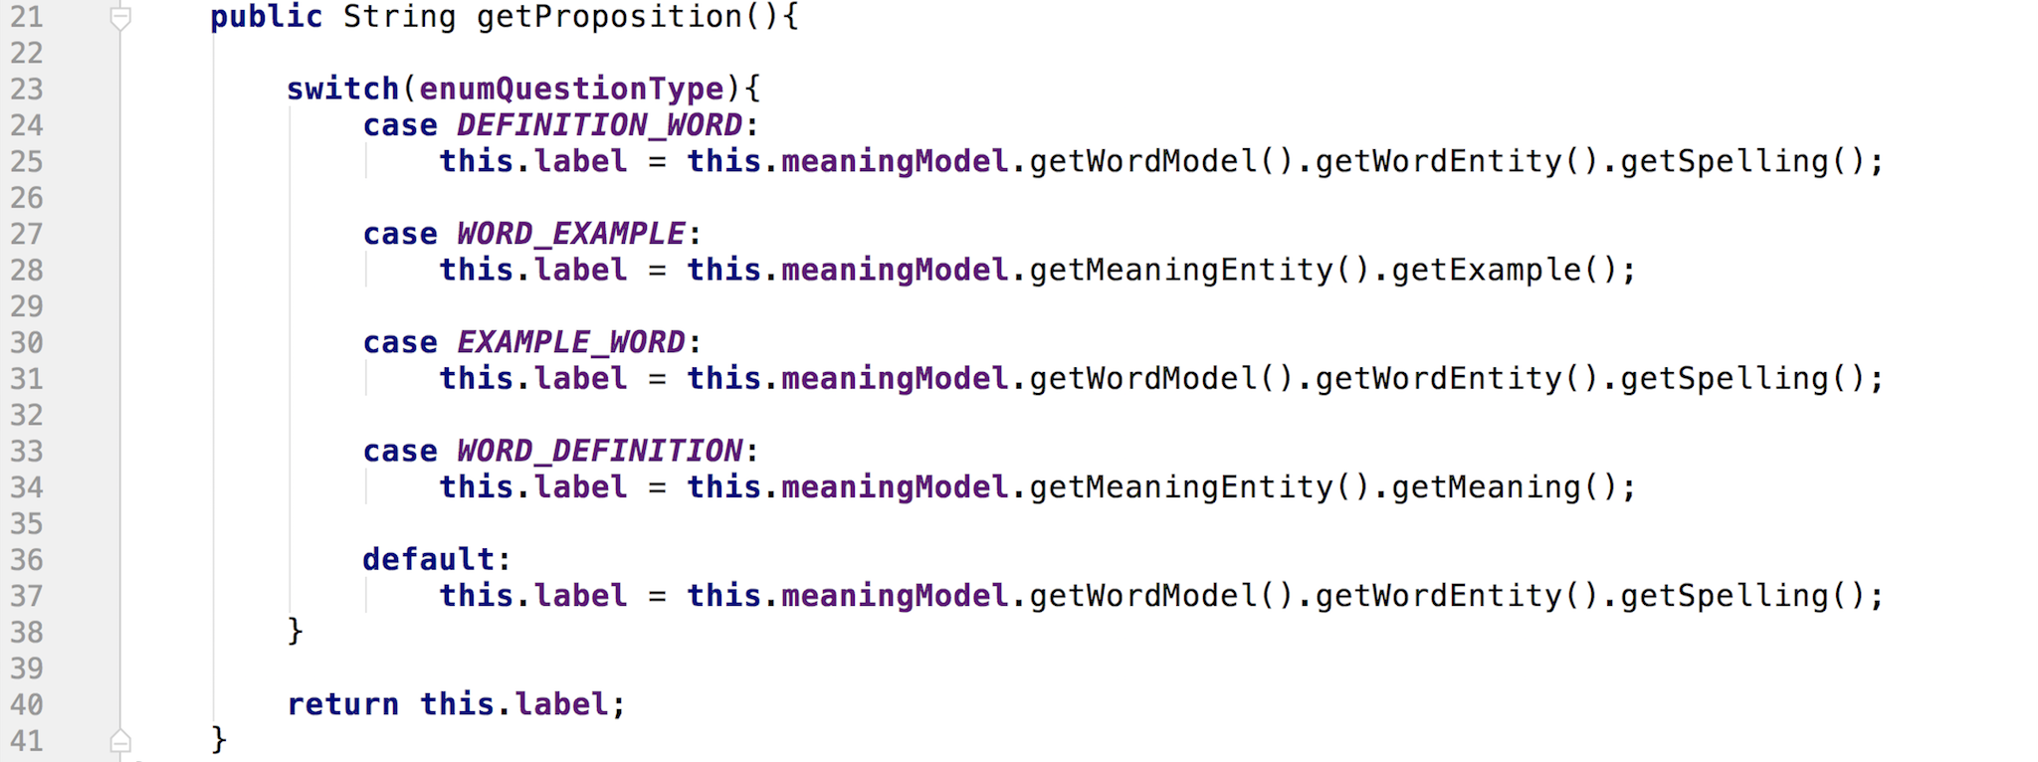
The test fails because the expected proposition does not match with the current proposition returned by the method “getProposition”

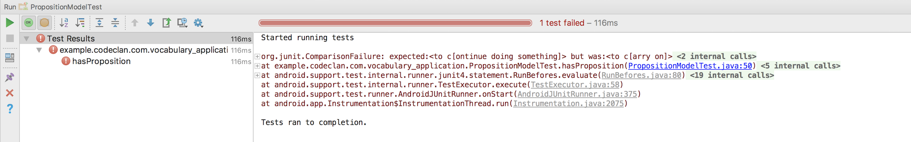

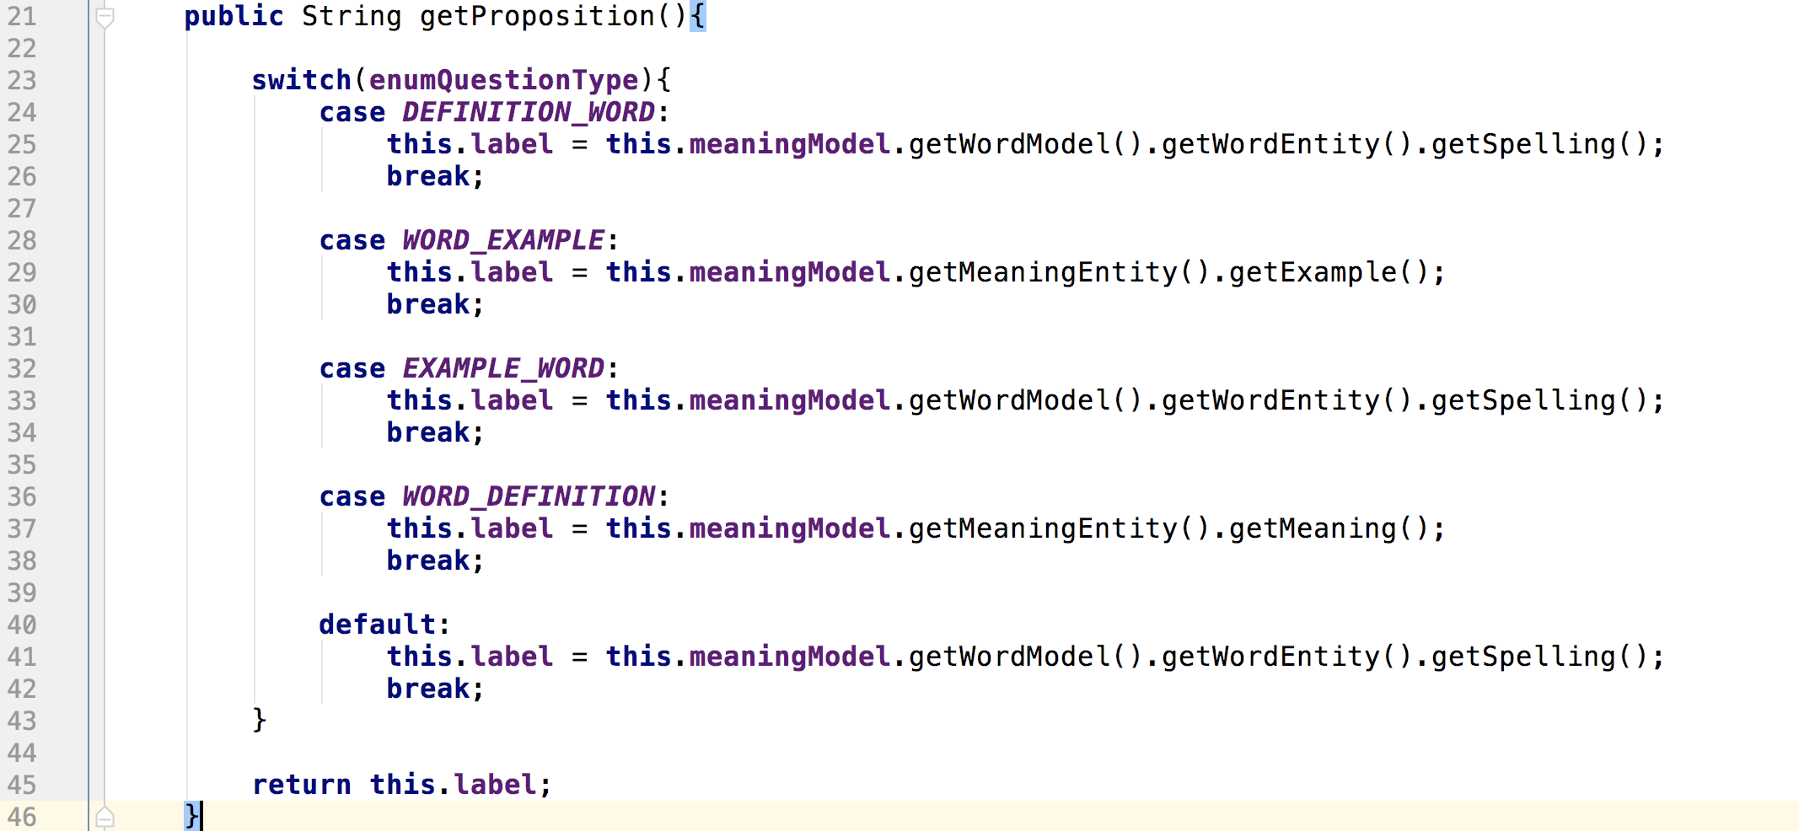
The “getProposition” method is fixed by adding the break statements which were missing for each “case” :

The test is passing after the correction :

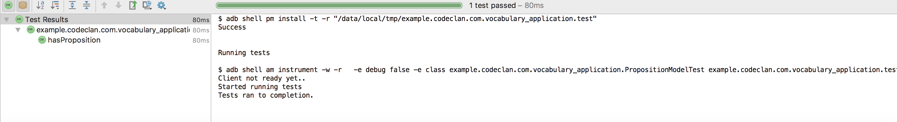
- Week 12
  - P16
The program uses a cryptocurrency API to collect some data like the current price, the intraday volume exchanged, the last 24h fluctuation.

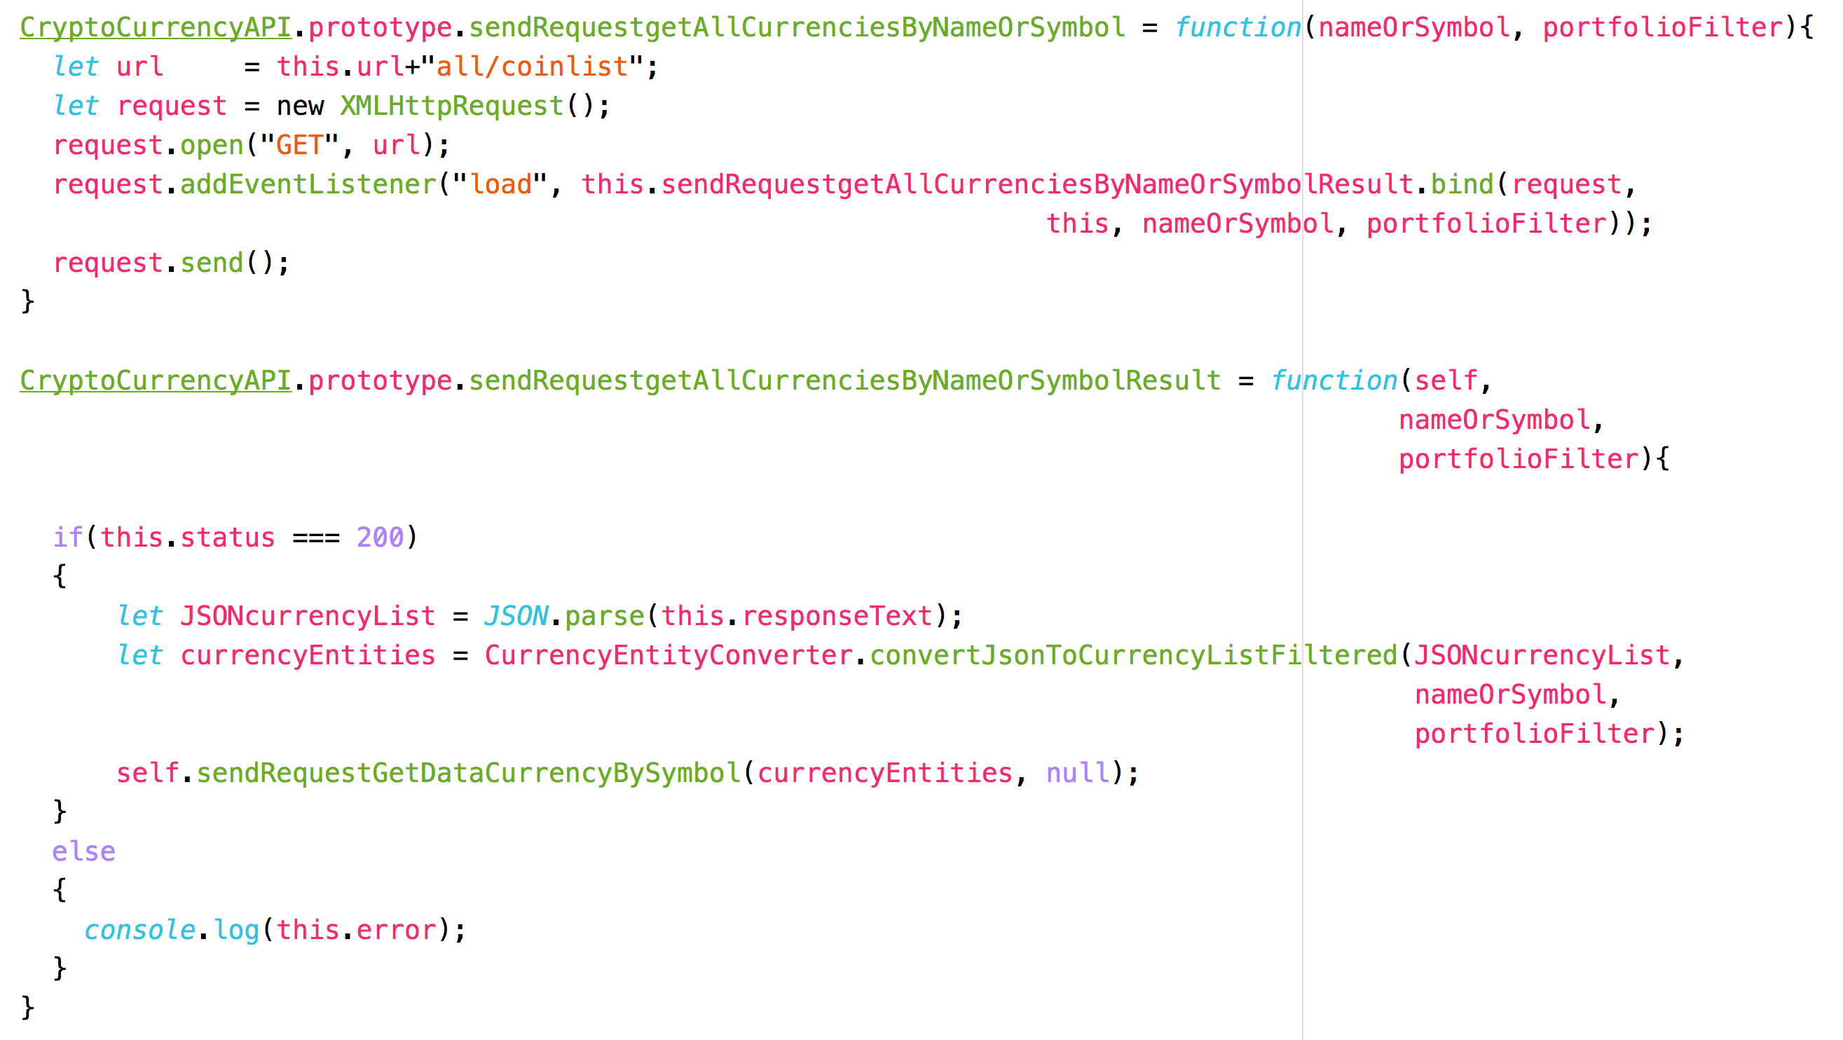
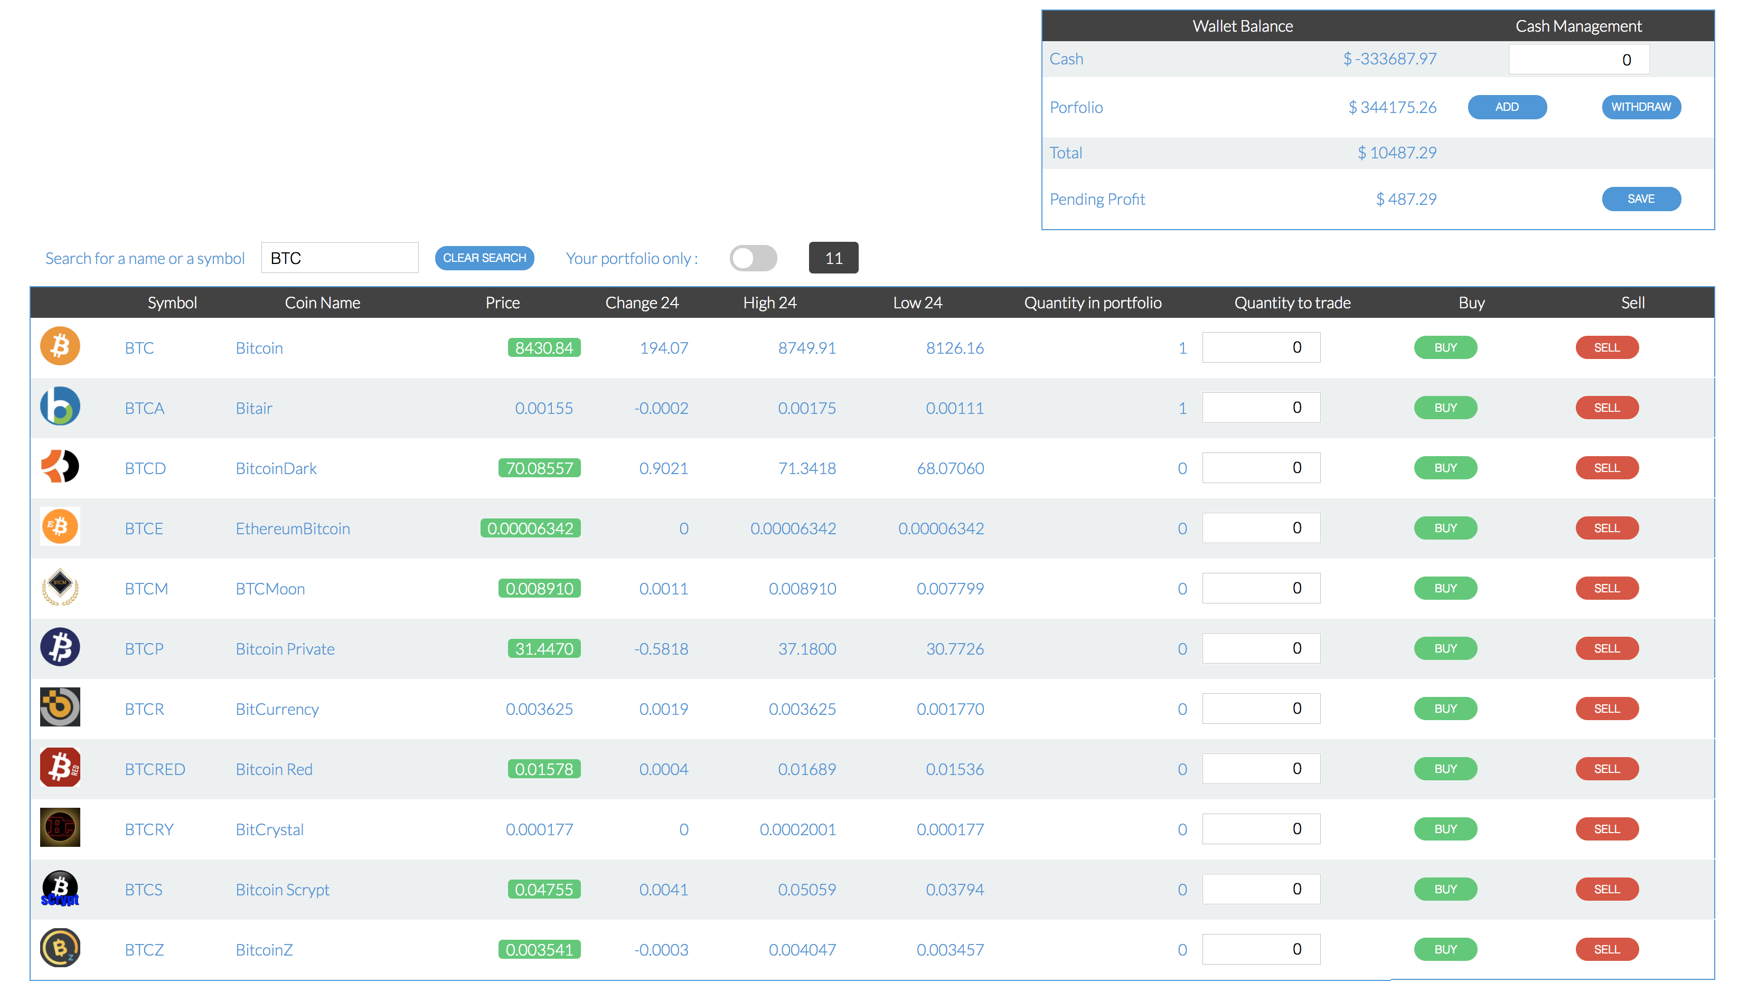
All these data provided by the API are rendered through this user interface which belongs to a portfolio management application :
- Week 14
  - P1
My profile is “BlueMorning” :
https://github.com/rossghill/CodeClan-Group-Project/graphs/contributors

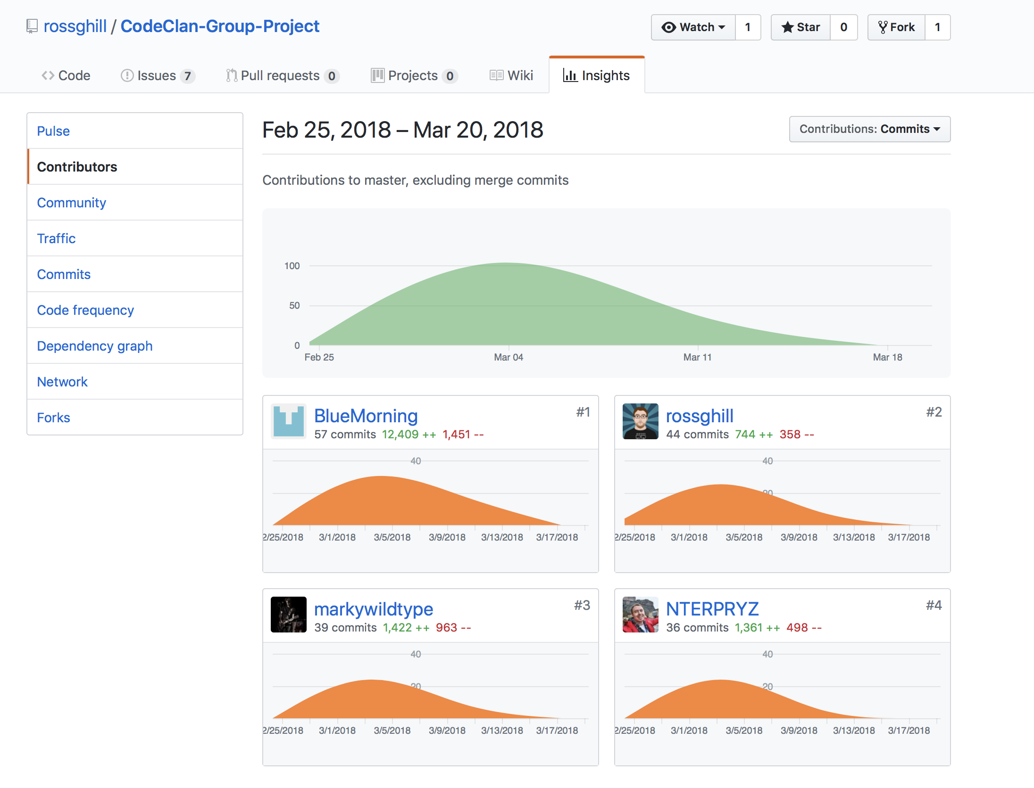
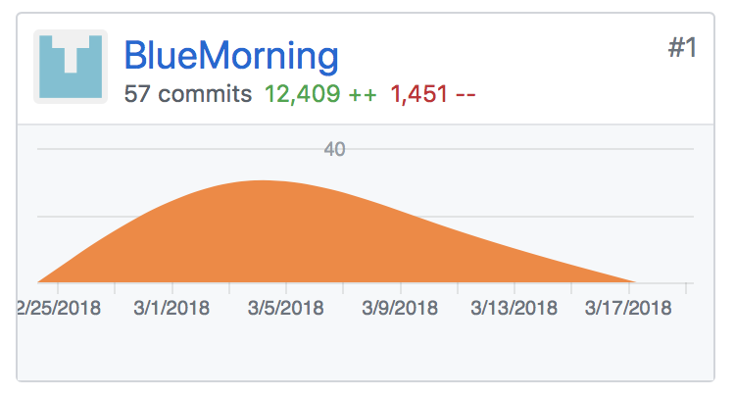

  - P2
This brief describes the expected MVP and extensions for our Travel Packages application :

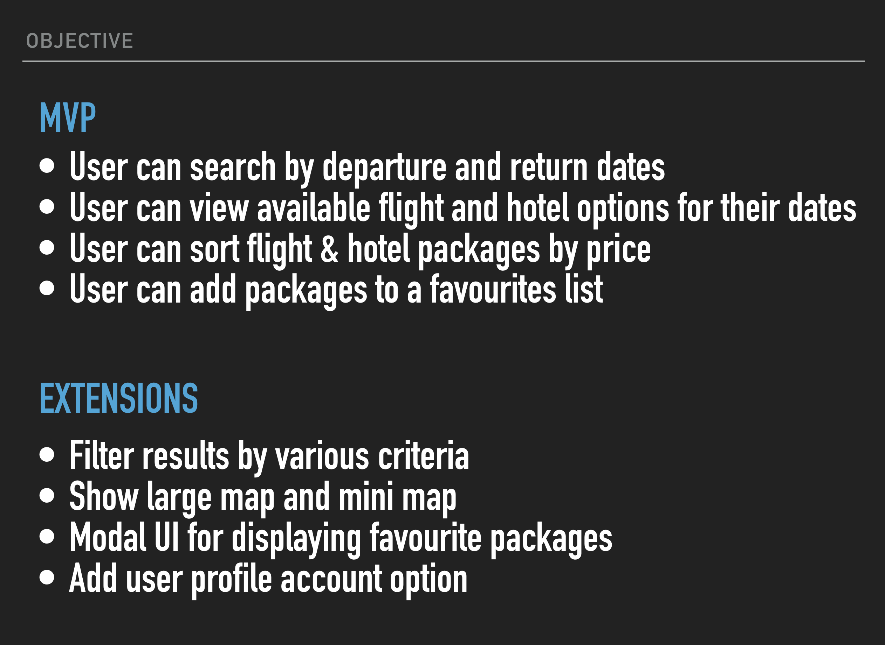

  - P3
This is the Trello MosCow board of our “Travel Packages” application :

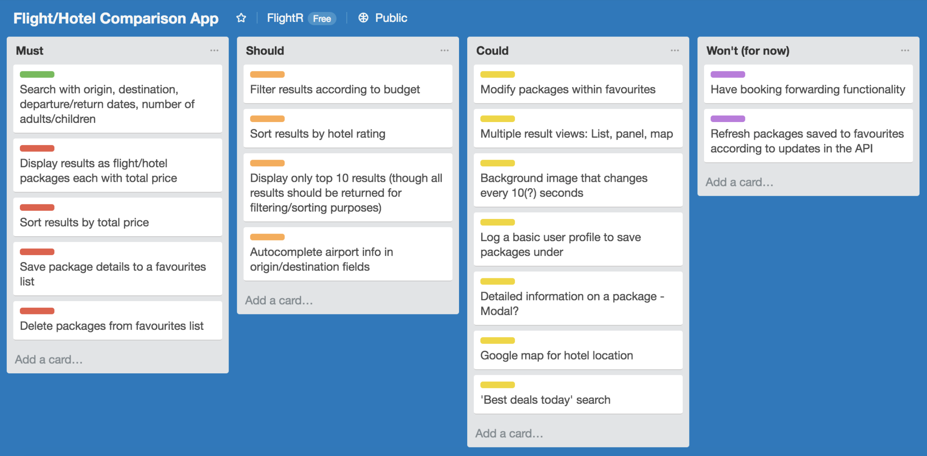

  - P4

Acceptance criteria | Expected Result/Output | Pass/Fail
A user is able to search for travel packages. | A list of travel packages is displayed to the user. | Passed.
A user can refine his searching criteria by package prices. | The list of travel packages is updated to match with the filter on price. | Failed.
A user can add a travel package to his favourite. | The travel package is added to the list of favourite of the user. | Passed.
A user can remove a travel package from his favourite | The travel package is removed from the list of favourite of the user. | Passed.
A user can select the display mode “map” | The list of travel packages is displayed on a GoogleMap. | Passed.
A user can browser his list of favourite travel packages. | The list of travel packages is displayed within a modal window. | Failed.
A user can set the number of adults and children who are going to travel. | The search bar for travel package displayed those filters and the search matches with them. | Passed.

  - P7
    - Sequence diagram

This sequence diagram describes the process of buying cryptocurrencies through the portfolio application.
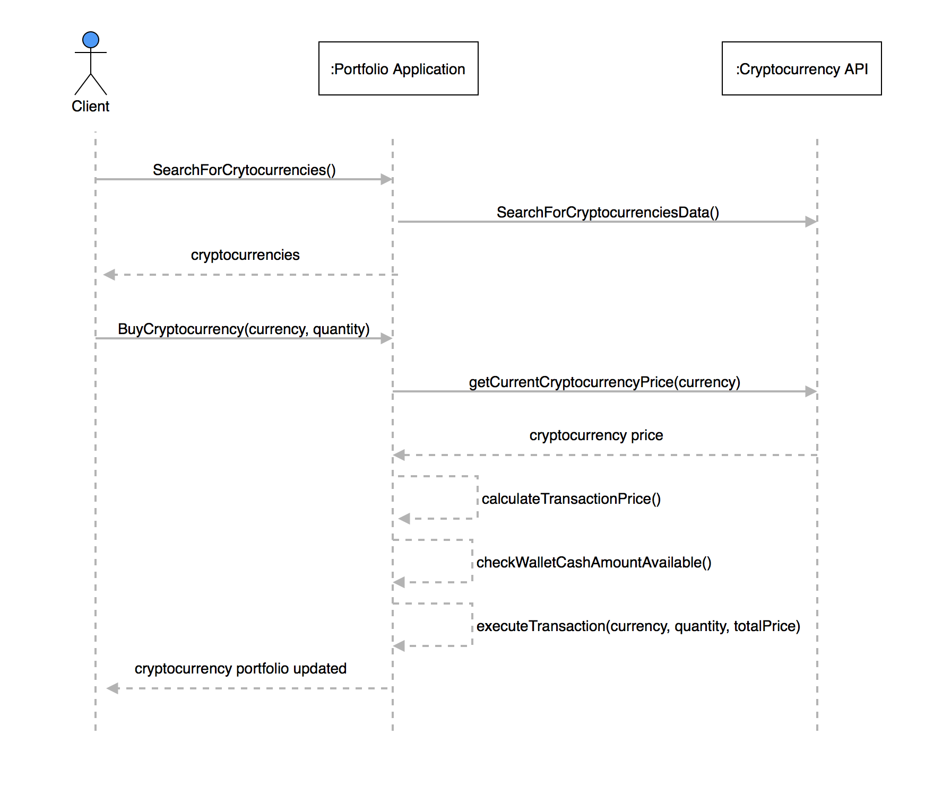
    - Collaboration diagram

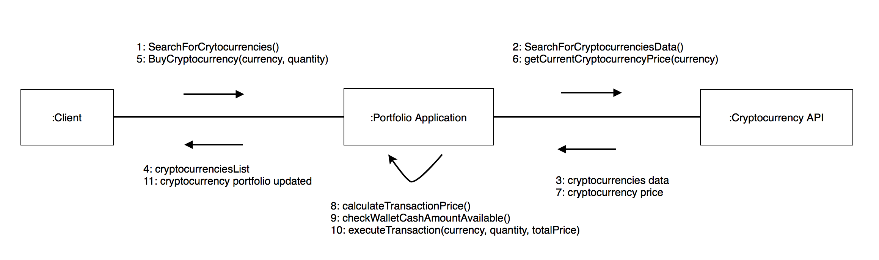
The collaboration diagram describes the objects committed in the process of buying cryptocurrency through the portfolio application.
  - P8

    - Object diagram N°1

This object diagram is a representation of a portfolio which contains 2 cryptocurrencies.

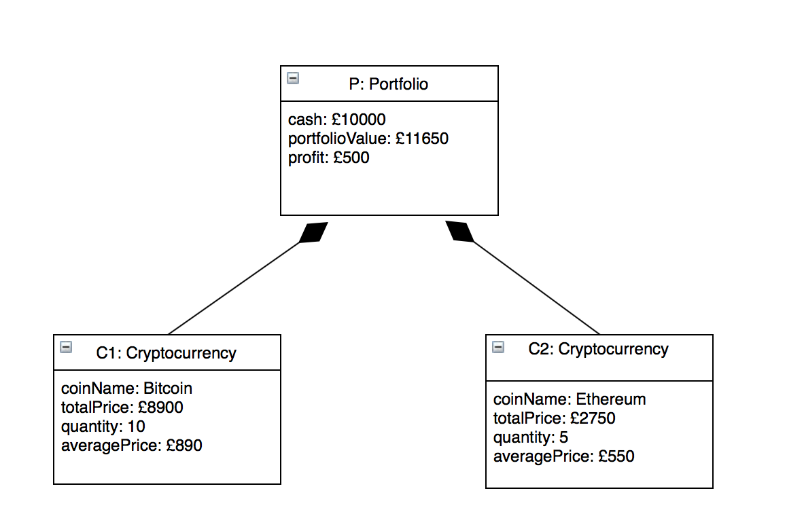

    - Object diagram N°2

This object diagram represents a travel package made of a flight return and a hotel booking.

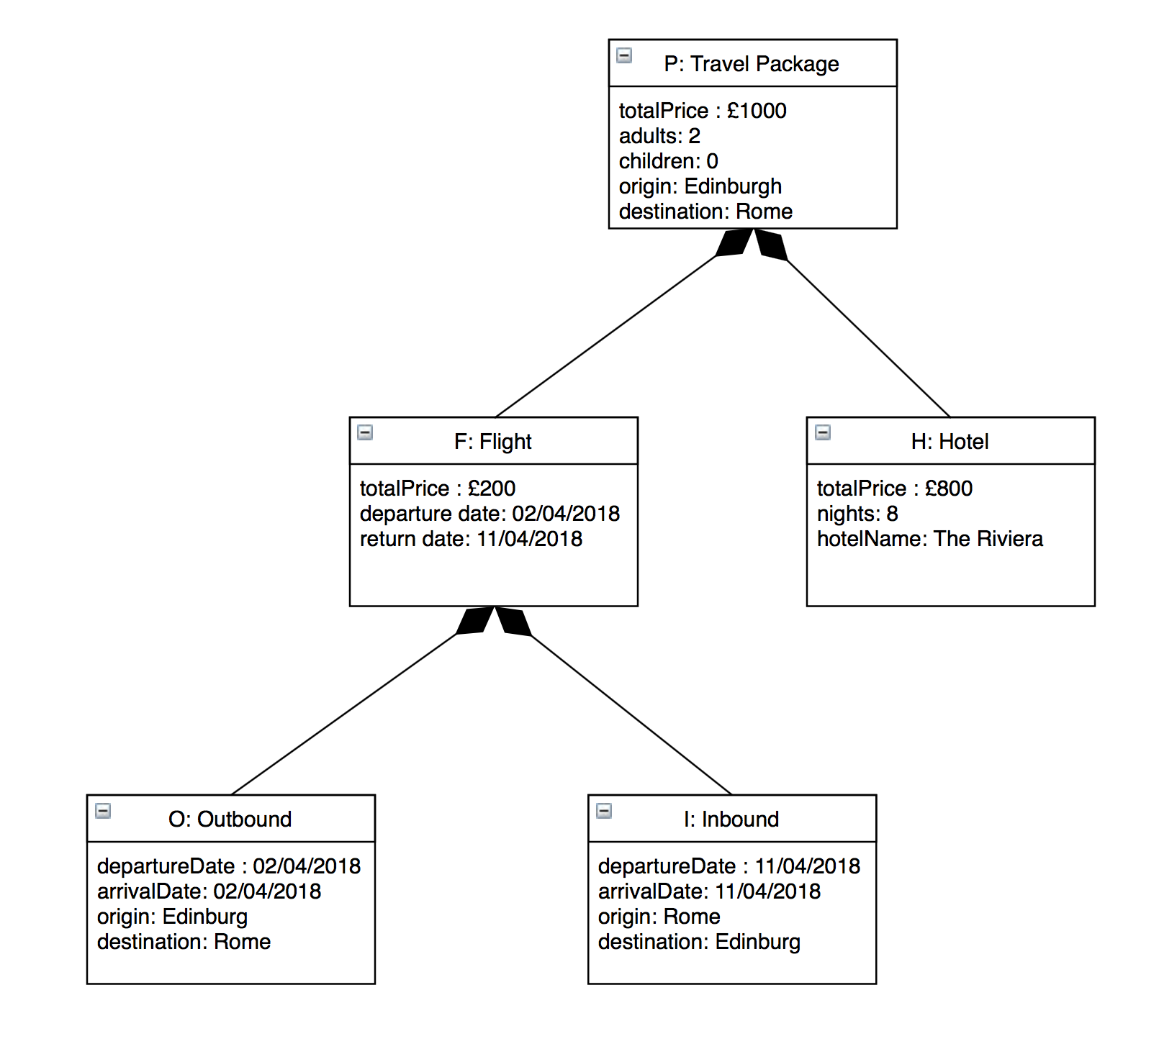
  - P9
    - Algorithm N°1
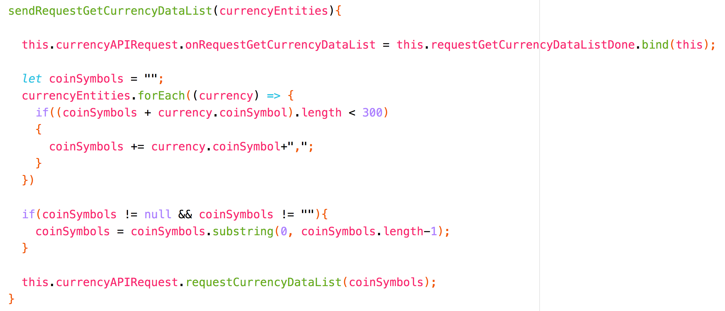
This algorithm aims at building the API query and call IT to get the current currency values. As this API only accepts a list of coin symbols as a String whose length is smaller than 300 characters then I need to check if the String length is short enough to add a new coin symbol.
Then the call to the API can be made without taking the risk to exceed its limit of 300 characters.

    - Algorithm N°2

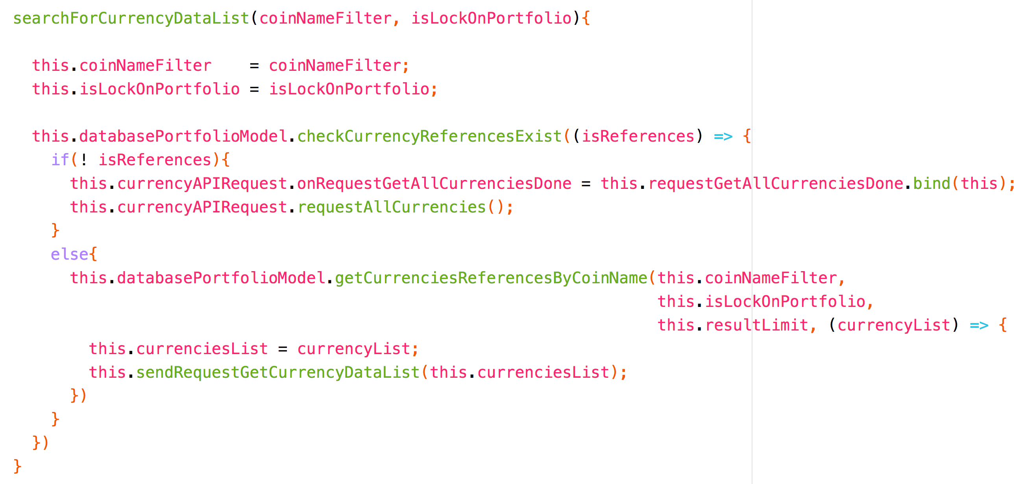
This algorithm aims at returning all the coins whose names match with the name filter passed as a parameter. If the coin list does not exist yet in the database then a method is called before executing the search in order to populate the database with the reference of all the coins. Then, the search is always performed on a list of references which exists in the database.

  - P17

Intent | Result | Action undertaken | Result again
Perform a search on coin names with “Bitcoin”. | Failed.  No results found. | Make the search case insensitive to be independent of lowercase and uppercase. | Passed.  The coins whose names start with “Bitcoin” are found.
Buy a quantity “n” of coins which does not exist in the portfolio. | Passed.  The quantity “n” has been added to the portfolio.
Sale a quantity “n” of coins. | Failed. The quantity “n” has been removed from the portfolio but the amount of cash available in the wallet has not been increased. | Couple the actions : sell and wire the money from the sale to the wallet cash amount. | Passed.
Buy a quantity “n” of coins which already exists in the portfolio. | Failed. The quantity already present in the portfolio should be increased by “n” while a new line has been created in the portfolio. | Check wether the coin line already exists in the portfolio : If it does then update the quantity otherwise insert a new line in the portfolio. | Passed.
Activate the mode “LiveData” | Passed. The current values of coins are refreshed automatically.
Activate the mode “Lock on portfolio” | Failed. The coins displayed should only be those from the user's portfolio. | Add a boolean as a new parameter on the query which get back the coins to check whether those coins are present in the user's portfolio. | Passed.  When the mode “Lock on portfolio” is activated then the coins displayed are those from the user's portfolio only.

  - I&T
Please check https://github.com/BlueMorning/Eric_Carles_E18_PDA for the Task B.

The unit tests passing :

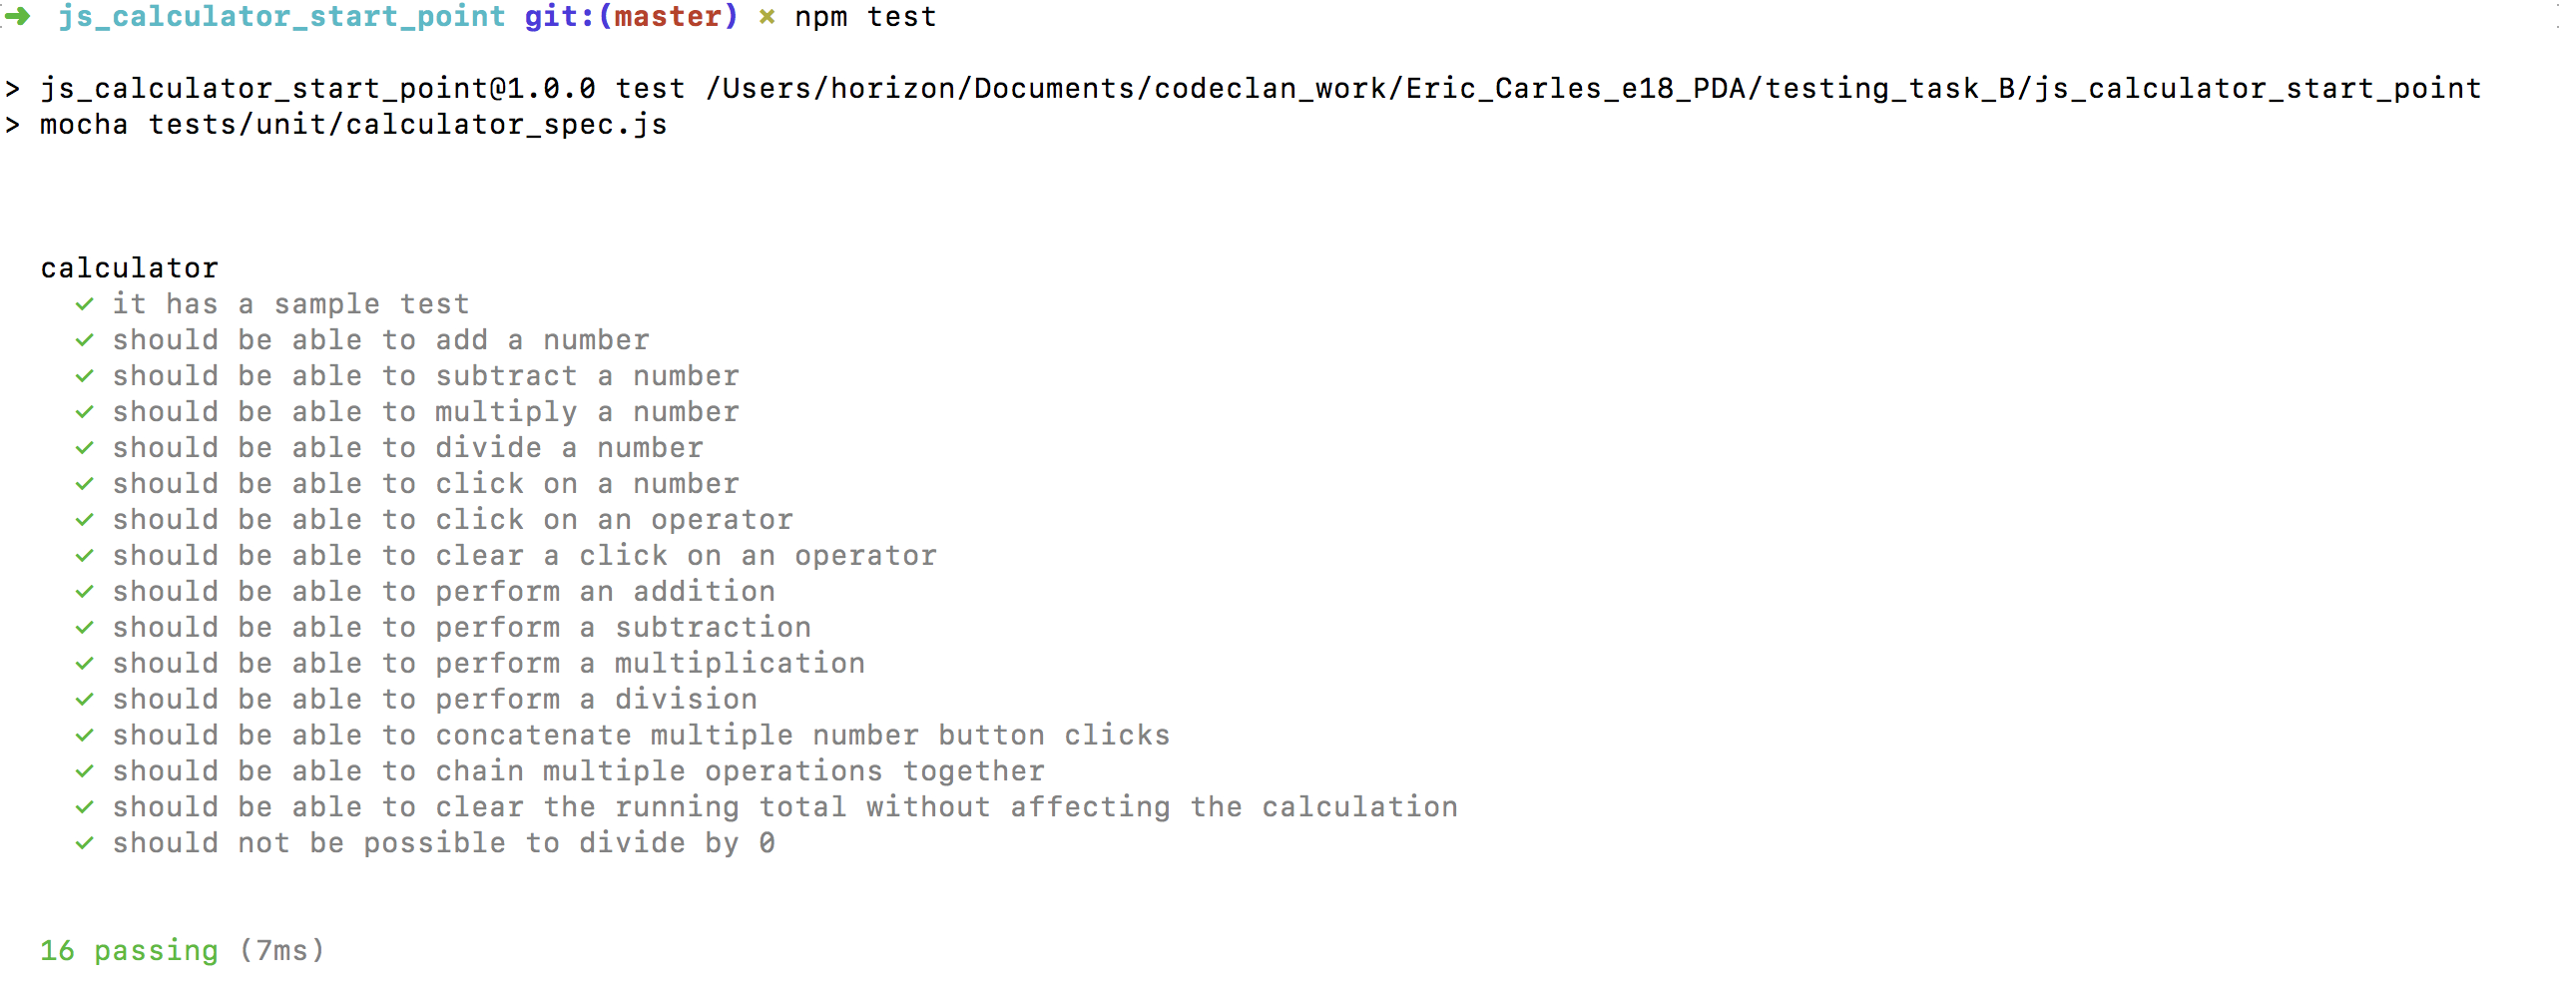

The integration tests passing :

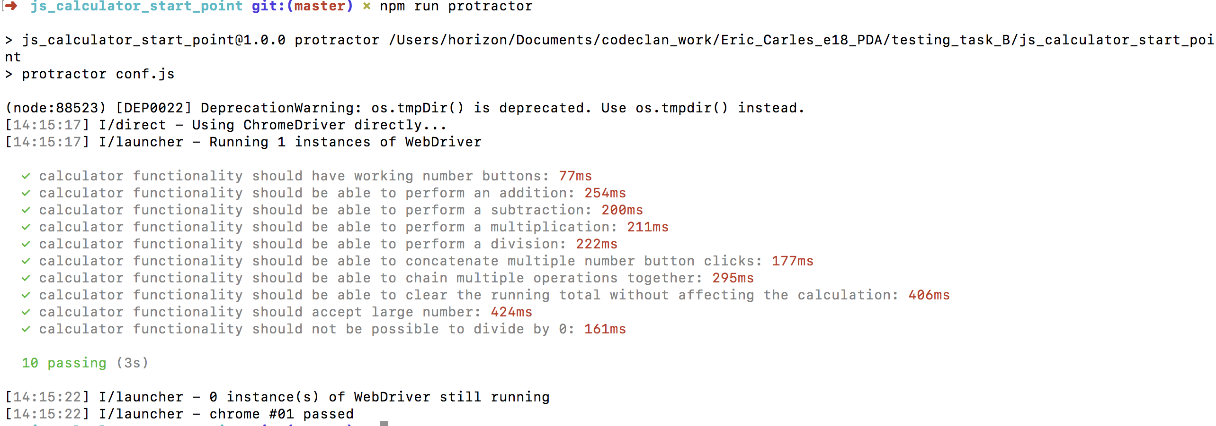

Acceptance criteria | Expected Result/Output | Pass/Fail
The user can perform an addition : 3+7= | The displayed result must be = 10  Output : 10. | Pass
The user can perform a subtraction : 12-4= | The displayed result must be = 8.  Output : 8. | Pass
The user can perform a multiplication : 3*5= | The displayed result must be = 15.  Output : 15. | Pass
The user can perform a division : 21/3= | The displayed result must be = 7.  Output : 7. | Pass
The user can clear the last operation : 2+4+3+clear= | The displayed result must be = 6.  Output : 6. | Pass
The user can perform a chain of operations : 2+4/2-1= | The displayed result must be = 2.  Output : 2. | Pass
The user can perform operations with positive numbers : 2+4 = | The displayed result must be = 6.  Output : 6. | Pass
The user can perform operations with negative numbers : -2-4 = | The displayed result must be = -6.  Output : -2. | Fail. It's not possible to enter the first number as negative.
The user can perform operations with float numbers : 1.5+2.5 = | The displayed result must be = 4  Output : 3. | Fail. It's not possible to enter a float number.
The user can perform operations with large numbers : 999999999+1 = | The displayed result must be = 10 000 000. | Pass
The user should not not be able to divide by 0. 4/0 : | The displayed result should be = 0  and the division by 0 should be clear to let the user try again.  Output : “Infinity” | Fail.

