Elite Dangerous Hud Mod (EDHM) User Interface (UI) Application
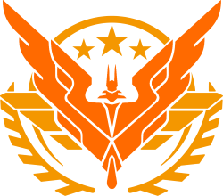

By Blue Mystic, Mod Author: psychicEgg

- This is the User Interface for the Elite Dangerous Hud Mod (EDHM).
- The App allows the user to Change almost all of the Mod's options using a graphical interface so you don't have to mess directly with the files.
- This App comes packed with the latest Mod version available so it can be used by new users to install both the Mod and its UI.
- Has a Preview feature that allow you to see in a WYSIWYG way your changes, preview is in Ultra HD.

Requirements
Microsoft .NET Framework 4.52 or superior. If you are on Windows 10 then you may already have it, otherwise get it from here: https://www.microsoft.com/en-us/download/details.aspx?id=30653

How to Install the UI App
- Download the Latest Release.
- Run the Installer and complete the steps.
- After the installer is complete, a new Shortcut Icon will be on your Desktop, double click on it to run the App.

First Run
The first time the App runs, it will ask you for the Elite Dangerous Game Folder, this is where the EDHM Mod will be (or is) installed, this location depends on what version of ED you have installed:
The default Steam location is:
C:\Program Files (x86)\Steam\steamapps\common\Elite Dangerous\Products\elite-dangerous-64 for Horizons.
or for Odyssey Version it’s ..\ elite-dangerous-odyssey-64 \
or ..\FORC-FDEV-DO-1000\

The default Epic location: C:\Program Files\Epic Games\EliteDangerous\Products\elite-dangerous-64
The default Frontier location: C:\Program Files (x86)\Frontier\Products\elite-dangerous-64\ `
`or C:\Users\%username%\AppData\Local\Frontier_Developments\Products\elite-dangerous-64\ `
- If the mod is not found, the App will install it for you.
- If an older version of the mod is found, the app will update it for you.
- Now you just choose your favorite colors and hit that big orange button labeled "Apply Theme" and go play.

Can i use this app to make the mod remember my colors and not having to cycle thru them every time?
That, my friend, was the original goal of this app, so YES you can!

If you haven't yet joined our Discord, you can do it now Here: https://discord.gg/ZaRt6bCXvj

What is a Theme Preset?
A theme Preset or 'Profile' is a pre-made set of color choices for your HUD, EDHM-UI comes with 32 Themes, you can load any of them or use them as base to create your own theme. You can Download new Themes shared by the community from our Discord.

You can simply click on any of the available themes, the Preview window will show you how it looks, you can Maximize the Preview to get a better look at it.

When you find a theme that you like, just click on the ‘Apply Theme’ Orange Button located on the Top Right Corner of the Window.

In order to view in the game any changes you make, you must hit that ‘Apply Theme’ Orange Button.

How do i make my own Theme?
- Load any Theme you want to use as Base. The default Elite Orange is called “Orange SideWinder”.
- Do all changes you want to it.
- Hit the "Make New Theme" button, give it a Name and follow the steps indicated by the program.
- Go play.

If you want to make further tweaks to your theme, load it, change it, and hit again the "Make New Theme" button, give it the same name as before and your changes will overwrite the old ones.

All Preset Themes are Saved and Loaded from the "..\elite-dangerous-64\EDHM-ini\DemoProfiles" folder.

If you download a Preset, save it in that folder and the App will just load it. Simply click the “Import Theme” button.

If you want to Share your Preset, just hit the “Export Theme” Button instead, this will do the same as before but it will also pack your theme into a ZIP file ready for uploading.

How do i change my Shield Colors?

- Click into the Squared Tile labeled “Shield & Holo”
- Open the Shield Color List of Options (Presets)
- And choose any you like.

If you click on the name of any of those Options you will see a brief description of what it does.

You can do the same to any of the other Modable Elements the App Offers.

Why i cant see my Color selection in game?
- Did you forgot to click the Orange ‘Apply Theme’ Button?
- Do it now.
- If you have your game Opened, you can hit the F11 key to reload the configuration and see ‘on the fly’ your changes.
- All your current Settings get stored into the very first Theme in the list, labeled ‘Current Theme’, as long as you had Applied them.

How do i Change my Panels?

There is a Tile labeled “Station & Ship Panels”, click it. That will open the XML Profiler tool.

The color of the Station and Ship Panels are moded with a Color Matrix XML, you will need to tweak the values of the Red, Green and Blue Sliders untill you find a color scheme you like.

Be careful, those sliders are tricky, it may test your paticence and dedication.

Or… if you want an easy way… In the Bottom left corner there is a button that you can use to open the NO2O (No To Orange) Website where you can find good looking and fully tested XML colors, just copy one from there, and paste it in the XML Text box, click the ‘Import XML’ buton and see it.

What’s the Dependent Check for?

By default both the Stations and Ship Panels are linked, so when you make a change in the Station’s XML, the Ship’s XML will change too, that is to make sure both of your panels have the same colors.

But if you want to have them with different colors you can simply ‘Lock’ them so they have their unique XML colors.

- The Ship’s XML will also be used by any Element you had set its value to 199=XML (User Defined). THEY ALL WILL USE THIS SAME XML.
- That’s pretty much it, mi confident you can figure out the remain options in the App, if you hover your mouse on a button it will tell you what it is for.

TP Mod Manager

The Third Party (TP or 3P) Mod Manager is a tool that allowe Modders to Create a Friendly User Interface (UI) for their Mods.

The EDHM UI can manage (or not) all mods present in the ..\elite-dangerous-odissey-64\EDHM-ini\3rdPartyMods\ folder, all a mod creator needs to do is to attatch a JSON file telling the UI how to manage their mod. The UI and this document will help you to do that.

1. The Mod Package:

Third Party Mods must be packaged for distribution in a ZIP compressed file that must have the following structure:

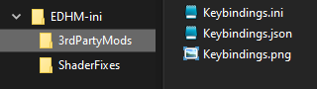

The ZIP will be Imported and un-compressed by the UI (or manually) in the ..\elite-dangerous-odissey-64\EDHM-ini\3rdPartyMods\ folder, all INI files in there will be automatically loaded by EDHM.

The ‘ShaderFixes’ folder will contain all Shaders needed by the mod, if they exist already, will be over-written, nothing gets deleted, just added and over-written.

The ‘3rdPartyMods’ folder will contain the Main INI file of the Mod and 2 optional files for the Manager, being the JSON file the one that tells the UI how to manage the INI file, and the PNG is just a Thumbnail image.

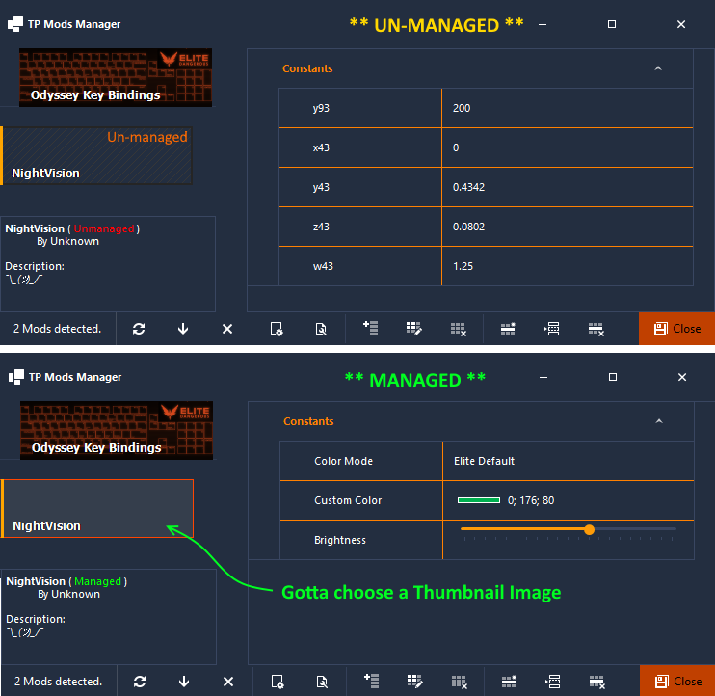
If the Mod package does NOT contain a JSON file with the same name of the INI file, then the UI program will consider the Mod as ‘Un-Managed’ and all options will be shown in simple Text editors.

A Managed Mod can have controls for Colors (Gamma Corrected), Integer and Decimal Numbers, booleans (On/Off) and Combo boxes with Custom Presets.

A managed mod can also choose a custom thumbnail image to identify the mod. This image must be PNG format and 200x61 pixels in size.

It will be a good practice if the Modder includes an Uninstall BAT to allow clean uninstallation of your mods, see the ‘Key-Bindings’ mod for example.

2. Managing a Mod with the UI

To start you must already have the INI and Shader files located in the ..\elite-dangerous-odissey-64\EDHM-ini\3rdPartyMods\ folder.
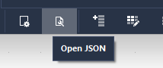
Now we must create the JSON file, you can do this manually or automatically, if choose the second way then simply click the ‘Open JSON’ button. If the mod is already managed this action will open the JSON file in your default Text Editor (Notepad).

If the mod is un-managed, then you will be asked about the creation and managing of the mod, if you choose YES, then a JSON with default basic settings will be created, also a default thumbnail image.

By default, every time you save the JSON this will be ‘fitted’ by the machine in a compact form, to make it human readable you need beautify it, copy the entire JSON string and use a JSON Formateer, the are many in Google, i recomend this one: https://jsonformatter.org/

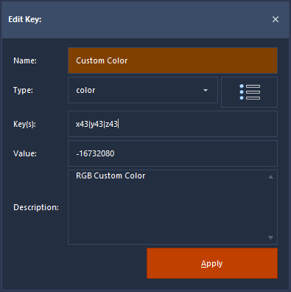
3. Editing the Keys
If you Double Click in the Name of a Key, the ‘Edit Key’ window will show up.

Here you can change the Name shown in the UI for the Key, and its Type.

The Type determine what Control will be shown in the UI, there are 6 types:

Text, Number (Integer), Decimal, Color, Toggle and Custom (Preset).

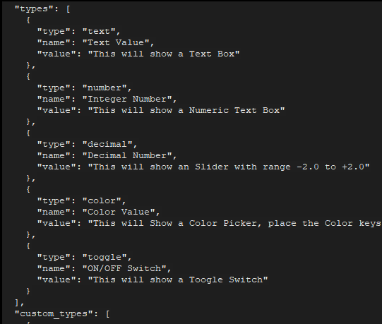
The Decimal type will show an Slider Control with default Range of -2,0 to +2,0.

The Color type will show a Color Picker, the ‘Key’ for Color is special because it is Multiple, instead of ‘x43’ for key, you will be adding the 3 or 4 keys in a string:

‘x43|y43|z43|w43’ That will be converted to RGBA values, the last value is optional, you only need the 3 RGB values for the color to function.

4. Custom Types
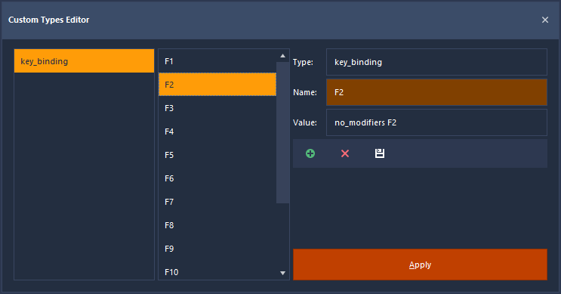
To add a new Custom Type click the (+) button, then write the type, asign a Name (shown to the User) and a Value, then click the Save button (White Floppy).

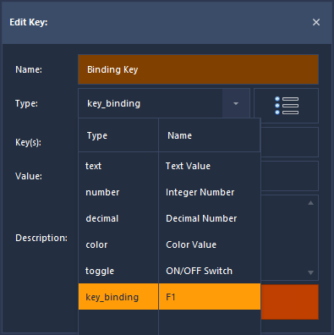
Custom types often have more than 2 Values so to make other Elements of the same type, copy what you wrote in the Type field, click the (+) button, paste it, asign a new Name and Value, repeat till you have all the Values for your Custom Type.

To add another Custom Type, do the same but using a different text for the Type Field.

Once you are done, click ‘Apply’. Now you can select your Custom Type in the Types Combo:

And your users will be able to choose its values:
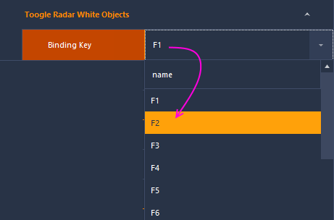

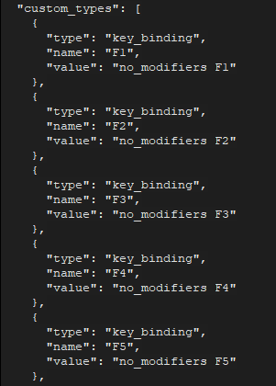

Custom Values are saved in the JSON file: ------------------------>

