Dear Editor,

Please find enclosed the manuscript titled “﻿Precision and Limits of Detection for Selected Commercially Available, Low-cost Carbon Dioxide and Methane Gas Sensors” by Wesley T. Honeycutt, M. Tyler Ley, and Nicholas F. Materer. The manuscript should be considered for publication as an article in *Sensors*.

This paper arose from a DOE project to explore gas emissions from an enhanced oil recovery site. In the paper, we discuss the metrology to determine the performance of selected carbon dioxide and methane gas sensors.

Sincerely,

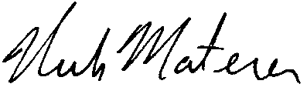

Nicholas Materer

Department of Chemistry

107 Physical Science

Oklahoma State University

Stillwater OK 74078

(405) 744-8671

materer@okstate.edu