Attached are JSON files for you to import to Atlas (if you haven't done it yet). If you ready ported your data to Atlas, then you don't have to redo it.

Use Compass and connect it to Atlas. Or you can use it to create the DB on your local computer if you want. You can get the connection string from Atlas by clicking “Connect” button as show below:

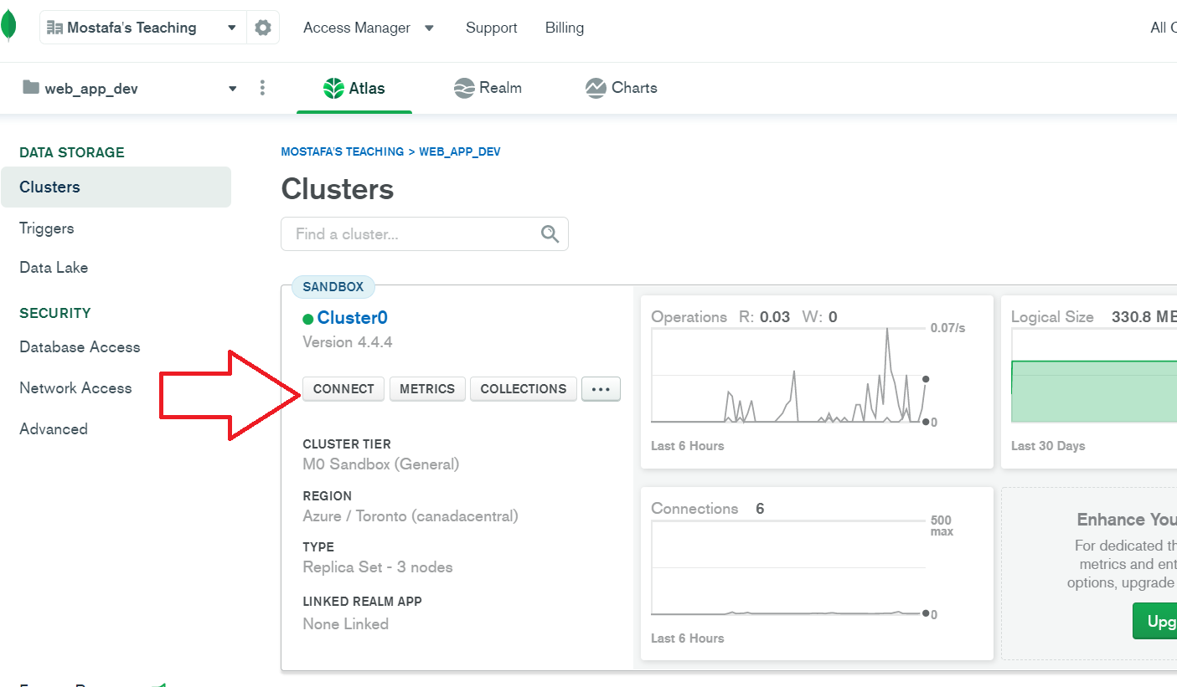

In Compass, You need to create a new Database on Atlas then for each JSON file in the attached ZIP, create a new collection with the same name as the file name. Inside this new collection, import the JSON file to have the data loaded. Do that for all attached JSON files.

Please see the blow images for more information.

