1.16

https://dynamitejobs.com/my-jobs?page=7&jid=AKuuQBDKkGPq3HIg6iXB&text=full+stack

Databento

1.17.2023
https://www.guru.com/work/
10.40
https://www.ycombinator.com/companies?query=front%20end&regions=Fully%20Remote&status=Active
11.45
https://nodesk.co/remote-jobs/
1.17 8.21 pm
https://lgbtqremotely.com/job/cornershop-creative-full-time-wordpress-developer-support-specialist/

I have more than ten years of experience in SEO & SMO. I assure you, I will boost your website ranking up and also provide you an excellent SEO & SMO services to make your website in the top search over Google by following White Hat SEO techniques. Please let me know if you have any targeted keywords or I will provide high-quality keywords and also provide you the technical assistance required for website maintenance. Please check some well known popular websites that I have ranked along with best SMO, showing first position on Google:- * I ensure your efficient communication and support at every point. * I ensure you of weekly progress reports. Thanks & Regards,

Digital Marketing Expert with 11+ years of experience♛ can provide you with Guaranteed Top rankings. I also have extensive expertise in SEO, SMO, Google AdWords, Daily AdWords Monitoring, Google Analytics, Search Engine Marketing etc. We are expert in PPC .Google Ads, AdWords, and Google Analytics Should be able to run Google Ad Campaign We will help you take advantage of these platforms and reach audiences like never before. ➽Facebook-Average Posting- 12 on Facebook, Average Posting- 12, Facebook Wall Page-Designing, Average Posting- 12 on Facebook, Facebook Analytic Tracking, Increase visitors and likes, Increase traffic ➽Twitter- Creating a Twitter Page (If required), Theme for Twitter created by you, Writing Content for a Profile, 12 average tweets, Investigate and keep track of pertinent accounts. ➽Instagram - Create a Business Profile (If Required), Writing Instagram profile content, Average Number of Posts-12, Optimization & Post-Creation, Relevant Profile Follow, Increase visitors and likes, Increase traffic. We aim to deliver quality work with the help of creative services that help in growing your business. ✦✦ will give the exact pricing after getting complete requirements ✦✦ Looking forward to work with you and build a long term business relationship ✦✦✦Please Open your chat Box and send me message, so we can discuss more about your requirement✦✦✦ ✦✦✦Thanks✦✦✦

Dear Hiring Manager, I have gone through your job posting and become very much interested in working with you. I am an expert in these fields. I have already completed several projects like this. For evidence, you can see my profile. I have an excellent command of English. I am a hard worker, productive, and worthy of your attention. I hope I will be the right candidate for this post. I am awaiting an affirmative response from you. Kinds Regards, Mehedi Hasan. 28th January 2023(19)

I have read your project details clearly and understand your requirement.I am social media specialist with 10 years works experience here. I have worked on several similar projects like this. I will provide you quality work according to your instructions .You can see an example of one of those projects in my portfolio here: www.freelancer.com/u/Nishit65 I'm interested to hear more about the project and about the subject matter of requirements. If you award me the project I'd be very happy to discuss the further and get started for you as soon as possible. Thanks! Nishit

Hello there, I will help you in Social Media Optimization. I have 10 years of SMO. I am an established marketing professional team, I will execute a strategic plan of social media marketing. I will handle all social media platforms (Instagram, Twitter, and Facebook, etc) from A to Z By designing Images, writing content, and posting. I do: - Create eye-catching Creative / Graphics. - Create content - Post regular - Post promotion of graphics (3 per week) - Creation of video (1 per week) - Manual and paid (optional) boosting of posts. Weekly report Let's talk in detail. Raghav AKH

Hello, sir. Thank you for your project offer. I read your job description carefully and understood what you want to build now. I am Social Media Marketing expert. Especially I have more experience on Facebook /Twitter /Instagram /YouTube /Pintrest /Google review Marketing. I can give you like/followers in worldwide, USA, Canada, UK, Australia any targeted country. My main target is customer satisfaction. I can finish this job perfectly because of that I have real experience and high skill in smo. I am waiting for your response. Thanks

I feel that with my current skill sets and my experience in the this project, the job requirements this role presented are a perfect match for me. I could visualize myself in that role as it aligned with my career aspirations, skills, and expertise. Besides, I have researched your company and found that it has impressive and promising projections which made me excited to be a part of the amazing future. I would take pride in working under the great leadership of this company and I found this place to be a perfect fit for utilizing my expertise along with the promising aspect of personal growth.

Whatever task that I set to do, I always give my best and complete it diligently well in advance.

I apologize for any inconvenience.

Hi, thanks.
I think it is a good suggestion from you.
I like work in this job and I have 9 years experience as a Sr. Front end developer..
But I have some problems.
Now I live in Serbia.
I am finding a full remote job in English.
I wish you are agree.
Good luck.
Thanks again,
Milorad

Hi, thanks.
I think it is a good suggestion from you.
I like work in this job.
But I have some problems.
I am finding a full remote job in English.
I wish you are agree for it.
Good luck.
Thanks again,

///////////
Hi, my name is Milorad Kosticd I am a front end engineer with 9 years of experience. I have a strong passion for web development, particularly in the areas of React and Angular. I'm excited to bring my expertise and knowledge to your team."

I have a deep understanding of HTML, CSS, and JavaScript, and have worked with various front end frameworks and libraries, including React and Angular.
I'm particularly interested in creating responsive, user-friendly designs that are optimized for performance and speed.
I have experience collaborating with designers and developers, and I'm comfortable working in an agile environment.
I stay up-to-date with the latest trends and technologies in front end development, and I'm always looking for ways to improve my skills and knowledge.

I was part of a team that successfully launched a complex web application using React, which received positive feedback from users and stakeholders.
I designed and implemented a responsive website for a client, which resulted in a significant increase in user engagement and conversion rates.
I'm particularly proud of the accessible user interface I created for a web application, which allowed users with disabilities to easily navigate and use the platform.

Thanks for your attention.
/////////QA//////
Collaboration and communication: Foster a culture of collaboration and communication between the testing and development teams, enabling a shared understanding of requirements, challenges, and goals.

Continuous learning: Encourage continuous learning and professional development for the testing team, providing access to training, resources, and feedback.

Process improvement: Regularly evaluate and improve the testing process, incorporating feedback from stakeholders and metrics such as defect rates and testing efficiency.

Automation and tooling: Invest in automation and tooling to streamline testing and improve its quality, accuracy, and speed.

Risk management: Prioritize testing based on the risks associated with the application or feature, focusing on critical and high-risk areas first.

Overall, a successful approach to testing and improving QA involves a combination of planning, execution, analysis, feedback, collaboration, and continuous learning and improvement.
////////////////////////

Credit is My Motto! I'm a Full-Stack developer with 6+ years of experience developing React,Node.js, FrontEnd, blockchainbackend applications.
I have developed multiple custom solutions for both large and small project and clients for React, Node.js, JavaScript, PHP, Blockchain, Django, Python(5+ years).
I love to keep in touch with clients.

Hi, thank for your email.
I have 10 years of experience as a React JS developer building websites and web applications using React JS and modern JavaScript tools/frameworks.
Whatever task that I set to do, I always give my best and complete it diligently well in advance.
So I think I am perfect fit for this job.
Good luck, best Regards.
Milorad.

Passionate Web3 Developer offering 9 years of relevant experience in Web3. I have experience developing Defi, DEX, DApp, Trading Bot, Token, autonomous systems and artificial intelligence. I am fluent in Cosmwasm. Cosmos, Solana, Rust, Solidity, Web3.js, Cosmjs, Python and JavaScript and have worked on a variety of projects as a consultant, helping clients achieve their goals. I am also keen on several JavaScript and Python web framworks like Vue, React, Django and Flask. I am a life-long learner and is looking forward to working on exciting and challenging projects.

- 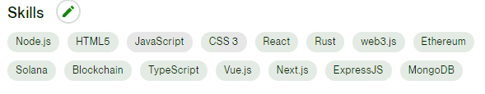
- 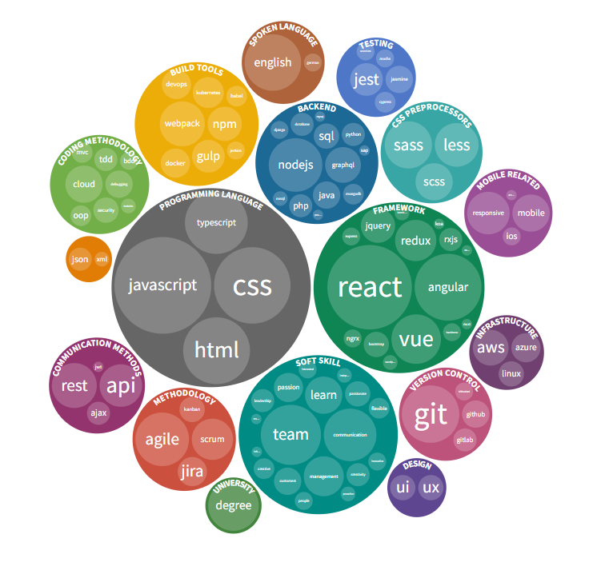
China: US$30.074 trillion (up 12.6% from 2021)
- United States: $25.035 trillion (up 10.1%)
- India: $11.665 trillion (up 13.2%)
- Japan: $6.110 trillion (up 5.9%)
- Germany: $5.317 trillion (up 6.9%)
- Russia: $4.650 trillion (up 9.1%)
- Indonesia: $4.024 trillion (up 8)
- Brazil: $3.783 trillion (up 9)
- United Kingdom: $3.776 trillion (up 11.9%)
- France: $3.688 trillion (up 11.2%)
- Turkey: $3.321 trillion (up 16)
- Italy: $3.022 trillion (up 11.1%)
- Mexico: $2.920 trillion (up 9.1%)
- Canada: $2.240 trillion (up 8.9%)
- Spain: $2.216 trillion (up 9.5%)
- Saudi Arabia: $2.018 trillion (up 7.5%)
- Egypt: $1.662 trillion (up 7.6%)
- Taiwan: $1.622 trillion (up 11)
- Australia: $1.615 trillion (up 9.3%)
More than 11 years of experience in constant work with sites based on Wordpress (in all aspects except seo), solving exceptional problems of any complexity.

Leveraged strong understanding of WordPress core to manipulate admin and theme components.
Created and updated re-usable code libraries to streamline WordPress development cycle.
Reviewed application requirements and interface designs and provided feedback on feasibility.

