Order Up Database

Jack MacCallum & Mathew Hickey

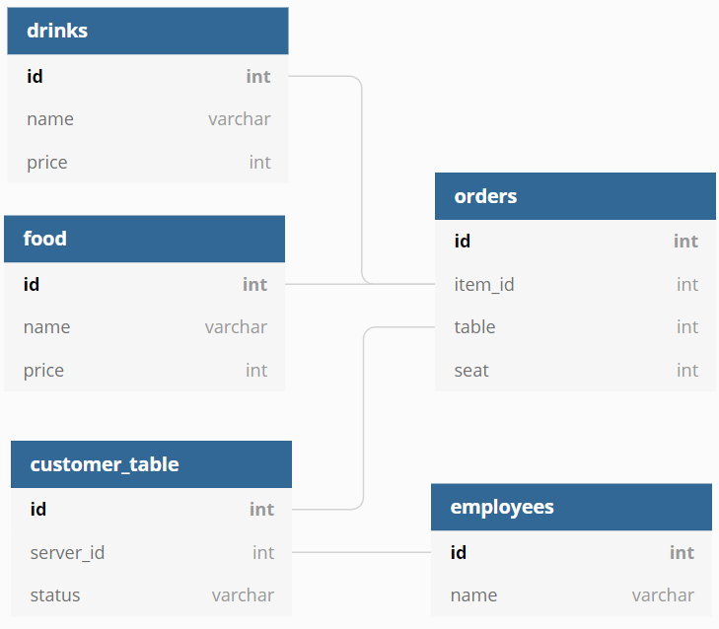

# Project Scope

The purpose of this project is to provide a relational database for our application we’ve previously created. This application provides a POS and order management system for restaurants or other serving establishments. Part of this application in a database that contains the relevant data for the users in the system such as the tables being served, which server controls that table, and what orders have been placed by that table.

# Problems Resolved by Project

This application and database provides a unified and responsive system to manage orders and tables compared to existing POS systems which are slow, clumsy, and inconsistent.

# Intended Audience

The intended audience of this database are the waitstaff, cooks, and managers of restaurants.

# Data Acquisition

Most of the data will be randomly generated either via software or by hand. This data will be the food/drinks, customer_tables, and employees.

# Time Line

By the 29th we expect to have a finalized database design.

By the 5th we expect to have all the diagrams based on the initial design completed.

By the 12th we expect to have the database built in MySQL but, lacking more than test data.

By the 19th we expect to have fully populated the database and begun writing potential demonstration queries.

By the 26th we expect to have completed the queries and written report and be nearing completion of the presentation.

By the 28th we expect to have fully completed the project, report, and presentation.