Smart-X Enterprise IoT Ecosystem
Real-Time Command Orchestration & Predictive Telemetry Processing
Student Name: Taahir Basson
Student Number: ST10282092
Module: PROG7312 (Programming 3B)

1. Architectural Overview
The Smart-X IoT Ecosystem is a stateful, high-throughput industrial telemetry platform designed for real-time command orchestration. This documentation details the core stream-processing engine, which utilizes advanced data structures and behavioral algorithms to manage live edge-device telemetry.
- Firebase Operator Authentication: Secures the gateway using the Google Firebase Identity Toolkit REST API, establishing zero-trust access without relying on hardcoded credentials.
- Real-Time Command Stream: A high-performance stream processing engine managing live device states, telemetry queues, and priority alerts.
- Predictive Action Engine: An automated insight module that cross-references live out-of-range sensor data with historical operator interactions to surface proactive command recommendations.

2. Core Data Structures
To ensure strict $O(1)$ and $O(logn)$ algorithmic performance across the real-time stream, the backend architecture strictly enforces the following dedicated C# collections:
Instance Name | C# Collection | Algorithmic Complexity | Smart-X Implementation Purpose
TelemetryQueue | Queue<string> | $O(1)$ Enqueue / Dequeue | First-In-First-Out (FIFO) processing of standard incoming edge-node telemetry packets.
CriticalAlertQueue | PriorityQueue<string, int> | $O(logn)$ Enqueue / Dequeue | Min-heap priority queue ensuring critical alerts (e.g., severe moisture drops or voltage spikes) bypass standard telemetry for immediate processing.
CommandUndoStack | Stack<OverrideCommand> | $O(1)$ Push / Pop | First-In-Last-Out (FILO) manual override history allowing safe, instantaneous one-click state restoration.
DeviceRegistry | Dictionary<string, DeviceState> | $O(1)$ Average Lookup | Hash table keyed on MAC addresses for instantaneous device telemetry updates, state mutations, and dashboard filtering.
SensorTimeline | SortedDictionary<DateTime, string> | $O(logn)$ Insertion | Self-balancing binary search tree keyed on UTC timestamps to strictly order and render timeline event logs chronologically.
DisconnectedNodes | HashSet<string> | $O(1)$ Add / Contains | Maintains a unique set of faulty MAC addresses to suppress duplicate alert processing and prevent operator UI fatigue.
ActiveCategoriesSet | SortedSet<string> | $O(logn)$ Insertion | Automatically sorts and deduplicates unique operational categories for dynamic dashboard dropdown filtering.

3. Setup and Execution

Firebase Configuration
- Open appsettings.json in the root directory.
- Insert the Firebase Web API Key:
"Firebase": {
"WebApiKey": "YOUR_FIREBASE_WEB_API_KEY_HERE"
}

Application Launch
Option A: IDE (Rider / Visual Studio)
- Open Smart-X-Ecosystem.slnx or .csproj.
- Select the http launch profile and run the application. The system will launch at http://localhost:5000.
Option B: Docker Containerization
docker build -t smart-x-ecosystem .
docker run -p 8080:8080 smart-x-ecosystem

Navigate to http://localhost:8080.

4. System Workflows and Functional Proof

A. Secure Gateway Authentication
The system strictly requires Firebase REST API authentication before allowing access to the command stream.
- Launch the application and enter operator credentials.
- Upon successful authentication, the encrypted session unlocks the dashboard routing.
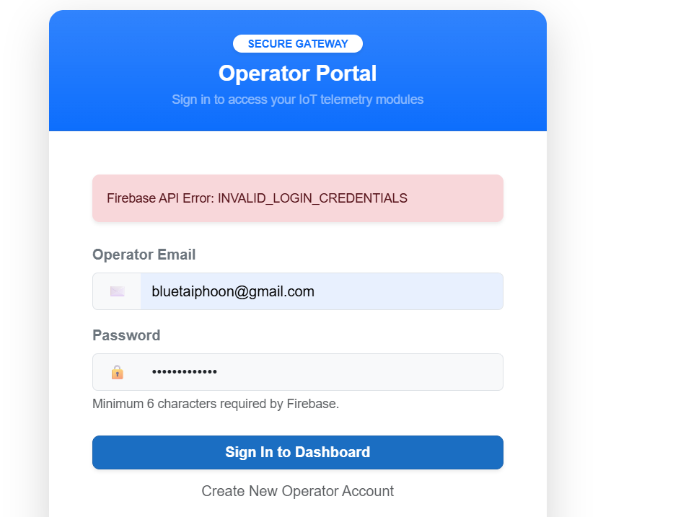
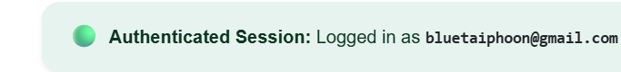

B. High-Priority Alert Bypassing (Queues vs Priority Queues)
The platform differentiates between standard telemetry and critical hardware failures.
- Navigate to the Command Stream module.
- Enqueue multiple standard packets into the TelemetryQueue.
- Trigger a high-priority anomaly (e.g., Moisture < 20%) to populate the CriticalAlertQueue.
- Process the queue to observe the Priority 1 alert explicitly bypassing the standard FIFO queue.
[Insert Screenshot Here: Show the UI with packets in both queues, and the timeline logging the Priority Queue being dequeued first.]

C. Duplicate Alert Suppression (HashSet)
To prevent alert fatigue, duplicate disconnect signals are algorithmically suppressed.
- Click Simulate Disconnect for a targeted node. The MAC address is added to the unique DisconnectedNodes set.
- Trigger the exact same disconnect again. The HashSet.Add() method safely rejects the duplicate.
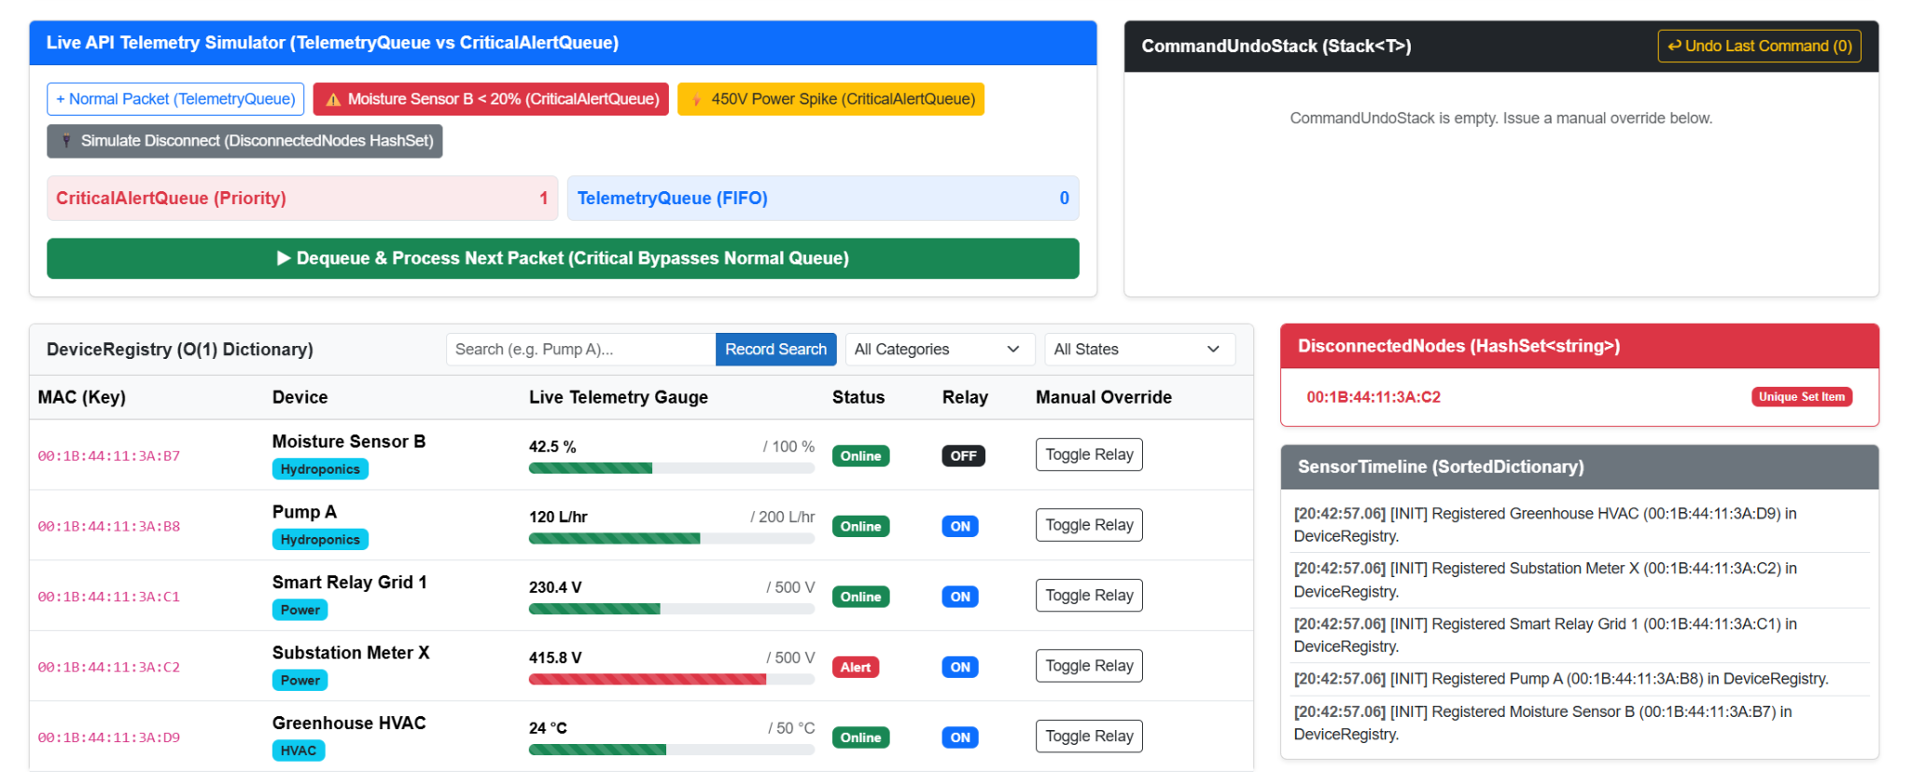

D. Safe State Restoration (Stack LIFO)
Operators can manually override hardware relays and instantly revert mistakes.
- Trigger a Toggle Relay command on an active node. The state is pushed to the CommandUndoStack.
- Click Undo Last Command. The previous hardware state is popped from the FILO stack and restored in $O(1)$ time.
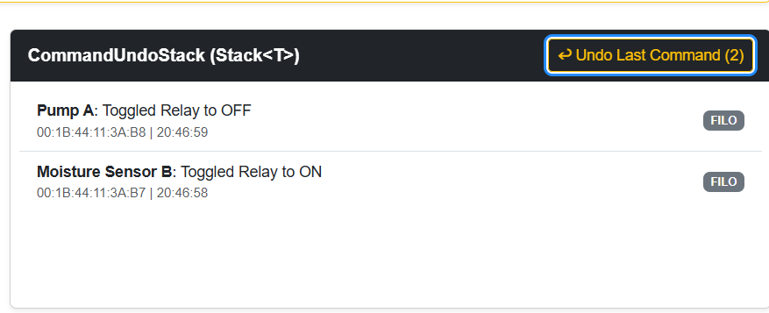

E. Predictive Action Engine (Algorithmic Co-occurrence)
The system learns from operator workflows to suggest proactive interventions.
- Register a search pattern for a specific device (e.g., Pump A).
- Trigger an associated environmental anomaly (e.g., Moisture drop).
- The engine mathematically analyzes the co-occurrence and generates a high-confidence automated insight, suggesting the operator activate the pump.
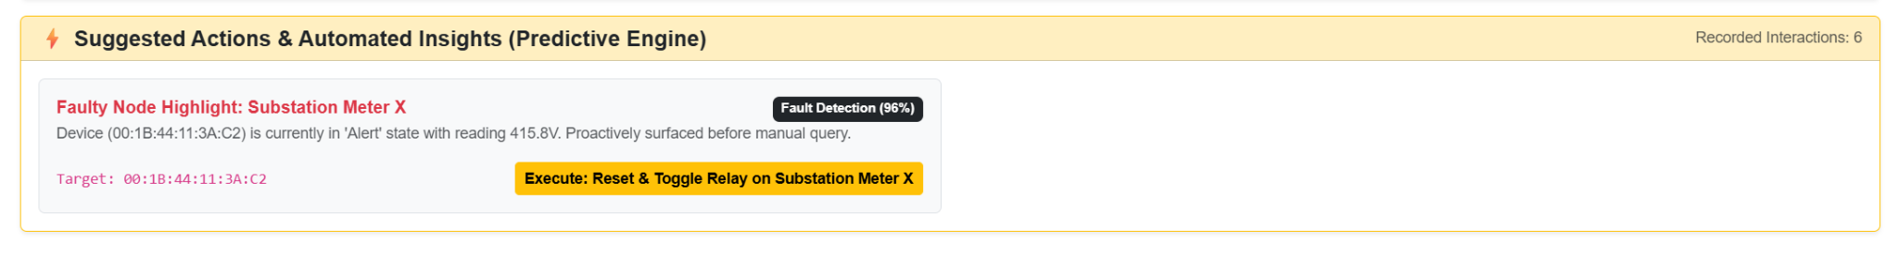

5. References
- Jamro, M., 2018. C# data structures and algorithms. Birmingham: Packt Publishing.
- Nakov, S., Kolev, V. et al., 2013. Fundamentals of computer programming with C#. Sofia: Telerik Software Academy.

Github
https://github.com/BlueTai/ST10282092_Prog7312_Poe.git

