Missing Person

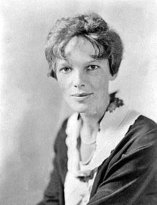
  First Name:
  Amelia Mary
  Amelia Earhart went missing in the central pacific ocean near Howland Island.
  She and her co-pilot Fred Noonan were flying along a line of position (taken from a "sun line" running on 157–337 degrees) which Noonan would have calculated and drawn on a chart as passing through Howland.
  It's possible she landed on an uncharted island. Anyone with any information on her wherabouts is asked to contact us.
  Last Name:
  Earhart
  Date of Birth:
  July 24, 1897
  Age:
  116
  Sex:
  Height:
  Weight:
  Last Seen:
  Central Pacific Ocean near Howland Island
  Friday, July 02, 1937

  Contact:
  A person
  A phone number
  An Email Address

