

Software Requirements Specification

for

Animal Database

Version <2.0>

Prepared by

Group Name: Group 20

|  |  |  |
| --- | --- | --- |
| Vinh Duong | 11613642 | vinh.duong@wsu.edu |
| John Stevenson | 011639605 | john.stevenson@wsu.edu |
| Yevgeniy Diriyenko | 11679399 | Yevgeniy.diriyenko@wsu.edu |
| Seth Lanante | 11458512 | seth.lanante@wsu.edu |

|  |  |
| --- | --- |
|  |  |
| Date: | December 16, 2020 |
|  |  |
|  |  |
|  |  |

Content

Revisions iii

1 Introduction 1

1.1 Document Purpose 1

1.2 Product Scope 1

1.3 Intended Audience and Document Overview 1

1.4 Definitions, Acronyms and Abbreviations 1

1.5 Document Conventions 1

1.6 References and Acknowledgments 2

2 Overall Description 3

2.1 Product Perspective 3

2.2 Product Functionality 3

2.3 Users and Characteristics 3

2.4 Operating Environment 3

2.5 Design and Implementation Constraints 4

2.6 User Documentation 4

2.7 Assumptions and Dependencies 4

3 Specific Requirements 5

3.1 External Interface Requirements 5

3.2 Functional Requirements 6

3.3 Behavior Requirements 6

4 Other Non-functional Requirements 7

4.1 Performance Requirements 7

4.2 Safety and Security Requirements 7

4.3 Software Quality Attributes 7

5 Other Requirements 8

Appendix A – Data Dictionary 9

Appendix B - Group Log 10

Revisions

| Version | Primary Author(s) | Description of Version | Date Completed |
| --- | --- | --- | --- |
| 1.0 | Vinh Duong  John Stevenson  Yevgeniy Diriyenko  Seth Lanante | Completed submission of SRS. | 11/06/20 |
| 2.0 | Vinh Duong  John Stevenson  Yevgeniy Diriyenko  Seth Lanante | Do final revisions on the SRS. | 12/16/20 |

# Introduction

This project will be an animal database that the user can log in and interact with animals that they created there. In this section the reader will see the basics of how this project will be implemented.

## Document Purpose

The product of specified in this document is an animal database. This SRS will cover all parts of the product including the data to be maintained/manipulated and the different pages the user will be able to navigate. The document covers the layout, design, and plan for the project. We are bringing about a new system based on already existing principles. This product is a standalone interactive design where users can create content and interact with content created.

## Product Scope

The software being specified is an animal database that users will be able to upload to and interact with the content they made along with other user’s content. The objectives and goals of this product is to allow the user to upload content to the database and interact with the content that they and other users have made. The benefit of this product is purely for entertainment reason by allowing the user to have some fun.

## Intended Audience and Document Overview

The intended audience of this SRS is the professor and kids who would be into these kinds of things. This document is also intended for the developers so that everyone can use this information to build the database. The rest of this SRS contains technical information of the product, what the product needs to do and other considerations like what we will use to make the software. For developers, the suggested reading order of this document will be the product perspective and then the functional requirements. The suggested reading order for the player user who would use this software would be the Use Case View section since it shows visually the functionality and would be the one that pertains most to them. For the professor, the recommended reading is the over sections and then reading the document in order since it explains from the beginning what this software should do.

## Definitions, Acronyms and Abbreviations

|  |  |
| --- | --- |
| Browser | Interface for connecting to the product made |
| Database | Where the information for animals will be stored |
| HTTPS | Secure method of communication for web browsers. |
| Software | Set of instructions to implement a functionality. |
| SRS | Software Requirements Specification |

## Document Conventions

This document will follow the IEEE conventions. The font size will be Ariel size 11. Italics will be used for comments. The Document will be single space with a 1” margin. Section header will start with the section number and the section title. Subsection will be the section number followed by a period and subsection number and then a title.

## References and Acknowledgments

We did not cite or paraphrase any other source to the best of our knowledge except using the pictures from the SRS example as a guide to fill some of the sections. Also used SemanticsUI as a framework for the HTML code.

# Overall Description

## Product Perspective

The animal database will be accessible through a web browser. The user will be able to log into an account on the animal database. Once logged in the user will then be able to create an animal by selecting options and inputting a name. There will be some activity the user can do for fun like feed the pets and play games with them.

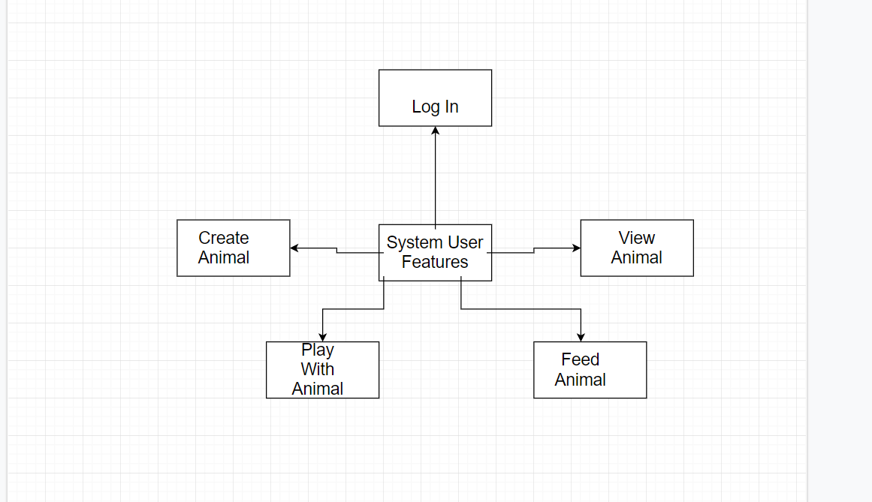

(Context Diagram)

## Product Functionality

* Allow the user to log into an account on the animal database
* The user will be able to create an animal.
* The user will be able to view the animals on the database.
* The user will be able to feed their animals and play games with them.

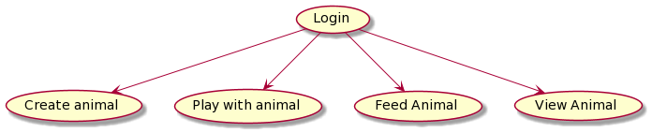

(Data Flow Diagram)

## Users and Characteristics

**Player user:** Will be most of the user who will use this game to have fun.

## Operating Environment

The software will be hosted on a windows machine and the minimum requirements are the ability to run all the necessary computation and have enough space on the system to hold the software. The software will be tested using Google Chrome. There should be no other dependencies necessary to host this software.

## Design and Implementation Constraints

A constraint is the security aspect for logging in since we need to make sure that the credentials are secured. Under normal circumstances we would also need to make sure the website is in HTTPS to keep the user credentials secured. We are also going to be constrained by whatever limitation there is for the database. The language constraint we have is that we are going to be implementing the animal database in JavaScript.

## User Documentation

We would need to include an online tutorial with the user manual for the people who are going to be using the database. This is necessary to walk through to the user what they can do with the database and how to use the functionalities of it. The online tutorial would most likely be a guided thing where the user will be forced to go through the functionalities one by one until they go through everything.

## Assumptions and Dependencies

Some of the assumptions we are making for the user is that they have a web browser that can run JavaScript. We are assuming that the user has the necessary hardware requirements to run any computation we need to do and be able to render any image we give them. We are also assuming that the user has enough space to download our software.

# Specific Requirements

## External Interface Requirements

### User Interfaces

When the user first open the database they will be presented with a screen to log in where they can input a username and password.

Once they log in the user will be presented with the main page that shows the information about the animal database and contains some links along with a logout button. At the top of the page will be the different buttons to the different parts of the animal database. All the pages of the animal database except the log in will have these buttons at the top.

Create animal will have the picture to pick, attribute of the animals, item to pick, and home to pick. There will also be a field to choose the string of the animal, or you can click a button to get a random string.

View animal will have a search bar that you can use to search for the name of the animal, a like button, and there is a place where the picture of the animal will go or an error message that it could not find anything.

Play with animal will have the picture of the animal along with a ball that the user can drag. There will be a progress bar at the bottom and a blank bar that will show a message that the animal has leveled up.

The feed animal page will display the name of the animals for the user and if the user clicks on the name will be taken to a page that has a feed button and the picture of the animal.

### Hardware Interfaces

* **Display Monitor:** A basic monitor that can display images that is shown through the web browser is sufficient for this software.
* **Input Devices:** The user will just need a mouse and keyboard to be able to use our software.

### Software Interfaces

* A database will be used to store all the details of the animals that the user creates. There will be multiple subsets of the database, one for the user’s animals that they made, one for the animals that the user can share, and one for the global shared animals viewable by everyone.
* The web browser will be primary interface for the software with the user sending data through it and receiving it in the form of web pages.
* Will use the underscore function to help streamline part of the code.

### Communications Interfaces

Under normal circumstances HTTPS will be implemented to make sure that the credentials for the user is secured. The browser will be the primary way that the user will communicate with our software. The user will text, user their mouse, and be able to upload files to the web browser. The web browser will then respond appropriately with correspond pages.

## Functional Requirements

**Login:** The user will be able to log in to the animal database and the feed animal page will display the different animal names depending on which user is logged in.

**Creating an animal:** The user can choose the type of animal along with a few other options and then they can input the name of the animal or click a button to generate a random name from a list.

**Viewing animals:** The user will be able to search by name of the animal in the database and can click arrows on the bottom of the screen to cycle through the different animals.

**Feeding animals:** The user would be able to select their animals to go feed them by clicking on button to feed them. If they feed their animals a certain number of times, then the animal will get a star that can be seen when the animal is viewed. The animal will get more stars the more they are fed.

**Playing with animals:** The user can drag a ball to the animal they have created and a sound of the animal will be played. If you play with the animal enough times they will level up.

## Behavior Requirements

### Use Case View

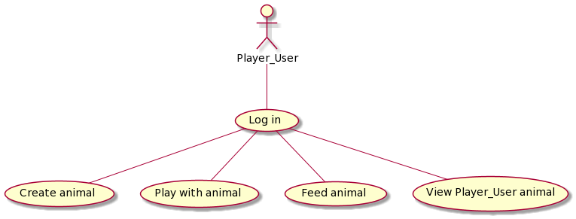

(Use Case Diagram)

# Other Non-functional Requirements

## Performance Requirements

It will not take more than five seconds for any of the main pages to load so that the user will not have to wait long to get what they want. It will not take longer than ten seconds to list all the animals so that the user can quickly look through for the animal they want.

## Safety and Security Requirements

Under ideal circumstances the log in credentials will be encrypted so that it cannot be accessed by unauthorized parties. Also, under ideal circumstances we will be using HTTPS so that the username and passwords will not be sent over plain text. Some other considerations is if user uploads graphic images or graphic comments, then the developers or moderators will need to go in with a special account that can remove the content and possibly remove the user.

## Software Quality Attributes

4.3.1 Availability:

The software would ideally be available all the time except for some periods of maintenance that happens during times we know that user traffic is low.

4.3.2 Portability:

For portability, the software would ideally work on any kind of devices with adjustment being made for the between the screen sizes.

4.3.3 Testability and Usability:

For testability and usability, we would go through all the links and perform every action that we can just to make sure that everything works as it should. We would also have other people go through the software so that they can report bugs and test performance.

# Other Requirements

Our work is still in progress, and as of now no additional requirements have come to light. However, may need to be specified in the future.

Appendix A – Data Dictionary

|  |  |
| --- | --- |
| Browser | Interface for connecting to the product made |
| Database | Where the information for animals will be stored |
| HTTPS | Secure method of communication for web browsers. |
| Software | Set of instructions to implement a functionality. |
| SRS | Software Requirements Specification |

Appendix B - Group Log

|  |  |
| --- | --- |
| 10/10/20 | Went over Git hub and tried to get the GitHub desktop app working. Talked about the SRS document. Agreed on a new meeting time. |
| 10/16/20 | Catch up on trying to get the git hub accounts working and worked on the SRS document. |
| 10/24/20 | Had to change communication method for a group member and added them to the git hub repository. |
| 11/6/20 | Final gathering before submitting SRS document, Final revision, edits, and submission. |
| 11/13/20 | Meeting to discuss how we will do project milestone 2 and then assigning the roles for the document. |
| 11/19/20 | Checkup about project milestone 2. |
| 11/21/20 | Finished the project milestone 2 document. |
| 12/01/20 | Try to set up the IntelliJ folder and get a basic web page working. |
| 12/04/20 | Member: Vinh and John. Do a quick check in on what we have so far and plans for moving forward. |
| 12/05/20 | Members: Vinh, John and Yev. Looked at what we have done so far and decided on what to do next. |
| 12/09/20 | Members: Vinh, Seth, Yev. Go over what we have and what we need to do. Specifically different use cases (what different users will do), log in page, how we will connect everything from page to page. |
| 12/11/20 | Members: Vinh, John and Seth. Review what we have and worked on the project during the zoom call. |
| 12/13/20 | Members: Vinh and Yev. Talked about the requirements Yev needs to do for the view animal page. |
| 12/14/20 | All member present. Group discussion on what we have and what we need to do. |
| 12/15/20 | Afternoon meeting Vinh, Yev, and John are present: John talked about an easier way to pass data around the web pages.  Night meeting all members present: Worked on making the presentation to present to the teacher. |
| 12/16/20 | Morning meeting all members present: Make sure everything is working for the presentation.  Night meeting all members present: Finalize everything and turn it in. |

Link to Github Repository: https://github.com/Bluealternate/CS320Project