CareFlow AI

CMS Medicare Data — Expanded Analysis Report

Records Analyzed: 1,500,000
Unique Providers: 184,865
Report Generated: May 29, 2026 at 11:48 PM
Source: Centers for Medicare & Medicaid Services (CMS)

1. Executive Summary
This expanded report analyzes 1,500,000 Medicare provider-service records covering 184,865 unique healthcare providers across 108 medical specialties, 60 states/territories, and 4,860 distinct procedures in 7,770 cities.
Key Statistics at a Glance:
Metric | Value
Total Records | 1,500,000
Unique Providers (NPI) | 184,865
Unique Specialties | 108
Unique Procedures (HCPCS) | 4,860
States/Territories | 60
Cities | 7,770
PROVIDER: Avg Submitted Charge | $431.17
PROVIDER: Median Submitted Charge | $179.00
MEDICARE: Avg Allowed Amount | $106.96
MEDICARE: Avg Payment to Provider | $83.49
MEDICARE: Median Payment to Provider | $52.55
MEDICARE: Avg Standardized Amount | $83.09
PATIENT: Est. Avg Out-of-Pocket (20% coinsurance) | $23.47
WRITE-OFF: Avg Charge-to-Payment Gap | $347.68 (80.6%)
Max Medicare Payment | $27,000.37
Min Medicare Payment | $0.00
Avg Patients per Provider-Service | 84.6
Median Patients per Provider-Service | 32.0
Avg Services per Provider-Procedure | 286.4
Median Services per Provider-Procedure | 44.0

1.5 Payment Field Definitions — Who Pays What?
The CMS dataset contains 4 payment-related fields. Understanding who each amount belongs to is critical for interpreting every chart in this report:
Field | Who Pays/Sets This | What It Means
Avg Submitted Charge | PROVIDER (billed amount) | The price the provider charges — their "sticker price." Medicare almost never pays this full amount.
Avg Medicare Allowed Amount | MEDICARE (approved max) | The maximum Medicare approves for this service. This is the payment ceiling.
Avg Medicare Payment | MEDICARE (actual payment) | What Medicare actually pays the provider — typically 80% of the Allowed Amount. This is real revenue.
Avg Medicare Standardized Amount | MEDICARE (geo-adjusted) | Same as Medicare Payment but adjusted for geographic cost differences. Used for fair state comparisons.

Payment Flow Summary:
Provider charges $100 (Submitted Charge) → Medicare approves $40 (Allowed Amount) → Medicare pays $32 to provider (80% of Allowed) → Patient pays $8 coinsurance (20% of Allowed) → Provider writes off $60 (Charge minus Allowed = lost revenue)
What the Patient Pays:
Patient cost is NOT a separate column, but can be calculated: Patient Cost = Allowed Amount − Medicare Payment ≈ 20% of Allowed Amount. Average estimated patient cost: $23.47 per service.
What the "Gap" or "Write-Off" Means:
Gap = Submitted Charge − Medicare Payment = $347.68. This is NOT what the patient pays. It is unrealized revenue — the provider billed it but neither Medicare nor the patient pays it. The provider must write it off.
In Medicare billing, the provider may submit a high “charge,” but Medicare only recognizes a lower Medicare-approved/allowed amount. If the provider accepts Medicare assignment, they agree to accept that Medicare-approved amount as full payment and cannot collect more than the patient’s deductible, coinsurance, or copayment
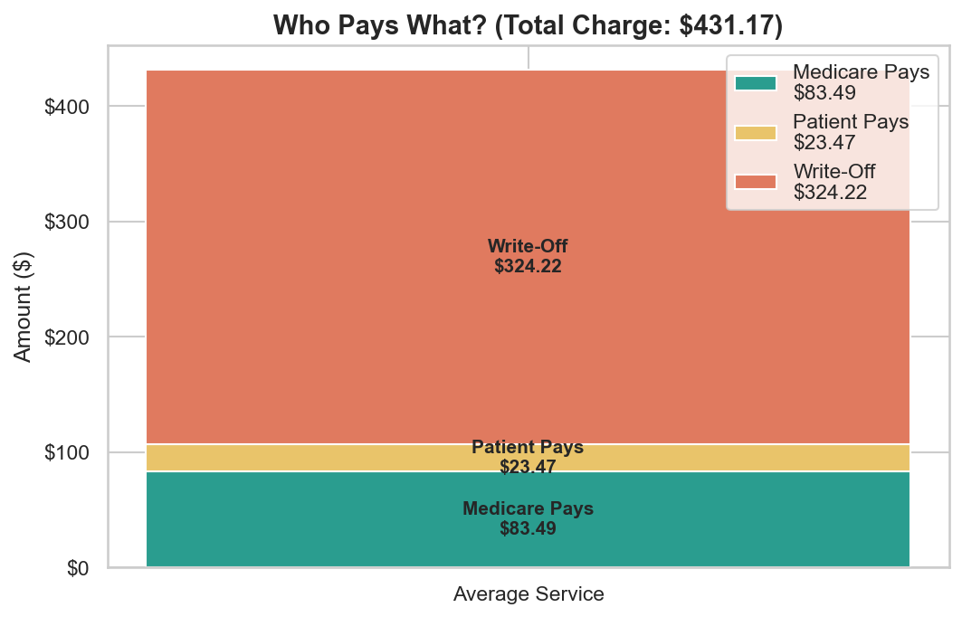
Figure: Who Pays What (Average per Service)
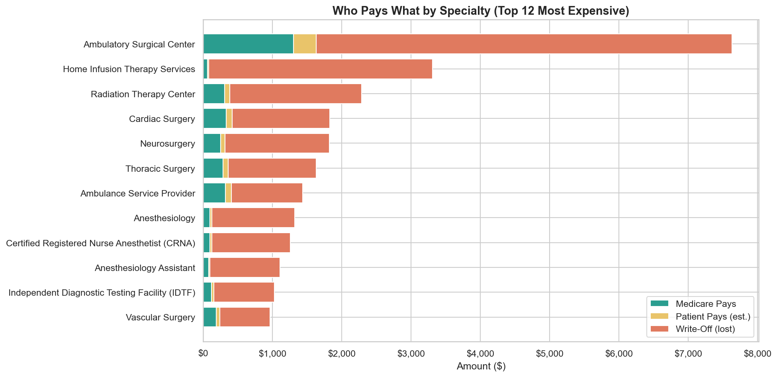
Figure: Who Pays What by Specialty

2. Provider Specialty Analysis
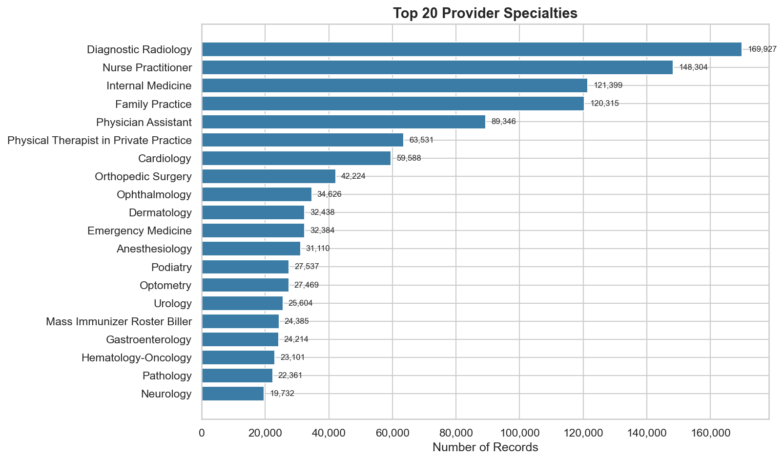
Figure 1: Top 20 Provider Specialties
What This Chart Shows:
This horizontal bar chart ranks the 20 most common medical specialties in the dataset by number of records. The top specialty is "Diagnostic Radiology" with 169,927 records (11.3% of all records). The top 5 specialties account for 43.3% of the dataset, while there are 108 total specialties — meaning most specialties have very few records.
Problem Identified:
The extreme concentration in a few specialties creates two problems: (1) Prior authorization rules and denial patterns differ dramatically by specialty, so a one-size-fits-all AI model will fail. CareFlow AI must build specialty-specific models. (2) Rare specialties with few records will lack sufficient training data for accurate prediction, creating blind spots in the system.
Provider Credentials:
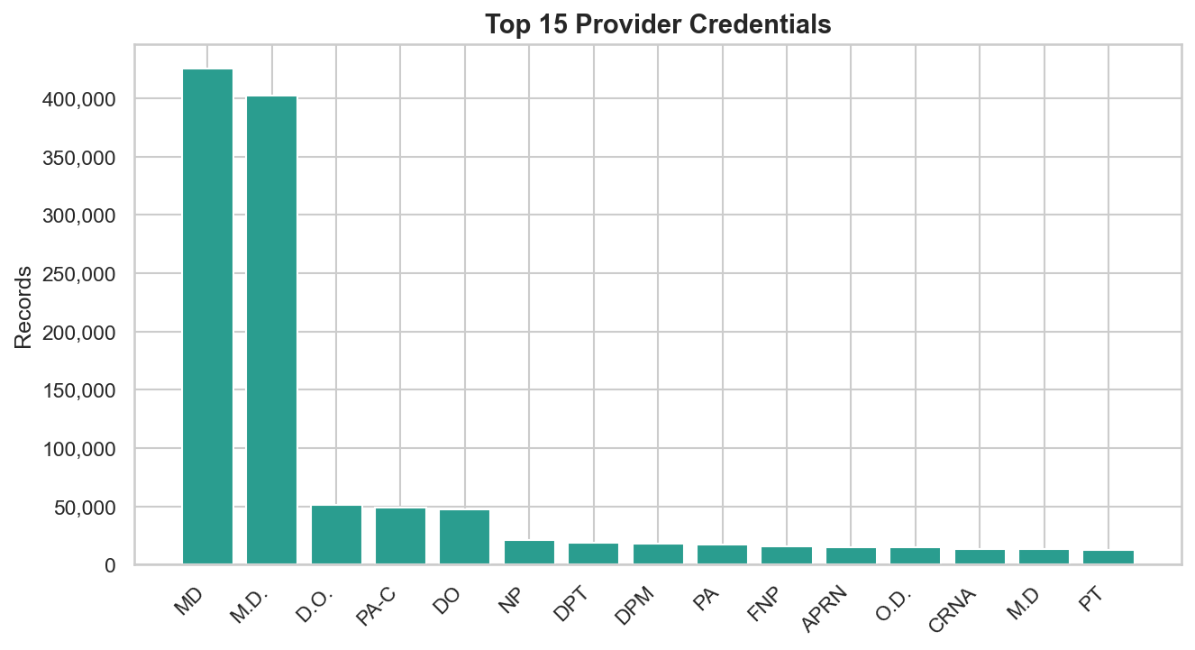
Figure 2: Top 15 Provider Credentials
What This Chart Shows:
This chart shows the distribution of professional credentials among providers. The most common credential is "MD" (425,336 records), followed by "M.D." and "D.O.". This reflects the predominance of physicians (M.D./D.O.) in Medicare billing.
Problem Identified:
Different credential types (M.D., D.O., NP, PA) have different scope-of-practice rules and prior authorization requirements. Nurse practitioners and physician assistants may face additional authorization hurdles for procedures that physicians can perform without prior auth. CareFlow AI must factor in credential type when predicting authorization requirements.

3. Geographic Distribution
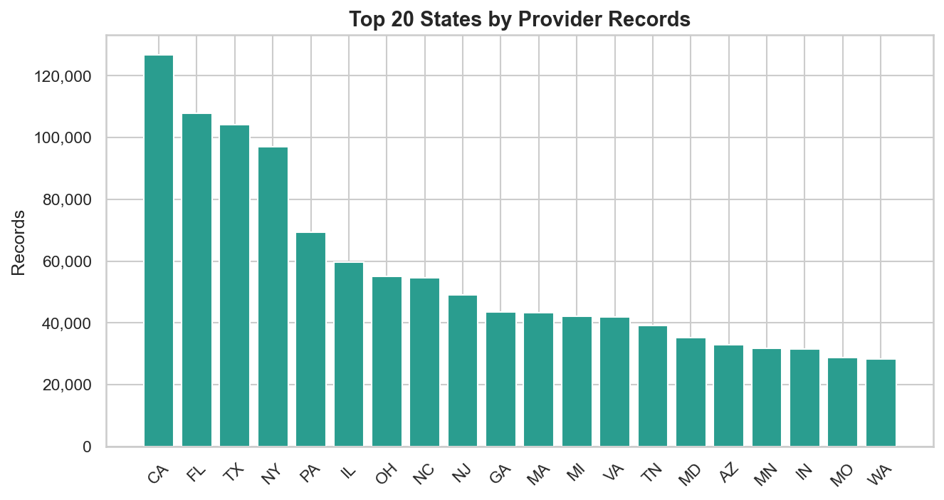
Figure 3: Top 20 States by Records
What This Chart Shows:
This chart ranks states by total number of Medicare provider-service records. The top 5 states (CA, FL, TX, NY, PA) account for 33.7% of all records. Population-heavy states dominate.
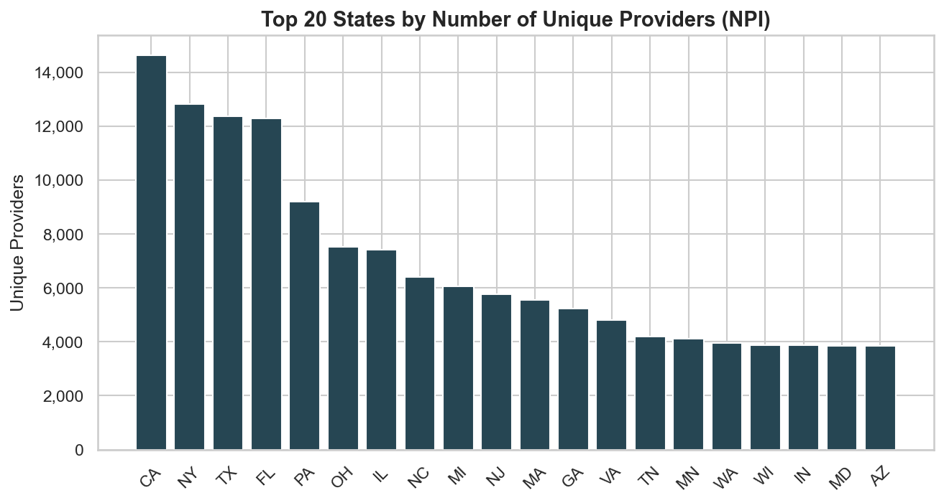
Figure 4: Top 20 States by Unique Providers
What This Chart Shows:
This chart shows unique provider count (NPI) per state. The top 5 states hold 61,292 of 184,865 unique providers (33.2%). This confirms the geographic concentration is not just about billing volume — the actual number of healthcare professionals is heavily skewed.
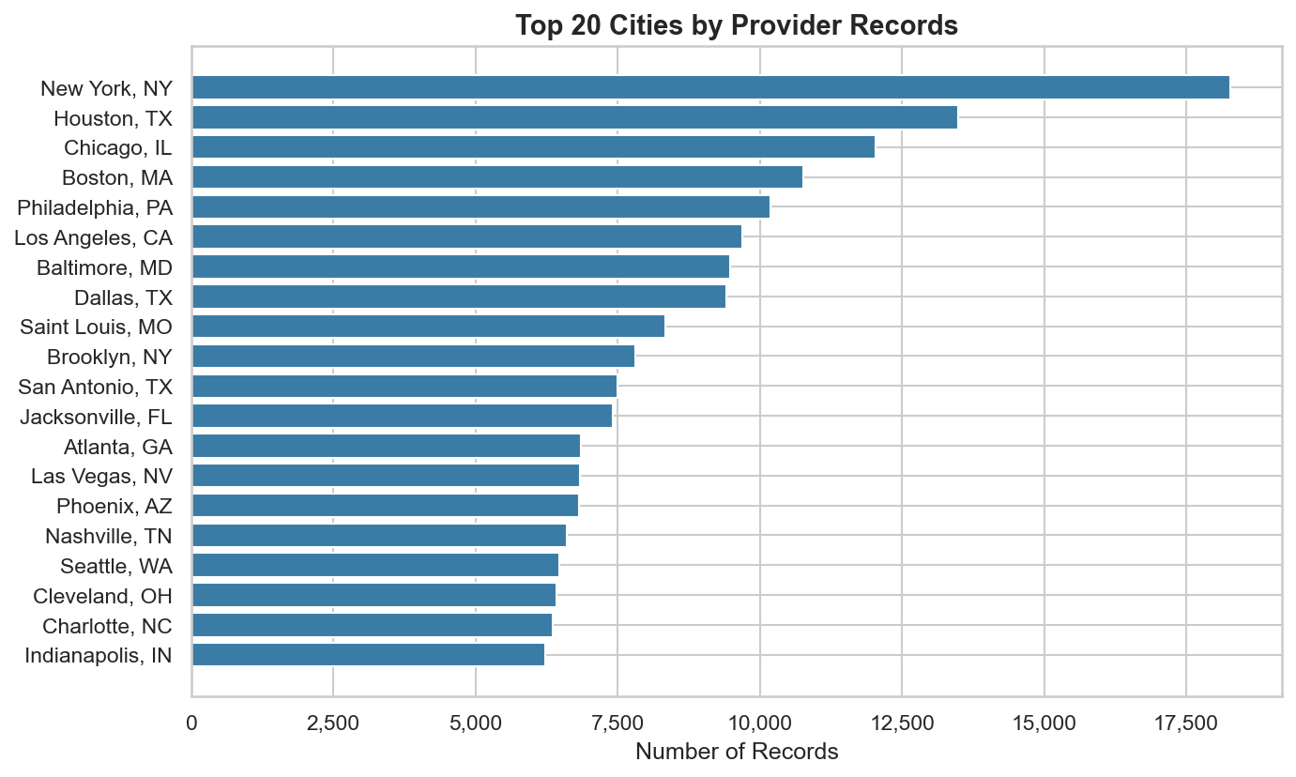
Figure 5: Top 20 Cities
What This Chart Shows:
This chart drills down to the city level. Major metropolitan areas (New York, Houston, Chicago, Los Angeles, Philadelphia) dominate, reflecting urban concentration of healthcare providers.
Problem Identified:
Geographic concentration creates severe access disparities. While urban areas have an abundance of providers, rural states and small towns face critical shortages. Patients in underserved areas experience longer wait times, fewer specialist options, and must travel further for care. This directly impacts no-show rates, delayed diagnoses, and patient outcomes. CareFlow AI should flag patients in underserved ZIP codes for proactive scheduling support and recommend telehealth alternatives when in-person access is limited.
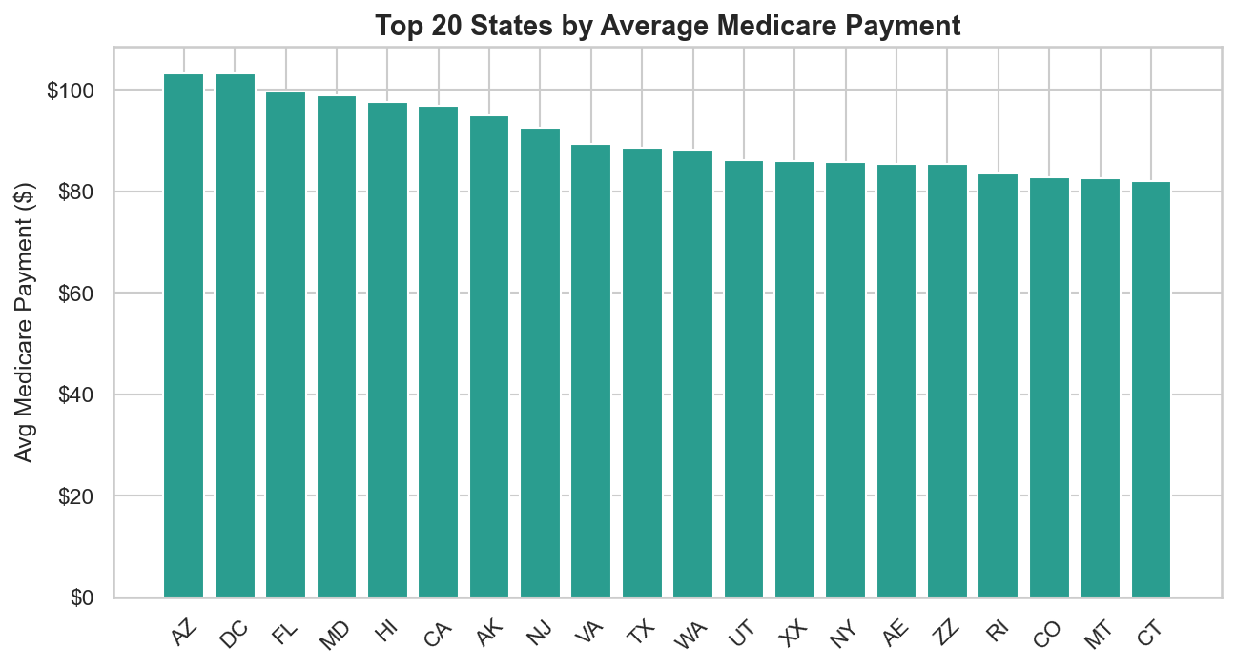
Figure 6: Average Payment by State
What This Chart Shows:
This chart shows average Medicare payment by state. Higher payments in certain states reflect higher cost of living, geographic practice cost indices (GPCI), and specialty mix. States with expensive real estate and higher wages naturally have higher Medicare fee schedules.
Problem Identified:
State-level payment variation means a provider performing the same procedure in two different states will receive different reimbursement. CareFlow AI must use location-adjusted predictions rather than national averages when estimating expected payments.

4. Payment Analysis

4.1 Charges vs Payments
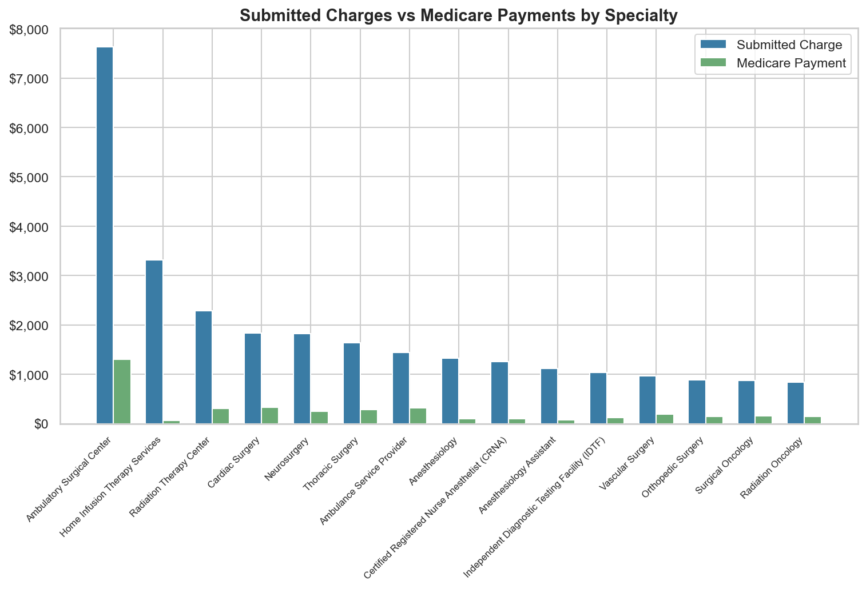
Figure 7: Charges vs Payments by Specialty
What This Chart Shows:
This grouped bar chart compares what providers charge (blue) versus what Medicare pays (green) for the top 15 most expensive specialties. On average, providers submit $431.17 but receive only $83.49 — a 80.6% reduction. The Medicare Allowed Amount averages $106.96, and the Standardized Amount (geography-adjusted) averages $83.09.
Problem Identified:
The massive gap between submitted charges and actual payments is the #1 revenue cycle problem. Providers who set charges based on internal cost structures receive far less than expected. This creates cash flow unpredictability, inflated patient bills, and administrative burden from write-offs. CareFlow AI must provide real-time expected payment estimates so billing staff can set realistic revenue expectations before claims are submitted.

4.2 Revenue Gap by State
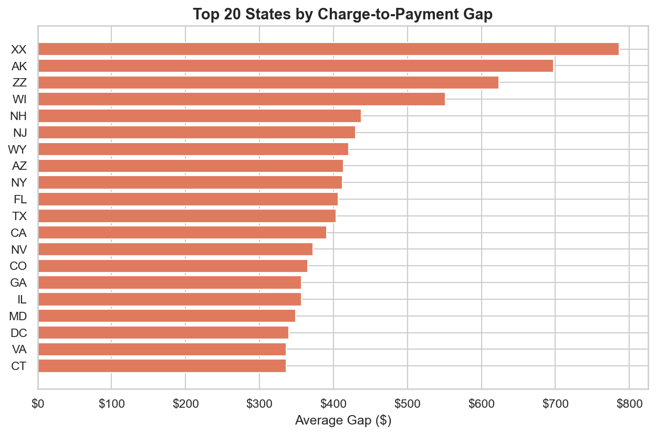
Figure 8: Charge-to-Payment Gap by State
What This Chart Shows:
This chart ranks states by the average dollar gap between submitted charges and Medicare payments. The largest gap is in XX ($786.16), followed by AK ($697.34) and ZZ ($623.97).
Problem Identified:
States with larger gaps face greater revenue unpredictability. Providers in high-gap states are likely submitting charges based on commercial insurance rates, which are much higher than Medicare fee schedules. This leads to large write-offs, accounts receivable buildup, and potential patient balance billing. CareFlow AI should provide state-specific reimbursement benchmarks and alert billing staff when charges are significantly above expected payment.

4.3 Payment Distribution
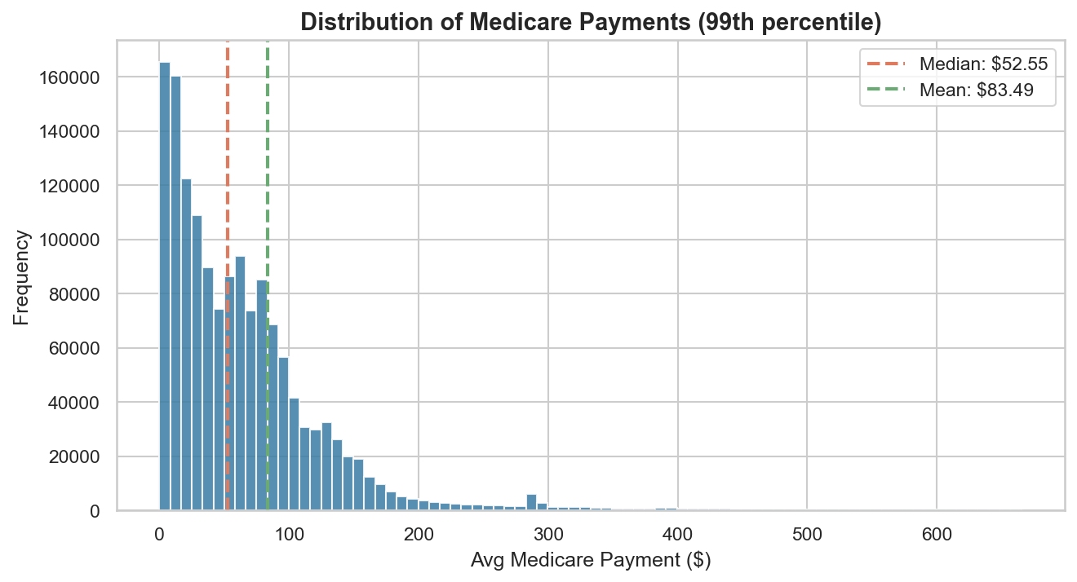
Figure 9: Medicare Payment Distribution
What This Chart Shows:
This histogram shows how Medicare payments are distributed across all 1,500,000 records. The dashed lines show the median ($52.55) and mean ($83.49). The distribution is heavily right-skewed — most services receive relatively low payments, while a small tail of high-value procedures pulls the mean above the median.
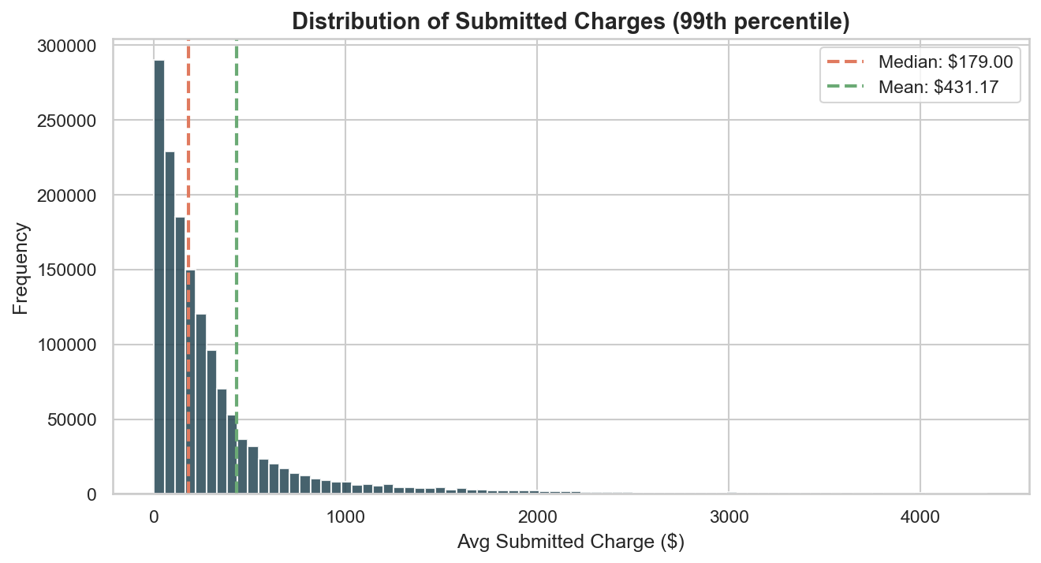
Figure 10: Submitted Charge Distribution
What This Chart Shows:
This histogram shows submitted charges. The median charge ($179.00) is much lower than the mean ($431.17), showing even more extreme skewness than payments.
Problem Identified:
The skewed distributions mean most services are low-value routine care, but a small number of high-value claims drive disproportionate revenue. If even a few of these high-value claims are denied, the financial impact is severe. CareFlow AI should implement a priority queue that gives extra scrutiny to high-dollar claims before submission.

4.4 Payment Efficiency
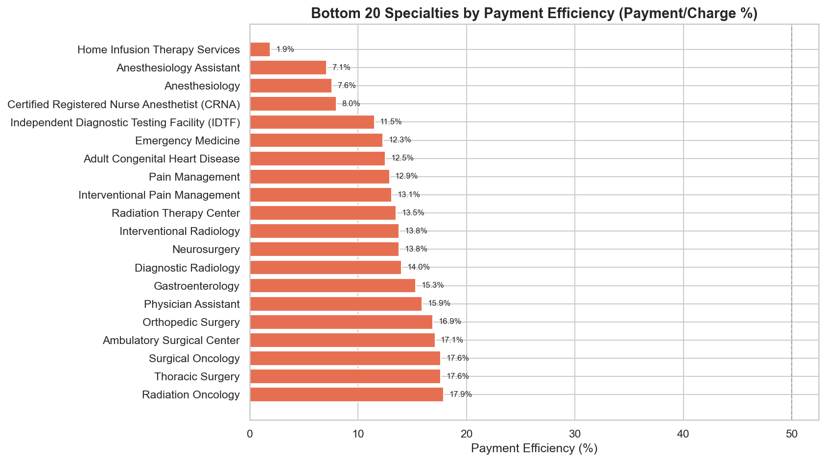
Figure 11: Payment Efficiency by Specialty
What This Chart Shows:
Payment efficiency measures what percentage of the submitted charge Medicare actually pays. The bottom 20 specialties are shown. The worst efficiency is Home Infusion Therapy Services at 1.9%, meaning Medicare pays less than a quarter of what is charged.
Problem Identified:
Specialties with very low payment efficiency (below 30%) face the most severe revenue shortfalls. Providers in these specialties may not realize how little Medicare will reimburse until after services are rendered. CareFlow AI should provide specialty-specific fee schedule lookups and warn providers when their charges significantly exceed expected reimbursement, preventing surprise revenue shortfalls.

4.5 Payment by Specialty (Box Plot)
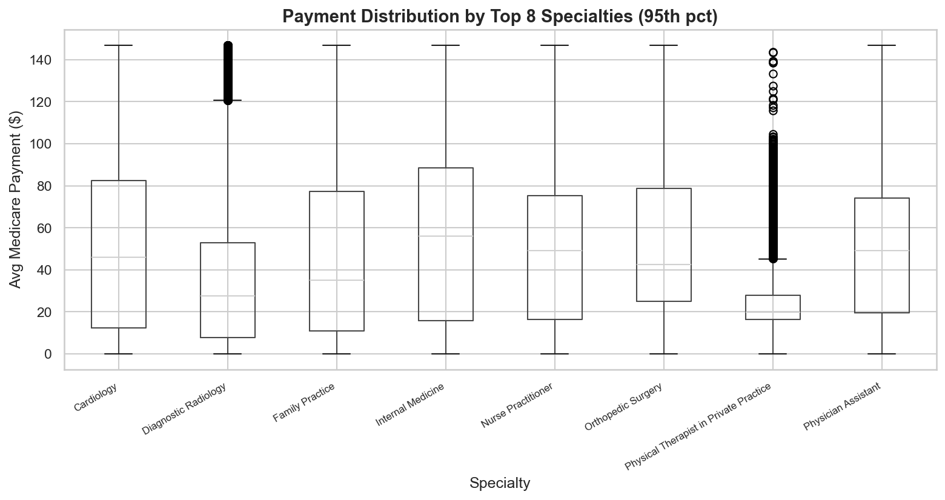
Figure 12: Payment Distribution by Top Specialties
What This Chart Shows:
This box plot shows the payment distribution within each of the top 8 specialties. The box represents the interquartile range (25th-75th percentile), the line is the median, and whiskers extend to 1.5x the IQR. This reveals how predictable or variable payments are within each specialty.
Problem Identified:
Specialties with wide payment spreads (tall boxes and long whiskers) have unpredictable reimbursement. Revenue forecasting is difficult for these specialties. Specialties with narrow boxes have more predictable payments, making financial planning easier. CareFlow AI should factor in specialty-level payment variance when generating revenue forecasts and confidence intervals.

5. Payment Breakdowns

5.1 By Gender

Figure 13: Gender Distribution
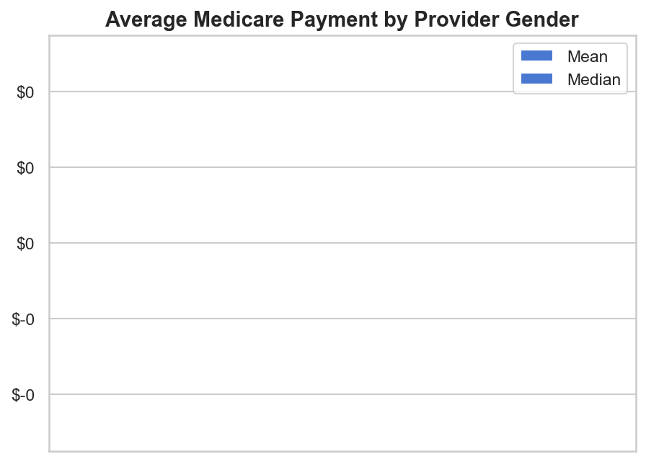
Figure 14: Payment by Gender
What These Charts Show:
Problem Identified:
The gender payment gap does not necessarily indicate discrimination — it more likely reflects the uneven distribution of specialties between genders. Male providers are overrepresented in higher-paying surgical specialties, while female providers are more concentrated in primary care and pediatrics. CareFlow AI should control for specialty when analyzing payment equity to avoid misleading conclusions.

5.2 By Entity Type
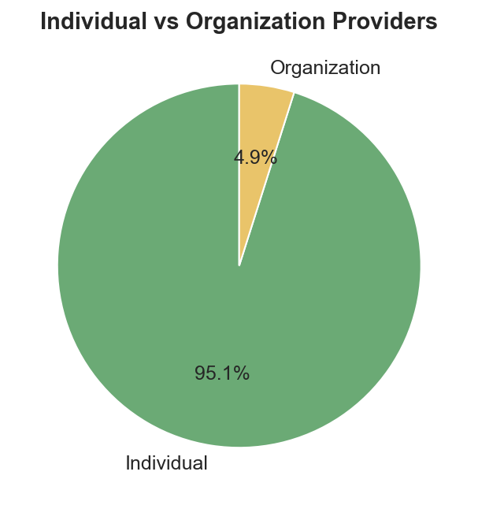
Figure 15: Entity Type Distribution
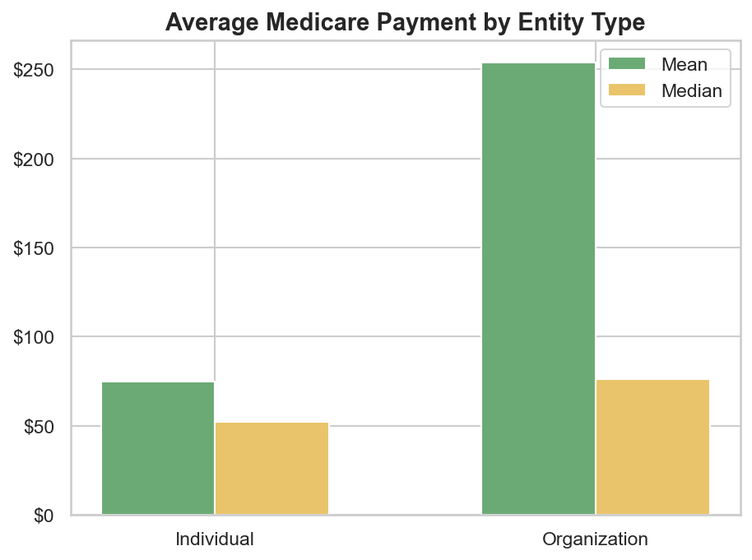
Figure 16: Payment by Entity Type
What These Charts Show:
The pie chart shows individual vs organizational providers. Organizations average $253.81 per service vs individuals at $74.74. Organizations include hospitals, clinics, labs, and imaging centers.
Problem Identified:
Organizations typically perform higher-cost procedures (surgeries, imaging, dialysis) and have different billing patterns than individual providers. They also face different prior authorization rules and are more likely to submit facility fees on top of professional fees. CareFlow AI must distinguish between individual and organizational billing patterns when predicting claim outcomes and expected payments.

5.3 By Place of Service
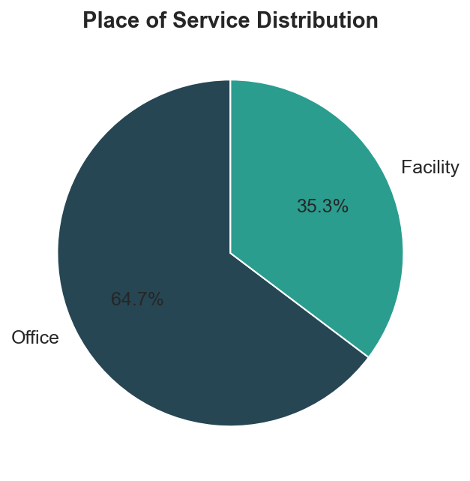
Figure 17: Place of Service
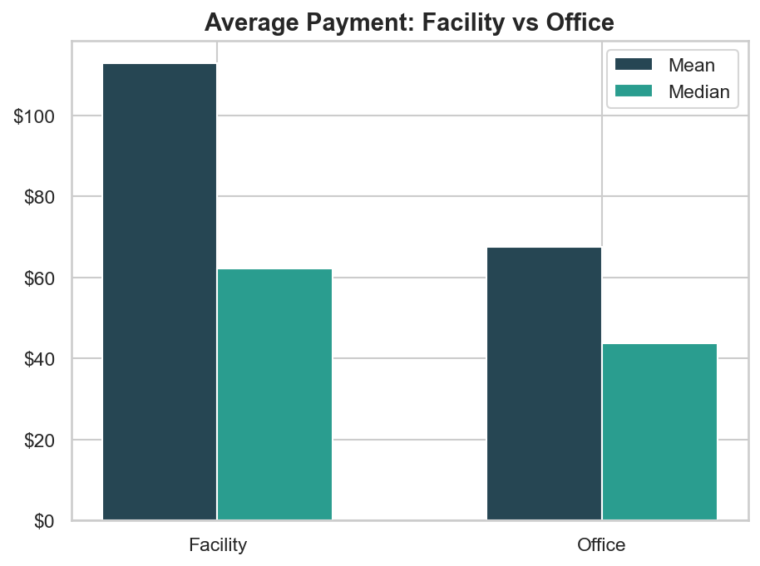
Figure 18: Payment by Place of Service
What These Charts Show:
The pie chart shows the split between facility and office settings. Facility-based services average $112.84 vs office-based at $67.49. Facility services account for 35.3% of records.
Problem Identified:
The same procedure performed in a facility vs an office can result in dramatically different reimbursement. Facility fees add significant cost. Patients are often unaware that the same procedure costs much more at a hospital than in a doctor's office. CareFlow AI should flag place-of-service as a key variable in cost estimates and recommend office-based alternatives when clinically appropriate to reduce patient costs.

5.4 Medicare Participation
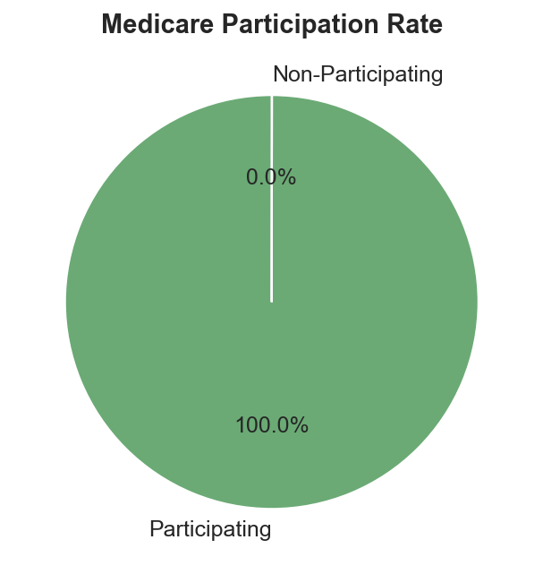
Figure 19: Medicare Participation
What This Chart Shows:
100.0% of provider records are from Medicare-participating providers. Participating providers accept Medicare's approved amount as full payment. Non-participating providers can charge up to 15% above the Medicare fee schedule.
Problem Identified:
Non-participating providers create cost uncertainty for patients. They may charge more than the Medicare-approved amount, leaving patients responsible for the excess ("balance billing"). CareFlow AI should flag non-participating providers in the scheduling module and warn patients about potential higher out-of-pocket costs before appointments are booked.

6. Service & Utilization Analysis

6.1 Drug vs Non-Drug Services
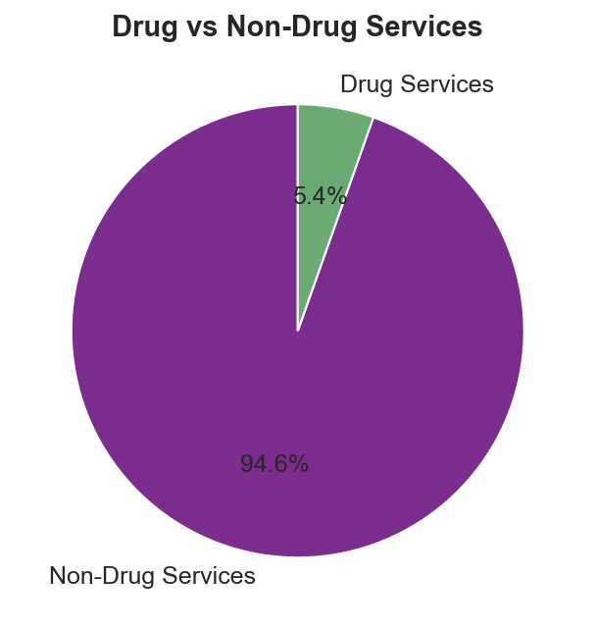
Figure 20: Drug vs Non-Drug
What This Chart Shows:
This pie chart splits services into drug-related (5.4%) and non-drug (94.6%) categories. Drug services include administered medications, infusions, and injections billed under Part B.
Problem Identified:
Drug services have fundamentally different authorization requirements than non-drug services. Many high-cost specialty drugs (biologics, chemotherapy, immunotherapy) require prior authorization with clinical documentation. Drug prices also fluctuate more than procedure fees, making cost prediction harder. CareFlow AI must maintain separate authorization workflows for drug vs non-drug services and track drug price changes in real time.

6.2 Top Procedures
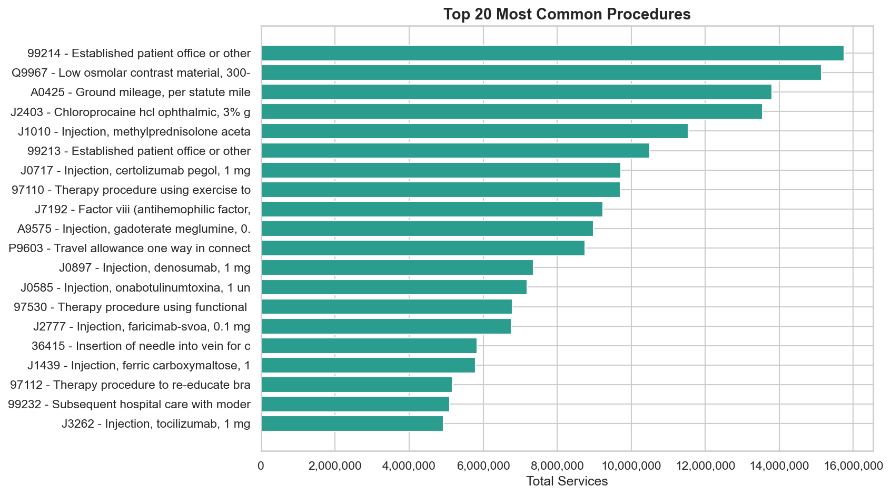
Figure 21: Top 20 Most Common Procedures
What This Chart Shows:
This chart ranks the 20 most frequently billed HCPCS/CPT codes by total service volume. The most common is 99214 — "Established patient office or other outpatient visit with moderate level of decision making, if using time, 30 minutes or more" with 15,752,190 total services. Office visits and evaluation/management (E&M) codes dominate, as expected in outpatient Medicare.
Problem Identified:
High-volume procedures are the most likely targets for payer audits, prior authorization requirements, and coding reviews. A single policy change affecting a top-20 procedure could impact thousands of claims. CareFlow AI should monitor payer policy updates for these high-volume codes and pre-populate authorization forms with commonly required documentation.

6.3 Highest-Paying Procedures
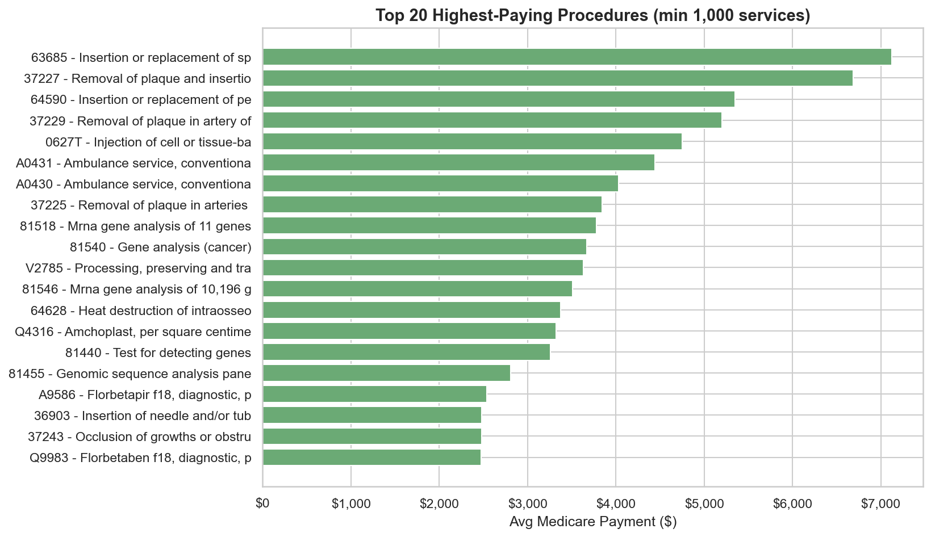
Figure 22: Highest-Paying Procedures
What This Chart Shows:
This chart shows the 20 procedures with the highest average Medicare payment (minimum 1,000 services to ensure statistical significance). These are typically surgical procedures, complex imaging, and specialty treatments that command premium reimbursement.
Problem Identified:
High-paying procedures carry the most financial risk per denial. A single denied claim for a procedure that pays thousands of dollars has a far greater impact than denying a routine office visit. These claims need the most rigorous pre-submission review. CareFlow AI should flag all claims above a configurable dollar threshold for mandatory human review before filing.

6.4 Lowest-Paying Procedures
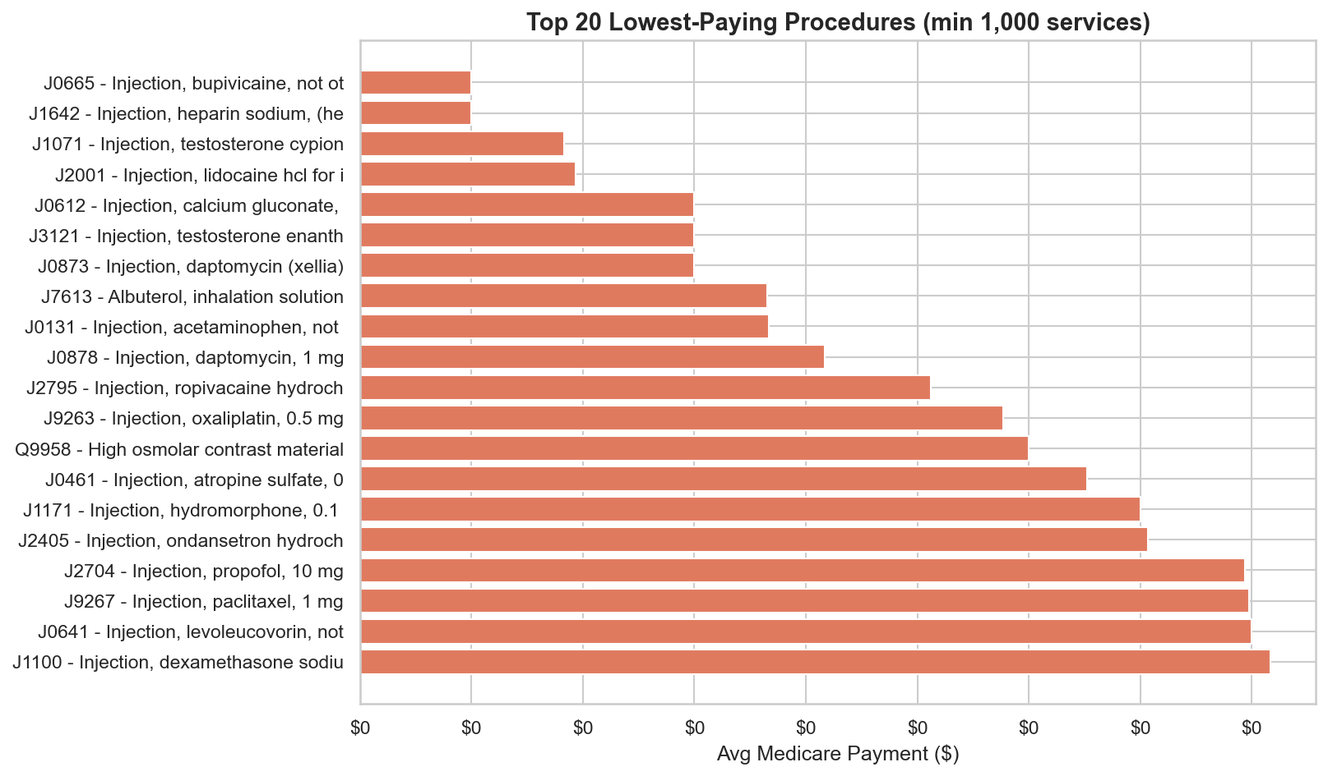
Figure 23: Lowest-Paying Procedures
What This Chart Shows:
This chart shows the 20 procedures with the lowest average Medicare payment (minimum 1,000 services). These are simple office visits, brief evaluations, and routine tests.
Problem Identified:
While individual low-paying procedures seem harmless, their sheer volume creates cumulative revenue risk. If a payer denies a large batch of routine claims due to a documentation deficiency or coding error, the total financial impact can be significant. CareFlow AI should batch-validate high-volume low-value claims before submission to catch systematic errors.

6.5 Utilization: Patients vs Services
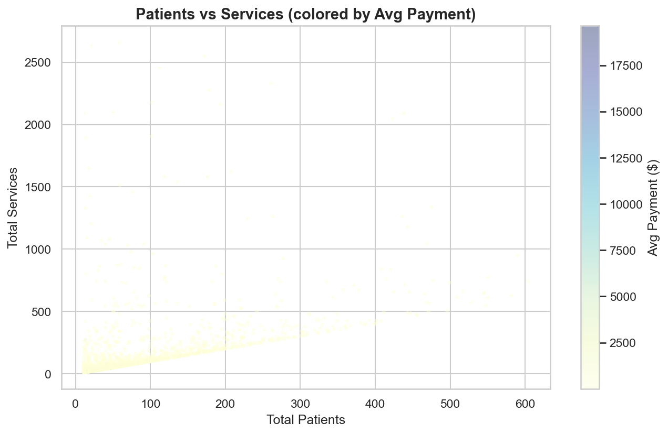
Figure 24: Patients vs Services Scatter
What This Chart Shows:
This scatter plot shows the relationship between patient count and service count per provider-procedure combination. Color intensity represents average payment amount. Most providers cluster in the lower-left (few patients, few services), while a few high-volume providers serve hundreds of patients. Darker dots indicate higher-paying services.
Problem Identified:
High-volume providers (upper-right) face the greatest prior authorization burden. If a provider performs the same procedure on hundreds of patients, a single prior auth policy change could affect all of them simultaneously. CareFlow AI should batch similar authorization requests for high-volume providers and proactively alert staff to policy changes that affect their most common procedures.

6.6 Services per Patient by Specialty
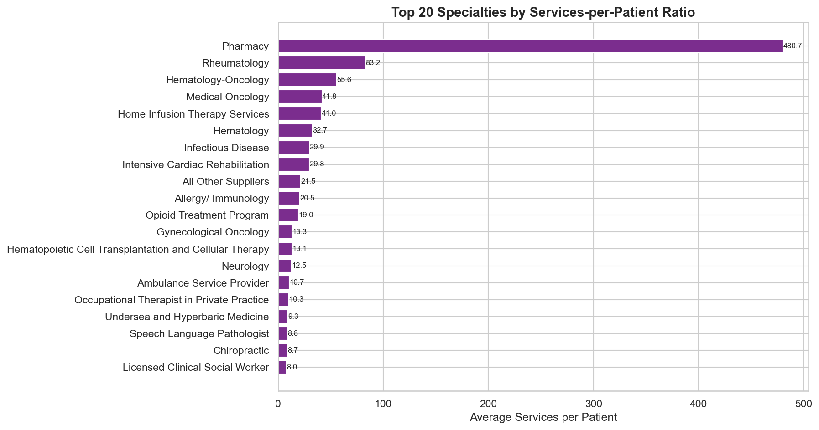
Figure 25: Services-per-Patient Ratio
What This Chart Shows:
This chart ranks specialties by how many services each patient receives on average. High ratios indicate specialties where patients need repeated treatments (dialysis, radiation therapy, physical therapy). Low ratios indicate one-time consultations.
Problem Identified:
Specialties with high services-per-patient ratios generate the most recurring prior authorization requests. Getting initial authorization once is not enough — these specialties need ongoing re-authorization. CareFlow AI should implement auto-renewal workflows for recurring treatment plans and predict when re-authorization is needed based on treatment frequency patterns.

6.7 Revenue Gap by Specialty
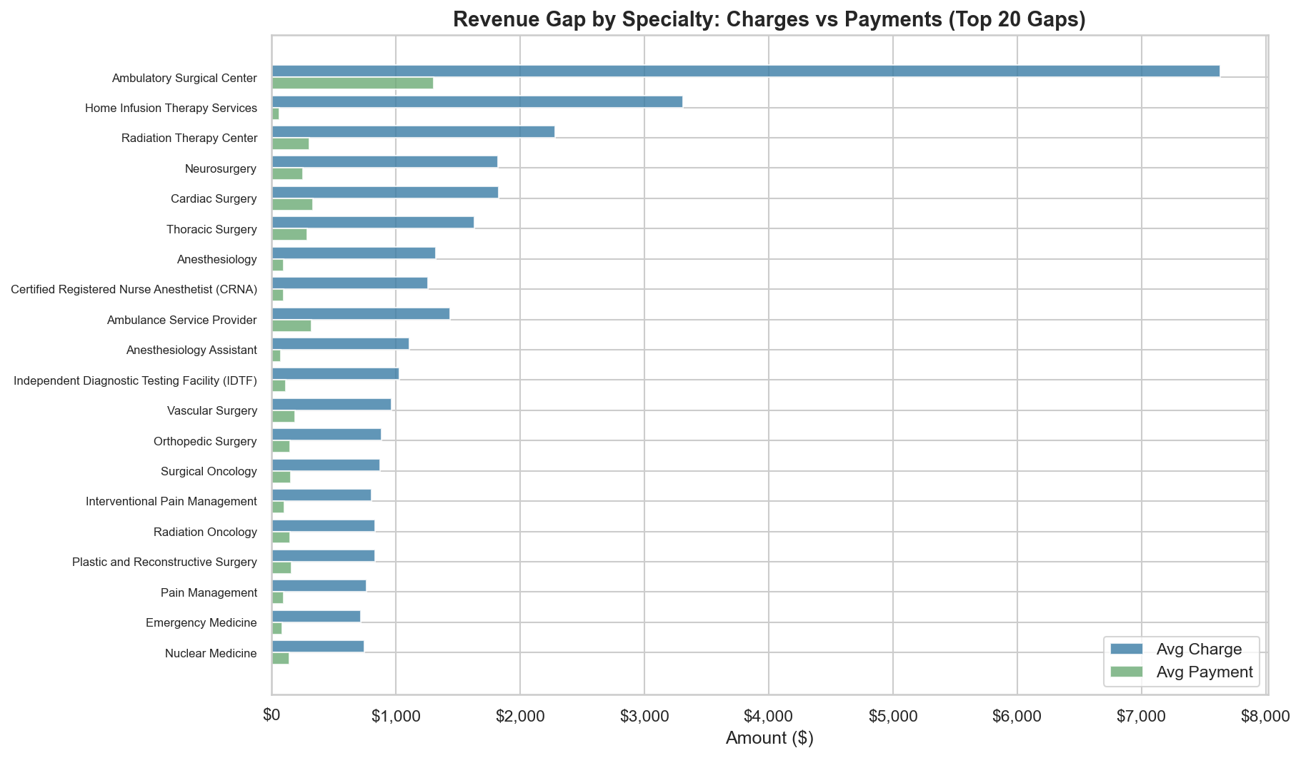
Figure 26: Revenue Gap by Specialty
What This Chart Shows:
This overlay chart directly compares average charges vs payments for the 20 specialties with the largest dollar gaps. The blue bars show charges, green bars show payments — the visible gap between them represents unrealized revenue.
Top 3 specialties by revenue gap:
- Ambulatory Surgical Center: Gap $6,333 (pays 17.1% of charges)
- Home Infusion Therapy Services: Gap $3,247 (pays 1.9% of charges)
- Radiation Therapy Center: Gap $1,977 (pays 13.5% of charges)
Problem Identified:
These specialties face the most severe disconnect between what they charge and what they receive. Providers in these specialties need the most help understanding Medicare fee schedules. CareFlow AI should provide specialty-specific dashboards showing expected reimbursement rates and recommend charge adjustments to minimize write-offs.

7. Correlation Analysis
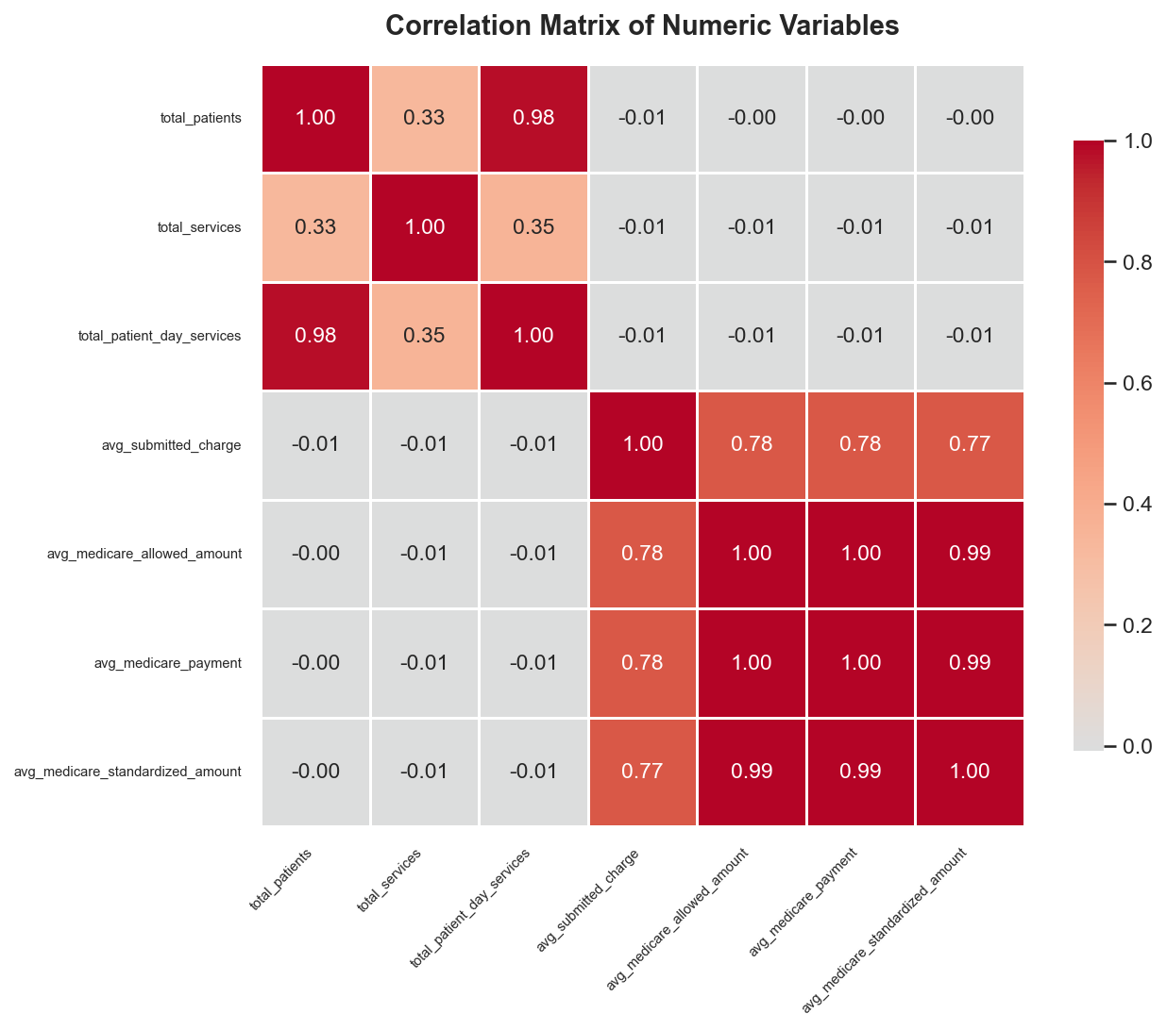
Figure 27: Correlation Matrix
What This Chart Shows:
This heatmap shows the Pearson correlation coefficient between all numeric variables in the dataset. Values range from -1 (perfect negative correlation) to +1 (perfect positive correlation). Red indicates positive correlation, blue indicates negative correlation.
Key correlations:
- Submitted charges and Medicare payments are strongly correlated — higher charges generally yield higher payments, but the relationship is not 1:1. This means charges DO influence payment but not proportionally.
- Total patients and total services are very highly correlated, confirming that more patients = more services in a roughly linear relationship.
- The standardized amount correlates strongly with actual payment but removes geographic variation, making it useful for fair cross-state comparisons.
- Medicare allowed amount and actual payment are nearly identical, confirming that Medicare pays close to what it approves.
Problem Identified:
The imperfect correlation between charges and payments (not 1.0) means that simply raising charges does NOT proportionally increase Medicare reimbursement. Many providers mistakenly believe higher charges will yield higher payments. CareFlow AI should educate users that Medicare payment is based on fee schedules, not submitted charges, and that inflating charges only increases the write-off burden.

8. Comprehensive Statistics

8.1 Descriptive Statistics (All Numeric Columns)
Full statistical breakdown of every numeric variable in the dataset:
Statistic | Patients | Services | Pt-Days | Charge | Allowed | Payment | Standardized
count | 1,500,000 | 1,500,000 | 1,500,000 | 1,500,000 | 1,500,000 | 1,500,000 | 1,500,000
mean | 84.56 | 286.42 | 136.73 | 431.17 | 106.96 | 83.49 | 83.09
std | 1,421.93 | 7,381.23 | 2,433.28 | 1,522.82 | 333.10 | 265.77 | 270.69
min | 11.00 | 4.40 | 11.00 | 0.00 | 0.00 | 0.00 | 0.00
25% | 17.00 | 21.00 | 20.00 | 73.00 | 25.52 | 19.69 | 19.51
50% | 32.00 | 44.00 | 41.00 | 179.00 | 71.68 | 52.55 | 52.78
75% | 72.00 | 119.00 | 106.00 | 366.00 | 121.15 | 90.92 | 90.80
max | 726,264.00 | 4,265,051.00 | 1,565,121.00 | 99,999.99 | 33,888.21 | 27,000.37 | 22,474.23

8.2 Data Quality — Missing Values
7 columns have missing values:
Column | Missing Count | Missing %
provider_gender | 1,500,000 | 100.0%
provider_street_address_2 | 1,165,067 | 77.7%
provider_middle_initial | 527,610 | 35.2%
provider_credentials | 166,618 | 11.1%
provider_first_name | 73,327 | 4.9%
provider_ruca_code | 786 | 0.1%
provider_rural_urban_description | 786 | 0.1%

8.3 Payment Statistics by Specialty (Top 25)
Column labels: Provider Charge = what the provider bills. Medicare Pays = what Medicare sends to the provider. Patient Pays = estimated patient coinsurance (Allowed − Medicare Payment). Write-Off = charge that is never collected.
Specialty | Records | Provider Charges | Medicare Pays | Patient Pays (est) | Write-Off | Eff%
Diagnostic Radiology | 169,927.0 | $337 | $47 | $14 | $275 | 14.0%
Nurse Practitioner | 148,304.0 | $219 | $54 | $17 | $148 | 24.5%
Internal Medicine | 121,399.0 | $234 | $68 | $17 | $149 | 29.1%
Family Practice | 120,315.0 | $171 | $56 | $13 | $101 | 32.8%
Physician Assistant | 89,346.0 | $346 | $55 | $18 | $273 | 15.9%
Physical Therapist in Private Practice | 63,531.0 | $96 | $30 | $10 | $56 | 31.2%
Cardiology | 59,588.0 | $387 | $87 | $26 | $274 | 22.5%
Orthopedic Surgery | 42,224.0 | $888 | $150 | $44 | $694 | 16.9%
Ophthalmology | 34,626.0 | $513 | $125 | $41 | $347 | 24.4%
Dermatology | 32,438.0 | $363 | $107 | $35 | $221 | 29.4%
Emergency Medicine | 32,384.0 | $722 | $89 | $27 | $606 | 12.3%
Anesthesiology | 31,110.0 | $1,324 | $101 | $27 | $1,197 | 7.6%
Podiatry | 27,537.0 | $179 | $59 | $21 | $100 | 32.7%
Optometry | 27,469.0 | $149 | $55 | $27 | $66 | 37.3%
Urology | 25,604.0 | $512 | $96 | $29 | $387 | 18.8%
Mass Immunizer Roster Biller | 24,385.0 | $101 | $93 | $0 | $8 | 91.8%
Gastroenterology | 24,214.0 | $689 | $105 | $28 | $556 | 15.3%
Hematology-Oncology | 23,101.0 | $230 | $54 | $16 | $161 | 23.4%
Pathology | 22,361.0 | $201 | $37 | $9 | $155 | 18.4%
Neurology | 19,732.0 | $442 | $95 | $30 | $316 | 21.5%
Pulmonary Disease | 19,050.0 | $309 | $71 | $21 | $217 | 22.9%
General Surgery | 18,856.0 | $691 | $136 | $39 | $516 | 19.7%
Certified Registered Nurse Anesthetist (CRNA) | 18,096.0 | $1,262 | $101 | $26 | $1,135 | 8.0%
Interventional Cardiology | 16,059.0 | $564 | $119 | $34 | $411 | 21.1%
Clinical Laboratory | 15,973.0 | $130 | $44 | $1 | $85 | 33.7%

8.4 Payment Statistics by State (All States)
Same column definitions as above. Efficiency = Medicare Payment / Provider Charge %.
State | Records | Providers | Provider Charges | Medicare Pays | Patient Pays (est) | Write-Off | Eff%
CA | 126,792.0 | 14,638.0 | $487 | $97 | $27 | $363 | 19.9%
FL | 107,941.0 | 12,278.0 | $506 | $100 | $28 | $379 | 19.7%
TX | 104,280.0 | 12,373.0 | $492 | $89 | $25 | $379 | 18.0%
NY | 96,951.0 | 12,810.0 | $498 | $86 | $24 | $388 | 17.2%
PA | 69,369.0 | 9,193.0 | $355 | $79 | $22 | $253 | 22.3%
IL | 59,755.0 | 7,405.0 | $435 | $79 | $22 | $334 | 18.1%
OH | 55,155.0 | 7,532.0 | $394 | $76 | $22 | $297 | 19.2%
NC | 54,589.0 | 6,397.0 | $374 | $75 | $21 | $279 | 19.9%
NJ | 49,103.0 | 5,770.0 | $522 | $93 | $25 | $405 | 17.7%
GA | 43,536.0 | 5,242.0 | $434 | $77 | $21 | $336 | 17.7%
MA | 43,363.0 | 5,539.0 | $412 | $82 | $23 | $307 | 19.9%
MI | 42,299.0 | 6,062.0 | $339 | $75 | $22 | $242 | 22.1%
VA | 41,958.0 | 4,799.0 | $425 | $89 | $25 | $311 | 21.0%
TN | 39,240.0 | 4,206.0 | $373 | $74 | $20 | $279 | 19.8%
MD | 35,191.0 | 3,860.0 | $448 | $99 | $27 | $322 | 22.1%
AZ | 32,978.0 | 3,844.0 | $517 | $103 | $29 | $385 | 20.0%
MN | 31,817.0 | 4,104.0 | $389 | $67 | $19 | $304 | 17.1%
IN | 31,519.0 | 3,881.0 | $412 | $81 | $23 | $308 | 19.6%
MO | 28,871.0 | 3,622.0 | $410 | $79 | $23 | $308 | 19.3%
WA | 28,281.0 | 3,968.0 | $371 | $88 | $26 | $257 | 23.8%
SC | 28,022.0 | 2,964.0 | $379 | $73 | $20 | $286 | 19.3%
WI | 26,151.0 | 3,884.0 | $623 | $72 | $21 | $530 | 11.6%
AL | 24,452.0 | 2,615.0 | $286 | $64 | $18 | $203 | 22.5%
CO | 23,618.0 | 3,225.0 | $448 | $83 | $24 | $341 | 18.5%
KY | 20,879.0 | 2,729.0 | $337 | $72 | $20 | $244 | 21.5%
LA | 19,435.0 | 2,496.0 | $411 | $80 | $22 | $309 | 19.3%
OK | 18,497.0 | 2,043.0 | $363 | $77 | $22 | $265 | 21.1%
CT | 17,992.0 | 2,581.0 | $418 | $82 | $22 | $313 | 19.6%
AR | 17,054.0 | 1,637.0 | $291 | $72 | $20 | $200 | 24.6%
OR | 16,605.0 | 2,161.0 | $360 | $74 | $22 | $264 | 20.5%
IA | 16,209.0 | 1,825.0 | $375 | $78 | $21 | $276 | 20.9%
KS | 15,589.0 | 1,822.0 | $360 | $76 | $21 | $263 | 21.0%
MS | 15,253.0 | 1,489.0 | $400 | $79 | $22 | $299 | 19.8%
NE | 12,181.0 | 1,289.0 | $360 | $72 | $20 | $268 | 20.0%
NV | 12,099.0 | 1,363.0 | $454 | $82 | $23 | $349 | 18.0%
UT | 11,816.0 | 1,552.0 | $395 | $86 | $24 | $284 | 21.8%
NH | 8,278.0 | 1,073.0 | $508 | $70 | $21 | $417 | 13.8%
WV | 7,480.0 | 1,053.0 | $291 | $67 | $20 | $204 | 23.1%
ID | 6,908.0 | 1,011.0 | $376 | $77 | $23 | $277 | 20.3%
DE | 6,308.0 | 716.0 | $366 | $75 | $21 | $270 | 20.6%
NM | 6,291.0 | 949.0 | $406 | $81 | $24 | $302 | 19.9%
ME | 6,106.0 | 1,027.0 | $270 | $66 | $20 | $184 | 24.4%
RI | 5,764.0 | 818.0 | $396 | $83 | $24 | $288 | 21.1%
SD | 5,103.0 | 683.0 | $377 | $78 | $23 | $276 | 20.7%
MT | 4,537.0 | 678.0 | $338 | $82 | $25 | $231 | 24.4%
HI | 4,330.0 | 623.0 | $392 | $98 | $28 | $267 | 24.9%
ND | 4,238.0 | 589.0 | $313 | $62 | $19 | $233 | 19.6%
DC | 3,828.0 | 597.0 | $443 | $103 | $29 | $311 | 23.3%
AK | 3,165.0 | 406.0 | $792 | $95 | $29 | $669 | 12.0%
WY | 2,899.0 | 366.0 | $502 | $81 | $24 | $396 | 16.2%
VT | 2,767.0 | 433.0 | $272 | $63 | $19 | $189 | 23.3%
PR | 2,511.0 | 560.0 | $116 | $51 | $16 | $49 | 43.7%
GU | 294.0 | 35.0 | $247 | $75 | $28 | $144 | 30.5%
VI | 169.0 | 20.0 | $316 | $62 | $24 | $229 | 19.7%
AP | 79.0 | 6.0 | $333 | $56 | $18 | $259 | 16.8%
AE | 44.0 | 6.0 | $245 | $85 | $16 | $144 | 34.8%
ZZ | 39.0 | 10.0 | $709 | $85 | $24 | $600 | 12.0%
AA | 12.0 | 1.0 | $136 | $53 | $30 | $53 | 38.8%
MP | 8.0 | 5.0 | $378 | $66 | $38 | $274 | 17.5%
XX | 2.0 | 2.0 | $872 | $86 | $24 | $762 | 9.9%

9. Key Problems Identified

1. Revenue Leakage
Providers lose an average of $347.68 (80.6%) per service between what they charge and what Medicare pays. Across 1,500,000 records, this represents massive unrealized revenue.

2. Prior Auth Complexity
4,860 procedures across 108 specialties create an enormous matrix of payer-specific authorization rules that are impossible to manage manually.

3. Geographic Disparities
The top 5 states hold 33.7% of records. Rural and underserved areas have critical provider shortages.

4. Payment Unpredictability
The gap between mean ($83.49) and median ($52.55) payment shows extreme skewness. Revenue forecasting without data tools is unreliable.

5. High-Value Claim Risk
A small number of procedures command payments over $27,000. Denials on these claims cause severe financial harm.

6. Cost Transparency Gap
Submitted charges ($431.17) bear little resemblance to actual payments ($83.49), creating patient confusion and surprise bills.

7. Specialty Payment Inequality
Payment efficiency varies dramatically — some specialties receive less than 20% of submitted charges while others receive over 60%.

8. Coding Complexity
With 4,860 unique HCPCS codes, incorrect coding is a leading cause of claim denials. AI-assisted coding review is essential.

10. Recommendations for CareFlow AI

1. Real-Time Reimbursement Predictor
Use CMS data to predict actual payment for any provider/procedure/state combination before claim submission.

2. Denial Risk Scoring Engine
Assign risk scores to claims based on procedure code, specialty, state, and historical patterns.

3. Specialty-Specific Prior Auth Automation
Pre-populate authorization forms for the top 20 highest-volume procedures.

4. High-Value Claim Priority Queue
Flag claims in the top 5% by expected value for mandatory manual review.

5. Geographic Access Dashboard
Map provider availability to identify underserved areas for telehealth intervention.

6. Charge Optimization Alerts
Alert billing staff when submitted charges deviate significantly from expected Medicare rates.

7. Payment Trend Monitoring
Track payment efficiency over time by specialty and state to identify deteriorating reimbursement.

8. Patient Cost Estimator
Show patients expected out-of-pocket costs using actual Medicare payment data instead of submitted charges.

11. Conclusion
This expanded analysis of 1,500,000 Medicare records reveals systemic challenges in healthcare revenue cycle management. The 80.6% charge-to-payment gap, combined with 4,860 procedure codes and 108 specialties, creates complexity that demands AI-driven solutions. CareFlow AI is positioned to transform these challenges into operational improvements.

Disclaimer: This report uses public CMS data for demonstration only. No real patient data is included.

