README.md
Mantine Mockup Builder

Build interactive mockups with ease using the power of Mantine's React UI library directly within an Electron environment.
Table of Contents

Features: #features
Getting Started: #getting-started
Usage: #usage
Contributing: #contributing
License: #license

Features
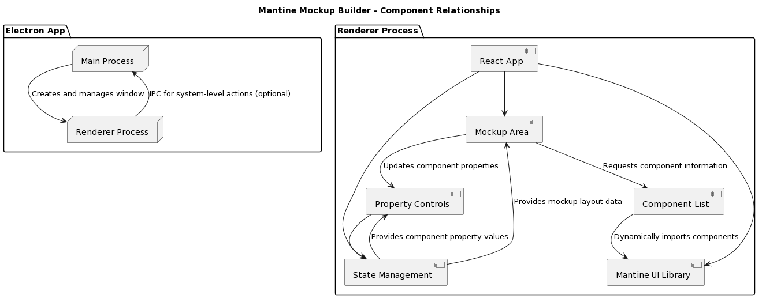
Dynamic Component Import: Drag-and-drop components from the Mantine library directly into your mockup workspace.
Intuitive Property Controls: Customize the look and behavior of Mantine components using a user-friendly interface.
State Management: Maintain the layout, component positions, and properties of your mockup with robust state management.
Mockup Export: Export your designed mockups in a format suitable for integration into your main React project.

Getting Started

Prerequisites

Node.js and npm (or yarn) installed

Installation

Clone the repository:
Bash

git clone https://github.com/your-username/mantine-mockup-builder.git

Use code with caution.

Install dependencies:
Bash

cd mantine-mockup-builder
npm install

Use code with caution.
Start the development server:
Bash

npm start

Use code with caution.

Usage

Component Selection: Browse the list of available Mantine components and drag them onto the mockup canvas.
Customization: Use the property controls panel to adjust component styles, text content, behaviors, and more.
Layout: Arrange components within the mockup using flexible layout tools.
Export: Once your mockup is complete, export it in your desired format for integration into your client codebase.

Contributing

We welcome contributions to the Mantine Mockup Builder! Please refer to our CONTRIBUTING.md file for guidelines on how to submit issues, feature requests, and pull requests.

