**INDEX**

|  |  |  |
| --- | --- | --- |
| **1** | ABSTRACT | 2 |
| **2** | EXISTING SYSTEM | 3 |
| **3** | DISADVANTAGES OF EXISTING SYSTEM | 3 |
| **4** | PROPOSED SYSTEM | 4 |
| **5** | ADVANTAGES OF PROPOSED SYSTEM | 4 |
| **7** | MODULES DESCRIPTION | 5 |
| **8** | HARDWARE REQUIREMENTS | 6 |
| **9** | SOFTWARE USED | 6 |
| **10** | SYSTEM DESIGN | 7 |

**ABSTRACT**

This web application is developed to reduce the task of manually calculating the performance of the lecturers given by the students in the feedback form. The feedback form of the lecturers is given in a sheet with 5 columns in it 1) EXCELLENT 2) GOOD 3) AVERAGE 4) BAD 5) POOR.

The students selects any one of the 5 columns based upon the performance of lecturers and this information is noted in a Sheet by checking every paper and the user manually calculates the count of excellent, good, average, bad and poor for each faculty.

With this application the user can enter the feedback of the lecturers given by students in a webpage and after the completion of the feedback forms the browser displays the result in a tabular form based upon user requirement (class wise, ID wise, Name wise).

Advantage of the Application:

The main advantage of this application is to reduce the time and human effort in calculating the performance of the faculty. This application is developed mainly for the college.

**EXISTING SYSTEM:**

Students receive a sheet of paper with the list of faculty with 4-5 columns namely

1) Excellent 2) V.Good 3) Good 4) Average 5) Bad/Poor. The student has to mark any of these 5 columns against each lecturer/faculty. Now the collage management collects all the sheets form all the classes and then manually calculate the performance of each faculty by adding there performances from each sheet.

This is a highly time taking process and the right action might not be taken at the right time. There might be chances of Human errors while handling with 60-70 sheets per class.

Hence this is a very tedious task to do with high human effort.

**DISADVANTAGES:**

1. Lot of human effort required.
2. Time taking process
3. High chances of data inconsistency.

**PROPOSED SYSTEM:**

Once the college management receives the feedback form sheets from the students, this web application provides an interface to user to directly map the data from the details given by users on to the application and just click submit.

On the college management can directly get the results processed by application.

The application provides results not just class wise but also faculty wise. This decreases the human efforts required as user need not count and make calculation but just enter the data in the application and click submit.

This application saves a lot of human efforts, time and action can be taken immediately for the benefit of students as well as the college.

**ADVANTAGES:**

1. Quick Results
2. Less human efforts.
3. Easy to use.

**MODULES DESCRIPTION:**

1. **Class generation**
2. **Data Entry**
3. **Results**

**Class Generation**

In this module the user has to enter all the class details i.e. the faculty details, subject names, etc. Once user clicks generate after entering all the details, a table will be created for that class in the database.

**Data Entry**

In this module the user has to enter the feedback given by user on to the application and it is repeated for each and every sheet received. This module analyzes the data and stores the data in appropriate form such that it is easy to retrieve results from the database.

**Results**

This module analyzes the data and displays the results to the user on the screen.

The user can request for class wife results, Faculty wise results, etc.

**Software Requirments:**

Language : Java - JDK (1.8.0)

Frontend : HTML

Backend : MySQL – (Servlets)

IDE : Eclipse LUNA

Operating System : windows 7

**Hardware Requirements:**

Processor : Pentium IV

Hard Disk : 10GB

RAM : 2GB

**Future work:**

The main aim of our application is to retrieve results as fast as possible with less human efforts.

**SYSTEM DESIGN**

**Use case:**

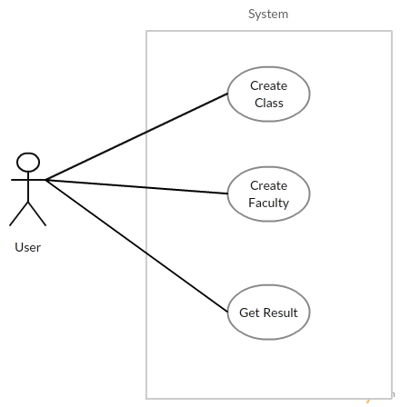

**Class Diagram:**

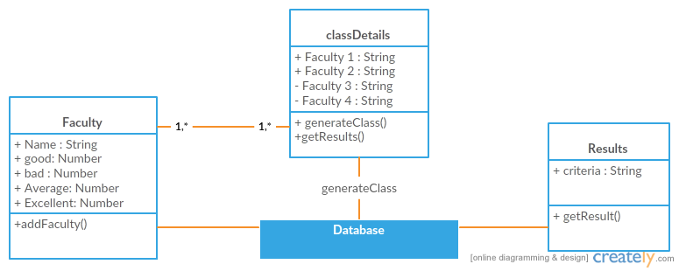

**Sequence Diagram:**

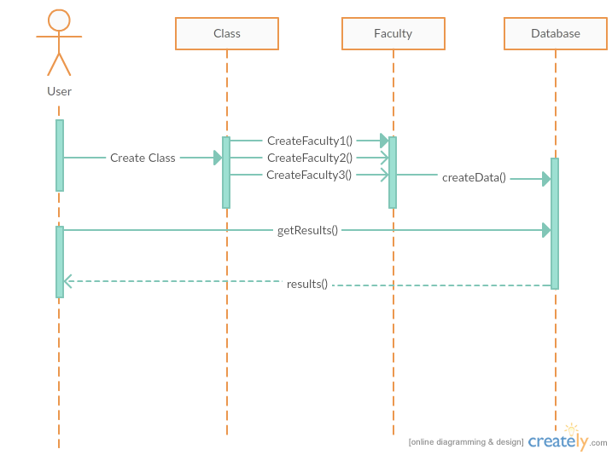

**Activity diagram:**

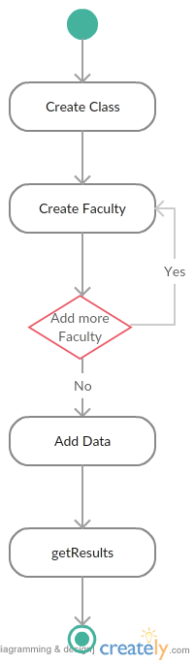

**Component Diagram:**

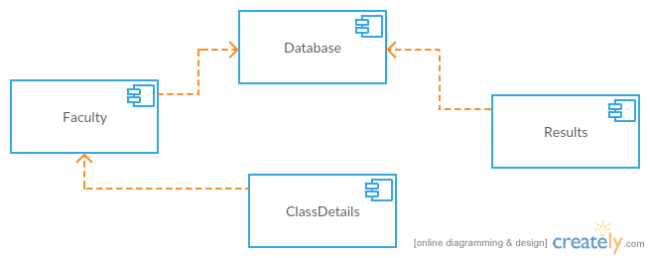

**Prepared By:**

1. **Rohit Uppala (13BD1A05B7)**
2. **K.Anudeep Raj (13BD1A0583)**
3. **L.Rahul Reddy (13BD1A0590)**
4. **J. Ravi Kumar (13BD1A0582)**

**Prepared By:**

1. **Rohit Uppala (13BD1A05B7)**
2. **K.Anudeep Raj (13BD1A0583)**
3. **L.Rahul Reddy (13BD1A0590)**
4. **J. Ravi Kumar (13BD1A0582)**