1. Download Java Platform, Enterprise Edition 8 SDK

<https://www.oracle.com/technetwork/java/javaee/downloads/java-ee-sdk-downloads-3908423.html>

<https://javaee.github.io/glassfish/download>

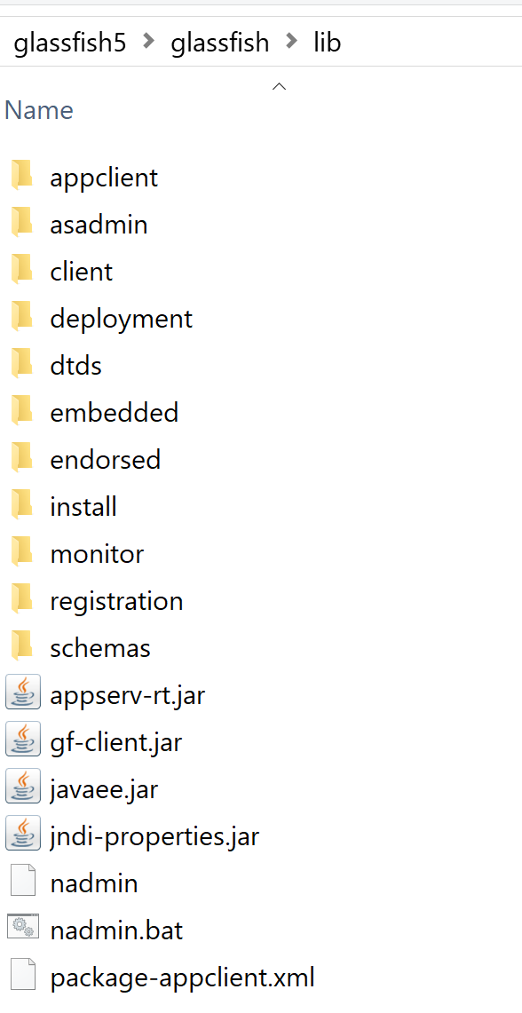

1. Eclipse IDE for Java EE Developers

<https://www.eclipse.org/downloads/packages/>

1. Install GlassFish Tools

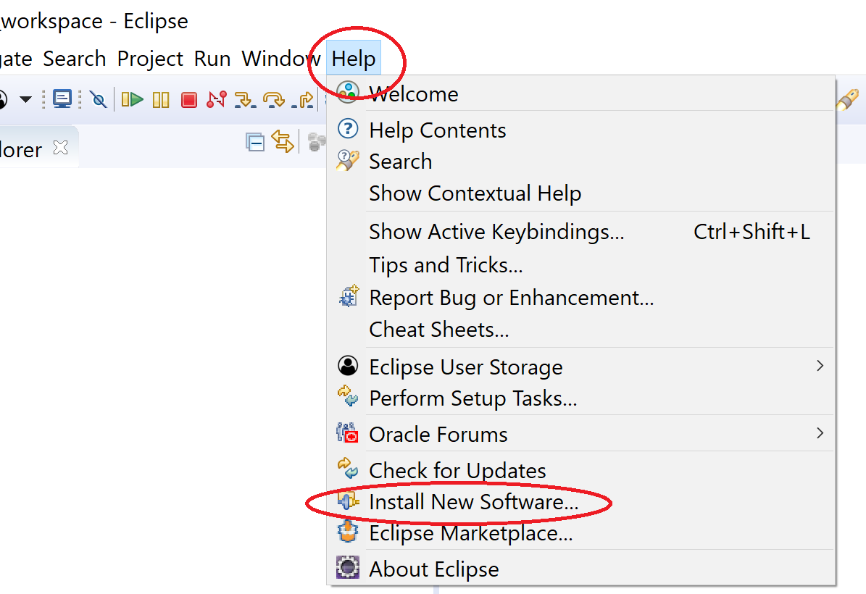

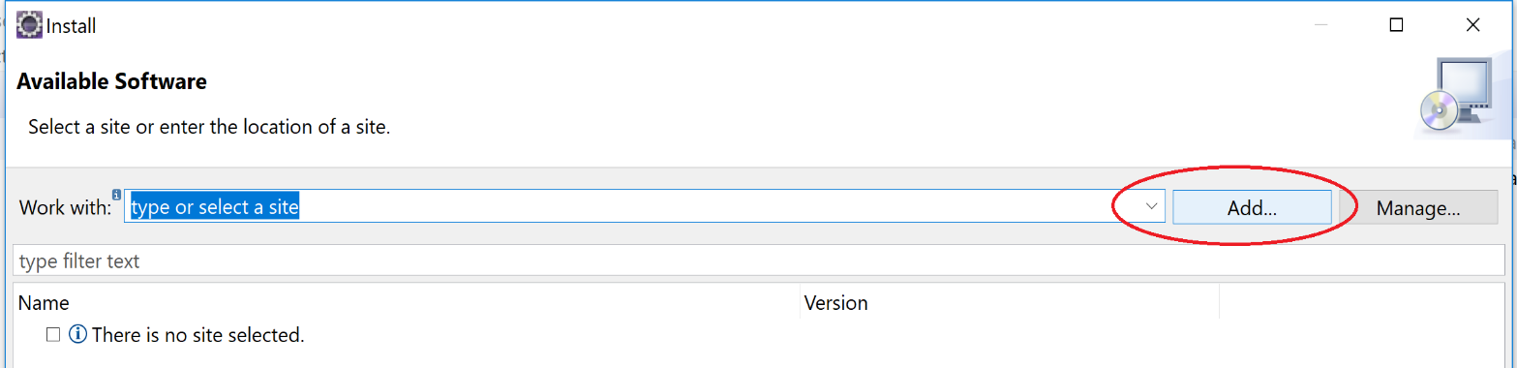

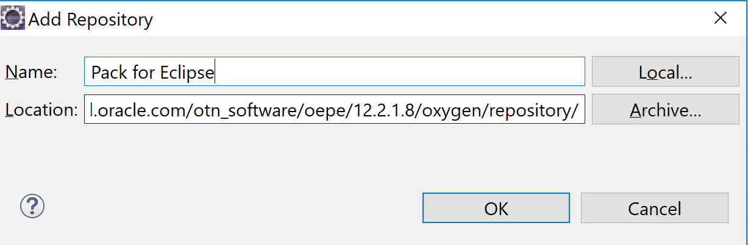

<https://download.oracle.com/otn_software/oepe/12.2.1.8/oxygen/repository/>

Available Software 🡪 Chọn Tools 🡪 Chọn Oracle Java EE Tools 🡪 Click Next 🡪 Click Next 🡪 Accept license 🡪 Click Finish. Chờ đến khi cài xong.

Tạo Glassfish Server:



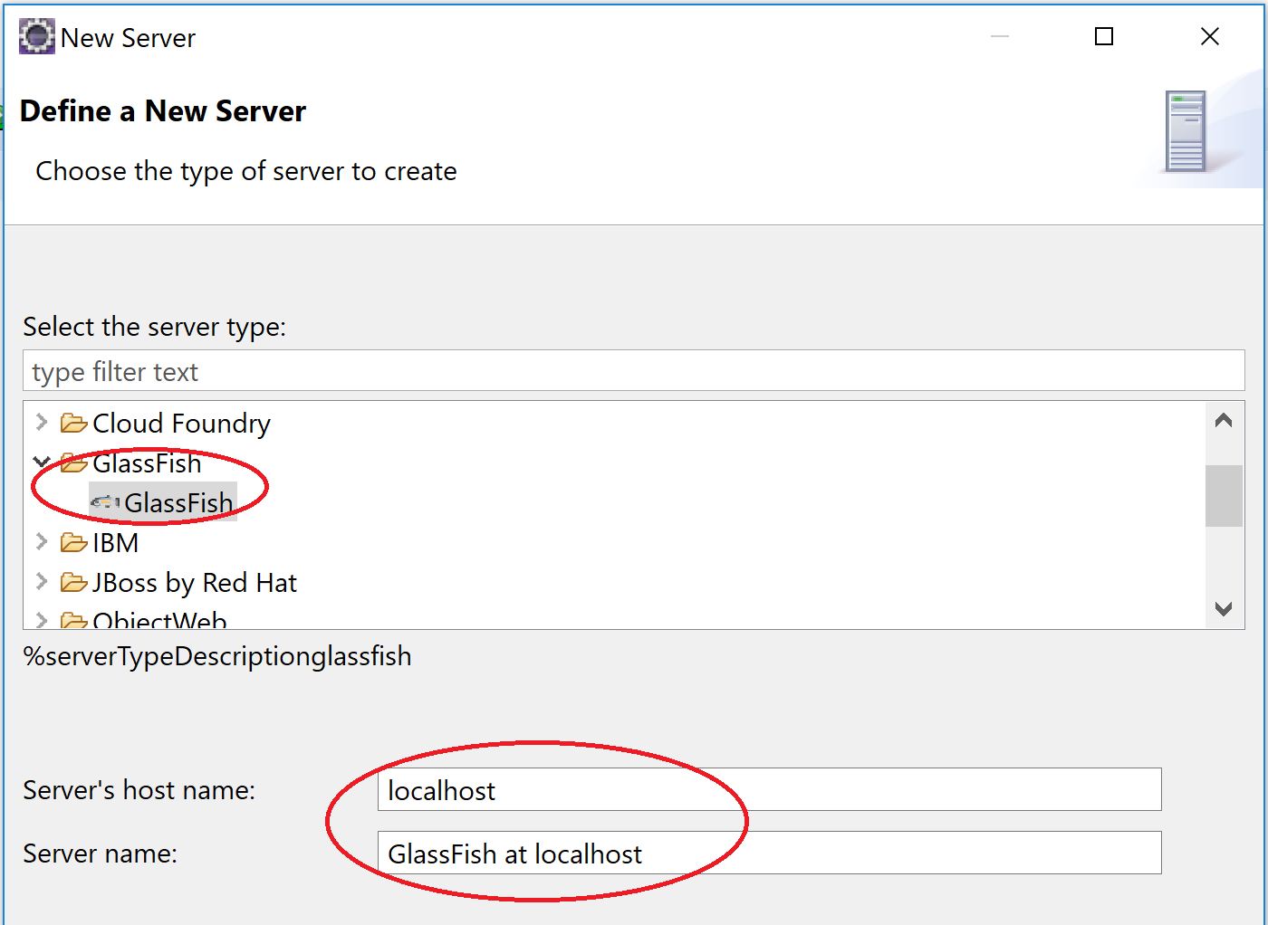

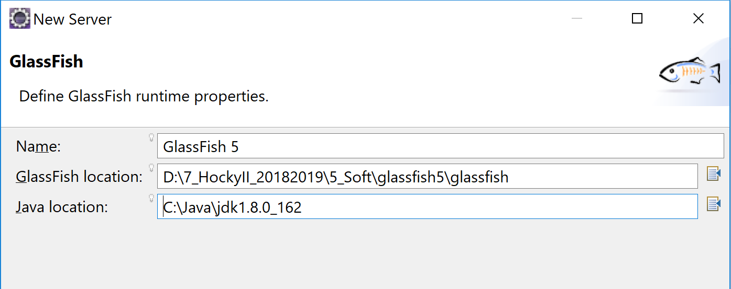

Start server

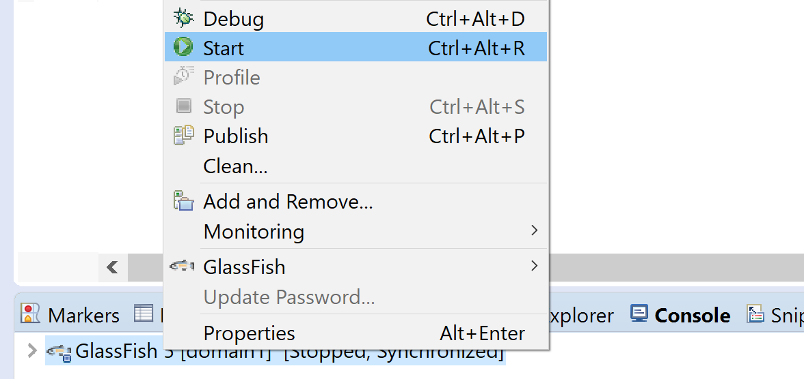

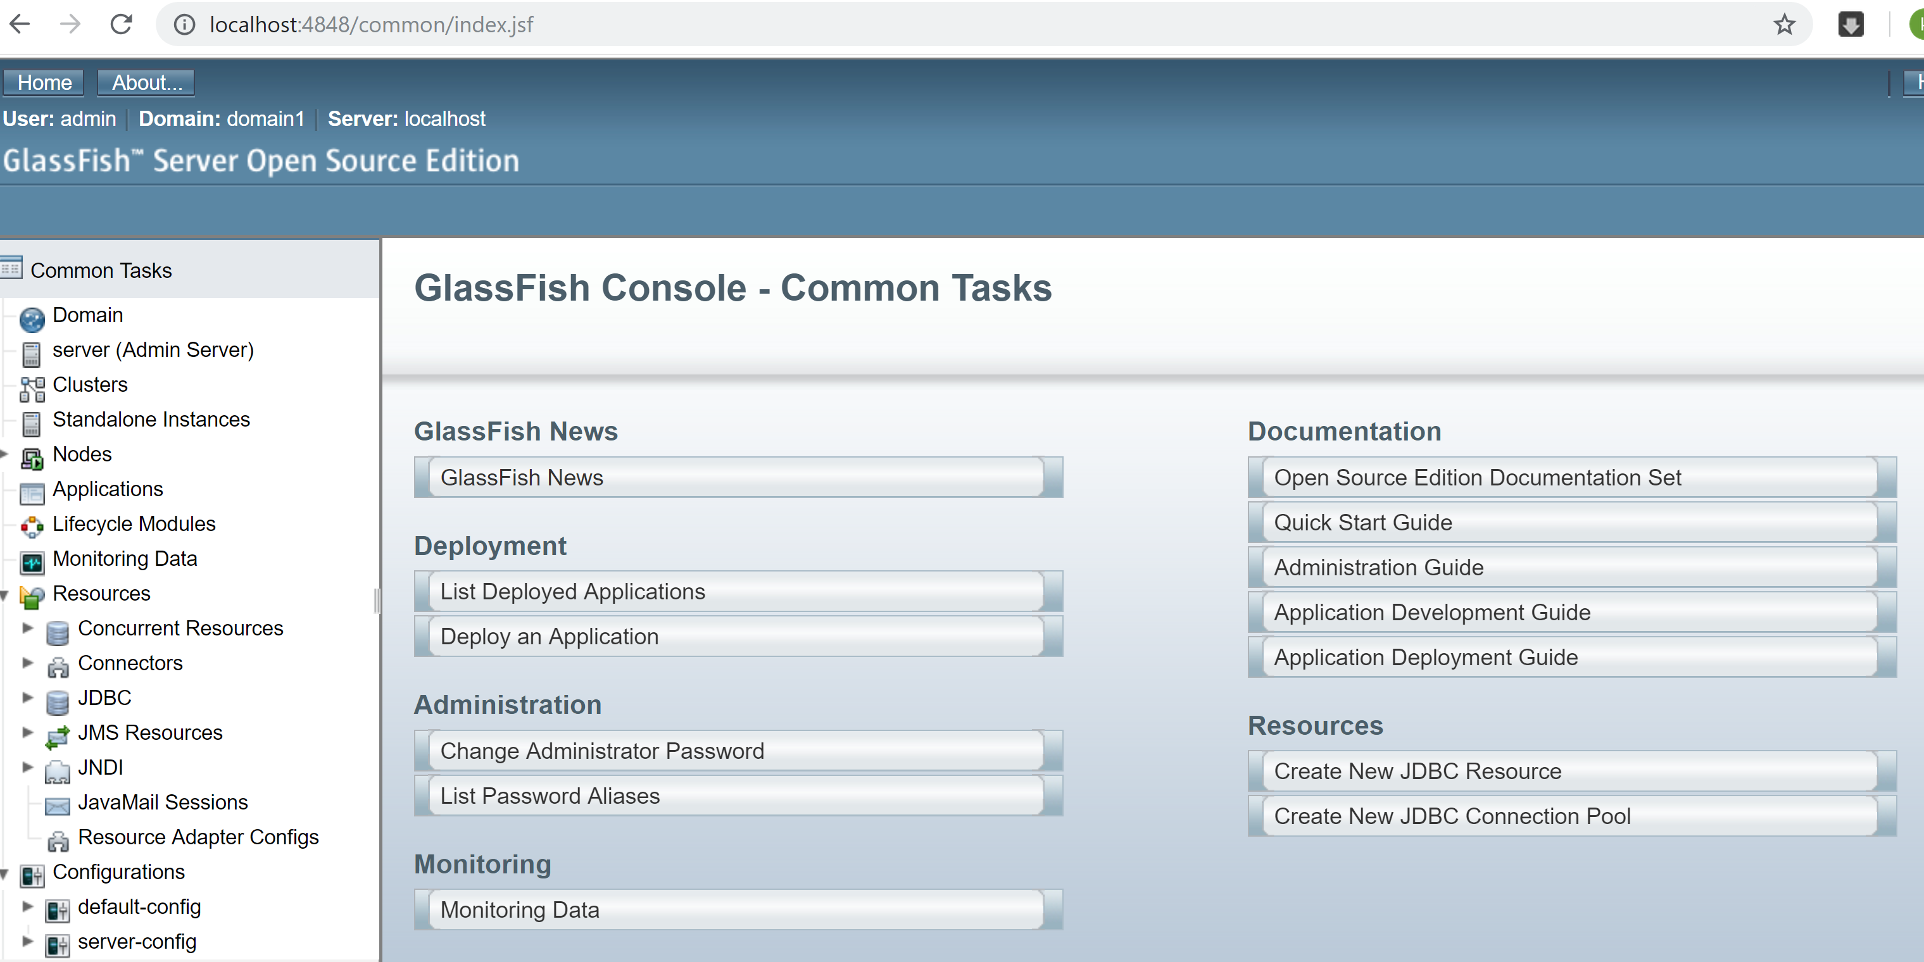

Note Substitute localhost with the machine name or Ip address if you are trying to gain access from a machine other than the one on which GlassFish is installed. You will have to enter the username and password on the administration console login page. If you changed the port number during installation, use that port instead of 4848.

**Change Administrator Password**

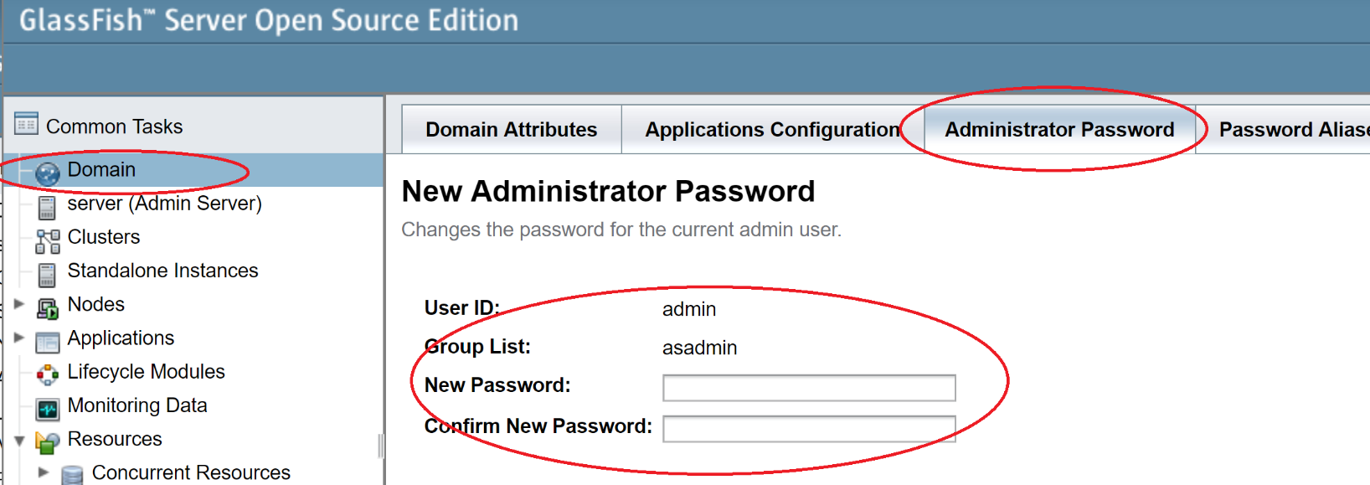

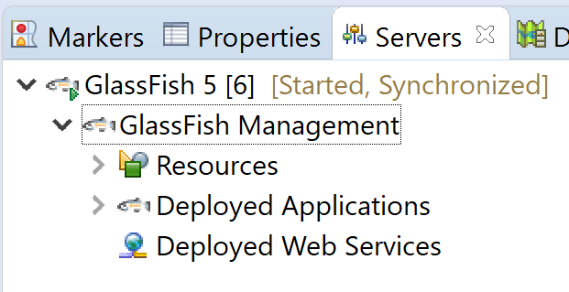

**EJB Project**

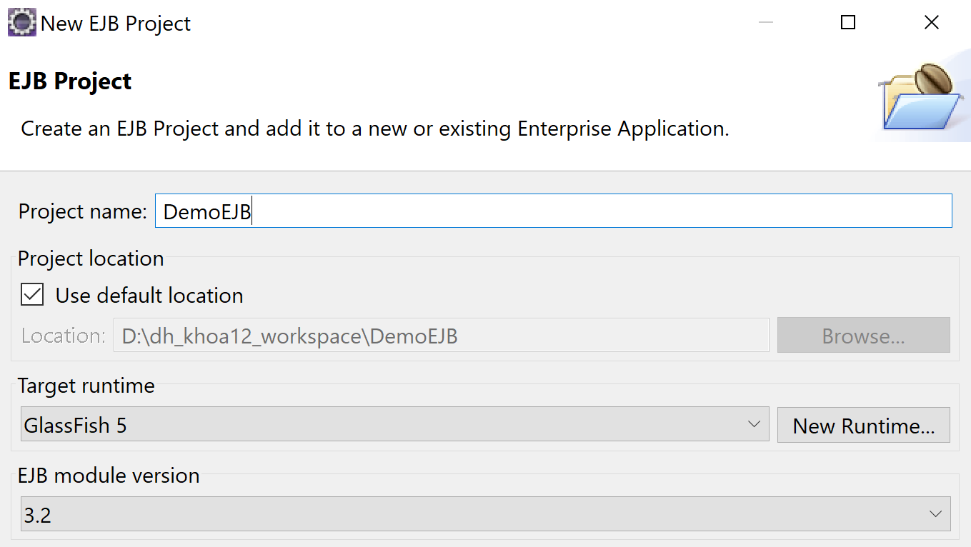

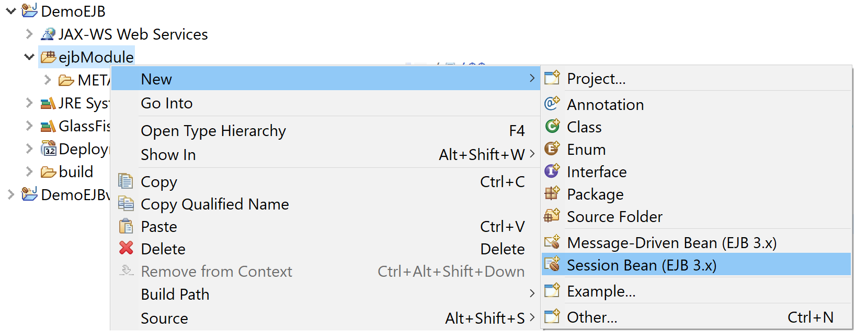

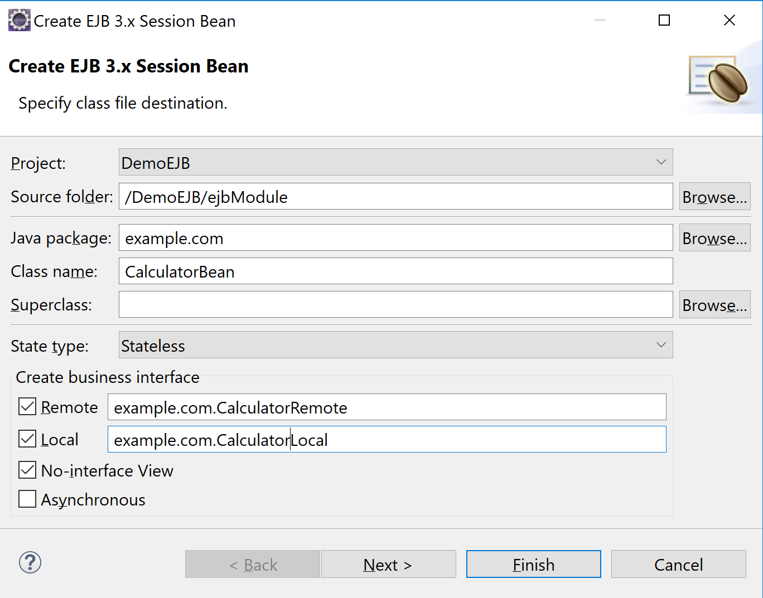

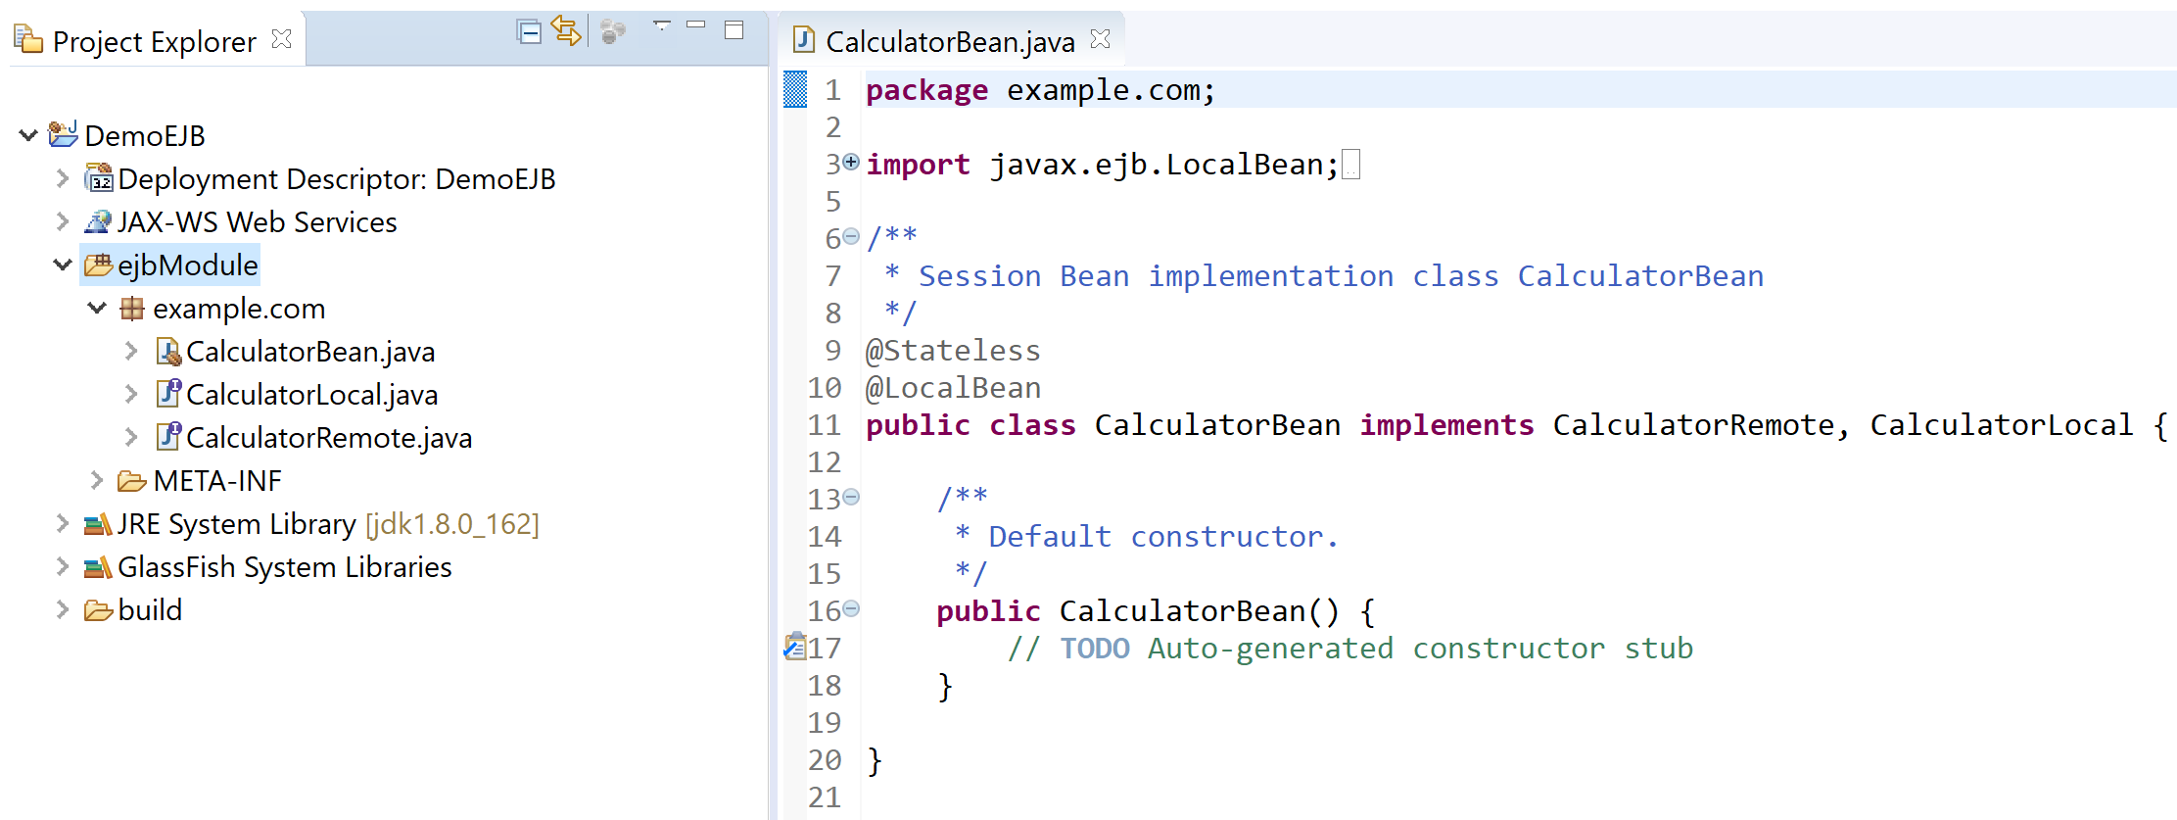

@Remote

**public** **interface** CalculatorRemote {

**int** cong(**int** a, **int** b);

**int** tru(**int** a, **int** b);

}

@Local

**public** **interface** CalculatorLocal {

**int** nhan(**int** a, **int** b);

}

|  |
| --- |
| /**  * Session Bean implementation class CalculatorBean  */  @Stateless (name="MyCal", mappedName="ejb/MyCalJNDI")  @LocalBean  **public** **class** CalculatorBean **implements** CalculatorRemote, CalculatorLocal {  /**  * Default constructor.  */  **public** CalculatorBean() {  }  @Override  **public** **int** nhan(**int** a, **int** b) {  **return** a * b;  }  @Override  **public** **int** cong(**int** a, **int** b) {  **return** a + b;  }  @Override  **public** **int** tru(**int** a, **int** b) {  **return** a - b;  }  } |

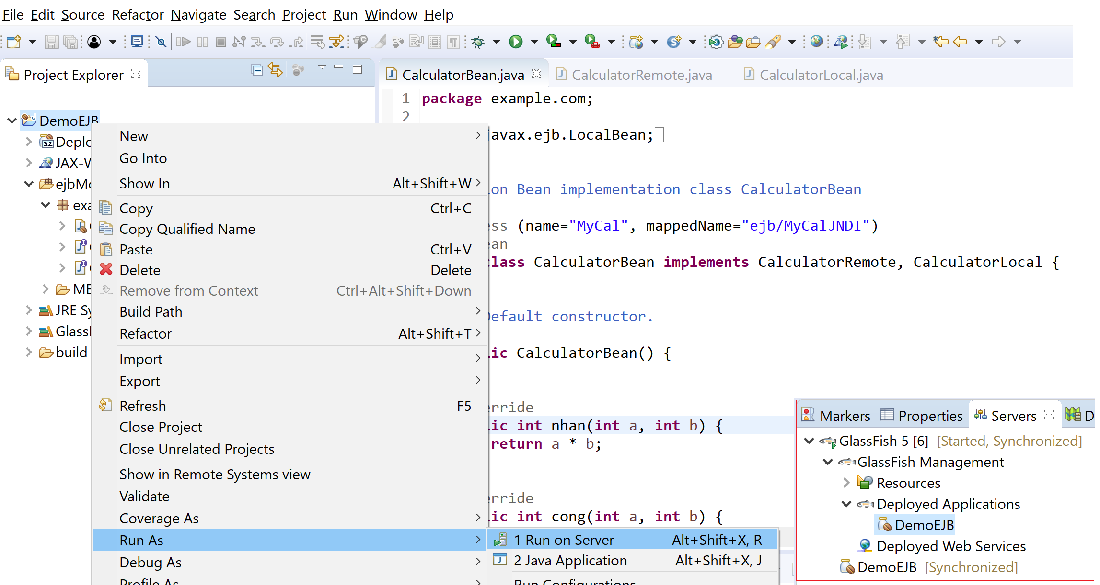

**Desktop Application Client**

Tạo 1 Application Client Project 🡪 Add gf-client.jar và DemoEJB.jar vào classpath

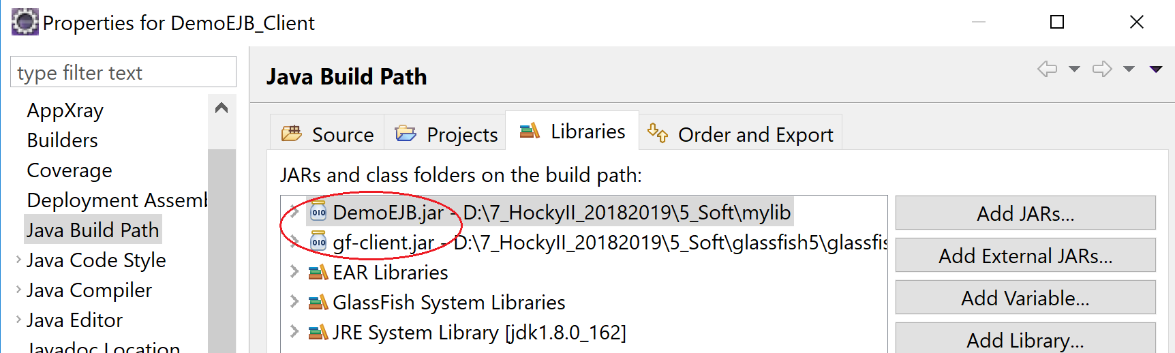

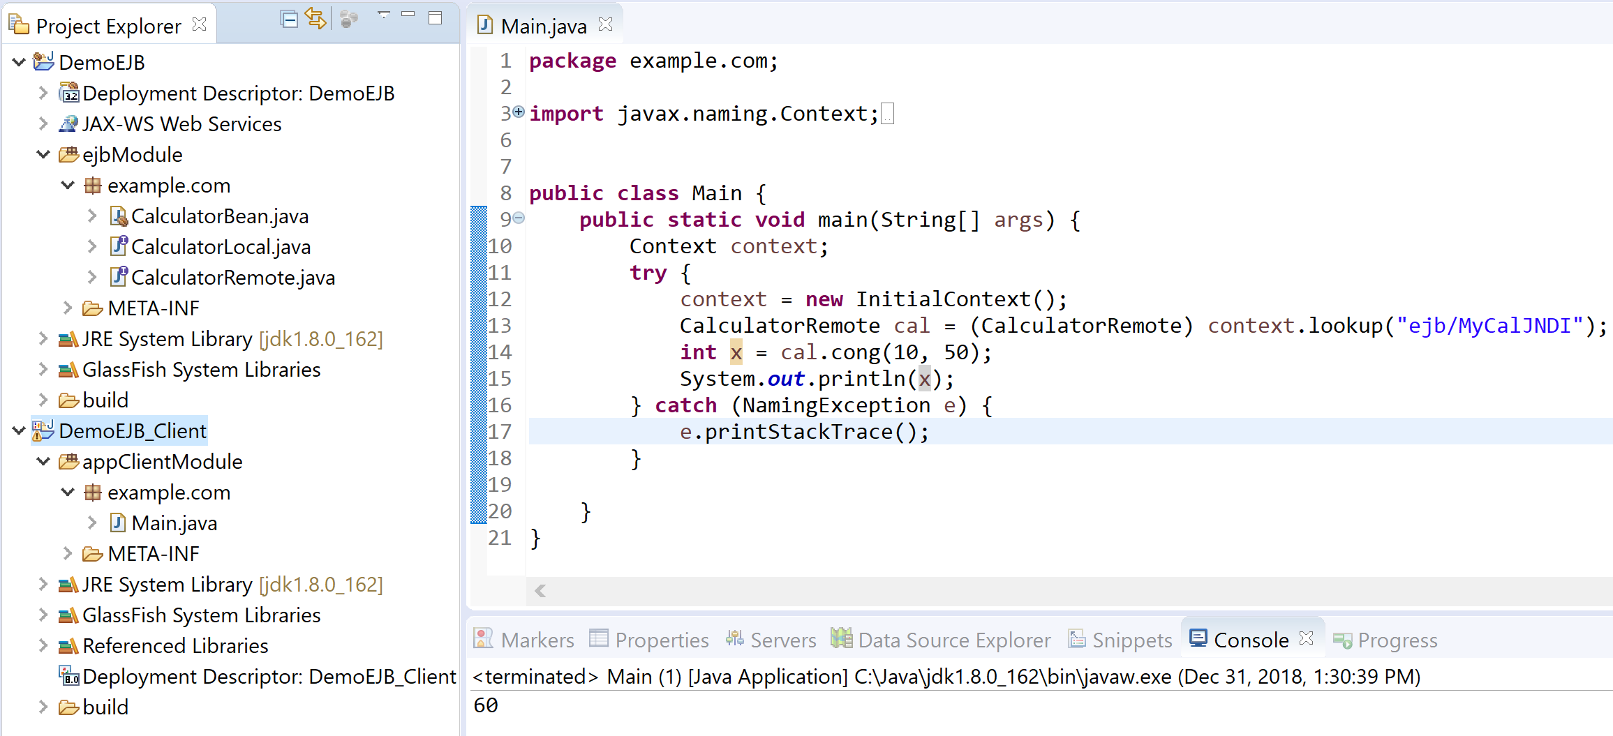

**Dynamic Web Project**

Tạo 1 Dynamic Web Project 🡪 Add DemoEJB.jar vào classpath

Tạo trang index.jsp

|  |
| --- |
| <%@ page language=*"java"* contentType=*"text/html; charset=UTF-8"*  pageEncoding=*"UTF-8"*%>  <!DOCTYPE html PUBLIC "-//W3C//DTD HTML 4.01 Transitional//EN" "http://www.w3.org/TR/html4/loose.dtd">  <html>  <head>  <meta http-equiv=*"Content-Type"* content=*"text/html; charset=UTF-8"*>  <title>index</title>  </head>  <body>  <form action=*"CalcServlet"*>  Nhập a:<input name=*"a"*/><br/>  Nhập b:<input name=*"b"*/><br/>  <input type=*"submit"* value=*"Tính"*/>  </form>  </body>  </html> |

Tạo 1 Servlet

|  |
| --- |
| **package** example.com;  **import** java.io.IOException;  **import** javax.ejb.EJB;  **import** javax.servlet.ServletException;  **import** javax.servlet.annotation.WebServlet;  **import** javax.servlet.http.HttpServlet;  **import** javax.servlet.http.HttpServletRequest;  **import** javax.servlet.http.HttpServletResponse;  /**  * Servlet implementation class CalcServlet  */  @WebServlet("/CalcServlet")  **public** **class** CalcServlet **extends** HttpServlet {  **private** **static** **final** **long** ***serialVersionUID*** = 1L;    @EJB  **private** CalculatorRemote calc;  /**  * **@see** HttpServlet#HttpServlet()  */  **public** CalcServlet() {  **super**();  }  /**  * **@see** HttpServlet#doGet(HttpServletRequest request, HttpServletResponse response)  */  **protected** **void** doGet(HttpServletRequest request, HttpServletResponse response) **throws** ServletException, IOException {  **int** a = Integer.*parseInt*(request.getParameter("a"));  **int** b = Integer.*parseInt*(request.getParameter("b"));    **int** tong = calc.cong(a, b);  **int** hieu = calc.tru(a, b);    response.getWriter().printf("%d + %d = %d <br/>",a,b,tong);  response.getWriter().printf("%d - %d = %d <br/>",a,b,hieu);  }  /**  * **@see** HttpServlet#doPost(HttpServletRequest request, HttpServletResponse response)  */  **protected** **void** doPost(HttpServletRequest request, HttpServletResponse response) **throws** ServletException, IOException {  doGet(request, response);  }  } |

**Enterprise Application Project**

Tạo 1 Enterprise Application Project

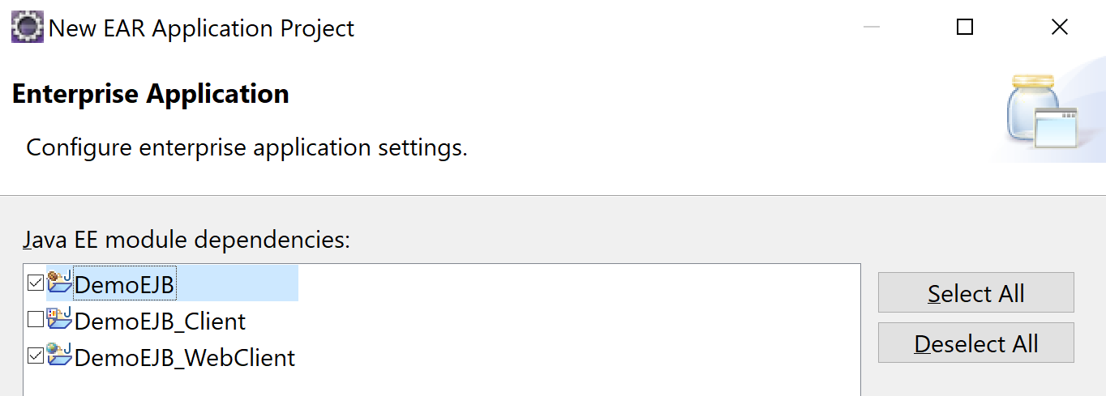

* Thực thi Enterprise Application Project vừa tạo

Thực thi Dynamic Web Project

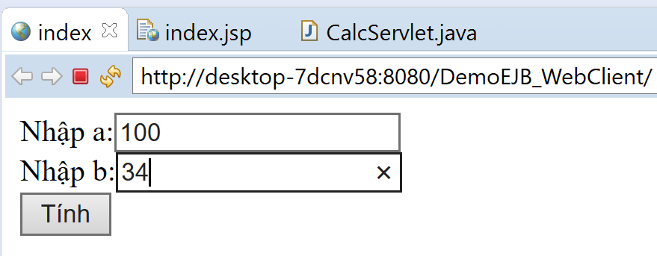

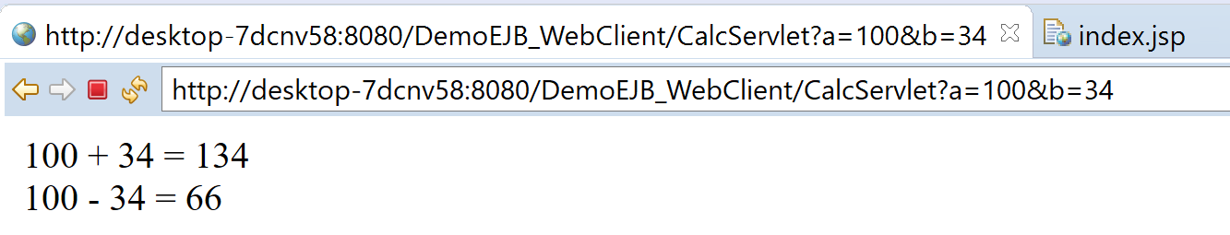

BÀI TẬP

1. Tạo một stateless session cho việc chuyển đổi tiền tệ từ 1 loại tiền tệ này thành một loại khác. (giữa USD/VND/EUR). Viết chương trình client để thử.