BUILDING MOBILE APPS with OPENUI5

OSCON 2014

Exercises / Solutions

Frederic Berg, Andreas Kunz / SAP AG   
DJ Adams / Bluefin Solutions

Table of Contents

Exercise 0 – Getting Started 3

Exercise 1 – Resource Model 7

Exercise 2 – Object Controls 10

Exercise 3 – Formatter 13

Exercise 4 – Search 17

Exercise 5 – Split App & Shell 19

Exercise 6 – Additional Device Adaptation 22

Exercise 7 – Supplier Tab 25

Exercise 8 – Approval Process 27

Exercise 9 – Line Item 31

Exercise 10 – Grouping 35

# Exercise 0 – Getting Started

## Objective

Set up the development environment:

1. Follow the instructions in setup.md to set up your basic development environment.
2. Point your browser to the initial application by opening the following URL:

**http://localhost:8888/openui5/projects/OSCON-2014/**

1. Press **F12** to start the Chrome Developer Tools  
   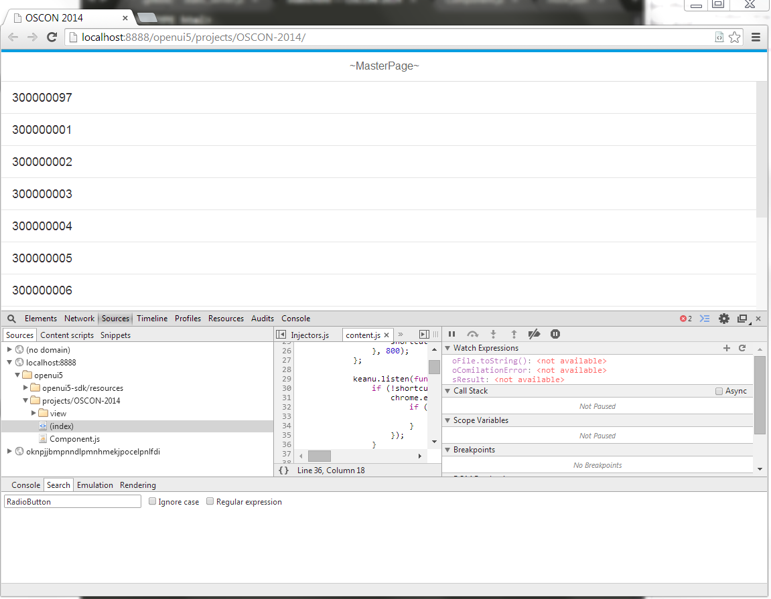
2. Click on the settings button.  
   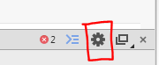
3. Under “**Settings -> General”** chose the option **“Disable cache (while the DevTools is open)”**  
     
   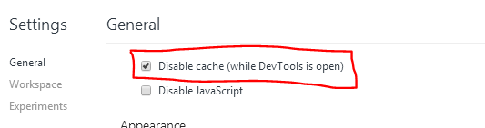
4. Make sure the Chrome drawer is shown:   
   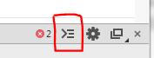
5. Under **Emulation**: Set the User Agent to “**iPhone 5** and press the “**Emulate**” button. Close the drawer.  
   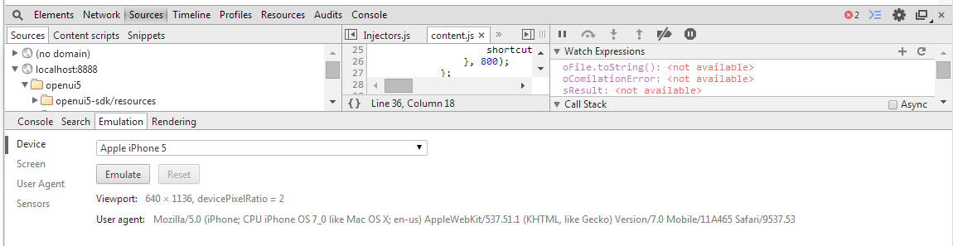
6. Open the tab “**Sources**”. Press **CTRL-O** and enter “**Master**” in the search field. Now the file “**Master.controller.js**” is selected and you press the Enter key.  
     
   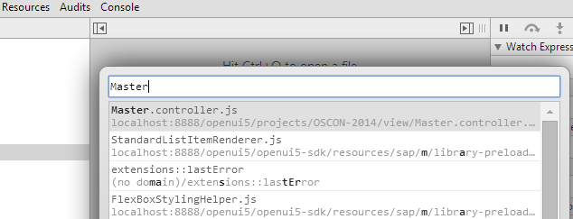
7. Set a breakpoint in line 4 by clicking on the line number until it is highlighted in blue. Notice the listing of the breakpoint in the right panel.  
     
   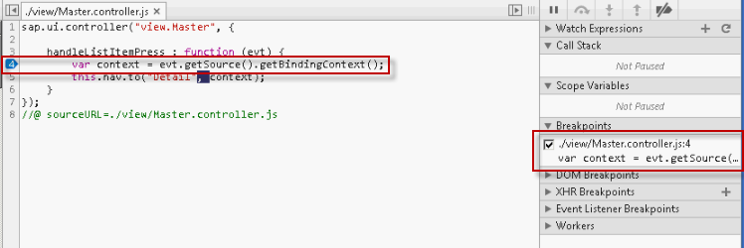
8. Now click on a line item in the running application. This causes the application to stop at the breakpoint.  
     
   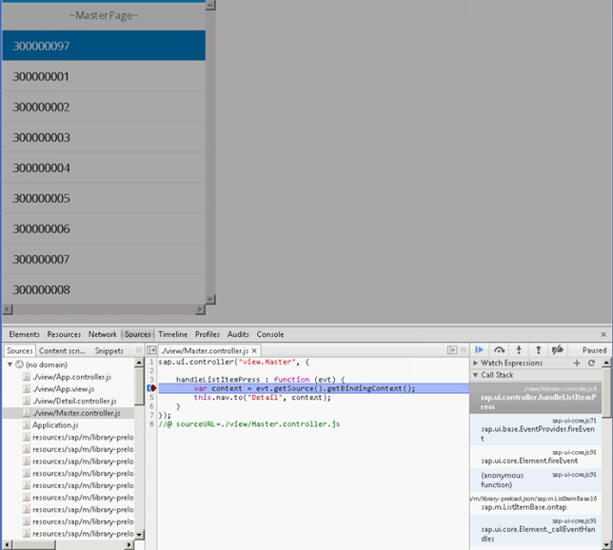
9. Collapse the panel “**Call Stack**” and open “**Scope Variables**”. Investigate the event parameter **evt** in the right panel. With this you can understand the current state at runtime.

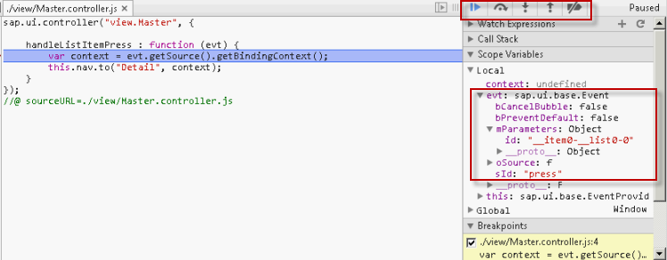

1. Click on the “**Play**” button (blue) to resume the application execution.  
     
   
2. The application now displays the **DetailPage**  
   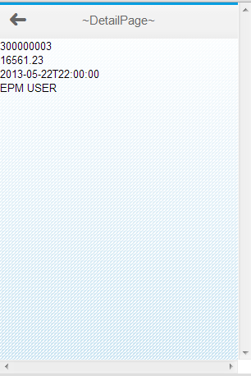

# 

# Exercise 1 – Resource Model

Objective

Set proper titles to master and detail pages by implementing a resource model (aka i18n model, *i18n* stands for i*nternationalizatio*n).

## Preview

Before: 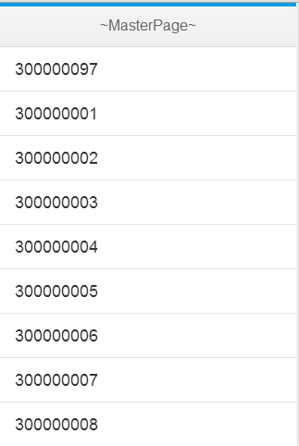 After: 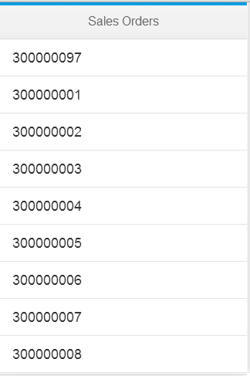

## Description

What we’re going to do in this exercise is to replace the hardcoded texts in the views with references to texts in a separate properties file. This is done via a resource model, which is used as a wrapper for resource bundles and has a one-time binding mode. Once the texts are abstracted into separate files, they can then be maintained, and translated, independently.

So we’ll modify the Master and Detail views, and create the properties file with the text contents.

## Changes

### i18n/messageBundle.properties (ADD NEW FOLDER i18n > ADD NEW FILE messageBundle.properties)

* Create a new folder named “**i18n**”
* Add new file **messageBundle.properties** in your folder i18n and put the below content there
* Make sure the file does NOT start with an empty line
* Save the new message bundle file with **CTRL+S**

MasterTitle=Sales Orders

DetailTitle=Sales Order

### Component.js

* The message bundle is loaded with the help of a *ResourceModel*
* The *ResourceModel* is made available as global model under the name “**i18n**”

createContent : **function**() {

// create root view

**var** oView = sap.ui.view({

id : "app",

viewName : "oscon2014.view.App",

type : "JS",

viewData : { component : **this** }

});

// set i18n model

**var** i18nModel = **new** sap.ui.model.resource.ResourceModel({

bundleUrl : "i18n/messageBundle.properties"

});

oView.setModel(i18nModel, "i18n");

// set data model on root view

**var** oModel = **new** sap.ui.model.json.JSONModel("model/mock.json");

oView.setModel(oModel);

// done

**return** oView;

}

### view/Master.view.xml

* Switch the title to point to the “**i18n**” model and there to the text “**MasterTitle**”
* Save the modified **Master.view.xml** file with keyboard shortcut **CTRL+S**

<core:View

controllerName=*"oscon2014.view.Master"*

xmlns=*"sap.m"*

xmlns:core=*"sap.ui.core"* >

<Page

title=*"{i18n>MasterTitle}"* >

…

### view/Detail.view.xml

* Also adjust the title of the detail view
* Save the modified **Detail.view.xml** file with shortcut **CTRL+S**

<core:View

controllerName=*"oscon2014.view.Detail"*

xmlns=*"sap.m"*

xmlns:core=*"sap.ui.core"* >

<Page

title=*"{i18n>DetailTitle}"*

showNavButton=*"true"*

navButtonPress=*"handleNavButtonPress"* >

…

|  |
| --- |
| Further Reading:  * ModelViewController: <https://sapui5.netweaver.ondemand.com/sdk/#docs/guide/MVC.1.html> * Component Concept: <https://sapui5.netweaver.ondemand.com/sdk/#docs/guide/Components.html> * Databinding: <https://sapui5.netweaver.ondemand.com/sdk/#docs/guide/DataBinding.html> * Localization: <https://sapui5.netweaver.ondemand.com/sdk/#docs/guide/I18NinAppDev.html> * ResourceModel: <https://sapui5.netweaver.ondemand.com/sdk/#docs/guide/ResourceModel.html> |

# Exercise 2 – Object Controls

Objective

Make the UI of the master list and the detail page more beautiful by using the SAPUI5 controls ***sap.m.ObjectListItem*** and ***sap.m.ObjectHeader***.

Preview

Before: 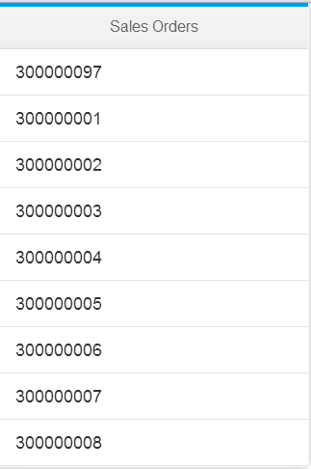 After: 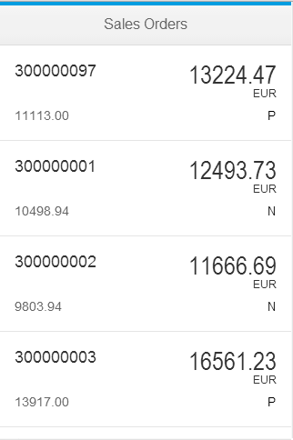

Before: 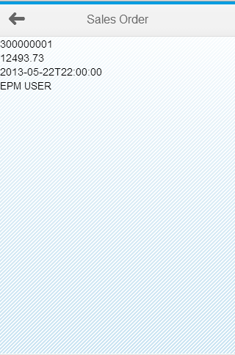 After: 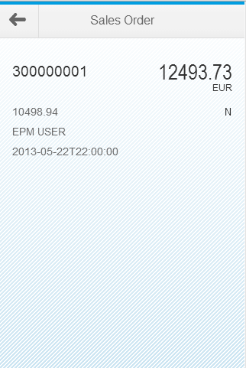

## Description

In this exercise we will replace a couple of controls; one in the Master view and the other in the Detail view.

In the Master view, rather than the simple flat list item style presented by the *StandardListItem* control that is in use currently, we’ll present the overview of the sales orders in a more readable and useful way by using the *ObjectListItem* control instead.

In the Detail view, we’ll make a similar change, replacing the simple layout (currently afforded by the *VBox* control) with a more readable display thanks to the *ObjectHeader* control.

Along the way we’ll add a few more properties from the data model, such as *CurrencyCode*.

## Changes

### view/Master.view.xml

* Replace the ***StandardListItem*** control with the more powerful ***ObjectListItem***
* Attributes and statuses are defined by own objects
* Save the modified **Master.view.xml** file with shortcut **CTRL+S**

<core:View

controllerName=*"oscon2014.view.Master"*

xmlns=*"sap.m"*

xmlns:core=*"sap.ui.core"* >

<Page

title=*"{i18n>MasterTitle}"* >

<List

items=*"{/SalesOrderCollection}"* >

<ObjectListItem

type=*"Active"*

press=*"handleListItemPress"*

title=*"{SoId}"*

number=*"{GrossAmount}"*

numberUnit=*"{CurrencyCode}"* >

<attributes>

<ObjectAttribute text=*"{BuyerName}"* />

</attributes>

<firstStatus>

<ObjectStatus text=*"{LifecycleStatus}"* />

</firstStatus>

</ObjectListItem>

</List>

</Page>

</core:View>

### view/Detail.view.xml

* Replace the texts with the more beautiful ***ObjectHeader***control *(*which has almost the same API as the *ObjectListItem* control but utilizes the space in a different way).
* Save the modified **Detail.view.xml** file with shortcut **CTRL+S**

<core:View

controllerName=*"oscon2014.view.Detail"*

xmlns=*"sap.m"*

xmlns:core=*"sap.ui.core"* >

<Page

title=*"Sales Order"*

showNavButton=*"true"*

navButtonPress=*"handleNavButtonPress"* >

<ObjectHeader

title=*"{SoId}"*

number=*"{GrossAmount}"*

numberUnit=*"{CurrencyCode}"* >

<attributes>

<ObjectAttribute text=*"{BuyerName}"* />

<ObjectAttribute text=*"{CreatedByBp}"* />

<ObjectAttribute text=*"{CreatedAt}"* />

</attributes>

<firstStatus>

<ObjectStatus text=*"{LifecycleStatus}"* />

</firstStatus>

</ObjectHeader>

</Page>

</core:View>

|  |
| --- |
| Further Reading:  * Working with lists: <https://sapui5.netweaver.ondemand.com/sdk/#docs/guide/List.html> * ObjectHeader API: <https://sapui5.netweaver.ondemand.com/sdk/#docs/api/symbols/sap.m.ObjectHeader.html> * ObjectListItem API: <https://sapui5.netweaver.ondemand.com/sdk/#docs/api/symbols/sap.m.ObjectListItem.html> |

# Exercise 3 – Formatter

## Objective

Format status *color* and *date* properly by implementing custom formatters that are used in data binding.

## Preview

Before:  After: 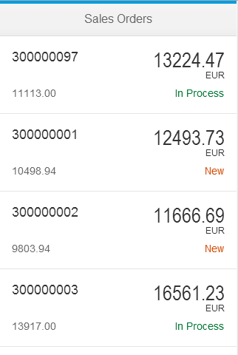

Before:  After: 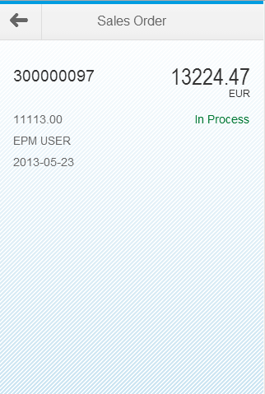

## Description

In this exercise we will introduce a couple of formatting functions and use them in the application. They are custom functions so we put them in a module file ‘*Formatter.js*’ in a separate folder (in this case we’ve chosen the folder name ‘util’). One of the functions uses an SAPUI5 static class for date formatting so we specify that requirement (for *sap.ui.core.format.DateFormat*) before defining our functions.

We then use the formatting functions in the *Detail* and *Master* views; in order to do this, we need to ‘*require’* the new module in the respective controllers. To execute the formatting on the property paths from the data model (such as ‘*CreatedAt’* or ‘*LifecycleStatus’*) we need a different binding syntax and for that we have to add a *bindingSyntax* parameter in the SAPUI5 bootstrap.

## Changes

### i18n/messageBundle.properties

* Add two new texts to the properties file that are used to display the status

MasterTitle=Sales Orders

DetailTitle=Sales Order

StatusTextN=New

StatusTextP=In Process

### util/Formatter.js (ADD NEW FOLDER **util** > ADD NEW FILE **Formatter.js**)

* Create a new folder named “**util**” in WebContent
* Add new file Formatter.jsin your folder util and put the below content there
* This file contains functions to format dates, status text and status colors.

jQuery.sap.declare("oscon2014.util.Formatter");

jQuery.sap.require("sap.ui.core.format.DateFormat");

oscon2014.util.Formatter = {

_statusStateMap : {

"P" : "Success",

"N" : "Warning"

},

statusText : **function** (value) {

**var** bundle = **this**.getModel("i18n").getResourceBundle();

**return** bundle.getText("StatusText" + value, "?");

},

statusState : **function** (value) {

**var** map = oscon2014.util.Formatter._statusStateMap;

**return** (value && map[value]) ? map[value] : "None";

},

date : **function** (value) {

**if** (value) {

**var** oDateFormat = sap.ui.core.format.DateFormat.getDateTimeInstance({pattern: "yyyy-MM-dd"});

**return** oDateFormat.format(**new** Date(value));

} **else** {

**return** value;

}

}

### };

### index.html

* Open the “**index.html”** with the HTML editor of eclipse by right clicking on the file and choosing “**Open With > HTML Editor**”
* For the formatting we want to use the “**complex**” binding syntax of SAPUI5. This we enable in the bootstrap script tag.

<!DOCTYPE html>

<html>

…

<script

id=*"sap-ui-bootstrap"*

src=*"../../resources/sap-ui-core.js"*

data-sap-ui-theme=*"sap_bluecrystal"*

data-sap-ui-libs=*"sap.m"*

data-sap-ui-xx-bindingSyntax=*"complex"*

data-sap-ui-resourceroots=*'{*

*"oscon2014": "./"*

*}'* >

</script>

…

</html>

### view/Detail.view.xml

* Use a complex binding with a formatter for the ***text***field of attribute ‘*CreatedAt*’.
* Use a complex binding with a formatter for the **text** and ***state***field (which controls the semantical color of the status text) of status ‘*LifecycleStatus*’.

<core:View

controllerName=*"oscon2014.view.Detail"*

xmlns=*"sap.m"*

xmlns:core=*"sap.ui.core"* >

<Page

title=*"{i18n>DetailTitle}"*

showNavButton=*"true"*

navButtonPress=*"handleNavButtonPress"* >

<ObjectHeader

title=*"{SoId}"*

number=*"{GrossAmount}"*

numberUnit=*"{CurrencyCode}"* >

<attributes>

<ObjectAttribute text=*"{BuyerName}"* />

<ObjectAttribute text=*"{CreatedByBp}"* />

<ObjectAttribute text=*"{*

*path: 'CreatedAt',*

*formatter: 'oscon2014.util.Formatter.date'*

*}"* />

</attributes>

<firstStatus>

<ObjectStatus

text=*"{*

*path: 'LifecycleStatus',*

*formatter: 'oscon2014.util.Formatter.statusText'*

*}"*

state=*"{*

*path: 'LifecycleStatus',*

*formatter: 'oscon2014.util.Formatter.statusState'*

*}"* />

</firstStatus>

</ObjectHeader>

</Page>

</core:View>

### view/Detail.controller.js

* Require the formatter file in the controller of the view

jQuery.sap.require("oscon2014.util.Formatter");

sap.ui.controller("oscon2014.view.Detail", {

…

### view/Master.view.xml

* Use a complex binding with a formatter for the **text** and **state**field (which controls the semantical color of the status text) of status ‘*LifecycleStatus*’.

<core:View

controllerName=*"oscon2014.view.Master"*

xmlns=*"sap.m"*

xmlns:core=*"sap.ui.core"* >

<Page

title=*"{i18n>MasterTitle}"* >

<List

items=*"{/SalesOrderCollection}"* >

<ObjectListItem

type=*"Active"*

press=*"handleListItemPress"*

title=*"{SoId}"*

number=*"{GrossAmount}"*

numberUnit=*"{CurrencyCode}"* >

<attributes>

<ObjectAttribute text=*"{BuyerName}"* />

</attributes>

<firstStatus>

<ObjectStatus

text=*"{*

*path: 'LifecycleStatus',*

*formatter: 'oscon2014.util.Formatter.statusText'*

*}"*

state=*"{*

*path: 'LifecycleStatus',*

*formatter: 'oscon2014.util.Formatter.statusState'*

*}"* />

</firstStatus>

</ObjectListItem>

</List>

</Page>

</core:View>

### view/Master.controller.js

* Require the formatter file in the controller of the view

jQuery.sap.require("oscon2014.util.Formatter");

sap.ui.controller("oscon2014.view.Master", {

…

|  |
| --- |
| Further Reading:  * Bootstrap Configuration Options: [https://sapui5.netweaver.ondemand.com/sdk/#docs/guide/Configuration.html#ListofConfigurationOptions](https://sapui5.netweaver.ondemand.com/sdk/#docs/guide/Configuration.html) * Property Binding and Formatting: <https://sapui5.netweaver.ondemand.com/sdk/#docs/guide/BindingProperties.html> * Modularization and Dependency Management (require/declare modules): <https://sapui5.netweaver.ondemand.com/sdk/#docs/guide/ModularizationConcept.html> |

# Exercise 4 – Search

## Objective

Implement a search on the master list by using ***sap.m.SearchField***

## Preview

Before: 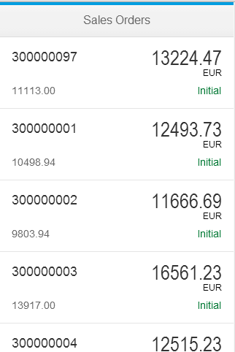 After: 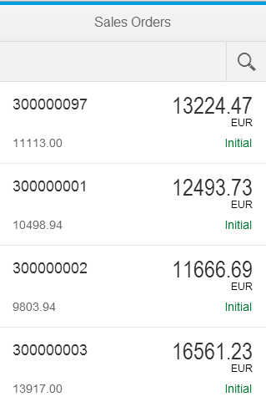

## Description

Now we’re going to add a *SearchField* control to the initial page of the application. We’ll add it as a child within the Page’s ‘*subHeader’* aggregation which expects a *Bar* (*sap.m.Bar*) control.

To handle the search, we’ll specify a handler for the search field’s ‘*search’* event. This handler ‘*handleSearch’* is defined in the view’s controller, and the search effect is achieved by adding a ‘*contains string*’ filter to the binding of the List control’s items aggregation.

## Changes

### view/Master.view.xml

* The search field is put to a bar that is placed in the sub header of the page.
* Set the search field to **100%** width to utilize all the space
* Do not forget to add an “**id**” to the list in order to access the list later on in the controller

<core:View

controllerName=*"oscon2014.view.Master"*

xmlns=*"sap.m"*

xmlns:core=*"sap.ui.core"* >

<Page

title=*"{i18n>MasterTitle}"* >

<subHeader>

<Bar>

<contentLeft>

<SearchField

search=*"handleSearch"*

width=*"100%"* >

</SearchField>

</contentLeft>

</Bar>

</subHeader>

<List

id=*"list"*

items=*"{/SalesOrderCollection}"* >

### view/Master.controller.js

* Implement a new handler function on the view controller. Make sure to separate the function from the other handler function with a “**,**”
* Access the “**query**” as a parameter of the event object
* If the “**query**” is not empty add a ***FilterOperator*** to the array of filters.
* Access the list instance by calling “**byId**” on the view.
* Apply the filter array on the binding object of the list.

jQuery.sap.require("oscon2014.util.Formatter");

sap.ui.controller("oscon2014.view.Master", {

handleListItemPress : **function** (evt) {

**var** context = evt.getSource().getBindingContext();

**this**.nav.to("Detail", context);

},

handleSearch : **function** (evt) {

// create model filter

**var** filters = [];

**var** query = evt.getParameter("query");

**if** (query && query.length > 0) {

**var** filter = **new** sap.ui.model.Filter("SoId", sap.ui.model.FilterOperator.Contains, query);

filters.push(filter);

}

// update list binding

**var** list = **this**.getView().byId("list");

**var** binding = list.getBinding("items");

binding.filter(filters);

}

});

## Google Chrome browser

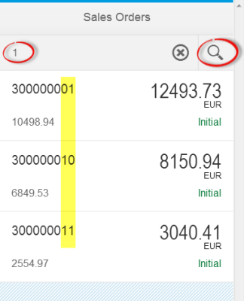

|  |
| --- |
| Further Reading:  * SearchField: <https://sapui5.netweaver.ondemand.com/sdk/#docs/api/symbols/sap.m.SearchField.html> * Model Filter: <https://sapui5.netweaver.ondemand.com/sdk/#docs/api/symbols/sap.ui.model.Filter.html> |

# Exercise 5 – Split App & Shell

## Objective

Utilize the additional space by using the ***sap.m.SplitApp***control which shows the master and detail view next to each other. Wrap the split app in a shell that fills the remaining space on the desktop.

## Preview

Before:

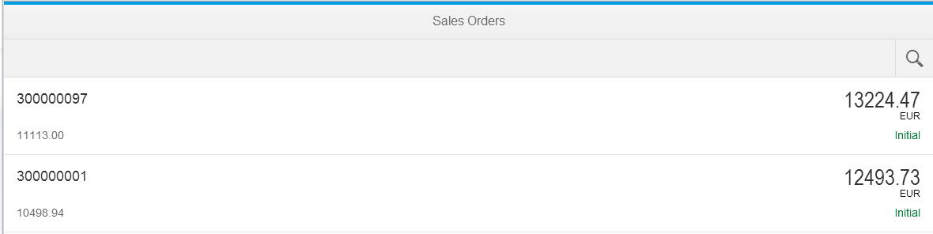

After

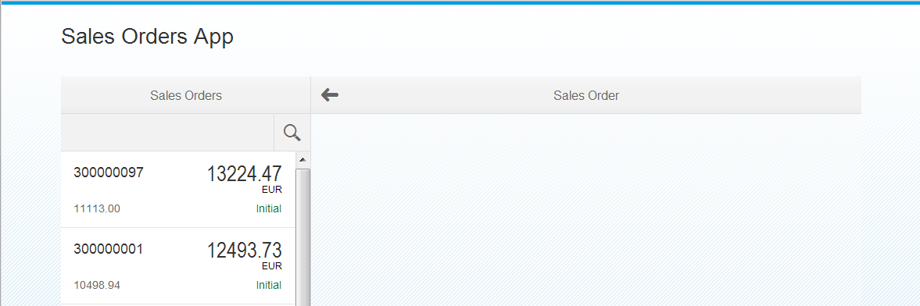

## Description

So far we’ve had 3 views in our application – *App*, *Master* and *Detail*. *App* is our top-level view, containing the *Master* and *Detail* views. In the *App* view we used an *App* control (yes, the same name) to contain the *Master* and *Detail* views via the *App* control’s ‘pages’ aggregation.

This is a typical scenario for an app designed primarily for a smartphone-sized screen. But if the screen size is larger (e.g. on a tablet or desktop) we want to automatically utilize the extra space and for that we will switch from the *App* control to the *SplitApp* control. Alongside swapping out the control, we’ll add new view ‘*Empty’* which will be shown in the detail part of the *SplitApp* – straightaway, if there is enough space.

Finally, for optimal utilization of space on larger devices such as desktops, we will wrap the whole thing in a *Shell* control.

## Changes

### view/Empty.view.xml (create NEW XML view **view/Empty.view.xml**)

* This is only a very empty page

<core:View

xmlns=*"sap.m"*

xmlns:core=*"sap.ui.core"* >

<Page>

</Page>

</core:View>

### view/App.view.js

* Load the empty view **instead of the** detail view

sap.ui.jsview("oscon2014.view.App", {

getControllerName: **function** () {

**return** "oscon2014.view.App";

},

createContent: **function** (oController) {

// to avoid scroll bars on desktop the root view must be set to block display

**this**.setDisplayBlock(**true**);

// create app

**this**.app = **new** sap.m.SplitApp();

// load the master page

**var** master = sap.ui.xmlview("Master", "oscon2014.view.Master");

master.getController().nav = **this**.getController();

**this**.app.addPage(master, **true**);

// load the empty page

**var** empty = sap.ui.xmlview("Empty", "oscon2014.view.Empty");

**this**.app.addPage(empty, **false**);

**return** **this**.app;

}

});

### index.html

* Wrap the split app in a shell control using the title defined before.
* **Why in the index.html?** This is done outside of the component because if you would plug a component in the SAP Fiori Launchpad this already renders the shell.

<!DOCTYPE html>

<html>

<head>

<meta http-equiv=*"X-UA-Compatible"* content=*"IE=edge"* />

<meta charset=*"UTF-8"*>

<title>OSCON 2014 5</title>

<script

id=*"sap-ui-bootstrap"*

src=*"../../resources/sap-ui-core.js"*

data-sap-ui-theme=*"sap_bluecrystal"*

data-sap-ui-libs=*"sap.m"*

data-sap-ui-xx-bindingSyntax=*"complex"*

data-sap-ui-resourceroots=*'{*

*"oscon2014": "./"*

*}'* >

</script>

<script>

**new** sap.m.Shell({

app : **new** sap.ui.core.ComponentContainer({

name : "oscon2014"

})

}).placeAt("content");

</script>

</head>

<body class=*"sapUiBody"* id=*"content"*>

</body>

</html>

* In the Chrome Dev Tools, remove flags for User Agent and Device Metrics override. This will display the SplitApp control.

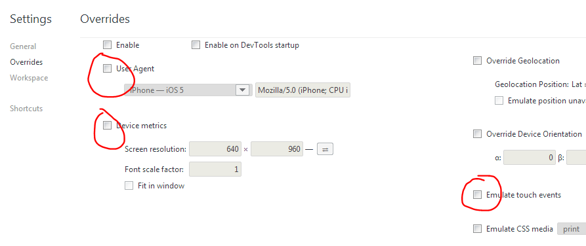

|  |
| --- |
| Further Reading:  * SplitApp control: <https://sapui5.netweaver.ondemand.com/sdk/#docs/guide/SplitApp.html> * SplitApp API: <https://sapui5.netweaver.ondemand.com/sdk/#docs/api/symbols/sap.m.SplitApp.html> * Shell API: <https://sapui5.netweaver.ondemand.com/sdk/#docs/api/symbols/sap.m.Shell.html> |

# Exercise 6 – Additional Device Adaptation

## Objective

Adapt the controls to phone/tablet/desktop devices:

* Show the back button in the detail page only on the phone.
* Switch the list to selection mode on the tablet and desktop.

## Preview

Before:

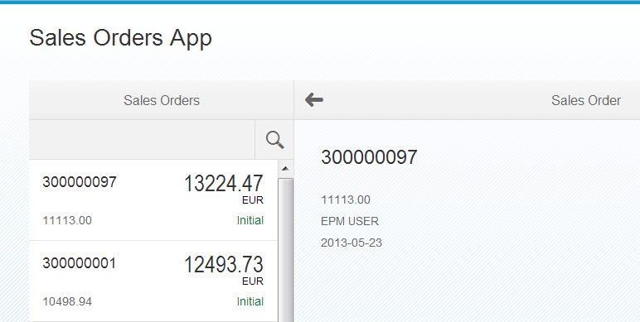

After:

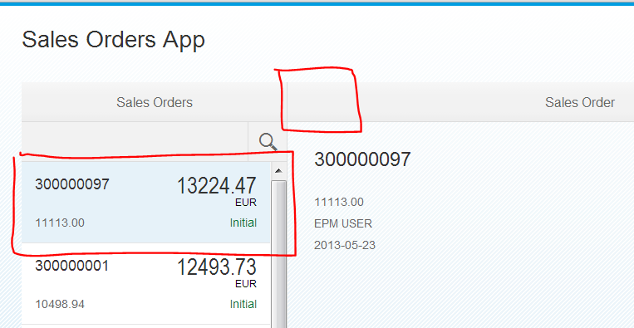

## Description

If the user can see both the master and detail section of the *SplitApp* at the same time because, say, they’re using a tablet, there’s not much point in showing a back button on the detail section – it’s only really relevant on smaller screen sizes where either one or the other section is visible. So we will set the visibility of the back button (referred to as the ‘navigation button’ in the control) to be device dependent.

Also, depending on the device, we will set different list and item selection modes. Notice that we do the device determination up front when the application starts (in *Component.js*) setting the results of the determination in a one-way bound named data model, data from which can then be used in property path bindings in the *Detail* and *Master* views.

## Changes

### Component.js

* Set a global model named “**device**”
* Set **isPhone**, **listMode** and **listItemType** with the help of the “**device API**”.

jQuery.sap.declare("oscon2014.Component");

sap.ui.core.UIComponent.extend("oscon2014.Component", {

createContent : **function**() {

…

// set device model

**var** deviceModel = **new** sap.ui.model.json.JSONModel({

isPhone : jQuery.device.is.phone,

isNoPhone : ! jQuery.device.is.phone,

listMode : (jQuery.device.is.phone) ? "None" : "SingleSelectMaster",

listItemType : (jQuery.device.is.phone) ? "Active" : "Inactive"

});

deviceModel.setDefaultBindingMode("OneWay");

oView.setModel(deviceModel, "device");

// done

**return** oView;

}

});

### view/Detail.view.xml

* Bind the **showNavButton** property to the device model

<core:View

controllerName=*"oscon2014.view.Detail"*

xmlns=*"sap.m"*

xmlns:core=*"sap.ui.core"* >

<Page

title=*"{i18n>DetailTitle}"*

showNavButton=*"{device>/isPhone}"*

navButtonPress=*"handleNavButtonPress"* >

### view/Master.view.xml

* Bind the “**list**” mode and the “**list item type**” to the device model
* Add a select event to the list

<List

id=*"list"*

mode=*"{device>/listMode}"*

select=*"handleListSelect"*

items=*"{/SalesOrderCollection}"* >

<ObjectListItem

type=*"{device>/listItemType}"*

press=*"handleListItemPress"*

title=*"{SoId}"*

number=*"{GrossAmount}"*

numberUnit=*"{CurrencyCode}"* >

### view/Master.controller.js

* Implement the select event in the view’s controller

jQuery.sap.require("oscon2014.util.Formatter");

sap.ui.controller("oscon2014.view.Master", {

handleListItemPress : **function** (evt) {

**var** context = evt.getSource().getBindingContext();

**this**.nav.to("Detail", context);

},

handleSearch : **function** (evt) {

…

},

handleListSelect : **function** (evt) {

**var** context = evt.getParameter("listItem").getBindingContext();

**this**.nav.to("Detail", context);

}

});

# Exercise 7 – Supplier Tab

## Objective

Add an info tab to the detail page that shows a little form with data of the business partner of the sales order.

## Preview

Before: 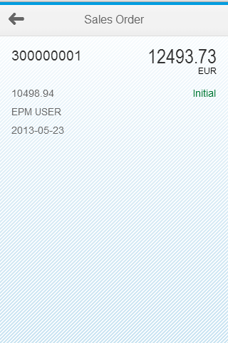 After: 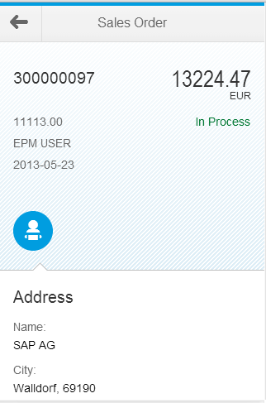

## Description

In this exercise we will enhance the display of the sales order detail view with a section showing the supplier name and address.

In the *Detail* view, we’ll use an *IconTabBar* control to introduce the information visually, and a *SimpleForm* control to display the information. The *SimpleForm* control is from the *sap.ui.layout* library, so we need to add this to the SAPUI5 bootstrap in the *index.html* too.

## Changes

### index.html

* Load the additional UI library “**sap.ui.layout**”

<!DOCTYPE html>

…

<script

id=*"sap-ui-bootstrap"*

src=*"../../resources/sap-ui-core.js"*

data-sap-ui-theme=*"sap_bluecrystal"*

data-sap-ui-libs=*"sap.m, sap.ui.layout"*

data-sap-ui-xx-bindingSyntax=*"complex"*

data-sap-ui-resourceroots=*'{*

*"oscon2014": "./"*

*}'* >

</script>

…

### view/Detail.view.xml

* Set xml namespaces for the new package (form)
* Implement a **sap.m.IconTabBar**
* Implement a **sap.ui.layout.SimpleForm** and bind the data. The data source will be connected in the next step.

<core:View

controllerName=*"oscon2014.view.Detail"*

xmlns=*"sap.m"*

xmlns:form=*"sap.ui.layout.form"*

xmlns:core=*"sap.ui.core"* >

<Page

title=*"{i18n>DetailTitle}"*

showNavButton=*"{device>/isPhone}"*

navButtonPress=*"handleNavButtonPress"* >

<ObjectHeader

…

</ObjectHeader>

<IconTabBar

expanded=*"{device>/isNoPhone}"* >

<items>

<IconTabFilter

icon=*"sap-icon://supplier"*>

<form:SimpleForm

id="SupplierForm"

minWidth="1024" >

<core:Title text="Address" />

<Label text="Name"/>

<Text text="{CompanyName}" />

<Label text="City"/>

<Text text="{City}, {PostalCode}" />

<Label text="Street"/>

<Text text="{Street}" />

</form:SimpleForm>

</IconTabFilter>

</items>

</IconTabBar>

</Page>

</core:View>

• **Bind the supplier form** we just created to the data of the structure “**BusinessPartner**”

sap.ui.controller("oscon2014.view.Detail", {

handleNavButtonPress : **function** (evt) {

**this**.nav.back("Master");

},

onBeforeRendering:**function**(){

**this**.byId("SupplierForm").bindElement("BusinessPartner");

}

});

|  |
| --- |
| Further Reading:  * Icon Tab Bar API: <https://sapui5.netweaver.ondemand.com/sdk/#docs/api/symbols/sap.m.IconTabBar.html> * Simple Form API: <https://sapui5.netweaver.ondemand.com/sdk/#docs/api/symbols/sap.ui.layout.form.SimpleForm.html> |

# Exercise 8 – Approval Process

## Objective

Add button to the footer of the detail page to trigger the approval of a sales order. When the user presses the button a confirmation dialog is shown. If the user confirms the dialog the sales order is deleted from the model and a confirmation message is shown.

**Disclaimer**: The server is not really called.

## Preview

Before:

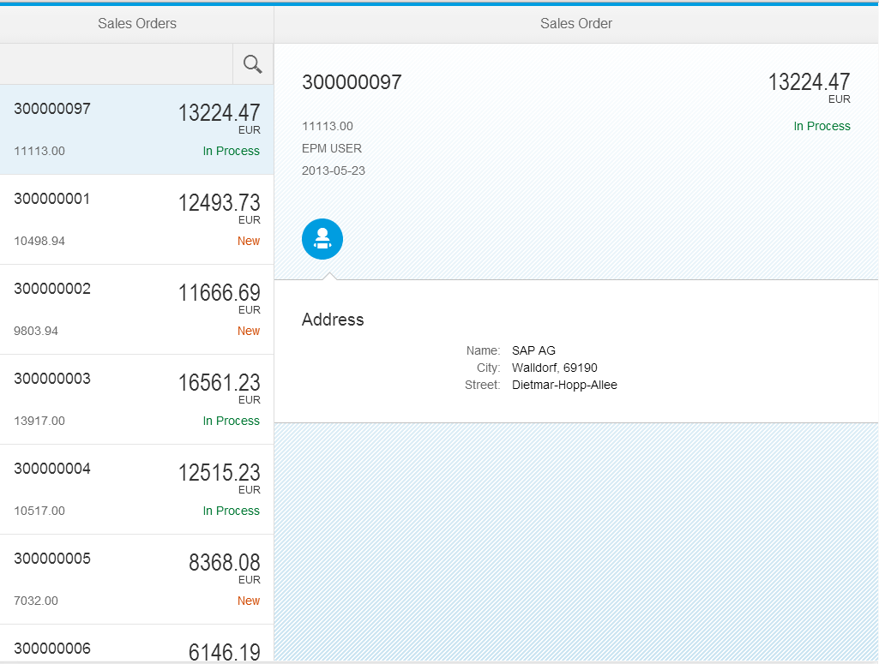

After:

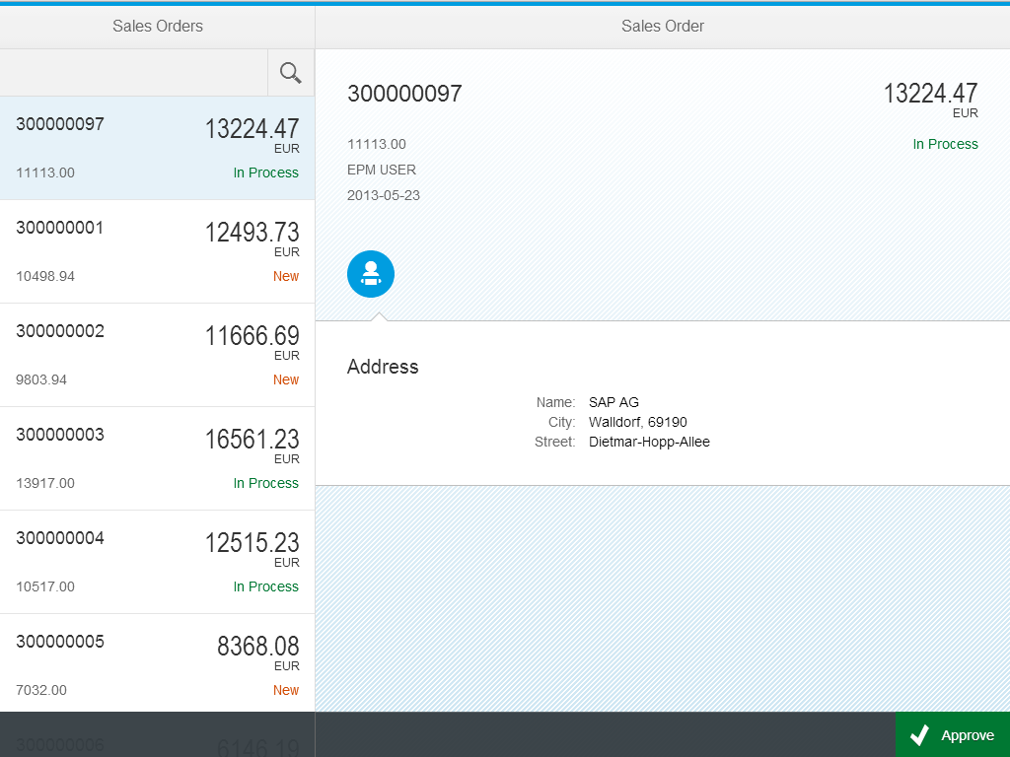

## Description

To achieve the aim of this exercise, we’ll be making small changes to lots of the files in the project.

We need to add a footer bar (a *Bar* control within the footer aggregation of the Page) to each of the views (*Detail*, *Empty* and *Master*) to keep things visually nice and consistent.

We’ll add a *Button* control to the right side of the footer bar in the Detail view, and in the corresponding controller we’ll define the function to be called (‘*handleApprove’*) when the Button’s ‘*press’* event is fired. We’ll just simulate the approval process by displaying a *MessageBox* popup control and then showing a *MessageToast*. For this we’ll need to show some texts, so we’ll add them to the same properties file we set up earlier in relation to the resource model.

## Changes

### i18n/messageBundle.properties

* Add more texts for the approve button and dialog

MasterTitle=Sales Orders

DetailTitle=Sales Order

StatusTextN=New

StatusTextP=In Process

ApproveButtonText=Approve

ApproveDialogTitle=Approve Sales Order

ApproveDialogMsg=Do you want to approve this sales order now?

ApproveDialogSuccessMsg=The sales order has been approved

### view/Detail.view.xml

* Add a footer to the Detail page which holds the button to trigger the approval

< IconTabBar >

…

</IconTabBar>

<footer>

<Bar>

<contentRight>

<Button

text=*"{i18n>ApproveButtonText}"*

type=*"Accept"*

icon=*"sap-icon://accept"*

press=*"handleApprove"* />

</contentRight>

</Bar>

</footer>

</Page>

</core:View>

### view/Detail.controller.js

* First we need to register 2 more classes used to work with dialogs (*MessageBox*, MessageToast)
* On handling the approve event we first show a confirmation dialog (*MessageBox*)
* If the user confirms we only show a success message (*MessageToast*). **Calling a real service is not part of this exercise.**

jQuery.sap.require("oscon2014.util.Formatter");

jQuery.sap.require("sap.m.MessageBox");

jQuery.sap.require("sap.m.MessageToast");

sap.ui.controller("oscon2014.view.Detail", {

handleNavButtonPress : **function** (evt) {

**this**.nav.back(“Master”);

},

handleApprove : **function** (evt) {

// show confirmation dialog

**var** bundle = **this**.getView().getModel("i18n").getResourceBundle();

sap.m.MessageBox.confirm(

bundle.getText("ApproveDialogMsg"),

**function** (oAction) {

**if** (sap.m.MessageBox.Action.OK === oAction) {

// notify user

**var** successMsg = bundle.getText("ApproveDialogSuccessMsg");

sap.m.MessageToast.show(successMsg);

// **TODO** call proper service method and update model (not part of this session)

}

},

bundle.getText("ApproveDialogTitle")

);

},

onBeforeRendering:**function**(){

**this**.byId("SupplierAddress").bindElement("BusinessPartner");

}

});

### view/Empty.view.xml

* We now need footers in all pages for symmetry

<core:View

xmlns=*"sap.m"*

xmlns:core=*"sap.ui.core"* >

<Page>

<footer>

<Bar>

</Bar>

</footer>

</Page>

</core:View>

### view/Master.view.xml

* We now need footers in all pages for symmetry

…

</ObjectListItem>

</List>

<footer>

<Bar>

</Bar>

</footer>

</Page>

</core:View>

|  |
| --- |
| Further Reading:  * Page API: <https://sapui5.netweaver.ondemand.com/sdk/#docs/api/symbols/sap.m.Page.html> * Modularization and Dependency Management (require/declare modules): <https://sapui5.netweaver.ondemand.com/sdk/#docs/guide/ModularizationConcept.html> |

# Exercise 9 – Line Item

## Objective

Extend the detail page with a table that shows the line items of the sales order. The rows are active and allow navigating to the new line item page.

## Preview

Before:



After:

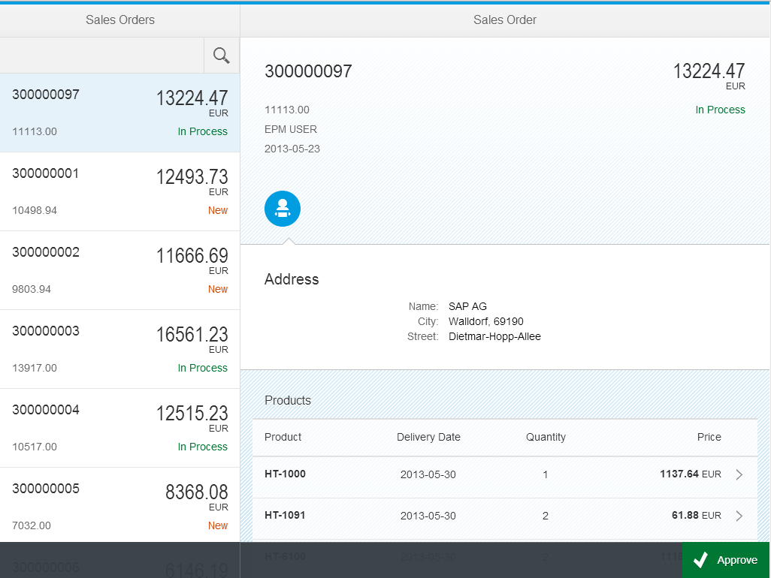

## Description

In this exercise we’re going to add some more details to the existing *Detail* view, specifically a new *Table* control containing the line items from the selected order. We’ll put the Table control underneath the *IconTabBar* that we introduced in an earlier exercise.

To format each order item’s quantity, we’ll add a further function called ‘quantity’ to the *Formatter.js* module we already have. This will then be used in the complex binding definition of the respective ‘*quantity’* text in the table *ColumnListItem’s* cells aggregation.

We’ll handle the selection of a line in the line items table with a ‘*handleLineItemsPress’* function in the *Detail* view’s controller. This is bound to the press event of the Table’s *ColumnListItem* as you can see in the *Detail* view XML below. On selection, we want to navigate to a new view, *LineItem*, passing the context of the selected item.

So we’ll create a new *LineItem* view, also containing a *Page* control with a *Bar* in the footer aggregation, like all the other views, and display line item details. When the navigation button is pressed we transition back to the *Detail* view with a simple handler ‘*handleNavBack’* in the *LineItem* controller.

## Changes

### i18n/messageBundle.properties

* Add more message texts

MasterTitle=Sales Orders

DetailTitle=Sales Order

StatusTextN=New

StatusTextP=In Process

ApproveButtonText=Approve

ApproveDialogTitle=Approve Sales Order

ApproveDialogMsg=Do you want to approve this sales order now?

ApproveDialogSuccessMsg=The sales order has been approved

LineItemTableHeader=Products

LineItemTitle=Product

### util/Formatter.js

* We need a new formatter for quantities that removes the trailing zeros from the number

jQuery.sap.declare("oscon2014.util.Formatter");

jQuery.sap.require("sap.ui.core.format.DateFormat");

oscon2014.util.Formatter = {

…

},

quantity : **function** (value) {

**try** {

**return** (value) ? parseFloat(value).toFixed(0) : value;

} **catch** (err) {

**return** "Not-A-Number";

}

}

};

### view/Detail.view.xml

* We set a CSS class on the page control that will set proper margins on the table control in this page.
* There is quite a bit of change to implement the table with the help of a list

<core:View

controllerName=*"oscon2014.view.Detail"*

xmlns=*"sap.m"*

xmlns:form=*"sap.ui.layout.form"*

xmlns:core=*"sap.ui.core"* >

<Page

title=*"{i18n>DetailTitle}"*

class=*"sapUiFioriObjectPage"*

showNavButton=*"{device>/isPhone}"*

navButtonPress=*"handleNavButtonPress"* >

…

</IconTabBar>

<Table

headerText=*"{i18n>LineItemTableHeader}"*

items=*"{LineItems}"* >

<columns>

<Column>

<header><Label text=*"Product"* /></header>

</Column>

<Column

minScreenWidth=*"Tablet"*

demandPopin=*"true"*

hAlign=*"Center"* >

<header><Label text=*"Delivery Date"* /></header>

</Column>

<Column

minScreenWidth=*"Tablet"*

demandPopin=*"true"*

hAlign=*"Center"* >

<header><Label text=*"Quantity"* /></header>

</Column>

<Column

hAlign=*"Right"* >

<header><Label text=*"Price"* /></header>

</Column>

</columns>

<ColumnListItem

type=*"Navigation"*

press=*"handleLineItemPress"* >

<cells>

<ObjectIdentifier

title=*"{ProductId}"* />

<Text

text=*"{*

*path:'DeliveryDate',*

*formatter:'oscon2014.util.Formatter.date'*

*}"*/>

<Text

text=*"{*

*path:'Quantity',*

*formatter:'oscon2014.util.Formatter.quantity'*

*}"*/>

<ObjectNumber

number=*"{GrossAmount}"*

numberUnit=*"{CurrencyCode}"* />

</cells>

</ColumnListItem>

</Table>

<footer>

…

</footer>

</Page>

</core:View>

### view/Detail.controller.js

* When a line item is pressed we navigate to the new line item page

…

handleApprove : **function** (evt) {

…

},

handleLineItemPress : **function** (evt) {

**var** context = evt.getSource().getBindingContext();

**this**.nav.to("LineItem", context);

},

onBeforeRendering:**function**(){

**this**.byId("SupplierAddress").bindElement("BusinessPartner");

}

});

### view/LineItem.view.xml (ADD NEW XML view LineItem, REPLACE all initial code)

* For the sake of simplicity we only put an object header to the line item page.

<core:View

controllerName=*"oscon2014.view.LineItem"*

xmlns=*"sap.m"*

xmlns:core=*"sap.ui.core"* >

<Page

id=*"page"*

title=*" {i18n>LineItemTitle}"*

showNavButton=*"true"*

navButtonPress=*"handleNavBack"* >

<footer>

<Bar>

</Bar>

</footer>

<content>

<ObjectHeader

title=*"{ProductId}"*

number=*"{GrossAmount}"*

numberUnit=*"{CurrencyCode}"* >

<attributes>

<ObjectAttribute text=*"{*

*path:'DeliveryDate',*

*formatter:'oscon2014.util.Formatter.date'*

*}"* />

<ObjectAttribute text=*"{*

*path:'Quantity',*

*formatter:'oscon2014.util.Formatter.quantity'*

*}"* />

</attributes>

</ObjectHeader>

</content>

</Page>

</core:View>

### view/LineItem.controller.js (gets NEWLY added with view/LineItem.view.xml, REPLACE all initial code)

* We only need to handle the back navigation to the **Detail** page

sap.ui.controller("*oscon2014.view*.LineItem", {

handleNavBack : **function** (evt) {

**this**.nav.back("Detail");

}

});

# Exercise 10 – Grouping

## Objective

Add a “**Select**” to the master list that lets the user select a grouping. Handle the user selection and apply the grouping to the data binding.

## Preview

Before: 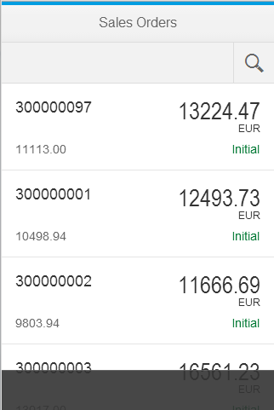 After: 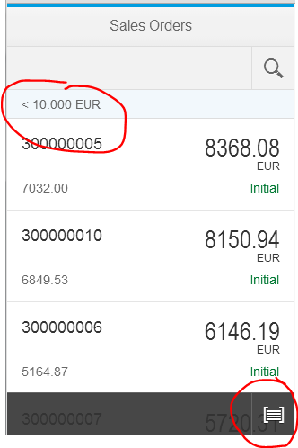

## Description

We’re almost there. In this last exercise we’re going to add grouping features that can be applied when aggregation bindings are sorted. In this case the binding is the one between the sales orders in the data model and the items aggregation in the *List* control in the *Master* view.

We’ll create a new file in the ‘*util’* folder, containing two custom grouping functions. We’ll add a *Select* control to the *Bar* in the Page footer in the *Master* view, and in the corresponding controller, we will handle the button press with a function ‘*handleGroup’* that updates the data binding of the list.

## Changes

### i18n/messageBundle.properties

* Add more message texts

MasterTitle=Sales Orders

DetailTitle=Sales Order

StatusTextN=New

StatusTextP=In Process

ApproveButtonText=Approve

ApproveDialogTitle=Approve Sales Order

ApproveDialogMsg=Do you want to approve this sales order now?

ApproveDialogSuccessMsg=The sales order has been approved

LineItemTableHeader=Products

LineItemTitle=Product

MasterGroupNone=None

MasterGroupStatus=Status

MasterGroupAmount=Amount

### util/Grouper.js (ADD NEW file Grouper.js)

* This new file contains two functions that implement the logic to group sales orders by
  + **Status** (simple string comparison)
  + **Amount** (a little bit more sophisticated price checks)

jQuery.sap.declare("oscon2014.util.Grouper");

oscon2014.util.Grouper = {

bundle : **null**, // somebody has to set this

LifecycleStatus : **function** (oContext) {

**var** status = oContext.getProperty("LifecycleStatus");

**var** text = oscon2014.util.Grouper.bundle.getText("StatusText" + status, "?");

**return** {

key: status,

text: text

};

},

GrossAmount : **function** (oContext) {

**var** price = oContext.getProperty("GrossAmount");

**var** currency = oContext.getProperty("CurrencyCode");

**var** key = **null**,

text = **null**;

**if** (price <= 5000) {

key = "LE10";

text = "< 5000 " + currency;

} **else** **if** (price > 5000 && price <= 10000) {

key = "LE100";

text = "< 10.000 " + currency;

} **else** **if** (price > 10000) {

key = "GT100";

text = "> 10.000 " + currency;

}

**return** {

key: key,

text: text

};

}

};

### view/Master.view.xml

* Add a select control to the footer of the master page to choose a criteria for grouping

<core:View

controllerName=*"oscon2014.view.Master"*

xmlns=*"sap.m"*

xmlns:core=*"sap.ui.core"* >

…

<footer>

<Bar>

<contentRight>

<Select

id=*"groupSelect"*

change=*"handleGroup"*

icon=*"sap-icon://group-2"*

type=*"IconOnly"*

selectedKey=*"None"*

autoAdjustWidth=*"true"* >

<core:Item

key=*"None"*

text=*"{i18n>MasterGroupNone}"*/>

<core:Item

key=*"GrossAmount"*

text=*"{i18n>MasterGroupAmount}"*/>

<core:Item

key=*"LifecycleStatus"*

text=*"{i18n>MasterGroupStatus}"*/>

</Select>

</contentRight>

</Bar>

</footer>

</Page>

</core:View>

### view/Master.controller.js

* Require the new “**Grouper.js**” file
* Implement the “**handleGroup**” function
  + Compute the sorter object that will perform the grouping
  + Apply the grouping to the data binding

jQuery.sap.require("oscon2014.util.Formatter");

jQuery.sap.require("oscon2014.util.Grouper");

sap.ui.controller("oscon2014.view.Master", {

handleListItemPress : **function** (evt) {

**var** context = evt.getSource().getBindingContext();

**this**.nav.to("Detail", context);

},

handleSearch : **function** (evt) {

// create model filter

**var** filters = [];

**var** query = evt.getParameter("query");

**if** (query && query.length > 0) {

**var** filter = **new** sap.ui.model.Filter("SoId", sap.ui.model.FilterOperator.Contains, query);

filters.push(filter);

}

// update list binding

**var** list = **this**.getView().byId("list");

**var** binding = list.getBinding("items");

binding.filter(filters);

},

handleListSelect : **function** (evt) {

**var** context = evt.getParameter("listItem").getBindingContext();

**this**.nav.to("Detail", context);

},

handleGroup : **function** (evt) {

// compute sorters

**var** sorters = [];

**var** item = evt.getParameter("selectedItem");

**var** key = (item) ? item.getKey() : **null**;

**if** ("GrossAmount" === key || "LifecycleStatus" === key) {

oscon2014.util.Grouper.bundle = **this**.getView().getModel("i18n").getResourceBundle();

**var** grouper = oscon2014.util.Grouper[key];

sorters.push(**new** sap.ui.model.Sorter(key, **true**, grouper));

}

// update binding

**var** list = **this**.getView().byId("list");

**var** oBinding = list.getBinding("items");

oBinding.sort(sorters);

}

});

|  |
| --- |
| Further Reading:  * Select API: <https://sapui5.netweaver.ondemand.com/sdk/#docs/api/symbols/sap.m.Select.html> |