Bluefish ESP indicator figures

Abigail Tyrell & Samantha Werner

08 Nov 2022

# Background

## Ecosystem background

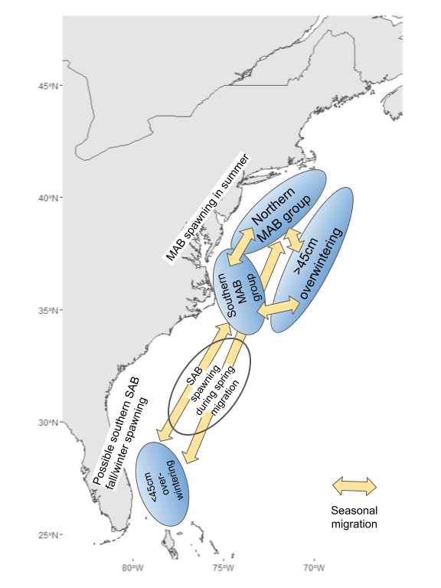

##### Figure 1. Conceptual model of bluefish seasonal migrations.

## Socioeconomic background

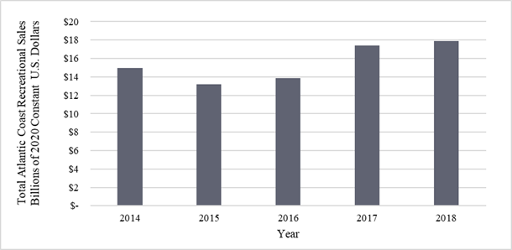

##### Figure 2. Total annual recreational sales from Atlantic coastal states over 2014-2018 in billions of 2020 constant U.S. Dollars. Data obtained from the Fisheries Economics of the United States Reports (2014-2018). Values were adjusted using the Gross Domestic Product Implicit Price Deflator.

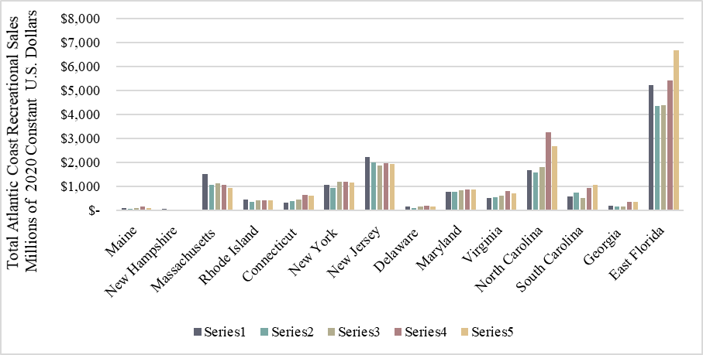

##### Figure 3. Total annual recreational sales by Atlantic Coastal state from 2014-2018 in millions of 2020 constant U.S. Dollars. Data obtained from the Fisheries Economics of the United States. Values were adjusted using the Gross Domestic Product Implicit Price Deflator.

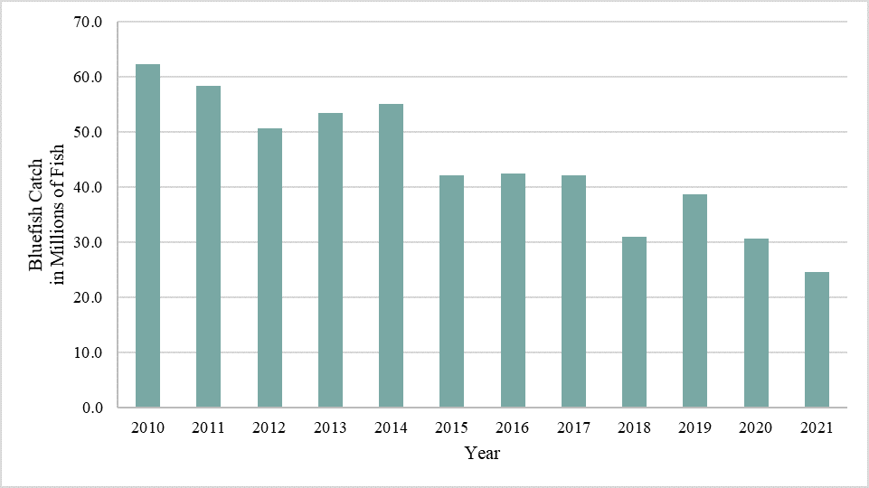

##### Figure 4. Recreational bluefish catch from Atlantic Coastal states over 2010-2021. Data acquired from the Marine Recreational Information Program (MRIP) query tool in January 2022.

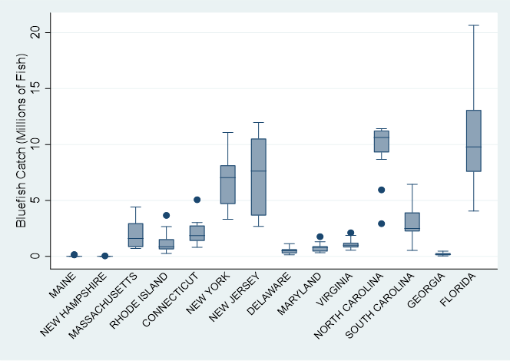

##### Figure 5. Recreational bluefish catch box plots from 2010-2021 by Atlantic coastal states. Data retrieved from the Marine Recreational Information Program (MRIP) query tool in January 2022.

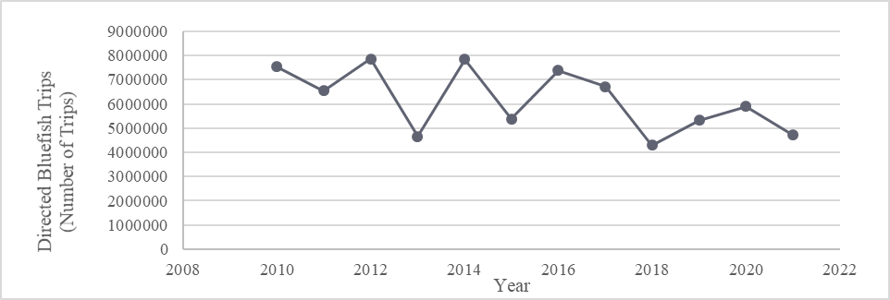

##### Figure 6. Number of directed recreational bluefish trips from Atlantic coastal states (2010-2021). Data retrieved from the Marine Recreational Information Program (MRIP) query tool in January 2022.

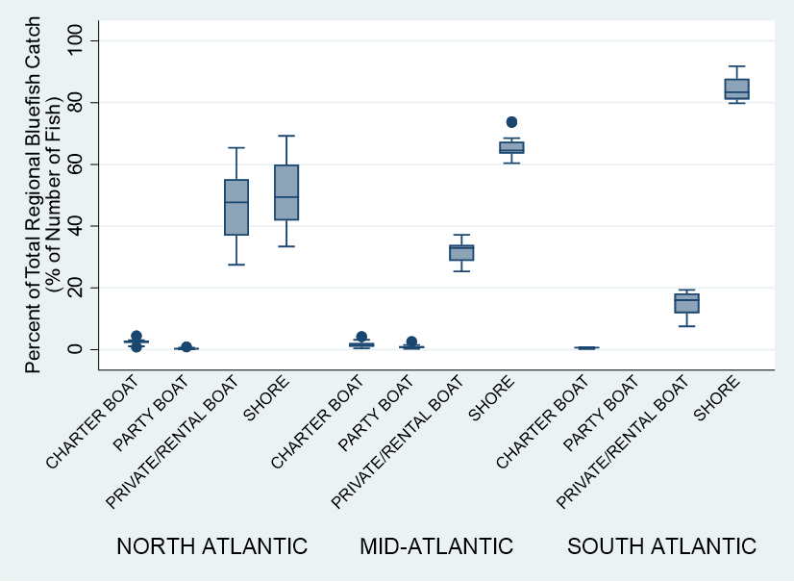

##### Figure 7. Proportion of regional recreational bluefish catch in number of fish by fishing mode (2010-2021). Data retrieved from the Marine Recreational Information Program (MRIP) query tool in January 2022.

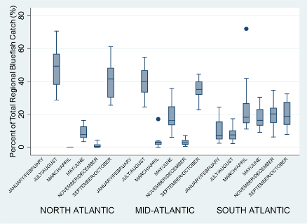

##### Figure 8. Proportion of total recreational bluefish catch by month grouping and region (2010-2021). Data retrieved from the Marine Recreational Information Program (MRIP) query tool in January 2022

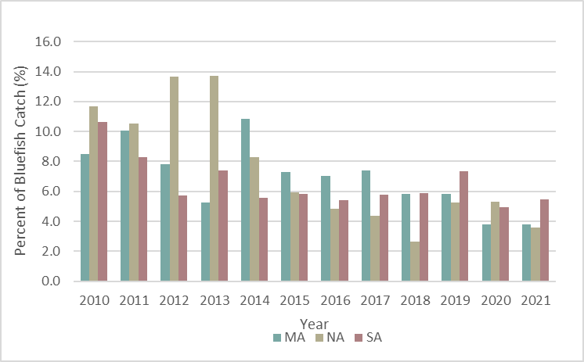

##### Figure 9. Recreational bluefish catch as a percent of total recreational catch by region over 2010-2021. Data retrieved from the Marine Recreational Information Program (MRIP) query tool in January 2022.

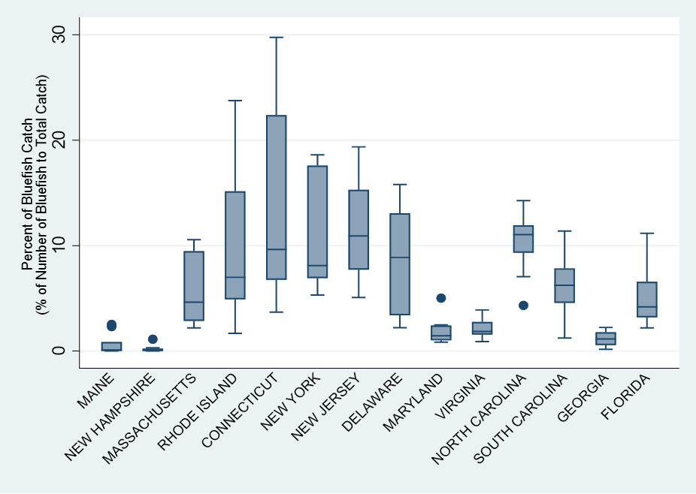

##### Figure 10. Box plots of recreational bluefish catch as a percent of total recreational catch by sate over 2010-2021. Data source: Data retrieved from the Marine Recreational Information Program (MRIP) query tool in January 2022. Conneticut has the hightes percent of bluefish catch relative to other species and New Hampshire the lowest.

# Diet

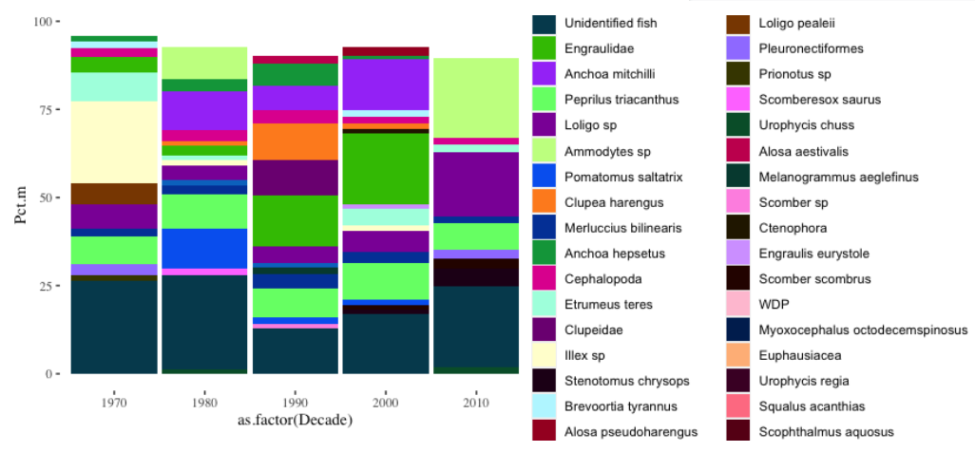

##### Figure 11. Bluefish diet by decade (all regions and bluefish sizes) from the Northeast Fisheries Science Center (NEFSC) bottom trawl survey, 1973-2020.

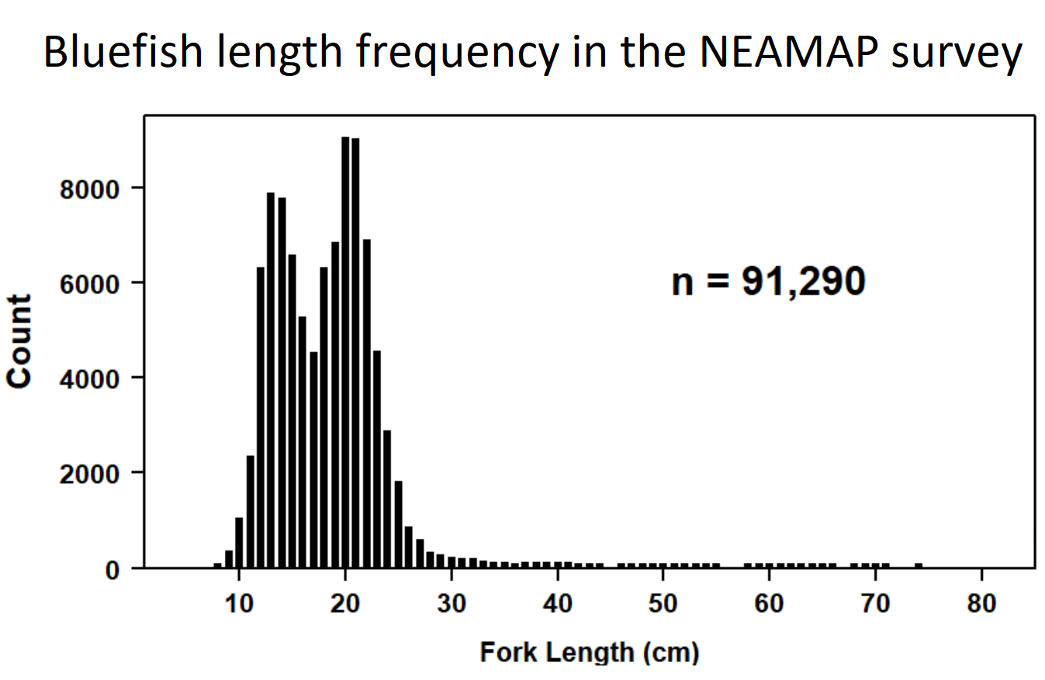

##### Figure 12. Length frequency of bluefish samples taken for diet analysis in the NEAMAP survey, 2007-2020.

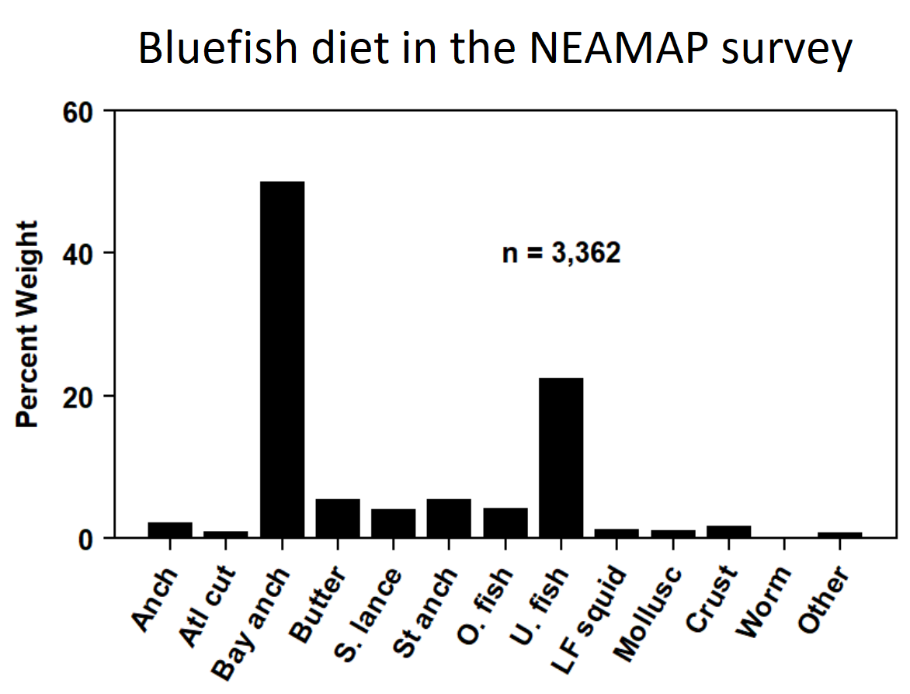

##### Figure 13. Bluefish prey species in the NEAMAP survey, 2007-2020.

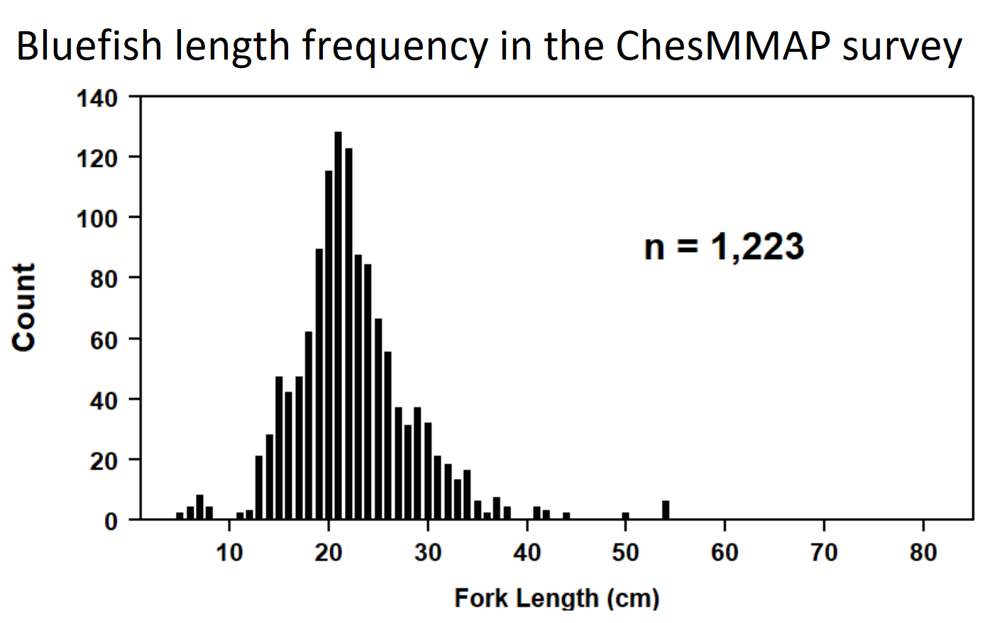

##### Figure 14. Length frequency of bluefish samples taken for diet analysis in the ChesMMAP survey, 2002-2020.

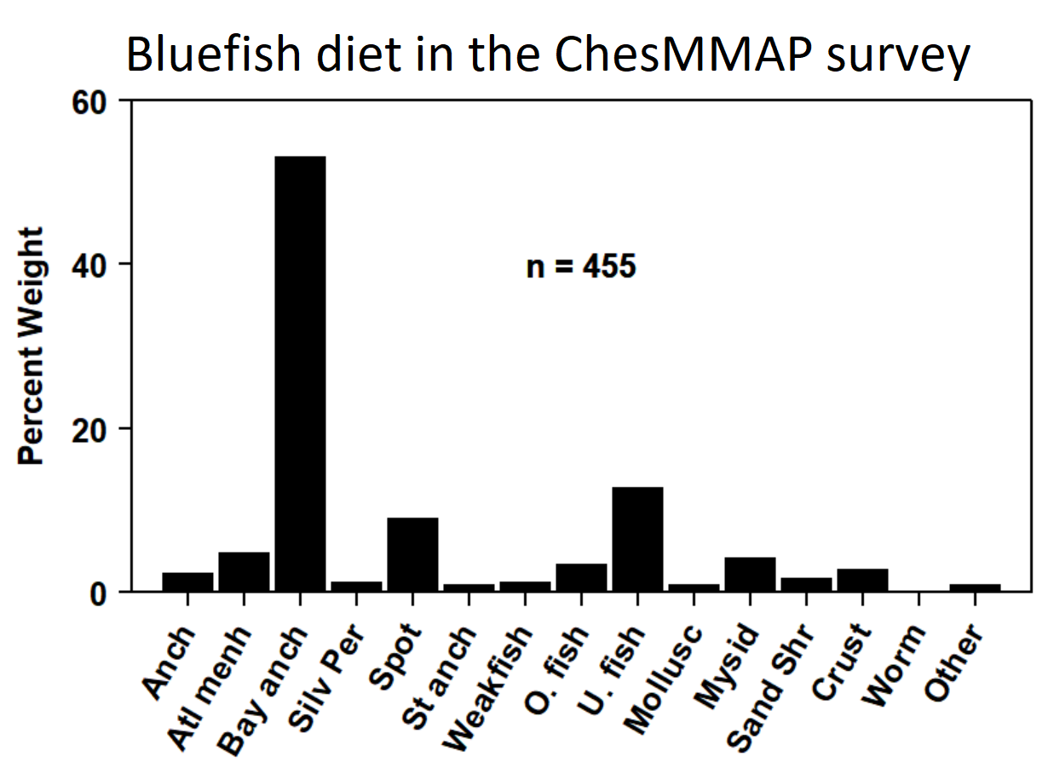

##### Figure 15. Bluefish prey species in the ChesMMAP survey, 2002-2020.

# Environment and distribution

## Eggs

### EcoMon/MARMAP

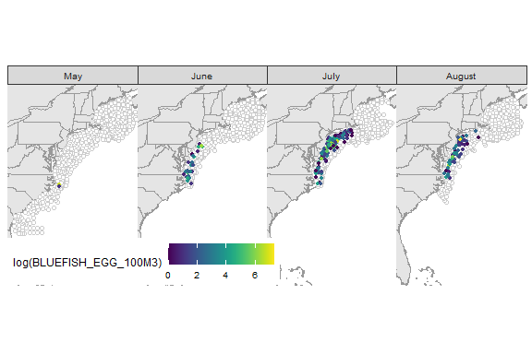

##### Figure 16. Map of bluefish egg distribution in the Northwest Atlantic, as collected in the Marine Resources Monitoring, Assessment and Prediction (MARMAP) program (1977-1987) and inthe Ecosystem Monitoring (EcoMon) program (1993 only). No eggs were collected in January through April or September through December.

## Larvae

### EcoMon/MARMAP

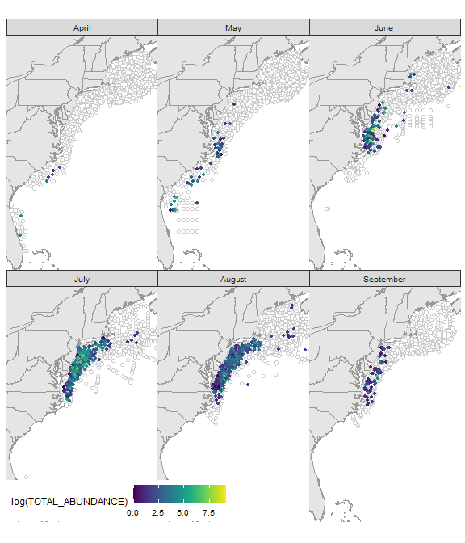

##### Figure 17. Map of bluefish larvae distribution in the Northwest Atlantic, as collected in the Herring and Sand Lance Program (1988-1994), Georges Bank Global Ocean Ecosystems Dynamics (1995-1999), MARMAP (1977-1987), and EcoMon (1992 – present). No larvae were collected in February or March, or October through December. There was one positive tow in January (not shown).

## Juveniles and adults

### MRIP catch and CPUE

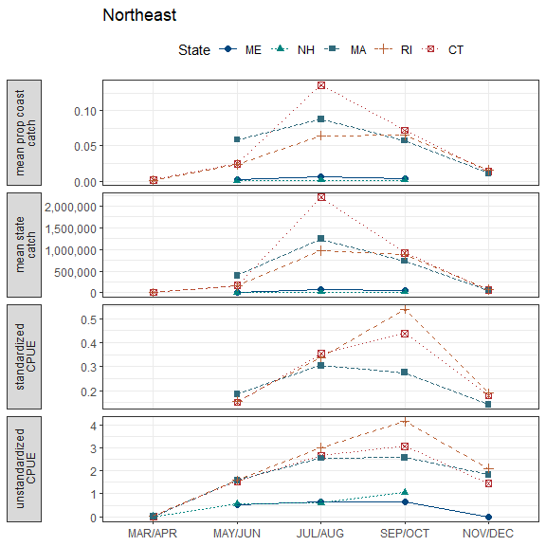

##### Figure 18. Mean proportion of coastwide catch, mean state catch (lbs), standardized CPUE, and unstandardized CPUE for Northeast states in March through December.

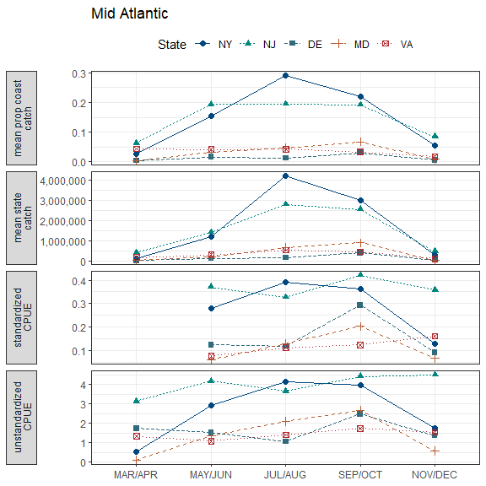

##### Figure 19. Mean proportion of coastwide catch, mean state catch (lbs), standardized CPUE, and unstandardized CPUE for Mid Atlantic states in March through December.

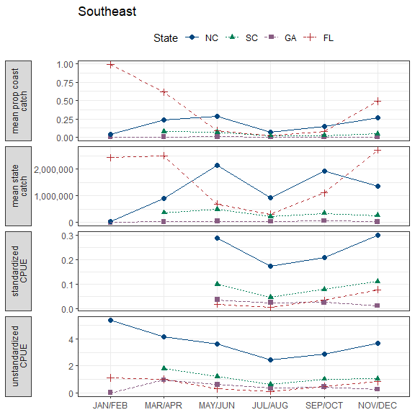

##### Figure 20. Mean proportion of coastwide catch, mean state catch (lbs), standardized CPUE, and unstandardized CPUE for Southeast states in January through December.

### NMFS bottom trawl

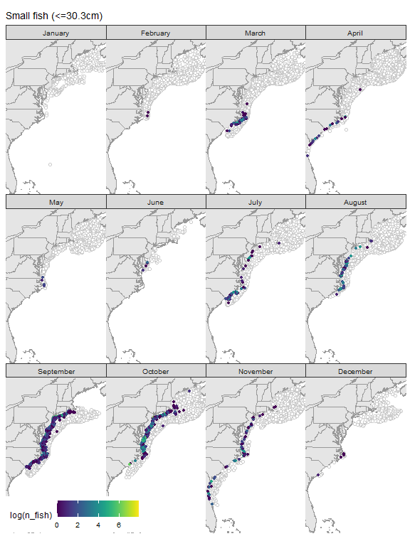

##### Figure 21. Map of small (<=30.3cm) bluefish distribution in the Northwest Atlantic, as collected in the NMFS bottom trawl survey, which has sampled most years since 1963.

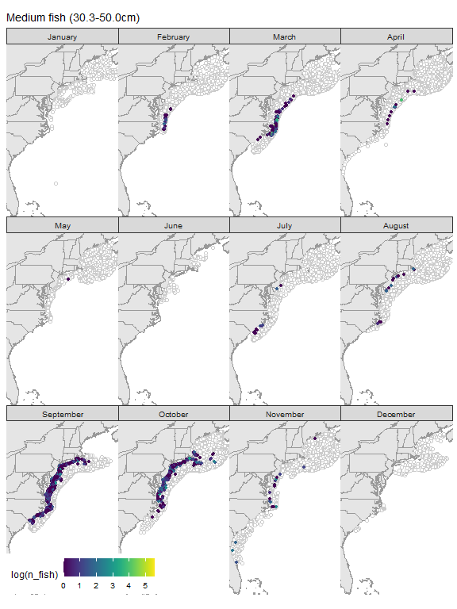

##### Figure 22. Map of medium (30.3-50.0cm) bluefish distribution in the Northwest Atlantic, as collected in the NMFS bottom trawl survey, which has sampled most years since 1963.

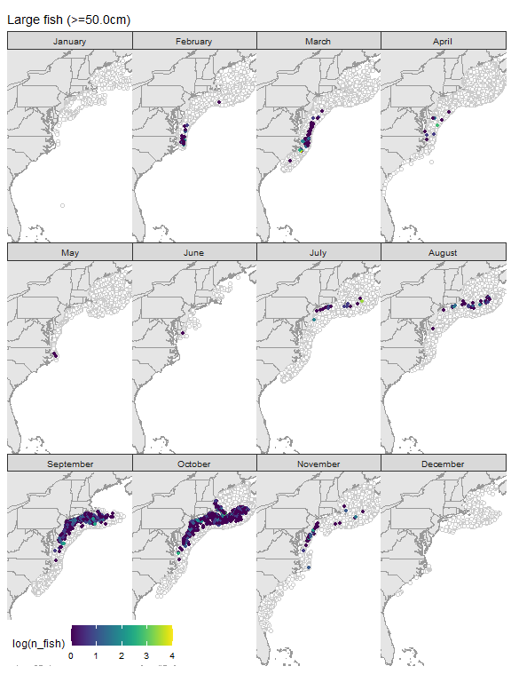

##### Figure 23. Map of large (>50.0cm) bluefish distribution in the Northwest Atlantic, as collected in the NMFS bottom trawl survey, which has sampled most years since 1963.

#### Length distributions

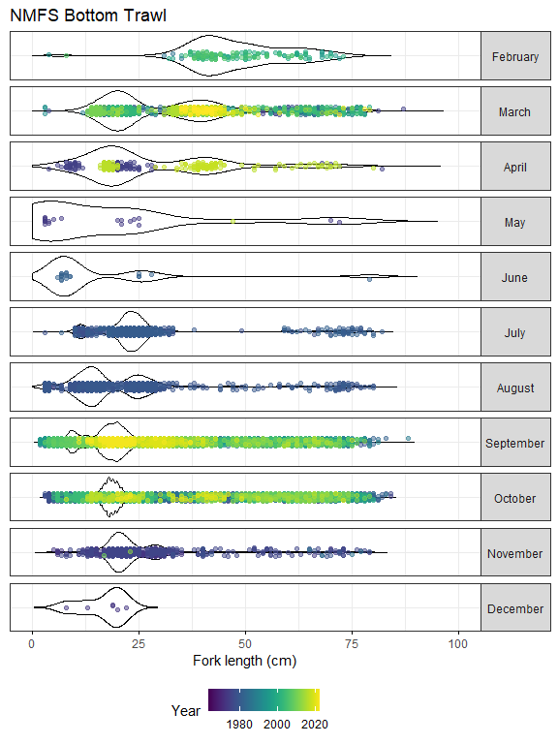

##### Figure 24. Bluefish length distributions in all NEFSC NMFS bottom trawl samples.

### State surveys

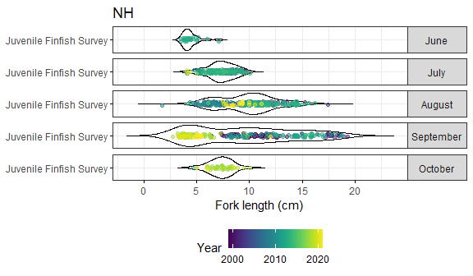

##### Figure 25. Bluefish length distributions in the New Hampshire Juvenile Finfish Survey.

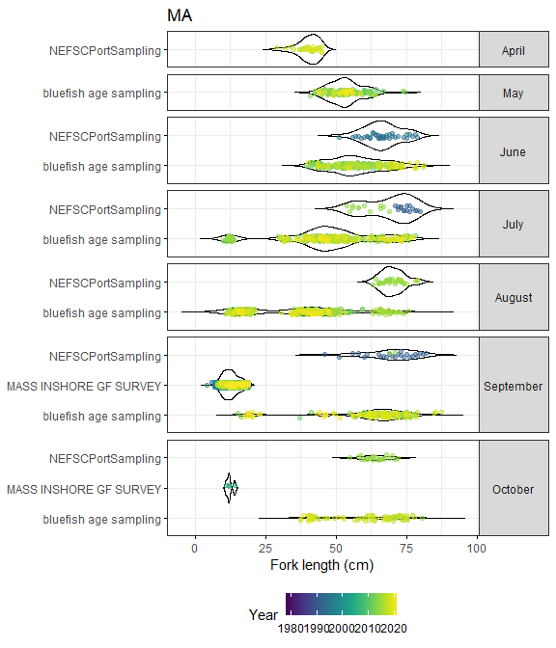

##### Figure 26. Bluefish length distributions in Massachusetts-based surveys and samples.

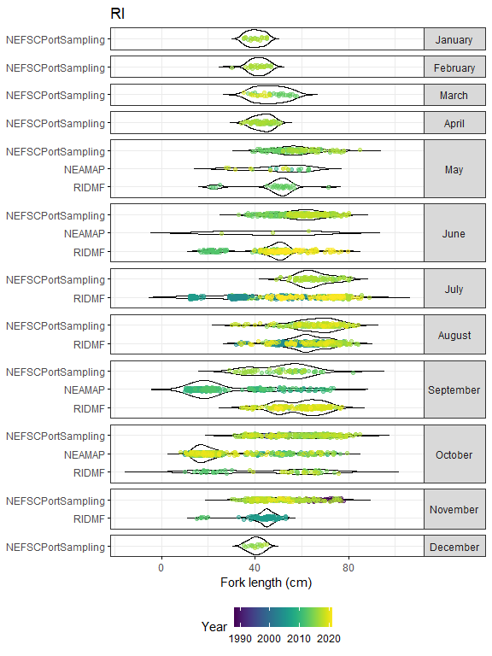

##### Figure 27. Bluefish length distributions in Rhode Island-based surveys and samples.

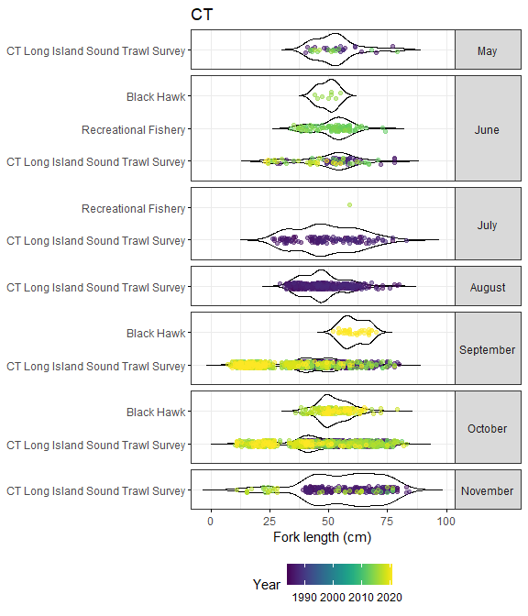

##### Figure 28. Bluefish length distributions in Connecticut-based surveys and samples.

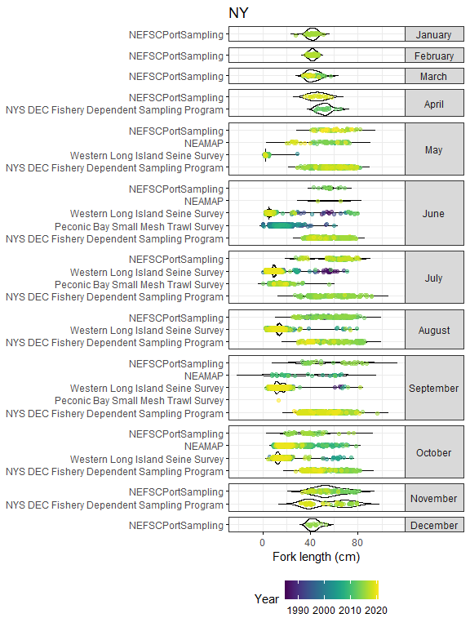

##### Figure 29. Bluefish length distributions in New York-based surveys and samples.

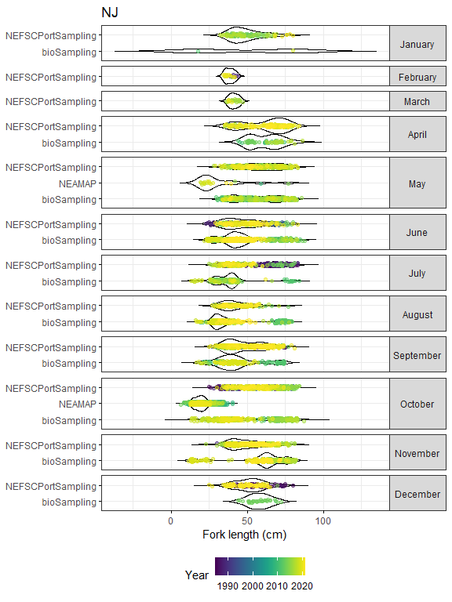

##### Figure 30. Bluefish length distributions in New Jersey-based surveys and samples.

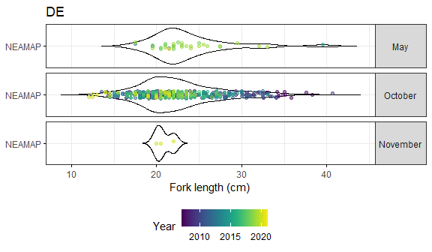

##### Figure 31. Bluefish length distributions in NEAMAP survey samples taken in Delaware.

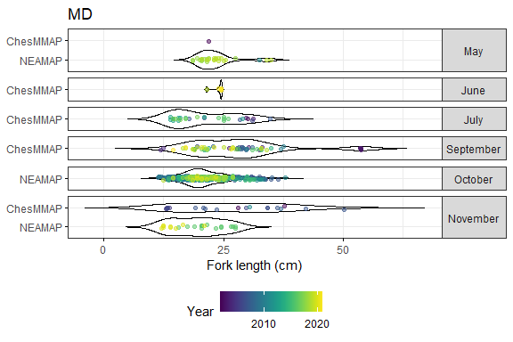

##### Figure 32. Bluefish length distributions in Maryland-based surveys and samples.

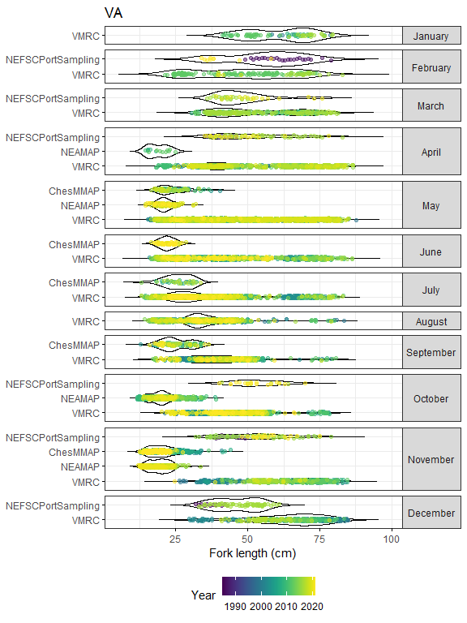

##### Figure 33. Bluefish length distributions in Virginia-based surveys and samples.

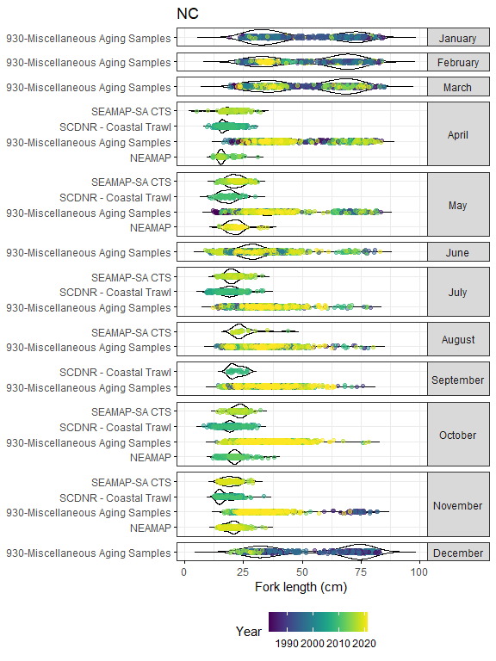

##### Figure 34. Bluefish length distributions in North Carolina-based surveys and samples.

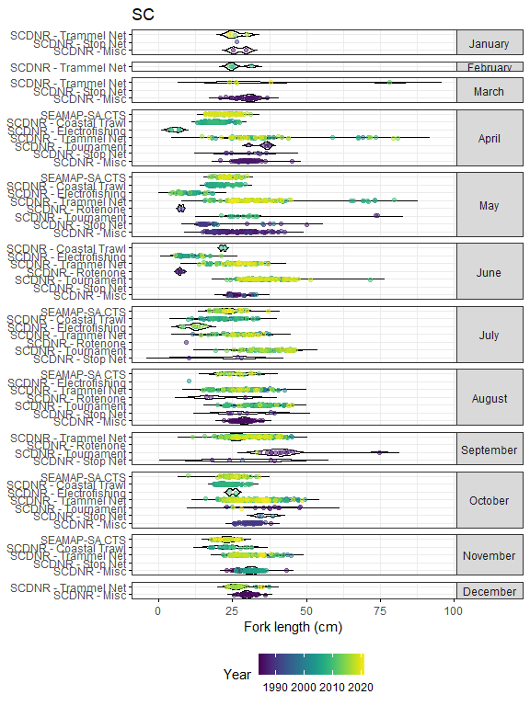

##### Figure 35. Bluefish length distributions in South Carolina-based surveys and samples.

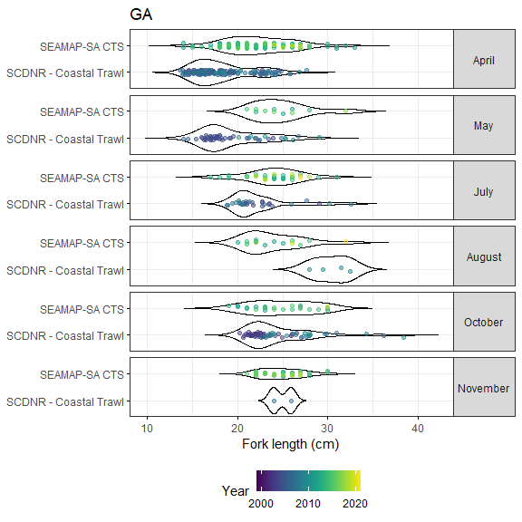

##### Figure 36. Bluefish length distributions in Georgia-based surveys and samples.

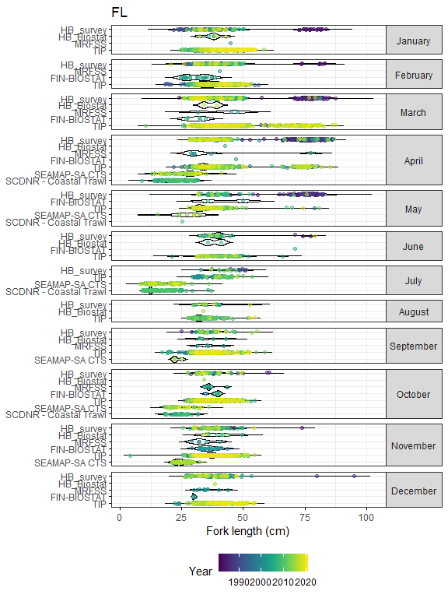

##### Figure 37. Bluefish length distributions in Florida-based surveys and samples.

### Bluefish length cohorts

#### Observations by month

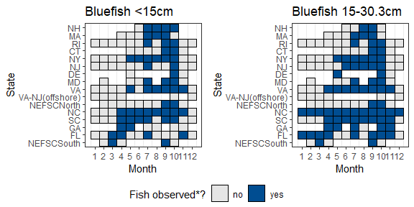

##### Figure 38. Summary of months when bluefish <15cm and between 15-30.3cm have been found in all coastal Atlantic states and in federal surveys. (*) Bluefish are marked as observed if the month had more than 20 fish observed over 3 or more years. {-}

#### New Hampshire

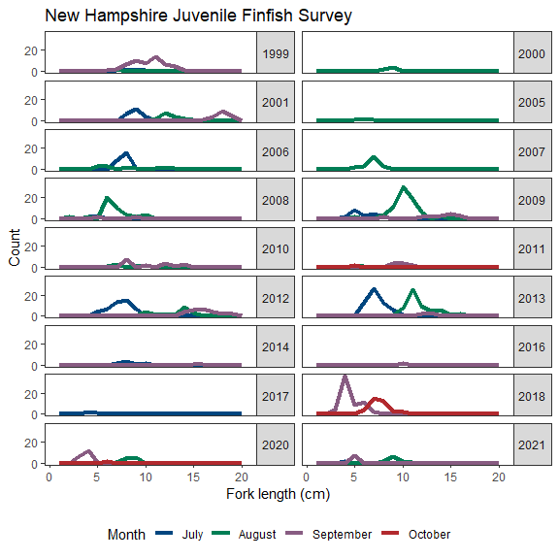

##### Figure 39. Length distributions of bluefish under 30.3cm by month in the New Hampshire Juvenile Finfish Survey.

#### New York

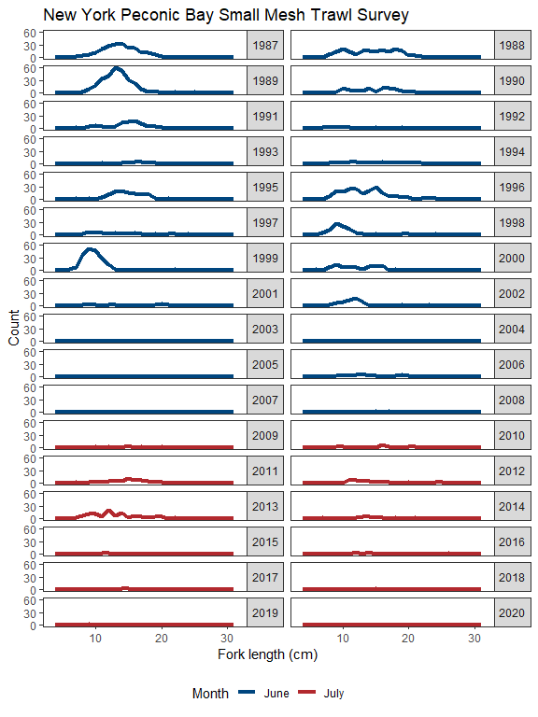

##### Figure 40. Length distributions of bluefish under 30.3cm by month in the New York Peconic Bay Small Mesh Survey. Bimodal cohort length peaks are visible in several years, including 1993, 2001, and 2007.

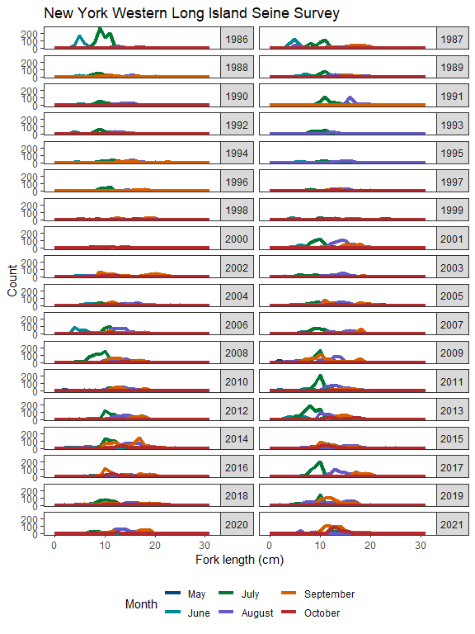

##### Figure 41. Length distributions of bluefish under 30.3cm by month in the New York Western Long Island Seine Survey. Bimodal cohort length peaks are visible in several years, including 1998, 2002, and 2016.

#### NEAMAP

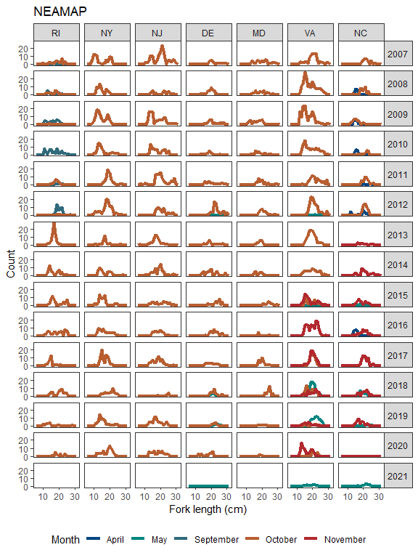

##### Figure 42. Length distributions of bluefish under 30.3cm by month in the NEAMAP survey. Bimodal cohort length peaks are visible in several years in some states.

#### SEAMAP and South Carolina DNR Coastral Trawl

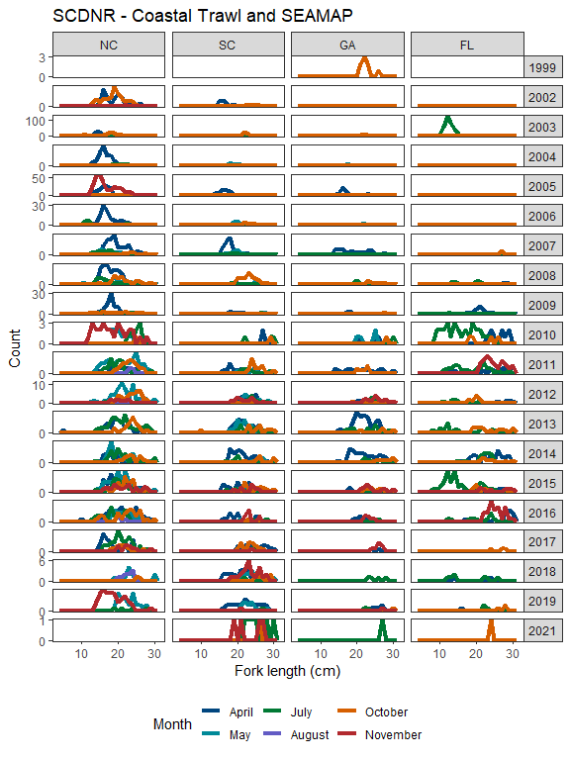

##### Figure 43. Length distributions of bluefish under 30.3cm by month in the South Carolina DNR Coastal Trawl (1999-2010) and SEAMAP (2011-2021) samples. Bimodal cohort length peaks are visible in North Carolina in April 2002 and November 2005.

#### NMFS bottom trawl

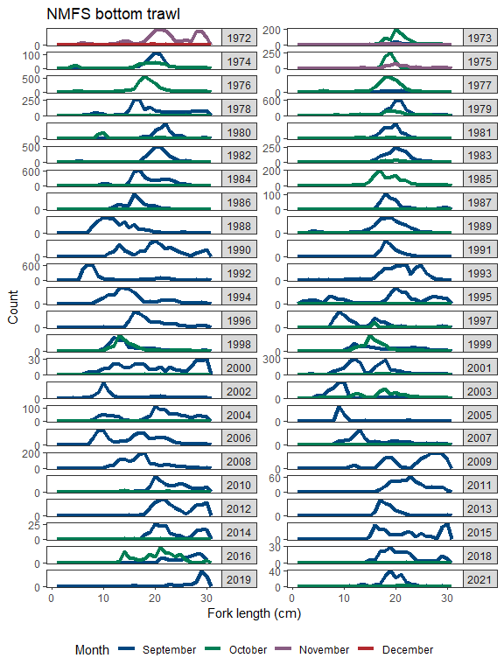

##### Figure 44. Length distributions of bluefish under 30.3cm by month in the NMFS bottom trawl fall survey. Bimodal cohort length peaks are visible in several years, including 1990, 1995, 2001, and 2006. Note, after 2008, inshore strata were no longer sampled in the NMFS survey, and were instead sampled in the NEAMAP survey.

# Indicator methods

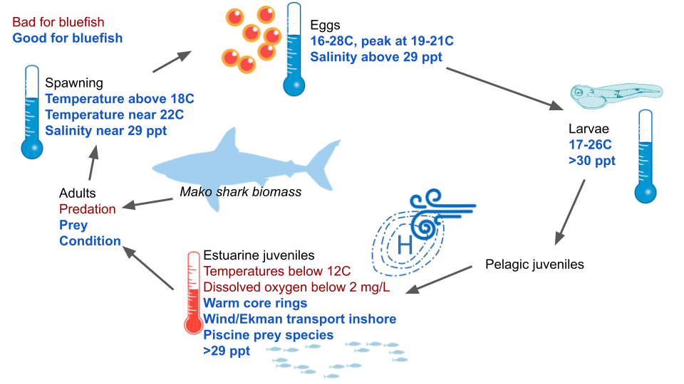

##### Figure 45. Life history conceptual model of bluefish.

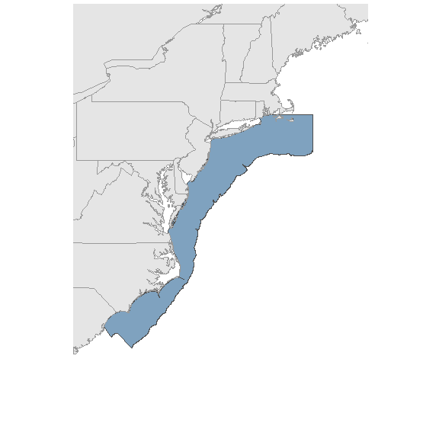

##### Figure 46. Map of the Central Atlantic region used in calculating spatially averaged indicators.

# ESP time series

## Ecosystem Indicators

### Distribution

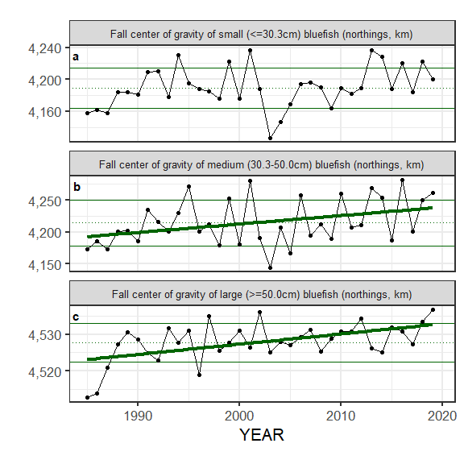

#### Figure 47. Selected ecosystem indicators for bluefish with time series ranging from 1991 - present: (a) center of gravity (northings, km) of small (<=30.3cm), (b) medium (30.3-50.0cm), and (c) large (>=50.0cm) bluefish as modeled by VAST. Upper and lower solid green horizontal lines are plus and minus one standard deviation of the time series mean. Dotted green horizontal line is the mean of the time series.

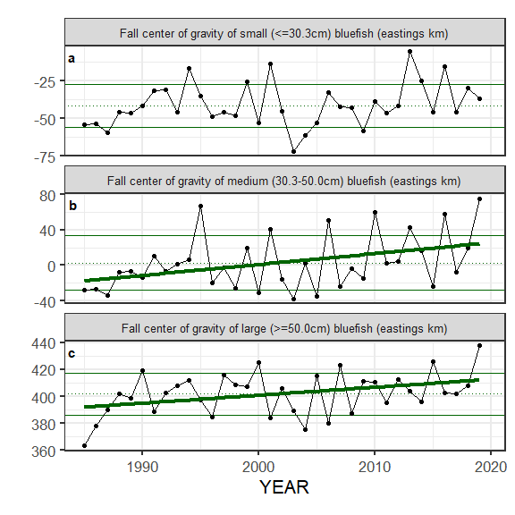

#### Figure 48. Selected ecosystem indicators for bluefish with time series ranging from 1991 - present: (a) center of gravity (eastings, km) of small (<=30.3cm), (b) medium (30.3-50.0cm), and (c) large (>=50.0cm) bluefish as modeled by VAST. Upper and lower solid green horizontal lines are plus and minus one standard deviation of the time series mean. Dotted green horizontal line is the mean of the time series.

### Climate

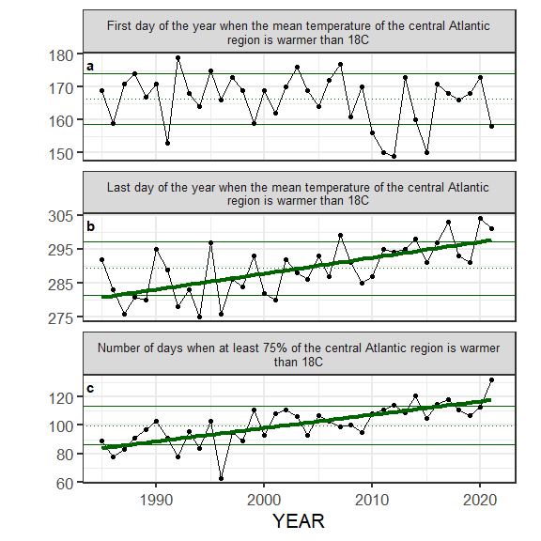

#### Figure 49. Selected ecosystem indicators for bluefish with time series ranging from 1985 - present: (a) first day of the year when the mean temperature of the central Atlantic region is warmer than 18C, (b) last day of the year when the mean temperature of the central Atlantic is warmer than 18C, and (c) number of days when at least 75% of the central Atlantic region is warmer than 18C. Upper and lower solid green horizontal lines are plus and minus one standard deviation of the time series mean. Dotted green horizontal line is the mean of the time series.

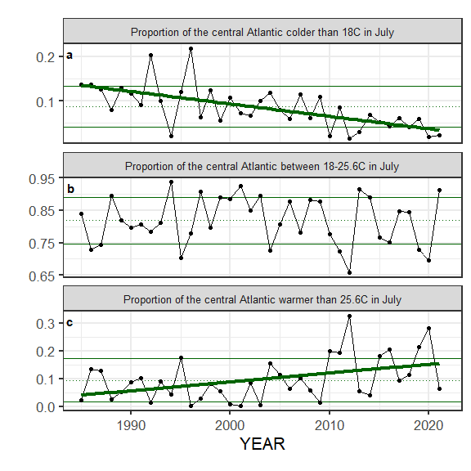

#### Figure 50. Selected ecosystem indicators for bluefish with time series ranging from 1985 - present: (a) proportion of the central Atlantic colder than 18C in July, (b) proportion of the central Atlantic between 18-25.6C in July, and (c) proportion of the central Atlantic warmer than 15.6C in July. Upper and lower solid green horizontal lines are plus and minus one standard deviation of the time series mean. Dotted green horizontal line is the mean of the time series.

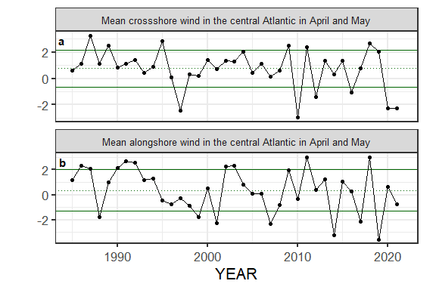

#### Figure 51. Selected ecosystem indicators for bluefish with time series ranging from 1985 - present: (a) mean crossshore wind in the central Atlantic in April and May, and (b) mean alongshore wind in the central Atlantic in April and May. Upper and lower solid green horizontal lines are plus and minus one standard deviation of the time series mean. Dotted green horizontal line is the mean of the time series.

### Natural mortality

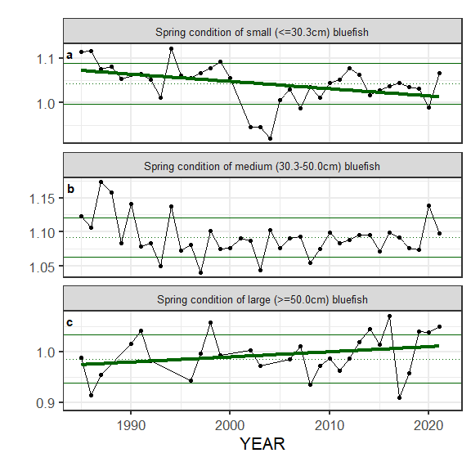

#### Figure 52. Selected ecosystem indicators for bluefish with time series ranging from 1985 - present: (a) spring condition of large (>=50.0cm) bluefish, (b) fall condition of large (>=50.0cm) bluefish, (c) spring condition of medium (30.3-50.0cm) bluefish, and (d) fall condition of medium (30.3-50.0cm) bluefish. Upper and lower solid green horizontal lines are plus and minus one standard deviation of the time series mean. Dotted green horizontal line is the mean of the time series.

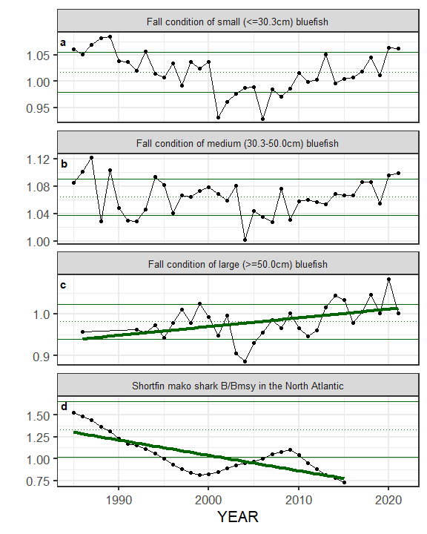

#### Figure 53. Selected ecosystem indicators for bluefish with time series ranging from 1985 - present: (a) spring condition of small (<=30.3cm) bluefish, (b) fall condition of small (<=30.3cm) bluefish, and (c) shortfin mako shark B/Bmsy in the North Atlantic. Upper and lower solid green horizontal lines are plus and minus one standard deviation of the time series mean. Dotted green horizontal line is the mean of the time series.

## Socioeconomic Indicators

### Recreational

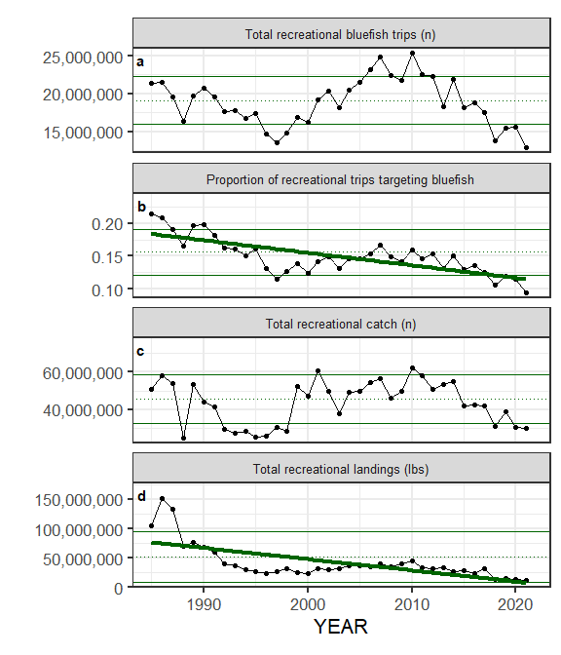

#### Figure 54. Selected socioeconomic indicators for bluefish with time series ranging from 1985 - present: (a) number of directed recreational bluefish trips from, (b) proportion of directed recreational bluefish trips relative to other directed trip, (c) total recreational bluefish catch in number of fish, (d) total recreational bluefish landings (lbs). Upper and lower solid green horizontal lines are plus and minus one standard deviation of the time series mean. Dotted green horizontal line is the mean of the time series.

### Commercial

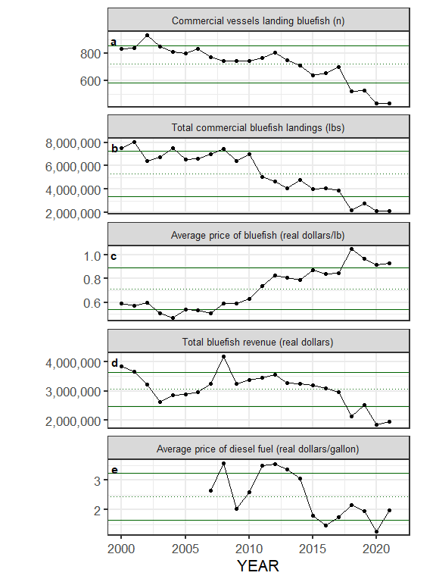

#### Figure 55. Selected socioeconomic indicators for bluefish with time series ranging from 2000 - present: (a) number of commercial vessels landing bluefish, (b) commercial bluefish landings (lbs.), (c) ex-vessel bluefish prices (2021 constant U.S. dollars per lb), (d) total annual commercial bluefish revenue in 2021 constant U.S. dollars, and (e) average annual ultra-low-sulfur number 2 diesel fuel prices (2021 constant U.S. dollars) from 2007-2021. Upper and lower solid green horizontal lines are plus and minus one standard deviation of the time series mean. Dotted green horizontal line is the mean of the time series.

### Community

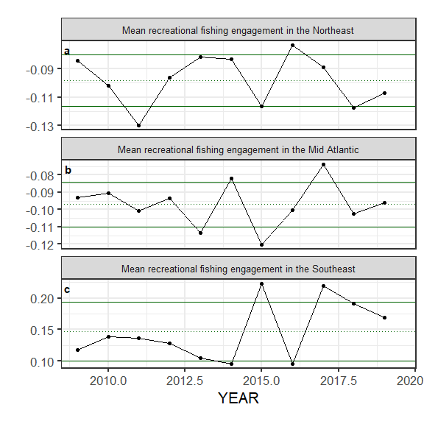

#### Figure 56. Selected socioeconomic indicators for bluefish with time series ranging from 2009-2019: (a) average annual recreational engagement scores for the Northeast region, (b) average annual recreational engagement scores for the Mid-Atlantic region, and (c) average annual recreational engagement scores for the Southeast region. Upper and lower solid green horizontal lines are plus and minus one standard deviation of the time series mean. Dotted green horizontal line is the mean of the time series.

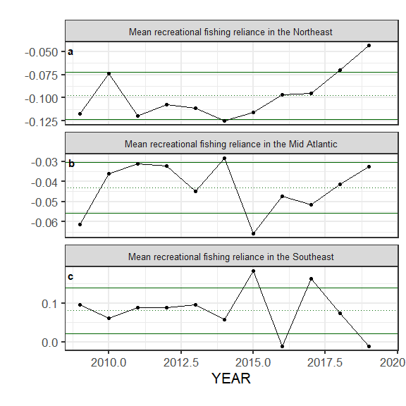

#### Figure 57. Selected socioeconomic indicators for bluefish with time series ranging from 2009-2019: (a) average annual recreational reliance scores for the Northeast region, (b) average annual recreational reliancescores for the Mid-Atlantic region, and (c) average annual recreational reliancescores for the Southeast region. Upper and lower solid green horizontal lines are plus and minus one standard deviation of the time series mean. Dotted green horizontal line is the mean of the time series.

# Tables

## Environmental data

Summary of environmental conditions where bluefish eggs were found in federal surveys

| MONTH | n_tows | n_positive_tow | total_n | n_per_tow | n_years | n_positive_years | mean_surface_temp | n_temp | mean_surface_sal | n_sal |
| --- | --- | --- | --- | --- | --- | --- | --- | --- | --- | --- |
| 5 | 1,681 | 2 | 875.96 | 0.52 | 12 | 2 | 19.90 | 875.96 | 35.33 | 2.54 |
| 6 | 996 | 28 | 1,636.39 | 1.64 | 10 | 4 | 20.44 | 1,636.39 | 31.56 | 551.28 |
| 7 | 966 | 132 | 10,321.29 | 10.68 | 11 | 8 | 21.51 | 10,321.29 | 31.04 | 3,016.70 |
| 8 | 1,183 | 53 | 3,095.61 | 2.62 | 11 | 8 | 24.41 | 3,095.61 | 32.62 | 32.27 |

Summary of environmental conditions where bluefish larvae were found in federal surveys

| MONTH | n_tows | n_positive_tow | total_n | n_per_tow | n_years | n_positive_years | mean_surface_temp | n_temp | mean_surface_sal | n_sal |
| --- | --- | --- | --- | --- | --- | --- | --- | --- | --- | --- |
| 1 | 1,789 | 1 | 2.19 | 0.00 | 26 | 1 |  |  |  |  |
| 4 | 3,266 | 13 | 260.30 | 0.08 | 44 | 1 |  |  |  |  |
| 5 | 3,477 | 105 | 11,913.09 | 3.43 | 38 | 11 | 21.91 | 10,285.48 | 31.11 | 10,285.48 |
| 6 | 3,083 | 218 | 15,961.08 | 5.18 | 34 | 17 | 22.33 | 9,463.08 | 31.03 | 9,919.76 |
| 7 | 1,430 | 1,010 | 46,984.94 | 32.86 | 21 | 17 | 23.33 | 5,376.52 | 31.71 | 5,376.52 |
| 8 | 3,011 | 915 | 18,413.01 | 6.12 | 31 | 27 | 24.46 | 7,522.94 | 31.58 | 7,520.73 |
| 9 | 2,210 | 96 | 631.47 | 0.29 | 43 | 19 | 23.79 | 564.12 | 32.19 | 564.12 |

Summary of environmental conditions where small bluefish (<=30.3cm) were found in the NMFS bottom trawl

| MONTH | n_tows | total_n | n_per_tow | mean_surface_temp | n_temp | mean_surface_sal | n_sal |
| --- | --- | --- | --- | --- | --- | --- | --- |
| 2 | 2,381 | 2 | 0.00 | 13.93 | 2 | 35.16 | 2 |
| 3 | 8,746 | 987 | 0.11 | 11.69 | 980 | 32.86 | 518 |
| 4 | 8,252 | 200 | 0.02 | 17.00 | 198 | 35.08 | 94 |
| 5 | 1,803 | 18 | 0.01 | 18.58 | 18 |  |  |
| 6 | 123 | 18 | 0.15 | 19.88 | 18 |  |  |
| 7 | 959 | 840 | 0.88 | 26.39 | 724 |  |  |
| 8 | 1,366 | 1,418 | 1.04 | 23.96 | 1,345 |  |  |
| 9 | 7,066 | 62,129 | 8.79 | 21.48 | 50,962 | 30.87 | 25,825 |
| 10 | 8,974 | 15,643 | 1.74 | 18.79 | 12,862 | 30.80 | 3,667 |
| 11 | 3,512 | 787 | 0.22 | 18.42 | 786 | 31.87 | 2 |
| 12 | 243 | 6 | 0.02 | 14.42 | 6 |  |  |

Summary of environmental conditions where medium bluefish (30.3-50.0cm) were found in the NMFS bottom trawl

| MONTH | n_tows | total_n | n_per_tow | mean_surface_temp | n_temp | mean_surface_sal | n_sal |
| --- | --- | --- | --- | --- | --- | --- | --- |
| 2 | 2,381 | 86 | 0.04 | 10.27 | 79 | 33.91 | 78 |
| 3 | 8,746 | 642 | 0.07 | 11.66 | 493 | 34.36 | 386 |
| 4 | 8,252 | 76 | 0.01 | 8.45 | 75 | 33.69 | 75 |
| 5 | 1,803 | 1 | 0.00 | 8.38 | 1 | 32.74 | 1 |
| 7 | 959 | 23 | 0.02 | 25.93 | 21 |  |  |
| 8 | 1,366 | 34 | 0.02 | 22.20 | 28 |  |  |
| 9 | 7,066 | 2,728 | 0.39 | 21.45 | 2,364 | 31.09 | 1,594 |
| 10 | 8,974 | 836 | 0.09 | 18.10 | 711 | 31.73 | 206 |
| 11 | 3,512 | 76 | 0.02 | 18.90 | 76 |  |  |

Summary of environmental conditions where large bluefish (>=50.0cm) were found in the NMFS bottom trawl

| MONTH | n_tows | total_n | n_per_tow | mean_surface_temp | n_temp | mean_surface_sal | n_sal |
| --- | --- | --- | --- | --- | --- | --- | --- |
| 2 | 2,381 | 62 | 0.03 | 10.16 | 61 | 33.66 | 59 |
| 3 | 8,746 | 264 | 0.03 | 11.26 | 184 | 34.61 | 137 |
| 4 | 8,252 | 29 | 0.00 | 10.34 | 27 | 33.83 | 23 |
| 5 | 1,803 | 2 | 0.00 | 18.75 | 2 |  |  |
| 6 | 123 | 1 | 0.01 | 21.50 | 1 |  |  |
| 7 | 959 | 59 | 0.06 | 17.64 | 58 |  |  |
| 8 | 1,366 | 70 | 0.05 | 17.24 | 70 |  |  |
| 9 | 7,066 | 908 | 0.13 | 18.75 | 703 | 31.85 | 496 |
| 10 | 8,974 | 1,733 | 0.19 | 15.61 | 1,507 | 32.19 | 718 |
| 11 | 3,512 | 66 | 0.02 | 15.40 | 62 |  |  |

## Indicator summary table

**Table** : Summary of recent indicator values

| **Indicator category** | **Indicator** | **2017 Status** | **2018 Status** | **2019 Status** | **2020 Status** | **2021 Status** |
| --- | --- | --- | --- | --- | --- | --- |
| Distribution | Fall center of gravity of small (<=30.3cm) bluefish (northings, km) | neutral | high | neutral | NA | NA |
| Distribution | Fall center of gravity of medium (30.3-50.0cm) bluefish (northings, km) | neutral | neutral | high | NA | NA |
| Distribution | Fall center of gravity of large (>=50.0cm) bluefish (northings, km) | neutral | high | high | NA | NA |
| Distribution | Fall center of gravity of small (<=30.3cm) bluefish (eastings km) | neutral | neutral | neutral | NA | NA |
| Distribution | Fall center of gravity of medium (30.3-50.0cm) bluefish (eastings km) | neutral | neutral | high | NA | NA |
| Distribution | Fall center of gravity of large (>=50.0cm) bluefish (eastings km) | neutral | neutral | high | NA | NA |
| Climate | First day of the year when the mean temperature of the central Atlantic region is warmer than 18C | neutral | neutral | neutral | neutral | low |
| Climate | Last day of the year when the mean temperature of the central Atlantic region is warmer than 18C | high | neutral | neutral | high | high |
| Climate | Number of days when at least 75% of the central Atlantic region is warmer than 18C | high | neutral | neutral | neutral | high |
| Climate | Proportion of the central Atlantic colder than 18C in July | neutral | neutral | neutral | low | low |
| Climate | Proportion of the central Atlantic between 18-25.6C in July | neutral | neutral | low | low | high |
| Climate | Proportion of the central Atlantic warmer than 25.6C in July | neutral | neutral | high | high | neutral |
| Climate | Mean crossshore wind in the central Atlantic in April and May | neutral | high | neutral | low | low |
| Climate | Mean alongshore wind in the central Atlantic in April and May | low | high | low | neutral | neutral |
| Natural mortality | Spring condition of small (<=30.3cm) bluefish | neutral | neutral | neutral | low | neutral |
| Natural mortality | Spring condition of medium (30.3-50.0cm) bluefish | neutral | neutral | neutral | high | neutral |
| Natural mortality | Spring condition of large (>=50.0cm) bluefish | low | neutral | high | high | high |
| Natural mortality | Fall condition of small (<=30.3cm) bluefish | neutral | neutral | neutral | high | high |
| Natural mortality | Fall condition of medium (30.3-50.0cm) bluefish | neutral | neutral | neutral | high | high |
| Natural mortality | Fall condition of large (>=50.0cm) bluefish | neutral | high | neutral | high | neutral |

**Table** : Summary of recent indicator values

| **Indicator category** | **Indicator** | **2017 Status** | **2018 Status** | **2019 Status** | **2020 Status** | **2021 Status** |
| --- | --- | --- | --- | --- | --- | --- |
| Recreational | Total recreational bluefish trips (n) | neutral | low | low | low | low |
| Recreational | Proportion of recreational trips targeting bluefish | neutral | low | low | low | low |
| Recreational | Total recreational catch (n) | neutral | low | neutral | low | low |
| Recreational | Total recreational landings (lbs) | neutral | neutral | neutral | neutral | neutral |
| Commercial | Commercial vessels landing bluefish (n) | neutral | low | low | low | low |
| Commercial | Total commercial bluefish landings (lbs) | neutral | low | low | low | low |
| Commercial | Average price of bluefish (real dollars/lb) | neutral | high | high | high | high |
| Commercial | Total bluefish revenue (real dollars) | neutral | low | neutral | low | low |
| Commercial | Average price of diesel fuel (real dollars/gallon) | neutral | neutral | neutral | low | neutral |
| Community | Mean recreational fishing engagement in the Northeast | neutral | low | neutral | NA | NA |
| Community | Mean recreational fishing engagement in the Mid Atlantic | high | neutral | neutral | NA | NA |
| Community | Mean recreational fishing engagement in the Southeast | high | neutral | neutral | NA | NA |
| Community | Mean recreational fishing reliance in the Northeast | neutral | high | high | NA | NA |
| Community | Mean recreational fishing reliance in the Mid Atlantic | neutral | neutral | neutral | NA | NA |
| Community | Mean recreational fishing reliance in the Southeast | high | neutral | low | NA | NA |

## Indicator correlations

### Ecosystem indicators and recruitment

| Category | Indicator | Conn Index | Conn Index per SSB | Modeled recruitment (2019) | Modeled recruits per SSB (2019) |
| --- | --- | --- | --- | --- | --- |
| Climate | First day of the year when the mean temperature of the central Atlantic region is warmer than 18C | Correlation coefficient: 0.117   p-value: 0.472 | Correlation coefficient: 0.1   p-value: 0.573 | Correlation coefficient: -0.018   p-value: 0.922 | Correlation coefficient: 0.012   p-value: 0.947 |
| Climate | Last day of the year when the mean temperature of the central Atlantic region is warmer than 18C | Correlation coefficient: -0.179   p-value: 0.269 | Correlation coefficient: -0.152   p-value: 0.391 | Correlation coefficient: -0.066   p-value: 0.711 | Correlation coefficient: -0.12   p-value: 0.5 |
| Climate | Number of days when at least 75% of the central Atlantic region is warmer than 18C | Correlation coefficient: -0.187   p-value: 0.248 | Correlation coefficient: -0.094   p-value: 0.599 | Correlation coefficient: 0.021   p-value: 0.906 | Correlation coefficient: -0.015   p-value: 0.934 |
| Climate | Proportion of the central Atlantic colder than 18C in July | Correlation coefficient: 0.182   p-value: 0.26 | Correlation coefficient: 0.115   p-value: 0.517 | Correlation coefficient: 0.037   p-value: 0.834 | Correlation coefficient: 0.046   p-value: 0.794 |
| Climate | Proportion of the central Atlantic between 18-25.6C in July | Correlation coefficient: 0.193   p-value: 0.232 | Correlation coefficient: 0.261   p-value: 0.136 | Correlation coefficient: 0.333   p-value: 0.054 | Correlation coefficient: 0.334   p-value: 0.053 |
| Climate | Proportion of the central Atlantic warmer than 25.6C in July | Correlation coefficient: -0.286   p-value: 0.074 | Correlation coefficient: -0.324   p-value: 0.062 | Correlation coefficient: -0.344   p-value: 0.046 | Correlation coefficient: -0.351   p-value: 0.042 |
| Climate | Mean crossshore wind in the central Atlantic in April and May | Correlation coefficient: 0.088   p-value: 0.582 | Correlation coefficient: -0.038   p-value: 0.831 | Correlation coefficient: 0.123   p-value: 0.489 | Correlation coefficient: 0.09   p-value: 0.614 |
| Climate | Mean alongshore wind in the central Atlantic in April and May | Correlation coefficient: -0.071   p-value: 0.657 | Correlation coefficient: -0.193   p-value: 0.274 | Correlation coefficient: -0.053   p-value: 0.768 | Correlation coefficient: -0.053   p-value: 0.766 |
| Natural mortality | Spring condition of small (<=30.3cm) bluefish | Correlation coefficient: 0.213   p-value: 0.218 | Correlation coefficient: 0.194   p-value: 0.288 | Correlation coefficient: 0.123   p-value: 0.501 | Correlation coefficient: 0.085   p-value: 0.642 |
| Natural mortality | Spring condition of medium (30.3-50.0cm) bluefish | Correlation coefficient: 0.335   p-value: 0.042 | Correlation coefficient: 0.182   p-value: 0.303 | Correlation coefficient: 0.005   p-value: 0.976 | Correlation coefficient: -0.139   p-value: 0.433 |
| Natural mortality | Spring condition of large (>=50.0cm) bluefish | Correlation coefficient: -0.198   p-value: 0.278 | Correlation coefficient: 0.209   p-value: 0.317 | Correlation coefficient: -0.086   p-value: 0.682 | Correlation coefficient: 0.187   p-value: 0.37 |
| Natural mortality | Fall condition of small (<=30.3cm) bluefish | Correlation coefficient: 0.219   p-value: 0.192 | Correlation coefficient: 0.255   p-value: 0.146 | Correlation coefficient: 0.108   p-value: 0.545 | Correlation coefficient: 0.146   p-value: 0.411 |
| Natural mortality | Fall condition of medium (30.3-50.0cm) bluefish | Correlation coefficient: 0.171   p-value: 0.312 | Correlation coefficient: 0.074   p-value: 0.679 | Correlation coefficient: 0.254   p-value: 0.147 | Correlation coefficient: 0.113   p-value: 0.526 |
| Natural mortality | Fall condition of large (>=50.0cm) bluefish | Correlation coefficient: 0.134   p-value: 0.473 | Correlation coefficient: 0.337   p-value: 0.08 | Correlation coefficient: 0.004   p-value: 0.983 | Correlation coefficient: 0.259   p-value: 0.183 |

### Ecosystem indicators and SSB

| Category | Indicator | Modeled SSB (2019) |
| --- | --- | --- |
| Natural mortality | Spring condition of small (<=30.3cm) bluefish | Correlation coefficient: 0.127   p-value: 0.487 |
| Natural mortality | Spring condition of medium (30.3-50.0cm) bluefish | Correlation coefficient: 0.275   p-value: 0.116 |
| Natural mortality | Spring condition of large (>=50.0cm) bluefish | Correlation coefficient: -0.351   p-value: 0.086 |
| Natural mortality | Fall condition of small (<=30.3cm) bluefish | Correlation coefficient: 0.017   p-value: 0.924 |
| Natural mortality | Fall condition of medium (30.3-50.0cm) bluefish | Correlation coefficient: 0.234   p-value: 0.183 |
| Natural mortality | Fall condition of large (>=50.0cm) bluefish | Correlation coefficient: -0.307   p-value: 0.111 |
| Natural mortality | Shortfin mako shark B/Bmsy in the North Atlantic | Correlation coefficient: 0.465   p-value: 0.008 |

### Socioeconomic indicators and catch

| Category | Indicator | Recreational catch (n) | Commercial landings (lbs) |
| --- | --- | --- | --- |
| Commercial | Average price of diesel fuel (real dollars/gallon) | Correlation coefficient: 0.616   p-value: 0.014 | Correlation coefficient: 0.524   p-value: 0.045 |