PPL Week-6
Rachit Takate – 230962294 – B54
I. Write a program in CUDA which performs convolution operation on 1D input array N of size width using a mask array M of size mask width to produce the resultant 1D array P of size width.
#include <stdio.h>
#include <stdlib.h>
#include <cuda.h>

__global__ void conv1D(float *arr, float *ker, float *res, unsigned int mLen, unsigned int len) {
int i = blockDim.x * blockIdx.x + threadIdx.x;
int start = i - mLen / 2;

float val = 0;
for(int j = 0; j < mLen; j++) {
if(start + j >= 0 && start + j < len)
val += arr[start + j] * ker[j];
}

res[i] = val;
}

void printArrf(float *arr, unsigned int len) {
for(unsigned int i = 0; i < len; i++)
printf("%.0f ", arr[i]);
printf("\n");
}

int main() {
float *arr, *ker, *res;
float *dArr, *dKer, *dRes;
int n, m;

printf("Array size: ");
scanf("%d", &n);
printf("Mask size: ");
scanf("%d", &m);
size_t nSize = sizeof(float) * n, mSize = sizeof(float) * m;

res = (float *) malloc(nSize);
arr = (float *) malloc(nSize);
ker = (float *) malloc(mSize);
for(int i = 0; i < n; i++) {
arr[i] = rand() % 10;
if(i < m)
ker[i] = rand() % 10;
}

printf("Array:\n");
printArrf(arr, n);
printf("Kernel:\n");
printArrf(ker, m);

cudaMalloc((void **) &dRes, nSize);
cudaMalloc((void **) &dArr, nSize);
cudaMalloc((void **) &dKer, mSize);

cudaMemcpy(dArr, arr, nSize, cudaMemcpyHostToDevice);
cudaMemcpy(dKer, ker, mSize, cudaMemcpyHostToDevice);

conv1D<<<1, n>>>(dArr, dKer, dRes, m, n);
cudaMemcpy(res, dRes, nSize, cudaMemcpyDeviceToHost);

printf("Result:\n");
printArrf(res, n);

cudaFree(dArr);
cudaFree(dKer);
cudaFree(dRes);

printf("Rachit 54\n");
return 0;
}

Output
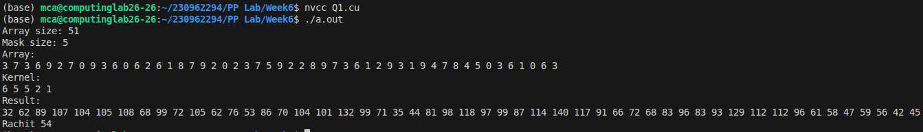
II. Write a program in CUDA to perform selection sort in parallel.
#include <stdio.h>
#include <stdlib.h>
#include <cuda.h>

__global__ void selectSort(float *arr, float *res, unsigned int len) {
int i = blockDim.x * blockIdx.x + threadIdx.x;

if(i < len) {
unsigned int rank = 0;
for(unsigned int j = 0; j < len; j++)
if(arr[i] > arr[j] || (arr[i] == arr[j] && j < i))
rank++;

res[rank] = arr[i];
}
}

void printArrf(float *arr, unsigned int len) {
for(unsigned int i = 0; i < len; i++)
printf("%.0f ", arr[i]);
printf("\n");
}

int main() {
float *arr;
float *dArr, *dRes;
int n;

printf("Array size: ");
scanf("%d", &n);
size_t len = sizeof(float) * n;

arr = (float *) malloc(len);
for(int i = 0; i < n; i++)
arr[i] = rand() % 100;

printf("Unsorted:\n");
printArrf(arr, n);

cudaMalloc((void **) &dArr, len);
cudaMalloc((void **) &dRes, len);

cudaMemcpy(dArr, arr, len, cudaMemcpyHostToDevice);

selectSort<<<(len - 1) / 256 + 1, 256>>>(dArr, dRes, n);
cudaMemcpy(arr, dRes, len, cudaMemcpyDeviceToHost);

printf("Sorted:\n");
printArrf(arr, n);

cudaFree(dArr);
cudaFree(dRes);

printf("Rachit 54\n");
return 0;
}

Output
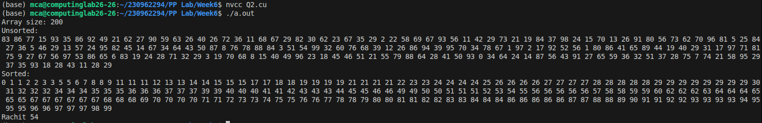

III. Write a program in CUDA to perform odd even transposition sort in parallel.
#include <stdio.h>
#include <stdlib.h>
#include <cuda.h>

__global__ void oddEvenSort(float *arr, unsigned int len, bool isOdd) {
int i = blockDim.x * blockIdx.x + threadIdx.x;

if(i < len && i % 2 == isOdd) {
float temp;
if(arr[i] > arr[i + 1]) {
temp = arr[i];
arr[i] = arr[i + 1];
arr[i + 1] = temp;
}
}
}

void printArrf(float *arr, unsigned int len) {
for(unsigned int i = 0; i < len; i++)
printf("%.0f ", arr[i]);
printf("\n");
}

int main() {
float *arr;
float *dArr;
int n;

printf("Array size: ");
scanf("%d", &n);
size_t len = sizeof(float) * n;

arr = (float *) malloc(len);
for(int i = 0; i < n; i++)
arr[i] = rand() % 100;

printf("Unsorted:\n");
printArrf(arr, n);

cudaMalloc((void **) &dArr, len);
cudaMemcpy(dArr, arr, len, cudaMemcpyHostToDevice);

for(int i = 0; i < n; i++) {
oddEvenSort<<<(len - 1) / 256 + 1, 256>>>(dArr, n, i % 2);
cudaDeviceSynchronize();
}
cudaMemcpy(arr, dArr, len, cudaMemcpyDeviceToHost);

printf("Sorted:\n");
printArrf(arr, n);

cudaFree(dArr);

printf("Rachit 54\n");
return 0;
}

Output
