PPL Week-1
Rachit Takate – 230962294 – B54
I. Write a simple MPI program to find out pow (x, rank) for all the processes where ‘x’ is the integer constant and ‘rank’ is the rank of the process. Write a program in MPI where even ranked processes print “Hello” and odd ranked processes print “World”.
#include <stdio.h>
#include <mpi.h>

int powi(int x, int y) {
int res = 1;
for(int i = 0; i < y; i++)
res *= x;

return res;
}

int main(int argc, char* argv[]) {
int rank, size;
MPI_Init(&argc, &argv);

MPI_Comm_rank(MPI_COMM_WORLD, &rank);
MPI_Comm_size(MPI_COMM_WORLD, &size);

printf("Val of P%d: %d\n", rank, powi(size, rank));

if(rank % 2)
printf("World\n");
else
printf("Hello\n");

if(rank == 0)
printf("Rachit 230962294\n");
MPI_Finalize();
return 0;
}

Output
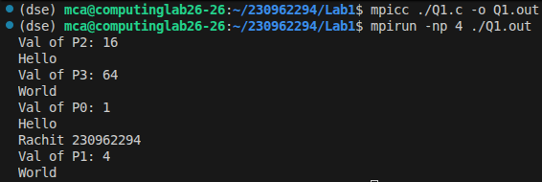

II. Write a program in MPI to simulate a simple calculator. Perform each operation using different processes in parallel.
#include <stdio.h>
#include <mpi.h>

int main(int argc, char* argv[]) {
int a = 6, b = 3, res;
int rank;
MPI_Init(&argc, &argv);

MPI_Comm_rank(MPI_COMM_WORLD, &rank);

switch (rank) {
case 0:
res = a + b;
break;
case 1:
res = a - b;
break;
case 2:
res = a * b;
break;
case 3:
res = a / b;
break;
}

printf("P%d: %d\n", rank, res);
if(rank == 0)
printf("Rachit 230962294\n");
MPI_Finalize();
return 0;
}

Output
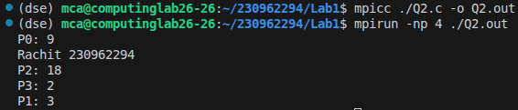

III. Write a program in MPI to toggle the character of a given string indexed by the rank of the process.
#include <stdio.h>
#include <mpi.h>

char inp[] = "HELLO";

int main(int argc, char* argv[]) {
int rank;
MPI_Init(&argc, &argv);

MPI_Comm_rank(MPI_COMM_WORLD, &rank);

if(inp[rank] > 96)
inp[rank] -= 32;
else
inp[rank] += 32;

printf("%s\n", inp);
if(rank == 0)
printf("Rachit 230962294\n");
MPI_Finalize();
return 0;
}

Output
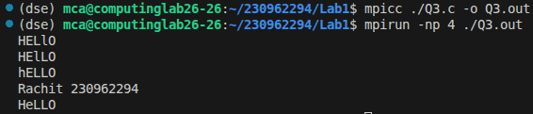

IV. Write a program in MPI where even ranked processes print the factorial of the rank and odd ranked processes print the Fibonacci number of the rank.
#include <stdio.h>
#include <mpi.h>

int main(int argc, char* argv[]) {
int rank, res = 1;
MPI_Init(&argc, &argv);

MPI_Comm_rank(MPI_COMM_WORLD, &rank);

if(rank % 2) {
if(rank < 3)
res = rank;
else {
int a = 0, b = 1;

for(int i = 2; i <= rank; i++) {
res = a + b;
a = b;
b = res;
}
}
}
else {
for(int i = 2; i <= rank; i++)
res *= i;
}

printf("P%d: %d\n", rank, res);

if(rank == 0)
printf("Rachit 230962294\n");
MPI_Finalize();
return 0;
}

Output
