Firewall Configuration

Overview
This section documents the configuration of the Fortinet firewall within the cyber range environment. The firewall was configured to manage network traffic, enforce security policies, and control access between internal and external systems.

Allowing Outbound Traffic
The firewall was configured to allow internal systems to communicate with external networks.
- Configured policies to allow outbound traffic
- Verified connectivity by successfully pinging external devices from within the firewall
Configuring the firewall to allow pings through to internal:
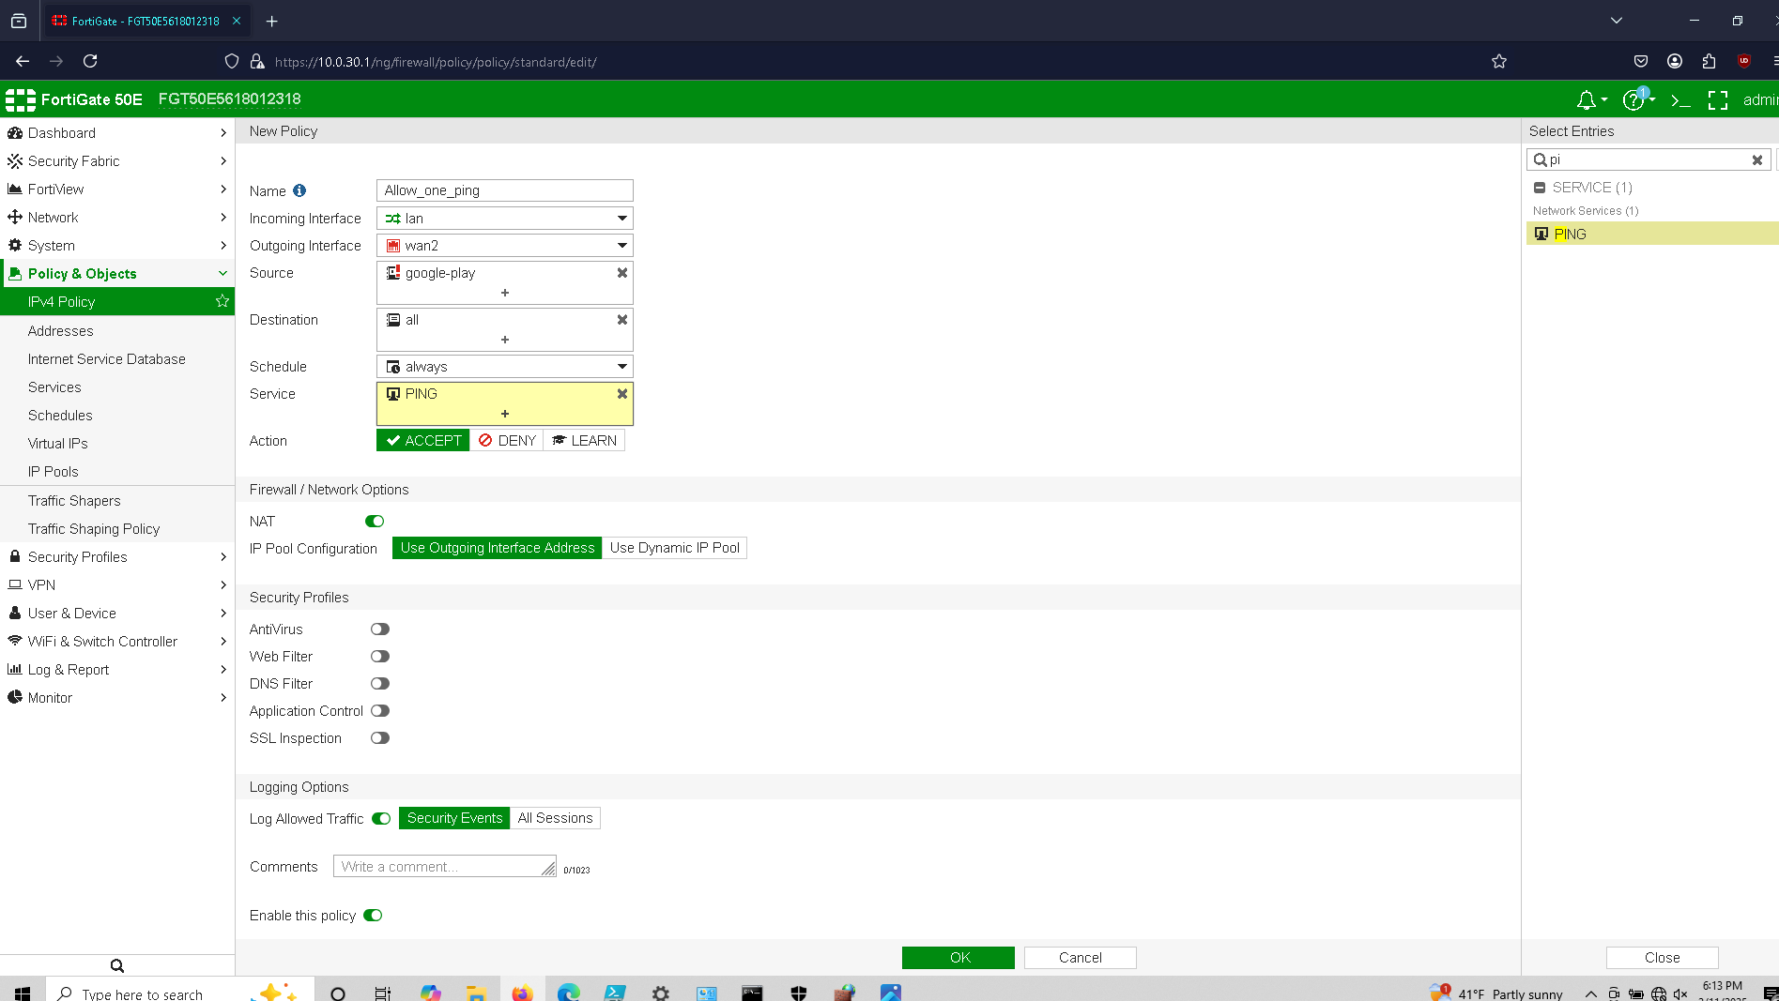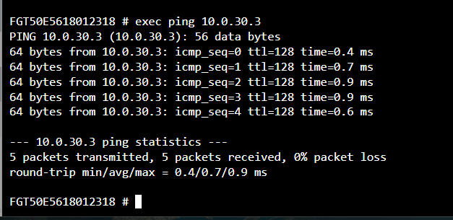

Pinging from inside the firewall to outside devices:
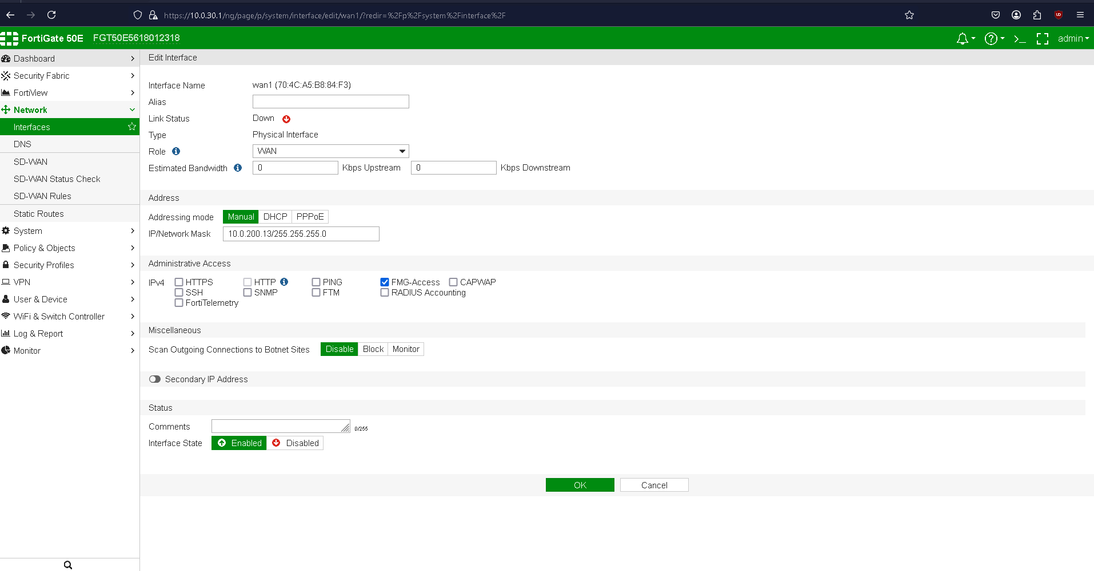
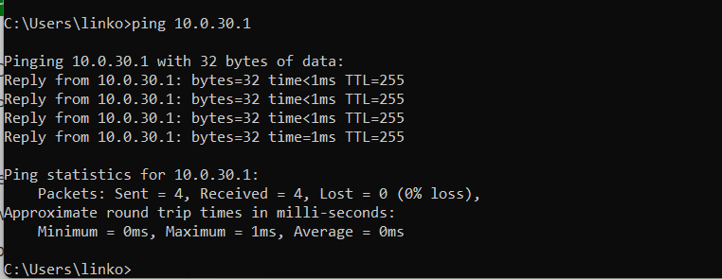

Restricting Access to the Firewall
Security measures were implemented to reduce exposure:
- Disabled ping responses on the firewall
- Prevented external systems from directly interacting with the firewall
This helps reduce the attack surface and limits unnecessary visibility of the device.
Preventing unauthorized IPs from pinging firewall:
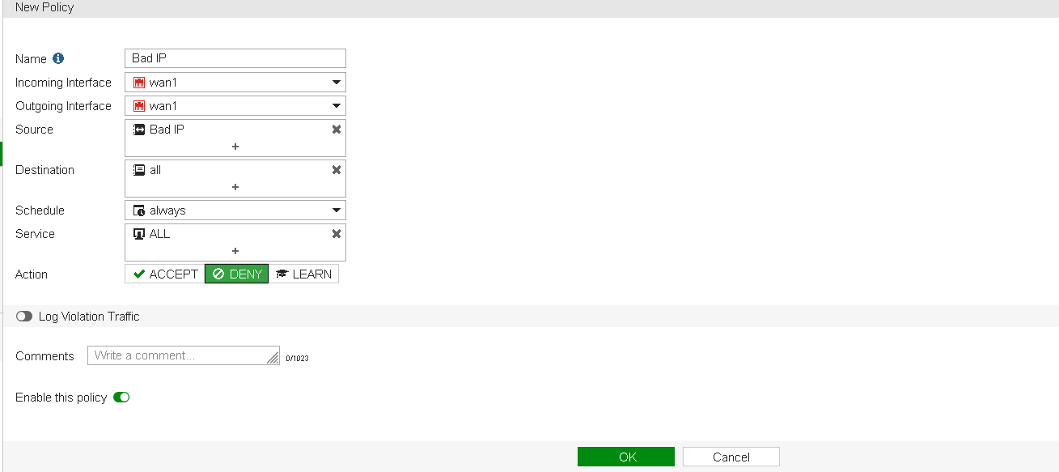

Virtual IP (VIP) Configuration
Virtual IPs were created to allow controlled access to internal services:
- Configured port forwarding from external to internal systems
- Enabled access to services such as FTP and SSH
- Grouped VIPs for easier management
Making Virtual IPs:
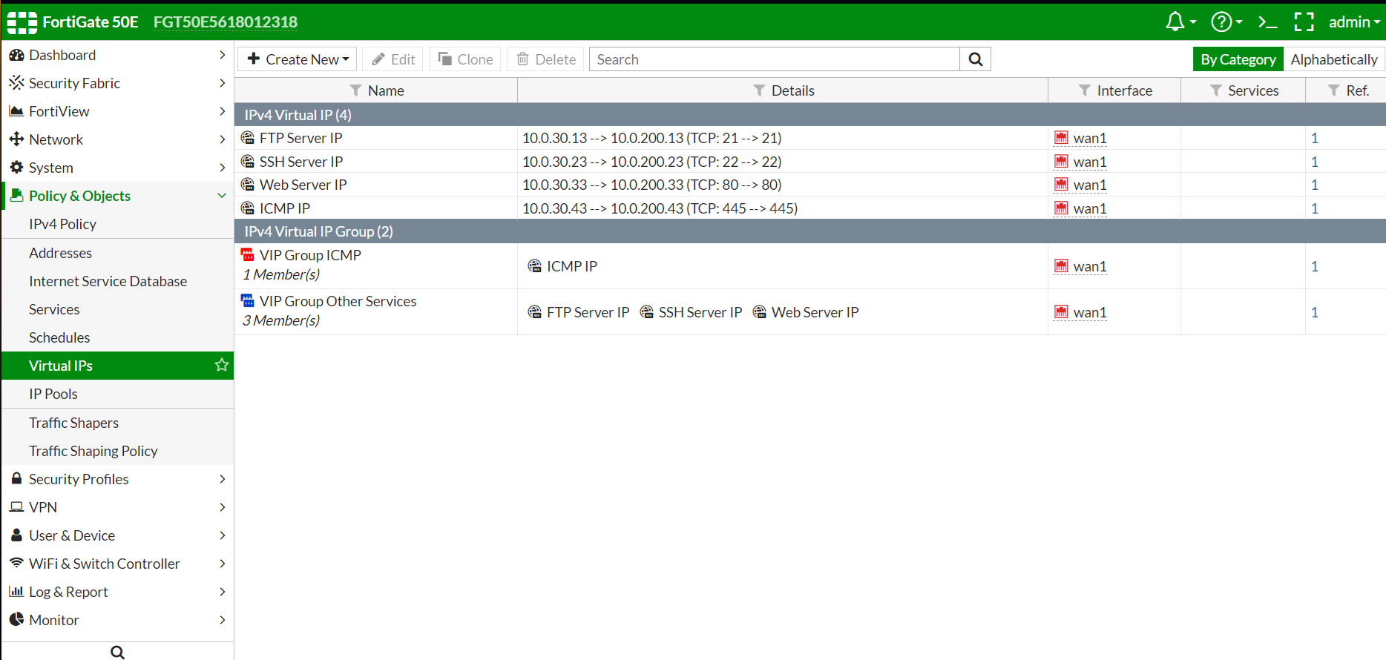
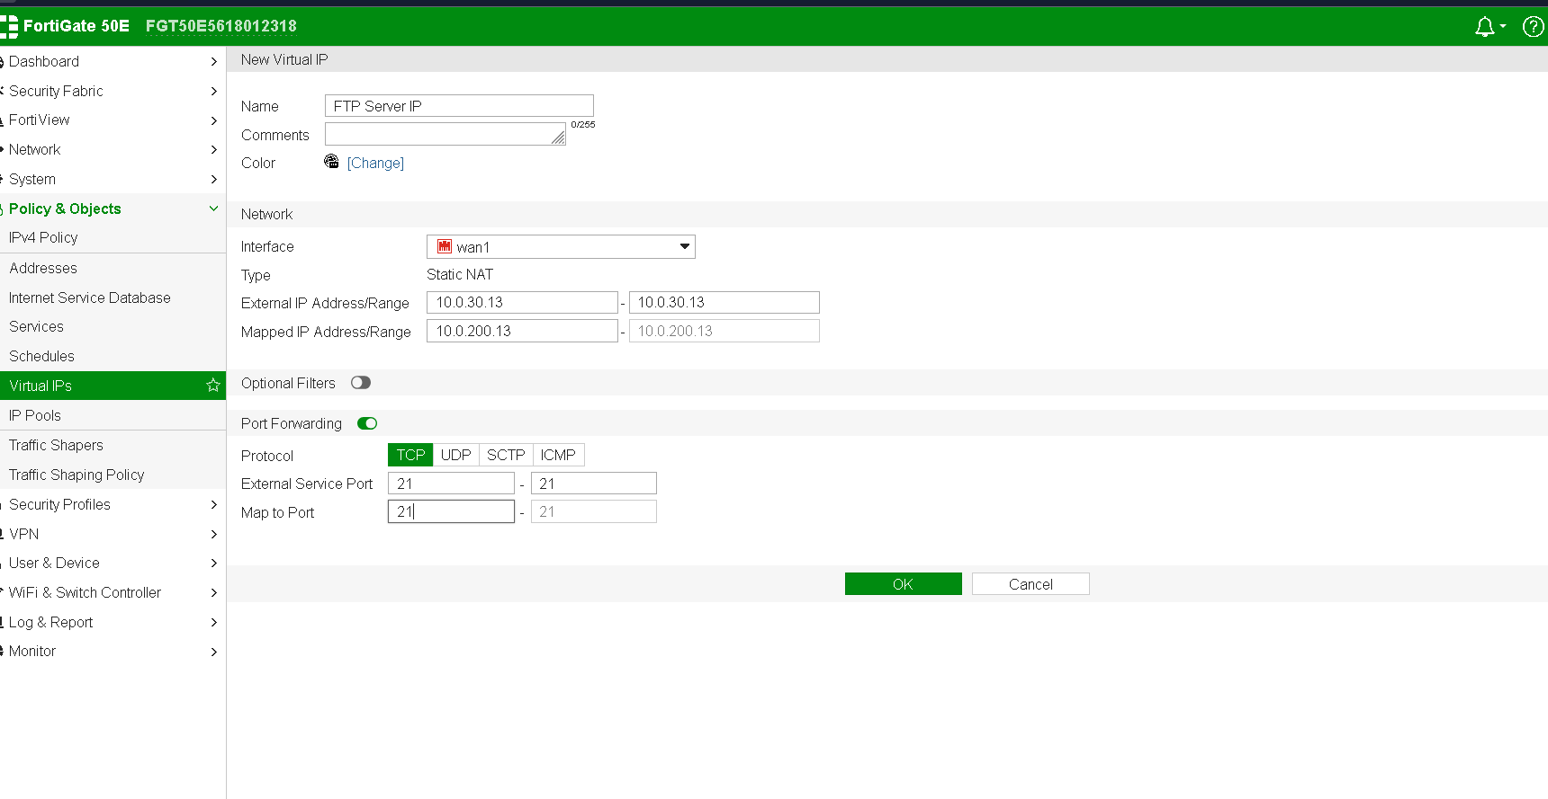
Outcome
The firewall was successfully configured to:
- Allow controlled outbound communication
- Restrict direct access to the firewall
- Block unwanted traffic
- Provide secure access to internal services through VIPs
Firewall complete:
