BIT703A2
Task 2.
b) JavaScript was used to add interactive e-commerce functionality to the Aotearoa Adventure Gear website. The implementation uses separate JavaScript files so that the functionality is organised according to the page where it is required. For example, home.js controls the floating anchor, cart.js calculates shopping-cart totals, and shipping.js determines whether an order qualifies for free shipping.
Bootstrap is used as the user-interface framework. Its carousel component supports the featured products on the home page, and its responsive components help maintain a consistent layout across different screen sizes. Custom JavaScript extends this functionality where the standard HTML elements are not sufficient.
HTML5 validation is used where possible, including required, type="email", type="number", min, max, and pattern. However, HTML5 alone cannot perform all the required e-commerce calculations. JavaScript is therefore used to calculate totals, respond immediately when quantities change, transfer the cart subtotal between checkout pages using local Storage, and automatically apply free standard shipping when the order subtotal exceeds $600.
This combination provides browser-based validation, responsive presentation and interactive behaviour while keeping the website able to run directly in a browser without requiring a web server.

Task 3.
- The Aotearoa Adventure Gear website uses both HTML5 and JavaScript validation to improve the accuracy of information entered during the shopping and checkout process. HTML5 validation is used as the first level because it provides built-in browser validation without requiring unnecessary custom code. Required fields use the required attribute, email addresses use type="email", quantities use type="number" with min, max and step, and the New Zealand postcode field uses a four-digit pattern.
JavaScript provides additional validation where HTML5 alone cannot fully enforce the website's business rules. For example, shopping-cart quantities are checked before calculating totals, preventing zero, negative or non-numeric quantities from affecting the order. Product prices are also checked to ensure that invalid or negative monetary values are not included in calculations. On the payment page, JavaScript compares the selected card expiry month with the current date so that a past expiry date cannot be accepted.
Bootstrap validation styling is used to provide clear visual feedback when required information is missing or incorrectly formatted. This makes validation messages easier for customers to identify and correct.
The website also uses JavaScript to maintain valid e-commerce calculations between the cart, shipping and payment pages. The cart subtotal is stored using localStorage, while shipping and final order totals are recalculated from validated numeric values. This combination of HTML5 constraints, JavaScript business-rule validation and Bootstrap feedback provides a more reliable and user-friendly checkout prototype.

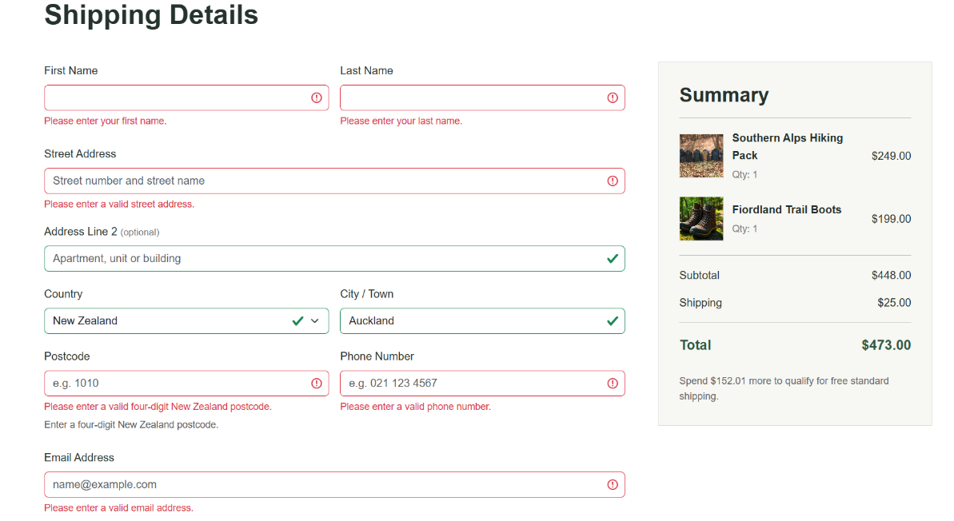

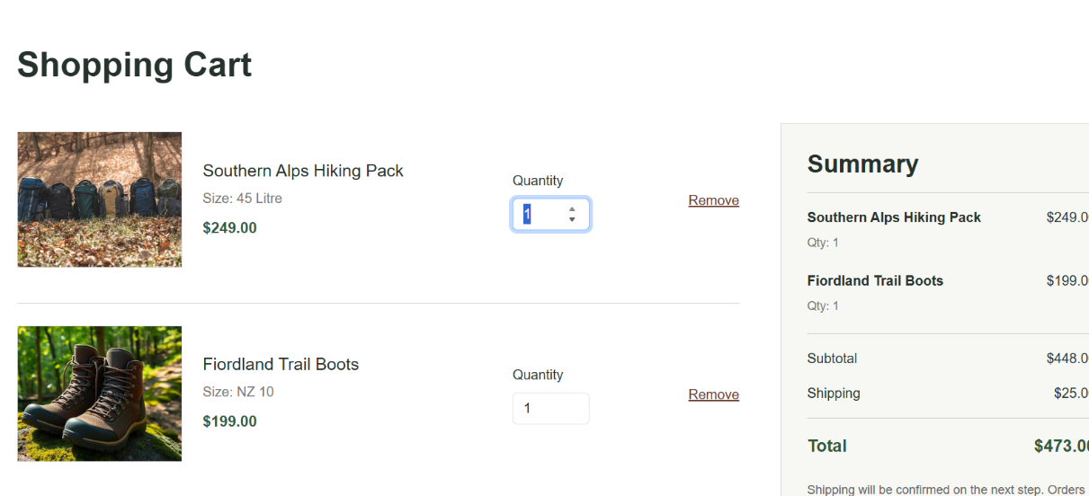

Quantity validation: The quantity input has a minimum permitted value of 1. HTML5 validation and JavaScript prevent zero or negative quantities from being used in the shopping-cart calculation.

REPOSITORY URL: https://github.com/Blues12580/BIT703-A2-Aotearoa-Adventure-Gear.git

