

Purchase Order Module — Functional Specification
This specification describes the Purchase Order (PO) module of the Procure-to-Pay system for Release R3. It is the source of record for PO creation, approval routing and downstream posting.

1. Introduction

1.1 Purpose
The PO module allows a requisitioner to raise a purchase order against an approved supplier, route it for approval according to value thresholds, and transmit the approved order to the supplier. It replaces the spreadsheet-based ordering process used in Release R2 and earlier.

1.2 Document Control
Owner: Procurement Systems. Reviewed quarterly.



2. Process Overview
A purchase order moves through five states. A requisitioner creates the order in Draft. Submitting it runs a budget check; if the budget check passes the order moves to Pending Approval, and if it fails the order returns to Draft with a validation message. An approver either approves the order, moving it to Approved, or rejects it, returning it to Draft with mandatory rejection comments. An Approved order is transmitted to the supplier overnight and moves to Issued. An order may be cancelled from any state before Issued.
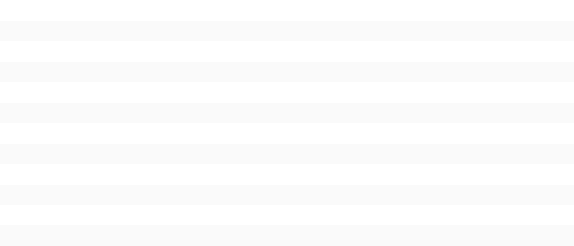
Figure 1: End-to-end purchase order process flow.

3. Roles and Responsibilities
Three roles operate the module. Role assignment is managed in the identity system and is not maintained within the PO module itself.
Role | Can do | Cannot do
PO Creator | Create, edit and submit a draft order; cancel own draft | Approve any order, including own
PO Approver | Approve or reject orders within their threshold; add comments | Edit the line items of an order under approval
Procurement Admin | Maintain supplier records; reopen an Issued order | Change approval thresholds



4. Purchase Order Creation

4.1 Create Purchase Order screen
The Create Purchase Order screen is reached from Procurement > Orders > New. The header captures supplier, delivery date and cost centre; the lines grid captures one row per item ordered. The order total is calculated from the lines and cannot be typed directly.

Figure 2: The Create Purchase Order screen, header and lines grid.

4.2 Field rules
The following rules apply to the header fields.
Field | Mandatory | Rule
Supplier | Yes | Must be an active supplier; blocked suppliers are not selectable
Delivery Date | Yes | Must be today or later; back-dating is rejected
Cost Centre | Yes | Defaults from the requisitioner's profile; may be overridden
Internal Reference | No | Free text, 30 characters
Order Total | No | Calculated from the lines; read-only

4.3 Business rules
A purchase order must contain at least one line before it can be submitted. A line quantity must be greater than zero. The system runs a budget check on submission, not on save, so a draft may be saved that would fail the budget check. An order that fails the budget check returns to Draft and the requisitioner is shown the shortfall amount.



5. Purchase Order Approval

5.1 Approval thresholds
Approval routing is determined by the order total. Where an order exceeds the approver's threshold it routes to the next level; it is never split.
Order total | Approver level | Service level
Up to 5,000 | Line Manager | 2 working days
5,001 to 50,000 | Department Head | 3 working days
Above 50,000 | Finance Director | 5 working days

5.2 Approve Purchase Order screen
The approver opens the order from their approval queue. The screen shows the order header, the lines, and the budget check result. Approve and Reject are both available; Reject requires a comment of at least ten characters.
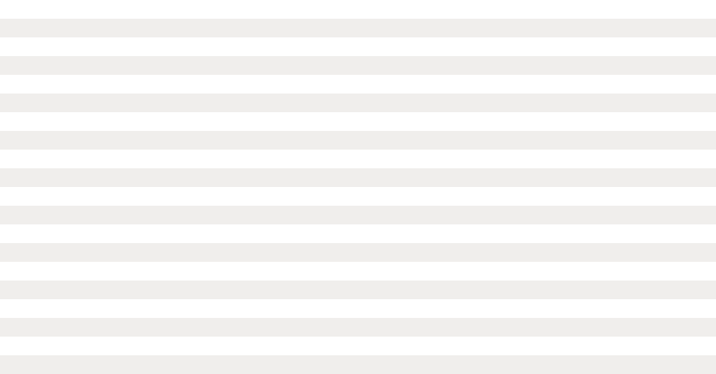
Figure 3: The Approve Purchase Order screen with the approval queue.

5.3 Exceptions and error handling
If an approver is absent, an order remains in their queue until reassigned by a Procurement Admin; there is no automatic escalation in Release R3. If the supplier is blocked after the order was created but before approval, approval is refused with the message 'Supplier is blocked'. If transmission to the supplier fails, the order stays in Approved and appears on the overnight exception report.

6. Integrations
On reaching Issued, the order is posted to the finance ledger as a commitment. Goods receipt is recorded in the warehouse system and matched back to the order line. A cancelled order releases its commitment on the next ledger run.

7. Revision History
Version | Date | Change
1.0 | 2026-02-11 | Initial issue
1.1 | 2026-05-03 | Approval thresholds updated for R3

