**CSCE 606 TAMU Software Engineering**

**Team Island Rush V3**

**Team Roles:**

Product Owner: Spencer Adolph

Scrum Master: Minhwan Oh

Developer: Barret Pickett, David Huarng, Jonathan Weishuhn, Bozhao Zhang, Shipeng Yang

**Customer Meeting date/time/place:**

First meeting was a group-phone call. (They are in Colorado)

Call took place 10/18/2019 @ 1pm

Next call scheduled for 2 weeks from now.

**Summary:**

Our main customer represents the Military and Strategic Studies department in the Air Force Academy. They are primarily focused on developing their core class (MSS 251) which currently utilizes Island Rush Version 2. The customer had Version 3 created in the beginning of 2019, and we are continuing that development. Included with what we were given is documentation on the expected final product, as well as an already started codebase.

The stakeholders (faculty members teaching MSS 251), have advised us that at the end of our development we will be handing off the project to a new team of contractors. Until then, they have indicated which features (from the documentation) they would like us to focus on developing. Beyond these features, we are to continue to fix the current codebase and make it better.

Github: <https://github.com/island-rush/K3>

Pivotal: <https://www.pivotaltracker.com/n/projects/2400557>

Wiki : <https://github.com/island-rush/K3/wiki>

Video: (N/A -> Customer is remote)

**User Stories & Status:**

|  |  |  |  |  |
| --- | --- | --- | --- | --- |
| **No** | **Feature** | **Description** | **Status** | **Owner** |
| 1 | Create new sections for unit classification | Currently, there is only one section which include every unit. We'd like to seperate 3 sections such as air, land, ocean section. | Done | Minhwan  Bozhao  Shipeng |
| 2 | Refuel Air Pieces | Feature: Refuel Air Pieces As an Air Commander Player So that I can best understand refueling and utilizing game resources / strategy I want to transfer fuel from tanker pieces to other aircraft pieces | Done | Spencer |
| 3 | Minimize popups to view board | minimize popups (battle, refuel, containers*) to the left side of the board to a tab underneath the other menus. This enables a person to see the board where the event is taking place, and this event should highlight the position. | Done | Spencer  Barret |
| 4 | Add a game | Feature: Add a game As a Course Director So that my faculty members have their own games to play I want to add a game to the Island Rush Database | Done | Spencer |
| 5 | Put the documentation values into the constant files | See google docs | Done | Spencer  Jonathan |
| 6 | Modify Course Director Page | Current course director page has lots of information, but text size is big. Need to resize for UI. | Done | Minhwan |
| 7 | Changing passwords / setting team passwords | CourseDirector should have ability to change passwords for a game (adminpass, and each team pass) | Done | Minhwan |
| 8 | Images for capabilities and dice combinations |  | Done | Barret  Bozhao |
| 9 | News Alerts | Feature: News Alerts As a teacher So that I control which team has an advantage in the game I want to add & modify news alerts that negatively or positively affect gameplay | Done | Spencer |
| 10 | Fuel and Movement Rules | Constraints on how pieces move based on how many moves they have left, how much fuel they have left (handling when fuel reaches 0)  Also preventing plans that exceed moves | Done | Jonathan  David |
| 11 | Inventory split into controller sections | sections (for pieces) into air, land, sea, special | Done | Shipeng |
| 12 | minimize functionality to other popups | Add Minimize Toggle functionality to the other popups (and anything else that needs to be minimized)... | Done | Spencer  Barret |
| 13 | Capabilities (Warfare Options) | Non-piece purchaseables (effects on gameplay)  Satellite scans, cyber attacks, ....etc | Done | Spencer |
| 14 | Rods from God (capability) | rods from god capability from the documentation | Done | Spencer |
| 15 | Remote Sensing (capaiblity) | remote sensing capability (see documentation). Reveals enemy pieces in a selected area. | Done | Spencer |
| 16 | Insurgency (capability) | lever social media propaganda has caused an uprising in a single hex region. In the violence, the enemy team has a 1/3 chance of losing each unit in selected hex in an attempt to maintain control of that hex.  Cost: 20  Duration: Instant | Done | Spencer |
| 17 | Biological Weapons (capability) | Concentrated bio/chemical weapon that will destroy all units in selected hex (does not include aircraft (that are taken off)). Note tile remains toxic for duration of effect, any ground units that enter hex within duration will be immediately destroyed regardless of team. Note: Humanitarian assistance is restricted for the duration of this effect.  Cost: 25  Duration: 3 full turns (9 rounds) | Done | Spencer |
| 18 | Raise Morale (capability) | COCOM selects a functional commander to invest money into that component’s deployment MWR programs. Each unit in that component will receive +1 moves for that turn. It can be used as soon as it’s give from the COCOM.  Cost: 50  Duration: 1 Full turn (3 rounds) | Done | Spencer |
| 19 | Communications Interruption | All transmitted communications within enemy network are rendered useless for the duration of its use. Functional commander is unable to communicate with their troops and as a result troops in a 2 hex radius are unable to move for the duration of the capability.  Cost: 30  Duration: 1 Full Turn (3 rounds) | Done | Spencer |
| 20 | Island Capturing (and getting points from islands) | When ground units are on a capture point, and they are the only team there, they 'capture' the island and now 'own' it.  Need to keep track of these ownerships. These ownerships translate into giving points. Need to display these ownerships.  Possibly add 'win' condition when enemy captures main island of other team | Done | Shipeng  Spencer |
| 21 | Update login | change buttons into checkboxes for commander status | Done | Bozhao  Spencer |
| 22 | Golden Eye | Satellite based EMP strike that affects all units in a selected area ( radius 2 hex). In selected area: all air units are instantly destroyed and all other units are immobilized for 4 full turns.  Cost: 90  Duration: For aircraft: instant, for all other units: 4 full turns (12 rounds) | Done | Spencer |
| 23 | Piece rules | tanks can't go on water submarines can't go on land | Done | Jonathan  Spencer |
| 24 | Space Area UI for Left Side Bar | V2, there are only ocean and land area. Customer wants to add space area.  This likely ties into Capabilities story, as these space effects come from using those 'items' or 'capabilities' | Done | Minhwan |
| 25 | Remote Sensing Effect Change | Current remote sensing effect is not well visible. Needs to change for user convinience | Done | Minhwan |
| 26 | Commander Type Rules | Each commander has certain abilities, need to restrict who can do what (air commander planning air pieces...etc)  Possibly use more constants for this | Done | Jonathan  Spencer |
| 27 | Updates to all clients / sockets | Currently much of backend only sends update back to the requester, when updates should go to the whole team. Things like purchase and refund. | Done | Spencer |
| 28 | Containers | controls / rules / UI / functions for getting pieces into and out of container pieces (fighter on a carrier, SOF team in a C130, tank on a transport) | Done | Spencer |

**Main Work History**

1. Index page & Admin page

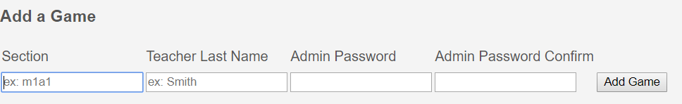

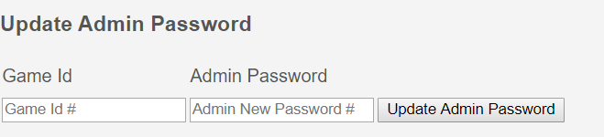 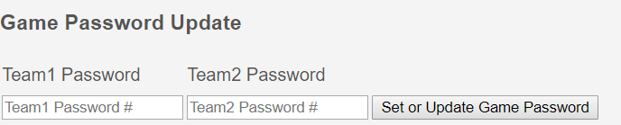

* It can create new game
* Preventing duplicated game
* It can change admin and game’s password

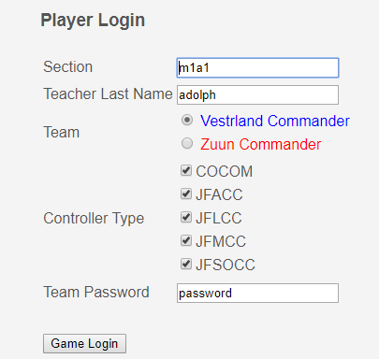

* Change buttons into checkboxes for commander status

1. Create new sections for separating units (Updated)

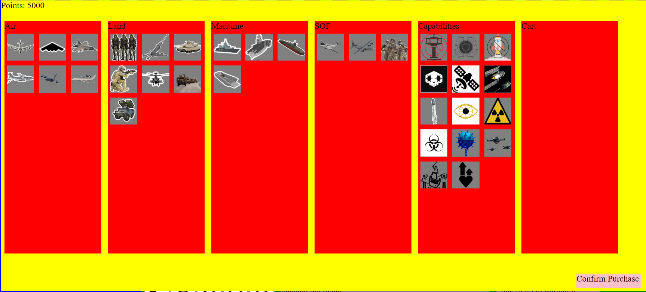

* Previously, units were in one section, so for improving UI, we created new sections, and separate into each section
* Created section for capabilities and special weapon items

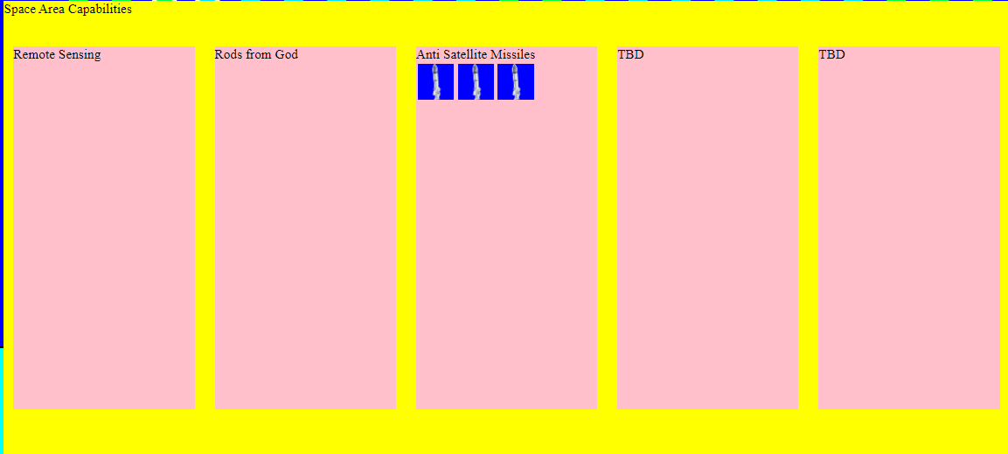

* Created new menu for space area

1. Refuel Air Pieces

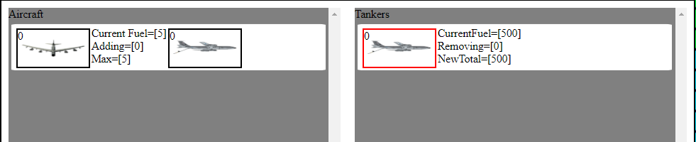

* Now, tanker can refuel air unit’s fuel

1. Minimize popup windows

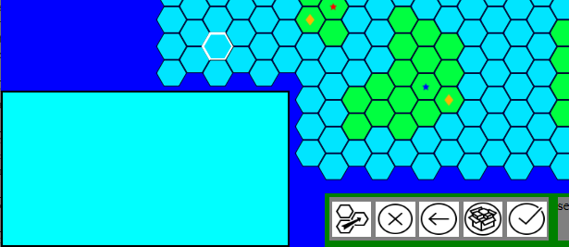

* Previously, popup windows were too big to interfere map. We decided to reduce popup window size optimally

1. News Alerts  
   - As a teacher so that I control which team has an advantage in the game  
   I want to add & modify news alerts that negatively or positively affect gameplay

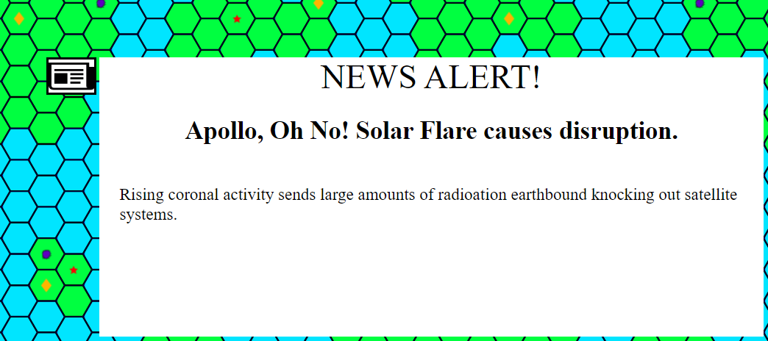

1. Rods from God, Remote Sensing, Biological Weapons, Insurgency (capability)

* Rods from god : The capability from the documentation
* Remote Sensing : The capability from the documentation
* Biological Weapons : The capability from the documentation
* Insurgency : The capability from the documentation
* Golden Eye: The capability from the documentation
* Communication Interruption : The capability from the documentation
* Raise Morale: The capability from the documentation

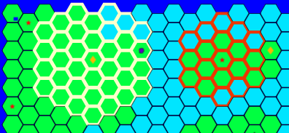

1. Island Rush V3 Wiki

* For future users and developers, we are working on v3 wiki below url
* <https://github.com/island-rush/K3/wiki>

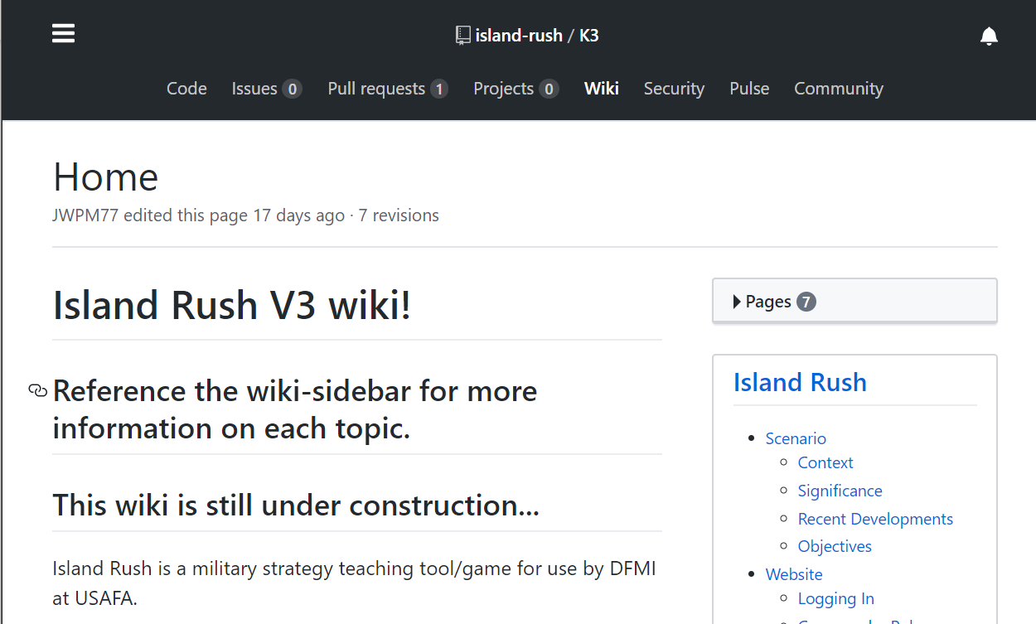

1. Following game rule

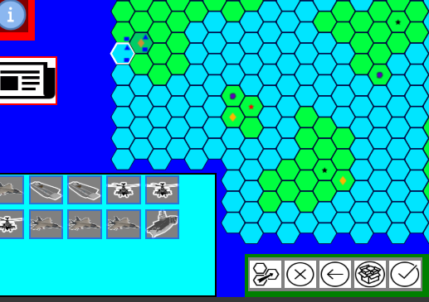

* Ccontrols / rules / UI / functions for getting pieces into and out of container pieces (fighter on a carrier, SOF team in a C130, tank on a transport)
* Each commander has certain abilities, need to restrict who can do what (air commander planning air pieces...etc)
* Tanks can't go on water  
  Submarines can't go on land

**User Interfaces:**

Most, almost all can be taken from Version 2 directly and re-used. Several are already implemented in Version 3’s existing codebase. Therefore there is no need for us to re-create user interfaces.

**Legacy:**

Our project can be considered a legacy project because we are taking in an existing codebase and continuing to develop it. Our overall strategy will begin with becoming familiar with the current codebase, getting it working and understanding which features are already implemented. Next, we will begin to work on the features that were emphasized by the customer. While we do this, we will additionally improve the codebase with better documentation and better organization. Finally we will make it easy to transition our development to the next team.

There is an already existing documentation for the final product we are working on. This contains detailed explanations of each feature, and how they are used by each user. These are where we will get our user stories for this project.