**Color Contrast Classification**

Please tick the checkbox, if the image displays the indicated color contrast.

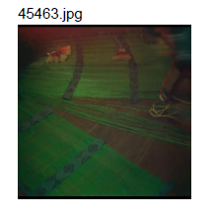

Contrast of saturation:

Contrast of extension:

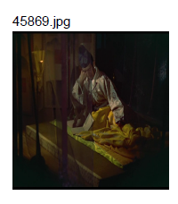

Contrast of saturation:

Contrast of extension:

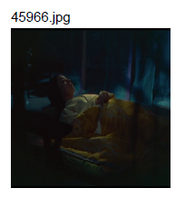

Contrast of saturation:

Contrast of extension:

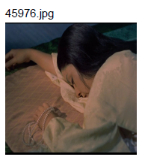

Contrast of saturation:

Contrast of extension:

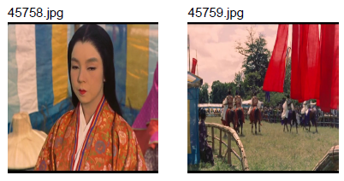

Contrast of saturation:

Contrast of extension:



Contrast of saturation:

Contrast of extension:



Contrast of extension:

Contrast of saturation:

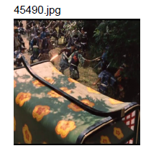

Contrast of extension:

Contrast of saturation:

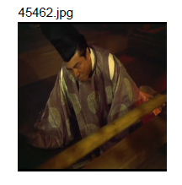

Contrast of extension:

Contrast of saturation:

Note that until now a rule was derived that whenever there is a contrast of extension there must also be a contrast of saturation, the vice versa is not true. Please consider the validity of this statements in your assessment of the above images. Thank you.