**Question 4**: Figure 1 shows the intercity rail transportation network of all stations. The cost of rail transportation is calculated by the following formula: cost = fixed cost ×[1+(actual/rated load)^3]. In this case, it is assumed that the actual shipment is allowed to exceed the rated shipment. The fixed cost and rated loading of all railways are given in Attachment 3. When transporting express, it is required that no more than 5 routes can be used between the cities of each "delivering-receiving" site city pair. Please build a mathematical model to give the lowest cost transportation scheme for the express company. Using the data in Attachments 2 and 3, calculate the company's daily minimum transportation cost from April 23 to 27, 2023, and fill in Table 4.

Note: For the convenience of calculation, the weight and size of the express are not differentiated. It is assumed that the weight of each express is 1 unit. Only transportation costs are considered, and other costs, such as transit costs, are not considered.

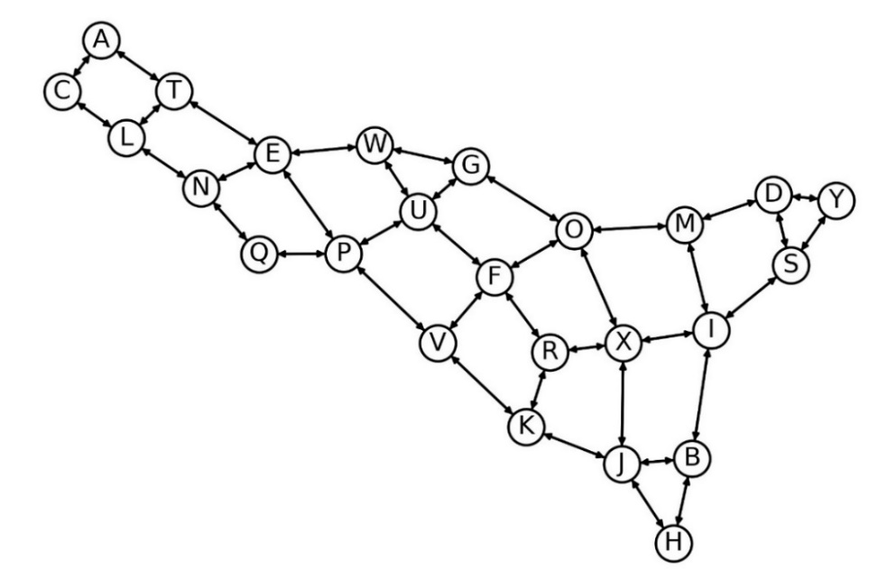

Figure 1 Railway transport network between station cities

Table 4 Results for Question 4

|  |  |
| --- | --- |
| Date | Minimum transport cost |
| April 23, 2023 |  |
| April 24, 2023 |  |
| April 25, 2023 |  |
| April 26, 2023 |  |
| April 27, 2023 |  |