Web SKOS Editor Tutorial

**Table of contents**

What is SKOS 3

Getting Started 5

System requirements 6

Installation 8

Preparing a page 9

Deploying the plugin 13

Using SKOS Editor 16

Setting up user account 19

Creating a new SKOS thesaurus 22

"Create Class Hierarchy" Wizard 26

Editing preferred labels 30

Downloading the edited SKOS thesaurus 33

**What is SKOS**

**Introduction to SKOS**

SKOS is an area of work developing specifications and standards to support the use of knowledge organization systems (KOS) such as thesauri, classification schemes, subject heading systems and taxonomies within the framework of the Semantic Web.

**SKOS & RDF**

SKOS provides a standard way to represent knowledge organization systems using the [Resource Description Framework (RDF)](http://www.w3.org/RDF/). Encoding this information in RDF allows it to be passed between computer applications in an interoperable way.

Using RDF also allows knowledge organization systems to be used in distributed, decentralised metadata applications. Decentralised metadata is becoming a typical scenario, where service providers want to add value to metadata harvested from multiple sources.

**Status & Development**

The [SKOS Specifications](http://www.w3.org/2004/02/skos/specs) are currently published as W3C Recommendations, which means that they are in stable state. See the SKOS Home Page for up-to-date information on SKOS developments.

**Community & Participation**

All SKOS-related development work is now carried out via the [public-esw-thes@w3.org](http://www.w3.org/2004/02/skos/mail) mailing list which is a completely open and publicly archived mailing list devoted to discussion of issues relating to knowledge organization systems, information retrieval and the Semantic Web. A [SKOS community wiki](http://www.w3.org/2001/sw/wiki/SKOS) is also provided as a support for discussing and exchanging datasets, tools, recipes to solve identified issues...

**External Links**

[Wikipedia on SKOS](http://en.wikipedia.org/wiki/SKOS)

*Created with the Personal Edition of HelpNDoc:* [*Easily create CHM Help documents*](http://www.helpndoc.com/feature-tour)

**System requirements**

**Preparing a liferay page**

"SKOS Editor" is a standalone deployable portlet plugin application for Liferay portal. Current plugin run on the most recent stabil Liferay Portal 6.2.0 version.   
Portlet is written according to JSR 286 specification. Plugins backend is done in Java, project is compiled under JDK 1.7 version.  
  
Plugins architectute follows a typical MVC pattern, where (M)odel is using Liferays ServiceBuilder feature to handle the database communication through Hibernate.   
  
The database is MySQL 5.6, plugin tables are automatically created by the ServiceBuilder and are of InnoDB type. Portlet is using the database to save files and file   
versions, as well as user specific settings, and collaboration details and history.  
  
The (V)iew part of MVC pattern is implemented as JSP pages and is actively using JSTL tags. The hierarchy tree is implemented in pure JSP, without any third-party   
libraries. Client-side functionality is supported by the latest jQuery library and custom JavaScript code.  
  
The (C)ontroller part is based on Liferays default GenericPortlet implementation.  
  
The plugin is an SPA (Single Page Application). Once loaded, all the further processing is performed on the same page without any reloads. Server and client   
communication is based on Ajax calls using jQuery library from the client-side and Liferay portlet from the server-side.

*Created with the Personal Edition of HelpNDoc:* [*Free EBook and documentation generator*](http://www.helpndoc.com)

**Preparing a page**

**Preparing a liferay page**

You have a few options for accessing the page creation interface. To simplify this, we’ll cover the Dockbar’s Manage menu slightly out of order. There are two interfaces to be aware of: Site Pages and Page. You can get to these from multiple places. Depending on what you’re editing and where you are on the portal, you’ll use either the Manage menu or the Control Panel to work with your pages. From the Control Panel, make sure you have the correct site selected in the context menu selector and click the Site Pages link in the content section. If you’ve already navigated to the site you wish to manage, click Manage from the Dockbar and select Site Pages. This is the exact same interface you see in the Control Panel. To manage the specific page of the site you’ve navigated to, click Manage and select Page.

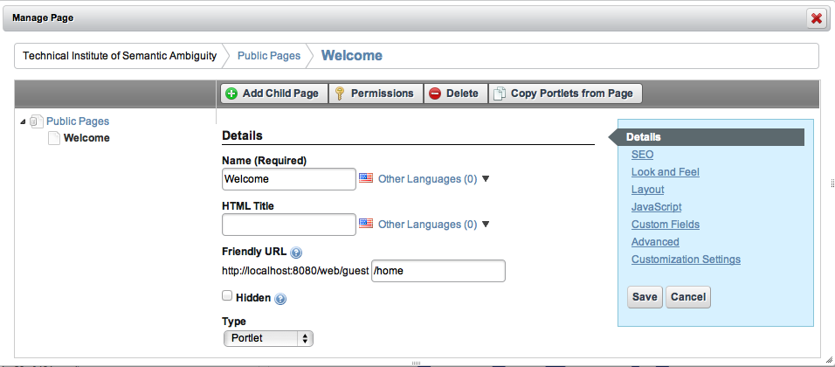

For convenience, you can also navigate to the Sites page under the Portal section of the Control Panel and click Actions → Manage Pages. To quickly add a single page while to the site you’re browsing, click Add from the Dockbar and select Page. Just enter a name for the page and it’s added immediately. Click the name of the page in the navigation menu to visit it and start working on it.

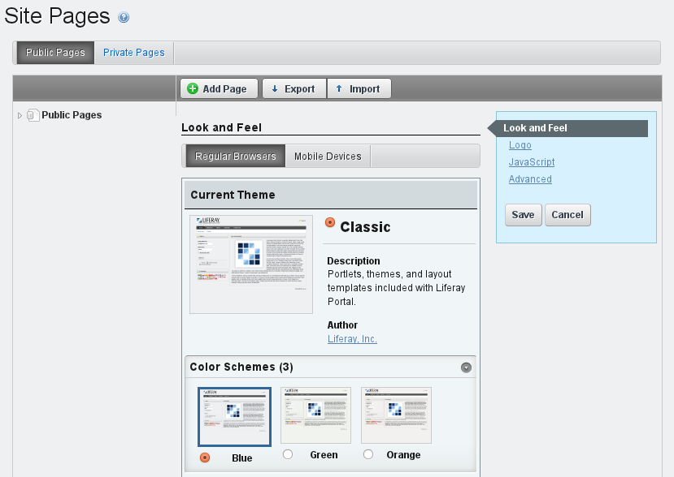

Site Pages is an interface to view existing pages, create new pages, view pages and export or import pages using Liferay Archive (LAR) files. Note that you can switch between managing a set of pages and managing a single page using the left-hand side navigation menu. Click on Public Pages or Private Pages to manage the group or click on an individual page to manage just that one. Switching views like this changes the list of available tabs to the right. By default, liferay.com, which we renamed to nosester.com, contains a single public page called Welcome.

Liferay’s page groups are always associated with sites. Even users’ personal pages are part of their personal sites. All pages belong to one of two types of page sets: public pages and private pages. By default, public pages are accessible to anyone, even non-logged in users (guests). Private pages are accessible only to users who are members of the site which owns the pages. This means the private pages of an organization’s site would only be viewable by site members and members of the organization.

Regardless of whether the pages are public or private, Liferay uses the same interface to manage them.

*Created with the Personal Edition of HelpNDoc:* [*Free PDF documentation generator*](http://www.helpndoc.com)

**Deploying the plugin**

Installing plugins manually is not quite as easy as installing plugins via the Marketplace interface but it’s still quite simple. There are several scenarios in which you would need to install plugins manually rather than from Liferay’s repositories:

Your server is firewalled without access to the Internet. This makes it impossible for your instance of Liferay to connect to the plugin repositories.

You are installing portlets which you have either purchased from a vendor, downloaded separately or developed yourself.

For security reasons, you do not want to allow portal administrators to install plugins from the Internet before they are evaluated.

You can still use the Control Panel to install plugins that are not available from the online repositories. This is by far the easiest way to install plugins.

If your server is firewalled, you will not be able to install plugins directly from the Liferay Marketplace. Instead, you will need to download the .lpkg file (in the case of a Marketplace app) or .war file (in the case of an individual plugin). Then navigate to the Control Panel and click on App Manager under the Apps heading. Then click on Install. This gives you a simple interface for installing an .lpkg or .war file containing an app or plugin to your Liferay Portal. Use the File Upload option to browse to and install from a local .lpkg or .war file. Use the URL option to install from a remote .lpkg or .war file.

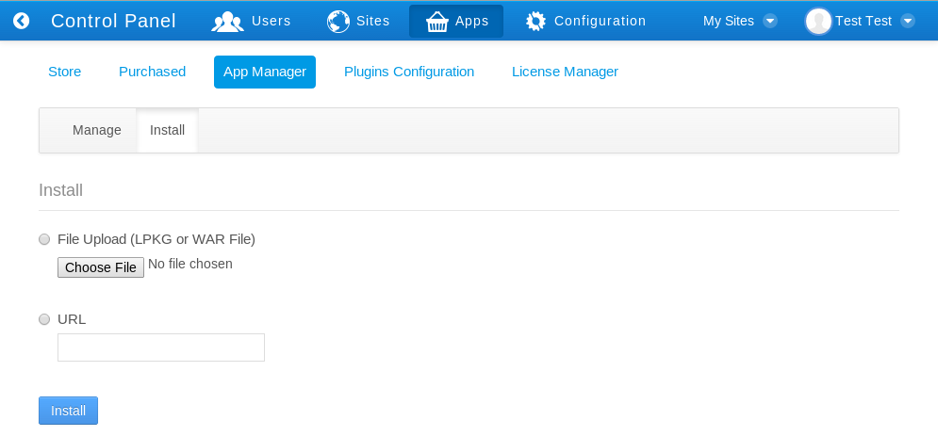

That’s all the information the App Manager needs in order to deploy your portlet, theme, layout template, hook, or web plugin. Click the Install button and your plugin will be uploaded to the server and deployed. If it is a portlet, theme, or layout template you should see it in the appropriate tab of the Plugins Configuration interface.

If you do not wish to use the App Manager to deploy plugins, you can also deploy them at the operating system level. The first time Liferay starts, it creates a hot deploy folder which is, by default, created inside the Liferay Home folder. This folder generally resides one directory up from where your application server is installed, though it may be elsewhere depending on which application server you are running. To find out where the Liferay Home folder is for your application server, please see the section on your server in this guide’s Installation and Setup chapter. The first time Liferay is launched, it creates a folder structure in Liferay Home to house various configuration and administrative data. One of the folders it creates is called deploy. If you copy a portlet or theme plugin into this folder, Liferay hot deploys it and makes it available for use just as though you’d installed it via App Manager in the Control Panel. In fact, this is what the App Manager does behind the scenes.

*Created with the Personal Edition of HelpNDoc:* [*Easy EPub and documentation editor*](http://www.helpndoc.com)

**Using SKOS Editor**

**Introduction**

This brief tutorial is designed to help you get up and running with Web SKOS Editor, a tool designed to support the creation, development, curation, and versioning of small-to-medium sized lexicons using the SKOS (Simple Knowledge Organization System) W3C standard. We will work through some simple examples in order to help you become familiar with the interface. A minimal knowledge of SKOS is probably required to benefit from this tutorial (There are several tutorial introduction to SKOS available).

All examples used in this tutorial are derived from a use case that involves developing a taxonomy of lexical cues designed to support the automatic identification of symptoms associated with depression from short, informal texts.

*Created with the Personal Edition of HelpNDoc:* [*Create iPhone web-based documentation*](http://www.helpndoc.com/feature-tour/iphone-website-generation)

**Setting up user account**

The account set up process is straightforward. Please go to:

<http://blulab2.chpc.utah.edu:8080/web/guest/skos>

And click on the blue “Create Account” button in the middle of the screen

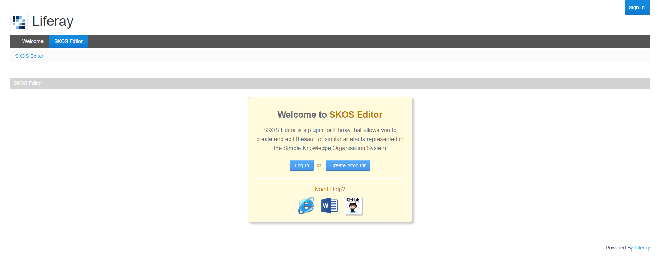

Then fill in your account details. Only the “First Name”, “Email Address”, and “Text Verification” are required.

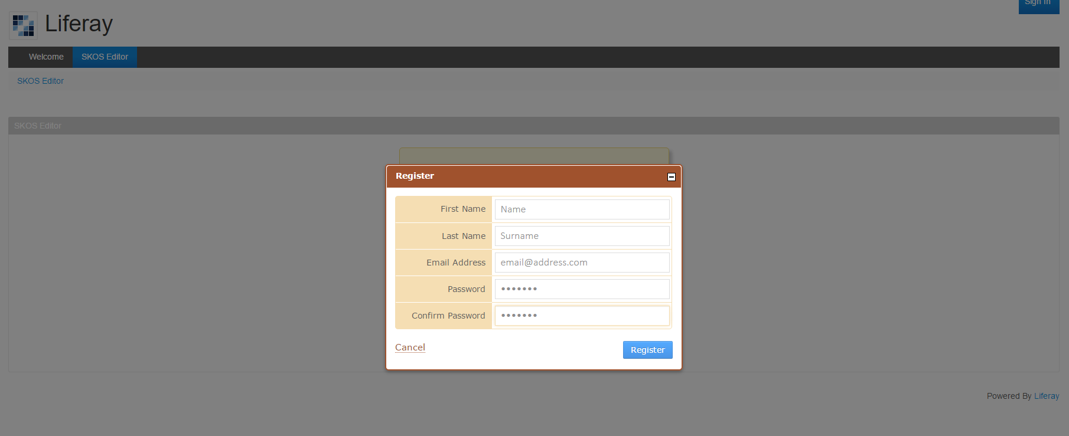

Then enter the email address and password supplied to log in.

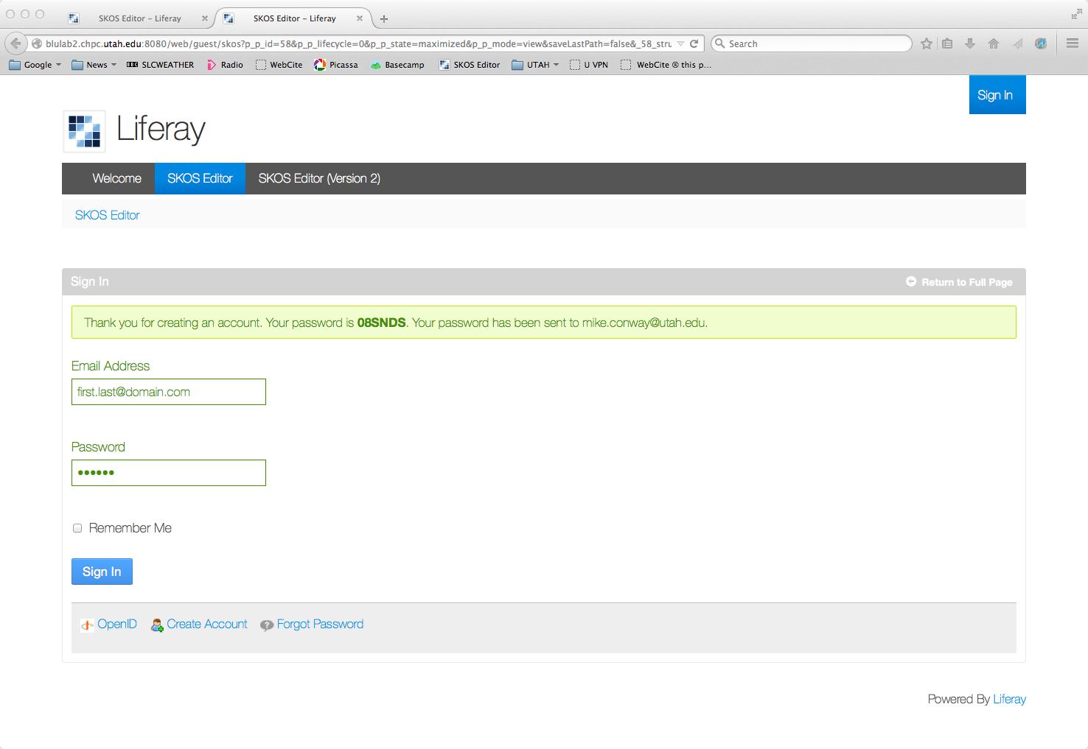

*Created with the Personal Edition of HelpNDoc:* [*Free PDF documentation generator*](http://www.helpndoc.com)

**Creating a new SKOS thesaurus**

**Creating a new SKOS thesaurus**

To create a new SKOS thesaurus, go to “File” ⇒ “Create New” (see figure below).

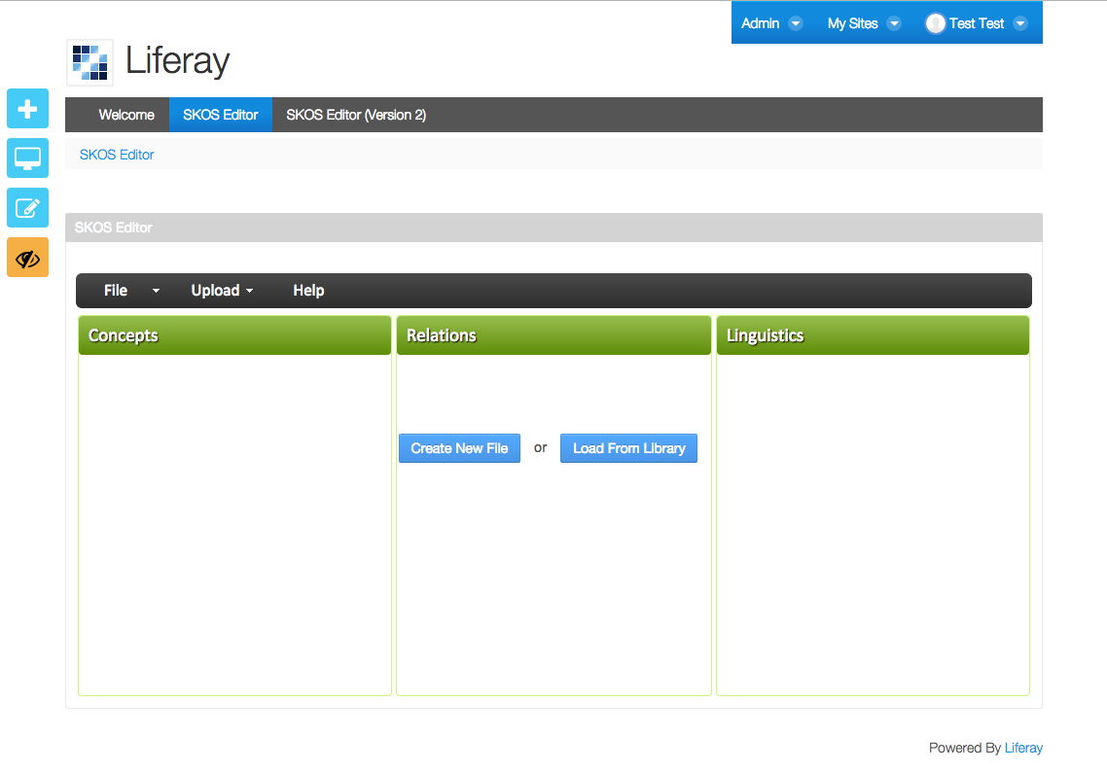

Then you will be presented with a “Create New SKOS Knowledge Base”. The figure below shows how to name and create metadata for the SKOS thesaurus.

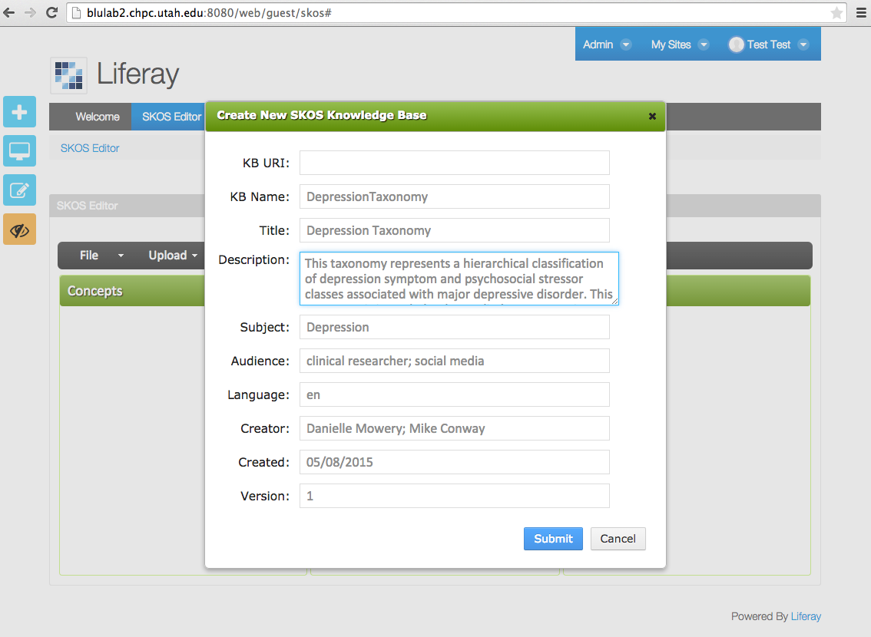

After pressing “Submit”, a new SKOS thesaurus is generated (see Figure below).

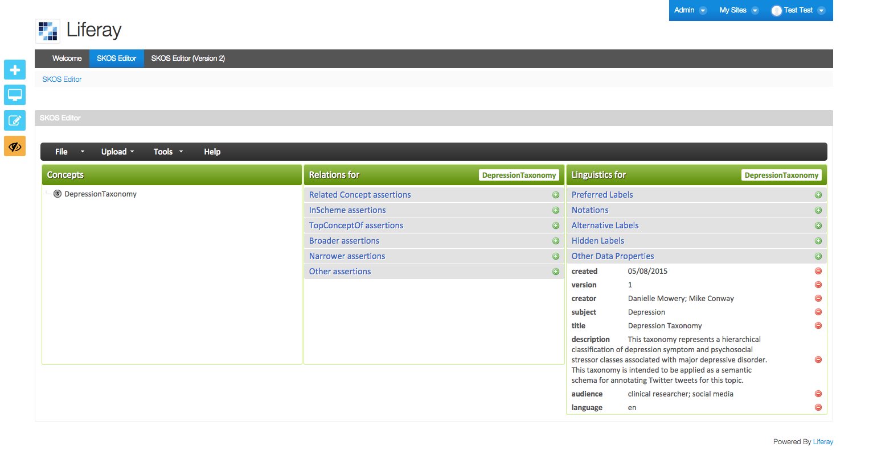

Note that if you do not wish to create a new SKOS file from scratch, an example file can be loaded by selecting “Upload” ⇒ “From URL”, then selecting option “i” from the dialog box.

*Created with the Personal Edition of HelpNDoc:* [*Generate EPub eBooks with ease*](http://www.helpndoc.com/create-epub-ebooks)

**"Create Class Hierarchy" Wizard**

**Populating the thesaurus using the "Create Class Hierarchy" Wizard**

Concepts can be entered using a GUI-based “Create Class Hierarchy” Wizard to support the rapid creation of SKOS concept hierarchies. The Wizard can be accessed via “Tools” ⇒ “Create Class Hierarchy” (see below)

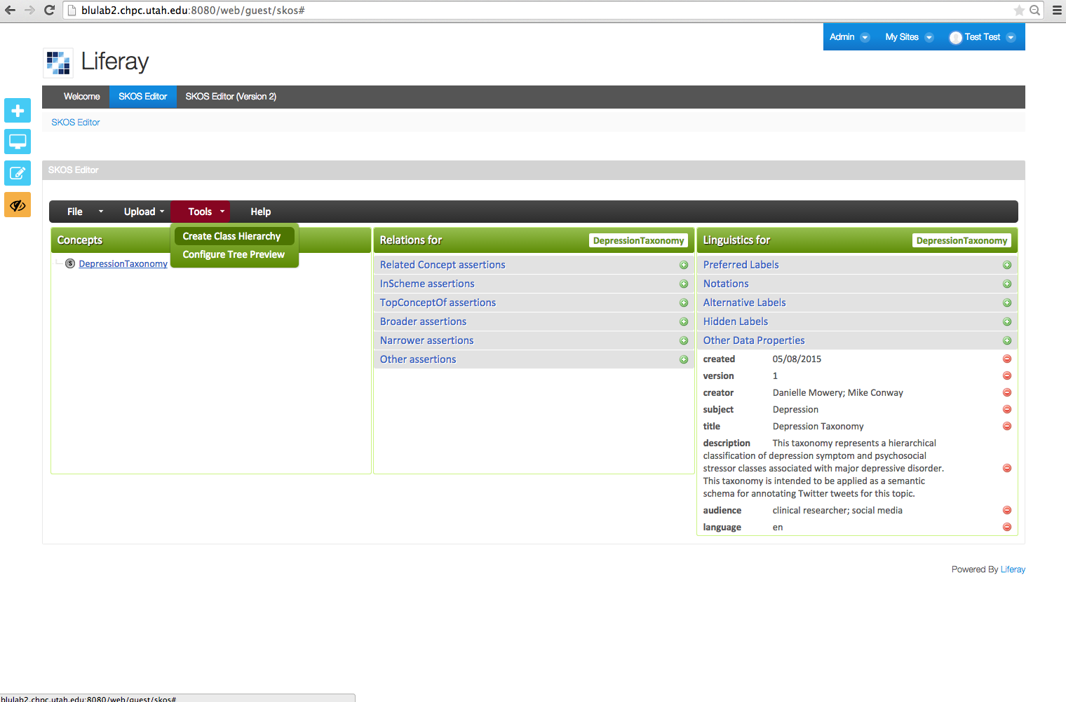

The desired concept hierarchy can be entered using a tab-indented text format (see “Hierarchy” text box below)

## 

*Created with the Personal Edition of HelpNDoc:* [*Full-featured Help generator*](http://www.helpndoc.com/feature-tour)

**Editing preferred labels**

**Editing preferred labels**

Once a concept hierarchy has been developed, it is straightforward to add preferred, alternative, and hidden labels for each concept. SKOS preferred labels can be added by clicking on the + character next to “Preferred Labels” in the Linguistics Panel (rightmost panel). The figure below shows an example preferred label creation dialog box for the “Disturbed_sleep” concept. Note that the language (e.g. “en”, “fr”, “es”, “jp”) can be selected from a drop-down list.

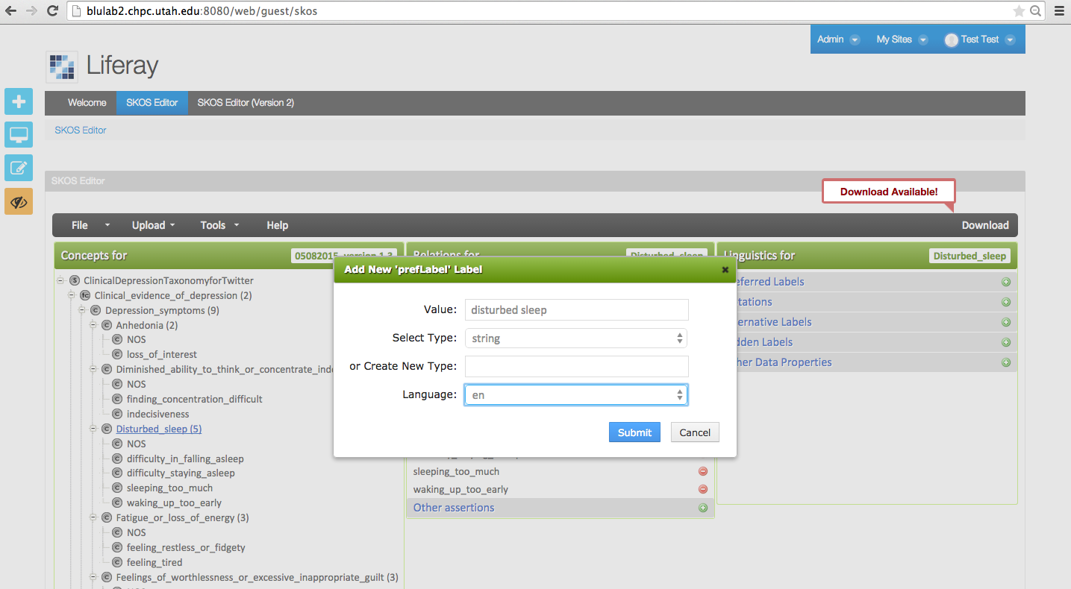

*Created with the Personal Edition of HelpNDoc:* [*Generate Kindle eBooks with ease*](http://www.helpndoc.com/feature-tour/create-ebooks-for-amazon-kindle)

**Downloading the edited SKOS thesaurus**

**Downloading the edited SKOS thesaurus**

The edited thesaurus can be downloaded using the “Download” button (top right corner of the interface – see below).

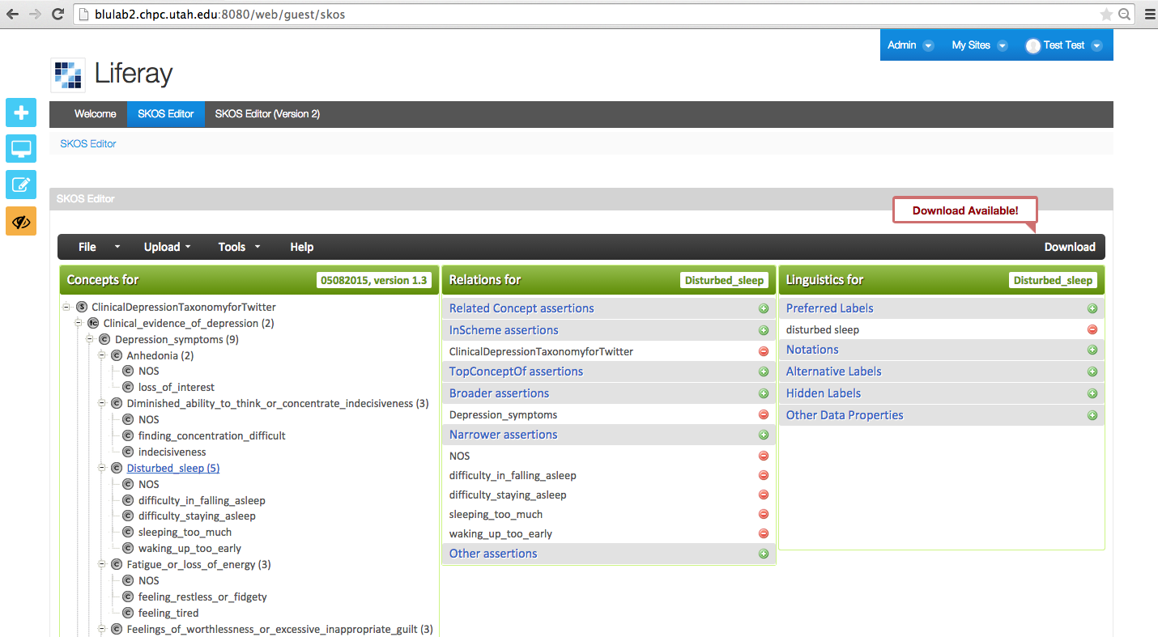

The downloaded OWL/XML is generated using the SKOS and OWL APIs (see screenshot below).

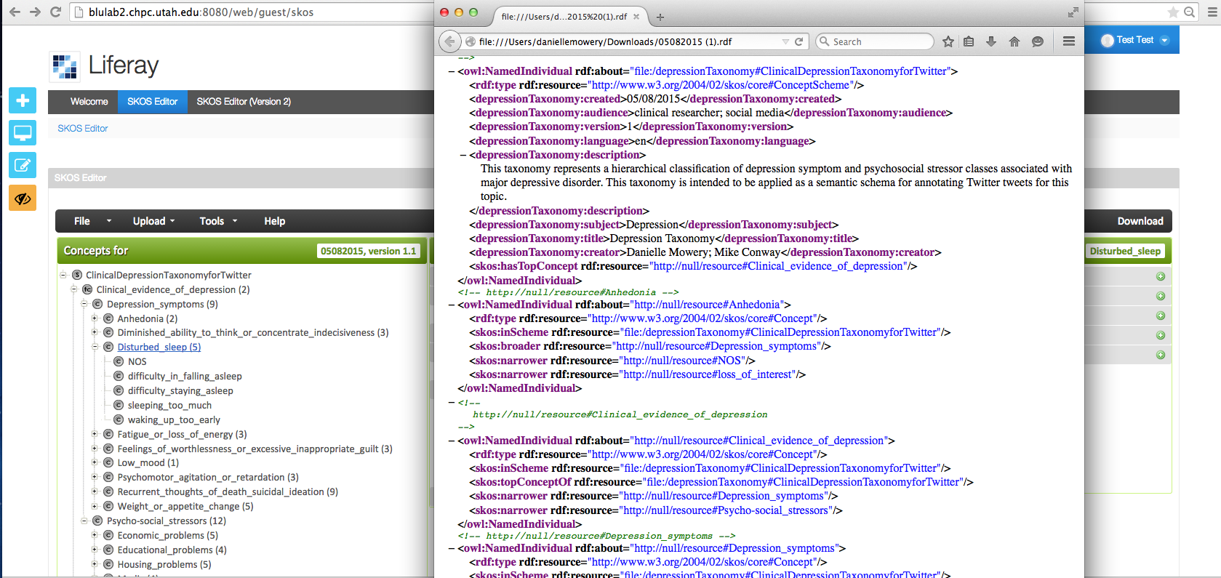

*Created with the Personal Edition of HelpNDoc:* [*Full-featured EBook editor*](http://www.helpndoc.com/create-epub-ebooks)