
System M-1 Manual

Doc. Version 2016-10-24-1
Author: Mario Blunk

Abstract: Introduction into System M-1. Instructions on operation, installation and maintenance. Basics on test generation for Boundary Scan Testing acc. to Std. IEEE 1149.1 also known as JTAG.

Keywords: Boundary Scan, JTAG, IEEE1149.1, netlist, partlist, import, database, UUT, module, hierarchic design, prefix, connectors, part, net, class, pull-down, pull-up, short, open, test coverage, primary net, secondary net, FPGA, CPLD, programmable logic, cell, input, output, highz, open-drain, open-collector, scanpath, scanport, TAP, scanchain, single step, breakpoint, current consumption, delay, timeout, shutdown, memory, RAM, FLASH, I²C, SPI, Microwire, mission critical, scripting, bash, Linux, Ada, gnat, gcc, git, version control, ASC-II, intrusive, non-intrusive, version control, git, development mode, production mode, graphical user interface, GUI

Table of Contents
1.Introduction 4
1.1.Financial investment 4
1.2.System overview 4
1.3.Features 5
2.Operation & Components 7
2.1.Licensing 7
2.2.Software 7
2.2.1.Version Controlling 7
2.2.2.Graphical User Interface (GUI) 7
2.3.Hardware 8
3.Where to get it 8
4.Installation 9
5.Support 9
6.Test Development Flowchart 10
6.1.Create Project (create) 11
6.2.Setup UUT Database 11
6.3.Import BSDL-Files (import_bsdl) 12
6.4.Import Net & Part List (import_cad) 12
6.4.1.Top Module & Sub Modules 13
6.4.2.Join Skeletons (join) 13
6.5.Make Nets (mknets) 14
6.6.Make Options (mkoptions) 15
6.6.1.Edit mkoptions.conf 15
6.6.2. Generate Options File 16
6.6.3.Routing Table 16
6.6.4.Options File Structure 16
1.Editing the Options File 16
6.7.Check Primary/Secondary Nets and Net Classes (chkpsn) 18
6.8.Test Program Generation 19
6.8.1.Scanpath (infrastructure) 19
6.8.2.Interconnection (intercon) 20
6.8.3.Memory Interconnetions (memcon) 20
6.8.4.Clock 21
6.8.5.Toggle 21
6.8.6.Manually Writing Tests 22
6.8.7.Sequence Instruction Set 23
7.Compiling Tests 25
8.Loading Tests 25
9.Executing Tests 26
9.1.Single Step Execution 26
9.1.1.Step Width SXR 26
9.1.2.Step Width TCK 26
9.2.Breakpoints 27
9.2.1.Setting the Breakpoint 27
9.2.2.Clearing the Breakpoint 27
9.3.Autonomous BSC Operation 28
10.Query Database Item 28
10.1. Nets 28
10.2.Boundary Scan ICs (BICs) 28
10.3.Shared Control Cells 28
11.Show System Configuration 29
12.Show Firmware 29
13.Scripting 29
14.Production Mode 30
14.1.Test / Script Start 31
14.2.Test / Script Abort 31
14.3.Test / Script PASS 32
14.4.Test / Script FAIL 33
15.References 34
16.Disclaimer 34

Introduction

Financial investment


To get right to the point: System M-1 is primary not for sale, it is for rent ! This defuses the standard question about the price slightly:
- The customer may rent System M-1 as long as required or may buy it.
- There is NO confusing features vs. license table (due to OpenSource). You get a development, repair and execution station in one package.
- Charges for training, test program setup and support apply.
- If the customer wants to buy it, she/he pays for the delivered hardware, that is the boundary scan controller (BSC) and the PC that comes along with it.

Please contact Blunk electronic for quotations.

System overview
The boundary scan system M-1 consists of:
- a regular Linux-PC with various software modules installed.
- a so called boundary scan controller (further-on referred to as BSC)
- the target hardware you want to test or debug → the unit under test (further-on referred to as UUT)

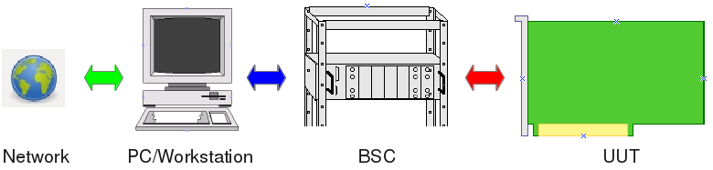
Figure 1: System M-1 components
On the PC you manage projects and generate test programs. The BSC executes test programs by sending serial data into the UUT and reading serial data from the UUT.

Features
There are some important features to point out:

- System M-1 includes a ready made PC with all the software required for test development, debugging and execution. The customer is freed from any software installation issues.

- Maintenance and support can be done remotely via the web interface. The network access may be corporate inside or from outside. The latter reduces traveling and on-site support.

- The operation system running on the shipped PC is Linux© . Linux is highly virus immune, long-term stable and highly network capable – a reasonable choice for an assembly line deployment.

- Scripting for automated build-processes


- Crucial parts of the System M-1 software have been written in ADA 2005 that perfectly fits the requirements of mission critical applications !

- The software is open to user specific applications or graphical user interfaces (GUI) !

- The software is well modularized. Updating is done regarding the very module affected, not all across the system. Each module can be accessed via external software i.e. in regard to system integration (Flying-Probe-Test, In-Circuit-Test, AOI, System Test, QM, …)

- Large parts of the software are open sourced (GNU General Public License).

- Most files that are generated by the individual software modules are strictly ASC-II formatted. They are human readable and editable thus allowing version controlling (like Git https://git-scm.com) and verifying.

- All the software of System M-1 is shipped fully installed. The customer does not need to worry about issues like:

    - operating system
    - hardware platforms
    - driver software
    - licensing

- By default, the BSC provides power monitoring of 3 individual channels to protect the UUT from power failure.

- By default, the BSC provides a full galvanic separation from the UUT upon power failure, test FAIL or non-test-mode. The latter is a constraint for interaction with other test systems.

- The BSC comes in a robust 19 inch housing with rugged connectors for fast and safe UUT change.

- The BSC can operate autonomously from the PC. For fast pre-testing of UUTs the operator activity is reduced to pushing front panel buttons START and STOP. Two LEDs indicate PASS or FAIL (see figure 2 page 9 and section 9 Executing Tests (run) on page 26).

Standard functions a Boundary Scan System acc. to IEEE1149.1 must provide are listed here without going further into the details at this point:

- Importing CAD data from any CAE system (Altium, ORCAD, ZUKEN, EAGLE , …)
- Minimal UUT access via a 5 wire serial test-bus (so called TAP)
- Adjustable TAP voltage (1.8V to 3.3V)
- Fault detection down to pin-level (stuck-at, shorts, opens, missing pull-resistor)
- Scanpath Test (Infrastructure Test)
- Interconnect Test
- Memory/Cluster-Interconnect Test (RAM, FLASH)
- Clock Test
- Pin-Toggle Test
- System Test

Operation & Components

Licensing
As said in section 1.1 Financial investment page 4, there is NO license required for the software. You get a system fully featured.
Regarding the hardware, that is the BSC, you are charged for buying or renting the BSC.

Software
The software of System M-1 is basically a collection of single executable Linux binaries (ELF). For managing projects, generating and executing test programs these executables get launched via command line. In production mode, means in an assembly line, tests are launched via graphical user interface (see section 14 Production Mode page 30).
A it is custom with UNIX and Linux applications, the system can be operated via a graphical user interface (GUI) as well as the command line. Major tactical functions for test execution and development/debugging are implemented in various executable files which can be launched individually by:
- local command line (console or terminal)
- a very lean GUI for launching tests
- a customized, tailored GUI
- a third party application (like Flying-Probe-Test, In-Circuit-Test, …) via system calls.
- remotely via network (ssh, remote desktop, vnc, ...)
The fact of individual executable files eases system updates and bug fixing. A malfunctioning executable can easily replaced instead of updating the whole system.
In addition it should be pointed out that the system is open for any extension made by the customer or third parties. As graphical user interfaces are frequently subject to individual constraints it proved ineffective to ship an over-sophisticated GUI to customers (see section 2.2.2).

Version Controlling and Software Verification
A files generated as intermediate steps are purely ASCII based text files (plain text). Only the executable code that runs in the boundary scan controller (BSC) is binary. So version control with tools like Git or software verification can be accomplished.

Graphical User Interface (GUI)
For test program development there is no graphical user interface. All functions are available by launching an executable with dedicated arguments.
For deployment in an assembly line, for executing tests, there is a lean GUI available. It is made for productive environment with the most essential widgets. See section 14 Production Mode on page 30 for more.

Hardware
The BSC comes in a robust 19 inch housing with rugged connectors for fast and safe UUT change (figure 2). It can operate autonomously from the PC. For fast pre-testing of UUTs the operator activity this can be reduced to just pushing front panel buttons START and STOP. Two LEDs indicate PASS or FAIL.

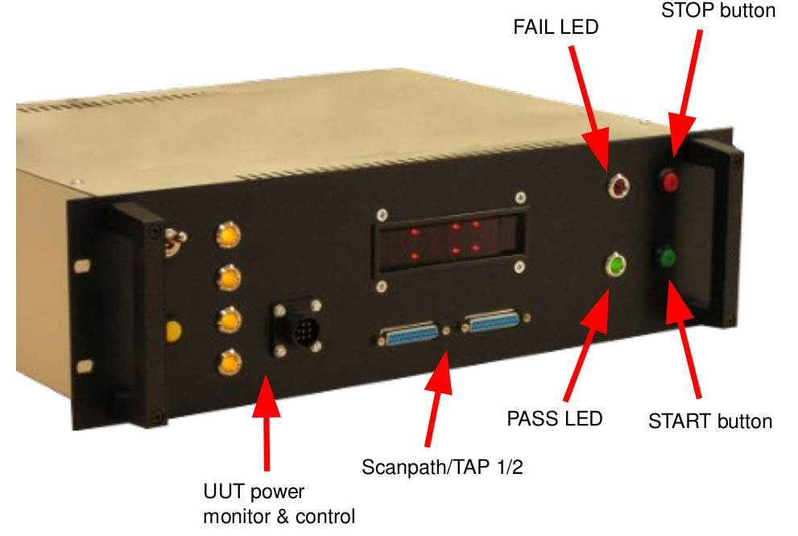figure 2: BSC front panel

Where to get it
The software is provided by us or available at GitHub:
https://github.com/Blunk-electronic/M-1
https://github.com/Blunk-electronic/lbr_ada

Installation
In general, the system is shipped fully installed. The user does not have to worry about installation issues. However, for evaluation the installation is as follows:
- Make sure gcc and gnat (C and Ada-Compiiler) are installed.
- Create a directory where the following repositories will be cloned in.
- Clone the M-1 repository from https://github.com/Blunk-electronic/M-1.git
- Clone the required Ada libraries from https://github.com/Blunk-electronic/lbr_ada.git
- Change into directory M-1 and run the install script install .

Support
In general boundary scan is support intensive. For training, consulting, test program setup please contact us at www.blunk-electronic.de.
You are highly welcome !

Test Development Flowchart
figure 3 depicts the general work-flow with basic actions required to generate test patterns or in-system programming actions, further-on referred to as ISP. Every tool the user launches directly or indirectly modifies the UUT database, further-on referred to as UDB. The UDB in turn is the data pool test generation bases on. Every action outlined here will be described more detailed in the following sections. So have this chart at hand throughout this manual.

figure 3: General Workflow (greyed box means: under construction)

Create Project (create)
The first step is to create a project. Open the console terminal and launch the command:
luno@notebook1:~/tmp/bscan_projects> bsmcl create my_project

It creates a directory my_project that contains the project structure of that project. Change into the directory my_project and have a look at its contents.

Setup UUT Database
Once a project has been created, a bare UUT database is available. Its name is composed of the actual project name and the extension .udb. So the database of our example project my_project is myproject.udb.
Open the database with a text editor and go to SubSection chain_1. Usually here you describe the scanpath(s) of your UUT. The scanpath (or scan chain) is the backbone where all boundary scan capable ICs – furhter-on referred to as BICs - are chained. For the start the SubSection contains only comments (headed by double dash). In our example here uncomment the fifth line in order to make IC301 the only BIC of scanpath #1. The comments in this example explain how to read this section.

SubSection chain 1
--UUT_TDI_1 / BSC_TDO_1
--device, package, path to bsdl model, option [ remove_pin_prefix p ]
--NOTE 1: use lower case letters for package names
--NOTE 2: position 1 is closest to BSC TDO !
--IC301 pc44 models/BSDL/xc9536_pc44.bsd
--UUT_TDO_1 / BSC_TDI_1
EndSubSection
Text 1: UUT database SubSection chain

This SubSection specifies the order of BICs in a particular scanpath, the package, the path to the BSDL model and some options.

Most of the following actions base on this configuration.

Import BSDL-Files (import_bsdl)
Once the scanpath has been specified the BSDL models should be imported into the database. Therefore run the command
Your database gets extended by the section registers. This section contains the BSDL information for all BICs as specified in Text 1 page 12. Read more on BSDL syntax in the IEEE1149.1 Standard, see reference (4).
luno@notebook1:~/bscan_projects> bsmcl import_bsdl my_project.udb
From this state of the database, the most basic test , the so called Scanpath Test (or Infrastructure Test) can be generated. In this case proceed with section 6.8.1 page 20.

Import Net & Part List (import_cad)
With the database in its current state you can't do much. Now we extend it with the so called netlist of the UUT. Every CAE design tool can export a netlist (an optionally a partlist) which reflect all the electrical connections of the board you want to test. Usually these files are strictly ASCII based, which means you can open them with any text editor, do net or part searching or even modifying (Yes there are cases when you are forced to edit a netlist file...).
The project directory of our dummy UUT my_project contains a sub folder named cad where you should copy net and partlists or where you can create symlinks to the acutal files. Links are favorable because they always point to the most recent version of the targeted file.
The command to import net and partlist requires specifying the format and the location of the netlist and partlist. If there is no partlist, just leave it off. Run the command from inside the project directory my_project:
For other netlist formats just type the command:
bsmcl import_cad eagle6 cad/netlist.txt cad/partlist.txt
It outputs the formats currently supported. Since System M-1 is widely opensouce, you are invited and free to write your own netlist importer. You may use any programming language to accomplish that. Important is to get as a result the skeleton file:
bsmcl import_cad
The outcome of the netlist import is a so called skeleton file, named skeleton.txt. By its extension it's clear this is also an ASCII file. Just have a look at it with a text edtor. The skelton file contains the whole UUT netlist in a standardized format.

Hierarchic Designs
As long as there is no skeleton file already in the projects root directoy, the netlist being imported is regarded as top module. A top module may have submodules. Whenever you are re-importing the netlist, the importer asks you whether you want to create or overwrite the skeleton. You may also decide whether it is to be imported as top module or sub module. If you are working with just a single board UUT always import as top module. The following sections can safely be skipped in this simple case. Just continue reading in section 6.5 Make Boundary Scan capable Nets (mknets) page 15.

Top Module & Sub Modules
If your UUT consists of more than one board, or if it is a whole system, one board must be selected as master module, further-on referred to as top module. All other boards will the be imported as sub modules. After importing the top module netlist, subsequent imports ask you for the name of the sub modules. Each import of a submodule creates a dedicated skeleton file that bears the name of the sub module like skeleton_X15.txt . All parts and nets of the sub module are therein prefixed with X15. So for example the resistor R5 in submodule X15 gets renamed to X15_R5. The reason for prefixing parts and nets is that later the test generators will see all modules as one target. The only way to tell which parts and nets belong to which module is by giving the prefixes.
After all, if this section confuses you, just play with the import command (see section 6.4 Import Net & Part List (import_cad) page 13), import sub modules and have a look at the resulting skeleton files. Next stop: Joining skeletons.

Join Skeletons (join)
In order to merge top module with one or more sub modules run for example the command:
It joins the sub module X15 with the top module skeleton. The result is a skeleton file that contains the nets and parts of both modules. This step can be repeated with other sub modules many times until all modules are joined in a single skeleton.txt.
bsmcl join_netlist skeleton_X15.txt

Make Boundary Scan capable Nets (mknets)
The designation skeleton speaks for itself. The skeleton file must be brought to life by transferring it into the database. The latter provides information on which pin (or pad) of a BIC (Boundary Scan capable IC) is connected to which net. The command
reads the skeleton file and imports it into the specified database (remember there can be many databases each of which represents a particular UUT configuration). The database gets extended by another section called netlist. Have a look into the database, scroll to section netlist and inspect the outcome:
bsmcl mknets my_project.udb
Every net now is a subsection. The subsection header also tells about the net class. By default all nets are in class NA, which means “not assigned”. A net of class NA is completely excluded from any test generation. So please consider this default as safety measure.
After the subsection header all parts connected to the net are listed with their name, part class (currently a placeholder '?'), package, value and pin name. A BIC pin has more information, the so called cell info. The cell info is derived from the information in section registers, which in turn was built from the specifications of the BSDL files (see 6.3 Import BSDL-Files (import_bsdl) page 13).

In this state of section netlist each net exists for itself, without any interconnections to other nets. The next step assists the user in adding interconnections.
SubSection SDA class PU
-- name class value package pin [port | in_cell: id type func safe | out_cell: id type func safe
RN300 '?' 8x1k8 SIL9 3
R400 '?' 160 0207/10 1
JP403 '?' MON2 2X20 6
IC301 '?' XC9536 PLCC-S44 33 pb01_11 | 20 BC_1 INPUT X | 19 BC_1 OUTPUT3 X 18 0 Z
EndSubSection

Make Options (mkoptions)
Frequently, nets are connected with each other by series resistors, solder bridges, wires, inductors, connectors and so on. Since System M-1 does not feature artificial intelligence, the user must declare parts that connect nets with each other.

Edit mkoptions.conf
The text file mkoptions.conf is where parts are specified, which connect nets. In order not to start from scratch, a well prepared file is already present in your project root directory. You only have to modify it according to your UUT. Open it with a text editor and have a look at it:
Comments start with double dash “--”. There is a “section connectors” where you specify by which connector pair a module is connected with another module. Note the prefix ! In this example sub module module_a has a connector X1 which mates with sub module module_b connector X3. Another connection is made by module_c, J55 and J1 on the top module. Remember, the top module does not have prefixes. The assumption is that the pins meet each other one-to-one, which is usually the case with board-to-board headers an the like.
Section connectors
-- device A , device B
module_a_X1 module_b_X3
module_c_J55 J1
EndSection

Section bridges
N*
RN302 array 1-2 3-4 5-6 7-8 -- wildcards do not work with RN
-- RN303 array 1-2 3-4 5-6 7-8
R3*
R99
module_a_R7
EndSection
Text 2: mkoptions.conf
Section “bridges” contains parts that act like a bridge between two nets. It does not matter if these devices are resistors, wires, inductors or whatsoever. Important is whether a certain part results in a series connection. In our example here there are lots of solder bridges whose name starts with N. So the notation N* addresses all parts of this kind. Dedicated declarations like the resistor R99 are also possible. A special case are arrays. Mostly we deal with resistor arrays. Specify the array name, followed by the keyword array and the pins where the internal resistors are tied with.

Generate Options File
After editing mkoptions.conf run the command:
The outcome is a so called options file, ending in *.opt, ASCII based of course, that contains the full net list of your UUT including all the interconnections you just specified in mkoptions.conf. By default the options file has the same name as the UUT database. Optionally, the name can be specified as
bsmcl mkoptions my_project.udb
bsmcl mkoptions my_project.udb another_options_file.opt

Routing Table
As a byproduct, interconnected nets are automatically written in a CSV file that has the same name as the UUT database. So if you open my_project.csv with a spreadsheet software the routing from one net to the other can be seen.

Options File Structure
The structure of the options file is as follows:
- statistics about bridges, arrays and net count
- net list with primary and secondary nets
Mkoptions decides which net is to be a primary net and which net is a subordinated secondary net. If a net contains a boundary scan capable driver, it is selected as primary net. Other nets, regardless if they have scan capable pins or not, become secondary nets. The idea behind is to specify in advance, for later test pattern generation, which net is the driving net and which net(s) are listening to their superordinated primary net during test execution.

Editing the Options File
Since the options file reflects the whole UUT (including net interconnections and dependencies) you are now requested to edit the net classes. By default all nets are in class NA, which means “not assigned”. This default is a safety measure that prevents activating drivers that contend with other unknown signal sources or control peripheral components. There is NO automatic net class assignment. You are requested to dig into the schematic and to assign net classes. In other words, study the UUT schematic and decide carefully which net is to be tested in which manner.
Available net classes are:
- NA (not assigned) → net completely excluded from test generation (default)
- NR (no restriction) → net can be tested without any restriction
- PU (pull-up) → net has pull-up behavior
- PD (pull-down) → net has pull-down behavior
- DH (drive-high) → net is to be driven permanently high (if scan capable driver available)
- DL (drive-low) → net is to be driven permanently low (if scan capable driver available)
- EH (expect high) → net is expected to be high (by whatever source)
- EL (expect low) → net is expected to be low (by whatever source)

Check Primary/Secondary Nets and Net Classes (chkpsn)
Chkpsn checks if the assignments in your options file are correct and feasible. Whenever you feel it is good to check if the settings you made in the options file, run the command
It reads the options file (same name as the database but with extension *.opt). If your options settings are correct and acceptable, they are imported into the UUT database. This command can be repeated any time in order to release more nets to the test generation.
bsmcl ckpsn my_project.udb
It is a good and safe approach to release on net (or a group thereof), generate a test, see the result and release the next net to the test generators.

Note: Currently, the routing table, generated by mkoptions does not get updated with the manually added primary-secondary net dependencies (see section 6.6.4.1).

Test Program Generation
As a general rule: Test program generation (or test pattern generation) bases strictly on a valid UUT database. As said earlier, you can have multiple databases living in the project root directory. Each of which represents a certain UUT configuration. When launching a test program generator, the name of the desired database is passed as argument, along with the test profile and other optional parameters.
The result of a test program generation is a directory, bearing the name of the actual test, that contains the source code of the test. The source code file is further-on called as sequence file. It is ASCII based, can be regarded as programming language and can be modified for fine tuning (see section 6.8.6 Manually Writing Tests page 23). Mostly it can be compiled right away by launching the compiler compseq (see section 7 Compiling Tests (compile) on page 25).

Scanpath Test (infrastructure)
The first test you usually generate is the so called scanpath test (or infrastructure test). Its only purpose is to ensure the scanpath that runs through your UUT is intact. The scanpath is the backbone where test data between UUT and Boundary Scan Controller travels through. This test is by nature non-intrusive, means it can be executed without affecting the UUT normal operation.
The scanpath test does not require netlist information. It can be generated right after importing BSDL files (see section 6.3 Import BSDL-Files (import_bsdl) on page 13).
Run this command in order to auto-generate a scanpath test:
bsmcl generate my_project.udb infrastructure my_infra_test

Interconnection Test (intercon)
Without the ability to run interconnect tests, boundary scan is worthless. In other words: Interconnect testing is the workhorse of boundary scan. This test is intrusive, means it directly stimulates driver pins and reads receiver pins, thus verifying the connections to and between BICs. The precondition for this test is an intact scanpath and at least one BIC has boundary scan capable pins. Usually an IC that is part of the scanpath, has scan capable pins. There are exceptions.
With just one IEEE1149.1 capable IC, we refer to it as BIC, on your UUT you can do a lot of testing, even if there is no other BIC to exchange data with. With a solitary BIC you can drive or read peripheral components (like relays, motors, valves, displays, lights, switches, jumpers, ...), drive and read inputs from non-scan ICs or units, test shorts between pins, test pull-resistors.
The test coverage ranges from light to moderate.
Things get better if there are other BICs on the board, because more interconnections can be tested.
Run this command in order to auto-generate an interconnect ion test:
bsmcl generate my_project.udb interconnect my_interconnect_test
CAUTION: The Interconnection test is intrusive !

Memory Interconnections Test (memcon)
As said in section 6.8.2 Interconnection Test (intercon) the connections between BICs are important to increase test coverage. If there are memories like RAMs which are connected with BICs, the test coverage can be boosted even more. Via Boundary Scan certain memory locations can be written with certain data. Reading back the content allows detecting faulty address, data or control nets.
Important for generating a memory interconnet test is a model of the memory device. System M-1 uses ASCII based text files wherein the device behavior is described. On automated test generation, the database, the test profile, the target device name, model file and the physical package is to be specified as shown in this example command:
CAUTION: The memory interconnections test is intrusive !
bsmcl generate mmu.udb memconnect my_ram_test IC2 models/U256.txt SO28

Clock (clock)
Frequently a clock signal is to be tested. In most cases it is fully sufficient to verify the signal is toggling. The actual frequency or duty cycle are of secondary importance. So in order to auto-generate a test that samples a clock signal, parameters like database, test profile, target net, target BIC, retry count and sample interval are to specify:
The example shown here generates a test that tests net “osc”, uses IC1 pin 7, samples 5 times with a pause in-between of 0.1 seconds. If no signal change can be detected, the net “osc” is faulty. The clock test is non-intrusive, means it does not affect the UUT operation. So the test can be executed while the UUT is in fully operational mode.
bsmcl generate mmu.udb clock osc IC1 7 5 0.1
NOTE: If a clock test is generated based on a database with DH or DL nets, it is going to fail when executed. Static driven nets of class DH or DL require intrusive mode.

Toggle (toggle)
While debugging a UUT, frequently a single net is to be driven high or low in order to lit an LED, turn on a relay or to take measurements. In an assembly line frequently LEDs must be tested. In contrast to the clock test (see above), the toggle test is intrusive, means it halts the UUT and stimulates a targeted net. When launching the automated test generator, the database, the test profile, the test name, the target net, the cycle count and the low/high-time specify the outcome.
The example shown here makes the net “OSC” toggle 10 times with a low-time of 0.1 and a high-time of 0.2 seconds. The test generator cares for selecting the appropriate driver pin.
bsmcl generate mmu.udb toggle my_osc_test OSC 10 0.1 0.2
CAUTION: The toggle test is intrusive !

Manually Writing Tests
In general, after automatic test generation or when writing test programs manually, the outcome is a ASCII based text file with extension *.seq. This sequence file can be regarded as high level programming language.
In most cases, a sequence file generated by an automatic test generator, serves as starting point to write well tailored code. Since this requires advanced skills and knowledge about the Boundary Scan technology, this section will be expanded later.
tbd

Instruction Set
Instruction | Example | Meaning
connect | connect port 1 | connects the scanport 1 with the UUT
disconnect | disconnect port 1 | disconnects the scanport 1 from the UUT
power up | power up 2 | connects power channel 2
power down | power down 2 | disconnects power channel 2
 | power up gnd | connects power channel GND (no current monitoring !)
 | power down all | disconnects all power channels
imax | imax 1 0.2 timeout 2 | sets maximum current of power channel 1 to 0.2A with a timeout of 2 sec.
delay | delay 0.5 | pauses for 0.5 sec.
set | set IC1 drv boundary 4=0 | assigns boundary register cell 4 of IC1 the drive value 0
set | set IC1 exp boundary 5=1 | assigns boundary register cell 5 of IC1 the expect value 1
sir | sir id 4 | instruction scan with id 4
sdr | sdr id 5 | data scan with id 5
 | sdr id 5 option retry 5 delay 1 | data scan with id 5, a retry count of 5 with an intermediate delay of 1sec.
trst | trst | scanpath reset (both hard and soft)
htrst | htrst | hard scanpath reset
strst | strst | soft scanpath reset
Table 1: Short Reference Sequence Instruction Set

Compiling Tests (compile)
Every test with its dedicated sequence file needs to be compiled in order to make an executable binary file. The executable binary file extension is *.vec and can be run on the Boundary Scan Controller exclusively. This file is the only non ASCII file within the UUT directory. After compiling, this file lives in the corresponding test directory. When launching the compiler compseq you must specify the database the test was generated on and the test itself.
bsmcl compile mmu.udb my_osc_test

Loading Tests into the BSC (load)
After compilation the binary must be uploaded into the Boundary Scan Controller. See the following example.
You can upload as many binaries until the controller RAM is full.
bsmcl load my_osc_test
NOTE: Each time a test is re-compiled, it must be uploaded again.

Executing Tests (run)
Once a test has been uploaded it can be started right away by a simple command as shown below:
bsmcl run my_osc_test
If faults are detected, a report is displayed in your terminal. The test report shows the faulty pin or net of the UUT.

Single Step Execution
If the step width is provided on launching a test, the test halts after every step.

Step Width SXR
SXR stands for Scan-Data/Instruction-Register. So SIR means instruction scan whereas SDR means data scan. The example
causes the test to halt right after every data or instruction scan. After every step the test status is displayed in the terminal window.
bsmcl run my_osc_test sxr
When halted the TAP-state-machines of the UUT wait in the end-state (with TCK cleared) as specified in section info of a test sequence file.

Step Width TCK
TCK means Test Clock. If a test is executed with this step width, it is halted after each change of the TCK signal. After every step the test status is displayed in the terminal window.
While shifting, this might be helpful:
BP (bits processed, one-based) increments when a TCK cycle is finished. A TCK cycle starts with a HL-edge (when TDOs and TMSs may change) and ends with a LH-edge (all TDIs and TMSs are sampled). So BP increments on every LH-edge of TCK. A bit is regarded as “processed” when the TCK cycle finishes.
bsmcl run my_osc_test tck

Breakpoints
Breakpoints allow the user to halt a program at a well defined position in order to investigate the state of the UUT. This way a test program can be debugged.

Setting the Breakpoint
A breakpoint is set by specifying the sxr ID followed by the bit position(one-based) to halt at. The bit position to halt at is optionally. If left off, the execution just halts after the specified sxr in its end-state (TCK cleared) as defined in the sequence file. The following example sets a breakpoint right after SXR number 6:
There is no distinction between data or instruction scan. If the test execution is to halt after a certain bit position, see the next example:
bsmcl break 6
bsmcl break 6 217
The breakpoint is not related or bound to any particular test. Execution halts whenever any test has processed the specified sxr and bit position.
Only one breakpoint can be set.

Clearing the Breakpoint
To delete the breakpoint just do:
bsmcl break 0
The test execution will not halt at a any position any more.

Autonomous BSC Operation
For fast GO/NOGO pre-testing just press the green START button at the BSC front panel. The last test executed via terminal, get started this way. The green or red front panel LEDs indicated a PASS or FAIL result.

Query Database Item
Frequently during test program setup, properties of certain items like a net, a boundary scan IC must be inquired for. Especially so called “shared control cell conflicts” required detailled information about the affected control cell.
The module udbinfo serves this need and keeps you from getting lost among schematics, assembly drawings, netlists and BSDL files.

Nets
For example if you need detailed information about the net ADR15 type the following command:
bsmcl udbinfo my_database.udb net ADR15

Boundary Scan ICs (BICs)
To obtain properties of an IC like IC303 do:
bsmcl udbinfo my_database.udb bic IC303

Shared Control Cells
The most valuable feature of this module is the control cell inquiry. To see which nets share the same control cell see the following example. It inquires for the nets which share control cell 4 of IC303:
bsmcl udbinfo my_database.udb scc IC303#4

Show System Configuration
To get a short report about the system configuration type this command:
It outputs names of base directories and the interface name (like /dev/ttyUSB0) the Boundary Scan Controller is connected with.
bsmcl configuration

Show Firmware
The firmware implemented in the boundary scan controller can be inquired by the command:
bsmcl firmware

Scripting
All commands shown in the sections above can be easily combined (also with other applications) and repeated using the traditional, powerful Linux/UNIX shell. Automated build processes can be implemented this way.
NOTE: Script files within System M-1 must end in *.sh.
The dummy UUT provided in the M-1 repository (sub folder uut) contains several bash scripts that generate tests very rapidly:
- build_nets.sh
- build_tests.sh
- load_tests.sh
- run_tests.sh

Production Mode
It is highly recommended to use the graphical user interface when operating System M-1 in an assembly line. The GUI is reduced to the most essential widgets required for board and system testing.
On start-up the GUI allows to select the UUT (or target) by clicking the button labeled with UUT (Screenshot 1).
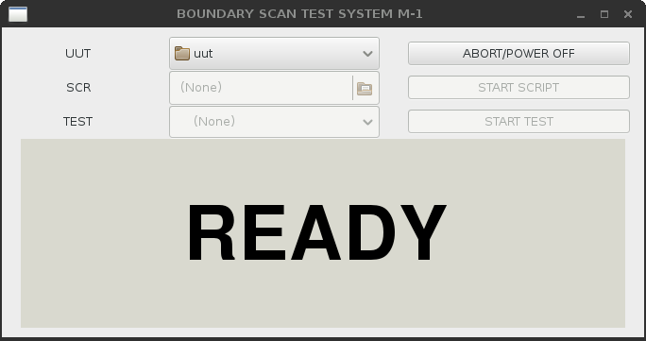Screenshot 1: Start-Up

Test / Script Start
After setting the UUT, a script (which is a batch of tests or other actions) or a test can be selected and launched as shown in Screenshot 2. While a script or test is being executed, the status window shows a bright yellow/black “RUNNING”.

Test / Script Abort
Aborting the script or test is possible by clicking “ABORT/POWER OFF”, the “STOP SCRIPT” or “STOP TEST” button. It may take up to two seconds for the software to shut down the UUT. The fastest abort can be achieved by pressing the red “STOP” button at the front panel of the boundary scan controller.

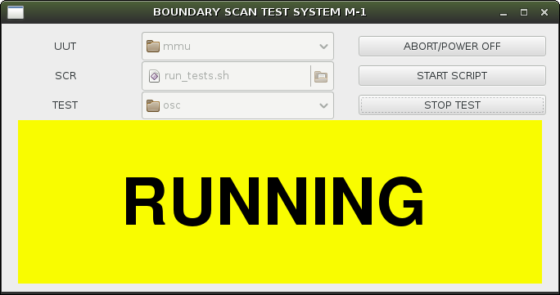Screenshot 2: Test/Script running

Test / Script PASS
The most obvious result of a test or a script is the brigth green “PASS” status window.

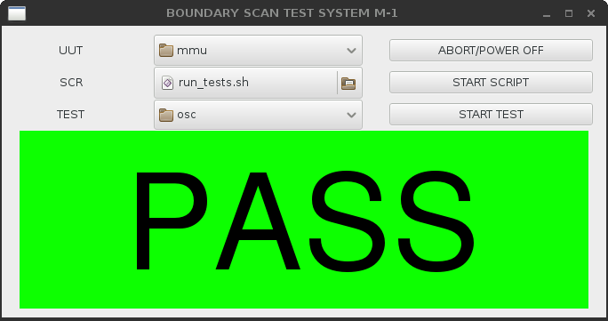Screenshot 3: Test/Script passed

Test / Script FAIL
A failed test or script is displayed by the alarming red “FAIL” readout. For production mode this display is fully sufficient to tell the bad from the good UUTs. For repair and debug the console outputs more detailed information on which net, device and pin had failed.

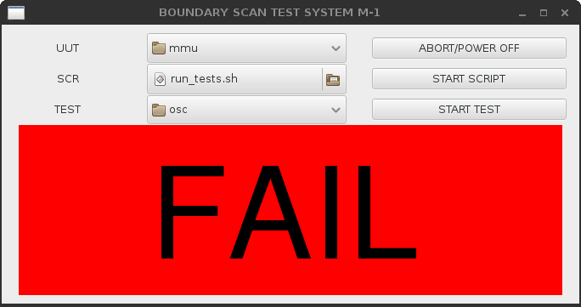Screenshot 4: Test/Scrip failed

References
- http://www.blunk-electronic.de/bsm/Boundary_Scan_Basics.pdf
- http://www.blunk-electronic.de/bsm/BSM_Product_Brief_en.pdf
- http://www.blunk-electronic.de/bsm/how_to_test.pdf
- The Institute of Electrical and Electronics Engineers, Inc. , 3 Park Avenue, New York, NY 10016-5997, USA; IEEE Std 1149.1-2001 “IEEE Standard Test Access Port and Boundary-Scan Architecture”

Disclaimer
This document is believed to be accurate and reliable. I do not assume responsibility for any errors which may appear in this document. I reserve the right to change it at any time without notice, and do not make any commitment to update the information contained herein.
Mario Blunk

Blunk electronic / Owner : Dipl. Ing. Mario Blunk / Buchfinkenweg 3 / 99097 Erfurt / Germany / Phone +49 361 6022 5184

© 2016 Mario Blunk Printed in Germany

Linux and UNIX systems do not insist on this extension in general. The extension eases locating scripts.

