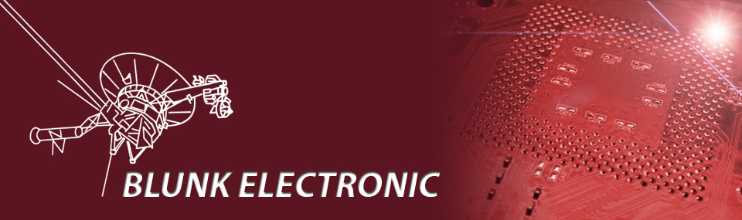
Selection Guide on how to test boards and systems
and
an introduction to the Boundary Scan System M-1

Doc. Version 2013-06-07-1
Author: Mario Blunk

Abstract: Guideline to decide the proper test method for boards and systems in an assembly line of an EMS provider or in the field. Questions relevant for the operator as well as the test engineer who decides about the deployment of the Boundary Scan System M-1. Specials regarding the benefits of Boundary Scan acc. to IEEE 1149.1 are also touched.

Keywords: Boundary Scan, JTAG, IEEE1149.1, nets, DFT, SMD, THT, FPGA, CPLD, CPU, MCU, pull resistors, prototype, soldering, reflow, shorts, stuck-at, connectors, I²C, functional test, in-circuit-test, flying-probe-test

Table of Contents
1 Introduction 2
2 Test Methods of the Art 3
2.1 Functional Test (FT) 3
2.2 In-Circuit-test (ICT) 5
2.3 Flying-Probe-Test (FPT) 7
2.4 Boundary Scan (BST) 8
3 The Boundary Scan System M-1 10
3.1 Financial investment 10
3.2 System overview 10
3.3 Software Operation 13
3.4 File System 14
3.4.1 System Files 14
3.4.2 User Files 15
3.5 In a Production Line 16
3.5.1 Test Preparation 17
3.5.2 Test Report 22
3.5.3 User Interaction 23
3.5.4 PC-less Operation / Pre-Test 24
3.6 Hardware Operation 25
4 GUI Issues 27
5 Useful Links 28
6 References 30
7 Disclaimer 30

Introduction
The first part of this document aims to provide a guide to select an appropriate test method according to the actual board or system – further-on referred to as UUT (Unit Under Test) – to be tested. An overview of test methods with their individual pros and contras will be given in an impartial manner.
Part two of this document shows outstanding features of the Boundary-Scan System M-1 and how it works in an assembly line. This section aims to give an overview of the system in order to decide for or against is. A detailed users manual will be given in a separate document.

I appreciate all critics to improve the quality of this document !

Test Methods of the Art

Functional Test (FT)
The easiest way to test an assembled UUT is the functional test (FT): Connect the UUT with all connections required, power-up and see what happens. Obviously this method only tells you about GO or NOGO. A detailed report of faults is close to impossible to get unless the operator has gained a lot of experience over dozens of test runs.

WARNING: The idea for FT might give the impression of an easy to get test at lowest price. Depending on the complexity of the UUT this assumption may prove true or may lead into endless attempts to repair boards, thus raising unacceptable costs.

FT in general always happens on system level. System test – several boards connected to each other e.g. in a rack – is possible, but the test result comes also on system level ! FT never outputs something like “Net ADR4 is stuck at low.” Instead the whole UUT does not work or fails partially which in turn raises questions and speculations about the actual fault. Imagine a CPU with some memory IC around. If only one of let say 32 address and 16 data nets is broken, the whole UUT will not come to life. Good luck finding the fault by functional testing...

WARNING: As the complexity of the UUT increases, FT covers less possible faults. The test run time required to go through every combination of states increases exponentially. In order to save time, lots of combinations will not be tested for sure ! So the result PASS of a complex UUT test is more of psychological nature.

Functional Test is a high-level system test to locate faults in a late production state of the UUT !
This statement implies: If a fault is detected while FT, a lot of labor has been invested into the UUT already e.g. wires soldered, housing assembled, series numbers noted, … . All those steps have to be repeated all over again until the board passes the FT !

A very simple UUT can be tested with FT. Very simple means: A fault can be located with reasonable and acceptable efforts as time and material goes.

Table 1 gives an overview of pros and contras of FT.
PRO | CONS | REMARKS
low price test equipment |  | - if UUT is very simple
space requirements |  | - app. 1m²
short setup time
simple test equipment
time to adapt modifications
test run time |  | - depends on how many functions and states are to be tested (see discussion above)
 | fault detection in a very late production state
system test
 | Faults may pass the test undetected. → UUT fails at the customer site
 | poor fault diagnosis → increased labor costs
 | high skilled personal required for test operation | - if complex functions are to be tested
 | error prone tasks while test operation | - if complex functions are to be tested
no serious preparation for testing required |  | - so called Design For Test (DFT)
Table 1: Pro and Contras of Functional Test (FT)

In-Circuit-test (ICT)
A powerful workhorse of board test over decades has been and still is the In-Circuit-Test (ICT). It allows a low level board test for the majority of boards assembled around the planet with a very detailed fault report.
As the boards are getting more dense in regard to the number of layers, the via types (buried and blind vias), pin spacing, pin accessibility (BGAs) the ICT is loosing ground. ICT-Nails can't be placed everywhere and a certain clearance between them must be guarantied. The more nails, the greater the force required to push the adaptor onto the board. Every test pad and every nail poses an extra capacitive and inductive load onto the affected net, and not to forget: eventually there is no more space left to place test pads or test points in the PCB layout.
In-Circuit-Test implies a financial burden of several thousands of Euro or Dollar for the nail adaptor to be manufactured, not to mention the ICT machine itself. As soon as the affected board undergoes modification or is discontinued, a very expensive piece of scrap moves into a dusty shelf. Concluding, the price is the major drawback of ICT.

In-Circuit-Test is a low-level structural test to locate faults in an early production state.
Table 2 gives an overview of pros and contras of ICT.
PRO | CONS | REMARKS
 | high price test equipment
 | long setup time | - concerning making the nail adaptor and wiring underneath
 | space requirements | - min. 2m²
 | complex and high skilled test equipment
 | time to adapt modifications | - In best case dismantling the adaptor, modifying nails, changing wiring required.  - In worst case the whole nail adaptor has to be made anew.  - Software changes are negligible.
test run time |  | - usually a matter of seconds
fault detection in an early production state
 | no reuse of test equipment | - concerning the nail adaptor and wiring underneath
mixed signal test
 | extra space required at the UUT | - for test points or test pads
 | extra capacitive or inductive load on the UUT signals | - non-test-mode and performance may be negatively affected
 | system test not possible
Close to all faults get detected. |  | - provided there are sufficient test points
Very good fault diagnosis → minimal labor costs
low skilled personal required in test operation
error safe tasks while test operation
 | careful preparation for testing required | - so called Design For Test (DFT)
Table 2: Pro and Contras of In-Circuit-Test (ICT)

Flying-Probe-Test (FPT)
A wonderful example of human ingenuity is the Flying-Probe-Test (FPT) – an “adaptable ICT” with so called “flying nails” which can contact the board at every exposed copper area like SMD-pads, THT-pads, vias, test pads, … Such a machine outnumbers the price of a home (200T – 500T EUR). So most EMS providers can't afford it.

Flying-Probe-Test is a low-level structural test to locate faults in an early production state.

PRO | CONS | REMARKS
 | very high price test equipment
short setup time
 | space requirements | - min. 3m²
 | complex and high skilled test equipment
time to adapt modifications
 | test run time | - depends on number of test points and board size
fault detection in an early production state
reuse of test equipment
mixed signal test
 | system test not possible
Close to all faults get detected.
Very good fault diagnosis → minimal labor costs
low skilled personal required in test operation
error safe tasks while test operation
no serious preparation for testing required |  | - so called Design For Test (DFT)  - if nails are to contact device pads and pins
Table 3: Pro and Contras of Flying-Probe-Test (FPT)

Boundary Scan (BST)
Initiated by the problem of limited space for test points, the growing density of parts fitted, the inaccessibility of nets (multilayer PCBs combined with BGA packages) the standard IEEE1149.1 has been ratified in the early nineties. Bulky test pads or test points have moved inside the integrated circuits (ICs). The access to those points is now adaptor-less, thus dramatically reducing the financial investment and increasing the flexibility to adapt UUT modifications.
IEEE1149.1 is entirely made for digital board tests. Mixed signal test can be achieved with lots of restrictions. Analog signal testing is not possible. There is the IEEE1149.4 standard for mixed signal test but it never made it into real life, unfortunately. Further on there is IEEE1149.5 (system test, but was discarded eventually), IEEE1149.6 (AC coupled digital test) and IEEE1149.7 (extension of IEEE1149.1 with an advanced bottom hardware layer).
However, IEEE1149.1 is the workhorse of boundary scan, frequently referred to as JTAG, which is a dutch company, based in Eindhoven, that provides boundary scan test systems.
WARNING: It should be noted that the Boundary-Scan-Test is no Wunderwaffe as advertised in some publications. As mentioned in Table 4 below, the UUT itself must have fitted at least one IC fully supporting IEEE1149.1. The IC implies testability !
In contrast to the early beginnings of IEEE1149.1 in the nineties, today the majority of CPLDs, FPGAs, CPUs, DSPs and Microcontrollers (MCUs) supports the standard by default. Presently the majority of boards used in the sector of telecommunication, entertainment, networking, industrial control, medical, avionics, military and automotive bear ICs that do support IEEE1149.1.
Boundary-Scan-Test is a low-level structural test to locate faults in an early production state.
The fact that the UUT has to be powered up during BST can be regarded both as curse and as blessing at the same time. A fully powered up UUT with unlucky paced faults tends to self-destruct unless careful power monitoring is done (see section 3.2 page 11 point ). But, the advantage of a powered up UUT and low-level access to pins allows testing of peripherals like displays, LEDs, relays, motor drivers in a production stage where no firmware etc. has been programmed into the UUT yet !!! With some programming efforts,
system test is possible !
It is obvious that entirely analog designs like an audio-amplifier are excluded from Boundary-Scan-Testing. BST is also oversized for testing a board with a simple monoflop-driven relay stage ...
The first and most crucial point in Table 4 addresses the financial investment in a BST-System. Usually small or start-up companies can't afford to by it. As a result of this shortage they either do not take orders to manufacture BST-capable boards or they default to functional test (FT) or optical inspection. An extra load is imposed by add-ons like maintenance contracts and thereof. See section 3.1 Financial investment on page 10 for a solution.
Table 4 gives an overview of pros and contras of BST.
PRO | CONS | REMARKS
 | very high price test equipment | - if the test system is to be bought, 20T – 50T EUR (plus extra price for maintenance and support)
short setup time |  | - from a few hours to one week, depending on UUT complexity
 | space requirements | - min. 0.5m²
 | complex and high skilled test equipment
time to adapt modifications |  | - a matter of minutes
test run time |  | - from a few seconds to 10 minutes (depending on the UUT complexity)
 | UUT powered up is mandatory | - power monitoring required
fault detection in an early production state
reuse of test equipment
 | mixed signal test | - very restricted possible with IEEE1149.1
system test possible |  | - several boards connected to each other e.g. in a rack
Close to all faults of digital nets get detected. |  | - provided the fitted ICs support IEEE1149.1
Very good fault diagnosis → minimal labor costs |  | - provided the fitted ICs support IEEE1149.1
low skilled personal required in test operation
error safe tasks while test operation
 | integration into other test systems | - provided the UUT can be galvanically separated from all test systems
 | careful preparation for testing required | - so called Design For Test (DFT)
Table 4: Pro and Contras of Boundary-Scan-Test (BST)

The Boundary Scan System M-1
This section aims to help decision-makers to be courageous and go for BST if the tables given above direct there.
The reader of this document may need an introduction into a Boundary Scan Test System. There is one: System M-1 made and supported by Blunk electronic based in Erfurt (Germany).
In the following you will find a survey of the outstanding features as well as general functions provided by a Boundary-Scan-Test system. Technical details like ratings and how to set up a test program will not be covered here.

Financial investment
To get right to the point: System M-1 is not for sale, it is for rent ! This wipes away the standard question about the price to purchase a Boundary Scan Test System.
- The customer rents System M-1 as long as required.
- There is no confusing features vs. license table. System M-1 is the one and only license. You get a development, repair and execution station in one package.
- Charges for test program setup and support apply of course.
Please contact Blunk electronic for quotations.

System overview
System M-1 consists of a regular Linux-PC connected with a 19 inch case which houses the Boundary Scan Controller (BSC) as shown in Figure 1. Test program generation, debugging and partially execution is done on the PC. Test program execution and UUT power monitoring is done in the BSC. The BSC drives test vectors into the UUT and reads them back from the UUT.

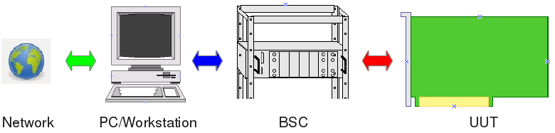
Figure 1: System M-1 components

There are some important features to point out:

- System M-1 includes a ready made PC with all the software required for test
- development, debugging and execution. The customer is freed from any software installation issues.

- Maintenance and support can be done remotely via the web interface. The network access may be corporate inside or from outside. The latter reduces traveling and on-site support.

- The operation system running on the shipped PC is Linux© . Linux is highly virus immune, long-term stable and highly network capable – a reasonable choice for an assembly line deployment.

- Crucial parts of the System M-1 software have been written in ADA 2005 that perfectly fits the requirements of safety critical applications !

- The software is open to user specific applications or graphical user interfaces (GUI) !

- The software is well modularized. Updating is done regarding the very module affected, not all across the system. Each module can be accessed via external software i.e. in regard to system integration (Flying-Probe-Test, In-Circuit-Test, AOI, System Test, QM, …)

- Large parts of the software are open sourced (GNU General Public License)

- All the software of System M-1 is shipped fully installed. The customer does not need to worry about issues like:

    - operating system
    - hardware platforms
    - driver software
    - licensing

- By default, the BSC provides power monitoring of 3 individual channels to protect the UUT from power failure.

- By default, the BSC provides a full galvanic separation from the UUT upon power failure, test FAIL or non-test-mode. The latter is a constraint for interaction with other test systems.

- The BSC comes in a robust 19 inch housing with rugged connectors for fast and safe UUT change.

- The BSC can operate autonomously from the PC. For fast pre-testing of UUTs the operator activity is reduced to pushing front panel buttons START and STOP. Two LEDs indicate PASS or FAIL.

Standard functions a Boundary-Scan-System acc. to IEEE1149.1 must provide are listed here without going further into the details at this point:

- Importing CAD data from any CAE system (Altium, ORCAD, ZUKEN, EAGLE , …)
- Minimal UUT access via a 5 wire serial test-bus (so called TAP)
- Adjustable TAP voltage (1.8V to 3.3V)
- Fault detection down to pin-level (stuck-at, shorts, opens, missing pull-resistor)
- Scan Path Test (Infrastructure Test)
- Interconnect Test
- Memory-Interconnect Test (RAM, FLASH)
- Digital Cluster Test
- Restricted ADC/DAC Test
- Clock Test
- Pin-Toggle Test
- System Test

Software Operation
A it is custom with UNIX and Linux applications, the system can be operated via a graphical user interface (GUI) as well as the command line. Major tactical functions for test execution and development/debugging are implemented in various executable files which can be launched individually by:
- local command line
- ANY graphical user interface
- ANY third party application (like Flying-Probe-Test, In-Circuit-Test, …) via system calls.
- remotely via network

The fact of several executable files eases system updates and bug fixing. A malfunctioning executable can easily replaced instead of updating the whole system.

In addition it should be pointed out that the system is open for any extension made by the customer or third parties. As graphical user interfaces are frequently subject to individual constraints it proved ineffective to ship an over-sophisticated GUI to customers.
For more background information on GUIs please read section 4 GUI Issues on page 27.

As said above, only the operation of the system in test execution mode will be shown briefly in the following chapters.

Test program development and setup is beyond the scope of this document and will be provided in a separate users manual.

File System
This section describes both the M-1 system files as well as the user specific files required for the Unit-Under-Test (UUT).

System Files
Per default, M-1 system files are to be found in directory “/opt/m-1/bin”. Here you find all executable files required for test program development and execution.
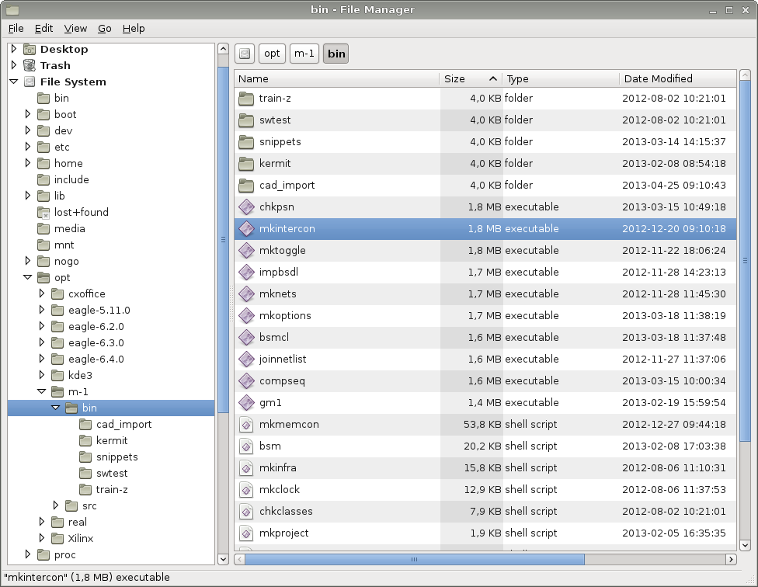Figure 2: M-1 System Files

User Files
User specific files belonging to UUTs are always stored in the respective home directory, e.g. /home/bsc_user/uut/...”.
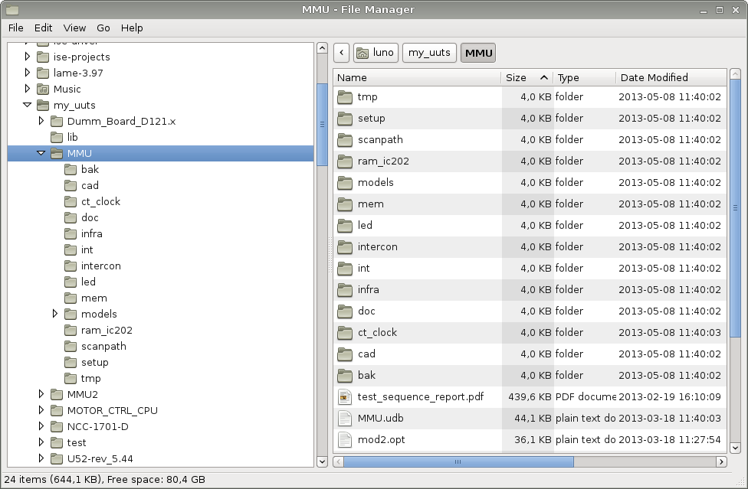Figure 3: User Files

In a Production Line
In the production mode the system is primarily operated via a graphical user interface.
The GUI provides only the most relevant functions required for a production line environment. In this mode, the operator cares usually only for:
- test selection
- test start
- if needed for the test result.

In the following screenshots of the lean and easy-to-use GUI that is shipped with System M-1 are shown.
As pointed out on page 13 section 3.3 Software Operation there may be any other tailor-made GUI implemented instead.

Test Preparation
In production mode, test execution is done via sequences. A test sequence may consist of a single or many individual tests. During test setup and development these sequences are defined.

The following steps are needed only once after system start up !

The first step upon system start is to upload all tests required into the Boundary Scan Controller by clicking the upload button (blue arrow in Figure 4).
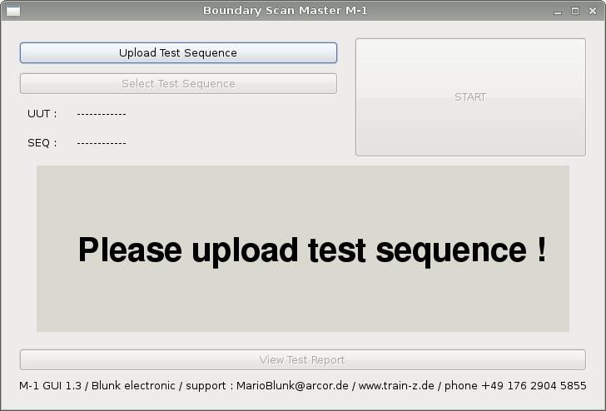Figure 4: System Start

The tests required for production are defined within an upload-file. It is located in the respective root directory of a UUT. The file extension is always *.load. In most cases this file is named load_all.load to indicate that all test are to be uploaded (Figure 5).

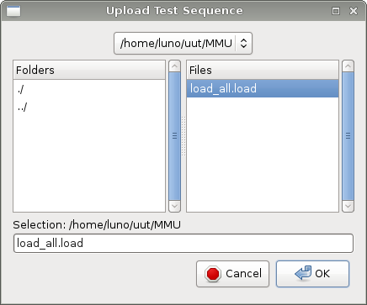Figure 5: Upload Test Sequence
Simultaneously the UUT is set without any further user interaction and test data is being uploaded (yellow arrow in Figure 6).

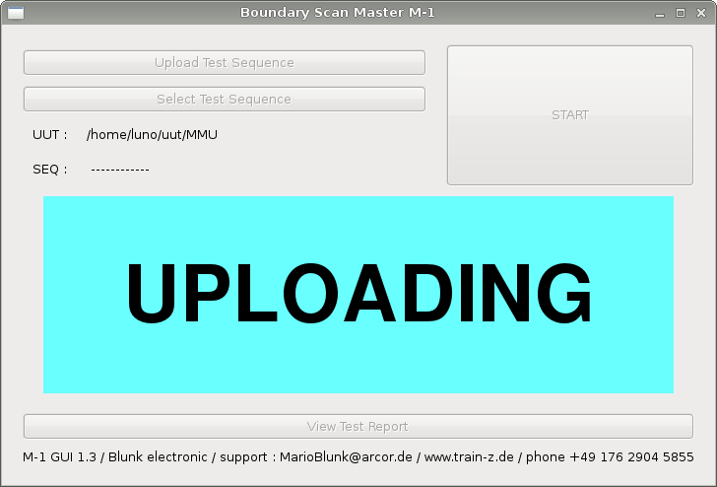Figure 6: Tests Uploading in Progress

Once the upload is done, a test sequence may be selected by clicking “Select Test
Sequence” (green arrow in Figure 7).

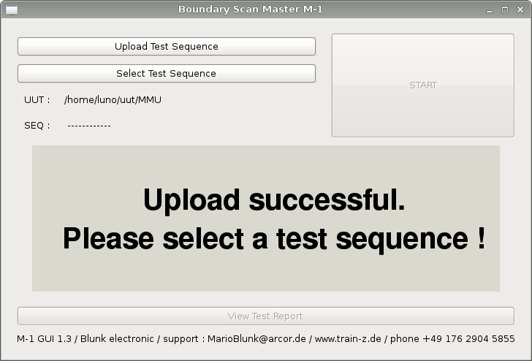Figure 7: Upload done
The test sequence files have by default the extension *.test. So, in our example there are two sequences available: run_all.test which indicates that all test are included in this sequence and test_connections.test. The naming or the test sequence file is not restricted, except the extension *.test of course, in order to tell the operator what kind of tests it is about.

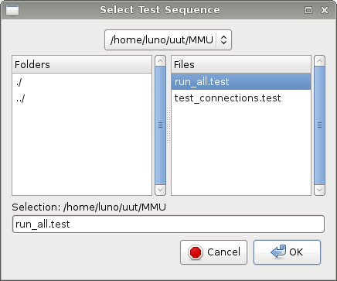Figure 8: Select Test Sequence

Figure 9 shows the software when it is ready to launch a test sequence. The operator clicks on the “START” button to get the test sequence executed (red arrow).

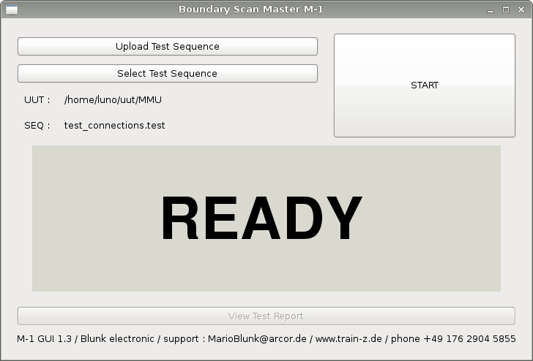Figure 9: ready for test
While the test sequence is being executed, the GUI displays a yellow “running” (Figure 10).
CAUTION: DO NOT DISCONNECT THE UUT FROM THE BOUNDARY SCAN CONTROLLER WHILE A TEST SEQUENCE IS BEING RUN !

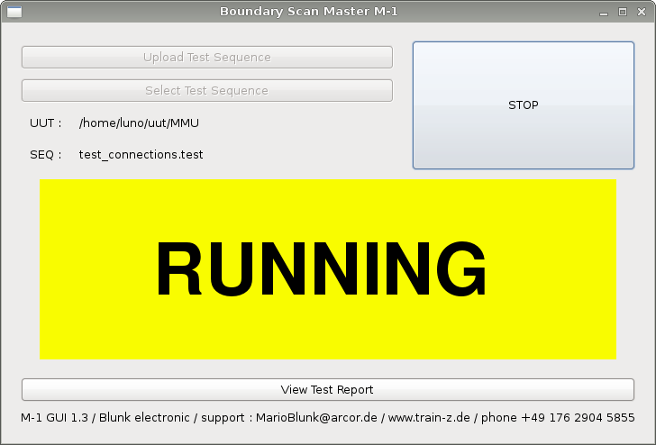Figure 10: Test Sequence Running
While test sequence run the operator waits until the test is done either with a nice green PASS or a bright red FAIL (Figure 11 and 12).
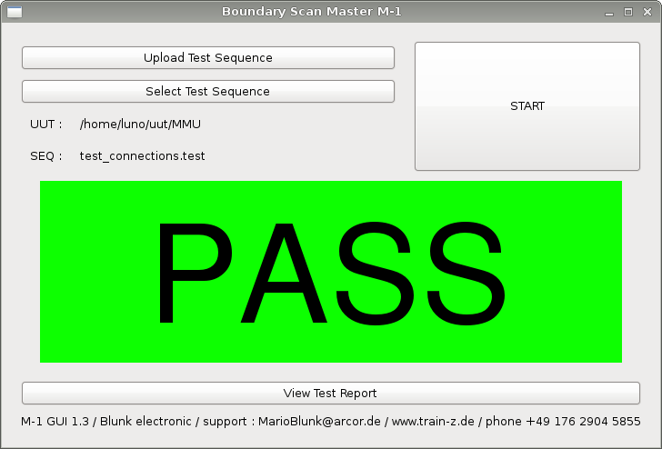Figure 11: Test Sequence Passed
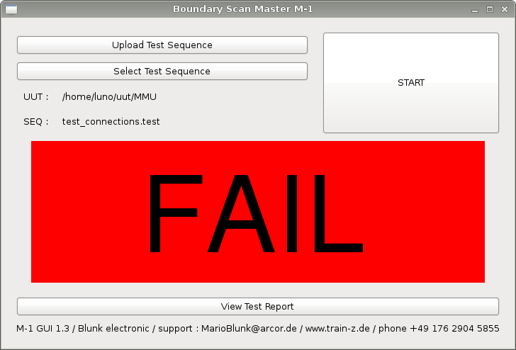Figure 12: Test Sequence Failed

Test Report
In case of a FAIL the PDF test report can be opened (Figure 12) and printed if the UUT is to be moved on to repair. Test reports may also be collected in an archive for the QM department.

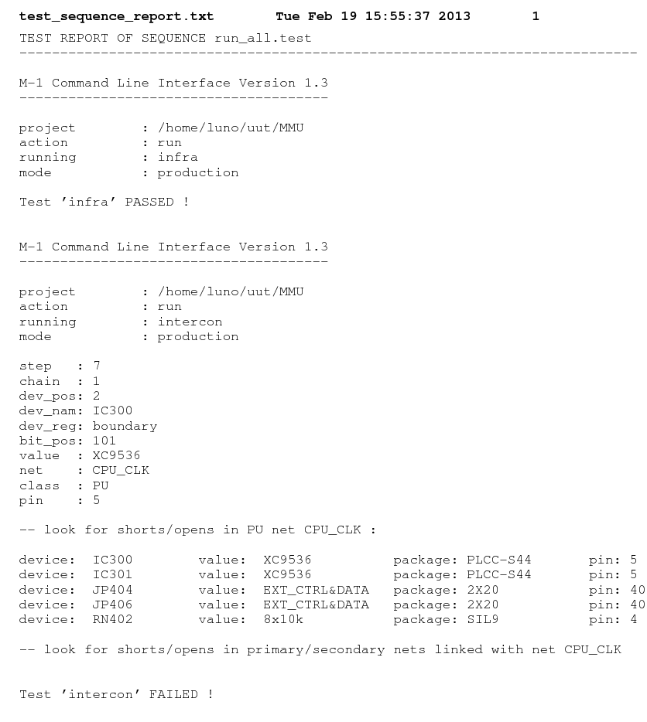Figure 13: PDF test report

User Interaction
Frequently the operator is requested to enter a number, a text or to acknowledge a certain event. For example: The LED H1 is to flash during a certain test. The sequencer asks the operator if her or he has watched it flashing properly. If the answer is “y” the test sequence continues. Otherwise the sequence is aborted with a bright red FAIL.

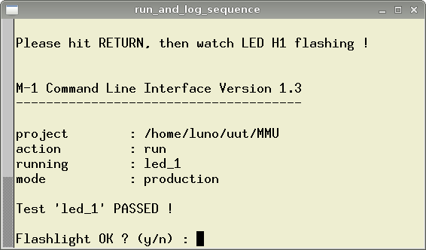Figure 14: Operator Interaction

PC-less Operation / Pre-Test
For a quick GO / NOGO pre-test of an assembled board, for example after reflow soldering, the Boundary Scan Controller (BSC) may be operated autonomously from the PC/Workstation.
As pointed out on page 16 section 3.5 In a Production Line , test execution is done sequence wise. The last test of the most recent executed sequence can be launched via the START button on the front panel of the Boundary Scan Controller (Figure 15).
The two LEDs at the front panel indicate PASS or FAIL without further detailed fault diagnostic.

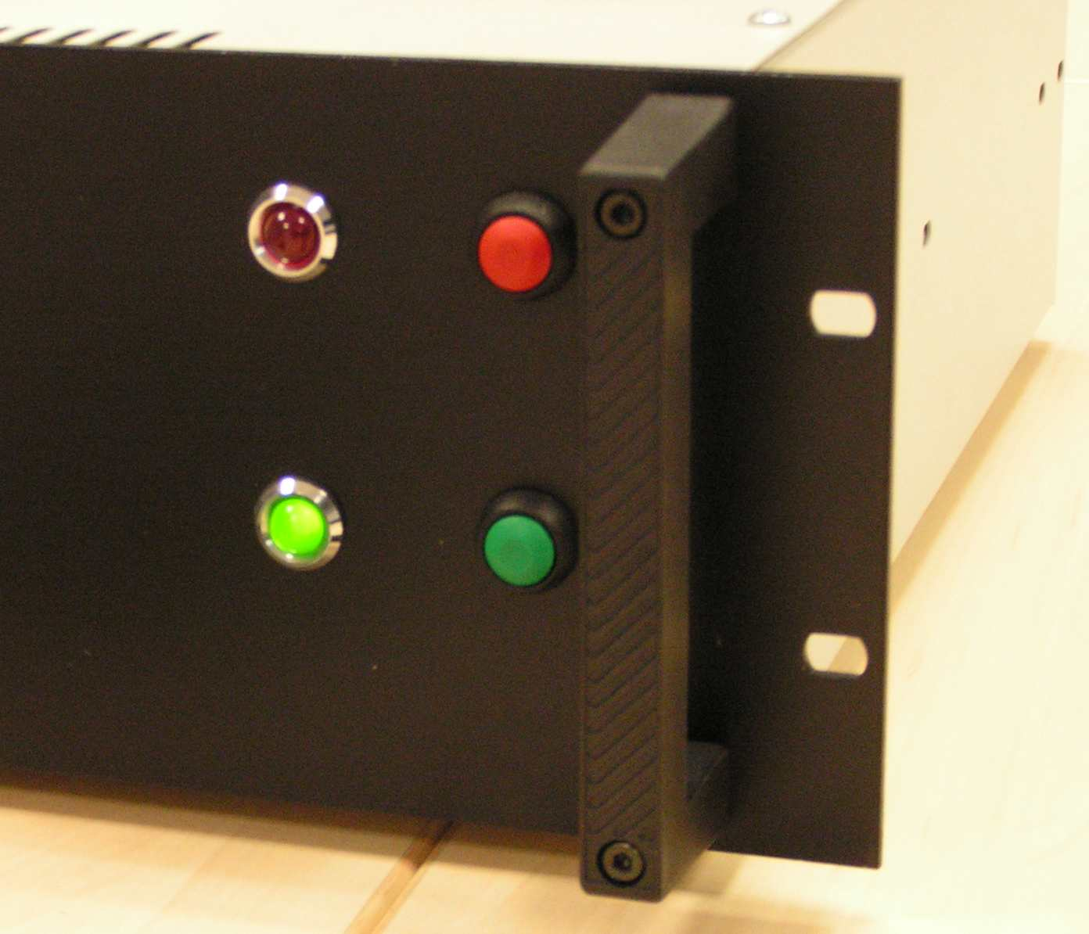Figure 15: PASS/FAIL LEDs and START/STOP Buttons

Hardware Operation
This section depicts the hardware that is the Boundary Scan Controller (BSC) which interfaces PC/Workstation and UUT.
STOP button
FAIL LED
START button
PASS LED
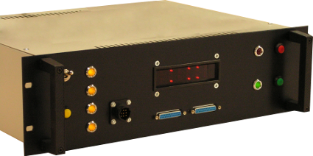
Scanpath/TAP 1/2
UUT power monitor & control

Figure 16: BSC front panel

Figure 17 shows an example of a UUT connected to the BSC. Ribbon cables carry the
Scanpath/TAP signals. Note the colored power wires connected to the UUT power monitor and control unit. The power supply itself is not shown here and must be provided by the customer.

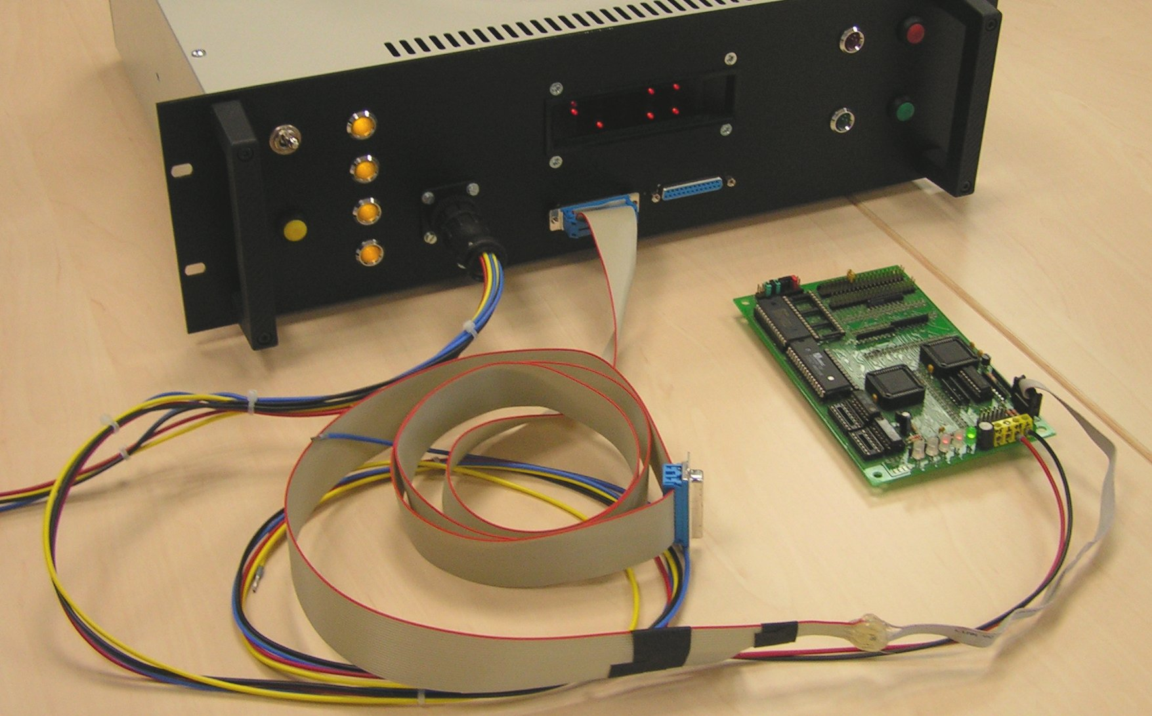Figure 17: UUT connected to BSC

GUI Issues
Over the years graphical user interfaces (GUI) for boundary scan test development, so called Integrated Desktop Environments (IDE), have been subject to countless discussions and reworking. There are some crucial issues with these GUIs:

- Customers often have their individual demands on GUIs.
- Fulfilling and maintain all the demands on a GUI devours time, manpower and money.
- By meeting all the customers requests, justified but countless wishes tend to accumulate in so called “featuritis” or bloatware.
- An “all-can-do-GUI” appears bloated and confusing (see page 29 References (3)) thus hiding the straight path to the intended outcome.

In order to stick to a lean software Blunk electronic has decided not to ship a GUI for setup and development with System M-1. By default all actions required for test program and test sequence setup are done via the UNIX/Linux command line interface:

- The user is guided though the setup process by the intelligent front end program bsmcl.
- bsmcl together with parameters can be accessed by external programs and applications via system calls.
- Templates for files are provided automatically.
- Command line parameters and options are shown in examples.
- 95 % of all data and control files are in ASCII format, thus allowing software verification, debug and easy manual editing.
- All ASCII files are in human readable format easy to read for electronics engineers and programmers.

On customers request a tailor-made GUI can be designed still. Please contact Blunk electronic for details.

Useful Links
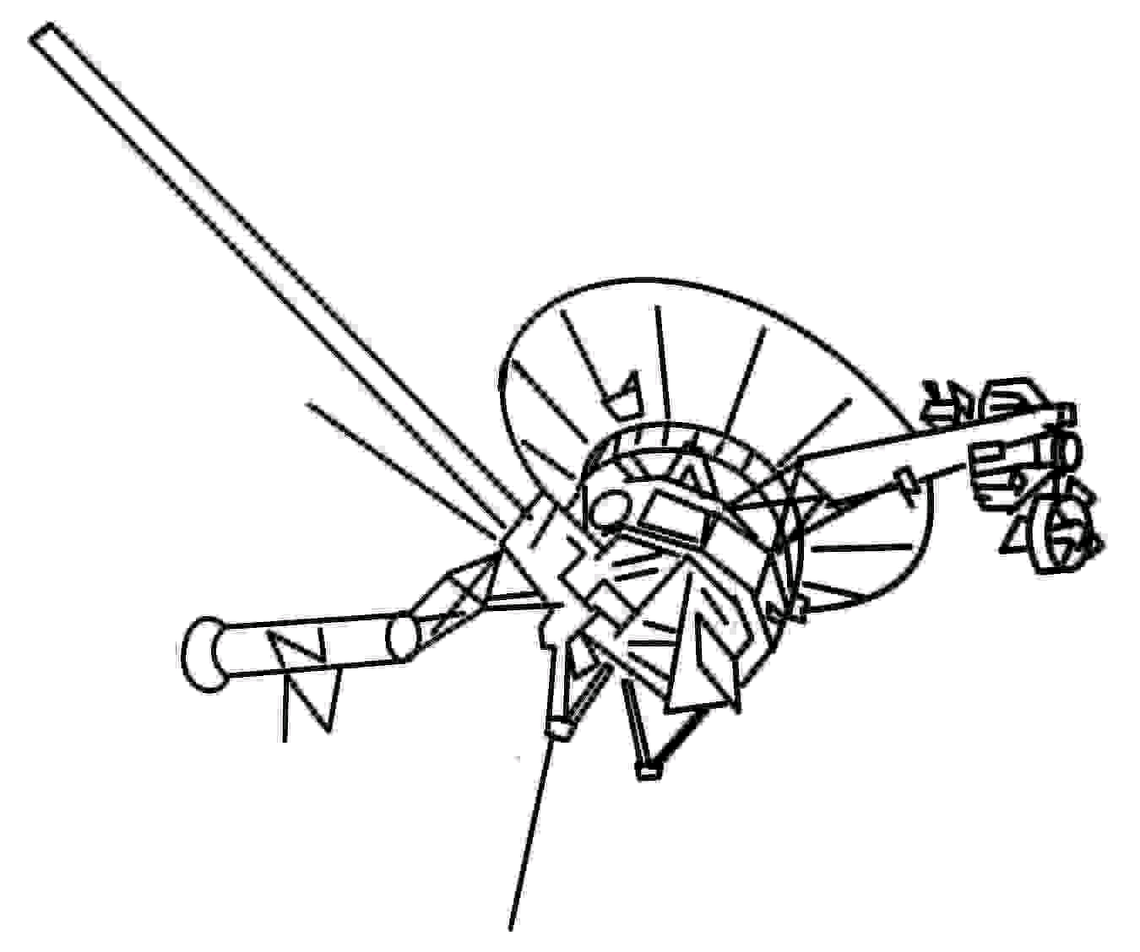
- Find updates of this document at
http://www.train-z.de

- What is Boundary Scan ?

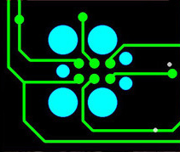
- Connect your Boundary Scan UUT with a Plug of Nails at www.Tag-Connect.com

- Debug SPI, I²C, Boundary Scan/JTAG and other hardware with the Logic Scanner
at http://www.train-z.de/logic_scanner/Logic_Scanner_UM.pdf

- CadSoft EAGLE Training and Consulting – a reasonable way to
reasonable work at http://www.train-z.de

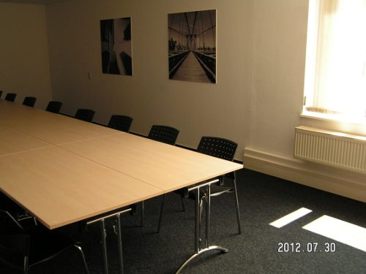
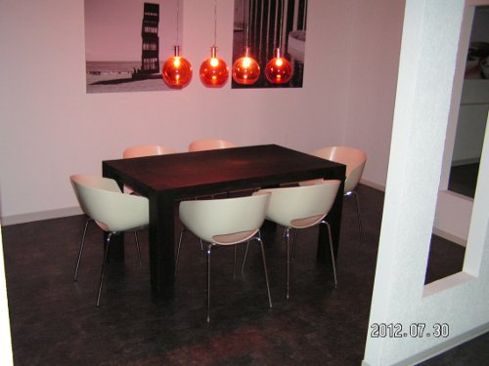
- ADA - the programming language for safe coding at www.adacore.com



- The office alternative : LibreOffice at http://www.libreoffice.org


References

- The Institute of Electrical and Electronics Engineers, Inc. , 3 Park Avenue, New York, NY 10016-5997, USA; IEEE Std 1149.1-2001 “IEEE Standard Test Access Port and Boundary-Scan Architecture”
- Mario Blunk, “A Guide to test methods and why to go for Boundary Scan” at http://www.train-z.de/bsm/how_to_test.pdf
- Niklaus Wirth (Wirthsches Gesetz): „A Plea for Lean Software“: E. Perratore, T. Thompson, J. Udell, and R. Malloy: „Fighting fatware“, Byte, Vol. 18, No. 4, April 1993, pp. 98-108

Disclaimer
This document is believed to be accurate and reliable. I do not assume responsibility for any errors which may appear in this document. I reserve the right to change it at any time without notice, and do not make any commitment to update the information contained herein.
Mario Blunk

-----------------------------------------
My Boss is a Jewish Carpenter

Blunk electronic / Holder : Dipl. Ing. Mario Blunk / Buchfinkenweg 5 / 99097 Erfurt / Germany +49 176 2904 5855 / http://www.train-z.de

© 2013 Mario Blunk Printed in Germany

These figures apply for the test procedure only. If additional data is to transferred into the UUT e.g. In-System-Programming (ISP), the time required is significantly more (in worst case up to 1hour).

