
PRODUCT BRIEF
Self-Assembly Kit

System TRAIN-Z
User Manual

Please read carefully before power up !

Doc. Version 2015-10-22-1
Author: Mario Blunk

Firmware Version: MAIN V9.3 / V9.4 , V9.5 / V9.6

Hardware Version: MAIN: V0.93r4
MMU: V1.01r4
Contents
1 Preface 5
2 System Overview 8
3 Hardware 8
3.1 Dimensions 8
3.2 Board MAIN 9
3.2.1.Schematics and Assembly Drawings 10
3.2.2.Oscillator and System Clock 11
3.2.3.Processor (CPU) 11
3.2.4.Serial Interface (SIO) 12
3.2.5.Counter Timer Channels (CTC) 15
3.2.6.Parallel Input-Output (PIO) 16
3.2.6.1 Configuration Handshake Signals 20
3.2.7.I²C-Bus 0 21
3.2.8.I²C-Bus 1 21
3.2.8.1 I²C-FLASH-EEPROM 21
3.2.8.2 I²C-Expander 22
3.2.9.External Reset and Non Mask-able Interrupt (NMI) 23
3.2.10.Z80-System Bus Connectors 24
3.2.11.Interrupt Priority Configuration 27
3.2.12.I/O-Addresses 28
3.3 Board MMU 29
3.3.1.Schematics and Assembly Drawings 31
3.3.2.4 kByte-ROM 32
3.3.3.27 kByte-SRAM 32
3.3.4.32 kByte-User-FLASH-EEPROM 33
3.3.5.32 kByte-SRAM 34
3.3.6.Z80 System Bus Connectors 35
3.3.7.Memory Map 38
3.4 Power Supply 38
4 RS232 and Terminal Program of the Host Computer 40
5 USB-to-RS232-Adapters 41
6 Operation and Command Set 43
6.1 I/O-Port Commands 45
6.1.1.portout 45
6.1.2.portin 45
6.2 I²C-Commands 46
6.2.1.rsti0 46
6.2.2.rsti1 46
6.2.3.i0f and i1f 46
6.2.4.i0p and i1p 47
6.3 Administrating the Memory 48
6.3.1.viewmem 48
6.3.2.copy 49
6.3.3.comp 50
6.3.4.fill 50
6.3.5.prgflash 50
6.3.6.eraseflash 51
6.3.7.testmem 52
6.3.8.load 53
6.3.9.Starting the User Program 56
6.3.9.1 call 56
6.3.9.2 Per Jumper 56
6.4 Miscellaneous 57
6.4.1.echooff 57
6.4.2.help 57
7 System Test 58
8 System Calls 58
8.1 Register Dump 58
9 Assemblers, Interpreters and Compilers 59
10 Device Mounting Options 60
11 Parts Delivered with System TRAIN-Z 61
12 Full Self-Assembly Shipment Option 61
13 RoHS conformity 61
14 Useful Links 62
15 Further Reading 64
16 Disclaimer 64

This page is left blank intentionally.

Preface
The ZiLOG Z80 is a 8-bit CISC microprocessor made and sold by ZiLOG from July 1976. It is one of the most popular microprocessors a whole generation of electronics and programmers has grown up with. It found usage in desktop and embedded computers – a wide spectrum from game console up to military applications. The Z80 derivatives and clones make this CPU the most used processor of all times. VHDL and Verilog Cores are also available (see section 14page 61 for more).

System TRAIN-Z does not aim to compete with the
powerful and sophisticated embedded computer systems of today.

What is System TRAIN-Z good for ?
- software development (assembly, C, ...)
- education and study (basics of computer engineering, programming, repair and maintenance)
- control and measurement
- education in assembly and troubleshooting of complex electronics

By consequent usage of ICs on sockets, THT devices and moderate clock frequencies of less than 11 Mhz the user has a robust and easy to repair computer system. System TRAIN-Z can be operated in the targeted application without any modifications. Photo 1 shows the hardware of System TRAIN-Z.

History:
To face the obsolescence of Z80-development tools System TRAIN-Z has come up. It is a very simple form of such a development system. During conception of System TRAIN-Z the key problem was to load a binary file (mostly this is Z80-machine code) into the RAM, test it and burn it into the on board FLASH-EEPROM.

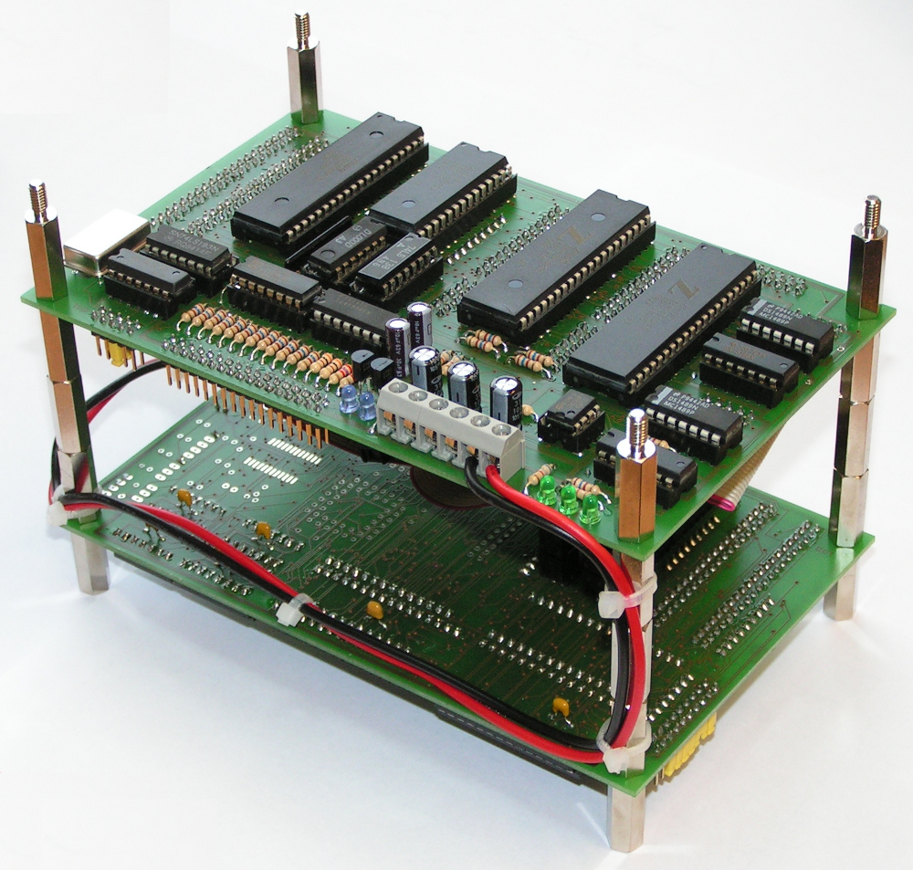Photo 1: System TRAIN-Z , view at board MAIN
What does System TRAIN-Z provide ?
- RS232-interface to host computer
- USB-Support via USB-to-RS232-Adapter with PL2303 chipset
- operating via terminal program running on host computer – thus not depending on any operation system of the host computer
- 4kByte bootloader and on board operating system
- hardware that can operate in the targeted application
- testing of the user written program in the 60kByte system RAM
- programming the user written program into the system 32 kByte-FLASH-EEPROM
- execution of the user written program at system start (see section 6.3.9 page 55)
- open system bus for user made hardware extensions
- I²C support for peripheral devices
- The user is free to change mountings of components, to make own configurations of both hardware and software.
- debugging via system call Register Dump

What does System TRAIN-Z NOT provide ?
- Any Z80 assembler, compiler or interpreter software (see section 9 page 58)
- single step program execution
- breakpoints
- video interfaces like VGA, composite, ...

System Overview
Drawing 1 shows System TRAIN-Z as a whole and its interaction with the host computer. This can be any computer that is equipped with a serial RS232 interface and a terminal program. So System TRAIN-Z can be operated with Linux, UNIX, MS-DOS and MS-Windows. Terminal programs of these operating systems are for example Minicom or HyperTerminal.

For information about the RS232 settings see section 4 page 39.

Drawing 1: overview System TRAIN-Z
MMU

MAIN

Z80 Addres & Cntrl Bus
TRAIN-Z

Host Computer +
Terminalprogram

Z80 Data & Cntrl Bus
JP406
JP404

JP407
JP405

JP6

JP12

user specific periphery

JP2

RS 232 null-modem

COMx
ttySx
power suppy +5V / +12V / -12V / GND

Hardware
The physical assembly consists of two Euro-Boards (100 x 160 mm), the main board MAIN and the memory board MMU (Memory Management Unit). Following sections describe the operation modes of system components related to System TRAIN-Z. The user is free to change them for his own needs.

Dimensions
The assembly of System TRAIN-Z as shown by Photo 1 on page 6 make the system having the following outline: 160 x 100 x 120 mm. By removing the stand offs the two boards became loose so that the user can mount them on his own way.

Board MAIN
A photo of this board shows Photo 2.
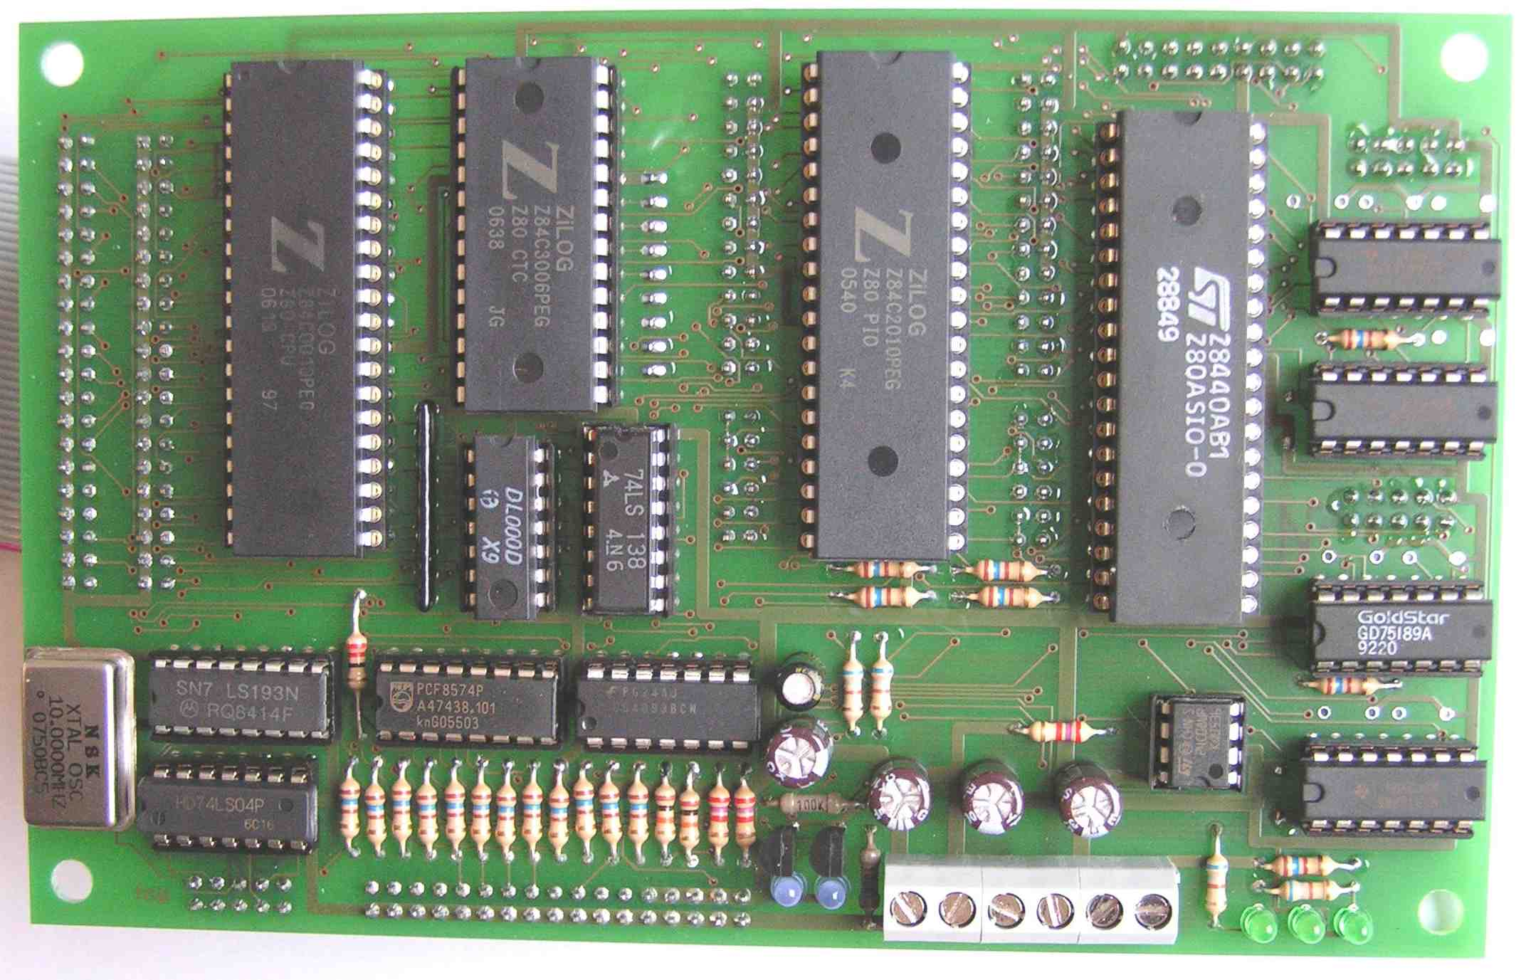Photo 2: top side of MAIN
Drawings 2 shows MAIN with its most relevant components.

Drawing 2: overview board MAIN
Ch A

CTC

PIO

PWR

CPU-Bus
CPU

Port B
Port A
I/O-Adr
Decoder

Oscillator +
CLK selector JP5

Cntrl & Adr JP 12 / Cntrl & Data JP6

I²C-FLASH-
EEPROM

I²C-PIO

JP 1

JP 10

LEDs
D0 & 1

JP 4

X1

X2

JP 7

JP 2

JP 20

INT-Priority

MAIN

JP 3

Ch B

SIO

Schematics and Assembly Drawings
As these drawings are updated from time to time they have been removed from this document. Please find them at:

http://www.train-z.de/train-z/hw

Oscillator and System Clock
The 10Mhz-master clock generates oscillator QG1. By means of a frequency divider the master clock gets divided by 2, 4, 8 and 16. JP5 allows the selection of the desired system clock by plugging a jumper on it. Default setting is 2,5Mhz. SeeTable 1.
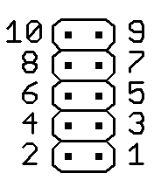Drawing 3: pins of JP5
jumper plugged on | system clock | comments
10 - 9 | 0,625 Mhz
8 - 7 | 1,25 Mhz
6 - 5 | 2,5 Mhz | default
4 - 3 | 5 Mhz
2 - 1 | 10 Mhz | not tested !
Table 1: jumper positions on JP5

The frequency of the system clock directly affects the data rate of the serial interface (see section 4 page 39) as well as all other timings withing System TRAIN-Z.
Note:
A system clock higher than 2,5 Mhz can be run safely only if all components depending on it support this clock frequency.

Processor (CPU)
Regarding the type of CPU mountable see section 10 page 59. See datasheet for more information.

Serial Interface (SIO)
Basically both channels A and B of the SIO can be used. System TRAIN-Z uses only channel A for the RS232. Transmit- and receive clock of both channels is fed by the CTC unit. Please see section 3.2.5 page 15 for information on the CTC. Channel A is connected to JP2 (physical view in Drawing 4, signals in Table 2), channel B on JP7 (physical view in Drawing 4, signals in Table 3). The state of line RI (Ring Indicator) can be monitored by PIO Port B. See section 3.2.6 page 16 for more.
Drawing 4: pins of JP2/7
If System TRAIN-Z is to be operated in an electromagnetic harsh environment the line receivers IC8 and IC10 may be equipped with external capacitors C28, 29, 30, 31 / C23, 25, 26, 27 in order to block noise from the lines RXD, CTS, DCD and RI. See datasheet of the line receivers regarding external capacitor values. The line receiver and driver IC are 1489 and 1488 compatible in order to fully meet the voltage specifications of the RS232 interface.
Regarding the mounting options see section 10 page 59. See datasheets for more information.
Please read about the settings of the RS232 in section 4 page 39. Operation via USB-to-RS232-Adapter is supported. Please read more in section 5page 40.

pin no. | signal | comments
10
9 | GND | - maximum load 100mA !  - Do NOT use as protective ground !
8 | RI | via series resistor connected to PIO B4
7 | DTR
6 | CTS
5 | TXD
4 | RTS
3 | RXD
2
1 | DCD
Table 2: signals of SIO channel A connected to JP2
pin no. | signal | comments
10
9 | GND | - maximum load 100mA !  - Do NOT use as protective ground !
8 | RI | via series resistor connected to PIO B5
7 | DTR
6 | CTS
5 | TXD
4 | RTS
3 | RXD
2
1 | DCD
Table 3: signals of SIO channel B connected to JP7

The signal wirings on JP2 and JP7 are made according to standardized adapters from 2x5 pin pinheader to 9 pin D-Sub (Photo 3on page 14). Table 4 on page 14 shows the wiring of this adapter which can be found in many PCs to contact the serial interface COMx or ttySx. Line DSR is not used by System TRAIN-Z. Pin 2 of JP2 and JP7 is not connected.

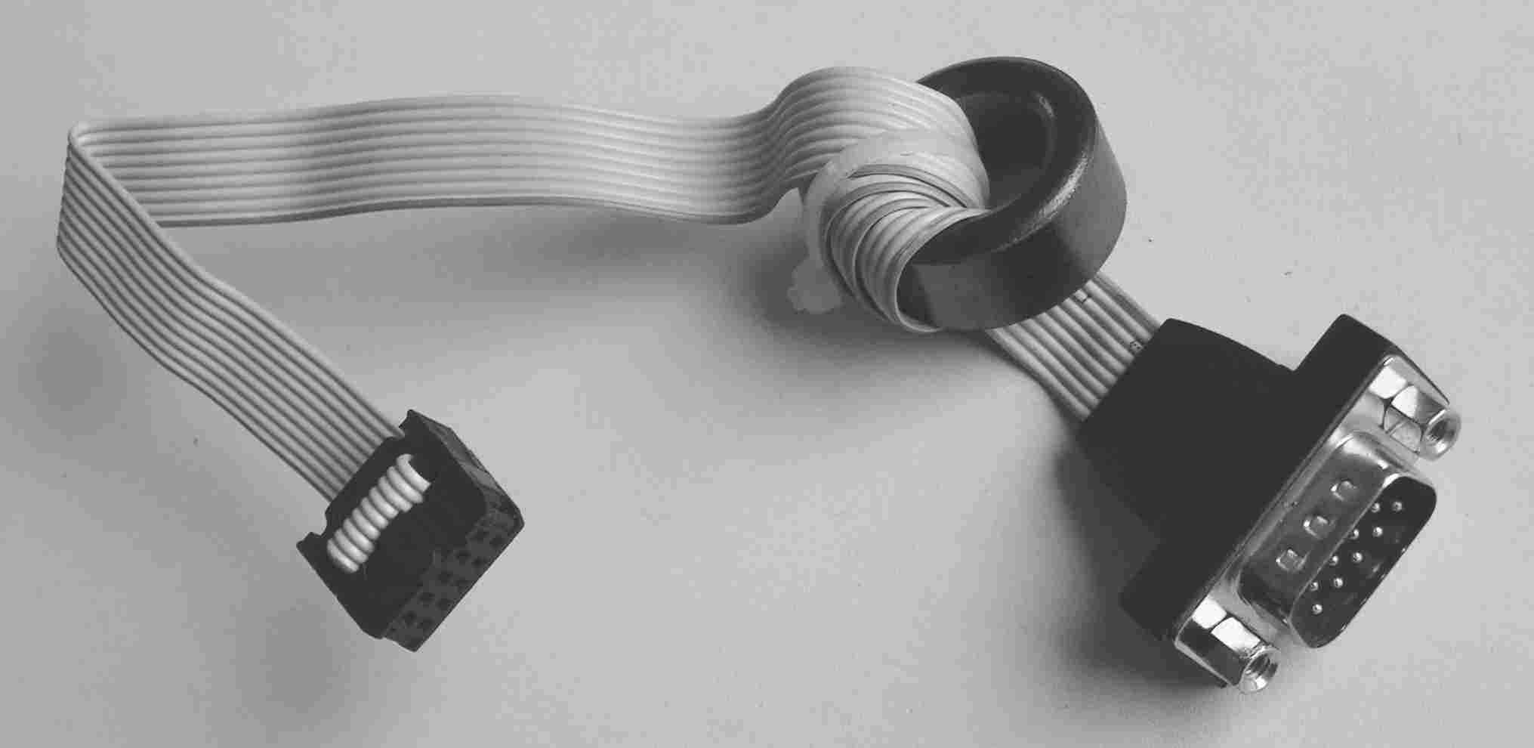Photo 3: RS232 adapter (ferrit core not required)
10 pol. pinheader | 9 pin D-Sub male | comments
10
9 | 5 | signal GND
8 | 9 | Ring Indicator (RI)
7 | 4 | Data Terminal Ready (DTR)
6 | 8 | Clear to Send (CTS)
5 | 3 | Transmit (TXD)
4 | 7 | Request to Send (RTS)
3 | 2 | Receivce (RXD)
2 | 6 | Data Set Ready (DSR)
1 | 1 | Data Carrier Detect (DCD)
Table 4: wiring of RS232 adapter as shown on Photo 3

Counter Timer Channels (CTC)
CTC0 feeds the transmit and receive clock into SIO channel A. CTC1 feeds the transmit and receive clock into SIO channel B. CTC2 and CTC3 are used by System TRAIN-Z for a very simple system test. Please see section 7 on page 57 for more. JP3 (see Drawing 5) is wired to all CTC-signals according to Table 5 on page 15.
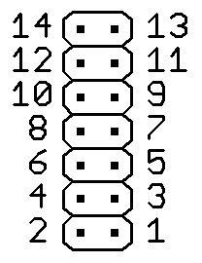Drawing 5: pins of JP3

Regarding the mounting options see section 10 page 59. See datasheet for more information.

pin no. | signal | comments
2, 4, 6, 8, 10, 12, 14 | GND | total maximum load 100mA !
13 | TRG3 | for system test connect to pin 11, internally pulled up by 10k resistor
11 | TO2 | for system test connect to pin 13
9 | TRG2 | internally pulled up by 10k resistor
7 | TO1
5 | TRG1 | internally pulled up by 10k resistor
3 | TO0
1 | TRG0 | internally pulled up by 10k resistor
Table 5: CTC-signals connected to JP3

Parallel Input-Output (PIO)
The Z80 PIO has two ports. Port A is free for any usage. Exception is the system test – described in section 7 on page 57 ! The logical state of signals A0 and A1 is displayed by the LEDs D0 and D1. Primarily port B controls both the I²C-buses 0 and 1, the monitoring of the RI-signals and the system start (see section 6.3.9 page 55). Minor hardware modifications by the user make port B free for any usage. Table 6 and 7 on page 18 give the wiring of port A and B.
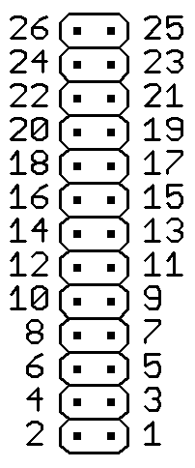Drawing 6: pins of JP10/1
JP10 and JP1 are wired in a way that allows the usage of adapters from 2x13 pin pinhead to 25 pin D-Sub female connectors (Photo 4 page 18). The wiring of these adapters can be found in Table 8 page 19. Adapters of this kind are used in many PCs to connect the printer port LPTx or lpx.

Regarding the mounting options see section 10 page 59. See datasheet for more information.
pin no. | signal | comments
1 | STRB | see section 3.2.6.1 page 20
2
3 | A0 | state showed by D0, internally pulled up by 10k resistor
4
5 | A1 | state showed by D1, internally pulled up by 10k resistor
6
7 | A2 | internally pulled up by 10k resistor
8
9 | A3 | internally pulled up by 10k resistor
11 | A4 | internally pulled up by 10k resistor
13 | A5 | internally pulled up by 10k resistor
15 | A6 | internally pulled up by 10k resistor
17 | A7 | internally pulled up by 10k resistor
19 | /ACK | see section 3.2.6.1 page 20
21 | BSY | see section 3.2.6.1 page 20
10, 12, 14, 16, 18, 20, 22, 24 | GND | total maximum load 100mA !
Table 6: signals of PIO port A connected to JP10

pin no. | signal | comments
1 | STRB | see section 3.2.6.1 page 20
2
3 | SCL0 | see section 3.2.7 page 21, internally pulled up by 10k resistor
4
5 | SDA0 | see section 3.2.7 page 21, internally pulled up by 10k resistor
6
7 | B2 | see section 3.2.8 page 21, internally pulled up by 10k resistor
8
9 | B3 | see section 3.2.8 page 21, internally pulled up by 10k resistor
11 | B4 | connected to signal RI of SIO Ch. A, internally pulled up by 10k resistor
13 | B5 | connected to signal RI of SIO Ch. B, internally pulled up by 10k resistor
15 | B6 | internally pulled up by 10k resistor
17 | B7 | see section 6.3.9 page 55, internally pulled up by 10k resistor
19 | /ACK | see section 3.2.6.1 page 21
21 | BSY | see section 3.2.6.1 page 20
10, 12, 14, 16, 18, 20, 22, 24 | GND | total maximum load 100mA !
Table 7: signals of PIO port B connected to JP1

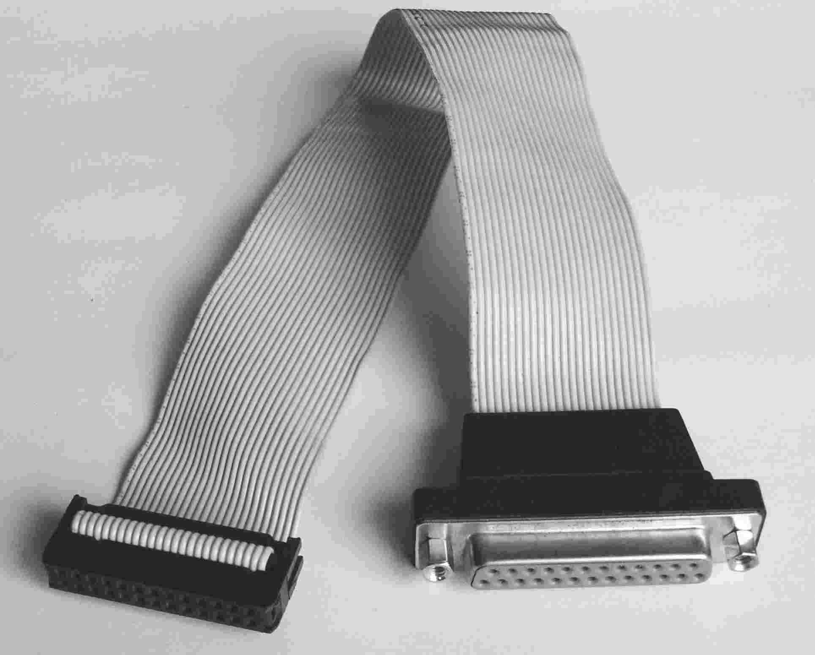Photo 4: parallel port adapter
26 pin pinhead | 25 pin D-Sub female | comments
1 | 1 | /STRB
3 | 2 | Data 0
5 | 3 | Data 1
7 | 4 | Data 2
9 | 5 | Data 3
11 | 6 | Data 4
13 | 7 | Data 5
15 | 8 | Data 6
17 | 9 | Data 7
19 | 10 | /ACK
21 | 11 | BUSY
23 | 12 | PAPER out
25 | 13 | SEL out
2 | 14 | /AUTOFD
4 | 15 | /ERROR
6 | 16 | /INIT
8 | 17 | SEL in
26
10, 12, 14, 16, 18, 20, 22, 24 | 18 - 25 | signal GND
Table 8: wiring of parallel port adapter as shown on Photo 4

Configuration Handshake Signals
The handshake signals of PIO port A and B can be customized on JP11 and JP9 regarding the desired data flow. Per default no Jumper is plugged on both JP11 or JP9. Drawing 7 shows the pin numbering of JP11 and 9. Table 9 and 10 on page 20 give possible configurations.

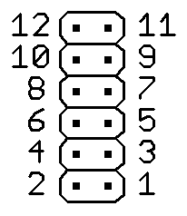Drawing 7: Pins of JP11/9
The PIO pins /ASTRB and /BSTRB are connected internally to 10k pull-up resistors.

jumper plugged on | signal flow | comments
1 – 2 | ARDY drives /ACK to periphery
3 – 4 | ARDY drives BUSY to periphery
5 – 6 | ARDY drives /STRB to periphery
7 – 8 | periphery drives /STRB to ASTRB
9 – 10 | periphery drives BUSY to ASTRB
11 – 12 | periphery drives /ACK to ASTRB
Table 9: jumper positions on JP11

jumper plugged on | signal flow | comments
1 – 2 | BRDY drives /ACK to periphery
3 – 4 | BRDY drives BUSY to periphery
5 – 6 | BRDY drives /STRB to periphery
7 – 8 | periphery drives /STRB to BSTRB
9 – 10 | periphery drives BUSY to BSTRB
11 – 12 | periphery drives /ACK to BSTRB
Table 10: jumper positions on JP9

I²C-Bus 0
The Z80 PIO port B operates as master of I²C-bus 0. User specific external I²C hardware can be connected to it. I²C-bus 0 is accessible at JP1 pins 3 (SCL0) and 5 (SDA0) (see Table 7 page 18). The PIO drives from its port B0 via a series resistor the signal SCL0. Port B1 drives in the same manner signal SDA0. There is no pull-up resistor for any external hardware required on SCL0 or SDA0.

I²C-Bus 1
The Z80 PIO port B operates as master of I²C-bus 1. Its purpose is to control the I²C-FLASH-EEPROM and I²C-expander of board MAIN. The PIO drives from its port B2 via a series resistor the signal SCL1. Port B3 drives the same way signal SDA1. SCL1 and SDA1 are not directly wired to JP1 (see Table 7 page 18). A pull-up resistor is already connected to both SCL1 and SDA1 each.

I²C-FLASH-EEPROM
Connected to I²C-bus 1 is a FLASH-EEPROM where the user may store any data. This storage is hard wired to address 001b. Depending on the type mounted this address is important when accessing the device.
Regarding the mounting options see section 10 page 59. See datasheet for more information. For commands to read or write the device see section 6.2 page 45.

I²C-Expander
Another member of I²C-bus 1 is the I²C-expander, which can be used to monitor or control external periphery. The address of the I²C-expander is hardwired to 000b. All its parallel inputs and outputs are protected against current overloading by series resistors of 160 Ohms. On the other end these resistors are connected to JP4. 160 Ohms allow direct connecting of LEDs or 7-segment-displays to JP4. Table 11 on page 22 shows the signals of the I²C-expander on JP4. Please see datasheet for more information.

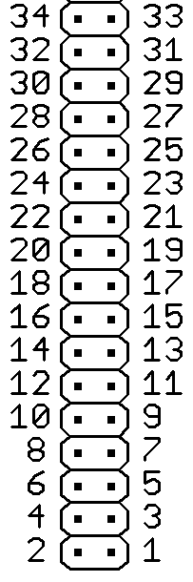Drawing 8: pins of JP4
Regarding the mountable type see section 10 page 59.

Commands required to write or read the I²C-expander are to be found in section 6.2 on page 45.
pin no. | signal | comments
1 | P7
3 | P6
5 | P5
7 | P4
9 | P3
11 | P2
13 | P1
15 | P0
17
19 | /EXT_NMI | see section 3.2.9 page 23
21 | /EXT_RESET
23 | RESET LED cathode
25, 27, 29, 31, 33 | +5V | total maximum load 100mA !
2, 4, 6, 8, 10, 12, 14, 16, 18, 20,  22, 24, 26, 28, 30, 32, 34 | GND | total maximum load 200mA !
Table 11: signals of the I²C-expander connected to JP4

External Reset and Non Mask-able Interrupt (NMI)
At pin 19 of JP4 a non mask-able interrupt may be triggered. At pin 21 an external system- RESET can be triggered. See Drawing 8 on page 22 and Table 11 on page 22 for the signals on JP4.
Note: To ensure a proper and safe start of System TRAIN-Z the external Reset must be active during power up and beyond for at least 1 second !
Behind pin 19 and 21 each an RC-lowpass and a Schmitt-Trigger are implemented which shape the signals applied there and drive them to the /NMI-input and the /RESET-input of the CPU. Optionally the active external system RESET can be displayed by an external LED. It is to be connected by its cathode on JP4 pin 23 and by its anode on +5V. No series resistor is needed for the LED.
System TRAIN-Z handles external NMI the same way as external reset: Address 0000h gets jumped to whereupon the execution of code residing there begins. The contents of all the SRAMs are NOT erased or altered.
See section 6.3.9 page 55 for execution of code in the 32 kByte-User-FLASH-EEPROM immediate after external reset or NMI.

Z80-System Bus Connectors
All signals of the system bus are connected to JP6 and JP12. JP6 holds the data bus D[7..0], JP12 holds the address bus A[15..0]. The control signals are distributed on both JP6 and JP12. Drawing 9 shows the pins of JP6 and 12. If ribbon cables get plugged on JP6 and JP12 the result is a GND signal between two bus signals. Most suitable are IDE-ribbon cables used in many PCs (Photo 5 page 24). Table 12 on page 25 and Table 13 on page 26 give the signals connected to JP6 and JP12.

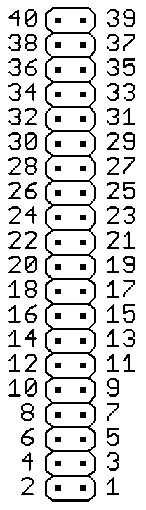Drawing 9: pins of JP6/12
Note: All wires of the IDE-ribbon cables must be accessible.
Note: Except /RESET, /NMI and CLK each output signals of the system bus is capable of driving maximal one Std. TTL input.

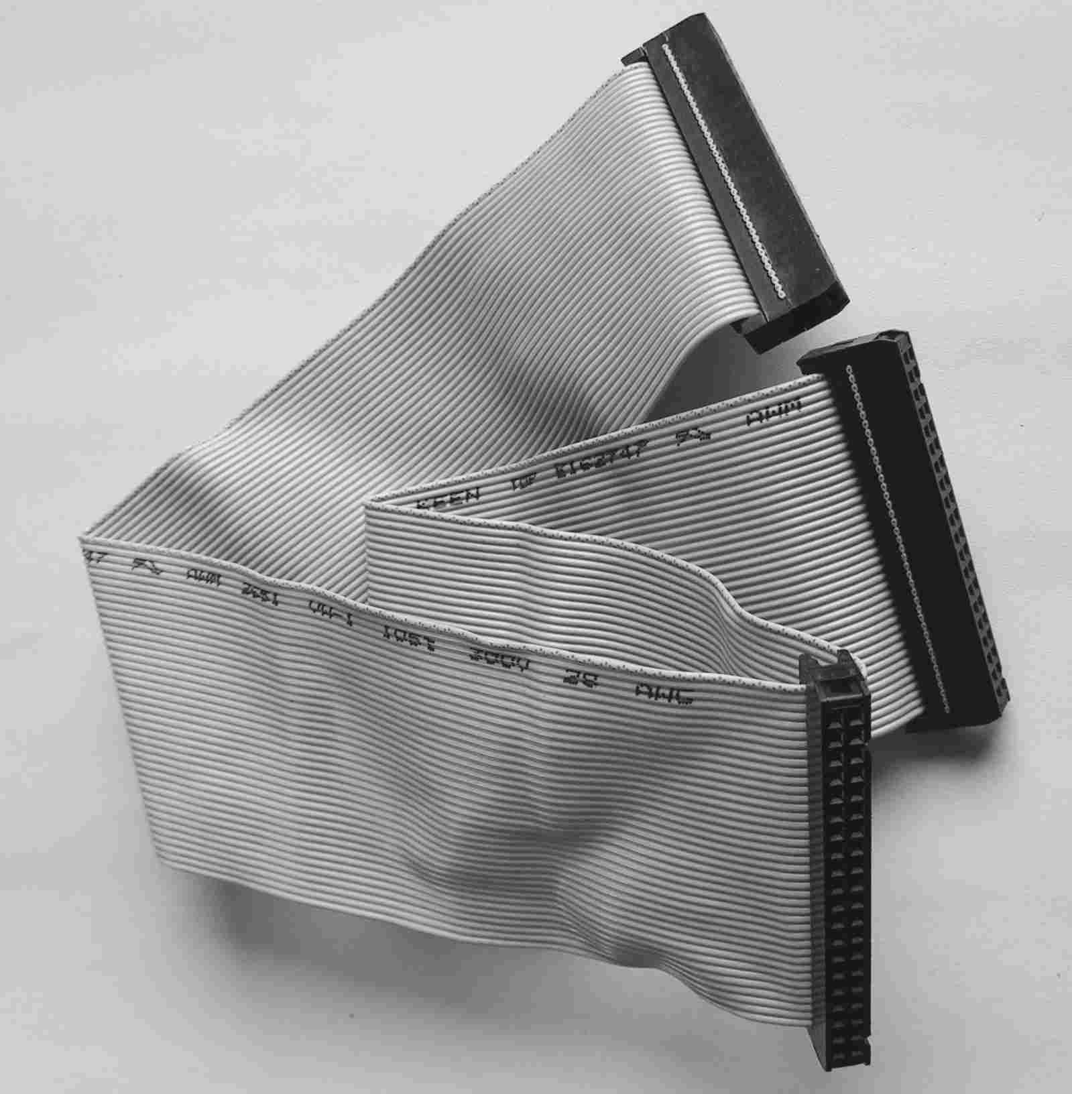Photo 5: 40 pin IDE connector
pin no. | signal | comments
2 | D0 | not buffered
4 | D1 | not buffered
6 | D2 | not buffered
8 | D3 | not buffered
10 | D4 | not buffered
12 | D5 | not buffered
14 | D6 | not buffered
16 | D7 | not buffered
18 |  | reserved
20 | /M1 | not buffered
22 | /MREQ | not buffered
24 | /IOREQ | not buffered
26 | /RD | not buffered
28 | /WR | not buffered
30 | /RFSH | not buffered
32 | /HALT
34 | /WAIT | has an internal 10k pull-up-resistor
36 | /BUSREQ | has an internal 10k pull-up-resistor
38 | /BUSACK | not buffered
40 | system clock CLK
1, 3, 5, 7, 9, 11, 13, 15, 17, 19, 21, 23, 25, 27, 29, 31, 33, 35, 37, 39 | GND | total maximum load 100mA !
Table 12: system bus signals connected to JP6

pin no. | signal | comments
2 | A0 | not buffered
4 | A1 | not buffered
6 | A2 | not buffered
8 | A3 | not buffered
10 | A4 | not buffered
12 | A5 | not buffered
14 | A6 | not buffered
16 | A7 | not buffered
18 | A8 | not buffered
20 | A9 | not buffered
22 | A10 | not buffered
24 | A11 | not buffered
26 | A12 | not buffered
28 | A13 | not buffered
30 | A14 | not buffered
32 | A15 | not buffered
34 | EXT IEI | see section 3.2.11 page 27
36 | /INT | not buffered, has an internal 10k pull-up-resistor
38 | /NMI | has an internal 10k pull-up-resistor, see section 3.2.9 page 23
40 | /RESET | has an internal appr. 80 Ohms pull-up-resistor, see section 3.2.9 page 23
1, 3, 5, 7, 9, 11, 13, 15, 17, 19, 21, 23, 25, 27, 29, 31, 33, 35, 37, 39 | GND | total maximum load 100mA !
Table 13: system bus signals connected to JP12

Interrupt Priority Configuration
To JP20 the IEO/IEO signals of CTC, SIO, PIO and the IEI signal of the external periphery are connected. Here the configuration of the interrupt priority order is possible. Drawing 10 shows the pin numbers of JP20 and Table 14 gives the signals connected to it.

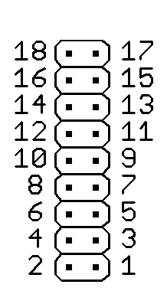Drawing 10: pins of JP20
Please do not change jumper positions of pins 11 to 17. Per default 15 and 16 are connected.

pin no. | signal | comments
10 | +5V | maximum load 100mA !
9 | CTC IEI | via Jumper per default connected to pin 10, internally connected to a 10 pull-up resistor
8 | SIO IEI | via Jumper per default connected to pin 7, internally connected to a 10 pull-up resistor
7 | CTC IEO | via Jumper per default connected to pin 8
6 | SIO IEO | via Jumper per default connected to pin 5
5 | PIO IEI | via Jumper per default connected to pin 6, internally connected to a 10 pull-up resistor
4 | external IEI | via Jumper per default connected to pin 3
3 | PIO IEO | via Jumper per default connected to pin 4
2 | GND | total maximum load 50mA !
1 | GND | total maximum load 50mA !
Table 14: interrupt configuration signals connected to JP20

Thus per default following priority order is set:
- CTC (highest priority)
- SIO
- PIO
- external periphery (lowest priority)

I/O-Addresses
Table 15 gives an overview of I/O-addresses already used by System TRAIN-Z.
periphery / channel | I/O-address | comments
CTC / 0 | 00h
CTC / 1 | 01h
CTC / 2 | 02h
CTC / 3 | 03h
SIO A / Data | 04h
SIO A / Control | 06h
SIO B / Data | 05h
SIO B / Control | 07h
PIO A / Data | 08h
PIO A / Control | 0Ah
PIO B / Data | 09h
PIO B / Control | 0Bh
Table 15: I/O-addresses of System TRAIN-Z

Board MMU
Photo 6 shows a photo of the MMU.
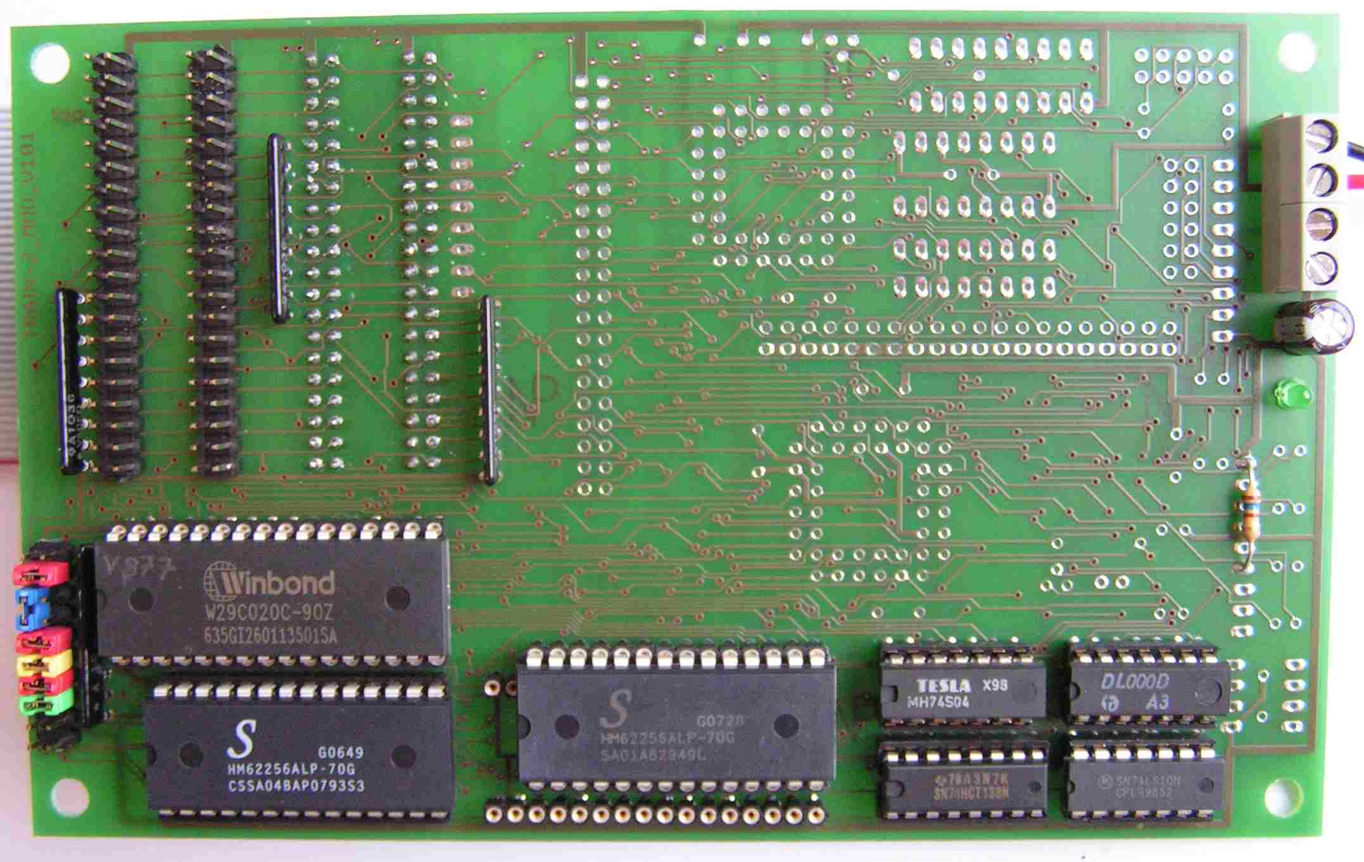Photo 6: top side of MMU

Drawing 11 illustrates the board MMU with its most relevant components.

Drawing 11: overview of board MMU
4 kByte
ROM

28 kByte
SRAM

CPU-Bus
Mem Adr
Decoder

Cntrl & Adr JP 405, JP407 /
Cntrl & Data JP 404, JP406

32 kByte
SRAM

32 kByte
User
FLASH-EEPROM

FLASH
configuration
JP 200

X400

PWR

MMU

Schematics and Assembly Drawings
As these drawings are updated from time to time, they have been removed from this document. Please find them at:

http://www.train-z.de/train-z/hw
and open sourced at:
https://github.com/Blunk-electronic/TRAIN-Z

4 kByte-ROM
The read only memory block holds the tiny operating system and the bootloader of System TRAIN-Z and uses the address range shown in Table 18 on page 37.
Regarding the mountable type see section 10 on page 59. Please read the datasheet for more.

26 kByte-SRAM
The mounting of this memory block is mandatory for the operating system of System TRAIN-Z. This memory block is free for use by the user. Files to be downloaded from the host computer into System TRAIN-Z may be put onto any location within these 26 kBytes of RAM. Please see section 6.3.8 on page 52 for more. The content of this memory block is NOT erased or altered by NMI or system Reset.
Regarding the mountable type see section 10 on page 59. Please read the datasheet for more.

32 kByte-User-FLASH-EEPROM
The user is free to store his own non volatile data or program code here. To program this memory area specific commands are available. Please read section 6.3 on page 47 for more. Table 18 on page 37 gives an overview of the address rage used by the 32 kByte-user-FLASH-EEPROM. It's possible to execute code residing there immediately after system reset or by a specific command. More can be read in section 6.3.9 on page 55.
The 32 kByte-user-FLASH-EEPROM can be mounted only, when the 32-kByte-SRAM is NOT mounted. Due to the same address range these two blocks share, both can not be mounted at the same time. See Table 18 on page 37.

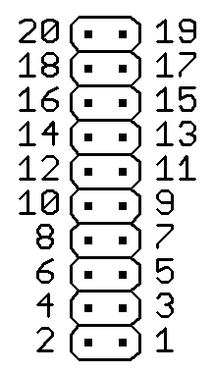Drawing 12: pins of JP200

JP200 (see Drawing 12) allows the setup of a hardware write protection for the 32 kByte-user-FLASH-EEPROM:
- pin 18 connected to pin 20 – protection active
- pin 18 connected to pin 17 – writing allowed (default setting)

Per default some more jumpers are plugged on JP200. Please do not change them:
- pin 5 connected to pin 6
- pin 7 connected to pin 8
- pin 9 connected to pin 10
- pin 11 connected to pin 12
- pin 14 connected to pin 16

Regarding the mountable type see section 10 on page 59. Please read the datasheet for more.
NOTE: The operating system of System TRAIN-Z version 9.4 and onwards supports programming of the FLASH type AM29F040. Type W29C020 (WINBOND) has been discontinued by WINBOND and is not supported any more since version 9.4.

32 kByte-SRAM
As an alternative to the 32 kByte-user-FLASH-EEPROM the upper 32 kByte-SRAM can be mounted. In addition to the lower 27 kByte-SRAM a total range of 59 kByte SRAM becomes available for the user. Files downloaded from the host computer into system TRAIN-Z may reside on any location within this 59 kByte. Please read section 6.3.8 on page 52 for more. The content of this memory block is NOT erased or altered by NMI or system Reset.
Note: On JP200 pin 18 must be connected to pin 17 in order to have write permission to the 32 kByte-SRAM ! See Drawing 12 on page 32.
The 32 kByte-SRAM can be mounted only if the 32-kByte-User-FLASH-EEPROM is NOT mounted since these two memory blocks share the same address range. See Table 18 on page 37.
Regarding the mountable type see section 10 on page 59. Please read the datasheet for more.

Z80 System Bus Connectors
All signals of the system bus are connected to JP405/407 and JP404/406 (see Drawing 13 on the left). JP405 and JP407 are connected in parallel, JP404 and JP406 are connected in parallel. This way the user can attach his own hardware easily to System TRAIN-Z. If ribbon cables are plugged on JP405/407 and JP404/406 an alternating order of GND, bus signal, GND and so on results. Common IDE-ribbon cables as they are used in PCs are suitable. Table 16 and Table 17 on pages 35 and 36 show the signals of JP404 through JP407.

Drawing 13: pins of JP404 - 407
Note: All wires of the IDE-ribbon cables must be accessible.
Note: Please read the comments Table 12 on page 25 and Table 13 on page 26 if you attach your own hardware extensions.

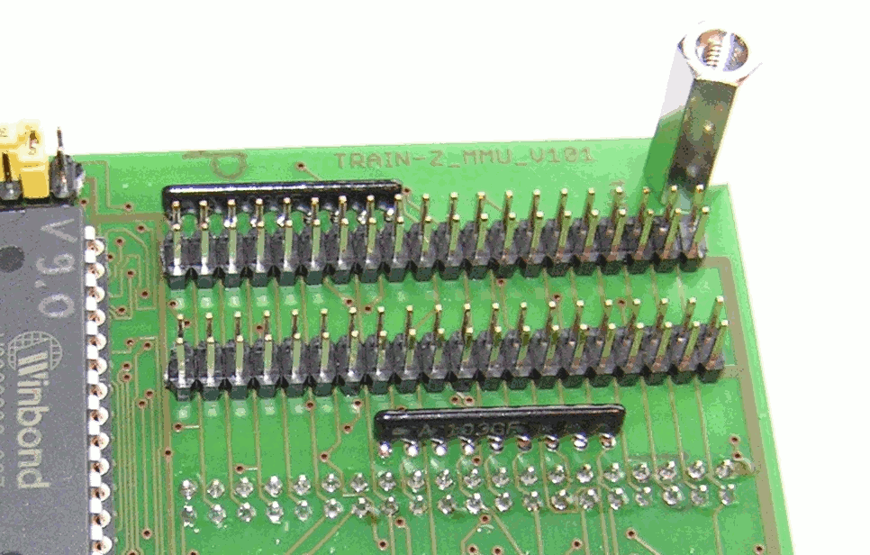
Photo 7: System Bus Connectors on MMU

pin no. | signal | comments
2 | D0 | has an internal 10k pull-up-resistor
4 | D1 | has an internal 10k pull-up-resistor
6 | D2 | has an internal 10k pull-up-resistor
8 | D3 | has an internal 10k pull-up-resistor
10 | D4 | has an internal 10k pull-up-resistor
12 | D5 | has an internal 10k pull-up-resistor
14 | D6 | has an internal 10k pull-up-resistor
16 | D7 | has an internal 10k pull-up-resistor
18 | RSVD0 | reserved
20 | /M1
22 | /MREQ | has an internal 10k pull-up-resistor
24 | /IOREQ
26 | /RD | has an internal 10k pull-up-resistor
28 | /WR | has an internal 10k pull-up-resistor
30 | /RFSH
32 | /HALT
34 | /WAIT
36 | /BUSREQ
38 | /BUSACK
40 | System clock CLK | has an internal 10k pull-up-resistor
1, 3, 5, 7, 9, 11, 13, 15, 17, 19, 21, 23, 25, 27, 29, 31, 33, 35, 37, 39 | GND | total maximum load 100mA !
Table 16: system bus signals connected to JP404 and JP406

pin no. | signal | comments
2 | A0 | has an internal 10k pull-up-resistor
4 | A1 | has an internal 10k pull-up-resistor
6 | A2 | has an internal 10k pull-up-resistor
8 | A3 | has an internal 10k pull-up-resistor
10 | A4 | has an internal 10k pull-up-resistor
12 | A5 | has an internal 10k pull-up-resistor
14 | A6 | has an internal 10k pull-up-resistor
16 | A7 | has an internal 10k pull-up-resistor
18 | A8 | has an internal 10k pull-up-resistor
20 | A9 | has an internal 10k pull-up-resistor
22 | A10 | has an internal 10k pull-up-resistor
24 | A11 | has an internal 10k pull-up-resistor
26 | A12 | has an internal 10k pull-up-resistor
28 | A13 | has an internal 10k pull-up-resistor
30 | A14 | has an internal 10k pull-up-resistor
32 | A15 | has an internal 10k pull-up-resistor
34 | EXT IEI
36 | /INT
38 | /NMI
40 | /RESET | has an internal 10k pull-up-resistor
1, 3, 5, 7, 9, 11, 13, 15, 17, 19, 21, 23, 25, 27, 29, 31, 33, 35, 37, 39 | GND | total maximum load 100mA !
Table 17: system bus signals connected to JP405 and JP407

Memory Map
Table 18 shows the memory map of System TRAIN-Z.
memory block | usage | comments
FFFFh  32 kByte  8000h | SRAM or FLASH-EEPROM for user program | - write protection per jumper possible  - resides in IC201
7FFFh  26 kByte  1800h | SRAM for user program | - physically in the same IC as the 2 kByte SRAM block of the operating system of System TRAIN-Z  - resides in IC203
17FFh  2 kByte  1000h | SRAM for operating system of System TRAIN-Z | - physically in the same IC as the 27 kByte SRAM block for the user program  - resides in IC202
0FFFh  4 kByte  0000h | ROM for operating system  of System TRAIN-Z | - resides in IC200
Table 18: memory map of System TRAIN-Z

Power Supply
Board MAIN:
The operating voltages of +5V , +12V and -12V of the board MAIN are to be fed into X1. Use X2 as power output for +5V and GND to supply the board MMU. See top assembly drawing for the labeling of X1 and X2. The green LEDs D4, D5 and D6 display the presence of these three operating voltages.
operating voltage | current consumption | comments
+5V | appr. 80 mA | without MMU, no jumpers, no adapters
+12V | appr. 50 mA | without MMU, no jumpers, no adapters
-12V | appr. 50 mA | without MMU, no jumpers, no adapters
Table 19: power consumption of board MAIN
Board MMU:
The operating voltage +5V of the board MMU is to be fed into X400. Please see top assembly drawing for labeling of X200. The green LED D400 displays the presence of the operating voltage.

operating voltage | current consumption | comments
+5V | appr. 40 mA | without MAIN, jumpers in default position
Table 20: power consumption MMU

operating voltage | current consumption | comments
+5V | app. 150 mA | at 2,5Mhz system clock, all jumpers in default position
+12V | app. 50 mA | serial connection to host computer established
-12V | app. 50 mA | serial connection to host computer established
Table 21: total power consumption System TRAIN-Z

Warning:
Both the boards MAIN and MMU do NOT provide any protection against overvoltage or wrong connecting of the power lines !
The tolerance of the +5V operating voltage must not exceed +/-0,25V !
The tolerance of the operating voltages +12V and -12V must be withing range of the operating voltage specified in the datasheets of the fitted RS232 line drivers and receivers !
Beyond this limits malfunctions or damage of System TRAIN-Z may occur.

RS232 and Terminal Program of the Host Computer
On the host computer a terminal program is required. Users running Linux or Solaris may use Minicom, under MS-Windows the Hyper Terminal program is recommended.
On Linux, if you are a non-root user make sure you are member of the group uucp otherwise Minicom will not start and respond with the message: “Cannot create lockfile. Sorry.”.
Please make sure there is a serial interface in your computer at all. COM or ttyS ports are increasingly less to be found in laptop PCs. Thus connecting the Unit via a USB-to-RS232-Adapter is needed. Please see section5on page 40 for more on this.

The parameters of the RS232 interface to communicate with System TRAIN-Z are to be set somewhere within the terminal program:
- data transfer rate 9600 bit/s
- 8 bits per character
- no parity
- 1 stop bit
- hardware flow control
The data transfer rate can be increased to 19200 bit/s by doubling the frequency of the system clock. Please read section 3.2.2 on page 11 for more.

Per default every character received by System TRAIN-Z gets echoed back to the host computer which makes the character visible on the screen. This way allows the verification of the character sent by the host computer. In order to reduce the data traffic the echo can be disabled. Please read section 6.4.1 on page 56 for more.
The communication of System TRAIN-Z with the host computer is designed to allow automated communication like scripting with Kermit.

USB-to-RS232-Adapters
There are various adapters and software drivers available. However, proper functionality has been verified with following system:
- Adapter: “PL-2303HX USB to Serial Bridge Controller” (Manufacturer Proflific at http://www.prolific.com.tw). See photo below.
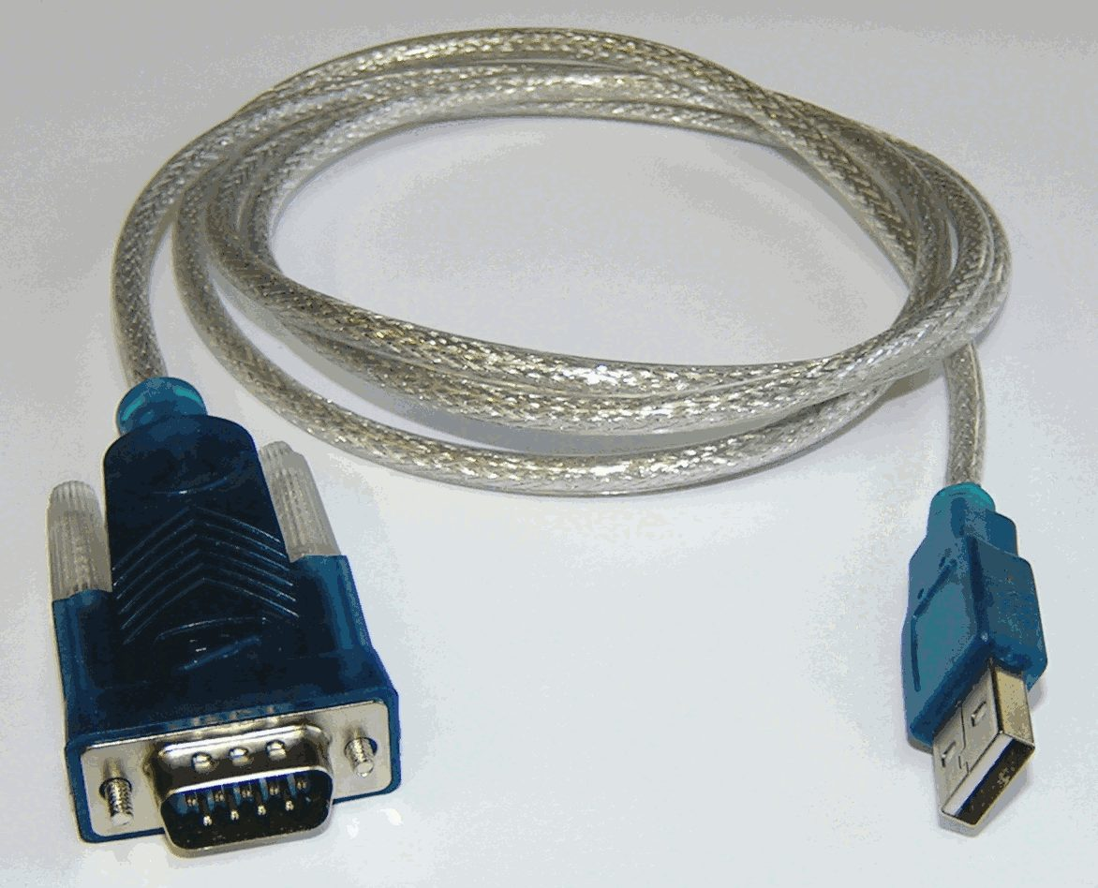
- Operating System OpenSuse Linux 11.1
- Driver pl2303 shippped with the operating system mentioned above.
- Device file to access the adapter: /dev/ttyUSB0
- If you are a non-root user make sure you are member of the group uucp otherwise Minicom will not start and respond with the message: “Cannot create lockfile. Sorry.”.

When using Minicom under Linux the interface settings are shown below.
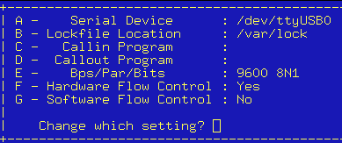Screen shot 1: USB-2-Serial interface settings
In the hardware management of MS-Windows the adapter should appear as regular COM interface.

Operation and Command Set
Upon power up, reset or NMI the operating System TRAIN-Z comes up with a command line on the terminal program as shown in 2. The terminal program used for the screen shots of this handbook is Minicom (available under Linux).
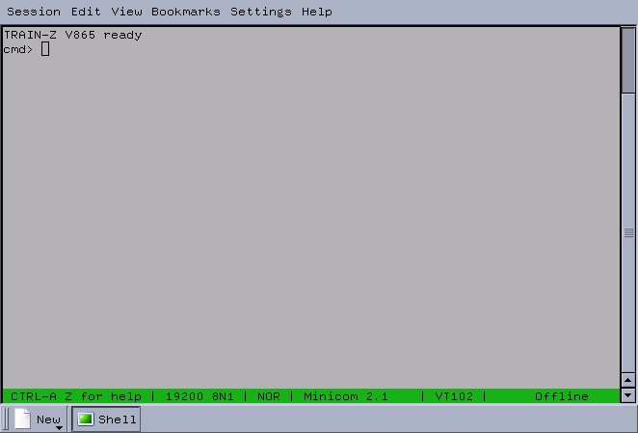Screen shot 2: system start
In the following all described commands can be given directly via the keyboard of the host computer. The execution of a command or the transfer of a number is done by pressing Enter.

In general this rules apply for all entries:
- hexadecimal reading and writing of all numbers
- Half bytes (nibbles) are not accepted. For example the entered number 4D0 brings up the error message „..?“ and cancels the operation.
- All numbers are integers of 8 or 16 bit length.
- The length of the number is not checked further on. Example:
If System TRAIN-Z expects a 16 bit number and receives instead a 45 oder 45EADD the operation gets not canceled. The result of the execution of the command is not defined.
- If a number contains any character but 0, 1, 2, 3, 4, 5, 6, 7, 8, 9, a, b, c, d, e, f, A, B, C, D, E, F, the operation does not get canceled and the result after the execution of the command is not defined.

I/O-Port Commands
These commands allow writing or reading of any I/O devices connected to the Z80 system bus. So a valuable tool for testing and debugging of user specific hardware is given.

portout
To write a byte to an I/O-address the command portout should be used. Upon starting the command the user is required to give the address and afterwards the byte to be written. This succession is shown in 3 as an example: On address 0Ah the data byte 0Fh will be written.
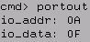Screen shot 3: portout

portin
In order to read a data byte from an I/O-address the command portin is suitable. The command asks the user for the respective address, whereupon the data read there is returned to the user. 4 shows an example of reading from address 08h the data byte FCh.
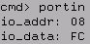Screen shot 4: portin

I²C-Commands
Using these commands the user can write or read from the I²C-buses 0 and 1 (see section 3.2.7 on page 21 and section 3.2.8 on page 21 for information about the hardware).

rsti0
This command brings all the members of I²C-bus 0 to a reset condition.

rsti1
This command brings all the members of I²C-bus 1 to a reset condition.

i0f and i1f
With i0f or i1f an I²C-FLASH-EEPROM connected to I²C-bus 0 or 1 can be read or written. These devices must be addressed by a 8 bit device address and a 8 bit memory address. The LSB of the device address determines read or write access: 0 – write access,
1 – read access.
5 shows an example for reading using command i1f : From device A1h, memory address 00h, the data byte 10h is read.
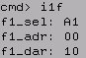Screen shot 5: i1f

In 6 a write access using command i1f is shown: Into device A0h, memory address 00h, the data byte 78h is written.
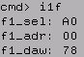Screen shot 6: i1f

i0p and i1p
By means of the commands i0p or i1p an I²C-expander connected to I²C-Bus 0 or 1 can be written or read, provided it has a 8 bit device address. The LSB of the device address determines read or write access: 0 – write access,
1 – read access.
7 shows an example how to read with command i1f : From device 41h the data byte 10h is read.
8 whereas pictures how to write using command i1f : Into device 40h the data byte 55h is written.
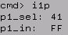Screen shot 7: i1p
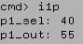Screen shot 8: i1p

Administrating the Memory
This section describes commands that affect only the memory area addressable directly by the Z80-CPU which ranges from 0000h to FFFFh.
Warning: These commands to not incorporate any protection against overwriting of system relevant memory areas ! Please see Table 18 on page 37.

viewmem
To get a view of 100h or 256d consecutive bytes within the system memory the command viewmem should be used. An example of how to use it have a look at 9: The contents of the memory area from 1800h to 18FFh is displayed here. After starting the command viewmem the user is requested to give the first address to be displayed (This can be even an odd number like 1701h.). The output is a view of the contents of the memory. In this example all locations are filled by 00h.
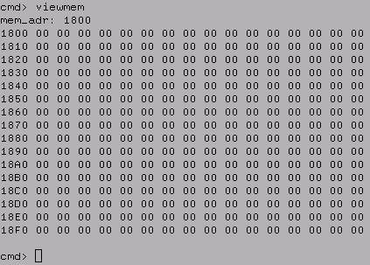Screen shot 9: viewmem

copy
Frequently the content of a memory area has to be copied into another area. This can be done using the command copy. 10 shows an example of how to use it: The 30h bytes residing from address 1800h upward are copied to address 7000h upward.
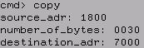Screen shot 10: copy

comp
In case two memory areas need to be compared with each other the command comp is suitable as shown in 11: 30h bytes residing from memory address 1800h upward get compared with 30h bytes residing from address 7000h upward. If these areas match each other comp returns to the prompt without any claim.
If there is a mismatch the command returns the respective address of the destination area and the expected and read data byte. 12 shows the case of a mismatch at address 7030h where a 1Ah is expected but a 00h is found instead.
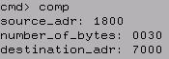Screen shot 11: comp
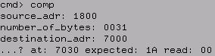Screen shot 12: comp

fill
Using fill a RAM memory area can be filled by a certain data byte. This command is also well applicable to modify a single data byte within the RAM. In the example shown in 13 30h bytes from address 7000h upward are filled by AAh.

prgflash
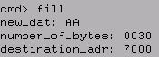Screen shot 13: fill
Given the 32k Byte-User-FLASH-EEPROM is mounted, it can be programmed by prgflash. The write protection must be deactivated. Please see section 3.3.4 on page 32 for more information. 14 shows in an example how to program 100h bytes residing from address 7000h (RAM area) upward into the address 8000h and upward of the 32k byte-user-FLASH-EEPROM. In the beginning of the program process the device ID code of the 32k byte-user-FLASH-EEPROM is displayed (in case of the AM29F040 it reads 01A4h). This code gets read only, not verified ! Afterward the 32k byte-user-FLASH-EEPROM gets first erased and then programmed byte wise using the DQ7 polling algorithm according to its datasheet.
There is no need to erase the 32k byte-user-FLASH-EEPROM prior to programming. Warning: prgflash does not verify the data programmed. To verify the data that has been programmed please use the command comp after programming !
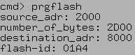Screen shot 14: prgflash

eraseflash
In order to erase the 32k byte-user-FLASH-EEPROM completely use command eraseflash. This command works like eraseflash but does not program any data into the device.
Warning: eraseflash does not verify the memory content against FFh after erasing. Please use the command comp in order to verify the device has been erased completely.

testmem
For a very simple detection of the highest available RAM address the command testmem is recommended. It does not perform a real memory test. If the 27 kbyte-SRAM is mounted only the command testmem returns the value 7FFFh (see example on 15). The value FFFFh gets returned if the optional 32 kbyte-SRAM is mounted.
Warning: The command testmem clears the whole user RAM area to a value of 00h on all locations !
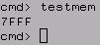Screen shot 15: testmem

load
If the user wants to download a file from the host computer into System TRAIN-Z the command load is provided. 16 shows the usage of load in an example: After entering and starting the command the user is asked for the address where the file should be loaded at. The destination address must be within the RAM area of System TRAIN-Z. From now the user has 16 seconds to transfer the file per X-modem protocol with his terminal program. (see 17, 18 and 19). If these 16 seconds expire before the user starts the transfer the system will hang and has to be restarted.
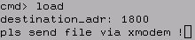Screen shot 16: load
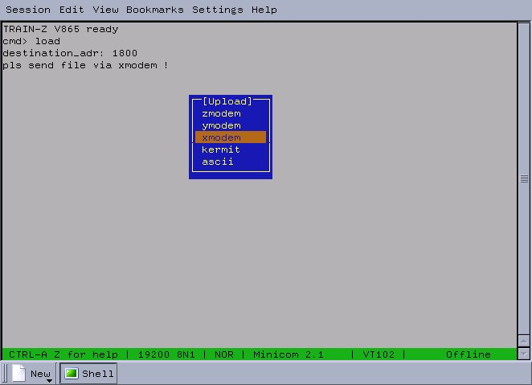Screen shot 17: xmodem

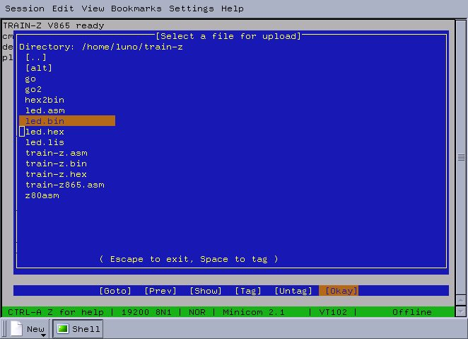Screen shot 18: file menu

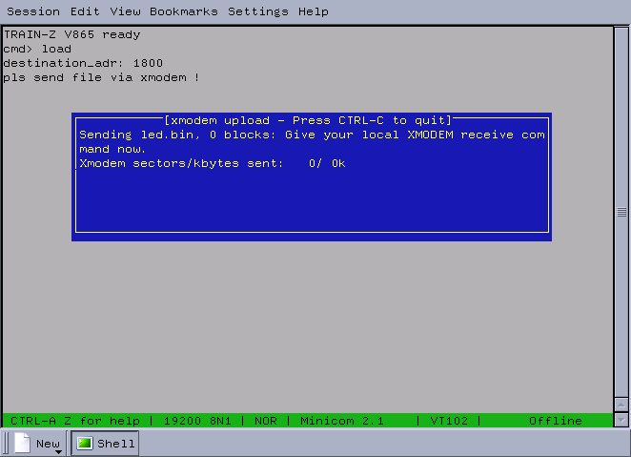Screen shot 19: transfer
After successful file transfer load returns to the prompt. Garbled data blocks are resent maximal 9 times whereupon the transfer gets canceled. If the host computer cancels the transfer for other reasons while a block is being sent the host is required to send the missing number of bytes. This is easily accomplished by holding any key pressed until the prompt comes back.

Starting the User Program
The user program residing in the RAM or the 32 kbyte-FLASH-EEPROM can be started by two ways:
- per software command call
- per jumper connecting pin 17 and 18 of JP1 (see Table 7 on page 18)

call
If executable Z80-machine resides somewhere within the memory it can be called by the command call. In general this is a call to a subroutine. The program called should have a RET instruction at its end to allow a return to the operating system TRAIN-Z . Upon return of the user program call returns to the prompt. 20 shows an example on how to call the code residing at address 8000h.
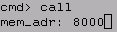Screen shot 20: call

Per Jumper
If you connect pins 17 and 18 of JP1 by plugging a jumper on them (see Table 7 on page 18) address 8000h will be jumped to after power up or reset. In contrast to command call this is no subroutine call but an unconditional jump to the fixed address 8000h.
The purpose of this way of start up is to run the user program residing in the 32 kByte-FLASH-EEPROM shortly after power up or reset.

Miscellaneous

echooff
The command echooff turns of the echo function of the serial interface to the host computer (see section 4 on page 39). This is useful to reduce the data traffic when operating System TRAIN-Z automated by a program running at the host computer (e.g. Kermit). By starting echooff the user does not see his entries any more on the terminal screen. Only by cold start or reset the echo can be enabled again.

help
The full command set of System TRAIN-Z can be listed by the command help. 21 shows the output of this command.
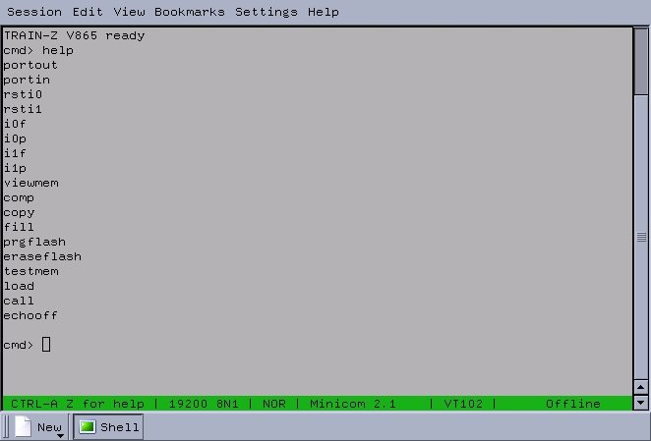Screen shot 21: help

System Test
If the pins 11 and 13 of JP3 are connected, the LEDs D0 and D1 flash in the order of a 2 bit binary counter. This gives a very crude statement of the functionality of CPU, CTC, PIO, 4 kByte-ROM, oscillator and wiring between the boards MAIN and MMU.
Note: As long as the system test is running no entries are allowed from the host computer.

System Calls
On request the user will be given memory addresses of the operating system and bootloader of System TRAIN-Z. This way the user gets access to various routines that allow for example I²C operation or x-modem file transfer.

Register Dump
Currently the most important routine is Register Dump, which when called from the user program, outputs the contents of the current CPU foreground registers, the index registers IX and IY, the program counter PC, the stack pointer SP and the interrupt register IR. Whenever the mainline program calls this routine by the command CALL 0BB6h the register contents are sent to the host computer to be displayed there. Of course this routine can also be called from the prompt of the operating system as shown below:
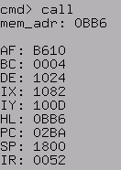
This routine does not alter the content of any register. It merely outputs their contents prior to calling Register Dump and restores them when returning to the mainline program. So the user has a tool to debug her/his program at runtime.

Assemblers, Interpreters and Compilers
This section just gives the link to the official Z80 homepage. Various compilers, simulators or assemblers can be downloaded there for free:
http://www.z80.info

Device Mounting Options
Table 22 provides an overview of device mounting options of most relevant ICs of System TRAIN-Z.
device | package | type mountable | delivery state
Z80-CPU | DIL40 | BU18400A-PS (ROHM)  D780C-1(NEC)  KP1858BM1/2/3 / KR1858BM1/2/3 (USSR)  LH0080 (Sharp)  MK3880x (Mostek)  T34VM1 / T34BM1 (USSR)  TMPZ84C00AP-8 (Toshiba)  UA880 / UB880 / VB880D (MME)  Z0840004 (ZiLOG)  Z0840006 (ZiLOG)  Z80ACPUD1 (SGS-Ates)  Z84C00AB6 (SGS-Thomson)  Z84C00 (ZiLOG)  Z8400A (Goldstar)  U84C00 (MME) | Z84C00 (ZiLOG)
Z80-SIO Typ 0 | DIL40 | UA8560 , UB8560 (MME)  Z0844004 (ZiLOG)  Z8440AB1 (ST)  Z0844006 (ZiLOG)  Z84C40 (ZiLOG)  U84C40 (MME) | Z84C40 (ZiLOG)
Z80-PIO | DIL40 | Z0842004/6 (ZiLOG)  UA855 / UB855 (MME)  Z84C20 (ZiLOG)  U84C20 (MME) | Z84C20 (ZiLOG)
Z80-CTC | DIL28 | Z84C30 (ZiLOG)  U84C30 (MME)  UA857 / UB857 (MME) | Z84C30 (ZiLOG)
27 kByte-SRAM  32 kByte-SRAM | DIL28 | UM62256 (UMC)  HM62256
32 kByte FLASH  4 kByte ROM | DIL32 | W29C020C-90 Z (Winbond) - discontinued  AM29F040 (AMD)  A29040B (AMIC) | N/A
I²C-Expander | DIL16 | PCF8574 (Philips)  PCF8574A (Philips) | PCF8574 (Philips)
I²C-FLASH | DIL8 | AT24C08 (Atmel)  ST24C08 (STMicroelectronics) | ST24C08 (STMicroelectronics)
Table 22: mounting options

Parts Delivered with System TRAIN-Z
System TRAIN-Z is assembled and delivered as kit and with these components to be fitted or plugged according to the users requirements:
- 1x board MAIN (mountings corresponding to Table 22 page 59)
- 1x board MMU (mountings corresponding to Table 22 page 59)
- 2x 40 pin ribbon cable (corresponding to Photo 5 page 24)
- 1x adapter for serial interface RS232 without ferrite core (corresponding to Table 4 page 14)
- 1x adapter for parallel interface (corresponding to Table 8 page 19)
- 1x 32 kByte-FLASH-EEPROM (corresponding to section 3.3.4 page 32)
- 1x 32 kByte-SRAM as accessory (corresponding to section 3.3.5 page 33)

Full Self-Assembly Shipment Option
You may order just the two bare boards MMU and MAIN without any devices soldered on them.

RoHS conformity

The kit System TRAIN-Z is RoHS compliant.

Useful Links
- Find updates of this document at http://www.train-z.de
- Debug SPI, I²C, Boundary Scan/JTAG and other hardware with the Logic Scanner
at http://www.train-z.de/logic_scanner/Logic_Scanner_UM.pdf
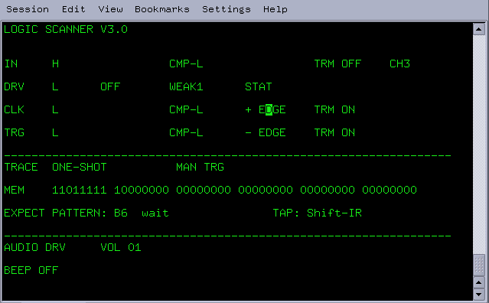
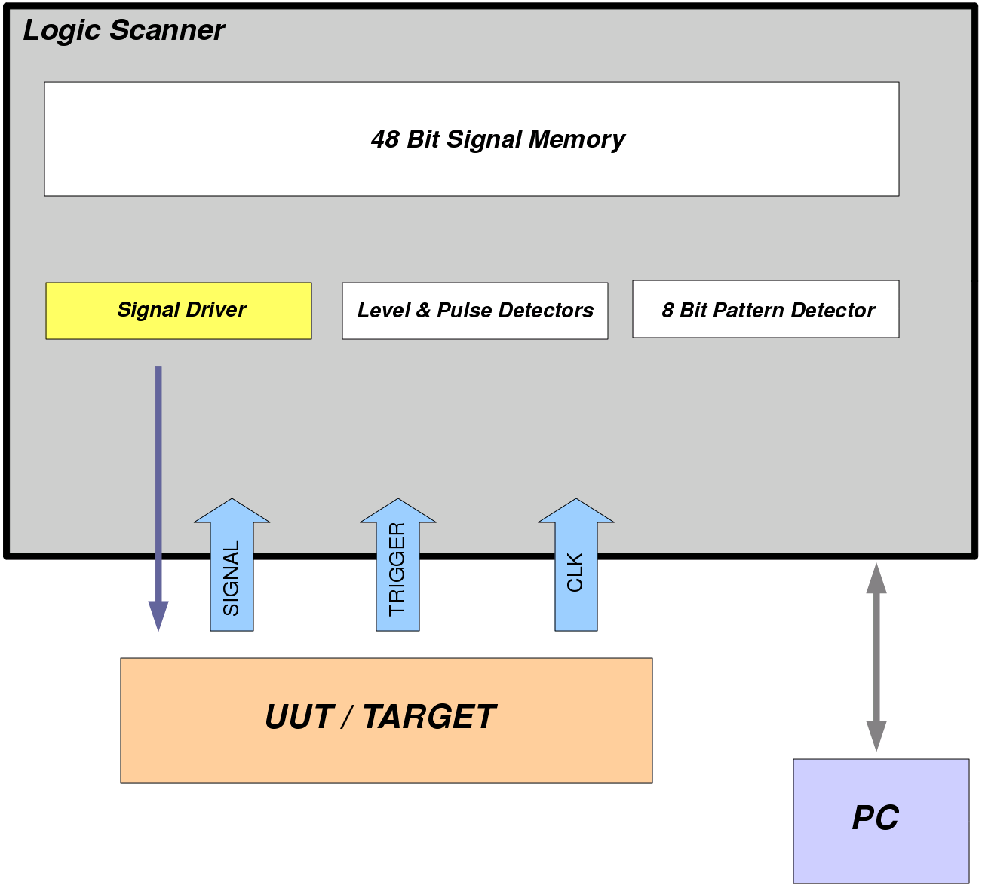
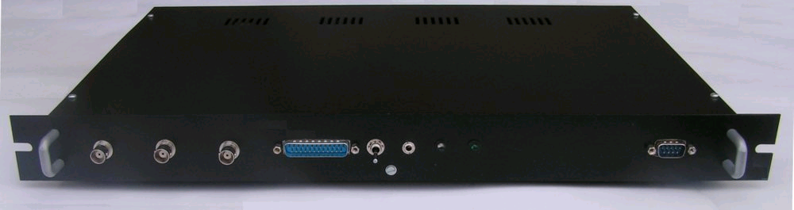

- Simplify Hardware Debugging with System M-1 the Boundary Scan/JTAG Tester at http://www.train-z.de/bsm/BSM_Product_Brief_en.pdf

- The powerful communication tool Kermit at http://www.columbia.edu/kermit/
- Z80 Verilog and VHDL Cores at http://www.cast-inc.com and http://opencores.org
- Z80 Application Notes at http://www.train-z.de/train-z/index.html
- The Z80 history at http://en.wikipedia.org/wiki/Zilog_Z80
- The X-Modem Protocol Reference
at http://www.trainz.de/trainz/pdf/xymodem.pdf


- The office alternative : LibreOffice at http://www.libreoffice.org


- EAGLE - an affordable and very efficient schematics and layout tool at http://www.cadsoftusa.com/

Further Reading
I recommend to read these books:

“Using C-Kermit” / Frank da Cruz, Christine M. Gianone / ISBN 1-55558-108-0 (english)
“C-Kermit : Einführung und Referenz” / Frank da Cruz, Christine M. Gianone / ISBN 3-88229-023-4 (german)

Disclaimer
This manual is believed to be accurate and reliable. I do not assume responsibility for any errors which may appear in this document. I reserve the right to change devices or specifications detailed herein at any time without notice, and do not make any commitment to update the information contained herein. I do not assume responsibility for any design errors which may appear in the hardware nor in the software of System TRAIN-Z nor for modifications made by the user. This product is not authorized for use as critical component in life support devices or systems.

Specifications mentioned in this manual are subject to change without notice.

------------------------------------------
My Boss is a Jewish Carpenter

Blunk electronic / Owner : Dipl.-Ing. Mario Blunk / Buchfinkenweg 5 / 99097 Erfurt / Germany +49 176 2904 5855 / http://www.train-z.de
© 2013 Mario Blunk Printed in Germany

Through-Hole-Technology
In order to have write access to a RAM mounted here instead of the FLASH-EEPROM this setting is a must.
Since operating system version 9.4 the auto enables feature of the Z-80 SIO is used in order not to override an eventually slow host computer.
provided the respective character is a “visible one” at all
The AT24C08 made by Atmel is one of this kind.
For example the PCF8574x by Philips is suitable.
16 sec are vaild at a system clock of 2,5Mhz. See section 3.2.2 on page 11 for more.
This is just a recommendation. A return is not mandatory.
There are still a few machine instructions System TRAIN-Z executes following reset or power up in order to read the status of pins 17 and 18 of JP1.

