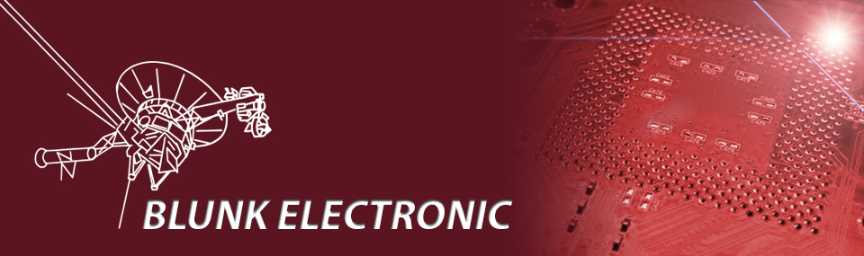
PRODUCT BRIEF
Self-Assembly Kit

Z80 Bus Monitor &
Cycle Stepper
User Manual

Please read carefully before power up !

Doc. Version 2013-10-28-1
Author: Mario Blunk

Firmware Version: V1.1
Hardware Version: V1.1

Table of Contents
1 Preface 3
2 Hardware 4
2.1 Z80-System Bus Connectors 6
2.2 PIO and Debug Connector 9
2.3 Switches and Push-Buttons 11
2.4 Display 12
2.5 CPU control LEDs 13
2.6 JTAG / IEEE 1149.1 13
2.7 Schematics and Assembly Drawings 14
2.8 Power Supply 14
3 Self Assembly Shipment Option 15
4 RoHS conformity 15
5 Useful Links 16
6 Disclaimer 17

Preface
With the objective of improving System TRAIN-Z toward a development system a bus monitor in connection with a cycle stepper circuitry was an immanent user demand. So a peripheral extension with these components has been designed. The whole unit, further on just referred to as Bus Monitor, fits on a single euro sized four-layer board (160 x 100 mm). See Photo 1. It is fully programmable via any hardware description language like Verilog or VHDL. The HDL-design presented here has been written in Verilog on the Xilinx System ISE.

System TRAIN-Z does not aim to compete with the
powerful and sophisticated embedded computer systems of today.

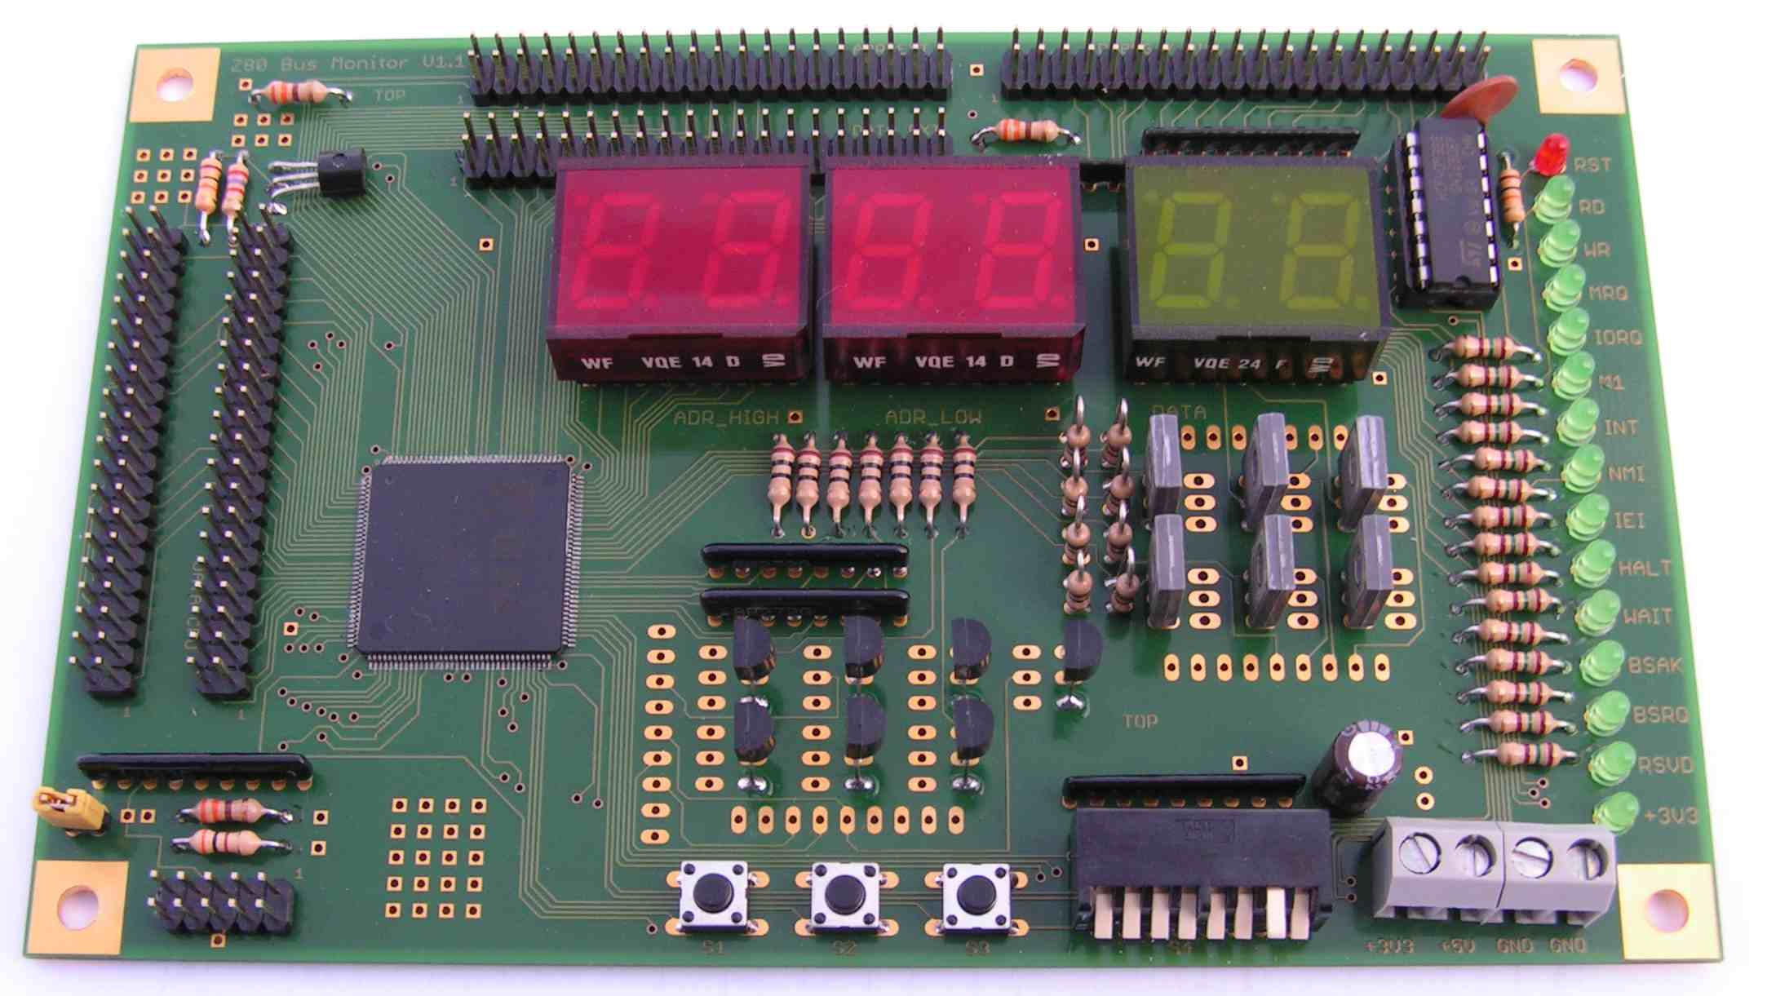Photo 1: Bus Monitor and Cycle Stepper

What is the Bus Monitor good for ?
- Single Step Z80 mnemonics execution (Please have the list-file handy.)
- Address, Data and Control signal Debugging
- PIO mode to control user specific hardware
- Level-Shifter from 5V Z80 world to 3,3V peripheral world
- Direct mounting on top of System TRAIN-Z via standoffs.

Hardware

3,3V Bus Signals
PIO & DEBUG

Push-Buttons & Mode Switch
3,3V power in
JTAG
3,3V Bus Signals
CPU control LEDs
3,3V Bus Signals
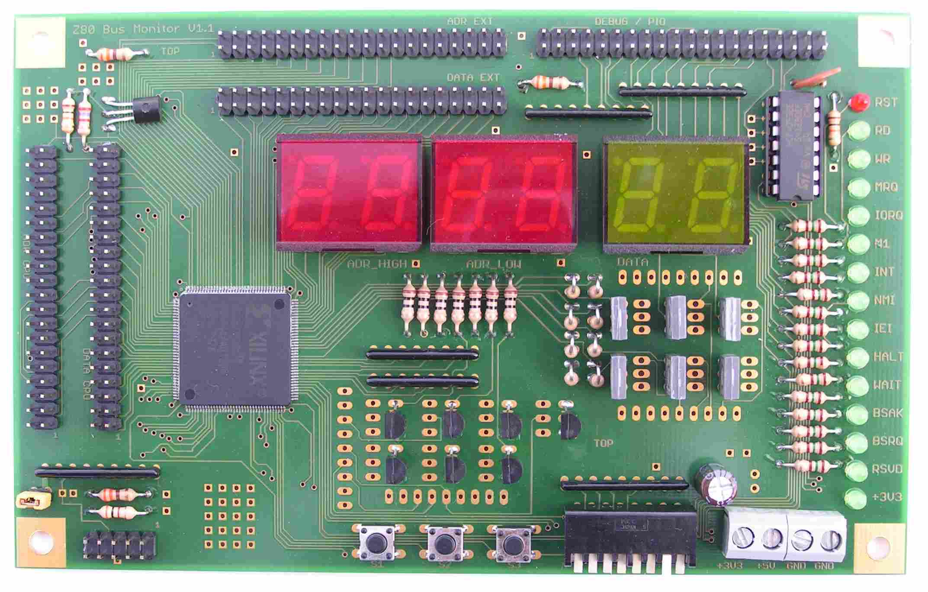
Photo 2: Bus Monitor Top View

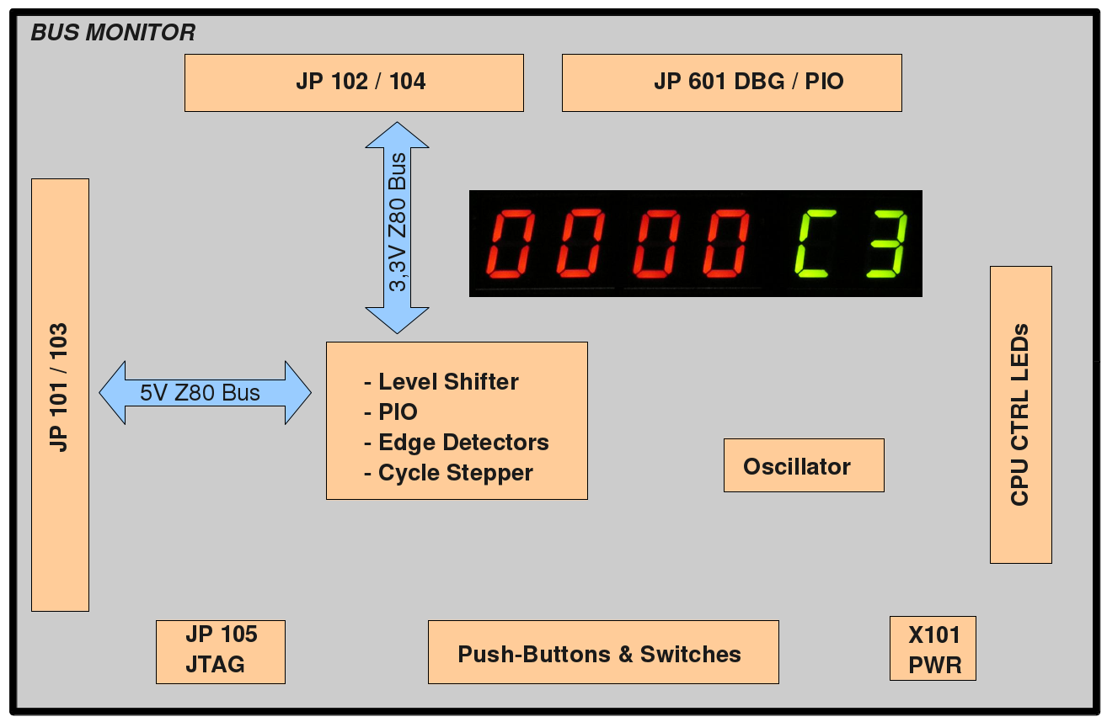Drawing 1: Bus Monitor Block Schematic

Z80-System Bus Connectors
All 5V-signals of the system bus coming from the Z80 CPU are connected to JP101 and JP103. JP101 holds the data bus D[7..0], JP103 holds the address bus A[15..0]. The control signals are distributed on both JP101 and JP103. Drawing 2 shows the their pins. If ribbon cables get plugged on both of them the result is a GND signal between two bus signals. Most suitable are IDE-ribbon cables used in many PCs (Photo 3 page 6). Table 1 on page 7 and Table 2 on page 8 give the signals connected to JP101 and JP103.

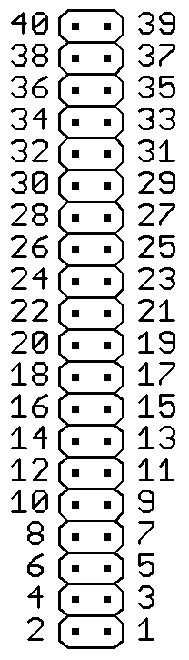Drawing 2: pins of JP101 / JP102 and JP103 / JP104
All 3,3V-signals of the system bus going to the peripherals are connected to JP102 and JP104.
If not noted otherwise, the DC input/output specifications of these pins are to be found in the XC95288XL datasheet at www.xilinx.com.
Note: All wires of the IDE-ribbon cables must be accessible.

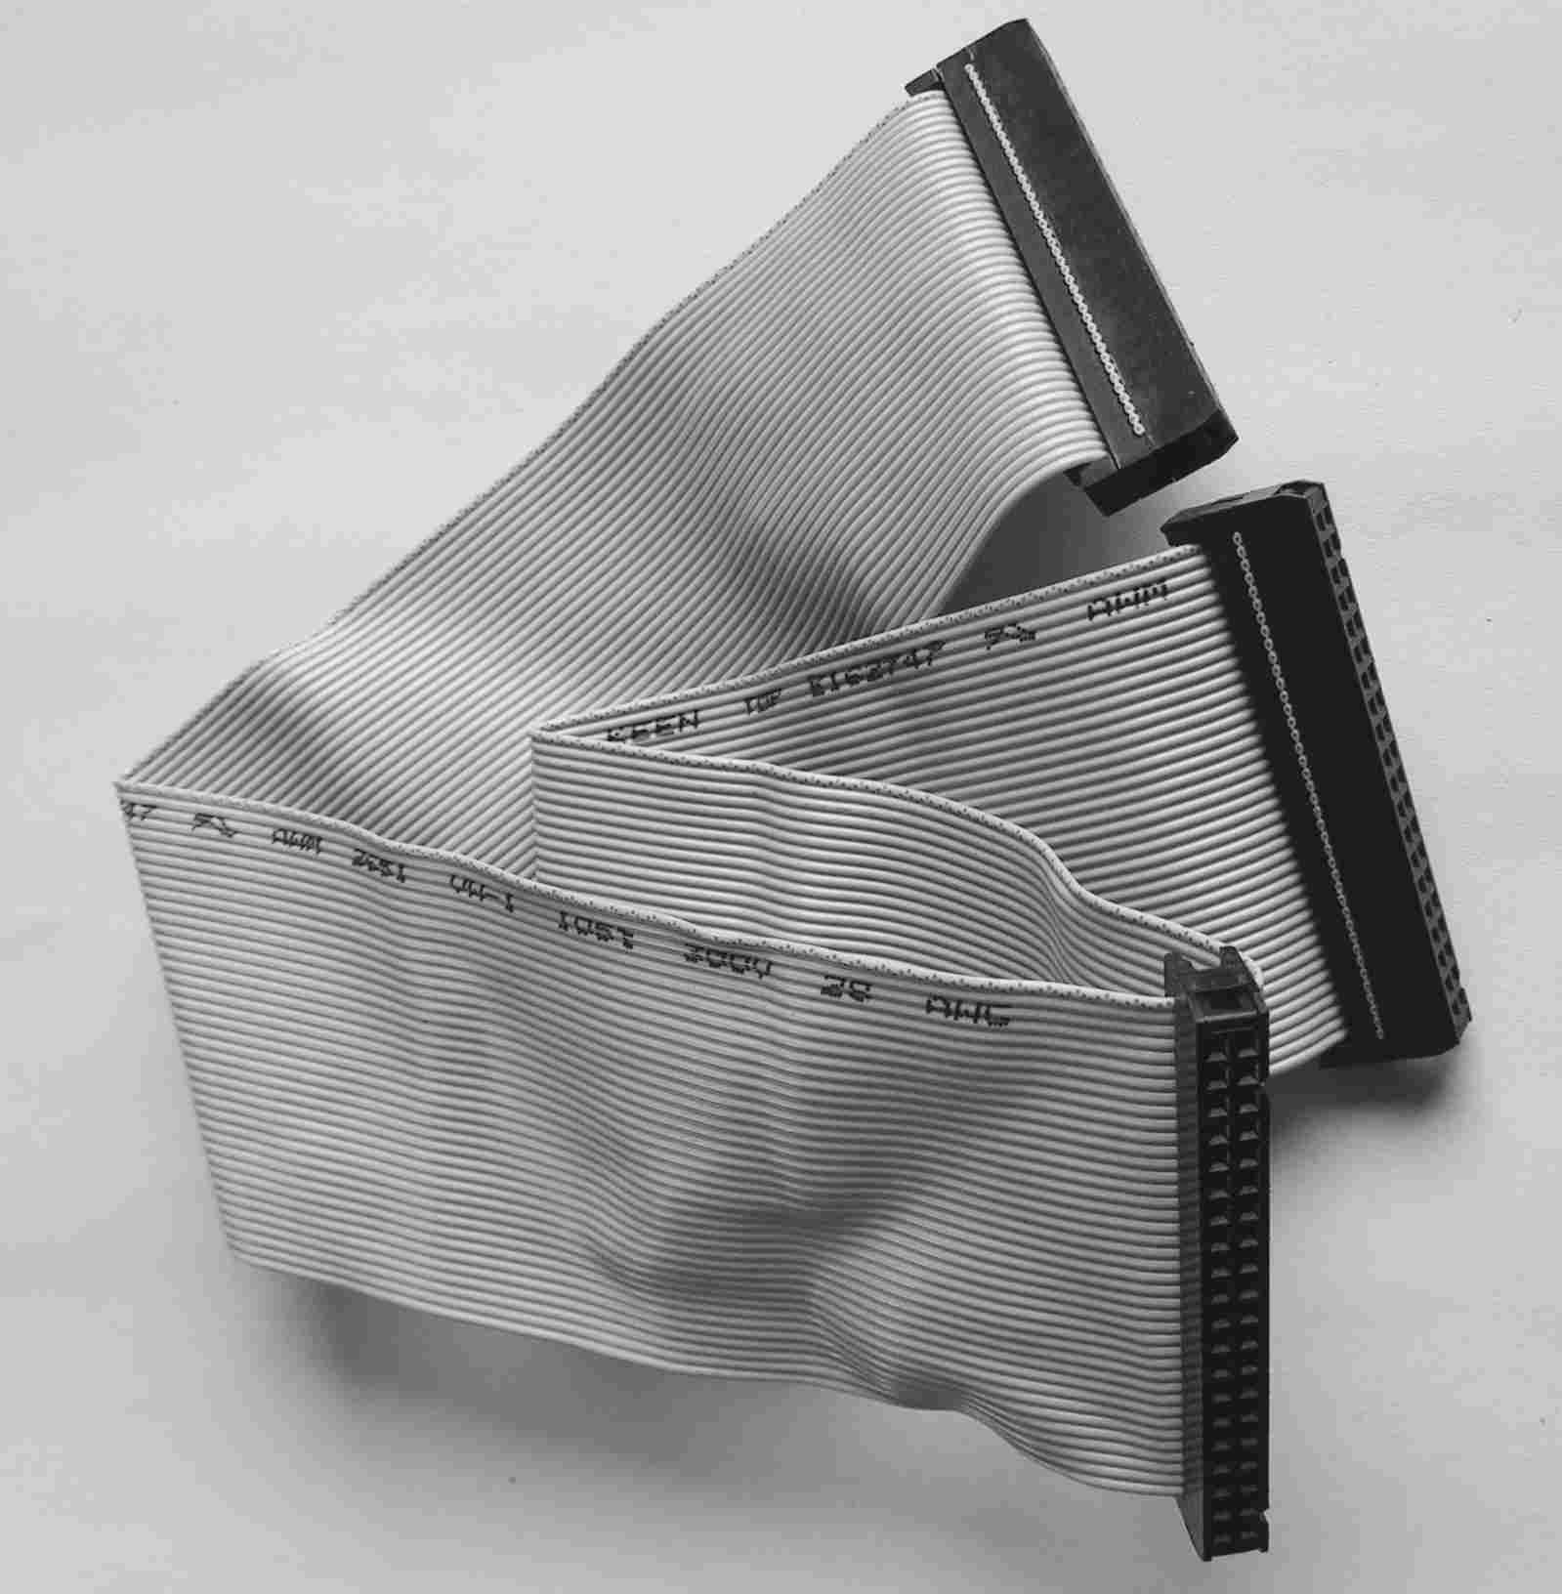Photo 3: 40 pin IDE connector

pin no. | signal | comments
2 | D0
4 | D1
6 | D2
8 | D3
10 | D4
12 | D5
14 | D6
16 | D7
18 |  | reserved
20 | /M1
22 | /MREQ
24 | /IOREQ
26 | /RD
28 | /WR
30 | /RFSH
32 | /HALT
34 | /WAIT
36 | /BUSREQ
38 | /BUSACK
40 | system clock CLK
1, 3, 5, 7, 9, 11, 13, 15, 17, 19, 21, 23, 25, 27, 29, 31, 33, 35, 37, 39 | GND
Table 1: Z80 system bus signals connected to JP101 / JP102

pin no. | signal | comments
2 | A0
4 | A1
6 | A2
8 | A3
10 | A4
12 | A5
14 | A6
16 | A7
18 | A8
20 | A9
22 | A10
24 | A11
26 | A12
28 | A13
30 | A14
32 | A15
34 | EXT IEI
36 | /INT
38 | /NMI
40 | /RESET | Open collector with 300 Ohms against 3,3V
1, 3, 5, 7, 9, 11, 13, 15, 17, 19, 21, 23, 25, 27, 29, 31, 33, 35, 37, 39 | GND
Table 2: Z80 system bus signals connected to JP103 / JP104

PIO and Debug Connector
The eight 3,3V PIO channels are to be found at JP601. Further-on signals for debugging, schmitt-trigger in/outputs and /CPU_RESET are accessible there.

Drawing 3: pins of JP601
If not noted otherwise, the DC input/output specifications of these pins are to be found in the XC95288XL datasheet at www.xilinx.com.

pin no. | signal | comments
2 | PIO0 | 10k Pull-Up-Resistor against 3,3V
4 | PIO1 | 10k Pull-Up-Resistor against 3,3V
6 | PIO2 | 10k Pull-Up-Resistor against 3,3V
8 | PIO3 | 10k Pull-Up-Resistor against 3,3V
10 | PIO4 | 10k Pull-Up-Resistor against 3,3V
12 | PIO5 | 10k Pull-Up-Resistor against 3,3V
14 | PIO6 | 10k Pull-Up-Resistor against 3,3V
16 | PIO7 | 10k Pull-Up-Resistor against 3,3V
18 | DEBUG0 | 10k Pull-Up-Resistor against 3,3V
20 | ST_IN0 | Complies with specs of a CD4093 operated at 3,3V, 10k Pull-Up-Resistor against 3,3V
22 | ST_IN1 | Complies with specs of a CD4093 operated at 3,3V, 10k Pull-Up-Resistor against 3,3V
24 | DEBUG1 | 10k Pull-Up-Resistor against 3,3V
26 | DEBUG2 | 10k Pull-Up-Resistor against 3,3V
28 | DEBUG3 | 10k Pull-Up-Resistor against 3,3V
30 | DEBUG4 | 10k Pull-Up-Resistor against 3,3V
32 | ST_OUT0 | Complies with specs of a CD4093 operated at 3,3V
34 | ST_OUT1 | Complies with specs of a CD4093 operated at 3,3V
36 | DEBUG5 | 10k Pull-Up-Resistor against 3,3V
38 | RSV_100 | 10k Pull-Up-Resistor against 3,3V
40 | /RESET | Open collector with 300 Ohms against 3,3V
1, 3, 5 | +3,3V | Output to operate user periphery
9, 11, 13, 15, 17, 19, 21, 23, 25, 27, 29, 31, 33, 35, 37, 39 | GND
7 | no connection
Table 3: PIO and Debug Signals at JP601

Switches and Push-Buttons
The operating mode of the Bus Monitor is to be set via the 8-fold DIL-Switch S602 / S4. Table 4 gives the operating modes available.

Switch # | state | Mode / Meaning
1 | off | single step execution
1 | on | CPU free run
2 |  | Parallel to Push-Button S603 / S2
3 | on | CPU Reset active
3 | off | CPU Reset inactive
4 |  | Parallel to signal DEBUG0
5 |  | Parallel to signal DEBUG1
6 |  | Parallel to signal DEBUG2
7 | off | display shows PIO state
7 | on | display shows bus address and data (in CPU free run or single step mode)
8 |  | Parallel to signal RSV_GCK2
Table 4: DIL-Switch S602 / S4

Push-Button # | Mode / Meaning
S601 / S1 | Reset CPU
S603 / S2 | CPU next cycle (if single step execution selected (see Table 4)
S604 / S3 | Temporarily CPU free run (if single step execution selected (see Table 4) as long as being pushed down
Table 5: Push-Buttons

Display
The Z80 Address and Data Bus or the PIO content may be displayed via the 6 digit LED displays DIS302, DIS301 (red) and DIS303 (green). In Bus Monitor mode the red displays show the current state of the address bus while the green display shows the data bus content.

Adr[15:8] or I/O Adr. 52h
Adr[7:0] or I/O Adr. 51h
Data[7:0] or I/O Adr. 50h
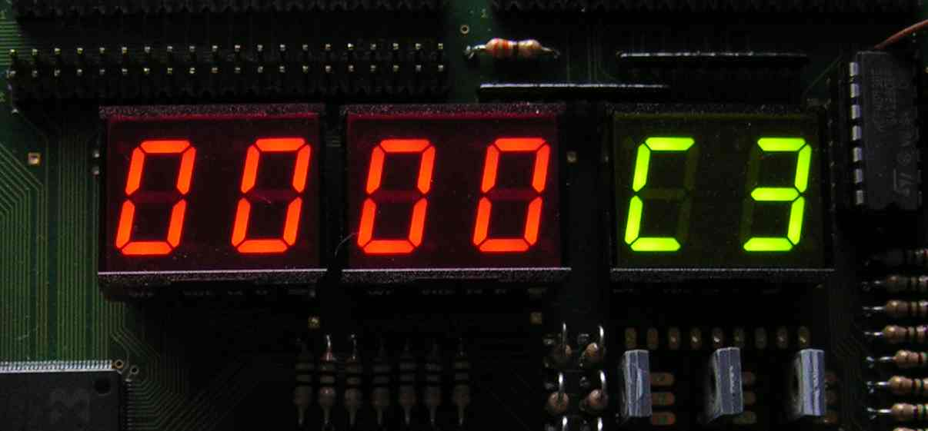Photo 4: Display Readout on CPU Reset
In PIO mode there are three eight bit wide output registers at I/O addresses 50h through 52h. They can be written at by CPU OUT commands any time. If switch 7 of S602 / S4 is off, the register content is displayed (see Table 4). Reading from these locations via the CPU IN commands is also possible any time. DIS302 and DIS301 show the content of the I/O addresses 51h and 52h.
The output of the register at location 50h is of open-drain characteristic and is connected to JP601 (see Table 3 on page 10). The very bit of this register set to H may serve as input channel to read the status of the PIO signals at JP601. DIS303 (green) shows the content of that register.
As this is a self-assembly kit, the displays need to be soldered or plugged by the user.

CPU control LEDs
These green LEDs indicate High-Low transitions (or negative edges) occurring on the Z80 control signals. On edge detection the LED affected flashes for about 0,1 seconds. See Photo 2 on page 4. The meaning of the LEDs is self explaining.
Note: The status of the CPU REFRESH signal is not displayed via an LED.

JTAG / IEEE 1149.1
To program the CPLD the IEEE1149.1 signals are accessible via JP105 .SeeTable 6.
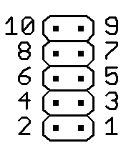Drawing 4: pins of JP105
Pin | Meaning | comments
1 | TCK
3 | TMS
5 | TDI | default
7 | TDO
10 | Vref | Required Xilinx Programming Cable
2, 4, 6, 8 | GND
Table 6: JTAG signals

NOTE: Some boundary scan masters may not require a reference voltage or may even get damaged if this voltage is provided by the Bus Monitor.
To disconnect the reference voltage provided by the Bus Monitor from JP105, please remove the jumper from JP106.

Schematics and Assembly Drawings
As these drawings are updated from time to time they are not included in this document. Please find them at:

http://www.train-z.de/train-z/hw

Power Supply
The operating voltage of +3,3V into X101. Please refer to the assembly drawing for labeling of X101. The green LED D101 displays the presence of the operating voltage.

operating voltage | current consumption | comments
+3,3V | max. 400 mA | all LEDs on
Table 7: power consumption MMU

Warning:
The board does NOT provide any protection against overvoltage or wrong connecting of the power lines !
The tolerance of the +3,3V operating voltage must meet the specifications given in the Xilinx XC95288XL datasheet !
Beyond this limits malfunctions or damage of the board may occur.

Self Assembly Shipment Option
You may order just the bare boards of the Bus Monitor without any devices soldered on it.

RoHS conformity

The Bus Monitor board without the displays is RoHS compliant.

Useful Links
- Debug your hardware with the Logic Scanner at
http://www.train-z.de/logic_scanner/Logic_Scanner_UM.pdf
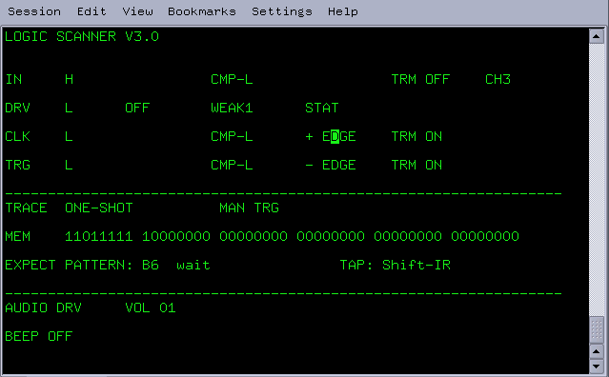
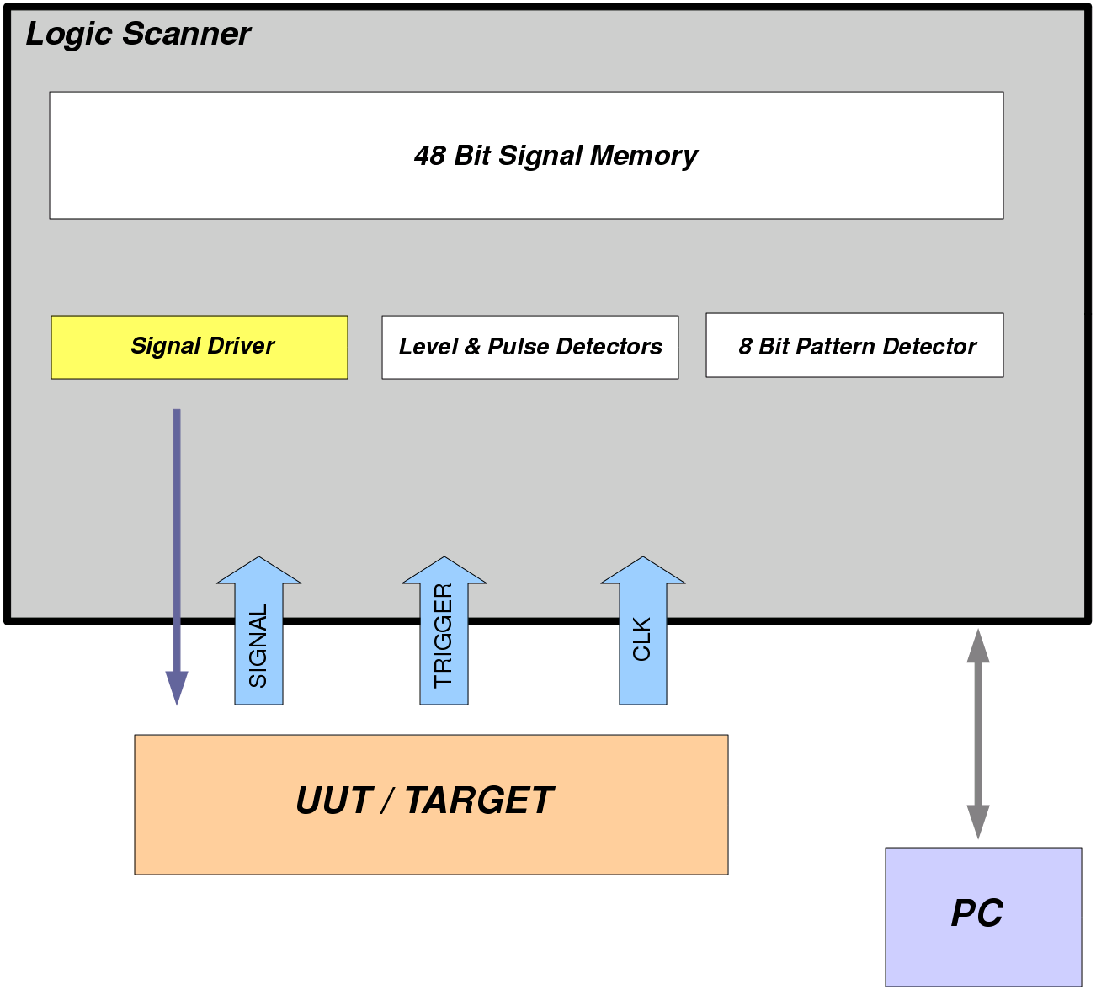
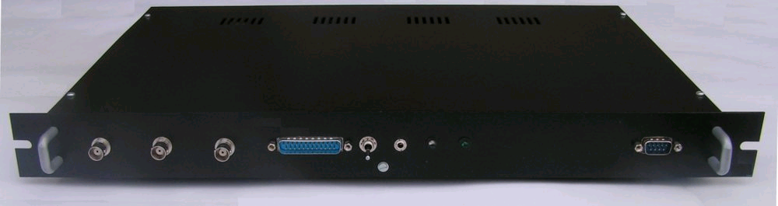

- A complete embedded Z80 system can be found at
http://www.train-z.de/train-z


- The Free and Open Productivity
Suite LibreOffice at http://www.libreoffice.org
- Z80 Verilog and VHDL Cores at http://www.cast-inc.com and http://opencores.org
- Z80 Application Notes at http://www.train-z.de/train-z/index.html

- EAGLE - an affordable and very efficient schematics and layout tool at http://www.cadsoftusa.com/

Disclaimer
This manual is believed to be accurate and reliable. I do not assume responsibility for any errors which may appear in this document. I reserve the right to change devices or specifications detailed herein at any time without notice, and do not make any commitment to update the information contained herein. I do not assume responsibility for any design errors which may appear in the hardware nor in the software of this product nor for modifications made by the user. This product is not authorized for use as critical component in life support devices or systems.
Specifications mentioned in this manual are subject to change without notice.
------------------------------------------
My Boss is a Jewish Carpenter

Blunk electronic / Oolder Mario Blunk / Buchfinkenweg 5 / 99097 Erfurt / Germany +49 (0) 176 2904 5855 / http://www.train-z.de
© 2013 Mario Blunk Printed in Germany

