Project Plan

File Train

24 April 2023

Amir Eastmond
Objective:

File Train is a simple program intended to send file, text and commands securely over a private network or the internet. It will have a graphical user interface and headless operation will also be supported on PC.
The primary purpose of File Train is to transfer files quickly and reliably between two devices. File Train will support Linux, Windows and Android, as the Apple ecosystem already has proprietary support for these features.
The creation of File Train was prompted by the need for a simple way to send photos and small files between my phone and Debian (Linux) laptop.

Solution Strategy:

The Linux and Windows systems will be written in rust with a web front-end using the Tauri library. The Android app will be written in either Flutter, React Native or Kotlin. Rust has been chosen because it is fast and memory safe, it is also a relatively new language so it will provide the developers with valuable experience.
The systems will use the Transmission Control Protocol for data transfer and Authenticated Encryption with Associated Data for data encryption and decryption. RSA Cryptography will be used for the sharing of encryption keys (aead and rsa will probably not be compatible)

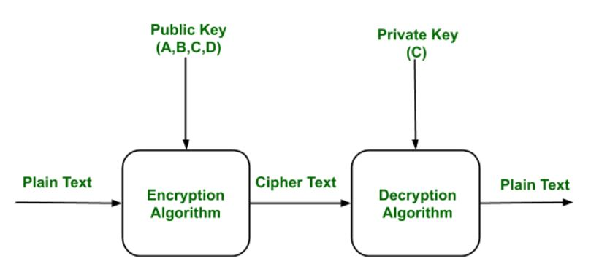Figure 1: RSA Cryptography

Portability:

The Linux and Windows systems will share the majority of their modules with little differences.

Response time:

Commands sent should execute within 1000ms of being sent.

Risk Analysis:

Hardware and Software Requirements:

Schedule :

File Train will start on May 15th and must be completed on or before 24 August 2023. This allows for 14 weeks and 5 days of development.

Work Breakdown:

