1. **INTRODUCTION**

The most frequent word one hears today is STEM (Science, Technology, Engineering, and Mathematics). We need to educate all students in the field of science, technology, engineering, and mathematics in order to be competitive in the global economy of the 21st century. Mathematics happen to be the building blocks for a STEM degree; this area of study must be emphasized in our school and colleges in other to make the course more attractive and allow students to pursue careers in science and technology in other to meet up with the industrial demand in science and technology. Mathematics gives us the ability to learn and think logically in any field of endeavor.

The quality of teaching and learning in mathematics is a major challenge for educators. General concern about mathematics achievement has been evident for the last 20 years. The current debate among scholars is what students should learn to be successful in mathematics. The discussion emphasizes new instructional design techniques to produce individuals who can understand and apply fundamental mathematics concepts. A central and persisting issue is how to provide instructional environments, conditions, methods, and solutions that achieve learning goals for students with different skill and ability levels. Innovative instructional approaches and techniques should be developed to ensure that students become successful learners (Tuncay S and Omur A).

It is important for educators to adopt instructional design techniques to attain higher achievement rates in mathematics. (Rasmussen & Marrongelle, 2006). Considering students’ needs and comprehension of higher-order mathematical knowledge, the instructional design provides a systematic process and a framework for analytically planning, developing, and adapting mathematics instruction (Saritas, 2004). “[Instructional design] is an effective way to alleviate many pressing problems in education. Instructional design is a linking science – a body of knowledge that prescribes instructional actions to optimize desired instructional outcomes, such as achievement and effect” (Reigeluth, 1983, p.5).

1. **ANALYSIS** 
   1. **About the Data**

The data contains information about five schools implementing the same math course in a semester with a total of 35 lessons. There are 30 sections in total. At the time of data collection, the semester is ¾ of the way through.

Below is the table that describes the columns in the datasets.

Columns Description

|  |  |
| --- | --- |
| School | 5 schools (A, B, C, D and E). Nominal |
| Section | School Session, Ordered |
| Very_Ahead | very ahead (more than 5 lessons ahead). Integer |
| Middling | middling (5 lessons ahead to 0 lessons ahead). Integer |
| Behind | behind (1 to 5 lessons behind). Integer |
| More_Behind | more behind (6 to 10 lessons behind). Integer |
| Very_Behind | very behind (more than 10 lessons behind). Integer |
| Completed | completed (finished with the course). Integer |
|  |  |

There are 30 observations with 8 variables. The session column is converted to ordinal since sessions are always in order. There are no missing values in all the 30 observation records and there are no duplicated records in the datasets.

**School:** There is a total of five schools designated with a nominal variable of A, B, C, D and E. 30 observations were recorded with only one observation from School D and School E, 3 observation from school C, 12 observation from school B and 13 observation from school A.

School A has the highest number of record sessions.

**Section:** There are 30 sessions in total. The session column is converted to ordinal as sessions are always considered to be ordered.

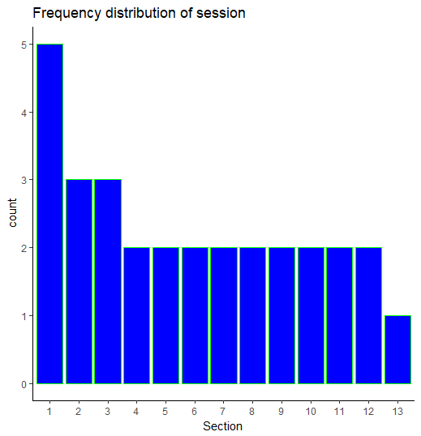

**Very Ahead:** This records the number of students that are ahead with more than five lessons. There is no school with records of a student that is very ahead.

**Middling:** This has a minimum of 2 and a maximum of 19 with an average of 7.40 and a median of 7.50.

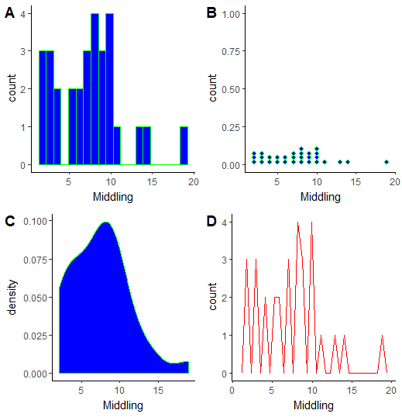

Fig 1 : A – Histogram, B-Dot plots, C- Density plot, D- Frequency polygon of Midling.

**Behind:** The lowest records of the student behind is 4 while the highest record is set at 56.

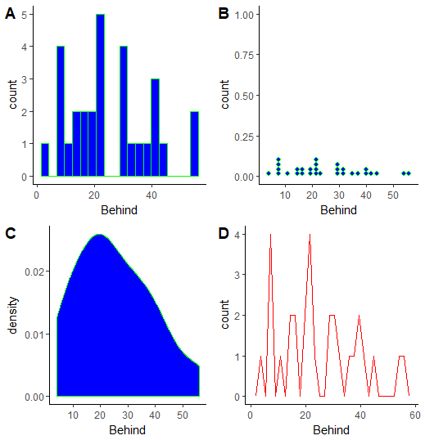

Fig 2: A – Histogram, B-Dot plots, C- Density plot, D- Frequency polygon of student Behind.

**More Behind:** The maximum number of students that are more behind is 12. Minimum is 0, the first quartile is 1, the median is 2 and the mean is 3.3. The distribution looks a bit skewed to the left.

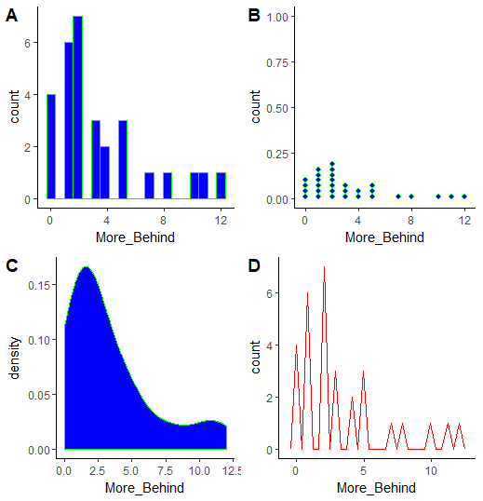

Fig 3: A – Histogram, B-Dot plots, C- Density plot, D- Frequency polygon of student More Behind.

**Very Behind:** This looks a bit skewed to the left. The minimum value is 0, maximum of 24, the first quartile is 1.25, the third quartile is 11.5, the median is 5.5 and the mean value is 6.97. There are no missing values in this column and the variable is numeric.

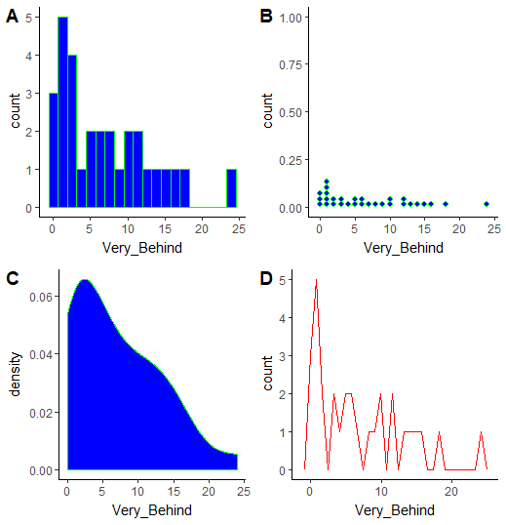

Fig 4: A – Histogram, B-Dot plots, C- Density plot, D- Frequency polygon of student Very Behind.

**Completed:** This variable is an integer with a minimum of 1 and maximum record of 27. There are no missing values. The mean is 10.53 and the median is 10.00 which mean the distribution is concentrated around the mean.

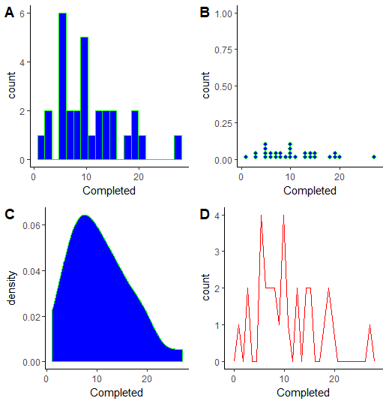

Fig 5: A – Histogram, B-Dot plots, C- Density plot, D- Frequency polygon of student Completed.

**School and Section:** School E and D has a record of one section, school C has a record of 3 sections, school B has a record of 12 sections and school A has a record of 13 sessions.

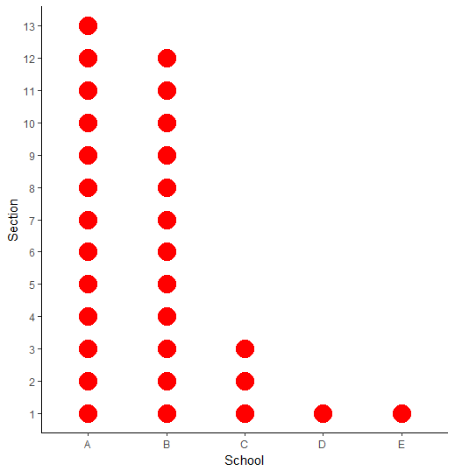

Fig 6: Frequency plot of school and section

**School and Middling:** School A has the highest number of student middling with an exceptional record of 19 when compared to other schools. This record of 19 can be considered as an outlier.

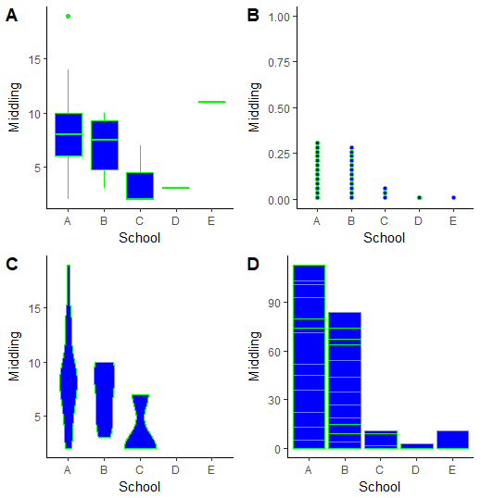

Fig 7: A- Boxplot, B- Dot plot, C- Violina, and D- Column bar of School and Middling

**School and Behind:** School E has the highest record of students that are left behind.

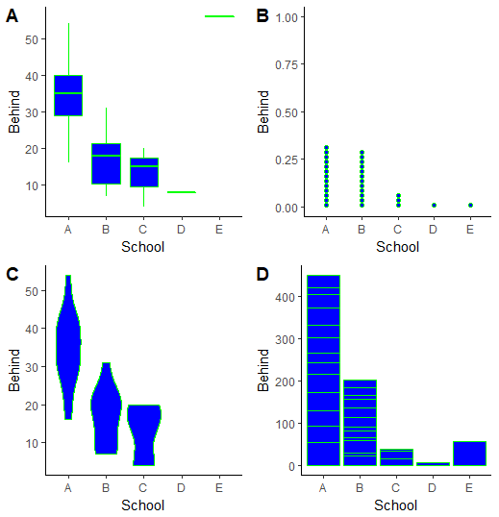

Fig 8: A- Boxplot, B- Dot plot, C- Violina, and D- Column bar of School and Behind

**School and more behind:** School A has the highest number of students that are more behind compared to other school records.

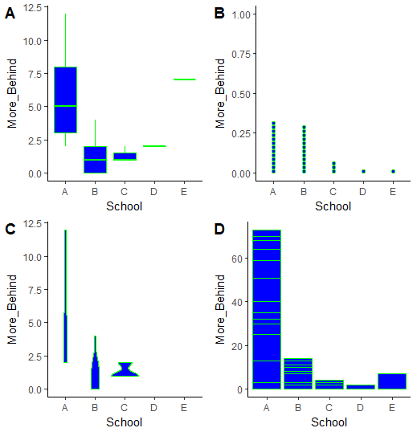

Fig 9: A- Boxplot, B- Dot plot, C- Violina, and D- Column bar of School and More Behind

**School and Very behind:** School A has the highest number of students that are very behind with an exceptional record of 24 which can be considered an outlier when it has been compared to another school.

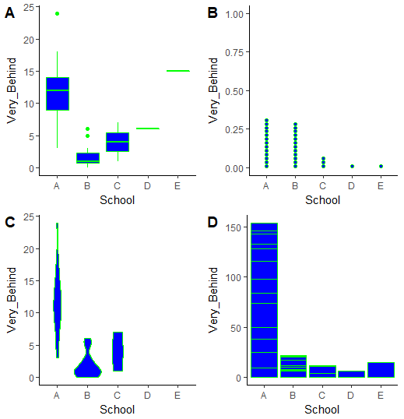

Fig 10: A- Boxplot, B- Dot plot, C- Violina, and D- Column bar of School and very behind

**School and Completed:** School E has the highest number of students that completed their section

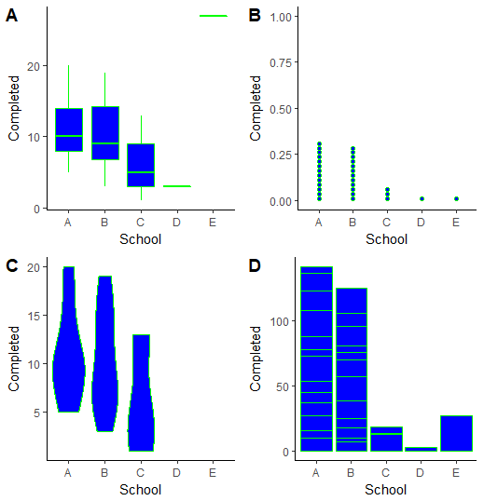

Fig 11: A- Boxplot, B- Dot plot, C- Violina, and D- Column bar of School and Completed

**Correlation Pair Plot:** There is a positive correlation between the student behind and the student that are very behind. There is a positive correlation between the students that are more behind and very behind.

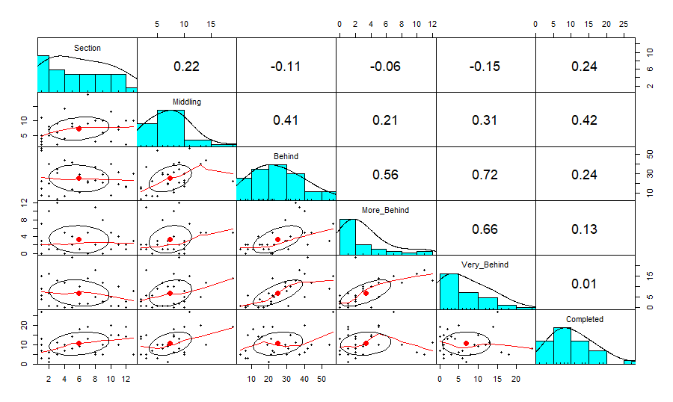

Fig 12 : Pearson correlation plots

1. **RESULTS**

**Middling and Behind:** With a p-value less than 0.05, it is statistically significant that a student middling might eventually fall behind. There is a positive correlation between student middling and the students that are behind.

Pearson's product-moment correlation

data: school_df$Middling and school_df$Behind

t = 2.364, df = 28, p-value = 0.02525

alternative hypothesis: true correlation is not equal to 0

95 percent confidence interval:

0.05582621 0.66974183

sample estimates:

cor

0.4078917

**Middling and more Behind:** With p-value greater than 0.05, it's not statistically significant that a student middling will eventually fall behind. But Middling and behind are positively correlated.

Pearson's product-moment correlation

data: school_df$Middling and school_df$More_Behind

t = 1.1339, df = 28, p-value = 0.2664

alternative hypothesis: true correlation is not equal to 0

95 percent confidence interval:

-0.1630434 0.5298085

sample estimates:

cor

0.2095337

**Middling and very behind:** With a p-value greater than 0.05, it's not statistically significant that a student middling will be very behind. Middling and Behind are positively correlated.

Pearson's product-moment correlation

data: school_df$Middling and school_df$Very_Behind

t = 1.7336, df = 28, p-value = 0.09398

alternative hypothesis: true correlation is not equal to 0

95 percent confidence interval:

-0.05510577 0.60387806

sample estimates:

cor

0.3113445

**Middling and Complet**ed: The p-value is less than 0.05; it is statistically significant to say that a student middling can also complete their session.

Pearson's product-moment correlation

data: school_df$Middling and school_df$Completed

t = 2.4251, df = 28, p-value = 0.02201

alternative hypothesis: true correlation is not equal to 0

95 percent confidence interval:

0.06631535 0.67550686

sample estimates:

cor

0.4166307

**Behind and More behind:** With a p-value less than 0.05, it is statistically significant to say that a student that falls behind is likely to fall more behind with a strong positive correlation of 0.6.

Pearson's product-moment correlation

data: school_df$Behind and school_df$More_Behind

t = 3.5667, df = 28, p-value = 0.001325

alternative hypothesis: true correlation is not equal to 0

95 percent confidence interval:

0.2487501 0.7651287

sample estimates:

cor

0.5589297

**Behind and very behind:** With a p-value of less than 0.05, it is statistically significant to say that a student that falls behind is likely to fall very behind with a strong positive correlation of 0.7.

Pearson's product-moment correlation

data: school_df$Behind and school_df$Very_Behind

t = 5.4284, df = 28, p-value = 8.609e-06

alternative hypothesis: true correlation is not equal to 0

95 percent confidence interval:

0.4795168 0.8556158

sample estimates:

cor

0.7160796

**More Behind and very behind:** With a p-value of less than 0.05, it is statistically significant to say that a student that falls more behind is likely to fall very behind with strong positive correlation of 0.7.

Pearson's product-moment correlation

data: school_df$More_Behind and school_df$Very_Behind

t = 4.6514, df = 28, p-value = 7.191e-05

alternative hypothesis: true correlation is not equal to 0

95 percent confidence interval:

0.3935567 0.8243978

sample estimates:

cor

0.6602163

**Behind and completed:** With a p-value greater than 0.05, it is not statistically significant to say that a student that falls behind is likely to complete his section with a positive correlation of 0.2.

Pearson's product-moment correlation

data: school_df$Behind and school_df$Completed

t = 1.3333, df = 28, p-value = 0.1932

alternative hypothesis: true correlation is not equal to 0

95 percent confidence interval:

-0.1271213 0.5556912

sample estimates:

cor

0.2443381

1. **CONCLUSION**

School A has the highest number of students behind when compared to other schools. It really has the highest number of sections recorded. School E has only one session recorded with the highest number of students that are behind. School E and D have only one record section, school C has 3, school B has 12 and school A has 13.

The schools need to pay attention to students that are middling and start to encourage them or initiate a program that will motivate the students to start working ahead of there section, there is no student from any of the school that is ahead of there section.

Students that start to be behind are more likely to be more behind and eventually be very behind which will hinder them to complete their sections.

References

1. Why is math so important? BY Mike Lefkowitz (blog.mindresearch.org)
2. http://itdl.org/Journal/Dec_09/article03.htm