Task 1: Android Networking APKs
I had a few of these apps installed a while ago, but I’ll write a little about them here. These apps were run on my Lenovo Tab3 8 or TB3-850F.

AirDroid
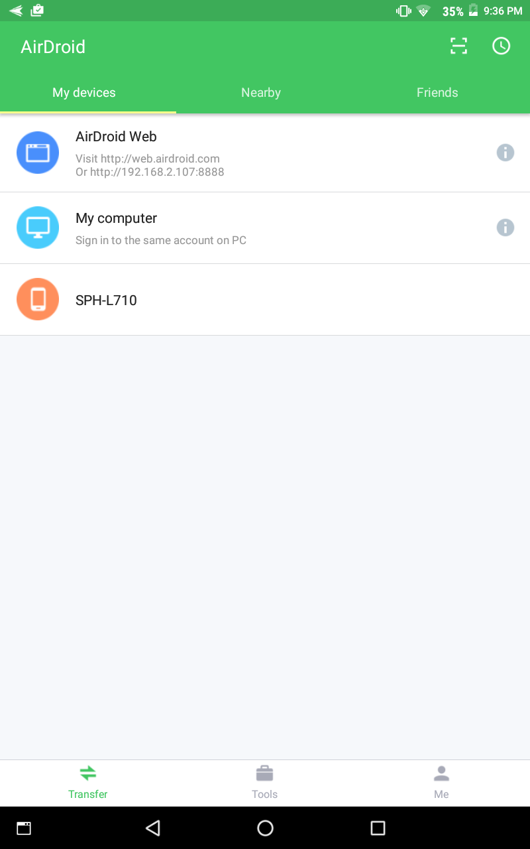
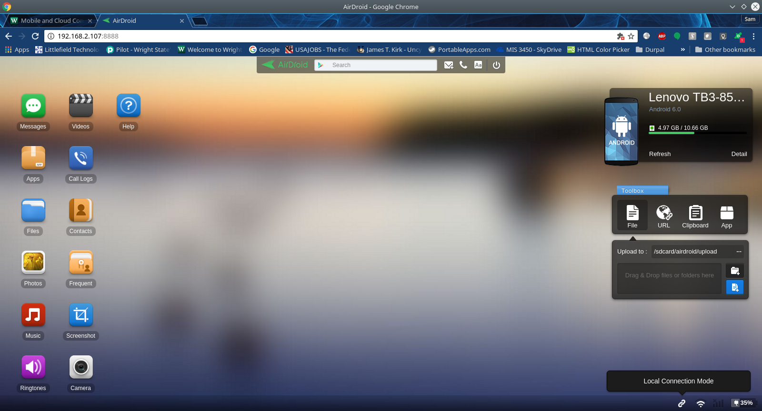
AirDroid is my favorite app that I’ve only just learned last semester. With AirDroid, you can install the app on your Android device and then access the device’s content using any web browser. The app, when you open it on the device, tells you the address that you need to type in your browser to access the contents. Once you type in that address and hit enter, the app even brings up a dialog to accept or reject the connect, along with the IP Address of who is trying to connect to your device. Once accepted, the web browser then acts as a Desktop, where you can look at and download files from the Android device. It is very helpful if you don’t want to deal with setting up a SFTP server on your Android device, or scan through the device on a USB connection to find files. The web browser front-end sets up every type of file to be easily found. Plus, you can also access the camera and other things on the device from the web browser.

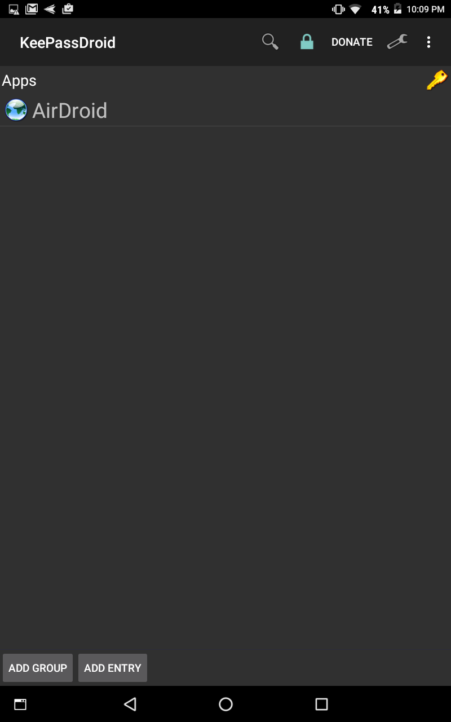
KeepPass
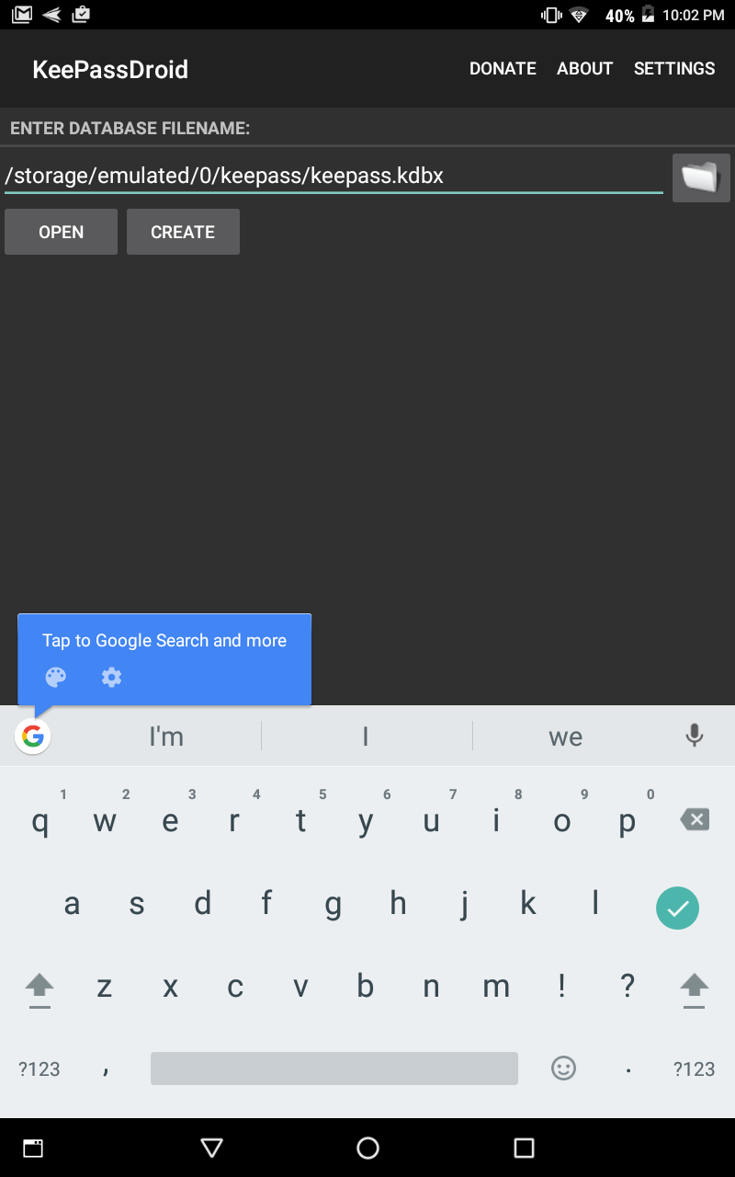

KeepPass was an app that I installed last year that I never really used. It can be used to save your passwords to an encrypted database file on your Android device. Here’s an image of me setting up that database file, there was also a screen after that where I gave it a password and an optional key file. Once that was all setup, you get a blank list. The picture on the right is what it looks like after adding a Group and one entry to that Group. I probably won’t use this app a whole lot since Google Chrome has saved all my passwords, and all my apps remember the passwords that I use with them. Plus, you have to open this app up, put in the Database password, find the entry, select the entry, select copy password ( an option that is hidden at the top right, which is shown after clicking on the dots ). The app just takes too many clicks to retrieve a password to use in an app or website.

AIDE
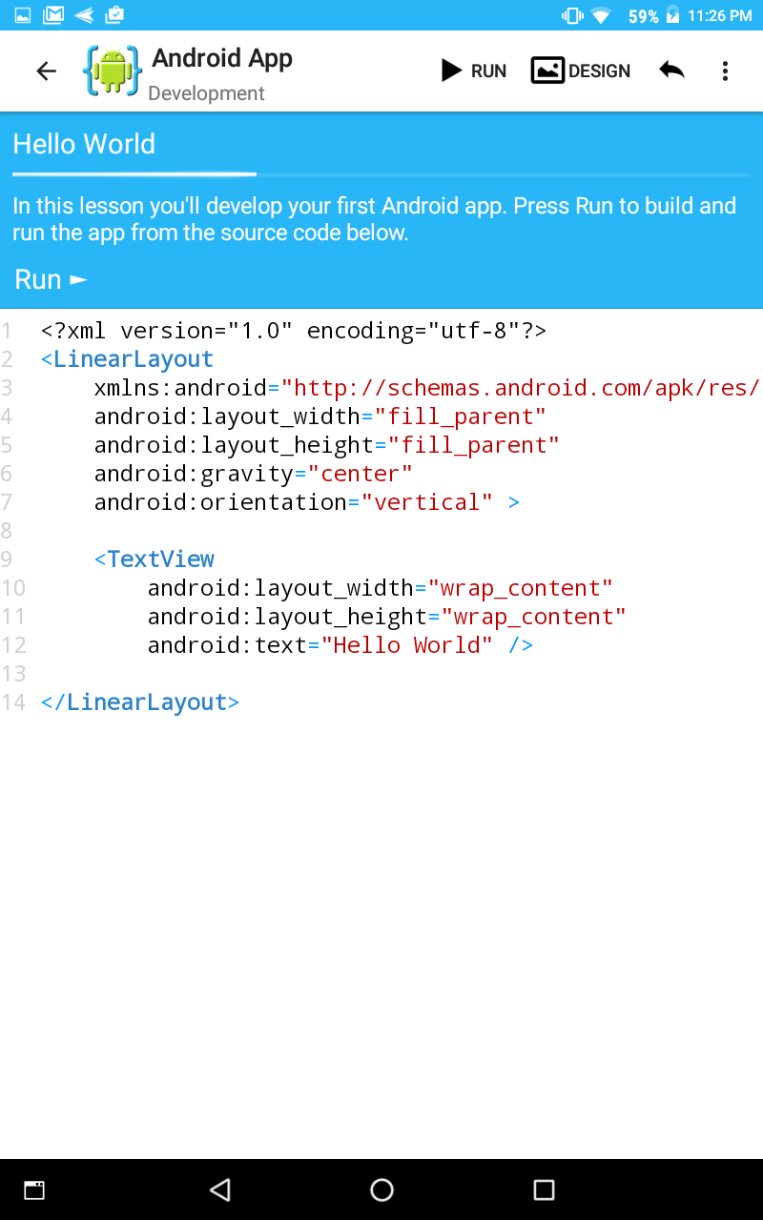
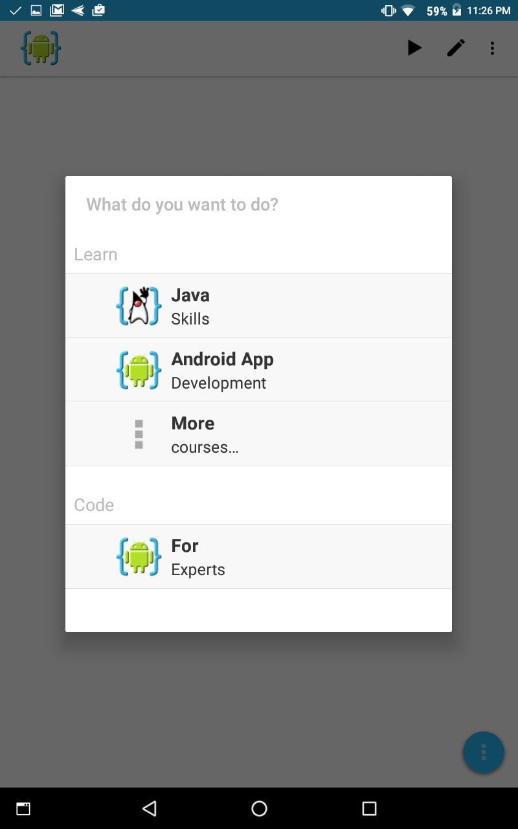
Here’s a cool app that I haven’t really used, even though I found out about this one by myself a few years ago. When it first came out, it was just a normal IDE. However, over the years, it now has this really cool menu in the beginning to give you the option to code or learn stuff. I picked an Android App Development Lesson to quickly show off the app in this report. The lessons give you a certain objective to complete, but you can see that it gives you the XML design code to work with. The source code in the app can be ran and it spawns off a separate app.

SSH Server
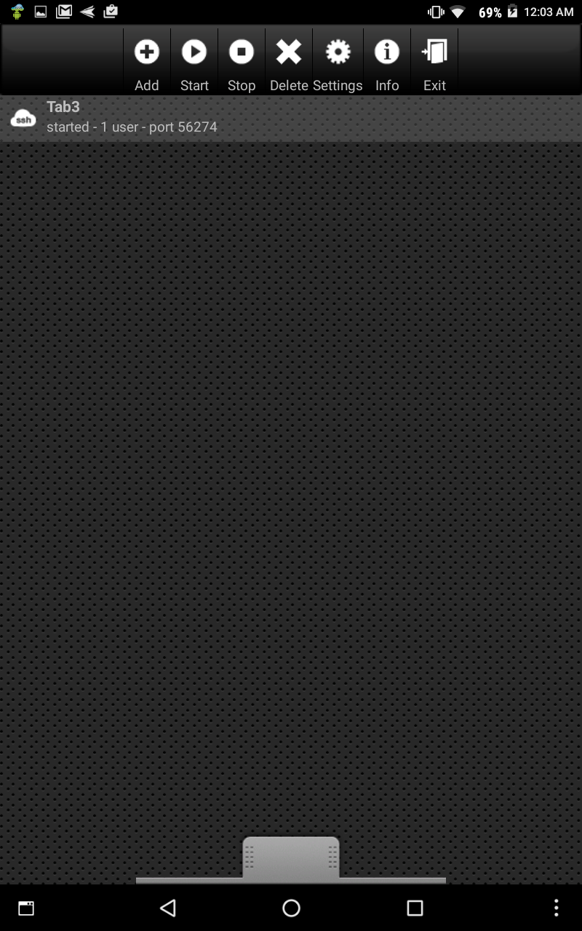
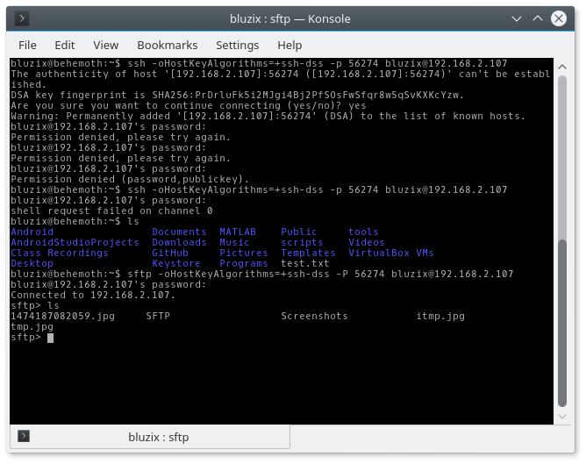
Here’s another app that I found out last semester that I don’t really use. There’s a free and pro version of this app, and the free version does not allow SSH connections. It does allow SFTP access, though. If you want SSH shell connections, then you have to pay up for the free app. However, to get SSH type connections, I just use the adb command to achieve the same result. Plus, I don’t have to remember to put in -oHostKeyAlgorithms=+ssh-dss when I use adb, unlike when I’m using this app.

Hacker’s Keyboard and Terminal IDE
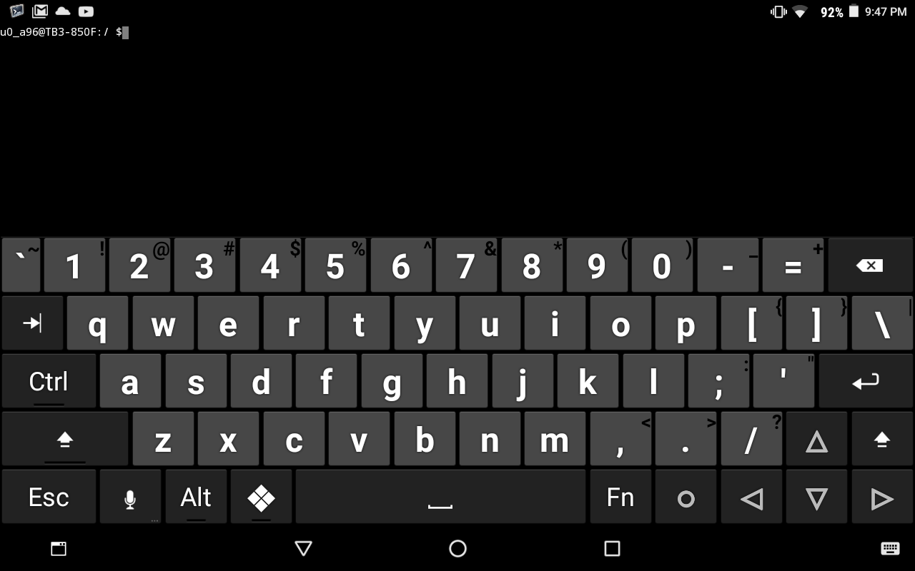
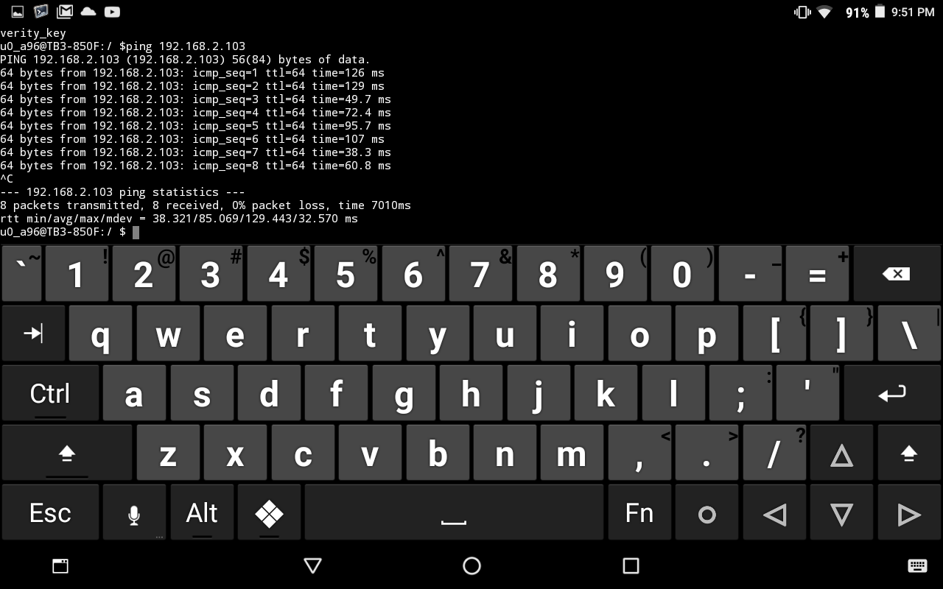
Hacker’s Keyboard is something new that I just found out. I really like that has the arrow keys, but the arrow keys are only available when the device is tilted to landscape. I’ve had issues trying to move the cursor that this keyboard seems to fix. There’s not a whole lot of other keys that would be useful in basic Android apps. However, this is a very nice keyboard for Terminal IDE. I would have to restart or shut down Terminal IDE after entering in the ping command, but this keyboard fixes that issue by allowing me to enter ctrl+c to stop the command. It’s also very nice to see that Terminal IDE returns real data with the ping command. I once had another Terminal Android app that just returned simulated data, which was not helpful at all during my network classes back when I was studying MIS.
Took 2 hours, 15 minutes, and 49 seconds to complete this Task

Task 2: Android Development
I had Android Studio previously installed, so all I had to do was call studio from my Kubuntu’s Terminal to get it up and running. The studio command is actually an alias that I have defined in my .bashrc file. That command actually is short for ‘/usr/local/android-studio/bin/studio.sh &’.
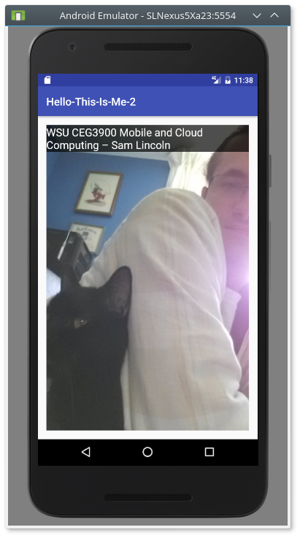
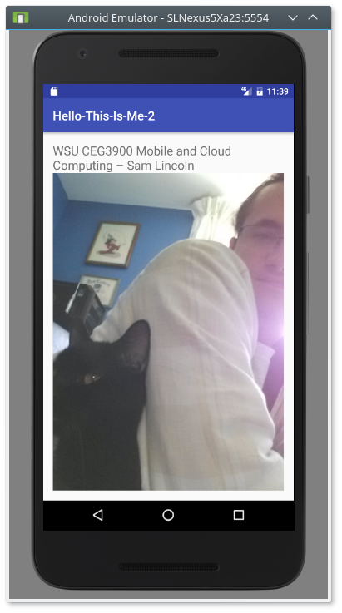
I completely created this new app from scratch. What I did was use a relative layout to a linear (vertical) layout for this app. I put in a different picture from my app that I had created in CEG 4440. Also, the pictures are now buttons, all you have to do is tap on an image to switch layouts.
Took 1 hour, 30 minutes, and 9 seconds to complete Task 2; 3 hours, 45 minutes, and 58 seconds total

Task 3: Build an Android Open Source APK
I decided to try to download and build MirakelX/mirakel-android from https://github.com/MirakelX/mirakel-android. All I had to do to download the source code was go to my GitHub folder I created, and type in git clone https://github.com/MirakelX/mirakel-android.git because I had previously downloaded git through apt-get.
I opened up the entire folder that was pulled from git inside of Android Studio. I had to wait for Android Studio to update the SDK, but afterwards, I downloaded the build tools for version 23.0.1. I was able to build it, but it had a few errors. One of the errors was that it was unable to locate a ‘./local.properties’ file on line 64 of the new_ui/build.gradle. I poked around the directory and found a local.properties.dist, so I just added the .dist to the file name on line 64. After the IDE finished that build, it asked if I wanted to upgrade the project’s Android Gradle plugin to version 2.1.3. I agreed to this, the IDE did it’s thing, and it finished with 146 warnings. I wasn’t able to get it to run. One of the developers decided to include a requirement for a debug.keystore file in the new_ui before I could build and run the thing. The problem was, that debug.keystore file was not included. I feel like the hour and a half I spent on this is good enough; plus, then instructions just say I have to get the app to build, and nothing about having it run correctly. I’m just going to build release APK, and we’ll see if it works or not later. Also, this app takes way too long to build between each attempt to run it.

Changes:
- Updated Android Gradle plugin to version 2.1.3 in build.gradle in mirakel-android
- Changed line 64 of build.gradle in mirakel-android/new_ui to load local.properties.dist
- Deleted the signingConfigs starting on line 65 of build.gradle in mirakel-android/new_ui
- Deleted the use of signingConfigs on lines 84 and 91 of build.gradle in mirakel-android/new_ui
Took 1 hour, 45 minutes, and 4 seconds to complete this task; 5 hours, 31 minutes, and 2 seconds total

Task 4: adb (Android Debug Bridge)

Install APKs
What I did was connect my Lenovo Tab3 to my computer using a USB cable. In the Terminal, I moved to the correct directory and typed in adb install apkName where the apkName is replaced with HelloThisIsMe.apk and mirakel.apk. Below is a picture that shows the success of those operations.
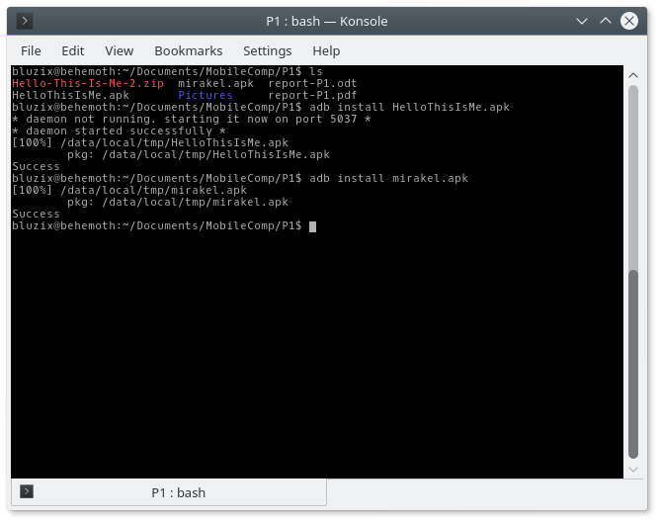
I then started up Mirakel on my Tab3, because I was curious to see if it was working. Well, it looks like generating a signed APK worked. I even took the time to create an entry for it, to make sure that it worked. Everything looks in order; I’ve place two pictures on the next page to show off the app working.
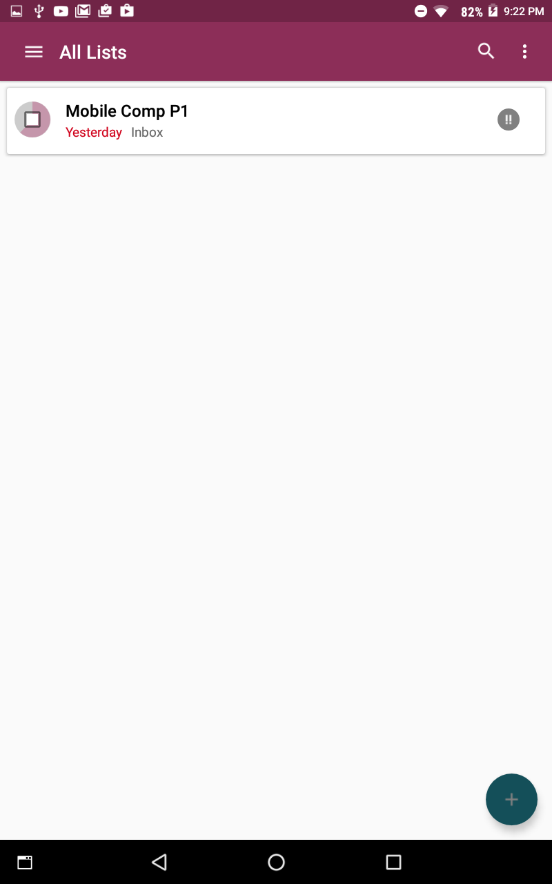
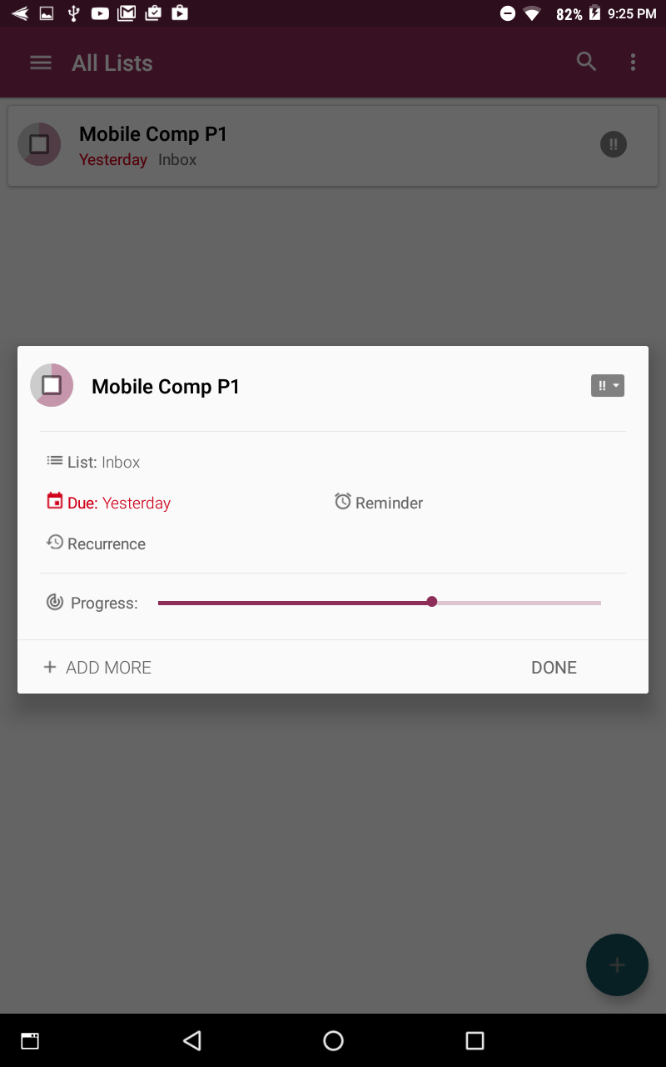
It’s a decent app, but I wish it had a check list for each entry; then a could just have the app calculate Progress for me instead of awkwardly entering it in manually. Plus, it could use an explanation on what sub tasks mean; because, they are not the checklist I thought they were, even though they have a check mark as their icon.
I called adb shell to access the shell of my Tab3 through the adb connection. Once I was in the shell of my device, I called cd directory where directory was /system/bin and /system/xbin. Since I forgot to call script before entering the shell, what I did was call ls > /storage/sdcard0/Download/fileName where the fileName was binFiles.txt and xBinFiles.txt to get a listing of the files located inside these system directories. Once I created these file, I called adb pull /storage/sdcard0/Download/fileName to grab the files. The next few pages shows the contents of these two files.

/system/bin
6620_launcher
6620_wmt_concurrency
6620_wmt_lpbk
AcdApiDaemon
MATest
MtkCodecService
acpi
aee
aee_archive
aee_core_forwarder
aee_dumpstate
akmd09911
akmd8963
akmd8975
am
ami304d
app_process
app_process32
app_process64
applypatch
applysig
appops
appwidget
atci_service
atcid
atrace
audiocmdservice_atci
autobt
autokd
badblocks
basename
batterywarning
bcc
blkid
blockdev
bmgr
bmm050d
boot_logo_updater
bootanimation
bu
bugreport
bzcat
cal
capture_audio.sh
cat
ccci_fsd
ccci_mdinit
chcon
chgrp
chmod
chown
chroot
cksum
clatd
clear
cmp
comm
content
cp
cpio
cut
dalvikvm
dalvikvm32
dalvikvm64
date
dd
debuggerd
debuggerd64
dex2oat
df
dhcp6c
dhcp6ctl
dhcp6s
dhcpcd
dirname
dm_agent_binder
dmesg
dmlog
dnsmasq
dos2unix
downloader
dpm
drmserver
du
dumpstate
dumpsys
e2fsck
echo
egrep
em_svr
env
epdg_wod
expand
expr
factory
fallocate
false
fgrep
find
free
fsck.f2fs
fsck_msdos
fsck_msdos_mtk
fuelgauged
gas_srv
gatekeeperd
ged_srv
geomagneticd
getenforce
getevent
getprop
grep
groups
gsm0710muxd
gsm0710muxdmd2
guiext-server
gzip
gzip_static
head
hid
hostapd
hostapd_cli
hostname
hwclock
id
idmap
ifconfig
iftop
ime
init.lct.bootcheck.sh
inotifyd
input
insmod
install-recovery.sh
installd
ioctl
ionice
ip
ip6tables
ipod
iptables
keystore
kill
kpoc_charger
lcdc_screen_cap
ld.mc
linker
linker64
lmkd
ln
load_policy
log
logcat
logd
logname
logwrapper
losetup
ls
lsm303md
lsmod
lsof
lsusb
magd
make_ext4fs
make_f2fs
matv
mc6420d
md5sum
md_ctrl
mdnsd
media
mediaserver
memorydumper
memsicd
memsicd3416x
meta_tst
mkdir
mke2fs
mknod
mkswap
mktemp
mmp
mobile_log_d
modinfo
monkey
more
mount
mountpoint
msensord
mtdinfo
mtkrild
mtkrildmd2
mtpd
muxreport
mv
nandread
ndc
netd
netdiag
netstat
newfs_msdos
nice
nl
nohup
nvram_agent_binder
nvram_daemon
oatdump
od
orientationd
paste
patch
patchoat
perf_native_test
pgrep
pidof
ping
ping6
pkill
playback_audio.sh
pm
pmap
ppl_agent
pppd
pppd_dt
pq
printenv
printf
prlimit
program_binary_service
ps
pwd
racoon
radvd
readlink
realpath
reboot
renice
requestsync
resize2fs
resize_ext4
restorecon
rm
rmdir
rmmod
route
rs2spir
rtt
run-as
runcon
s62xd
schedtest
screencap
screenrecord
sdcard
sed
sendevent
sensorservice
seq
service
servicemanager
setenforce
setprop
setsid
settings
sgdisk
sh
sha1sum
sink
sleep
slpd
sm
sn
sort
source
spir2cl
split
spm_loader
start
stat
stop
stp_dump3
strings
superumount
surfaceflinger
svc
swapoff
swapon
sync
sysctl
tac
tail
tar
taskset
tc
tee
telecom
terservice
tertestclient
thermal
thermal_manager
thermald
time
timeout
tiny_mkswap
tiny_swapoff
tiny_swapon
toolbox
top
touch
toybox
tr
true
truncate
tune2fs
tzdatacheck
ubiattach
ubidetach
ubiformat
ubimkvol
ubinfo
ubirmvol
ubiupdatevol
uiautomator
umount
uname
uncrypt
uniq
unix2dos
uptime
usleep
vdc
vmstat
vold
vtservice
watchprops
wc
which
whoami
wifi2agps
wm
wmt_loader
wpa_cli
wpa_supplicant
xargs
xlog
yes

/system/xbin
BGW
dexdump
mnld
showmap
tcpdump

mounts
To capture the mount points of my Tab3, I first exited the adb shell and called script mounts.txt to begin logging the Terminal’s output to a new mounts.txt file on my computer. I then called adb shell to access my device’s shell, and then called mount to get a listing of all the mount points on the device. To stop logging the Terminal’s output and create the mounts.txt file, I had to call exit twice: once to exit the adb shell, and another to stop script from logging Terminal’s output. Normally, script will stop logging Terminal output unless your doing things similar to adb shell. Below and on the next page, I have what script was able to capture for mount.
rootfs / rootfs ro,seclabel 0 0
tmpfs /dev tmpfs rw,seclabel,nosuid,relatime,mode=755 0 0
devpts /dev/pts devpts rw,seclabel,relatime,mode=600 0 0
proc /proc proc rw,relatime 0 0
sysfs /sys sysfs rw,seclabel,relatime 0 0
selinuxfs /sys/fs/selinux selinuxfs rw,relatime 0 0
debugfs /sys/kernel/debug debugfs rw,seclabel,relatime 0 0
none /acct cgroup rw,relatime,cpuacct 0 0
none /sys/fs/cgroup tmpfs rw,seclabel,relatime,mode=750,gid=1000 0 0
tmpfs /mnt tmpfs rw,seclabel,relatime,mode=755,gid=1000 0 0
none /dev/cpuctl cgroup rw,relatime,cpu 0 0
pstore /sys/fs/pstore pstore rw,seclabel,relatime 0 0
/dev/block/dm-0 /system ext4 ro,seclabel,relatime,data=ordered 0 0
/dev/block/platform/mtk-msdc.0/11230000.msdc0/by-name/cache /cache ext4 rw,seclabel,nosuid,nodev,noatime,discard,noauto_da_alloc,data=ordered 0 0
/dev/block/platform/mtk-msdc.0/11230000.msdc0/by-name/protect1 /protect_f ext4 rw,seclabel,nosuid,nodev,noatime,nodelalloc,noauto_da_alloc,commit=1,data=ordered 0 0
/dev/block/platform/mtk-msdc.0/11230000.msdc0/by-name/protect2 /protect_s ext4 rw,seclabel,nosuid,nodev,noatime,nodelalloc,noauto_da_alloc,commit=1,data=ordered 0 0
/dev/block/platform/mtk-msdc.0/11230000.msdc0/by-name/nvdata /nvdata ext4 rw,seclabel,nosuid,nodev,noatime,discard,noauto_da_alloc,data=ordered 0 0
adb /dev/usb-ffs/adb functionfs rw,relatime 0 0
tmpfs /storage tmpfs rw,seclabel,relatime,mode=755,gid=1000 0 0
/dev/block/dm-1 /data ext4 rw,seclabel,nosuid,nodev,noatime,discard,noauto_da_alloc,resuid=10010,data=ordered 0 0
/dev/fuse /mnt/runtime/default/emulated fuse rw,nosuid,nodev,noexec,noatime,user_id=1023,group_id=1023,default_permissions,allow_other 0 0
/dev/fuse /storage/emulated fuse rw,nosuid,nodev,noexec,noatime,user_id=1023,group_id=1023,default_permissions,allow_other 0 0
/dev/fuse /mnt/runtime/read/emulated fuse rw,nosuid,nodev,noexec,noatime,user_id=1023,group_id=1023,default_permissions,allow_other 0 0
/dev/fuse /mnt/runtime/write/emulated fuse rw,nosuid,nodev,noexec,noatime,user_id=1023,group_id=1023,default_permissions,allow_other 0 0
I completed Task 4 in 49 minutes; 6 hours, 20 minutes, and 2 seconds total

Task 5: Staring AWS Cloud Computing

Storage
I already had a Google Drive account and a OneDrive account. Here’s my music folder in both of those accounts. They both have the same ten music files; however, the Google Drive has one extra file.
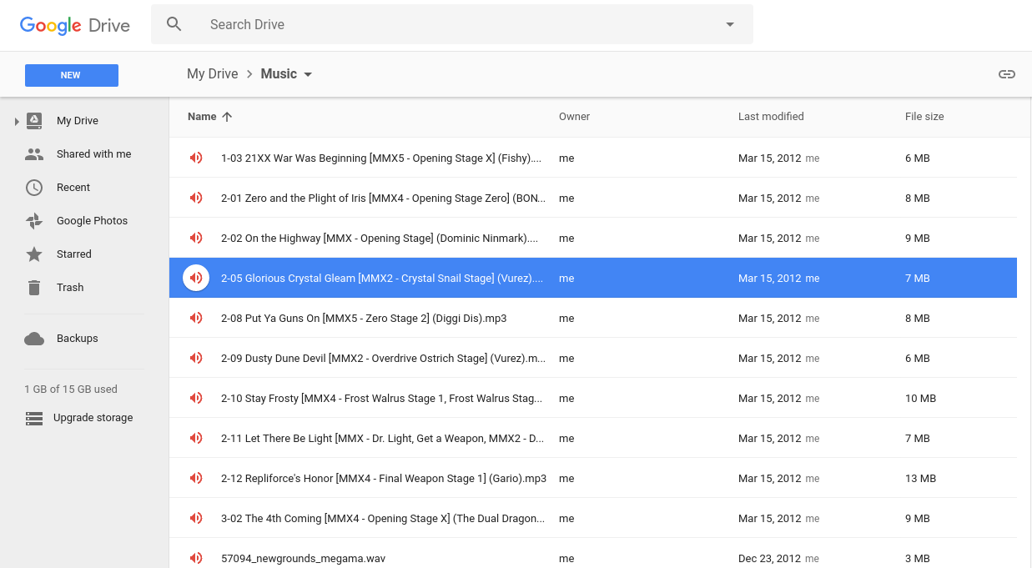
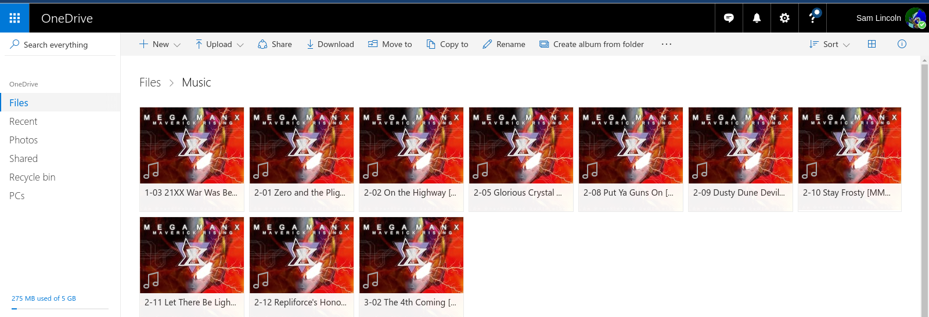

Amazon EC2
I already had an Amazon account, so I got to skip setting one up. Once I logged into the EC2 site, I picked the Services at the top, then picked EC2 from the window that showed up. I selected launch instance button, filtered by Free Tier only, I chose the Ubuntu 16.04 LTS (HVM) SSD Volume 64-bit; I couldn’t find version 12.04 sadly. I then picked the t2.micro type (only one available for free), checked to make sure the default storage was 8 GiB, tagged it with “CEG3900-WSU-Cloud-Lab”, left security groups alone, and then I created a key-pair after clicking launch. I created the key “slincoln-ceg3900-aws-ec2-key” and stored it in ~/keystore/EC2. Public DNS was ec2-54-213-198-66.us-west-2.compute.amazonaws.com.
To make things easier for me to document, I’ll just post my stuff from a few script commands. If I make any comments, I’ll highlight them to separate them from the script output. Plus, I’ll still continue my headers to help sort through this mess.

Logging in and doing #4
I logged in and did everything for question 4 in one go. I even copied everything from dpkg -l, but the total count is 448 programs.
#]0;bluzix@behemoth: ~/Documents/MobileComp/P1#bluzix@behemoth:~/Documents/MobileComp/P1$ ssh -X -i s##[K~/Keystore/EC2/slincoln-ceg3900-aws-
-ec2-key.pem ubuntu@ec2-54-213-198-66.us-west-2/compute.amazonaws.com#######################[1Pcompute.amazonaws.com#####################.compute.amazonaws.com######################[C#[C#[C#[C#[C#[C#[C#[C#[C#[C#[C#[C#[C#[C#[C#[C#[C#[C#[C#[C#[C#######
The authenticity of host 'ec2-54-213-198-66.us-west-2.compute.amazonaws.com (54.213.198.66)' can't be established.
ECDSA key fingerprint is SHA256:uZdbIOpeLdn0KRGM4qhcOXBQXP096UyuHKsc1MgyU5U.
Are you sure you want to continue connecting (yes/no)? yes
Warning: Permanently added 'ec2-54-213-198-66.us-west-2.compute.amazonaws.com,54.213.198.66' (ECDSA) to the list of known hosts.

Welcome to Ubuntu 16.04.1 LTS (GNU/Linux 4.4.0-53-generic x86_64)

* Documentation: https://help.ubuntu.com
* Management: https://landscape.canonical.com
* Support: https://ubuntu.com/advantage

Get cloud support with Ubuntu Advantage Cloud Guest:
http://www.ubuntu.com/business/services/cloud

0 packages can be updated.
0 updates are security updates.

The programs included with the Ubuntu system are free software;
the exact distribution terms for each program are described in the
individual files in /usr/share/doc/*/copyright.

Ubuntu comes with ABSOLUTELY NO WARRANTY, to the extent permitted by
applicable law.

/usr/bin/xauth: file /home/ubuntu/.Xauthority does not exist
To run a command as administrator (user "root"), use "sudo <command>".
See "man sudo_root" for details.

#]0;ubuntu@ip-172-31-22-202: ~#ubuntu@ip-172-31-22-202:~$ ps -aux; df -Th; more /etc/passwd
USER PID %CPU %MEM VSZ RSS TTY STAT START TIME COMMAND
root 1 0.2 0.5 37956 6060 ? Ss 03:57 0:03 /sbin/init
root 2 0.0 0.0 0 0 ? S 03:57 0:00 [kthreadd]
root 3 0.0 0.0 0 0 ? S 03:57 0:00 [ksoftirqd/0]
root 5 0.0 0.0 0 0 ? S< 03:57 0:00 [kworker/0:0H]
root 6 0.0 0.0 0 0 ? S 03:57 0:00 [kworker/u30:0]
root 7 0.0 0.0 0 0 ? S 03:57 0:00 [rcu_sched]
root 8 0.0 0.0 0 0 ? S 03:57 0:00 [rcu_bh]
root 9 0.0 0.0 0 0 ? S 03:57 0:00 [migration/0]
root 10 0.0 0.0 0 0 ? S 03:57 0:00 [watchdog/0]
root 11 0.0 0.0 0 0 ? S 03:57 0:00 [kdevtmpfs]
root 12 0.0 0.0 0 0 ? S< 03:57 0:00 [netns]
root 13 0.0 0.0 0 0 ? S< 03:57 0:00 [perf]
root 14 0.0 0.0 0 0 ? S 03:57 0:00 [xenwatch]
root 15 0.0 0.0 0 0 ? S 03:57 0:00 [xenbus]
root 17 0.0 0.0 0 0 ? S 03:57 0:00 [khungtaskd]
root 18 0.0 0.0 0 0 ? S< 03:57 0:00 [writeback]
root 19 0.0 0.0 0 0 ? SN 03:57 0:00 [ksmd]
root 20 0.0 0.0 0 0 ? SN 03:57 0:00 [khugepaged]
root 21 0.0 0.0 0 0 ? S< 03:57 0:00 [crypto]
root 22 0.0 0.0 0 0 ? S< 03:57 0:00 [kintegrityd]
root 23 0.0 0.0 0 0 ? S< 03:57 0:00 [bioset]
root 24 0.0 0.0 0 0 ? S< 03:57 0:00 [kblockd]
root 25 0.0 0.0 0 0 ? S< 03:57 0:00 [ata_sff]
root 26 0.0 0.0 0 0 ? S< 03:57 0:00 [md]
root 27 0.0 0.0 0 0 ? S< 03:57 0:00 [devfreq_wq]
root 28 0.0 0.0 0 0 ? S 03:57 0:00 [kworker/u30:1]
root 30 0.0 0.0 0 0 ? S 03:57 0:00 [kswapd0]
root 31 0.0 0.0 0 0 ? S< 03:57 0:00 [vmstat]
root 32 0.0 0.0 0 0 ? S 03:57 0:00 [fsnotify_mark]
root 33 0.0 0.0 0 0 ? S 03:57 0:00 [ecryptfs-kthrea]
root 49 0.0 0.0 0 0 ? S< 03:57 0:00 [kthrotld]
root 50 0.0 0.0 0 0 ? S< 03:57 0:00 [acpi_thermal_pm]
root 51 0.0 0.0 0 0 ? S< 03:57 0:00 [bioset]
root 52 0.0 0.0 0 0 ? S< 03:57 0:00 [bioset]
root 53 0.0 0.0 0 0 ? S< 03:57 0:00 [bioset]
root 54 0.0 0.0 0 0 ? S< 03:57 0:00 [bioset]
root 55 0.0 0.0 0 0 ? S< 03:57 0:00 [bioset]
root 56 0.0 0.0 0 0 ? S< 03:57 0:00 [bioset]
root 57 0.0 0.0 0 0 ? S< 03:57 0:00 [bioset]
root 58 0.0 0.0 0 0 ? S< 03:57 0:00 [bioset]
root 59 0.0 0.0 0 0 ? S< 03:57 0:00 [bioset]
root 60 0.0 0.0 0 0 ? S< 03:57 0:00 [bioset]
root 61 0.0 0.0 0 0 ? S< 03:57 0:00 [bioset]
root 62 0.0 0.0 0 0 ? S< 03:57 0:00 [bioset]
root 63 0.0 0.0 0 0 ? S< 03:57 0:00 [bioset]
root 64 0.0 0.0 0 0 ? S< 03:57 0:00 [bioset]
root 65 0.0 0.0 0 0 ? S< 03:57 0:00 [bioset]
root 66 0.0 0.0 0 0 ? S< 03:57 0:00 [bioset]
root 67 0.0 0.0 0 0 ? S< 03:57 0:00 [bioset]
root 68 0.0 0.0 0 0 ? S< 03:57 0:00 [bioset]
root 69 0.0 0.0 0 0 ? S< 03:57 0:00 [bioset]
root 70 0.0 0.0 0 0 ? S< 03:57 0:00 [bioset]
root 71 0.0 0.0 0 0 ? S< 03:57 0:00 [bioset]
root 72 0.0 0.0 0 0 ? S< 03:57 0:00 [bioset]
root 73 0.0 0.0 0 0 ? S< 03:57 0:00 [bioset]
root 74 0.0 0.0 0 0 ? S< 03:57 0:00 [bioset]
root 75 0.0 0.0 0 0 ? S 03:57 0:00 [scsi_eh_0]
root 76 0.0 0.0 0 0 ? S< 03:57 0:00 [scsi_tmf_0]
root 77 0.0 0.0 0 0 ? S 03:57 0:00 [scsi_eh_1]
root 78 0.0 0.0 0 0 ? S< 03:57 0:00 [scsi_tmf_1]
root 80 0.0 0.0 0 0 ? S< 03:57 0:00 [bioset]
root 84 0.0 0.0 0 0 ? S< 03:57 0:00 [ipv6_addrconf]
root 98 0.0 0.0 0 0 ? S< 03:57 0:00 [deferwq]
root 99 0.0 0.0 0 0 ? S< 03:57 0:00 [charger_manager]
root 139 0.0 0.0 0 0 ? S< 03:57 0:00 [bioset]
root 140 0.0 0.0 0 0 ? S< 03:57 0:00 [bioset]
root 141 0.0 0.0 0 0 ? S< 03:57 0:00 [bioset]
root 142 0.0 0.0 0 0 ? S< 03:57 0:00 [bioset]
root 143 0.0 0.0 0 0 ? S< 03:57 0:00 [bioset]
root 144 0.0 0.0 0 0 ? S< 03:57 0:00 [bioset]
root 145 0.0 0.0 0 0 ? S< 03:57 0:00 [bioset]
root 146 0.0 0.0 0 0 ? S< 03:57 0:00 [bioset]
root 147 0.0 0.0 0 0 ? S< 03:57 0:00 [kpsmoused]
root 261 0.0 0.0 0 0 ? S< 03:57 0:00 [raid5wq]
root 294 0.0 0.0 0 0 ? S< 03:57 0:00 [bioset]
root 318 0.0 0.0 0 0 ? S 03:57 0:00 [jbd2/xvda1-8]
root 319 0.0 0.0 0 0 ? S< 03:57 0:00 [ext4-rsv-conver]
root 377 0.0 0.6 36932 6924 ? Ss 03:57 0:00 /lib/systemd/systemd-jo
root 397 0.0 0.0 0 0 ? S< 03:57 0:00 [iscsi_eh]
root 402 0.0 0.0 0 0 ? S< 03:57 0:00 [ib_addr]
root 403 0.0 0.0 0 0 ? S< 03:57 0:00 [ib_mcast]
root 404 0.0 0.0 0 0 ? S< 03:57 0:00 [ib_nl_sa_wq]
root 405 0.0 0.0 0 0 ? S< 03:57 0:00 [ib_cm]
root 406 0.0 0.0 0 0 ? S< 03:57 0:00 [iw_cm_wq]
root 407 0.0 0.0 0 0 ? S 03:57 0:00 [kauditd]
root 408 0.0 0.0 0 0 ? S< 03:57 0:00 [rdma_cm]
root 435 0.0 0.1 94772 1696 ? Ss 03:57 0:00 /sbin/lvmetad -f
root 454 0.0 0.0 0 0 ? S 03:57 0:00 [kworker/0:4]
root 470 0.0 0.4 42768 4128 ? Ss 03:57 0:00 /lib/systemd/systemd-ud
root 540 0.0 0.0 0 0 ? S< 03:57 0:00 [kworker/0:1H]
systemd+ 542 0.0 0.2 100324 2552 ? Ssl 03:57 0:00 /lib/systemd/systemd-ti
root 930 0.0 0.2 16120 2828 ? Ss 03:57 0:00 /sbin/dhclient -1 -v -p
root 1086 0.0 0.0 5224 160 ? Ss 03:57 0:00 /sbin/iscsid
root 1087 0.0 0.3 5724 3524 ? S<Ls 03:57 0:00 /sbin/iscsid
root 1093 0.0 1.3 258188 13796 ? Ssl 03:57 0:00 /usr/lib/snapd/snapd
root 1096 0.0 0.2 26068 2588 ? Ss 03:57 0:00 /usr/sbin/cron -f
syslog 1104 0.0 0.9 260632 9828 ? Ssl 03:57 0:00 /usr/sbin/rsyslogd -n
root 1117 0.0 0.1 95368 1384 ? Ssl 03:57 0:00 /usr/bin/lxcfs /var/lib
root 1122 0.0 0.5 272944 5836 ? Ssl 03:57 0:00 /usr/lib/accountsservic
daemon 1124 0.0 0.2 26044 2184 ? Ss 03:57 0:00 /usr/sbin/atd -f
root 1143 0.0 0.3 28548 3076 ? Ss 03:57 0:00 /lib/systemd/systemd-lo
root 1145 0.0 0.1 4400 1320 ? Ss 03:57 0:00 /usr/sbin/acpid
message+ 1152 0.0 0.3 42900 3760 ? Ss 03:57 0:00 /usr/bin/dbus-daemon --
root 1202 0.0 0.0 13376 172 ? Ss 03:57 0:00 /sbin/mdadm --monitor -
root 1208 0.0 0.5 277180 6084 ? Ssl 03:57 0:00 /usr/lib/policykit-1/po
root 1277 0.0 0.1 12844 1820 ttyS0 Ss+ 03:57 0:00 /sbin/agetty --keep-bau
root 1279 0.0 0.1 14660 1748 tty1 Ss+ 03:57 0:00 /sbin/agetty --noclear
root 1322 0.0 0.5 65520 5488 ? Ss 03:57 0:00 /usr/sbin/sshd -D
root 1369 0.0 0.0 0 0 ? S 04:13 0:00 [kworker/0:0]
root 1392 0.0 0.6 95368 6880 ? Ss 04:21 0:00 sshd: ubuntu [priv]
ubuntu 1394 0.0 0.4 45248 4692 ? Ss 04:22 0:00 /lib/systemd/systemd --
root 1396 0.0 0.0 0 0 ? S 04:22 0:00 [kworker/0:1]
ubuntu 1397 0.0 0.2 61408 2128 ? S 04:22 0:00 (sd-pam)
root 1402 0.0 0.0 0 0 ? S 04:22 0:00 [kworker/0:2]
ubuntu 1450 0.0 0.3 95368 3316 ? S 04:22 0:00 sshd: ubuntu@pts/0
ubuntu 1453 0.0 0.5 21396 5196 pts/0 Ss 04:22 0:00 -bash
ubuntu 1478 0.0 0.3 36084 3336 pts/0 R+ 04:23 0:00 ps -aux
Filesystem Type Size Used Avail Use% Mounted on
udev devtmpfs 490M 0 490M 0% /dev
tmpfs tmpfs 100M 4.3M 95M 5% /run
/dev/xvda1 ext4 7.8G 916M 6.5G 13% /
tmpfs tmpfs 496M 0 496M 0% /dev/shm
tmpfs tmpfs 5.0M 0 5.0M 0% /run/lock
tmpfs tmpfs 496M 0 496M 0% /sys/fs/cgroup
tmpfs tmpfs 100M 0 100M 0% /run/user/1000
root:x:0:0:root:/root:/bin/bash
daemon:x:1:1:daemon:/usr/sbin:/usr/sbin/nologin
bin:x:2:2:bin:/bin:/usr/sbin/nologin
sys:x:3:3:sys:/dev:/usr/sbin/nologin
sync:x:4:65534:sync:/bin:/bin/sync
games:x:5:60:games:/usr/games:/usr/sbin/nologin
man:x:6:12:man:/var/cache/man:/usr/sbin/nologin
lp:x:7:7:lp:/var/spool/lpd:/usr/sbin/nologin
mail:x:8:8:mail:/var/mail:/usr/sbin/nologin
news:x:9:9:news:/var/spool/news:/usr/sbin/nologin
uucp:x:10:10:uucp:/var/spool/uucp:/usr/sbin/nologin
proxy:x:13:13:proxy:/bin:/usr/sbin/nologin
www-data:x:33:33:www-data:/var/www:/usr/sbin/nologin
backup:x:34:34:backup:/var/backups:/usr/sbin/nologin
list:x:38:38:Mailing List Manager:/var/list:/usr/sbin/nologin
irc:x:39:39:ircd:/var/run/ircd:/usr/sbin/nologin
gnats:x:41:41:Gnats Bug-Reporting System (admin):/var/lib/gnats:/usr/sbin/nologin
nobody:x:65534:65534:nobody:/nonexistent:/usr/sbin/nologin
systemd-timesync:x:100:102:systemd Time Synchronization,,,:/run/systemd:/bin/false
systemd-network:x:101:103:systemd Network Management,,,:/run/systemd/netif:/bin/false
systemd-resolve:x:102:104:systemd Resolver,,,:/run/systemd/resolve:/bin/false
systemd-bus-proxy:x:103:105:systemd Bus Proxy,,,:/run/systemd:/bin/false
syslog:x:104:108::/home/syslog:/bin/false
_apt:x:105:65534::/nonexistent:/bin/false
lxd:x:106:65534::/var/lib/lxd/:/bin/false
messagebus:x:107:111::/var/run/dbus:/bin/false
uuidd:x:108:112::/run/uuidd:/bin/false
dnsmasq:x:109:65534:dnsmasq,,,:/var/lib/misc:/bin/false
sshd:x:110:65534::/var/run/sshd:/usr/sbin/nologin
pollinate:x:111:1::/var/cache/pollinate:/bin/false
ubuntu:x:1000:1000:Ubuntu:/home/ubuntu:/bin/bash
#]0;ubuntu@ip-172-31-22-202: ~#ubuntu@ip-172-31-22-202:~$ wget http://www.cs.wright.edu/~pmateti/Courses/3900/Lectures/
Cloud/worms12.cpp
--2017-01-27 04:24:20-- http://www.cs.wright.edu/~pmateti/Courses/3900/Lectures/Cloud/worms12.cpp
Resolving www.cs.wright.edu (www.cs.wright.edu)... 130.108.74.59
Connecting to www.cs.wright.edu (www.cs.wright.edu)|130.108.74.59|:80... connected.
HTTP request sent, awaiting response... 302 Found
Location: http://cecs.wright.edu/~pmateti/Courses/3900/Lectures/Cloud/worms12.cpp [following]
--2017-01-27 04:24:21-- http://cecs.wright.edu/~pmateti/Courses/3900/Lectures/Cloud/worms12.cpp
Resolving cecs.wright.edu (cecs.wright.edu)... 130.108.74.79
Connecting to cecs.wright.edu (cecs.wright.edu)|130.108.74.79|:80... connected.
HTTP request sent, awaiting response... 200 OK
Length: 13933 (14K) [text/x-c]
Saving to: ‘worms12.cpp’

worms12.cpp 0%[ ] 0 --.-KB/s
worms12.cpp 100%[=========================>] 13.61K --.-KB/s in 0.1s

2017-01-27 04:24:21 (99.9 KB/s) - ‘worms12.cpp’ saved [13933/13933]

#]0;ubuntu@ip-172-31-22-202: ~#ubuntu@ip-172-31-22-202:~$ dpkgv##[K -l
Desired=Unknown/Install/Remove/Purge/Hold
| Status=Not/Inst/Conf-files/Unpacked/halF-conf/Half-inst/trig-aWait/Trig-pend
|/ Err?=(none)/Reinst-required (Status,Err: uppercase=bad)
||/ Name Version Architecture Description
+++-================-=============-=============-=====================================
ii accountsservice 0.6.40-2ubunt amd64 query and manipulate user account inf
ii acl 2.2.52-3 amd64 Access control list utilities
ii acpid 1:2.0.26-1ubu amd64 Advanced Configuration and Power Inte
ii adduser 3.113+nmu3ubu all add and remove users and groups
ii apparmor 2.10.95-0ubun amd64 user-space parser utility for AppArmo
ii apport 2.20.1-0ubunt all automatically generate crash reports
ii apport-symptoms 0.20 all symptom scripts for apport
ii apt 1.2.15ubuntu0 amd64 commandline package manager
ii apt-transport-ht 1.2.15ubuntu0 amd64 https download transport for APT
ii apt-utils 1.2.15ubuntu0 amd64 package management related utility pr
ii at 3.1.18-2ubunt amd64 Delayed job execution and batch proce
ii base-files 9.4ubuntu4.3 amd64 Debian base system miscellaneous file
ii base-passwd 3.5.39 amd64 Debian base system master password an
ii bash 4.3-14ubuntu1 amd64 GNU Bourne Again SHell
ii bash-completion 1:2.1-4.2ubun all programmable completion for the bash
ii bcache-tools 1.0.8-2 amd64 bcache userspace tools
ii bind9-host 1:9.10.3.dfsg amd64 Version of 'host' bundled with BIND 9
ii bsdmainutils 9.0.6ubuntu3 amd64 collection of more utilities from Fre
ii bsdutils 1:2.27.1-6ubu amd64 basic utilities from 4.4BSD-Lite
ii btrfs-tools 4.4-1 amd64 Checksumming Copy on Write Filesystem
ii busybox-initramf 1:1.22.0-15ub amd64 Standalone shell setup for initramfs
ii busybox-static 1:1.22.0-15ub amd64 Standalone rescue shell with tons of
ii byobu 5.106-0ubuntu all text window manager, shell multiplexe
ii bzip2 1.0.6-8 amd64 high-quality block-sorting file compr
ii ca-certificates 20160104ubunt all Common CA certificates
ii cloud-guest-util 0.27-0ubuntu2 all cloud guest utilities
ii cloud-init 0.7.8-49-g9e9 all Init scripts for cloud instances
ii cloud-initramfs- 0.27ubuntu1.2 all copy initramfs modules into root file
ii cloud-initramfs- 0.27ubuntu1.2 all write a network interface file in /ru
ii command-not-foun 0.3ubuntu16.0 all Suggest installation of packages in i
ii command-not-foun 0.3ubuntu16.0 amd64 Set of data files for command-not-fou
ii console-setup 1.108ubuntu15 all console font and keymap setup program
ii console-setup-li 1.108ubuntu15 all Linux specific part of console-setup
ii coreutils 8.25-2ubuntu2 amd64 GNU core utilities
ii cpio 2.11+dfsg-5ub amd64 GNU cpio -- a program to manage archi
ii cron 3.0pl1-128ubu amd64 process scheduling daemon
ii cryptsetup 2:1.6.6-5ubun amd64 disk encryption support - startup scr
ii cryptsetup-bin 2:1.6.6-5ubun amd64 disk encryption support - command lin
ii curl 7.47.0-1ubunt amd64 command line tool for transferring da
ii dash 0.5.8-2.1ubun amd64 POSIX-compliant shell
ii dbus 1.10.6-1ubunt amd64 simple interprocess messaging system
ii debconf 1.5.58ubuntu1 all Debian configuration management syste
ii debconf-i18n 1.5.58ubuntu1 all full internationalization support for
ii debianutils 4.7 amd64 Miscellaneous utilities specific to D
ii dh-python 2.20151103ubu all Debian helper tools for packaging Pyt
ii diffutils 1:3.3-3 amd64 File comparison utilities
ii distro-info-data 0.28ubuntu0.2 all information about the distributions'
ii dmeventd 2:1.02.110-1u amd64 Linux Kernel Device Mapper event daem
ii dmidecode 3.0-2ubuntu0. amd64 SMBIOS/DMI table decoder
ii dmsetup 2:1.02.110-1u amd64 Linux Kernel Device Mapper userspace
ii dns-root-data 2015052300+h+ all DNS root data including root zone and
ii dnsmasq-base 2.75-1ubuntu0 amd64 Small caching DNS proxy and DHCP/TFTP
ii dnsutils 1:9.10.3.dfsg amd64 Clients provided with BIND
ii dosfstools 3.0.28-2ubunt amd64 utilities for making and checking MS-
ii dpkg 1.18.4ubuntu1 amd64 Debian package management system
ii e2fslibs:amd64 1.42.13-1ubun amd64 ext2/ext3/ext4 file system libraries
ii e2fsprogs 1.42.13-1ubun amd64 ext2/ext3/ext4 file system utilities
ii eatmydata 105-3 all Library and utilities designed to dis
ii ed 1.10-2 amd64 classic UNIX line editor
ii eject 2.1.5+deb1+cv amd64 ejects CDs and operates CD-Changers u
ii ethtool 1:4.5-1 amd64 display or change Ethernet device set
ii file 1:5.25-2ubunt amd64 Determines file type using "magic" nu
ii findutils 4.6.0+git+201 amd64 utilities for finding files--find, xa
ii fonts-ubuntu-fon 1:0.83-0ubunt all Ubuntu Font Family Linux console font
ii friendly-recover 0.2.31 all Make recovery more user-friendly
ii ftp 0.17-33 amd64 classical file transfer client
ii fuse 2.9.4-1ubuntu amd64 Filesystem in Userspace
ii gawk 1:4.1.3+dfsg- amd64 GNU awk, a pattern scanning and proce
ii gcc-5-base:amd64 5.4.0-6ubuntu amd64 GCC, the GNU Compiler Collection (bas
ii gcc-6-base:amd64 6.0.1-0ubuntu amd64 GCC, the GNU Compiler Collection (bas
ii gdisk 1.0.1-1build1 amd64 GPT fdisk text-mode partitioning tool
ii geoip-database 20160408-1 all IP lookup command line tools that use
ii gettext-base 0.19.7-2ubunt amd64 GNU Internationalization utilities fo
ii gir1.2-glib-2.0: 1.46.0-3ubunt amd64 Introspection data for GLib, GObject,
ii git 1:2.7.4-0ubun amd64 fast, scalable, distributed revision
ii git-man 1:2.7.4-0ubun all fast, scalable, distributed revision
ii gnupg 1.4.20-1ubunt amd64 GNU privacy guard - a free PGP replac
ii gpgv 1.4.20-1ubunt amd64 GNU privacy guard - signature verific
ii grep 2.25-1~16.04. amd64 GNU grep, egrep and fgrep
ii groff-base 1.22.3-7 amd64 GNU troff text-formatting system (bas
ii grub-common 2.02~beta2-36 amd64 GRand Unified Bootloader (common file
ii grub-gfxpayload- 0.7 amd64 GRUB gfxpayload blacklist
ii grub-legacy-ec2 0.7.8-49-g9e9 all Handles update-grub for ec2 instances
ii grub-pc 2.02~beta2-36 amd64 GRand Unified Bootloader, version 2 (
ii grub-pc-bin 2.02~beta2-36 amd64 GRand Unified Bootloader, version 2 (
ii grub2-common 2.02~beta2-36 amd64 GRand Unified Bootloader (common file
ii gzip 1.6-4ubuntu1 amd64 GNU compression utilities
ii hdparm 9.48+ds-1 amd64 tune hard disk parameters for high pe
ii hostname 3.16ubuntu2 amd64 utility to set/show the host name or
ii ifenslave 2.7ubuntu1 all configure network interfaces for para
ii ifupdown 0.8.10ubuntu1 amd64 high level tools to configure network
ii info 6.1.0.dfsg.1- amd64 Standalone GNU Info documentation bro
ii init 1.29ubuntu3 amd64 System-V-like init utilities - metapa
ii init-system-help 1.29ubuntu3 all helper tools for all init systems
ii initramfs-tools 0.122ubuntu8. all generic modular initramfs generator (
ii initramfs-tools- 0.122ubuntu8. amd64 binaries used by initramfs-tools
ii initramfs-tools- 0.122ubuntu8. all generic modular initramfs generator (
ii initscripts 2.88dsf-59.3u amd64 scripts for initializing and shutting
ii insserv 1.14.0-5ubunt amd64 boot sequence organizer using LSB ini
ii install-info 6.1.0.dfsg.1- amd64 Manage installed documentation in inf
ii iproute2 4.3.0-1ubuntu amd64 networking and traffic control tools
ii iptables 1.6.0-2ubuntu amd64 administration tools for packet filte
ii iputils-ping 3:20121221-5u amd64 Tools to test the reachability of net
ii iputils-tracepat 3:20121221-5u amd64 Tools to trace the network path to a
ii irqbalance 1.1.0-2ubuntu amd64 Daemon to balance interrupts for SMP
ii isc-dhcp-client 4.3.3-5ubuntu amd64 DHCP client for automatically obtaini
ii isc-dhcp-common 4.3.3-5ubuntu amd64 common files used by all of the isc-d
ii iso-codes 3.65-1 all ISO language, territory, currency, sc
ii kbd 1.15.5-1ubunt amd64 Linux console font and keytable utili
ii keyboard-configu 1.108ubuntu15 all system-wide keyboard preferences
ii klibc-utils 2.0.4-8ubuntu amd64 small utilities built with klibc for
ii kmod 22-1ubuntu4 amd64 tools for managing Linux kernel modul
ii krb5-locales 1.13.2+dfsg-5 all Internationalization support for MIT
ii language-selecto 0.165.4 all Language selector for Ubuntu
ii less 481-2.1ubuntu amd64 pager program similar to more
ii libaccountsservi 0.6.40-2ubunt amd64 query and manipulate user account inf
ii libacl1:amd64 2.2.52-3 amd64 Access control list shared library
ii libapparmor-perl 2.10.95-0ubun amd64 AppArmor library Perl bindings
ii libapparmor1:amd 2.10.95-0ubun amd64 changehat AppArmor library
ii libapt-inst2.0:a 1.2.15ubuntu0 amd64 deb package format runtime library
ii libapt-pkg5.0:am 1.2.15ubuntu0 amd64 package management runtime library
ii libasn1-8-heimda 1.7~git201509 amd64 Heimdal Kerberos - ASN.1 library
ii libasprintf0v5:a 0.19.7-2ubunt amd64 GNU library to use fprintf and friend
ii libatm1:amd64 1:2.5.1-1.5 amd64 shared library for ATM (Asynchronous
ii libattr1:amd64 1:2.4.47-2 amd64 Extended attribute shared library
ii libaudit-common 1:2.4.5-1ubun all Dynamic library for security auditing
ii libaudit1:amd64 1:2.4.5-1ubun amd64 Dynamic library for security auditing
ii libbind9-140:amd 1:9.10.3.dfsg amd64 BIND9 Shared Library used by BIND
ii libblkid1:amd64 2.27.1-6ubunt amd64 block device ID library
ii libbsd0:amd64 0.8.2-1 amd64 utility functions from BSD systems -
ii libbz2-1.0:amd64 1.0.6-8 amd64 high-quality block-sorting file compr
ii libc-bin 2.23-0ubuntu5 amd64 GNU C Library: Binaries
ii libc6:amd64 2.23-0ubuntu5 amd64 GNU C Library: Shared libraries
ii libcap-ng0:amd64 0.7.7-1 amd64 An alternate POSIX capabilities libra
ii libcap2:amd64 1:2.24-12 amd64 POSIX 1003.1e capabilities (library)
ii libcap2-bin 1:2.24-12 amd64 POSIX 1003.1e capabilities (utilities
ii libcomerr2:amd64 1.42.13-1ubun amd64 common error description library
ii libcryptsetup4:a 2:1.6.6-5ubun amd64 disk encryption support - shared libr
ii libcurl3-gnutls: 7.47.0-1ubunt amd64 easy-to-use client-side URL transfer
ii libdb5.3:amd64 5.3.28-11 amd64 Berkeley v5.3 Database Libraries [run
ii libdbus-1-3:amd6 1.10.6-1ubunt amd64 simple interprocess messaging system
ii libdbus-glib-1-2 0.106-1 amd64 simple interprocess messaging system
ii libdebconfclient 0.198ubuntu1 amd64 Debian Configuration Management Syste
ii libdevmapper-eve 2:1.02.110-1u amd64 Linux Kernel Device Mapper event supp
ii libdevmapper1.02 2:1.02.110-1u amd64 Linux Kernel Device Mapper userspace
ii libdns-export162 1:9.10.3.dfsg amd64 Exported DNS Shared Library
ii libdns162:amd64 1:9.10.3.dfsg amd64 DNS Shared Library used by BIND
ii libdrm2:amd64 2.4.67-1ubunt amd64 Userspace interface to kernel DRM ser
ii libdumbnet1:amd6 1.12-7 amd64 dumb, portable networking library --
ii libeatmydata1:am 105-3 amd64 Library and utilities to disable fsyn
ii libedit2:amd64 3.1-20150325- amd64 BSD editline and history libraries
ii libelf1:amd64 0.165-3ubuntu amd64 library to read and write ELF files
ii liberror-perl 0.17-1.2 all Perl module for error/exception handl
ii libestr0 0.1.10-1 amd64 Helper functions for handling strings
ii libevent-2.0-5:a 2.0.21-stable amd64 Asynchronous event notification libra
ii libexpat1:amd64 2.1.0-7ubuntu amd64 XML parsing C library - runtime libra
ii libfdisk1:amd64 2.27.1-6ubunt amd64 fdisk partitioning library
ii libffi6:amd64 3.2.1-4 amd64 Foreign Function Interface library ru
ii libfreetype6:amd 2.6.1-0.1ubun amd64 FreeType 2 font engine, shared librar
ii libfribidi0:amd6 0.19.7-1 amd64 Free Implementation of the Unicode Bi
ii libfuse2:amd64 2.9.4-1ubuntu amd64 Filesystem in Userspace (library)
ii libgcc1:amd64 1:6.0.1-0ubun amd64 GCC support library
ii libgcrypt20:amd6 1.6.5-2ubuntu amd64 LGPL Crypto library - runtime library
ii libgdbm3:amd64 1.8.3-13.1 amd64 GNU dbm database routines (runtime ve
ii libgeoip1:amd64 1.6.9-1 amd64 non-DNS IP-to-country resolver librar
ii libgirepository- 1.46.0-3ubunt amd64 Library for handling GObject introspe
ii libglib2.0-0:amd 2.48.1-1~ubun amd64 GLib library of C routines
ii libglib2.0-data 2.48.1-1~ubun all Common files for GLib library
ii libgmp10:amd64 2:6.1.0+dfsg- amd64 Multiprecision arithmetic library
ii libgnutls-openss 3.4.10-4ubunt amd64 GNU TLS library - OpenSSL wrapper
ii libgnutls30:amd6 3.4.10-4ubunt amd64 GNU TLS library - main runtime librar
ii libgpg-error0:am 1.21-2ubuntu1 amd64 library for common error values and m
ii libgpm2:amd64 1.20.4-6.1 amd64 General Purpose Mouse - shared librar
ii libgssapi-krb5-2 1.13.2+dfsg-5 amd64 MIT Kerberos runtime libraries - krb5
ii libgssapi3-heimd 1.7~git201509 amd64 Heimdal Kerberos - GSSAPI support lib
ii libhcrypto4-heim 1.7~git201509 amd64 Heimdal Kerberos - crypto library
ii libheimbase1-hei 1.7~git201509 amd64 Heimdal Kerberos - Base library
ii libheimntlm0-hei 1.7~git201509 amd64 Heimdal Kerberos - NTLM support libra
ii libhogweed4:amd6 3.2-1 amd64 low level cryptographic library (publ
ii libhx509-5-heimd 1.7~git201509 amd64 Heimdal Kerberos - X509 support libra
ii libicu55:amd64 55.1-7 amd64 International Components for Unicode
ii libidn11:amd64 1.32-3ubuntu1 amd64 GNU Libidn library, implementation of
ii libisc-export160 1:9.10.3.dfsg amd64 Exported ISC Shared Library
ii libisc160:amd64 1:9.10.3.dfsg amd64 ISC Shared Library used by BIND
ii libisccc140:amd6 1:9.10.3.dfsg amd64 Command Channel Library used by BIND
ii libisccfg140:amd 1:9.10.3.dfsg amd64 Config File Handling Library used by
ii libjson-c2:amd64 0.11-4ubuntu2 amd64 JSON manipulation library - shared li
ii libk5crypto3:amd 1.13.2+dfsg-5 amd64 MIT Kerberos runtime libraries - Cryp
ii libkeyutils1:amd 1.5.9-8ubuntu amd64 Linux Key Management Utilities (libra
ii libklibc 2.0.4-8ubuntu amd64 minimal libc subset for use with init
ii libkmod2:amd64 22-1ubuntu4 amd64 libkmod shared library
ii libkrb5-26-heimd 1.7~git201509 amd64 Heimdal Kerberos - libraries
ii libkrb5-3:amd64 1.13.2+dfsg-5 amd64 MIT Kerberos runtime libraries
ii libkrb5support0: 1.13.2+dfsg-5 amd64 MIT Kerberos runtime libraries - Supp
ii libldap-2.4-2:am 2.4.42+dfsg-2 amd64 OpenLDAP libraries
ii liblocale-gettex 1.07-1build1 amd64 module using libc functions for inter
ii liblvm2app2.2:am 2.02.133-1ubu amd64 LVM2 application library
ii liblvm2cmd2.02:a 2.02.133-1ubu amd64 LVM2 command library
ii liblwres141:amd6 1:9.10.3.dfsg amd64 Lightweight Resolver Library used by
ii liblxc1 2.0.5-0ubuntu amd64 Linux Containers userspace tools (lib
ii liblz4-1:amd64 0.0~r131-2ubu amd64 Fast LZ compression algorithm library
ii liblzma5:amd64 5.1.1alpha+20 amd64 XZ-format compression library
ii liblzo2-2:amd64 2.08-1.2 amd64 data compression library
ii libmagic1:amd64 1:5.25-2ubunt amd64 File type determination library using
ii libmnl0:amd64 1.0.3-5 amd64 minimalistic Netlink communication li
ii libmount1:amd64 2.27.1-6ubunt amd64 device mounting library
ii libmpdec2:amd64 2.4.2-1 amd64 library for decimal floating point ar
ii libmpfr4:amd64 3.1.4-1 amd64 multiple precision floating-point com
ii libmspack0:amd64 0.5-1 amd64 library for Microsoft compression for
ii libncurses5:amd6 6.0+20160213- amd64 shared libraries for terminal handlin
ii libncursesw5:amd 6.0+20160213- amd64 shared libraries for terminal handlin
ii libnetfilter-con 1.0.5-1 amd64 Netfilter netlink-conntrack library
ii libnettle6:amd64 3.2-1 amd64 low level cryptographic library (symm
ii libnewt0.52:amd6 0.52.18-1ubun amd64 Not Erik's Windowing Toolkit - text m
ii libnfnetlink0:am 1.0.1-3 amd64 Netfilter netlink library
ii libnih1:amd64 1.0.3-4.3ubun amd64 NIH Utility Library
ii libnuma1:amd64 2.0.11-1ubunt amd64 Libraries for controlling NUMA policy
ii libp11-kit0:amd6 0.23.2-5~ubun amd64 library for loading and coordinating
ii libpam-modules:a 1.1.8-3.2ubun amd64 Pluggable Authentication Modules for
ii libpam-modules-b 1.1.8-3.2ubun amd64 Pluggable Authentication Modules for
ii libpam-runtime 1.1.8-3.2ubun all Runtime support for the PAM library
ii libpam-systemd:a 229-4ubuntu12 amd64 system and service manager - PAM modu
ii libpam0g:amd64 1.1.8-3.2ubun amd64 Pluggable Authentication Modules libr
ii libparted2:amd64 3.2-15 amd64 disk partition manipulator - shared l
ii libpcap0.8:amd64 1.7.4-2 amd64 system interface for user-level packe
ii libpci3:amd64 1:3.3.1-1.1ub amd64 Linux PCI Utilities (shared library)
ii libpcre3:amd64 2:8.38-3.1 amd64 Perl 5 Compatible Regular Expression
ii libperl5.22:amd6 5.22.1-9 amd64 shared Perl library
ii libpipeline1:amd 1.4.1-2 amd64 pipeline manipulation library
ii libplymouth4:amd 0.9.2-3ubuntu amd64 graphical boot animation and logger -
ii libpng12-0:amd64 1.2.54-1ubunt amd64 PNG library - runtime
ii libpolkit-agent- 0.105-14.1 amd64 PolicyKit Authentication Agent API
ii libpolkit-backen 0.105-14.1 amd64 PolicyKit backend API
ii libpolkit-gobjec 0.105-14.1 amd64 PolicyKit Authorization API
ii libpopt0:amd64 1.16-10 amd64 lib for parsing cmdline parameters
ii libprocps4:amd64 2:3.3.10-4ubu amd64 library for accessing process informa
ii libpython3-stdli 3.5.1-3 amd64 interactive high-level object-oriente
ii libpython3.5:amd 3.5.2-2ubuntu amd64 Shared Python runtime library (versio
ii libpython3.5-min 3.5.2-2ubuntu amd64 Minimal subset of the Python language
ii libpython3.5-std 3.5.2-2ubuntu amd64 Interactive high-level object-oriente
ii libreadline5:amd 5.2+dfsg-3bui amd64 GNU readline and history libraries, r
ii libreadline6:amd 6.3-8ubuntu2 amd64 GNU readline and history libraries, r
ii libroken18-heimd 1.7~git201509 amd64 Heimdal Kerberos - roken support libr
ii librtmp1:amd64 2.4+20151223. amd64 toolkit for RTMP streams (shared libr
ii libsasl2-2:amd64 2.1.26.dfsg1- amd64 Cyrus SASL - authentication abstracti
ii libsasl2-modules 2.1.26.dfsg1- amd64 Cyrus SASL - pluggable authentication
ii libsasl2-modules 2.1.26.dfsg1- amd64 Cyrus SASL - pluggable authentication
ii libseccomp2:amd6 2.2.3-3ubuntu amd64 high level interface to Linux seccomp
ii libselinux1:amd6 2.4-3build2 amd64 SELinux runtime shared libraries
ii libsemanage-comm 2.3-1build3 all Common files for SELinux policy manag
ii libsemanage1:amd 2.3-1build3 amd64 SELinux policy management library
ii libsepol1:amd64 2.4-2 amd64 SELinux library for manipulating bina
ii libsigsegv2:amd6 2.10-4 amd64 Library for handling page faults in a
ii libslang2:amd64 2.3.0-2ubuntu amd64 S-Lang programming library - runtime
ii libsmartcols1:am 2.27.1-6ubunt amd64 smart column output alignment library
ii libsqlite3-0:amd 3.11.0-1ubunt amd64 SQLite 3 shared library
ii libss2:amd64 1.42.13-1ubun amd64 command-line interface parsing librar
ii libssl1.0.0:amd6 1.0.2g-1ubunt amd64 Secure Sockets Layer toolkit - shared
ii libstdc++6:amd64 5.4.0-6ubuntu amd64 GNU Standard C++ Library v3
ii libsystemd0:amd6 229-4ubuntu12 amd64 systemd utility library
ii libtasn1-6:amd64 4.7-3ubuntu0. amd64 Manage ASN.1 structures (runtime)
ii libtext-charwidt 0.04-7build5 amd64 get display widths of characters on t
ii libtext-iconv-pe 1.7-5build4 amd64 converts between character sets in Pe
ii libtext-wrapi18n 0.06-7.1 all internationalized substitute of Text:
ii libtinfo5:amd64 6.0+20160213- amd64 shared low-level terminfo library for
ii libudev1:amd64 229-4ubuntu12 amd64 libudev shared library
ii libusb-0.1-4:amd 2:0.1.12-28 amd64 userspace USB programming library
ii libusb-1.0-0:amd 2:1.0.20-1 amd64 userspace USB programming library
ii libustr-1.0-1:am 1.0.4-5 amd64 Micro string library: shared library
ii libutempter0:amd 1.1.6-3 amd64 privileged helper for utmp/wtmp updat
ii libuuid1:amd64 2.27.1-6ubunt amd64 Universally Unique ID library
ii libwind0-heimdal 1.7~git201509 amd64 Heimdal Kerberos - stringprep impleme
ii libwrap0:amd64 7.6.q-25 amd64 Wietse Venema's TCP wrappers library
ii libx11-6:amd64 2:1.6.3-1ubun amd64 X11 client-side library
ii libx11-data 2:1.6.3-1ubun all X11 client-side library
ii libxau6:amd64 1:1.0.8-1 amd64 X11 authorisation library
ii libxcb1:amd64 1.11.1-1ubunt amd64 X C Binding
ii libxdmcp6:amd64 1:1.1.2-1.1 amd64 X11 Display Manager Control Protocol
ii libxext6:amd64 2:1.3.3-1 amd64 X11 miscellaneous extension library
ii libxml2:amd64 2.9.3+dfsg1-1 amd64 GNOME XML library
ii libxmuu1:amd64 2:1.1.2-2 amd64 X11 miscellaneous micro-utility libra
ii libxtables11:amd 1.6.0-2ubuntu amd64 netfilter xtables library
ii libyaml-0-2:amd6 0.1.6-3 amd64 Fast YAML 1.1 parser and emitter libr
ii linux-base 4.0ubuntu1 all Linux image base package
ii linux-headers-4. 4.4.0-53.74 all Header files related to Linux kernel
ii linux-headers-4. 4.4.0-53.74 amd64 Linux kernel headers for version 4.4.
ii linux-headers-ge 4.4.0.53.56 amd64 Generic Linux kernel headers
ii linux-headers-vi 4.4.0.53.56 amd64 Transitional package.
ii linux-image-4.4. 4.4.0-53.74 amd64 Linux kernel image for version 4.4.0
ii linux-image-virt 4.4.0.53.56 amd64 This package will always depend on th
ii linux-virtual 4.4.0.53.56 amd64 Minimal Generic Linux kernel and head
ii locales 2.23-0ubuntu5 all GNU C Library: National Language (loc
ii login 1:4.2-3.1ubun amd64 system login tools
ii logrotate 3.8.7-2ubuntu amd64 Log rotation utility
ii lsb-base 9.20160110ubu all Linux Standard Base init script funct
ii lsb-release 9.20160110ubu all Linux Standard Base version reporting
ii lshw 02.17-1.1ubun amd64 information about hardware configurat
ii lsof 4.89+dfsg-0.1 amd64 Utility to list open files
ii ltrace 0.7.3-5.1ubun amd64 Tracks runtime library calls in dynam
ii lvm2 2.02.133-1ubu amd64 Linux Logical Volume Manager
ii lxc-common 2.0.5-0ubuntu amd64 Linux Containers userspace tools (com
ii lxcfs 2.0.4-0ubuntu amd64 FUSE based filesystem for LXC
ii lxd 2.0.8-0ubuntu amd64 Container hypervisor based on LXC - d
ii lxd-client 2.0.8-0ubuntu amd64 Container hypervisor based on LXC - c
ii makedev 2.3.1-93ubunt all creates device files in /dev
ii man-db 2.7.5-1 amd64 on-line manual pager
ii manpages 4.04-2 all Manual pages about using a GNU/Linux
ii mawk 1.3.3-17ubunt amd64 a pattern scanning and text processin
ii mdadm 3.3-2ubuntu7. amd64 tool to administer Linux MD arrays (s
ii mime-support 3.59ubuntu1 all MIME files 'mime.types' & 'mailcap',
ii mlocate 0.26-1ubuntu2 amd64 quickly find files on the filesystem
ii mount 2.27.1-6ubunt amd64 tools for mounting and manipulating f
ii mtr-tiny 0.86-1ubuntu0 amd64 Full screen ncurses traceroute tool
ii multiarch-suppor 2.23-0ubuntu5 amd64 Transitional package to ensure multia
ii nano 2.5.3-2 amd64 small, friendly text editor inspired
ii ncurses-base 6.0+20160213- all basic terminal type definitions
ii ncurses-bin 6.0+20160213- amd64 terminal-related programs and man pag
ii ncurses-term 6.0+20160213- all additional terminal type definitions
ii net-tools 1.60-26ubuntu amd64 NET-3 networking toolkit
ii netbase 5.3 all Basic TCP/IP networking system
ii netcat-openbsd 1.105-7ubuntu amd64 TCP/IP swiss army knife
ii ntfs-3g 1:2015.3.14AR amd64 read/write NTFS driver for FUSE
ii open-iscsi 2.0.873+git0. amd64 iSCSI initiator tools
ii open-vm-tools 2:10.0.7-3227 amd64 Open VMware Tools for virtual machine
ii openssh-client 1:7.2p2-4ubun amd64 secure shell (SSH) client, for secure
ii openssh-server 1:7.2p2-4ubun amd64 secure shell (SSH) server, for secure
ii openssh-sftp-ser 1:7.2p2-4ubun amd64 secure shell (SSH) sftp server module
ii openssl 1.0.2g-1ubunt amd64 Secure Sockets Layer toolkit - crypto
ii os-prober 1.70ubuntu3 amd64 utility to detect other OSes on a set
ii overlayroot 0.27ubuntu1.2 all use an overlayfs on top of a read-onl
ii parted 3.2-15 amd64 disk partition manipulator
ii passwd 1:4.2-3.1ubun amd64 change and administer password and gr
ii pastebinit 1.5-1 all command-line pastebin client
ii patch 2.7.5-1 amd64 Apply a diff file to an original
ii pciutils 1:3.3.1-1.1ub amd64 Linux PCI Utilities
ii perl 5.22.1-9 amd64 Larry Wall's Practical Extraction and
ii perl-base 5.22.1-9 amd64 minimal Perl system
ii perl-modules-5.2 5.22.1-9 all Core Perl modules
ii plymouth 0.9.2-3ubuntu amd64 boot animation, logger and I/O multip
ii plymouth-theme-u 0.9.2-3ubuntu amd64 boot animation, logger and I/O multip
ii policykit-1 0.105-14.1 amd64 framework for managing administrative
ii pollinate 4.23-0ubuntu1 all seed the pseudo random number generat
ii popularity-conte 1.64ubuntu2 all Vote for your favourite packages auto
ii powermgmt-base 1.31+nmu1 all Common utils and configs for power ma
ii procps 2:3.3.10-4ubu amd64 /proc file system utilities
ii psmisc 22.21-2.1buil amd64 utilities that use the proc file syst
ii python-apt-commo 1.1.0~beta1bu all Python interface to libapt-pkg (local
ii python3 3.5.1-3 amd64 interactive high-level object-oriente
ii python3-apport 2.20.1-0ubunt all Python 3 library for Apport crash rep
ii python3-apt 1.1.0~beta1bu amd64 Python 3 interface to libapt-pkg
ii python3-blinker 1.3.dfsg2-1bu all fast, simple object-to-object and bro
ii python3-cffi-bac 1.5.2-1ubuntu amd64 Foreign Function Interface for Python
ii python3-chardet 2.3.0-2 all universal character encoding detector
ii python3-commandn 0.3ubuntu16.0 all Python 3 bindings for command-not-fou
ii python3-configob 5.0.6-2 all simple but powerful config file reade
ii python3-cryptogr 1.2.3-1ubuntu amd64 Python library exposing cryptographic
ii python3-dbus 1.2.0-3 amd64 simple interprocess messaging system
ii python3-debian 0.1.27ubuntu2 all Python 3 modules to work with Debian-
ii python3-distupgr 1:16.04.19 all manage release upgrades
ii python3-gdbm:amd 3.5.1-1 amd64 GNU dbm database support for Python 3
ii python3-gi 3.20.0-0ubunt amd64 Python 3 bindings for gobject-introsp
ii python3-idna 2.0-3 all Python IDNA2008 (RFC 5891) handling (
ii python3-jinja2 2.8-1 all small but fast and easy to use stand-
ii python3-json-poi 1.9-3 all resolve JSON pointers - Python 3.x
ii python3-jsonpatc 1.19-3 all library to apply JSON patches - Pytho
ii python3-jwt 1.3.0-1 all Python 3 implementation of JSON Web T
ii python3-markupsa 0.23-2build2 amd64 HTML/XHTML/XML string library for Pyt
ii python3-minimal 3.5.1-3 amd64 minimal subset of the Python language
ii python3-newt 0.52.18-1ubun amd64 NEWT module for Python3
ii python3-oauthlib 1.0.3-1 all generic, spec-compliant implementatio
ii python3-pkg-reso 20.7.0-1 all Package Discovery and Resource Access
ii python3-prettyta 0.7.2-3 all library to represent tabular data in
ii python3-problem- 2.20.1-0ubunt all Python 3 library to handle problem re
ii python3-pyasn1 0.1.9-1 all ASN.1 library for Python (Python 3 mo
ii python3-pycurl 7.43.0-1ubunt amd64 Python bindings to libcurl (Python 3)
ii python3-requests 2.9.1-3 all elegant and simple HTTP library for P
ii python3-serial 3.0.1-1 all pyserial - module encapsulating acces
ii python3-six 1.10.0-3 all Python 2 and 3 compatibility library
ii python3-software 0.96.20.5 all manage the repositories that you inst
ii python3-systemd 231-2build1 amd64 Python 3 bindings for systemd
ii python3-update-m 1:16.04.4 all python 3.x module for update-manager
ii python3-urllib3 1.13.1-2ubunt all HTTP library with thread-safe connect
ii python3-yaml 3.11-3build1 amd64 YAML parser and emitter for Python3
ii python3.5 3.5.2-2ubuntu amd64 Interactive high-level object-oriente
ii python3.5-minima 3.5.2-2ubuntu amd64 Minimal subset of the Python language
ii readline-common 6.3-8ubuntu2 all GNU readline and history libraries, c
ii rename 0.20-4 all Perl extension for renaming multiple
ii resolvconf 1.78ubuntu2 all name server information handler
ii rsync 3.1.1-3ubuntu amd64 fast, versatile, remote (and local) f
ii rsyslog 8.16.0-1ubunt amd64 reliable system and kernel logging da
ii run-one 1.17-0ubuntu1 all run just one instance of a command an
ii screen 4.3.1-2build1 amd64 terminal multiplexer with VT100/ANSI
ii sed 4.2.2-7 amd64 The GNU sed stream editor
ii sensible-utils 0.0.9 all Utilities for sensible alternative se
ii sgml-base 1.26+nmu4ubun all SGML infrastructure and SGML catalog
ii shared-mime-info 1.5-2ubuntu0. amd64 FreeDesktop.org shared MIME database
ii snap-confine 1.0.43-0ubunt amd64 Support executable to apply confineme
ii snapd 2.17.1ubuntu1 amd64 Tool to interact with Ubuntu Core Sna
ii software-propert 0.96.20.5 all manage the repositories that you inst
ii sosreport 3.2+git276-g7 amd64 Set of tools to gather troubleshootin
ii squashfs-tools 1:4.3-3ubuntu amd64 Tool to create and append to squashfs
ii ssh-import-id 5.5-0ubuntu1 all securely retrieve an SSH public key a
ii strace 4.11-1ubuntu3 amd64 System call tracer
ii sudo 1.8.16-0ubunt amd64 Provide limited super user privileges
ii systemd 229-4ubuntu12 amd64 system and service manager
ii systemd-sysv 229-4ubuntu12 amd64 system and service manager - SysV lin
ii sysv-rc 2.88dsf-59.3u all System-V-like runlevel change mechani
ii sysvinit-utils 2.88dsf-59.3u amd64 System-V-like utilities
ii tar 1.28-2.1ubunt amd64 GNU version of the tar archiving util
ii tcpd 7.6.q-25 amd64 Wietse Venema's TCP wrapper utilities
ii tcpdump 4.7.4-1ubuntu amd64 command-line network traffic analyzer
ii telnet 0.17-40 amd64 basic telnet client
ii time 1.7-25.1 amd64 GNU time program for measuring CPU re
ii tmux 2.1-3build1 amd64 terminal multiplexer
ii tzdata 2016j-0ubuntu all time zone and daylight-saving time da
ii ubuntu-cloudimag 2013.11.11 all GnuPG keys of the Ubuntu Cloud Image
ii ubuntu-core-laun 1.0.43-0ubunt amd64 Launcher for ubuntu-core (snappy) app
ii ubuntu-keyring 2012.05.19 all GnuPG keys of the Ubuntu archive
ii ubuntu-minimal 1.361 amd64 Minimal core of Ubuntu
ii ubuntu-release-u 1:16.04.19 all manage release upgrades
ii ubuntu-server 1.361 amd64 The Ubuntu Server system
ii ubuntu-standard 1.361 amd64 The Ubuntu standard system
ii ucf 3.0036 all Update Configuration File(s): preserv
ii udev 229-4ubuntu12 amd64 /dev/ and hotplug management daemon
ii ufw 0.35-0ubuntu2 all program for managing a Netfilter fire
ii uidmap 1:4.2-3.1ubun amd64 programs to help use subuids
ii unattended-upgra 0.90ubuntu0.2 all automatic installation of security up
ii update-manager-c 1:16.04.4 all manage release upgrades
ii update-notifier- 3.168.2 all Files shared between update-notifier
ii ureadahead 0.100.0-19 amd64 Read required files in advance
ii usbutils 1:007-4 amd64 Linux USB utilities
ii util-linux 2.27.1-6ubunt amd64 miscellaneous system utilities
ii uuid-runtime 2.27.1-6ubunt amd64 runtime components for the Universall
ii vim 2:7.4.1689-3u amd64 Vi IMproved - enhanced vi editor
ii vim-common 2:7.4.1689-3u amd64 Vi IMproved - Common files
ii vim-runtime 2:7.4.1689-3u all Vi IMproved - Runtime files
ii vim-tiny 2:7.4.1689-3u amd64 Vi IMproved - enhanced vi editor - co
ii vlan 1.9-3.2ubuntu amd64 user mode programs to enable VLANs on
ii wget 1.17.1-1ubunt amd64 retrieves files from the web
ii whiptail 0.52.18-1ubun amd64 Displays user-friendly dialog boxes f
ii xauth 1:1.0.9-1ubun amd64 X authentication utility
ii xdg-user-dirs 0.15-2ubuntu6 amd64 tool to manage well known user direct
ii xfsprogs 4.3.0+nmu1ubu amd64 Utilities for managing the XFS filesy
ii xkb-data 2.16-1ubuntu1 all X Keyboard Extension (XKB) configurat
ii xml-core 0.13+nmu2 all XML infrastructure and XML catalog fi
ii xz-utils 5.1.1alpha+20 amd64 XZ-format compression utilities
ii zerofree 1.0.3-1 amd64 zero free blocks from ext2, ext3 and
ii zlib1g:amd64 1:1.2.8.dfsg- amd64 compression library - runtime
#]0;ubuntu@ip-172-31-22-202: ~#ubuntu@ip-172-31-22-202:~$ ping 69.81.74.112##################[C#[C#[C#[C#[C-69.81.74.112############n69.81.74.112############ 69.81.74.112############569.81.74.112############ 69.81.74.112############
connect: Invalid argument
#]0;ubuntu@ip-172-31-22-202: ~#ubuntu@ip-172-31-22-202:~$ ping -n 5 69.81.74.112#################[1P#[1@c
PING 69.81.74.112 (69.81.74.112) 56(84) bytes of data.
64 bytes from 69.81.74.112: icmp_seq=1 ttl=35 time=104 ms
64 bytes from 69.81.74.112: icmp_seq=2 ttl=35 time=107 ms
64 bytes from 69.81.74.112: icmp_seq=3 ttl=35 time=104 ms
64 bytes from 69.81.74.112: icmp_seq=4 ttl=35 time=104 ms
64 bytes from 69.81.74.112: icmp_seq=5 ttl=35 time=104 ms

--- 69.81.74.112 ping statistics ---
5 packets transmitted, 5 received, 0% packet loss, time 4006ms
rtt min/avg/max/mdev = 104.339/105.071/107.653/1.339 ms

X11 apps
Here I’m going to cut out a lot of stuff, but I just want to show that I had to install x11-apps. I wasn’t able to capture an image of xclock, but I did get one of xcalc.
#]0;ubuntu@ip-172-31-22-202: ~#ubuntu@ip-172-31-22-202:~$ xclock &
[1] 1487
#]0;ubuntu@ip-172-31-22-202: ~#ubuntu@ip-172-31-22-202:~$ The program 'xclock' is currently not installed. You can install it by typing:
sudo apt install x11-apps

[1]+ Exit 127 xclock
#]0;ubuntu@ip-172-31-22-202: ~#ubuntu@ip-172-31-22-202:~$ echo $DISPLAY
localhost:10.0
#]0;ubuntu@ip-172-31-22-202: ~#ubuntu@ip-172-31-22-202:~$ sudo apt install x11-apps
A bunch of junk was downloaded, but I’ve cut it for the report. Below is my call for xclock.
#7#[0;34r#8#[1A#[J#]0;ubuntu@ip-172-31-22-202: ~#ubuntu@ip-172-31-22-202:~$ xlco##[K##[K##[Kclock
I nearly forgot that I needed to call TWO X11 apps, so here’s xcalc.
#]0;ubuntu@ip-172-31-22-202: ~#ubuntu@ip-172-31-22-202:~$ xcl##[Kalx##[Kc
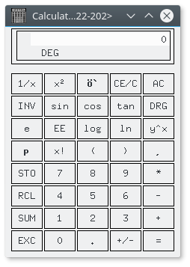

Compile Worms12.cpp
I couldn’t really get this to compile correctly. I installed g++, but I have no idea what you were trying to tell me in the instructions for this part of the lab/project. What does “Compile it as follows: = g++ -c worms12.cpp; ls -l worms*= Link as follows: <= g++ worms12.o -l ncurses -o worms12=.” mean? I tried g++ worms12.cpp, but it would fail due to lack of ncurses; which, would not give me the worms12.o files to do the “Link as follows...” part of the instructions. Script also forgot to capture wget, but I called it before trying g++.
#7#[0;34r#8#[1A#[J#]0;ubuntu@ip-172-31-22-202: ~#ubuntu@ip-172-31-22-202:~$ g++ -c worms12.cpp
#[01m#[Kworms12.cpp:103:21:#[m#[K #[01;31m#[Kfatal error: #[m#[Kncurses.h: No such file or directory
compilation terminated.
#]0;ubuntu@ip-172-31-22-202: ~#ubuntu@ip-172-31-22-202:~$ g++ -c worms12.cpp; ls-##[K -l wormss*##[K##[K*
#[01m#[Kworms12.cpp:103:21:#[m#[K #[01;31m#[Kfatal error: #[m#[Kncurses.h: No such file or directory
compilation terminated.

Cloud File Transfer
I tried to download the file directly using the Google Drive Share link. That did not work. I guess I’ll need an app to download to get my stuff from Google Drive.
#]0;ubuntu@ip-172-31-22-202: ~#ubuntu@ip-172-31-22-202:~$ wget https://drive.google.com/open?id=0BxLxA3AhetqsNmtVcFdRT2
EzdXc
--2017-01-27 04:56:20-- https://drive.google.com/open?id=0BxLxA3AhetqsNmtVcFdRT2EzdXc
Resolving drive.google.com (drive.google.com)... 172.217.3.174, 2607:f8b0:400a:800::200e
Connecting to drive.google.com (drive.google.com)|172.217.3.174|:443... connected.
HTTP request sent, awaiting response... 302 Moved Temporarily
Location: https://drive.google.com/folderview?id=0BxLxA3AhetqsNmtVcFdRT2EzdXc&usp=drive_web [following]
--2017-01-27 04:56:21-- https://drive.google.com/folderview?id=0BxLxA3AhetqsNmtVcFdRT2EzdXc&usp=drive_web
Reusing existing connection to drive.google.com:443.
HTTP request sent, awaiting response... 302 Moved Temporarily
Location: https://drive.google.com/drive/folders/0BxLxA3AhetqsNmtVcFdRT2EzdXc?usp=drive_web [following]
--2017-01-27 04:56:21-- https://drive.google.com/drive/folders/0BxLxA3AhetqsNmtVcFdRT2EzdXc?usp=drive_web
Reusing existing connection to drive.google.com:443.
HTTP request sent, awaiting response... 200 OK
Length: unspecified [text/html]
Saving to: ‘open?id=0BxLxA3AhetqsNmtVcFdRT2EzdXc’

open?id=0B [<=> ] 0 --.-KB/s
open?id=0Bx [ <=> ] 112.48K 354KB/s
open?id=0BxLxA3Ahetqs [ <=> ] 132.54K 417KB/s in 0.3s

2017-01-27 04:56:21 (417 KB/s) - ‘open?id=0BxLxA3AhetqsNmtVcFdRT2EzdXc’ saved [135720]

Terminate EC2 Instance
I right clicked the entry on the webpage, and selected the Terminate action.
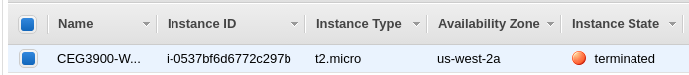
It took me 1 hour, 59 minutes, and 50 seconds to complete this Task; 7 hours, 30 minutes, and 52 seconds total

Feedback
This lab or project was WAY too long. I feel that Task 1 needs an app limit: tell us about the apps, but only require us to write about two or three of them. There could also be more links added for Task 3. The top 12 Open Source apps does not include GitHub links for the apps that it talks about. There was this really cool site that you were showing off for Google’s Sprayscape, and that would make a nice addition to the list. I’m still not skilled enough in Android Development to bypass something like the need for signed debug apps; which was the issue I ran into with mine. The Cloud Intro lab could use some rework: the set-up steps for AWS EC2 are out of order in the instructions, and I have no idea what you were trying to tell me about compiling the worms12.cpp file. I also didn’t know what you wanted to show that we did for the Cloud Intro lab, so I decided to copy some of my Terminal output while doing it. However, that added about 20 pages on this report.

