23CSE301 MACHINE LEARNING

LAB ACTIVITY 1

Data Visualization using Python

- Bar Chart

Code:

import matplotlib.pyplot as plt

subjects = ['Maths', 'Physics', 'Chemistry', 'Biology'] marks = [85, 78, 92, 88]
plt.bar(subjects, marks) plt.title("Student Marks") plt.xlabel("Subjects") plt.ylabel("Marks") plt.show()

Output:

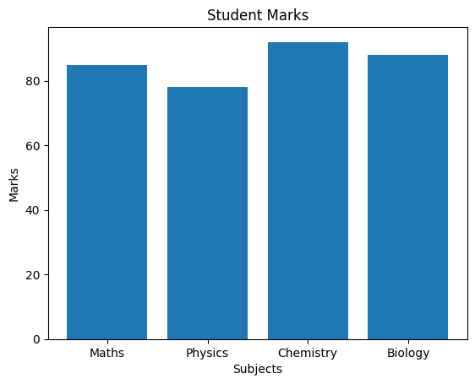

Line Chart

Code:
import matplotlib.pyplot as plt days = [1, 2, 3, 4, 5]
temperature = [30, 32, 35, 33, 31]
plt.plot(days, temperature, marker='o') plt.title("Temperature Variation") plt.xlabel("Day") plt.ylabel("Temperature (°C)") plt.show()

Output:

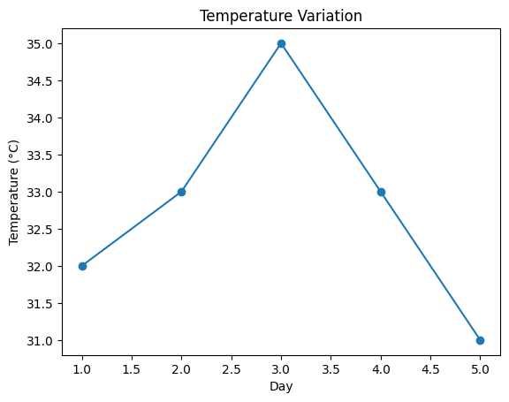

Pie Chart

Code:

import matplotlib.pyplot as plt

labels = ['A', 'B', 'C', 'D'] sizes = [30, 25, 20, 25]
plt.pie(sizes, labels=labels, autopct='%1.1f%%') plt.title("Market Share")
plt.show()

Output:

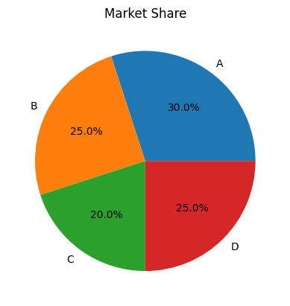

Histogram

Code:

import matplotlib.pyplot as plt

marks = [45, 50, 55, 60, 65, 70, 75, 80, 85, 90, 95]

plt.hist(marks, bins=5) plt.title("Distribution of Marks") plt.xlabel("Marks") plt.ylabel("Frequency")
plt.show()

Output:

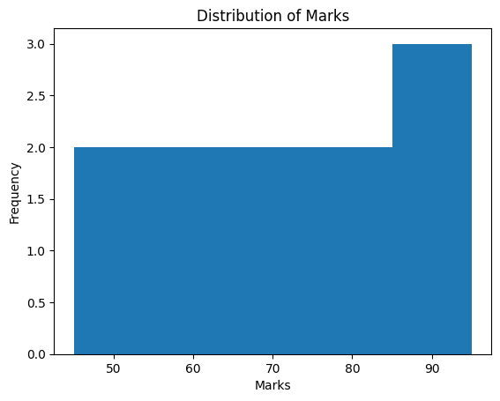

Scatter Plot

Code:

import matplotlib.pyplot as plt

height = [150, 155, 160, 165, 170, 175]
weight = [50, 55, 58, 63, 68, 72]

plt.scatter(height, weight) plt.title("Height vs Weight") plt.xlabel("Height (cm)") plt.ylabel("Weight (kg)") plt.show()

Output:

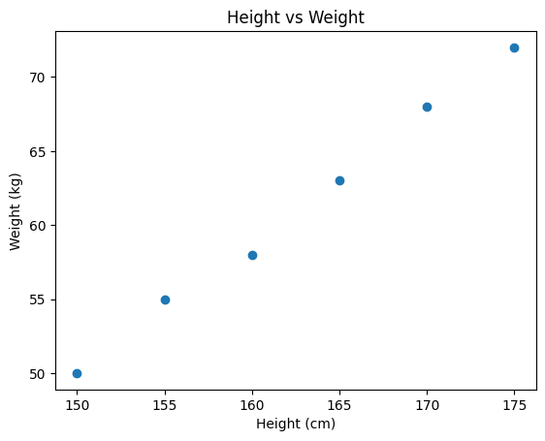

Box Plot

Code:

import matplotlib.pyplot as plt

data = [12, 15, 18, 22, 24, 25, 28, 30, 35]
plt.boxplot(data) plt.title("Box Plot") plt.show()

Output:

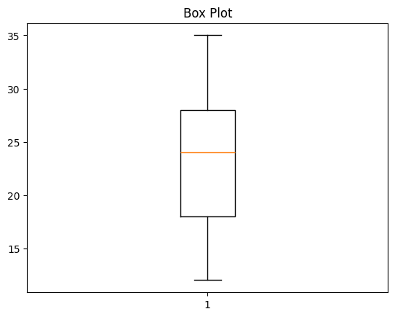

Correlation Heatmap

Code:

import pandas as pd import seaborn as sns
import matplotlib.pyplot as plt

data = {
'Maths':[80,90,70,85,95],
'Physics':[75,88,65,82,92],
'Chemistry':[78,85,68,80,90]
}

df = pd.DataFrame(data)

sns.heatmap(df.corr(), annot=True, cmap='coolwarm') plt.title("Correlation Heatmap")
plt.show()

Output:

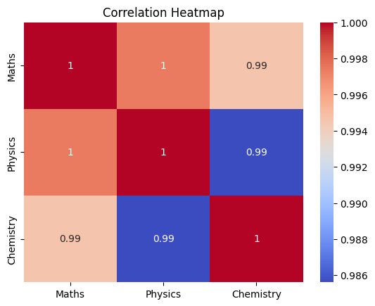

Dataset Visualization using Pandas

Code:

import pandas as pd
import matplotlib.pyplot as plt

df = pd.read_csv("students.csv")
df['Marks'].plot(kind='bar') plt.title("Student Marks") plt.show()

Multiple Line Plot

Code:

import matplotlib.pyplot as plt

months = ['Jan','Feb','Mar','Apr','May'] sales_A = [10,12,15,18,20]
sales_B = [8,11,14,16,19]
plt.plot(months, sales_A, label='Product A') plt.plot(months, sales_B, label='Product B')
plt.legend() plt.title("Monthly Sales") plt.xlabel("Months") plt.ylabel("Sales") plt.show()

Output:

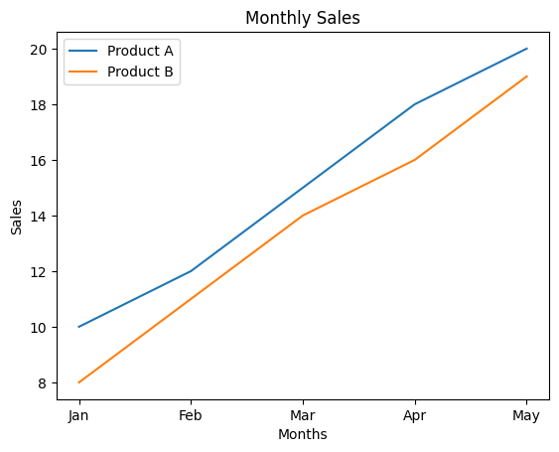

Pair Plot using Seaborn

Code:

import seaborn as sns
import matplotlib.pyplot as plt

iris = sns.load_dataset('iris')

sns.pairplot(iris, hue='species') plt.show()

Output:

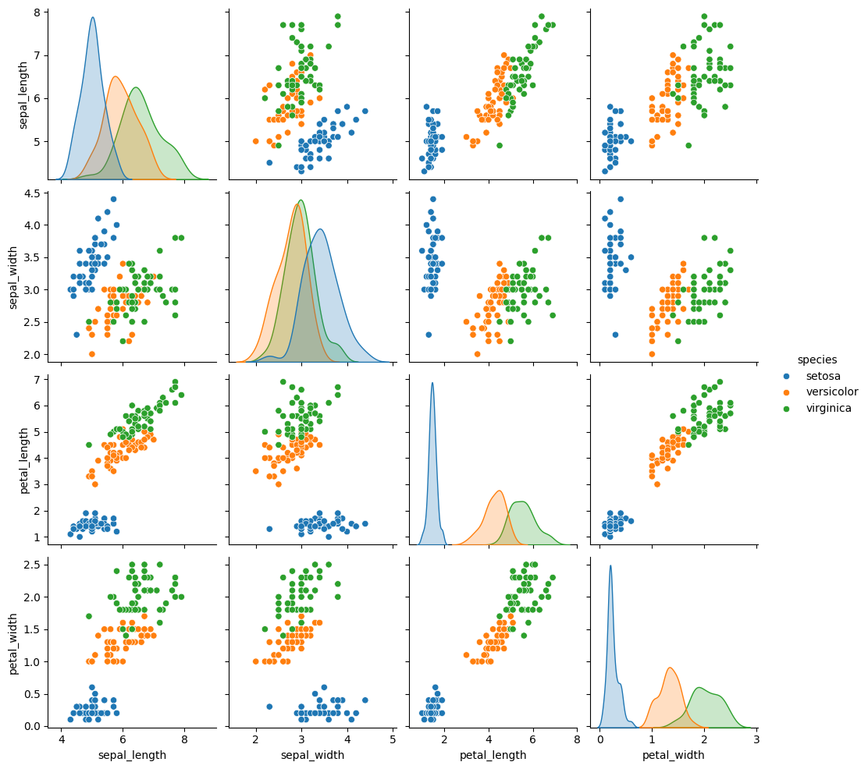

TASK: Using the titanic dataset visualize all possible graphs

Survival Count Graph:

import pandas as pd

import matplotlib.pyplot as plt

# Load dataset

url = "https://raw.githubusercontent.com/datasciencedojo/datasets/master/titanic.csv"

df = pd.read_csv(url)

# Create Family Size column

df["FamilySize"] = df["SibSp"] + df["Parch"] + 1

#Survival Count

survival = df["Survived"].value_counts()

plt.figure(figsize=(6,4))

plt.bar(["Not Survived","Survived"], survival)

plt.title("Survival Count")

plt.xlabel("Status")

plt.ylabel("Number of Passengers")

plt.show()

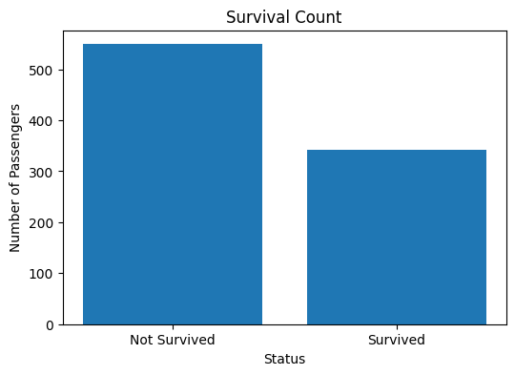

Pair Plot

import seaborn as sns

import matplotlib.pyplot as plt

# Use the already loaded DataFrame 'df'

sns.pairplot(df, hue='Survived')

plt.show(10)

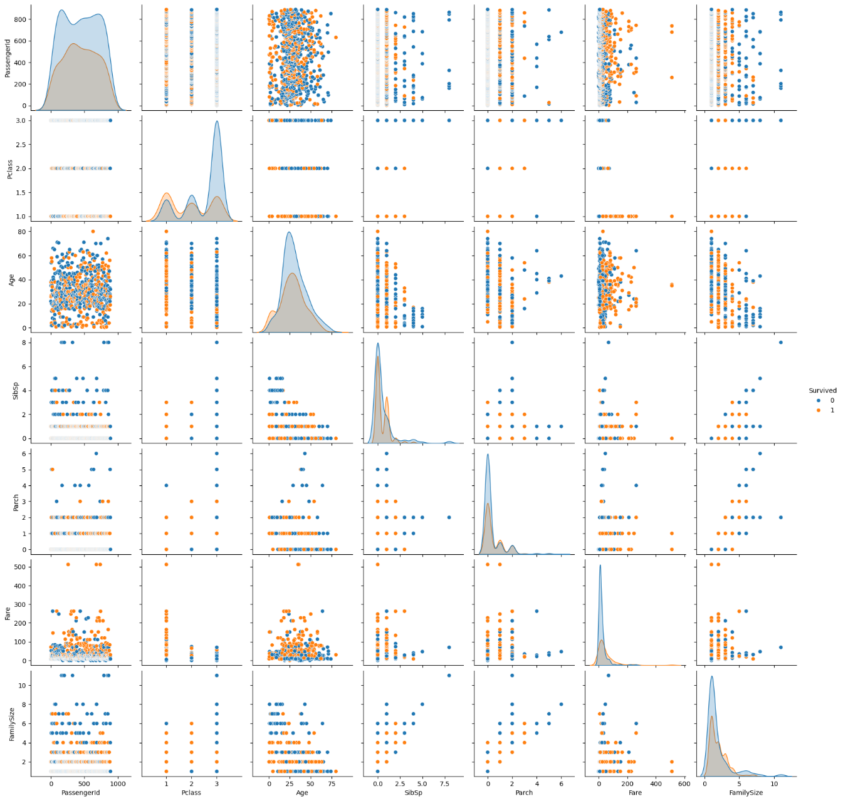

Passenger-Class Distribution

pclass = df["Pclass"].value_counts().sort_index()

plt.figure(figsize=(6,4))

plt.bar(pclass.index.astype(str), pclass.values)

plt.title("Passenger Class Distribution")

plt.xlabel("Class")

plt.ylabel("Passengers")

plt.show()

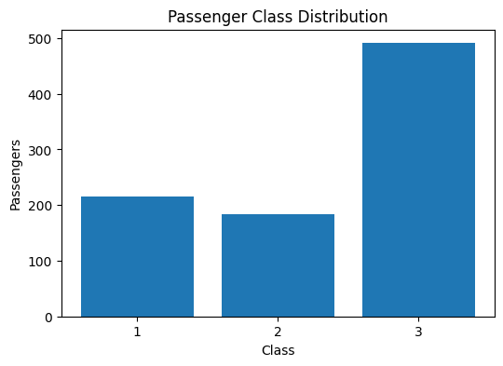

Percentage of Survival -Pie chat

survival = df["Survived"].value_counts()

plt.figure(figsize=(6,6))

plt.pie(

survival,

labels=["Not Survived","Survived"],

autopct="%1.1f%%",

startangle=90

)

plt.title("Survival Percentage")

plt.show()

Age Frequency

plt.figure(figsize=(8,5))

plt.hist(df["Age"].dropna(), bins=20)

plt.title("Age Distribution")

plt.xlabel("Age")

plt.ylabel("Frequency")

plt.show()

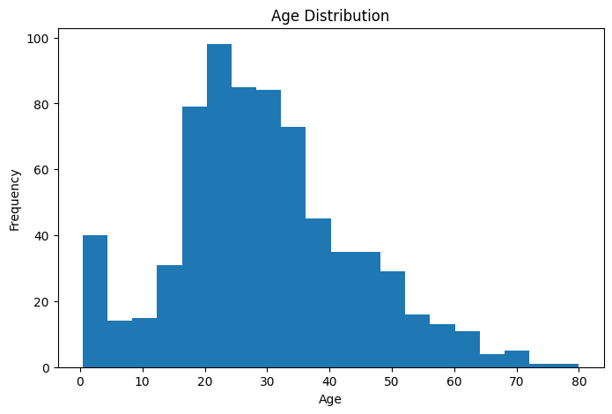

Age vs Fare

plt.figure(figsize=(8,5))

plt.scatter(df["Age"], df["Fare"])

plt.title("Age vs Fare")

plt.xlabel("Age")

plt.ylabel("Fare")

plt.show()

