Homework 1

Lavelle Burgess

Hawaii Pacific University

CSCI 3771, Python

Professor: Azhar Ishaque

Date: 01072019

**Write a program that accepts a sentence and calculate the number of letters and digits. Suppose the following input is provided to the program:**

**My First Python Program! 125789**

**The output should be:**

**Letters 25**

**Digits 6**

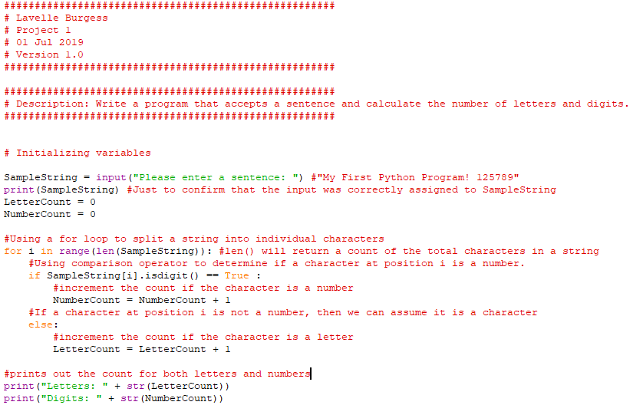

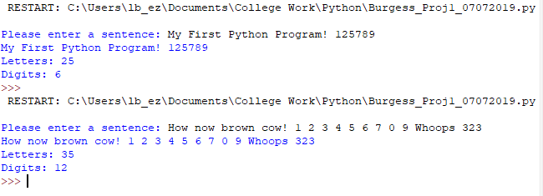

**Program documentation is always a best practice. Therefore, you must provide description/comments for each line to explain your code.**

**Deliverables:**

**Two Files:**

1. **Project Name_HW1.py with program description**
2. **This document Name_HW1.docs with screen shots of the output.**

**Due By: July 7, 2019**

References

Mark, Summerfield. (2010). Programming in Python 3. A Complete Introduction to the Python Language. (2nd edition). Pearson