Homework 2

Lavelle Burgess

Hawaii Pacific University

CSCI 3771, Python

Professor: Azhar Ishaque

Date: 14072019

Suppose you went to a family restaurant for a delicious meal. Write a Python program that will compute your bill including the tax and tip. The program should ask the user at least three menu items to order. The tax should be 4.76% of the meal charge. The tip should be 18% of the total after adding the tax. Calculate the per item price, tax amount, tip amount, and total bill as your output. Dollar values should include cents as two decimals. (i.e. $0.00)

**Deliverables:** Project file.py and the Word document with appropriate screenshots that display input and output.

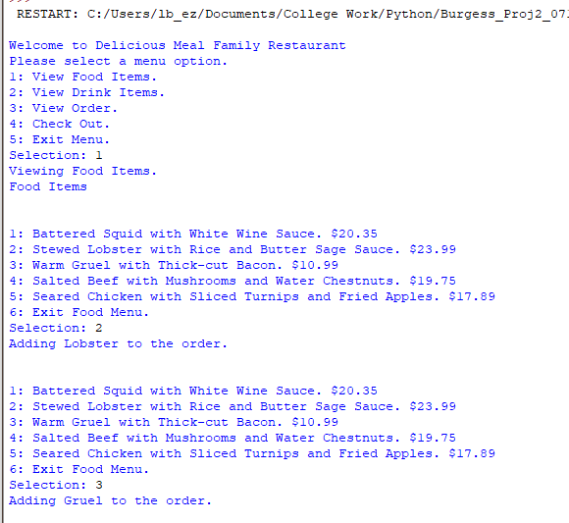

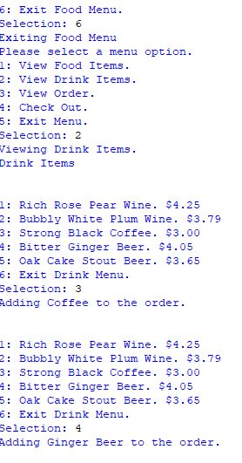 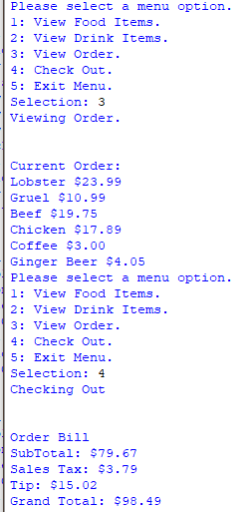

**Due By: 07/14/2019**

References

Mark, Summerfield. (2010). Programming in Python 3. A Complete Introduction to the Python Language. (2nd edition). Pearson