Homework 3

Lavelle Burgess

Hawaii Pacific University

CSCI 3771, Python

Professor: Azhar Ishaque

Date: 21072019

Write a program in Python 3.x that asks the user to input up to 10 numbers with two decimals into a list. The program should calculate and display the min, max, average and sum of the values entered. The output should include two decimals for the calculated values. Allow the user to reenter new numbers for calculation.

**Deliverables:** Project file.py and the Word document with appropriate screenshots that display input and output.

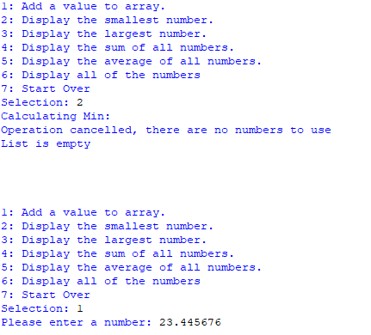

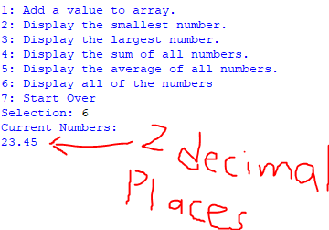

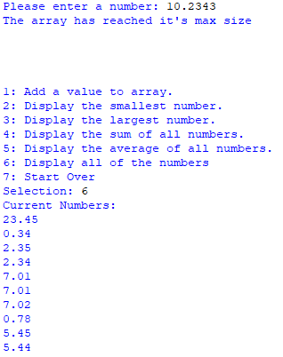





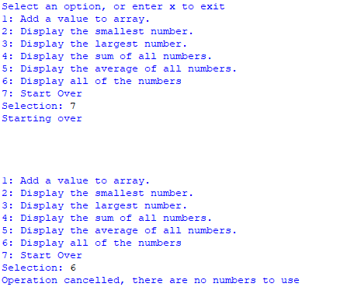

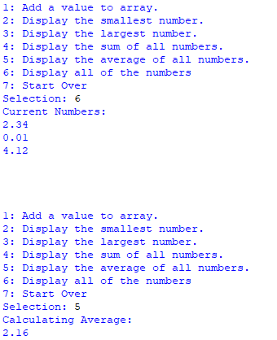

**Due By: 07/21/2019**

References

Mark, Summerfield. (2010). Programming in Python 3. A Complete Introduction to the Python Language. (2nd edition). Pearson