Homework 4

Lavelle Burgess

Hawaii Pacific University

CSCI 3771, Python

Professor: Azhar Ishaque

Date: 28072019

Write a program that create a class called Professors that would contain these attributes: Professor Name, Course_ID, Description, and Location.

Create a method named showResults that will display up to five records. Your program can include your favorite instructors. Below is a sample output.

**Sample Output:**

Professor Name Course_ID Description Location

Azhar Ishaque 3771 Python Hickam AFB

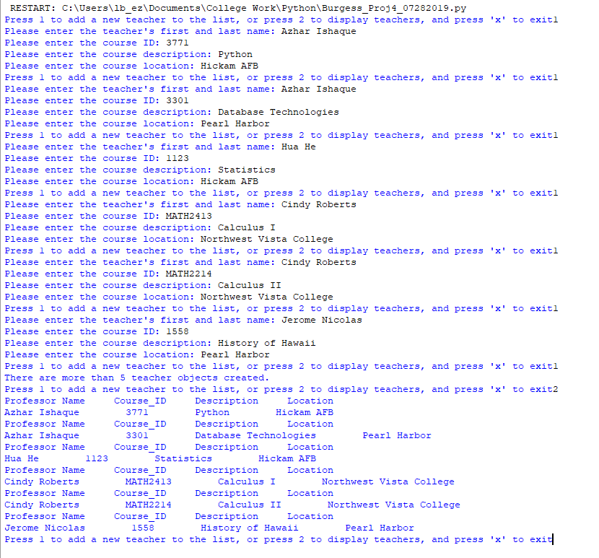

**Deliverables:** Project file.py and the Word document with appropriate screenshots that display input and output.

**Due By: 07/28/2019**

References

Mark, Summerfield. (2010). Programming in Python 3. A Complete Introduction to the Python Language. (2nd edition). Pearson