Homework 5

Lavelle Burgess

Hawaii Pacific University

CSCI 3771, Python

Professor: Azhar Ishaque

Date: 20190804

**Option 1**

Write a Python program that asks a user to enter score obtained from each of the five class projects and calculate the sum of scores. Each project should weigh 20 points to make up 100 points for the five projects. Then, add score for all five projects to find the grade according to the total score obtained by the student. The letter grade should be between A and F. Between 90-100 is A, 80-89, B, 70-79 is C, 60-69 D, and less than 60 will get F.

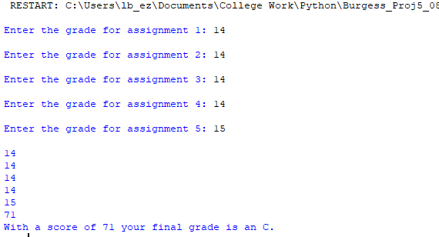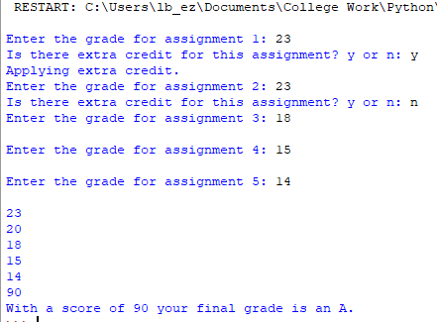

**Option-2**

Using turtle in Python, draw a flowchart of the course schedule with 7-weeks that will include assignments with quizzes and the final exam with due dates.

**OR**

Using turtle in Python, create a graphic of your choice that will use the nested loop.

**Deliverables:** Project file.py and the Word document with appropriate screenshots that display input and output.

**Due By: 08/4/2019**

References

Mark, Summerfield. (2010). Programming in Python 3. A Complete Introduction to the Python Language. (2nd edition). Pearson