Brief Descriptions:
- Composite1:
  - Children Objects: (‘N’ represents a set of objects)
Extrusion:
Object name | Profile | Path
h_frameN | frameprofile.txt | framepath.txt
v_frameN | frameprofile.txt | framepath2.txt
lid_frameN | frameprofile.txt | framepath3.txt
lid | lidprofile.txt | lidpath.txt
Sweep:
Object name | Profile
milk | milkprofile.txt
diamond[10]  Note: density = 8; useDiffuseShading(); | diamondprofile.txt
Cube:
Object name
pivot
Treasurebox: (this class makes changes on the basis of the opencube)
Object name
outface
insideface

  - Diagram:
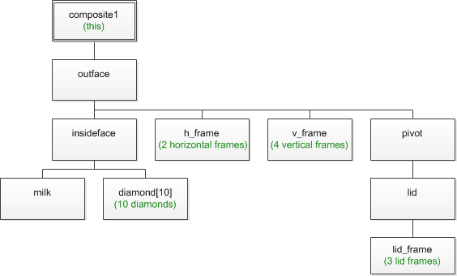
- Composite2 :
  - Children Objects : (‘N’ represents a set of objects)
Extrusion:
Object name | Profile | Path
face | faceprofile.txt | facepath.txt
body | bodyprofile.txt | bodypath.txt
pants | bodyprofile.txt | pantspath.txt
medal | bodyprofile.txt | medalpath.txt
browN | bodyprofile.txt | browpath.txt
sword | quadprofile.txt | swordpath.txt
tail | armprofile.txt | tailpath.txt
armN | armprofile.txt | armpath.txt
earN | earprofile.txt | earpath.txt
hoofN | hoofprofile.txt | hoofpath.txt
Sweep:
Object name | Profile
pantsN | onepantsprofile.txt
handle | handleprofile.txt
sh_handleN | handleprofile.txt
shield | shieldprofile.txt
Sphere:
Object name
arm_pivotN
arm_pivotN
tail_pivot
spotN
eyeN
orbitN
ballN
hornN
Torus:
Object name
noseN
nose_ring
appendant
sh_ring

  - Diagram :
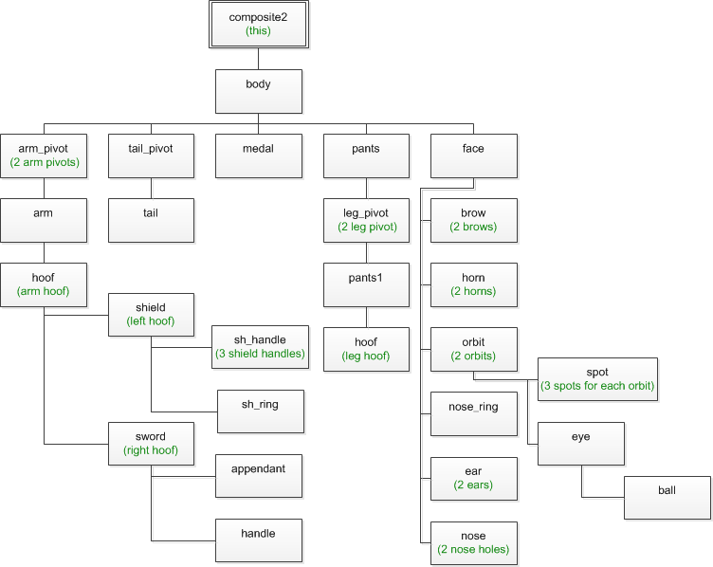

143277 Mei Kaicheng
Apr.27, 2012

